6. (a) The likelihood function converges to a certain value after about 5000 iterations with a learning rate of 0.001.

The log likelihood function value in the first 9 iterations are listed below.

log: -970.406052784 log: -701.315523713 log: -1637.42075794

log: -5535.01075562 log: -1555.18897641 log: -3766.53527502

log: -1727.2463233 log: -2537.32923792 log: -1174.17562683

log: -1348.51929809 log: -755.853656746 log: -715.744051387

Actually, during the first several iterations, the value is bouncing back and forth. Then start from the 12th iteration, the function value starts to gradient descent in one direction.

In the last 2000 iterations, the value converges very slowly towards -147.3495. Here I just list several values from the last iterations.

log: -147.349714556

log: -147.349700592

log: -147.349686643

log: -147.349672707

log: -147.349658786

log: -147.349644878

log: -147.349630985

log: -147.349617105

log: -147.349603239

log: -147.349589388

log: -147.34957555

log: -147.349561726

log: -147.349547916

log: -147.34953412

The weight vector is:

w: [-1.53301403 -1.48429062 -2.22079829 -0.97105807 -1.86732557 -0.4883959

0.88138338 2.04514895 1.03108567 -0.04839772 1.01757989 -0.66309329

-0.14786594 0.63340024 -1.57905459 0.02907137 2.95291747 1.27848733

1.01640661 0.34069904 0.26199445 -2.27179045 -3.27406204 -3.85295161

2.42791959 0.75005343 1.79097086 -0.58383879 -1.74188449 -0.55677888

0.46715707 -0.29512893 0.18246235 0.23393425 0.27509105 -1.0230082

-0.09269407 -0.07330668 -0.78303051 -0.14496728 1.35813881 -0.98776292

0.50471822 0.7916843 0.41091148 -0.80297218 0.01772689 -1.91028338

0.60648545 -0.35100621 1.17989136 0.91618812 -0.12399735 -0.19726054

0.61538495 -1.75124618 0.39788889 0.37184725 -0.87843639 5.41213072

0.36607671 0.43560885 0.0293102 -0.66265953]

The convergence plot is given.

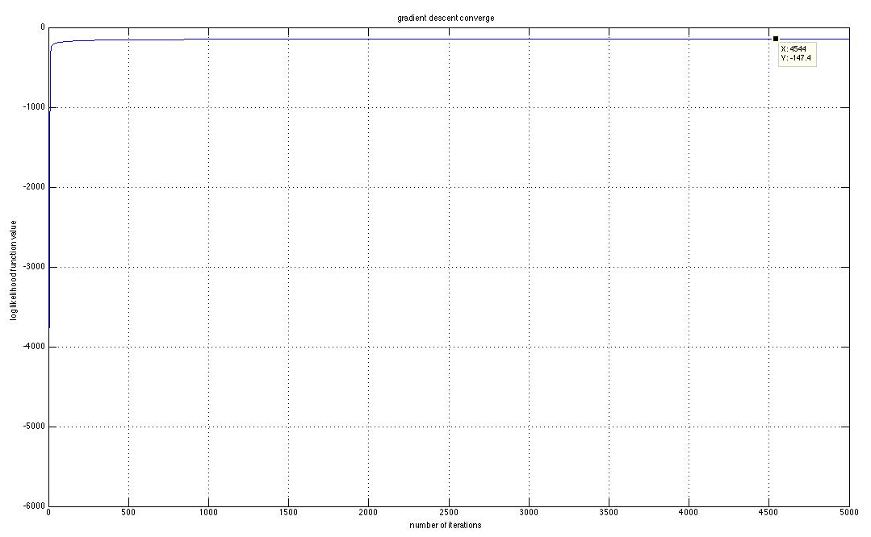

(b)

error on training data 3: 0.037142857

error on training data 5: 0.034285714

overall error on training data: 0.035714285

error on test data 3: 0.055

error on test data 5: 0.05

overall error on test data: 0.0525