Appendix

3. (c)

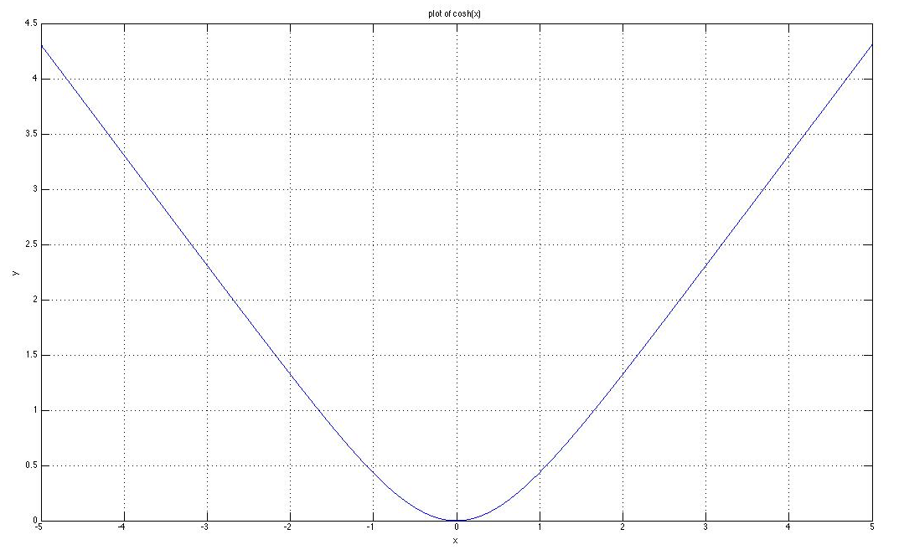

Figure 1 The plot of f(x)

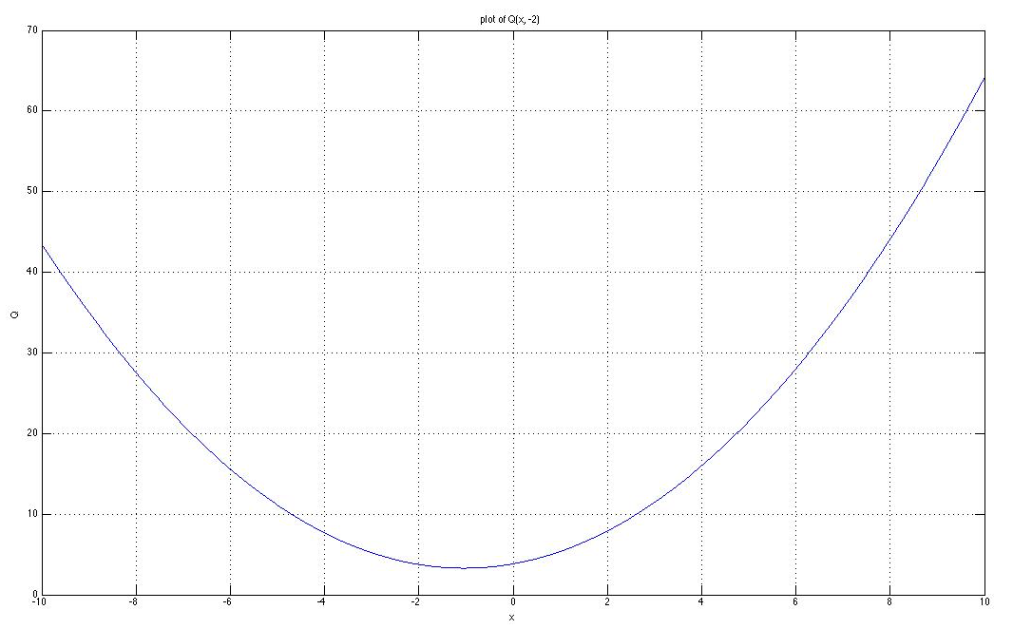

Figure 2 The plot of Q(x, -2)

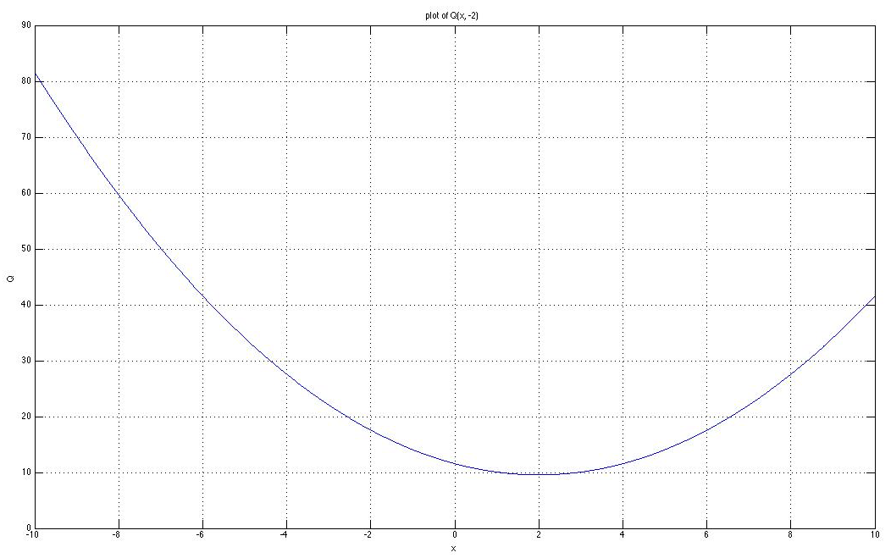

Figure 3 The plot of Q(x, 3)

(g)

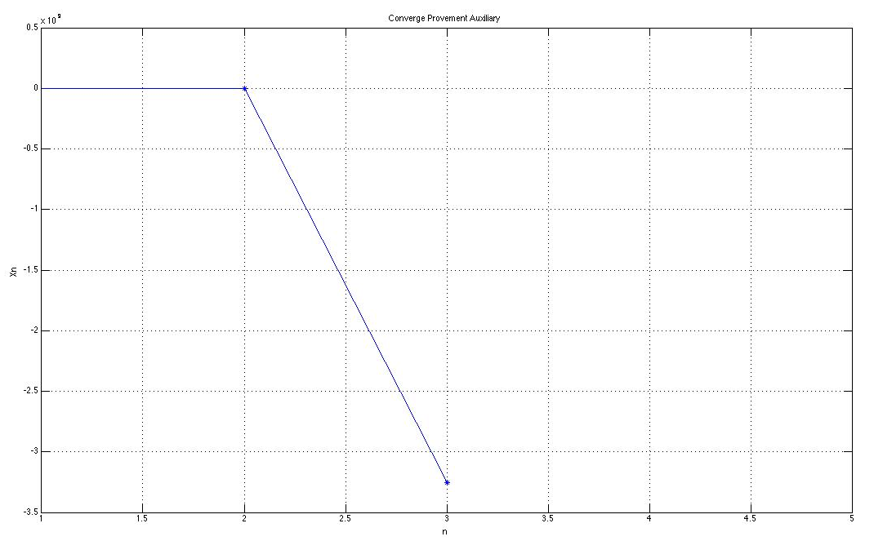

Figure 4 The non-converging plot of Newton’s method with x0 = -2

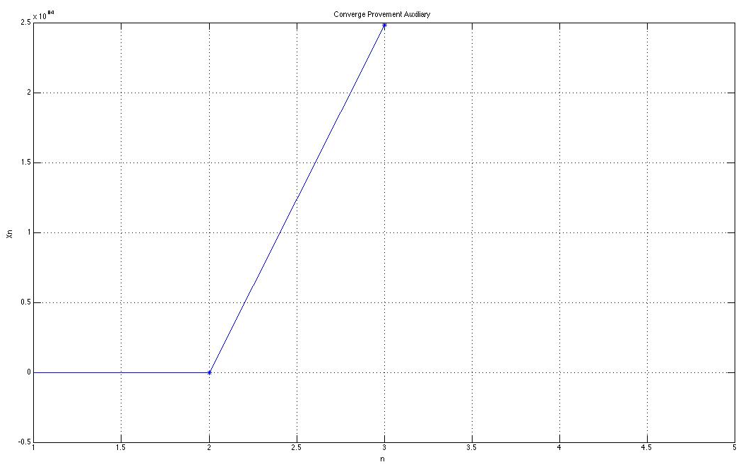

Figure 5 The non-converging plot of Newton’s method with x0 = 3

The source code for (f):

n = 10;

x = 1 : 1 : n;

xn = zeros(1, n);

xn(1) = -2;

for i = 2 : n

xn(i) = xn(i - 1) - tanh(xn(i - 1));

end

plot(x, xn, '\*-');

grid on;

title('Converge Provement Auxiliary');

xlabel('n');

ylabel('Xn');

n = 10;

x = 1 : 1 : n;

xn = zeros(1, n);

xn(1) = 3;

for i = 2 : n

xn(i) = xn(i - 1) - tanh(xn(i - 1));

end

plot(x, xn, '\*-');

grid on;

title('Converge Provement Auxiliary');

xlabel('n');

ylabel('Xn');

The sorce code for (g):

n = 5;

x = 1 : 1 : n;

xn = zeros(1, n);

xn(1) = -2;

for i = 2 : n

xn(i) = xn(i - 1) - tanh(xn(i - 1)) / sech(xn(i - 1)) ^ 2;

end

plot(x, xn, '\*-');

grid on;

title('Converge Provement Auxiliary');

xlabel('n');

ylabel('Xn');

n = 5;

x = 1 : 1 : n;

xn = zeros(1, n);

xn(1) = 3;

for i = 2 : n

xn(i) = xn(i - 1) - tanh(xn(i - 1)) / sech(xn(i - 1)) ^ 2;

end

plot(x, xn, '\*-');

grid on;

title('Converge Provement Auxiliary');

xlabel('n');

ylabel('Xn');

The source code for (k):

n = 10;

x = 1 : 1 : n;

xn = zeros(1, n);

xn(1) = 2;

g = zeros(1, n);

for i = 2 : n

temp = 0;

temp1 = 0;

for j = 1 : 10

temp = temp + tanh(xn(i - 1) + j ^ -0.5);

temp1 = temp1 + log(cosh(xn(i - 1) + j ^ -0.5));

end

xn(i) = xn(i - 1) - 0.1 \* temp;

g(i - 1) = temp1 \* 0.1;

end

g(n) = g(n - 1);

h = plot(x, g, '\*-');

grid on;

title('Converge Provement G(k) Auxiliary');

xlabel('n');

ylabel('G(k)');