2.

(a)The value list of V\*(s) is shown below:

V(3) = 71.394213900262173,

V(11) = 72.983050137169926,

V(12) = 72.173839772438029,

V(15) = 79.828078124075688,

V(16) = 80.723740387003275,

V(17) = 81.629451878503005,

V(20) = 73.801896668801092,

V(22) = 77.200256907244324,

V(23) = 78.066455962077924,

V(24) = 78.942353575718414,

V(26) = 82.545325350152467,

V(29) = 74.629945450442733,

V(30) = 75.46728524328195,

V(31) = 76.342925112169837,

V(34) = 84.408015578237283,

V(35) = 83.471474818225872,

V(39) = 74.397792548896234,

V(43) = 85.355064219303074,

V(47) = -99.999971634405,

V(48) = 64.886287227465203,

V(49) = -99.999971634405,

V(51) = -99.999971634405,

V(52) = 86.312738638656356,

V(53) = 90.519007743457593,

V(56) = 59.66755141316019,

V(57) = 68.949798850127252,

V(58) = 70.31429937981747,

V(59) = 80.325187732396827,

V(60) = 81.472904470173503,

V(61) = 92.202953763574044,

V(62) = 91.621159538199478,

V(65) = -99.999971634405,

V(66) = 59.66755141316019,

V(67) = -99.999971634405,

V(69) = -99.999971634405,

V(70) = 93.67473182161109,

V(71) = 92.635727612324672,

V(79) = 99.999971634405.

(b) The visualized result:

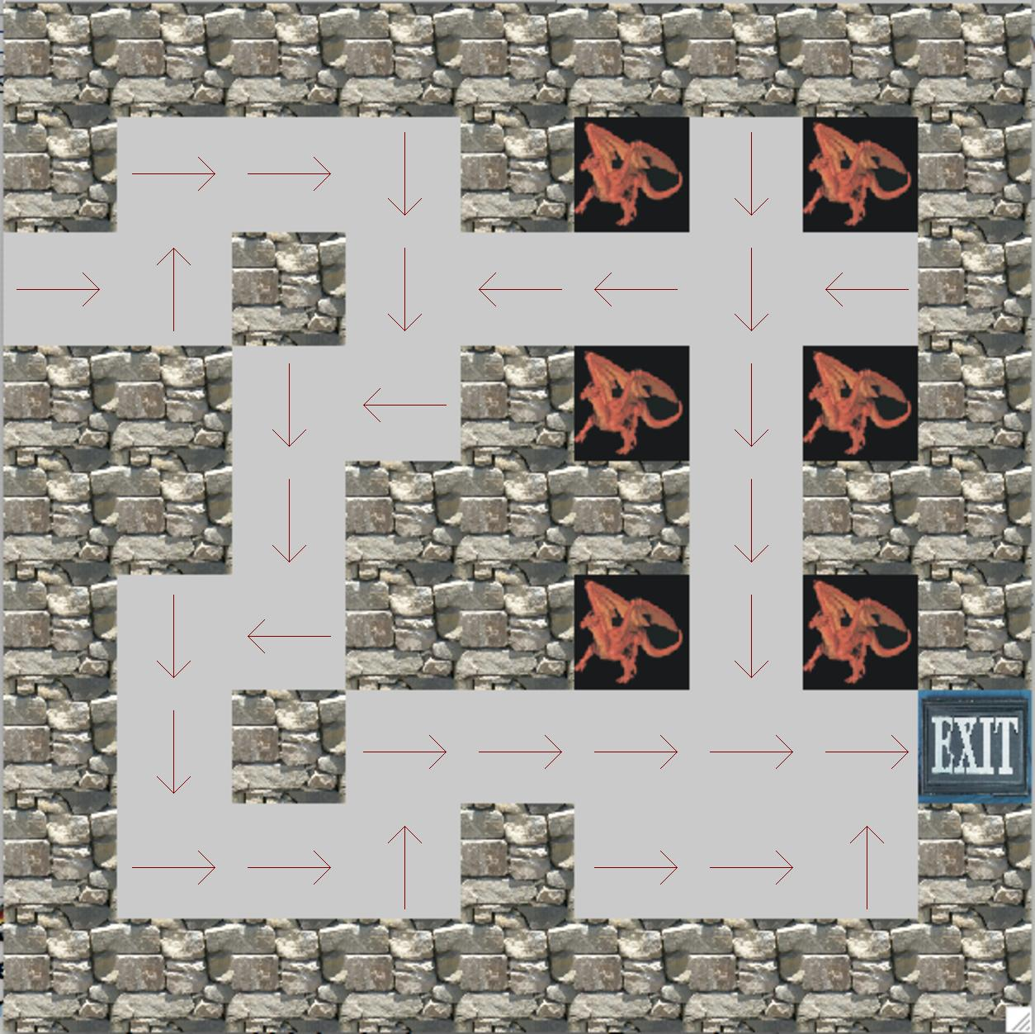

(c) The result is the same as (b). The plot is shown below:

