**A**

Project Report On

**“Smart Shopping Cart For Automatic Billing In Supermarket”**

Submitted in partial fulfilment of the requirements for the Degree of

**BACHELOR OF TECHNOLOGY**

**In**

**Electronics and Telecommunication Engineering**

SUBMITTED BY

Ms. Mahadik Sayali Yashwant

Ms. Mankar Komal Ramchandra

Ms. Suryavanshi Prajakta Pratap

Mr. Shinde Akshay Sanjay

Under the Supervision of **Guide: Prof.Mahamuni P.N.**

**Co-Guide: Prof. Bichkar J. S.**



# Department of Electronics and Telecommunication Engineering

**ARVIND GAVALI COLLEGE OF ENGINEERING, SATARA**

**2020-21**

# **Certificate**

This is to certify that the Project report entitled **“Smart Shopping Cart For Automatic Billing In Supermarket”** is a bonafide work carried out by:

Ms. Mahadik Sayali Yashwant

Ms. Mankar Komal Ramchandra

Ms. Suryavanshi Prajakta Pratap

Mr. Shinde Akshay Sanjay

under our supervision, during the year 2020-21 and submitted to the Faculty of Electronics and Telecommunication Engineering, AGCE, Satara in partial fulfilment of the requirements for the award of the Degree of Bachelor of Technology in Electronics and Telecommunication Engineering.

|  |  |
| --- | --- |
| **Prof. Mahamuni P. N.** | **Prof. Mahamuni P. N.** |
| Alumni Mentor | Guide |
| **Prof. Bichkar J. S.** | **Prof. Jagtap D. B.** |
| Project Co-ordinator | HOD |
| **Dr. Mirajkar G. S.** | **Dr. Pharande V. A.** |
| R&D Co-ordinator | Principal |

## **UNDERTAKING**

We hereby declare that the details furnished above are true and correct to the best of our knowledge and belief and we undertake to inform authorities about any changes therein, immediately. In case any of the above information is found to be false or untrue or misleading or misrepresenting, we are aware that we may be held liable for it.

|  |  |  |  |
| --- | --- | --- | --- |
| **Sr. No.** | **Name of Student** | **Roll No.** | **Sign** |
| 01 | Ms. Mahadik Sayali Yashwant | 4013 |  |
| 02 | Ms. Mankar Komal Ramchandra | 4015 |  |
| 03 | Ms. Suryavanshi Prajakta Pratap | 4028 |  |
| 04 | Mr. Shinde Akshay Sanjay | 4034 |  |

Date:

Place: Satara

## **Acknowledgement**

It is our privilege to acknowledge my deep sense of gratitude to my guide Prof. Mahamuni P. N. in Electronics and Telecommunication Engineering at Arvind Gavali College of Engineering, Satara for her valuable suggestions and guidance throughout our degree course and the timely help given to us in completion of our project work.

We are thankful to Dr. V. A. Pharande, Principal, Arvind Gavali College of Engineering, Satara and Prof. Jagtap D. B., Head of Electronics and Telecommunication Engineering department for their kind co-operation & morale support.

Finally, we wish to express our sincere thanks to all the staff members of Arvind Gavali College of Engineering, Satara for their direct and indirect help during the course of our project.

**Date:**

**Place: Satara**

**ABSTRACT**

Even though E Commerce has grown exponentially in the past few years, sales made from retail still account for around 85% of the total sales made. Among the difficulties faced by customers, one difficulty is to line up in a queue to follow through with the billing process. Though their intent is just to buy one or two products, waiting to bill products consumes time and also inconvenient these days as people live in a busy environment. The goal is to develop technology that can meet all the needs of the customer while simplifying the billing process and saving the time of the customer. The proposed method is to have the customer directly process products and bill them in the trolley instead of waiting in a queue for long periods of time. The customers have to add the products after a short scan in the trolley and when they’re done, the amount will be displayed in the trolley. The customer can also log in to the app which will display the list of all the products added and their amount. Once done, the customer can just pay on the counter; thus, cutting down on the time that would be otherwise spent in long queues and relieve them from the tediousness of scanning barcodes.

The project "Smart Shopping Cart For Automatic Billing In Supermarket "consists of RFID tags which were fitted on each product.Tags contains product information such as price, weight,etc.This information is scan by RFID reader.After scaning the scaning information is display on LCD display which fitted along with trolley.Arduino uno is used to control and program all the hardware.When shopping over the final bill detail will be display on BLYNK app.Then customer have to just pay bill on counter.

### **CONTENTS**

*ABSTRACT i*

*CONTENTS*  *ii*

*LIST OF FIGURES* *iii*

*LIST OF TABLES* *iv*

*LIST OF ABBREVIATIONS* *v*

### **CHAPTERS** **Page No**

#### **1.** **INTRODUCTION 11**

1.1 General introduction

1.2 Aims and objectives of the present work

#### **2. LITERATURE REVIEW**

2.1 Literature review

(Carried out for minimum 5 papers from peer-reviewed journals or reputed conferences)

#### **3. HARDWARE IMPLEMENTATION**

3.1 Components used

3.1.1 RFID tags

3.1.2 RFID reader

3.1.3 LCD display

3.1 4 ARDUINO UNO

3.2 Block diagram

3.3 Circuit diagram

#### **4. SOFTWARE IMPLEMENTATION**

4.1 Flow Chart/ Algorithm

4.2 Programming Language Used

#### **5. RESULT AND CONCLUSION**

5.1 Project Prototype Photographs

5.2 Result

5.3 Conclusion

5.4 Future Scope

#### **6. REFERENCES**

6.1 Books

6.2 Research Papers

6.3 Websites

#### **APPENDIX**

APPENDIX I: Synopsis

APPENDIX II: Primary Paper and 2 reference papers

APPENDIX III: Data Sheets

**LIST OF FIGURES**

|  |  |  |
| --- | --- | --- |
| **Figure No.** | **Caption** | **Page No.** |
| 3.1.1 | RFID Tags |  |
| 3.1.2 | RFID Reader |  |
| 3.1.3 | LCD Display |  |
| 3.1.4 | Arduino UNO |  |
| 3.2 | Block Diagram |  |
| 3.3 | Circuit Diagram |  |
| 4.1 | Flowchart |  |
| 4.2 | Arduino IDE |  |
| 5.1 | System Photograph |  |
|  |  |  |
|  |  |  |
|  |  |  |
|  |  |  |
|  |  |  |
|  |  |  |
|  |  |  |
|  |  |  |
|  |  |  |
|  |  |  |

**LIST OF TABLES**

|  |  |  |
| --- | --- | --- |
| **Table No.** | **Caption** | **Page No.** |
| 1 | Literature Review | 14 |
| 2 | Result | 23 |
|  |  |  |
|  |  |  |
|  |  |  |
|  |  |  |

**LIST OF ABBREVIATIONS**

|  |  |
| --- | --- |
| **Abbreviation** | **Meaning** |
| RFID | Radio Frequency Identification |
| IOT | Internet Of Things |
| LCD | Liquid Crystal Display |
| MHz | Mega Hertz |
| IDE | Integrated Development Environment |
|  |  |

**Chapter 1**

**INTRODUCTION**

**Chapter 1**

**INTRODUCTION**

* 1. **General Introduction**

Generally in Supermarkets people uses barcode tags for preparing the bill. Firstly the products scan one by one and then data is computerized. “Barcode Based product billing System”(B.B.P.B.S) is a software which utilizes barcode scanner which is integrated in mobile camera to record and maintain bills of product.

By using Barcode Based Product Billing System, at the time of shopping people have to collect all the products they need and the products are then billed at exit counter. So there's​ along queue for checkouts and payments at the exit counter. This additional time consuming at billing section is avoided by using IOT which creates its own WiFi network with from the inter section of RFID and the identification with the help of RFID reader present in trolley.

**1.2 Objectives**

1.This application should be Interactive and robust.The RFID is the connection between virtual world and the reality.2. When product gets added to trolley by customer, automatically amount is calculated and displayed. And complete offers of day are shown on display which is present in the trolley.

**Chapter 2**

**LITERATURE REVIEW**

**Chapter 2**

**LITERATURE REVIEW**

|  |  |  |
| --- | --- | --- |
| **Author** | **Method Followed** | **Outcome** |
| 2.1  1. HarpeetBedi  2. Kumar  S3. Gupta A | Smart phone | This application uses RFID to scan the products and sends the details to the database. Shopping commences by pressing start button and ends by pressing stop button provided in the trolley. |
| 2.2  1. Prasiddhi K.  2. Dhansashri H.Gawali | RFID Zigbee | Using RFID technology, an inexpensive RFID tag can be attached to each product and scan it with RFID reader. After scanning the products prices added automatically and as the shopping over, bill is send to the counter. |
| 2.3  1. Manikandan Thiyagarajan  2. Mohammed Aejaz | RFID | Using RFID technology, RFID reader present in each trolley and RFID tag for each item, reader scans each product rate and brand of the product and the information will be shown on the LCD screen. |
| 2.4  1.Manoj Kumar S.  2.Kiran S. | RFID IOT | Using RFID technology,the products can added to trolley and the data send to server.By application of IOT customers can do online payments. |
| 2.5  1.Sarika S. Pande  2.Soumya R. Gupta | RFID Visual Basics | Using RFID technology,the products can added to trolley and then data is send to visual Basics where the bill is generated. |

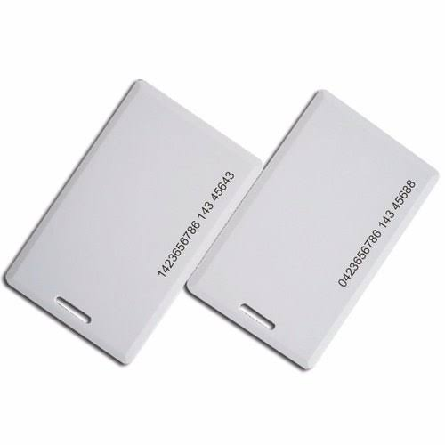

**Chapter 3**

**HARDWARE IMPLEMENTATION**

**Chapter 3**

**HARDWARE IMPLEMENTATION**

### **3.1 Components Used :**

### 

### **3.1.1** **RFID Tags:**

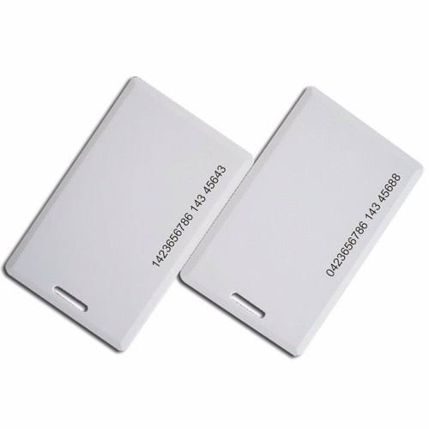

Each tag is fitted with a microchip that is used for storing the number as well as a coil which is used as an antenna for the radiation of information through radio-frequency waves. Depending on whether the kind is active or passive, it may or may not be equipped with a power source. Active tags have their own battery which they use to operate the circuitry and emit electromagnetic ways to generate a current in the antenna. Passive tags have no battery of their own and function by drawing power from the RFID reader and have a lower cost when compared to active tags. When the tag makes contact with the coverage range of RFID reader, the reader transmits radio-frequency waves to the tag which emits the waves back to the reader for the identification of an article.

**3.1.2 RFID Reader:**

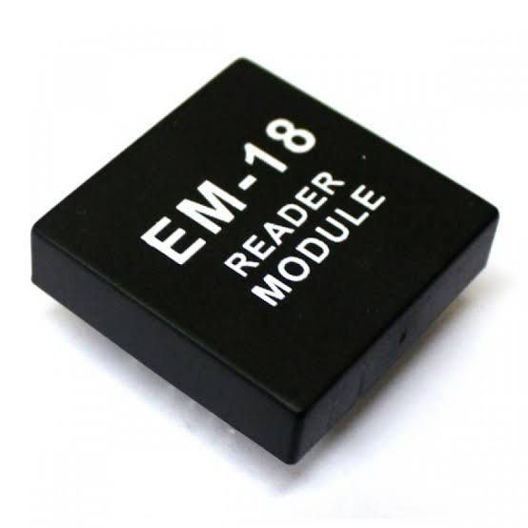

Each trolley is reinforced with an RFID reader, and the type of reader that is used is RFIDRC522. It is a low-cost RFID reader which can also write data into the tags if required and can be directly loaded into the reader module for modulation and demodulation of signals. It operates at 13.6 MHz frequency and can operate wirelessly and handsfree in any environment making it a suitable choice as an RFID reader for a supermarket trolley. It also supports encryption techniques and algorithms and error detection in modules for a reliable experience.

**3.1.3 LCD Display:**

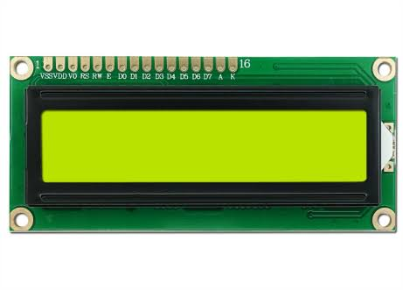

A 16X2 LCD touch-enabled LCD screen is used for displaying the information. The LCD screen can display a multitude of alphanumeric characters and graphics on its screen. It is connected to the I/O port of ATMEGA328P chip and can display information in real time.

**3.1.4 ARDUINO UNO:**

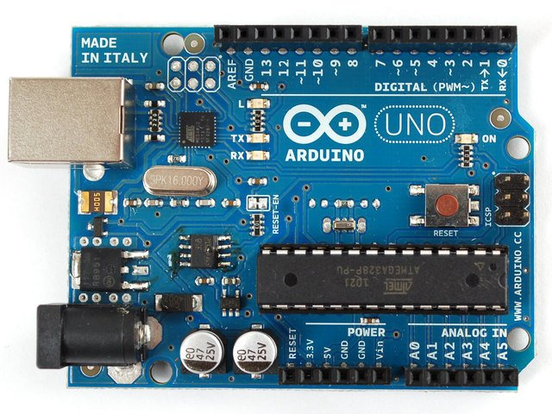

The Arduino Uno is an open-source microcontroller board based on the Microchip ATmega328P microcontroller. The board is equipped with sets of digital and analog input/output (I/O) pins that may be interfaced to various expansion boards (shields) and other circuits.The board has 14 digital I/O pins (six capable of PWM output), 6 analog I/O pins, and is programmable with the Arduino IDE (Integrated Development Environment), via a type B USB cable. It can be powered by the USB cable or by an external 9-volt battery, though it accepts voltages between 7 and 20 volts.

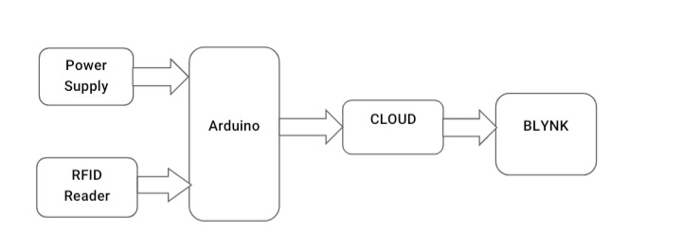**3.2 Block Diagram :**

**3.3 Circuit Diagram :**

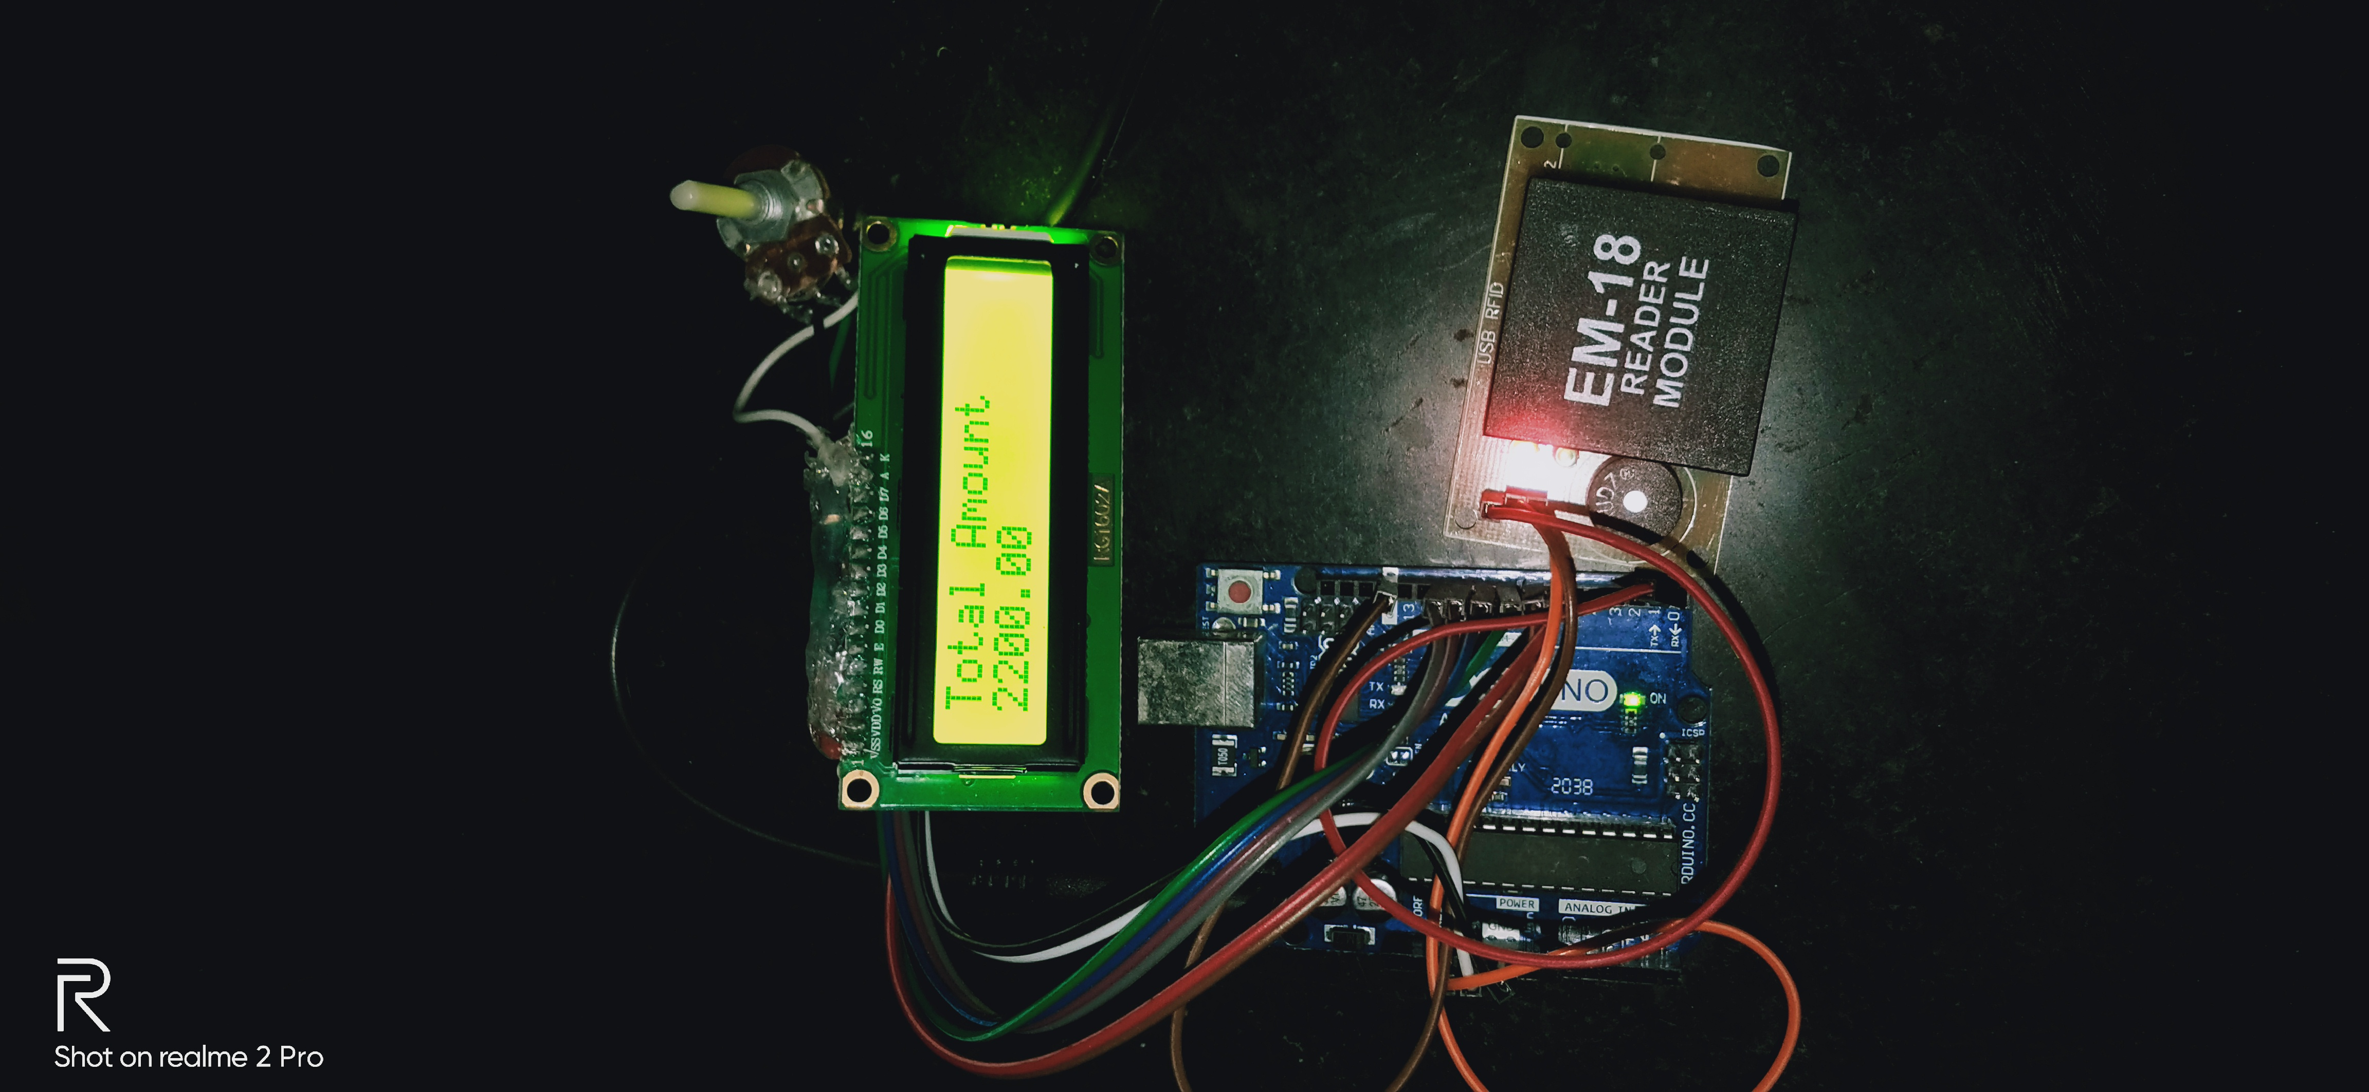

**Chapter 4**

**SOFTWARE IMPLEMENTATION**

**Chapter 4**

**SOFTWARE IMPLEMENTATION**

**4.1 Flow chart:** 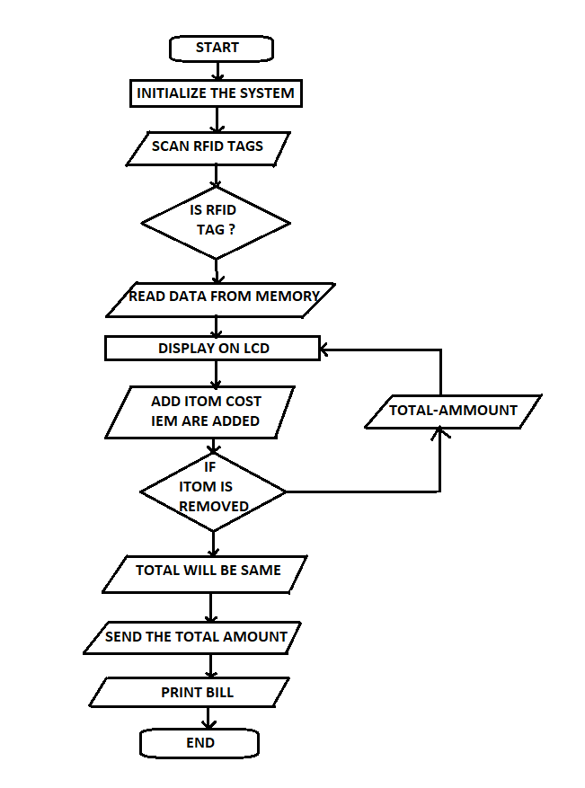

**4.2 Arduino IDE :**

The Arduino Integrated Development Environment (IDE) is a cross-platform application (for Windows, macOS, Linux) that is written in functions from C and C++.It is used to write and upload programs to Arduino compatible boards, but also, with the help of third-party cores, other vendor development boards.

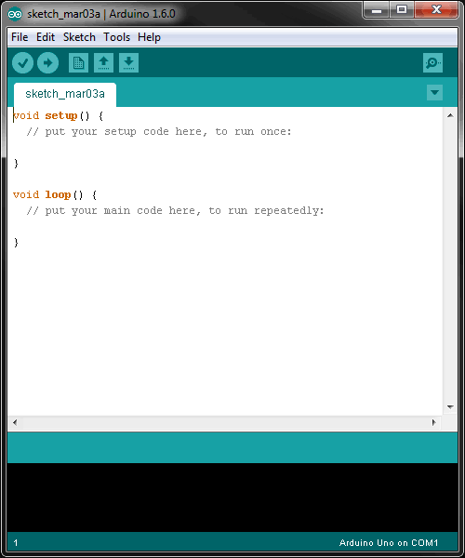

The Arduino IDE supports the languages C and C++ using special rules of code structuring.The Arduino IDE supplies a software library from the Wiring project, which provides many common input and output procedures.

## 

## 

## **Chapter 5**

**RESULTS AND CONCLUSION**

### 

### **Chapter 5**

**RESULT AND CONCLUSION**

The payment of bill by standing in long queue is a tiring factor when people want to purchase commodities from marts. Though people can pay instantly using electronic money facility, they are forced to wait in the queue for longertime. The idea which is proposed usingRFID technology will overcome the problem and it gives. The combined effects of easy and flexible implementation, secure transmission of account information, and reduced disputes offer the following benefits for all. It will save time, energyand manpower of Customer, Owner and supplier. . This will be a application which can be installed in all android smartphones.

**5.1 SYSTEM PHOTOGRAPHS:**



**5.2 RESULT:**

Customer can do the shopping by putting the product in the trolley after scanning it.We get the result of this system as:

|  |  |  |
| --- | --- | --- |
| **Sr. No.** | **Product** | **Amount** |
| 1. | Sanitizer | 100 |
| 2. | PPE Kit | 300 |
| 3. | Mask | 200 |
| 4. | Face shild | 400 |
|  | **Total** | **1000** |

**5.3 CONCLUSION**:

In this proposed paper, a secure smart shopping systemutilizing RFID technology is employed in enhancing shopping experiences and security issues. The smart shelves are able to monitor the items on the shelves by reading the RFID signals from the tags. The smart carts are able to read and retrieve information of the items inside the carts and finally, the checkout points can validate the purchase made by a customer.

The project will demonstrate the possibility of using Wireless system for developing a Smart Shopping System which automates the entire billing procedure. The system which is developing is highly reliable, fair and costeffective. It is reliable and fair because of the effectiveness of Wireless system. The system is also energy constraint as

it uses a passive sensor and it reduces the communication requirement.

**5.4 FUTURE SCOPE**:

1. At shopping process all details of product purchased is directly stored in cloud by which direct billing can be done . 2. A technology can be made for automatic rotating trolley which is based on Robotic mechanism .

3. The transferring of information from the trolley/basket to the Admin’s system can be made wireless instead of using a USB. Also, with emerging technologies, the movement of the cart can be automated, too. Hence, this system has a number of future applications and can be the basis of some advanced inventions in the future.

**Chapter 6**

**REFERENCES**

**REFERENCES:**

**6.1 Books :**

1.RFID: A Guide to Radio Frequency Identification By Pedro M. Reyes

McGraw-Hill Education, 2011.

2.RFID Design Fundamentals and Applications By Albert Lozano-Nieto

CRC Press, 2010.

3.Wireless Communication Handbook By Ashok Raj.

4.“The Internet of Things” by Samuel Greengard.

**6.2 Research Papers :**

1.Mohit Kumar, Jaspreet Singh, Anju, Varun Sanduja (2015) “Smart trolley with instant billing to ease Queues at shopping malls using Arm7 lpc2148: a review” International Journal of Advanced Research in Computer and Communication Engineering.2.Janhavi Iyer, Harshad Dhabu, Sudeep K. Mohanty (2015) “Smart Trolley System for Automated Billing using RFID and ZIGBEE” International Journal of Emerging Technology and Advanced Engineering (Volume 5, Issue 10, October 2015).3.Anjali Verma, Dr. Namit Gupta (2015) “RFID based Smart Multitasking Shopping Trolley System” International Journal for Scientific Research & Development (Vol. 3, Issue 06, 2015)4.Galande Jayshree, Rutuja Gholap, Preeti Yadav (2014) “RFID Based Automatic Billing Trolley” International Journal of Emerging Technology and Advanced Engineering (Volume 4, Issue 3, March 2014)5.Udita Gangwal, Sanchita Roy, Jyotsna Bapat (2013) “Smart Shopping Cart for Automated Billing Purpose using Wireless Sensor Networks” The Seventh International Conference on Sensor Technologies and Applications.6.Mayur Subhash Chaudhari (2015) “A Review on Electronic Shopping Cart Based on RFID

7.Zeeshan Ali & Reena Sonkusare,”RFID Based Smart and Billing”,International Journal of Advanced Research in Computer and Communication Engineering Vol.,India, December 2013,1-4

**6.3 Websites :**

www.google.com

**APPENDIX**

**APPENDIX I**

**APPENDIX II**

## **APPENDIX III**

**RFID Reader Datasheet Specification**

**RFID**

**Type Handheld RFID Scanner**

**Operating Frequency UHF(Ultra High Frequency) 860MHz~960MHz**

**HF(High Frequency) 13.56MHz**

**LF(Low Frequency) 125KHz**

**Protocol UHF: ISO18000-6C, EPC Class 1 Gen 2, ISO18000-6B**

**HF: ISO14443A/B, ISO15693**

**Reading Range UHF: 400 ~ 1300cm (Depend on tags and environment)**

**HF: 5 ~ 20cm**

**LF: 4 ~ 10cm**

**RSSI Received signal strength indication**

**Anti-collision Read up to 400 piece of tags simultaneously**

**Antenna Polarization Circular Polarized**

**SDK Free SDK provided attached to the Reader**

**System features**

**Operating system Microsoft® Windows CE® 6.0 or Android OS v2.2**

**Processor SAMSUNG Cortex-A8(1GHz)**

**Memory**

**Memory 256MB/512MB Mobile DDR RAM**

**Flash memory 256MB/512MB Nand Flash ROM**

**Expansion (Micro SD) 32G (Maximum)**

**Audio, Slots, and Ports**

**USB Ports Yes**

**Slots 1 MicroSD Slot, 1 GSM/GPRS Slot**

**Camera Extensible**

**1D Barcode Yes**

**2D Barcode Extensible**

**Input/Output devices**

**Input devices QWERTY keyboard, Color Touch screen, stylus, Trigger Button, Support handwriting input**

**Output devices 3.5” Transmissive LCD, QVGA(240 x 320) or VGA(480 x 640), LED x 2, Buzzer**

**Communication features**

**WiFi 802.11b/g**

**GPRS (GSM) GSM/GPRS/EDGE: 850/900/1800/1900MHz**

**3G WCDMA / CDMA2000**

**Bluetooth Bluetooth 2.1 + EDR class 2**

**GPS Integrated**

**Physical**

**Dimensions 190 x 75 x 30 mm ( L x W x H )**

**Weight 520g (Including Battery)**

**Case Color Mat Black**

**Energy Efficiency**

**Battery Rechargeable 3.7V 4000mAh battery**

**Power supply AC Adapter**

**Environment Requirement**

**International Protection IP65**

**Operating Temp -10°C to 50°C**

**Storage Temp -20°C to 65°C**

**Charge Temp 0°C to 40°C**

**Humidity 5% to 95% Non-condensing**