# Agenda: Azure Storage Service

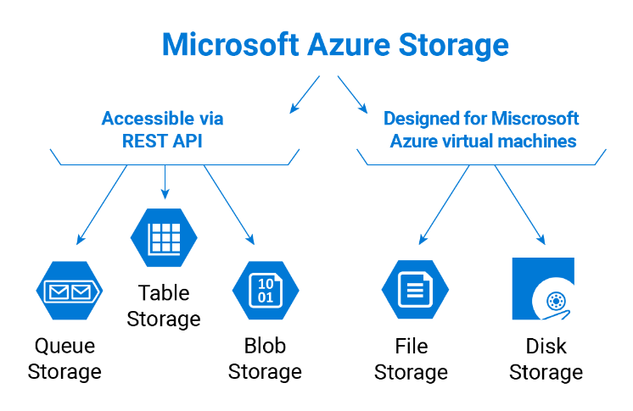

|  |
| --- |
| * **Azure Storage** is a PaaS service that you can use to store **both unstructured and partially structured data.** * Azure Storage is massively **scalable and elastic**: It can store and process *hundreds of terabytes of data to support the big data* scenarios required by scientific, financial analysis, and media applications. Or you can store the small amounts of data required for a small business website. * By default, you can create up to **100 storage accounts** in a single Azure subscription. Each standard storage account can contain up to ***500 TB of combined blob, queue, table and file data***. * As the demands on your storage application grow, Azure Storage automatically allocates the appropriate resources to meet them. We are charged only for what we use. |

|  |
| --- |
| **Azure Storage Account:** There are two types of storage accounts:   * A **standard storage** account includes Blob, Table, Queue, and File storage. * A **premium storage** account currently supports Azure Virtual Machine disks only. |

|  |
| --- |
| It offers **four types of storage services**, depending on the type of data that they are designed to store:   * **Blob Storage stores** file data. A blob can be any type of text or binary data, such as a document, media file, or application installer. Blob Storage is sometimes referred to as Object storage. * **Table Storage** stores partially structured datasets. Table storage is a NoSQL key-attribute data store, which allows for rapid development and fast access to large quantities of data. * **Queue Storage** provides reliable messaging for workflow processing and for communication between components of cloud services. * **File Storage** Similar to blobs, these provide storage for unstructured files, but they offer support for file sharing in the same manner as traditional on-premises Windows file shares. |

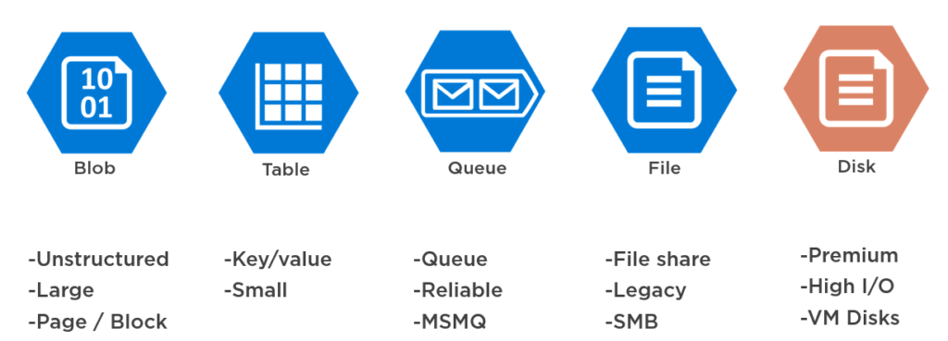

It has four types of Replication:

* Locally redundant storage (LRS)
* Zone-redundant storage (ZRS)
* Geo-redundant storage (GRS)
* Read-access geo-redundant storage (RA-GRS)

**Locally redundant storage** (**LRS**)

* It replicates **three copies of your data within the same data center** you have your data in. The write requests you do with your **storage are not committed until they are replicated to all three copies**, which means it replicates synchronously.
* LRS protects your data against server hardware failures but not against a failure of the facility itself.
* For Premium Storage accounts - This is the only option available.

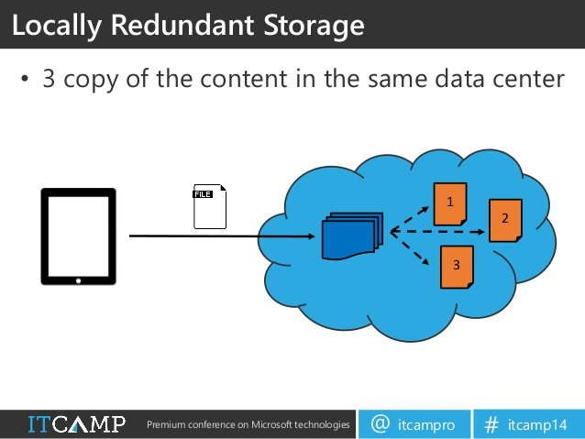

**Locally redundant storage** (**LRS**) - **Drawbacks**

* The least durable option, as it replicates only within the same data center.
* Your data will be lost if a catastrophic event, such as a volcanic eruption or flood, affects the data centre.

**Zone-redundant storage (ZRS)**

* It replicates **three copies of data across two or three data centers within one of two regions asynchronously**, plus the **three copies of data stored within the same data center** of the original source of the data.
* Consider ZRS for scenarios that require strong consistency, strong durability, and high availability even if an outage or natural disaster renders a zonal data center unavailable.

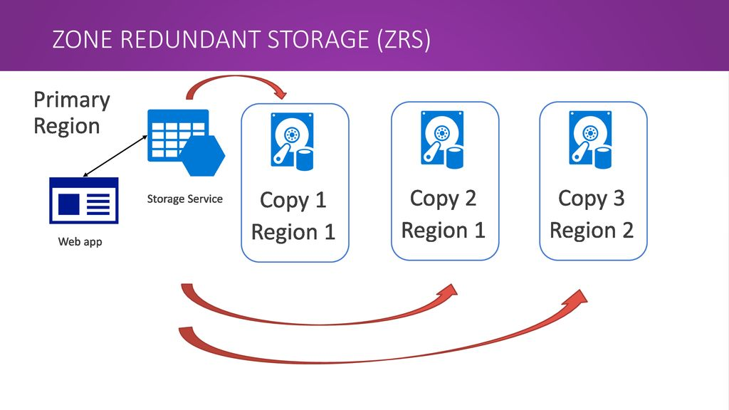

**Zone-redundant storage (ZRS)** - **Drawbacks**

* This type can only be used for Block Blobs and a Standard Storage.
* Does not support metrics or logging
* Does not support conversion for other replication types, such as LRS, GRS, and vice versa
* If **a disaster occurs, some data might be lost**.
* Once you have created your storage account and selected ZRS, you **cannot convert it to use to any other type of replication**, or vice versa.

**Geo-redundant storage (GRS)**

* It replicates data not only within the same region but also to another region. Firstly**, it replicates three copies of data within the same region synchronously, then it replicates another three copies of data to other regions asynchronously**.
* It provides the highest durability and availability, even if a disaster occurs in an entire region.

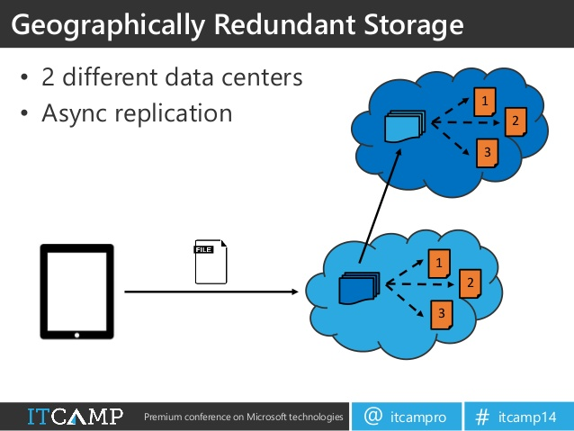

**Geo-redundant storage (GRS)** - **Drawbacks**

* If a disaster occurs, some data might be lost, because the data replicates to the other regions asynchronously
* If a disaster occurs, there will be some delay in accessing your data until Microsoft initiates failover to the secondary region.

**Read-access geo-redundant storage**

* It follows the same replication mechanism of GRS, in addition, to read access on your replicated data in the other regions.
* It provides the highest durability and availability, even if a disaster occurs in a whole region
* If a disaster occurs, you still only have read access to the storage, but no write access until Microsoft initiates failover to the secondary region
* The region with the read access can be used for data retrieval by the nearest offices to it without the need to go to another region to access the data; as a result, the data latency will decrease

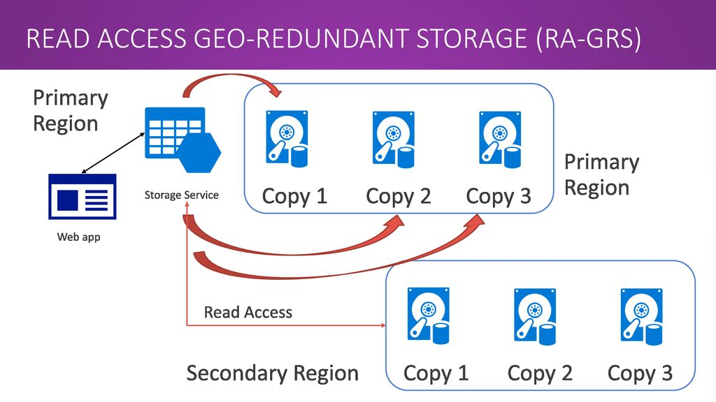

**Read-access geo-redundant storage** – **Drawback**

* If a disaster occurs, some data might be lost, because the data replicates to the other region asynchronously.

**Comparison Chart**



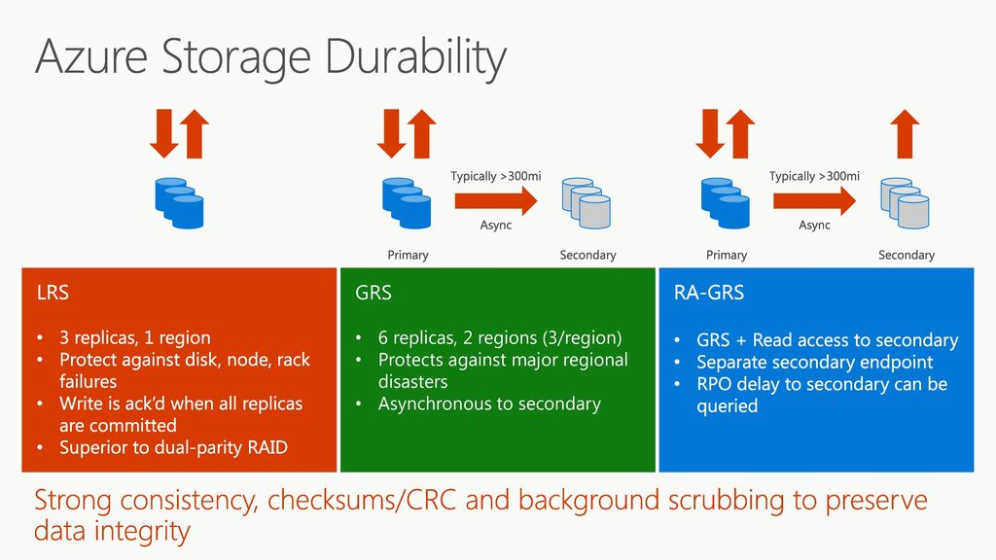

**Access tier**

* **Hot**, if objects will be more frequently accessed. This allows you to store data at a lower access cost.
* **Cool**, if objects will be less frequently accessed. This allows you to store data at a lower data storage cost.

