**Login to the URL** :- <http://10.191.152.39:8990/login>?

Username :- **wasadmin**

Password :- **Wasadmin@123**

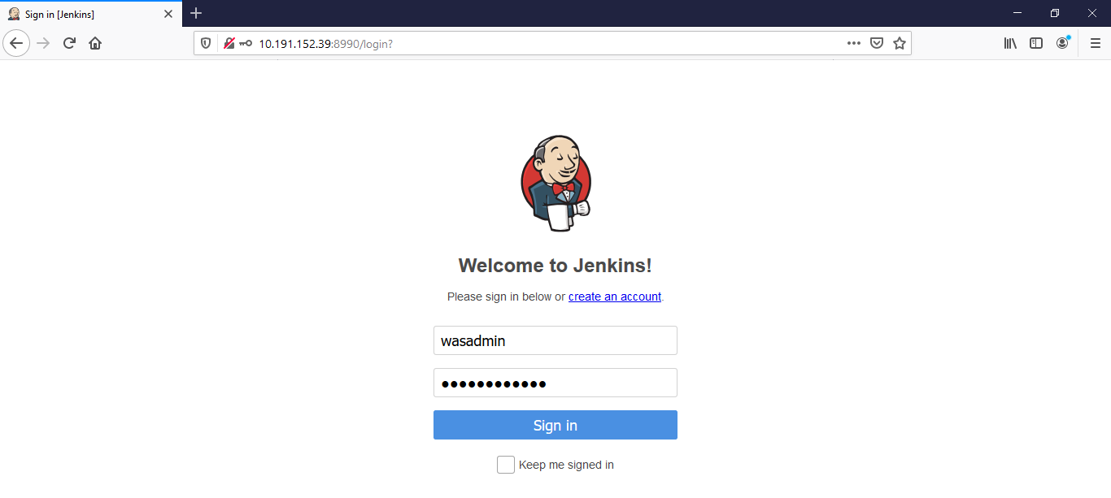

After logged in, below screen will appear

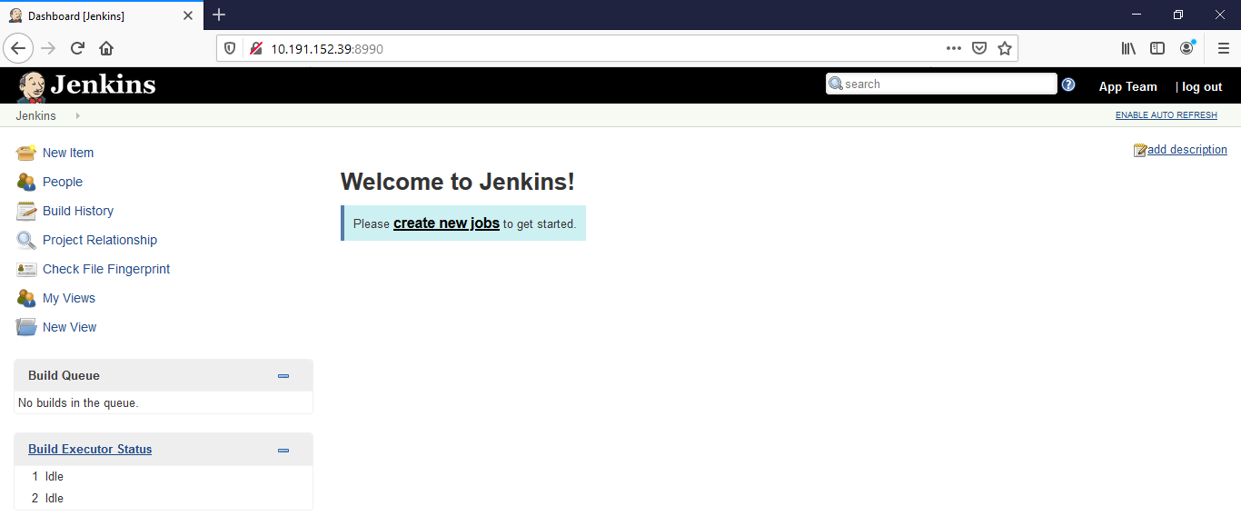

In order to start working with Jenkins, you will have to click on **Create New Jobs**

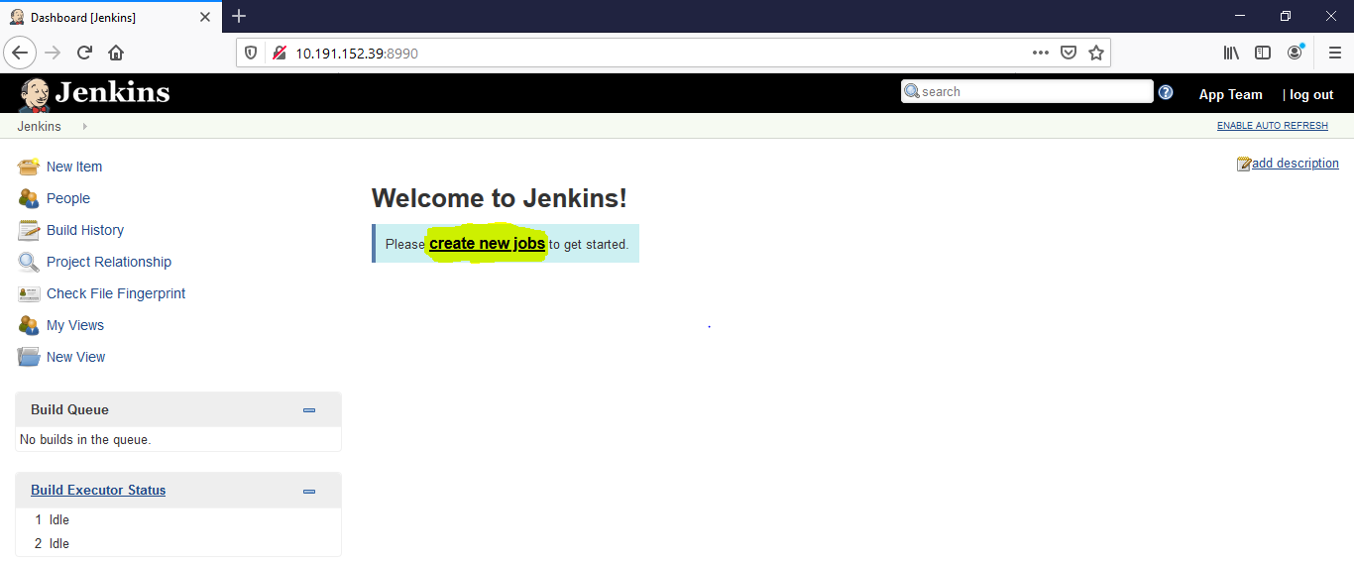

Select the “**Freestyle project” and Enter an Item name**

**\*\*\*\*Initial Project name should start with “App”\*\*\*\***

for e.g. for UAT environment :- Create it as **App_Branchfxout_UAT**

for Staging Environment :- Create it as **App_Branchfxout_SIT**

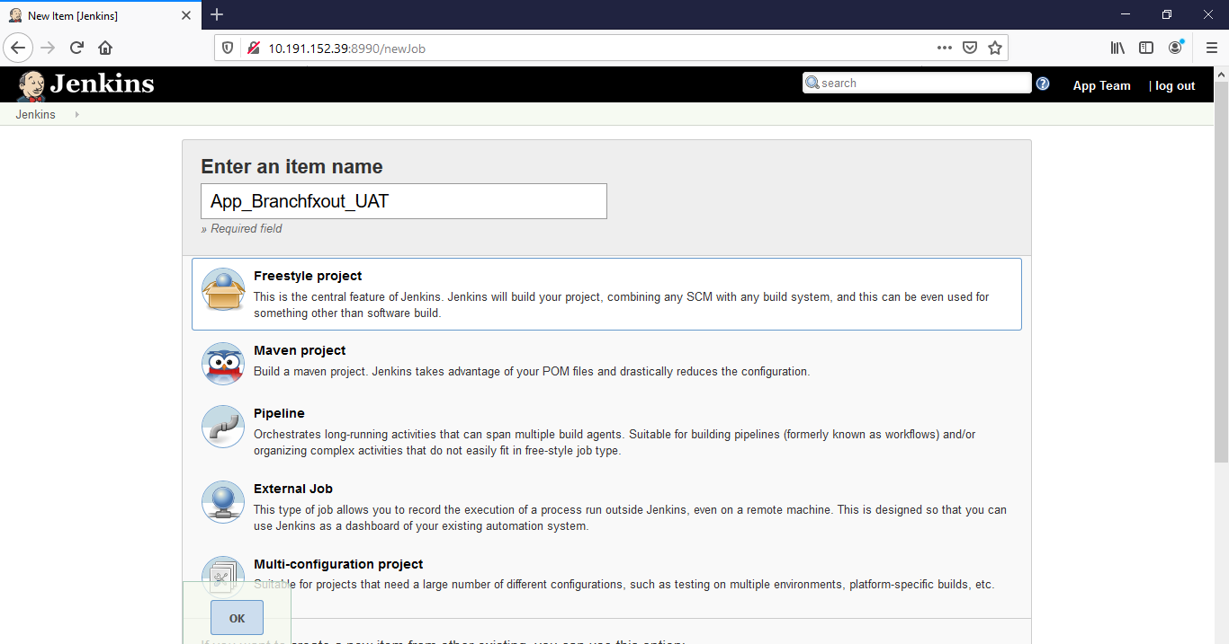

and click on **OK** to proceed below

Enter the **Description** which you wish to specify

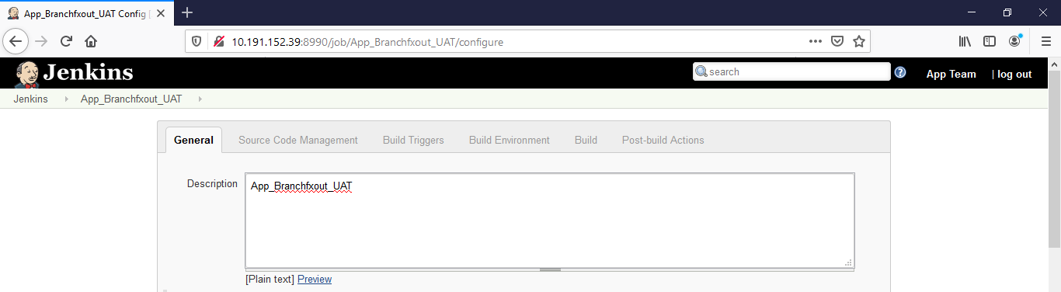

Leave the below settings **Un-Changed**

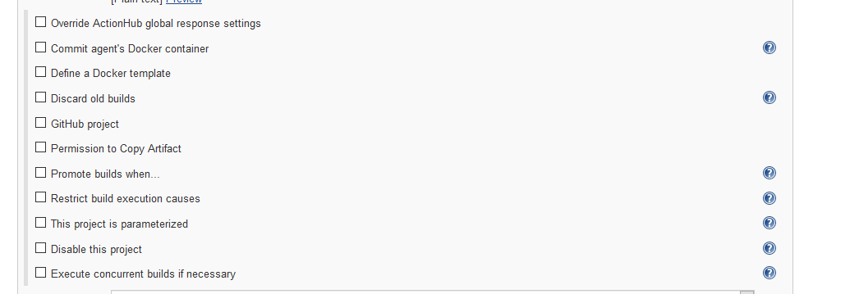

Select the JDK version suggested by respective developer

For now, we are creating the build with version **“jdk1.8.0.211”** compulsory



Select the Source Code Management as **“Subversion”**

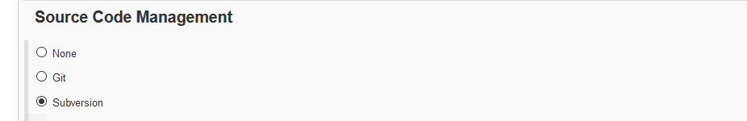

Enter the Repository URL given by respective Developer and paste it under **Repository URL** as shown below

Select the Credentials as **“sysadmin/******”** as shown below

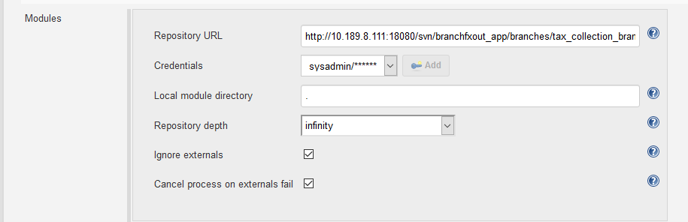

leave the further settings as it is and scroll down to **Build Environment**

**Click on With Ant**

1. **Select the Ant Version Ant1.10.6 (If you are creating a build with “jdk1.8.0.211” version**
2. **Select the Ant Version Ant1.9.4 (If you are creating a build with “jdk1.6.31” version**

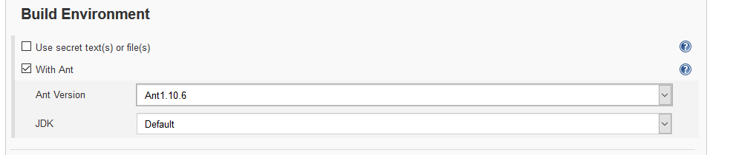

Select **Invoke Ant** under Build section

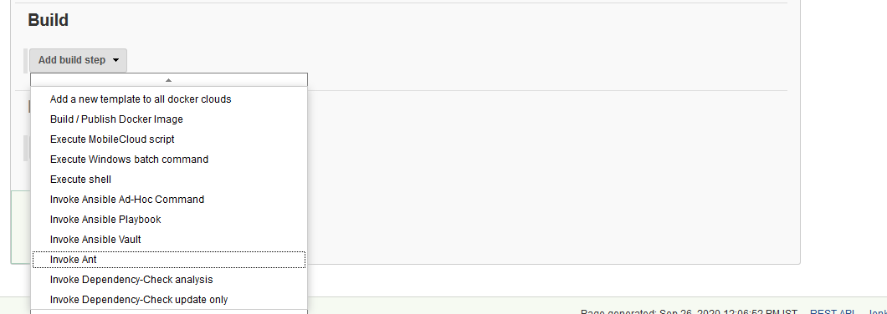

Select the Ant Version :- Ant1.10.6

1. **Select the Ant Version Ant1.10.6 (If you are creating a build with “jdk1.8.0.211” version**
2. **Select the Ant Version Ant1.9.4 (If you are creating a build with “jdk1.6.31” version**

Mention **“clean”** under Targets

Build File :- build.stage.xml **(.xml File name should be given by respective developer)**

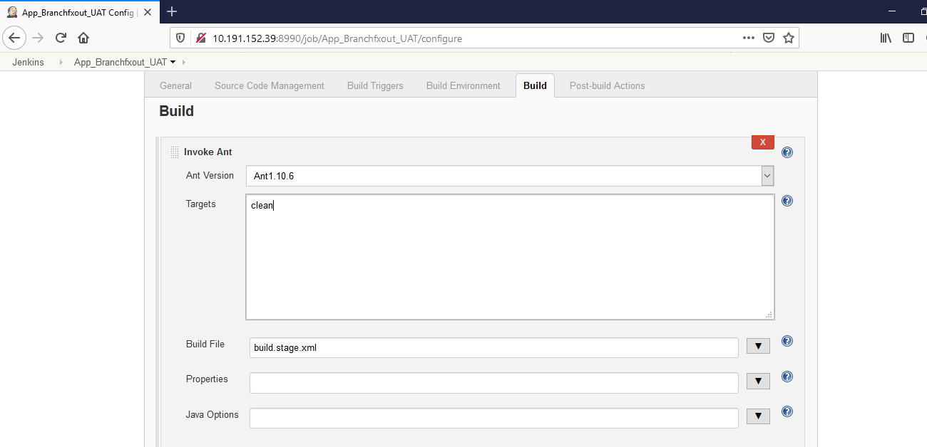

Again Click on Add Build Step and select Invoke Ant



Select the Ant Version :- Ant1.10.6

1. **Select the Ant Version Ant1.10.6 (If you are creating a build with “jdk1.8.0.211” version**
2. **Select the Ant Version Ant1.9.4 (If you are creating a build with “jdk1.6.31” version**

Mention **“war”** under Targets

Build File :- build.stage.xml **(.xml File name should be given by respective developer)**

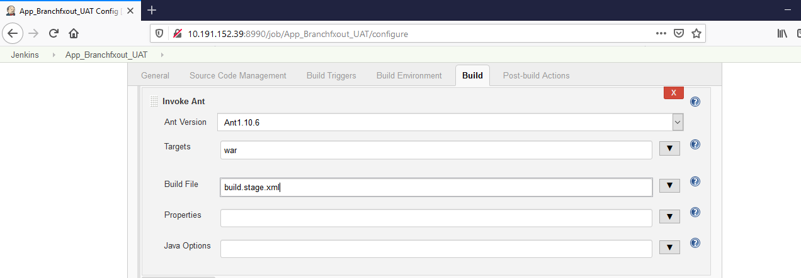

Finally click on Save Button

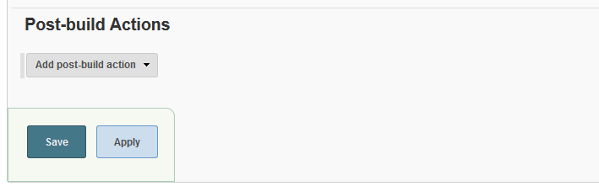

Create a Build using below steps

Select the respective project from main window of Jenkins

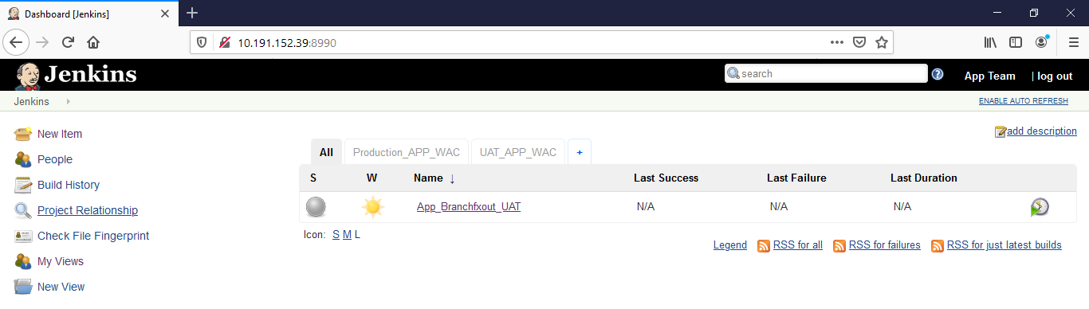

Click on Build Now button

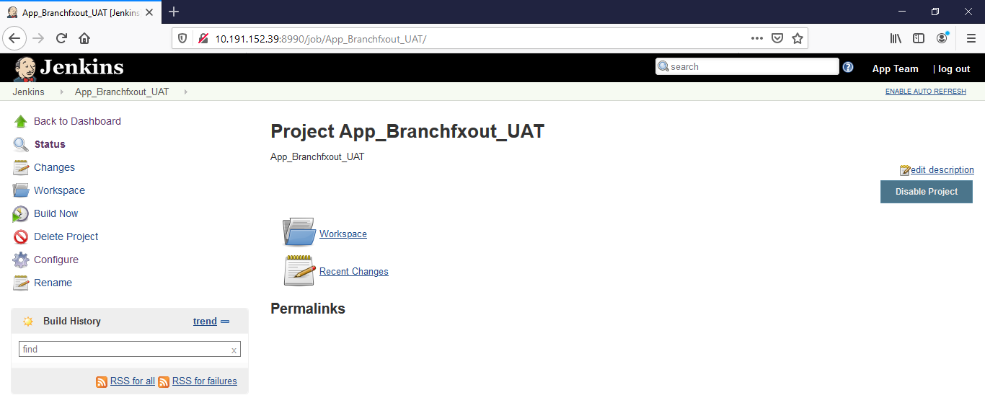

After successful build, the job will appear under Build History

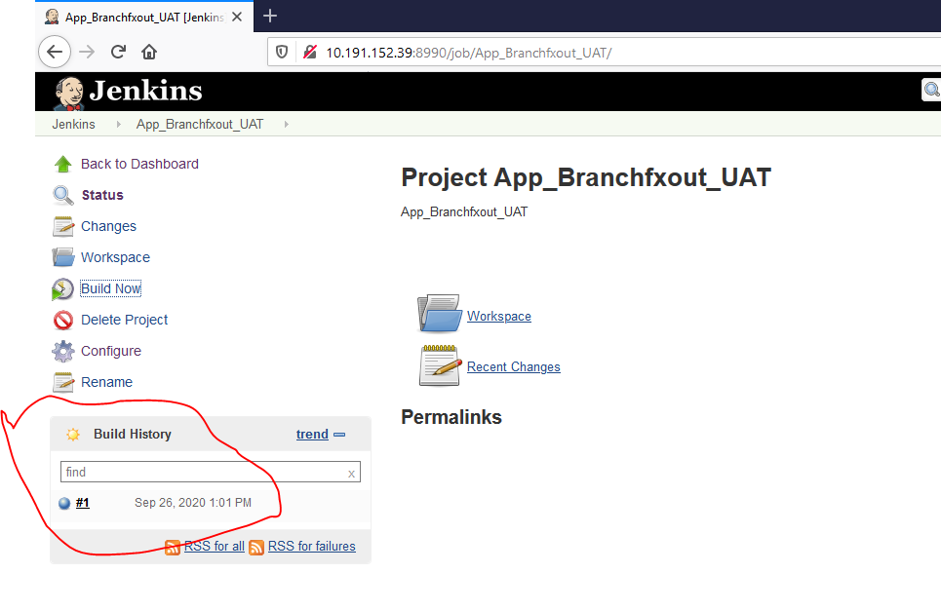

If it is with colour **“Blue”** the it’s successful and If it is with colour **“Red”** then some issues in build and need to check an errors to troubleshoot

In order to troubleshoot, click on **Red circle** and see for the logs at where it’s stuck

**Get the .war file from Jenkins server to UAT or Staging server for deployment purposes as per the below steps**

After the successful build, you need to login to Jenkins server through putty

Server IP Address :- 10.191.152.39

Username :- wasadmin

Password :- Wasadmin@123

After logged into Jenkins server through putty,

Go to Path :- cd /var/lib/jenkins/workspace/

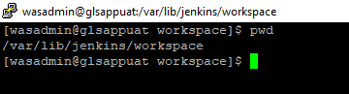

Copy the file from Jenkins server to UAT server 10.189.8.110 use below command

[wasadmin@glsappuat workspace]$ scp -pr branchfxout.war [wasadmin@10.189.8.110:/tmp/](mailto:wasadmin@10.189.8.110:/tmp/)

Copy the file from Jenkins server to Staging server 10.189.8.109 use below command

[wasadmin@glsappuat workspace]$ scp -pr branchfxout.war wasadmin@10.189.8.109:/export/home/wasadmin

