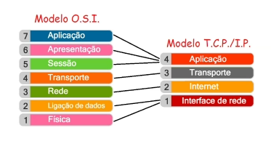

Protocolos e serviço de rede:
Serviço de diretório;
Ex: LDAP, ACTIVE Diretory;
Serviço de impressão;
Serviço de Comunicação e compartilhamento;
Serviço de Gerenciamento de Rede;
Serviço de Internet e WEB;
Serviço de segurança;
Serviço de Backup e recuperação;
Serviço de virtualização e cloud;
Serviço de compartilhamento de mídia e streaming;

Sem o DNS as redes não conseguem se conectar...

Linhas de comando importantes para redes:
CMD;
TCP/IP;
IPCONFIG;

PING (pedido do ICMP);
Tracert (Trace Route);
Netstat;
ARP.
Comando para gravar RIP no Packet a tracer:
Router# configure terminal
Router(config)# router rip
Router(config-router)# version 2
Router(config-router)# network 10.0.0.0
Router(config-router)# network 20.0.0.0
Router(config-router)# network 30.0.0.0
Router(config-router)# network 40.0.0.0
Router(config-router)# network 50.0.0.0
Router(config-router)# network 60.0.0.0
Router(config-router)# network 70.0.0.0
Router(config-router)# network 80.0.0.0
Router(config-router)# network 90.0.0.0
Router(config-router)# network 192.168.10.0
Router(config-router)# network 192.168.20.0
Router(config-router)# network 192.168.30.0
Router(config-router)# network 192.168.40.0
Router(config-router)# network 192.168.50.0
Router(config-router)# network 192.168.60.0
Router(config-router)# network 192.168.70.0
Router(config-router)# network 192.168.80.0
Router(config-router)# network 192.168.90.0
Router(config-router)# network 192.168.100.0
Router(config-router)# exit
Router(config)# exit
Router# write memory

192.168.10.1

access-list 1 permit 192.168.10.0 0.0.0.255
access-list 1 permit 192.168.20.0 0.0.0.255
interface gig2/0
ip nat outside
interface gig0/0
ip nat inside
interface gig1/0
ip nat inside
ip nat inside source list 1 interface gig2/0 overload

