# Problem Definition

The goal of the program to be developed is to implement an “Animal Guessing Game”. In this game, the player thinks of an animal and the computer tries to guess which animal the player is imagining by asking questions which can be answered `yes' or `no'. To begin each round of the game, the user needs to think of an animal. For example, suppose dog is the animal that the user is thinking of. The computer will then generate the question at the root node “Are you a mammal?" as the first question. The user has to press 'y' or 'n' (1 or 0) as the response. Based on the response the computer will generate the second question. The game continues until the leaf node is reached. At the leaf node the computer will generate the guess (dog, mouse, trout or sparrow in the example considered).

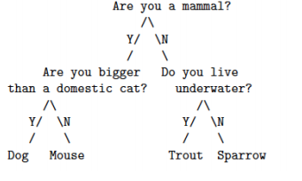

# Methodology

Here, in order to move left or right, use of IF-ELSE statements has been carried out.

## Algorithm and Program Flow

1. Start.
2. Print the first default question to the user.
3. Ask for input.
4. On the basis of input, select whether to go left or right.
5. Provide the output.
6. End.

## Implementation / Program

#include<stdio.h>

#include<conio.h>

int main()

{

char x,a;

printf("Are you a mammal?(y/n?)::");

scanf("%c",&x);

if(x=='y')

{

printf("\nAre you bigger than a domestic cat?(y/n?)::");

fflush(stdin);

scanf("%c",&a);

if(a=='y')

{

printf("-----------------------------------------------");

printf("\nYou are a Dog!!\n");

}

else

{

printf("-----------------------------------------------");

printf("\nYou are a Mouse!!\n");

}

}

else

{

printf("\nDo you live underwater?(y/n?)::");

fflush(stdin);

scanf("%c",&a);

if(a=='y')

{

printf("-----------------------------------------------");

printf("\nYou are a Trout\n");

}

else

{

printf("-----------------------------------------------");

printf("\nYou are a Sparrow\n");

}

}

getch();

}

# Outputs

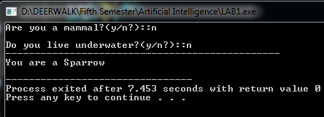

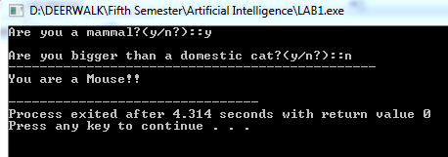

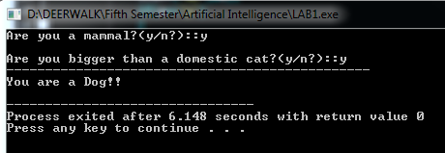

## Analysis of Output

Here, questions is asked such as “Are you a mammal?” Then, according to the problem definition, we need to traverse to the right sub-tree on every No and to the left sub-tree on every Yes. Since the user says No, we move to the right sub-tree. The question on the root of the right sub-tree is then asked: “Do you live under water?” The user again says No, so we move to the right sub-tree. We reach the leaf node. Traversal stops when the leaf node is reached. The result here then becomes: “Sparrow”.