**LAB II – Introduction to Prolog**

1. **Making a .pl file and consulting.**

Make a simple text file and rename it to test.pl.

Write in file

boy(ram).

**In Prolog Terminal,**

?- consult (“Absolute path of the file”).

(here)

?- consult("D:\\DEERWALK\\Fifth Semester\\Artificial Intelligence\\hello.pl").

true.

Then,

?- boy(hari).

true.

1. **First File**

In hello.pl

boy(hari).

girl(sita).

Terminal

1 ?- consult("D:\\DEERWALK\\Fifth Semester\\Artificial Intelligence\\hello.pl ").

2 ?- boy(ram).

true.

3 ?- boy(sita).

false.

1. **Graph Representation**

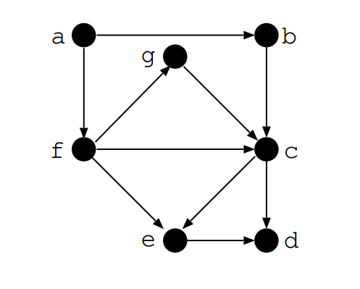

File name: graph.pl

edge(a,b). // ‘a’ vertex is connected to vertex ‘b ‘

edge(a,f).

edge(f,e).

edge(e,d).

edge(b,c).

edge(f,c).

edge(c,e).

edge(f,g).

edge(g,c).

edge(c,d).

path(Node1,Node2):- edge(Node1,Node2). //there exists path between Node1 and Node2

path(Node1, Node2) :- edge(Node1,Somenode),path(Somenode,Node2).

Terminal

1 ?- edge(a,b).

true .

2 ?- edge(X,c).

X = b ;

X = f ;

X = g.

3 ?- path(a,f).

true .

4 ?- path(a,d).

true ;

1. **Family Representation**

File name: family.pl

male(shreedhar).

female(nila).

female(shreha).

female(shreesha).

parent(shreedhar, shreha).

parent(shreedhar, shreesha).

parent(nila, shreha).

parent(nila, shreesha).

father(X,Y):-

male(X), parent(X,Y).

mother(X,Y):-

female(X), parent(X,Y).

sibling(X,Y):-

parent(Z,X) , parent(Z, Y), different(X,Y).

different(X,X) :- !,fail .

different(X, Y).

Terminal

?- consult("D:\\DEERWALK\\Fifth Semester\\Artificial Intelligence\\family.pl").  
true.

?- mother(nila, shreha).  
true.

?- father(shreedhar, shreesha).  
true.

?- father(shreedhar, shreha).  
true .

?- sibling(shreha, shreha).  
false.

?- sibling(shreha, shreesha).  
true .

?- parent(X, shreha).  
X = shreedhar ;  
X = nila.

?- sibling(nila, shreesha).  
false.