Matthew Burns
Project 2, DATA 789 | burns24@unc.edu
Real-Time Fraud Detection System
Technical Report

Part A: Streaming Pipeline & Feature Store

A1. System Architecture
A transaction simulator publishes to Kafka; a feature processor consumes the stream, maintains a rolling per-customer window, and writes aggregates to Redis; a FastAPI service reads those aggregates, merges them with the incoming transaction, and scores it.
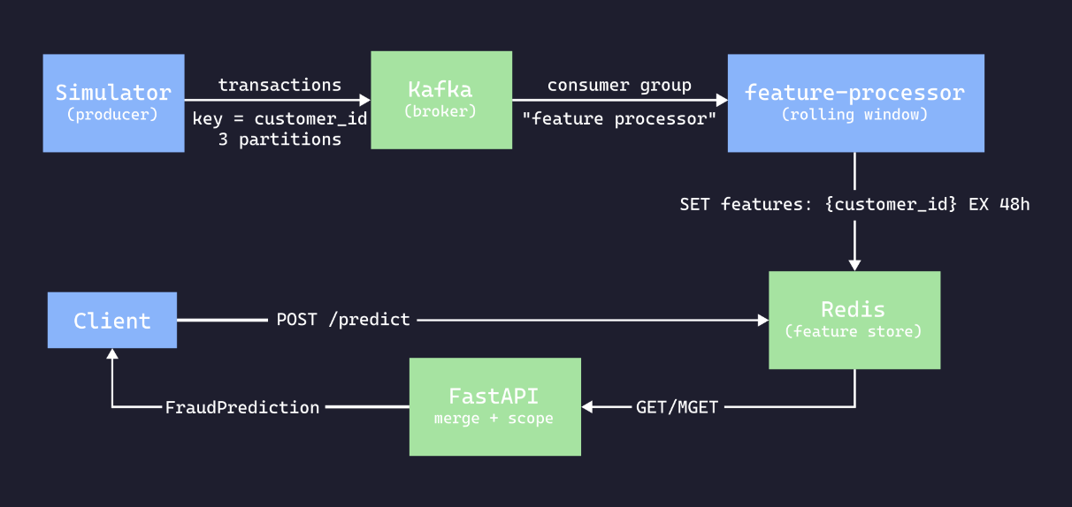
Figure 1: Transaction flow — simulator, Kafka, feature processor, Redis, FastAPI scorer. The ingest and serving halves communicate only through Redis; nothing in the request path touches Kafka.
The defining decision is that feature computation is decoupled from serving. Nothing in the request path touches Kafka. The two workloads differ: scoring needs bounded, predictable latency, while feature computation is stateful, bursty and subject to consumer lag. Coupling them would merge the failure modes — a broker hiccup would become a serving outage, and consumer lag would surface as client latency. Separating them reduces the API's work to one Redis GET plus one model call, 0.12 ms combined (see Section P3).
The cost is feature staleness: the API serves features as of the processor's last write, so a system needing read-your-writes consistency could not be built this way. For 24-hour aggregates it is immaterial, and the transaction's own attributes (which dominate the score) are always current. The decoupling also yields the key resilience property: the store is consulted, not depended upon, so its absence degrades accuracy rather than availability (see Section B1).
Service | Responsibility
simulator | Produces transactions; replays 24h backfill on start
kafka | Durable, replayable, partitioned transaction log
feature-processor | Consumes the topic, maintains windows, writes to Redis
redis | Feature store: the interface between the two halves
api | Joins cached features with the request and scores it
Table 1: Service Responsibilities
Configuration resolves through one frozen Settings dataclass (src/config.py) – every variable and default declared once, no scattered os.getenv. The single exemption is the kit-provided transaction_simulator.py.

A2. Topic & Partition Design
One topic, transactions, with 3 partitions (replication factor 1, a single-broker development constraint; production would use 3 with min.insync.replicas=2).
Messages are keyed by customer_id (transaction_simulator.py:88, with a key_serializer at :52), so the default partitioner hashes the key and routes each customer's events to one partition. This is a correctness requirement, not tuning: the processor holds per-customer window state in memory, so events split across consumers would each aggregate half the data and overwrite one another in Redis — counts silently wrong rather than visibly broken. Partitioning by key also caps parallelism at the partition count and makes rebalances migrate whole customers.
GROUP TOPIC PARTITION CURRENT-OFFSET LOG-END-OFFSET LAG CONSUMER-ID
feature-processor transactions 1 14306 14306 0 kafka-python-…0ba113c8
feature-processor transactions 2 15503 15503 0 kafka-python-…0ba113c8
feature-processor transactions 0 18632 18632 0 kafka-python-…0ba113c8
Figure 2: kafka-consumer-groups.sh --describe — all 3 partitions assigned to one consumer, 0 lag, 48,441 messages consumed, with uneven offsets (38.5 / 29.5 / 32.0%) confirming customer-key partitioning.
Three things follow. All three partitions are assigned to a single consumer — the CONSUMER-ID is identical on every row. Lag is zero on each, with 48,441 messages fully consumed. And the offsets are uneven (38.5 / 29.5 / 32.0 %), which is itself evidence that keying works: round-robin over a uniform producer would trend toward equal counts, whereas hashing 200 discrete customer keys into 3 buckets produces exactly this lumpiness. An even split would have been the suspicious result.

A3. Windowing
The window is half-open — (at_time − window) < event_time <= at_time. Adjacent windows then partition time cleanly, so a boundary event belongs to exactly one window; closed-closed bounds would double-count it, open-open would drop it. Evaluation uses event time, which is what makes the 24-hour backfill produce the same aggregates it would have produced live.
Aggregation lives in windowed_stats(), a pure function of (events, start, end) — no I/O or state, so it is testable in isolation.
Customer | Event Time | Amount | In Window?
CUST0001 | 2025-12-31T23:00:00Z | $999 | No – Before the window opens
CUST0001 | 2026-01-01T00:00:00Z | $100 | Yes
CUST0001 | 2026-01-01T00:30:00Z | $200 | Yes
CUST0001 | 2026-01-01T00:45:00Z | $300 | Yes
CUST0002 | 2026-01-01T00:40:00Z | $50 | Yes
Table 2: Grading fixture, 1-hour window evaluated at 00:50:00Z.
Expected: CUST0001 count 3 / avg 200.0; CUST0002 count 1 / avg 50.0.
The 999.0 event is the fixture's trap: aggregating full history instead of filtering the window yields count 4 / avg 399.75 — plausible numbers that no exception would reveal.
Delivery semantics. The consumer auto-commits (kafka-python default, 5 s interval), so delivery is at-least-once. Each consequence is real and each has a known fix:
Hazard | Effect | Fix
Duplicate delivery | update() appends unconditionally; no transaction_id dedup, so replays double-count | Bounded seen-ID set spanning the commit interval
Out-of-order event | Evaluated at its own timestamp, so a late event overwrites fresher state with staler state | Evaluate at max(seen_timestamp) per customer
Restart/rebalance | Resumes from committed offset with an empty window, under-counting until refilled (auto_offset_reset does not help — it applies only with no committed offset) | Checkpoint state, or rewind one window on start
Malformed record | Logged and skipped, keeping the consumer alive — effectively at-most-once for those | Dead-letter topic
Table 3: At-least-once consequences and mitigations.
Note the Redis write is idempotent (SET overwrites) while the in-memory accumulation is not — duplicates corrupt the aggregate, never the storage, which is why the fix belongs in update().

A4. Feature Store
One key per customer, features:{customer_id}, holding a JSON features dict. A flat key-per-customer layout suits an access pattern that is purely point lookup.
TTL is atomic with the write — SET ... EX, not SET then EXPIRE. Two commands can interleave with a failure and strand a key with no expiry; with ex= that state is structurally unreachable. TTL is 48 h against a 24 h window, so features outlive the window and a processor outage decays gracefully rather than falling straight to cache misses.
Batch retrieval is one round-trip. IDs are de-duplicated, a single MGET issued, and results zipped back by MGET's ordering guarantee (empty input short-circuits, since a zero-key MGET is an error). Verified behaviourally: after CONFIG RESETSTAT, a 5-transaction batch over 3 customers yields cmdstat_mget: calls=1 and no cmdstat_get at all.
Connections are pooled per (host, port, password). One detail fails silently: redis-py ignores connection kwargs on the client when a pool is supplied, so decode_responses=True must be set on the pool — otherwise values return as bytes and json.loads fails far from the mistake.
Run | Mean | p50 | p95 | p99 | Max
1 (cold) | 0.13 | 0.10 | 0.32 | 0.50 | 1.00
2-4 (warm) | 0.04 | 0.03-0.07 | 0.04-0.09 | 0.04-0.11 | 0.14-0.36
Table 4: Retrieval latency (ms). 1,000 reads per run.
Steady-state p95 is 0.04–0.09 ms, three orders of magnitude under the 50 ms requirement. Run 1 is reported rather than discarded: its inflated p95 is the pool opening its first socket lazily, and hiding it would conceal that the first request after a process start genuinely is slower. These cover single-key GET over loopback — batch is cheaper per customer, and a networked Redis would add a round-trip dominating this entirely.

A5. Links to Implementation
What | Where
Windowed aggregation | feature_processor.py, in windowed_stats()
Consumer loop | feature_processor.py, in run()
Producer keying | transaction_simulator.py, in _send()
Atomic-TTL write | feature_store.py, in store_customer_features()
Batch retrieval | feature_store.py, in get_customer_features_batch()
Connection pooling | feature_store.py, in _get_pool()
Configuration | config.py, in Settings
Windowing fixture | window_fixture.json
Table 5: Part A implementation index.

Part B: Model Serving & Containerization

B1. API Design and Endpoints
Method | Path | Purpose
GET | /health | Liveness probe; backs the container HEALTHCHECK
GET | /model/info | Reports the loaded model version
POST | /predict | Scores a single transaction
POST | /predict_batch | Scores a list, retrieving all features in one Redis command
Table 6: API surface
Validation is schema-driven. Transaction and FraudPrediction are Pydantic models, so FastAPI rejects malformed input at the boundary with HTTP 422 and a machine-readable body — verified for both a missing field and a wrong type. The same declaration drives request parsing, the 422 responses and the OpenAPI document at /docs, so they cannot drift apart.

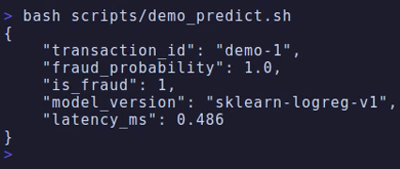
Figure 3: A scored transaction: $4,000 online against a customer whose
recent average is ~$125, returning fraud_probability: 1.0 in 0.49 ms.
The model is loaded once, at module scope (main.py:26). The cost avoided was measured: the first joblib.load takes ≈470 ms — mostly importing scikit-learn's unpickling machinery — and later loads 0.11 ms. Per-request loading would make each container's first request absorb 470 ms and every later one still pay 0.11 ms (17% of a 0.63 ms p50) for invariant work; --start-period=10s covers the startup cost. /model/info returns sklearn-logreg-v1, confirming the trained artifact, not the fallback.
/predict retrieves features, merges, scores and times the whole path. Transaction fields win on collision — cached features summarize history, while the transaction describes the event being scored. /predict_batch de-duplicates customer IDs, issues one MGET, and returns predictions in request order; each item's latency_ms is measured from batch start, so it means "elapsed when this prediction became available".
Redis failure degrades rather than propagates. Lookups catch redis.RedisError specifically — a bare except would turn every programming error into a plausible-looking prediction — log a warning, and score on the transaction alone. With Redis stopped, the suite passes and both endpoints return 200.
Timeouts make this fast rather than merely correct. A refused connection fails instantly, so stopping the container makes a naive implementation look resilient; a blackholed host would block indefinitely, since redis-py leaves socket timeouts unset. With both timeouts at 1 s, /predict against an unroutable address returns in 1.02 s. Testing only the easy failure would have shipped something that looked robust and was not.
Each request logs customer_id, latency_ms, fraud_probability and a degraded flag as bound structured fields. Known limitation: degraded is derived from stored is None, which is true for both a Redis error and an ordinary cache miss — so an unknown customer is logged as degraded even when Redis is healthy. The flag reliably indicates features were absent, not that Redis was unavailable, and should not be used to alert on store health.

B2. Containerization
A multi-stage build: the builder installs under --prefix=/install and the runtime copies that tree to /usr/local, which works because that is where the runtime image's site-packages lives. Getting it wrong yields an image that builds cleanly and dies at first import — so the build was verified by importing the real dependency graph inside the container.
.dockerignore excludes .venv/, .git/, caches, logs/ and .env, keeping the build context at 1.1 MB — the virtualenv alone is 537 MB. Excluding .env is a security property: it keeps credentials out of image layers, where they survive later deletion.
The image runs as non-root. chown runs before USER, so /app is owned by the account that runs the process; docker inspect confirms User=appuser.
The health check uses python -c "import urllib.request..." rather than curl, because python:3.11-slim ships no curl — the conventional probe would fail with "command not found" and report unhealthy forever while the service served traffic normally.
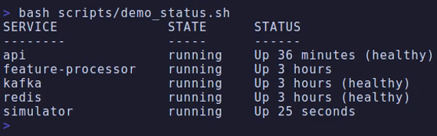
Figure 4: docker compose up brings all 5 services to healthy status in one command.
Compose gates application services on depends_on: service_healthy, not service_started (which asserts only that a container was created). One subtlety: feature-processor and simulator share the image and inherit its HTTP health check despite serving no HTTP, so both set healthcheck: { disable: true } — otherwise a service_healthy dependency on them would deadlock.

B3. Blue-Green Deployment
api-blue and api-green run simultaneously behind nginx, built from the same image and sharing Redis, so they differ only in version. Exactly one upstream server line is active. Clients use the stable :8080; each color is also reachable directly on :8001 / :8002.
switch_traffic.sh detects the current color by grepping the config (state lives in the config, so it cannot disagree with reality), health-gates the target on its direct port, flips the lines, then reloads nginx. The direct port is load-bearing: probing :8080 would confirm only that the active version is healthy. Because the gate runs before the config is touched, under set -euo pipefail, a target that fails to start yields a failed deployment, not an outage. Rollback is the same command, so that path cannot rot.
nginx -s reload keeps the listening socket open and forks new workers while old ones drain. Keep-alive connections are not pinned to draining workers — those close idle connections and clients reconnect onto the new color.
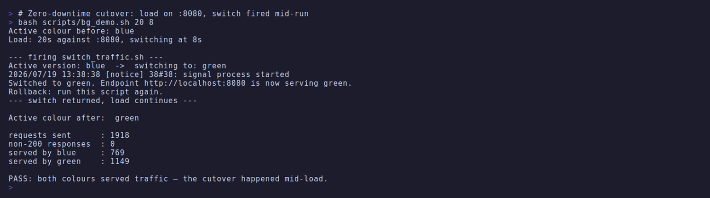
Figure 5: scripts/bg_demo.sh – 20 s of continuous load against :8080, switch fired at 8 s; 0 non-200 responses across the cutover and per-color request counts shift mid-run, proving a zero-downtime swap (see Table 7).
Measurement | Run A  (Green Blue) | Run B  (Blue Green, Rollback)
Requests sent | 1,559 | 1,918
Non-200 responses | 0 | 0
# Served by blue | 971 | 769
# Served by green | 588 | 1,149
Table 7: Two cutovers under continuous load, in opposite directions.
Run B is the rollback: re-running the same script switched back, confirming the rollback path works and is not merely asserted. The per-color counts are the proof, not the error count — both being non-zero can only be produced by traffic actually moving mid-run.
An earlier, longer run through the harness measured p50 1.14 / p95 3.28 / p99 4.78 ms at 720 req/s with 1 error in 60,000 (0.002%) — the keep-alive close race described above, corroborated by an independent new-connection probe seeing 0 failures in 140 requests.

B3.1: A Silent Failure in the Provided Switch Script
The first three cutover runs appeared to succeed and did not. The script printed Switched to green, nginx reloaded cleanly, the host config showed the new state, and the harness reported zero errors. Traffic never moved.
sed -i is not in-place: it writes a temporary file and renames it, producing a new inode (demonstrated: 2238265 2238266). The compose file bind-mounts nginx.conf as a single file, and single-file mounts bind the inode, not the path — so the rename detached the container's view and nginx reloaded the original, unchanged file. Every layer was correct in isolation, which is why it was invisible. Fixed by rewriting the original inode (cat "$CONF.tmp" > "$CONF"); recovery also needed --force-recreate nginx, since the running mount still resolved to the orphaned inode.
The deeper failure was that the verification could not detect the bug. errors: 0 is consistent with success, with a mistimed switch, and with no switch at all — so it distinguishes nothing. Per-colour counts have a signature no failure mode can fake. Verify the effect, not the actuator.

B4. Links to Implementation
What | Where
Startup model load (once) | main.py, module scope
/predict | main.py, in predict_fraud()
/predict_batch | main.py, predict_fraud_batch()
Graceful degradation | main.py, in lookup_features()
Scoring + fallback | fraud_detector.py, in predict()
Multi-stage image | Dockerfile
Service orchestration | docker-compose.yml
Cutover script | switch_traffic.sh
Table 8: Part B implementation index

Performance

P1. Method
Figures come from the provided harness with its fixed seed (789):
Shell
> python tests/test_performance.py --n 5000 --url http://localhost:8000

--n 5000, not the default 1000 — at ~1,500 req/s, 1,000 requests is under a second of sampling, too short for a stable p99 and dominated by startup.
Requests are cache hits, verified not assumed. The simulator creates CUST0000 - CUST0199 and the harness draws the same range, so every request exercises the full lookup merge score path, not the cache-miss shortcut.
The harness is sequential, so throughput_rps is the reciprocal of mean latency, not concurrent capacity. Concurrency changes (async Redis, more workers) would register as no improvement, which is why P4 targets per-request work. Every figure below is a median of repeated runs.

P2. Metrics
Requests | Errors | Throughput | p50 | p95 | p99 | Max
5,000 | 0 | 1,023 req/s | 0.63 ms | 2.97 ms | 3.95 ms | 6.51 ms
Table 9: Load-test results (results.json), direct to the API with the transaction stream live.
This is the median run of five; the figures quoted are that run's, so the committed artifact
and this table are the same measurement rather than a per-metric composite.
Spread across the five: 681–1178 req/s, p95 2.37–3.85 ms, zero errors in all five.
On measurement conditions. Throughput varies by ~1.7× run to run on an otherwise idle developer machine, so any single figure here should be read as an order of magnitude, not a benchmark. Stopping the simulator gives 1234 req/s and p95 2.71 ms. The live-stream numbers are quoted as the headline because a continuously fed stream is the system's intended operating condition, and it is the more conservative of the two.
Section B3's blue-green figures (p50 1.14 / p95 3.28 at 720 req/s) are worse on every axis because that run went through the nginx proxy, whereas Table 9 is direct to :8000. The difference is the proxy hop, not a regression.

P3. Bottleneck Analysis
Hypothesis: scikit-learn inference dominates — it is the only numerically intensive step, and predict_proba validates input on every call.
Input validation | Redis GET | Merge | Model Inference | Logging | Total
0.0049 | 0.0494 | 0.0006 | 0.0663 | 0.0215 | 0.1427
Table 10: Per-stage cost, in-process, n=2000
Falsified. Inference is the largest application term, but the entire application is 0.143 ms of a 0.552 ms request. Driving inference to zero would gain about 12%.
Benchmarking /health — which parses no body and touches no dependency — isolates the transport and framework floor: of the 0.552 ms /predict median, the /health floor is 0.241 ms (44%) and application work (above) is 0.143 ms (26%), leaving 0.168 ms (30%) of endpoint-specific framework cost.
The system is framework-bound, not compute-bound. Redis contributes 0.049 ms and inference 0.066 ms; well over half the request is transport and framework machinery no application change can reach.

P4. The Attempted Optimization
Hypothesis. FastAPI validates the response twice: the handler constructs a FraudPrediction, and response_model=FraudPrediction re-validates that finished object. Declaring response_model=None removes the second pass. An early measurement put the /predict-minus-/health gap at 0.509 ms and suggested this was the dominant term.
Method. The container was rebuilt for each variant and both were measured with the same paired benchmark — 3 x 4000 requests against /health and /predict per build — comparing the gap, so machine drift affects both terms equally.
Build | /health p50 | /predict p50 | Gap
Baseline (response_model=Fraud…) | 0.243 ms | 0.517 ms | 0.269 ms
Optimized (response_model=None) | 0.237 ms | 0.538 ms | 0.297 ms
Table 11: A/B comparison of the response-validation change
The hypothesis is not supported. Removing response validation produced no measurable improvement — the optimized build measured marginally slower, within run-to-run variation. Given the ~1.7x spread documented in P2, the effect being sought was far smaller than the noise floor of the instrument used to look for it.
Why the original estimate was wrong is the more useful finding. The 0.509 ms gap came from a single earlier measurement under different machine load; re-measuring the baseline alongside the optimized build gave 0.269 ms, and the apparent saving disappeared with it. A difference measured across time is not an A/B test — the same failure shape as Section B3.1, where a metric consistent with several realities was read as evidence for one.
Decision: reverted. With no latency benefit the trade is pure cost — response_model=None removes /predict's schema from the OpenAPI document for nothing in return. The remaining 0.168 ms is framework overhead spread across body parsing, dependency resolution, validation and serialization, not one removable component. Reducing it would need a different framework; at ~34x headroom there is no case for that.

Appendix: Defects Found in the Provided Infrastructure
Three latent defects surfaced during integration. All three failed silently, presenting as a healthy system while something essential did not work.
Defect | What looked fine | What actually exposed it
Kafka health check ran kafka-topics.sh off PATH (scripts live in /opt/kafka/bin) | Broker served traffic normally | service_healthy never satisfied
offsets.topic.replication.factor=3 on a single broker, so __consumer_offsets could not be created and no consumer group could form | Producer wrote 9,600 messages successfully | __consumer_offsets absent; Redis stayed empty
sed -i replaced the bind-mounted config's inode (Section B3.1) | Script reported success; nginx reloaded | Per-color request counts
Table 12: Silent failures and the evidence that exposed them.
The second requires docker compose down -v after the fix, since the broker persists the original replication factor in its metadata and a plain restart retains the broken setting.
The practice this project settled on is to verify the observable consequence rather than a mechanism's self-report — a key written by one service and read by another, dependencies imported inside a built image, request counts on both sides of a cutover. That discipline is why Section P4 reports a refuted hypothesis rather than a convenient improvement.

