

BAHCESEHIR UNIVERSITY
Faculty of Engineering and Natural Sciences
AIN-3009 — Machine Learning Operations (MLOps)
TERM PROJECT REPORT
Heart Disease Prediction
A Comprehensive MLOps Lifecycle with MLflow

Student | Ali Hawala
Student ID | 2101227
Course | AIN-3009 MLOps
Instructor | Prof. Murat Gösin Bakir
Submission Date | May 2026

1. Executive Summary 1
Key MLOps Capabilities Demonstrated 1
2. Project Architecture 1
2.1 Pipeline Orchestration 1
3. Data Preprocessing & Feature Engineering 1
3.1 Multi-Source Data Integration 1
3.2 Preprocessing Pipeline 1
3.3 Class Distribution Before & After SMOTE 1
3.4 Engineered Features (14 New Features) 1
4. MLflow Experiment Tracking 1
4.1 Experiment Setup 1
4.2 All Runs Overview (64 Total) 1
4.3 Per-Run Logging Detail 1
Metrics Logged (15 per run) 1
Parameters & Tags 1
4.4 Artifacts Logged per Run 1
5. Model Training Results 1
5.1 Five Models Trained 1
5.2 Model Comparison Plots 1
5.3 Analysis 1
6. Hyperparameter Tuning with Hyperopt 1
6.1 Tuning Configuration 1
Search Space 1
6.2 Nested MLflow Tracking 1
6.3 Convergence & Results 1
Best Hyperparameters Found 1
7. MLflow Model Registry 1
7.1 Model Registration & Stage Transitions 1
7.2 Registry Summary 1
8. Model Serving (Flask API) 1
8.1 REST API Endpoints 1
8.2 Web UI 1
9. Performance Monitoring & Data Drift Detection 1
9.1 Monitoring Pipeline 1
9.2 Monitoring Results 1
9.3 Drift Detection Analysis 1
10. Model Explainability (SHAP + LIME) 1
10.1 Why Explainability Matters in Healthcare 1
10.2 SHAP Analysis (Global Explanations) 1
10.3 Top Risk Factors (SHAP) 1
10.4 LIME Analysis (Local Explanations) 1
11. Technology Stack 1
12. Configuration Management 1
13. Testing 1
14. Conclusion 1
15. References 1

1. Executive Summary
This project implements a production-grade MLOps pipeline for heart disease prediction, demonstrating mastery of the complete ML lifecycle. The system integrates 6 heterogeneous datasets (567K+ records), trains 5 models (2 GPU-accelerated), performs automated hyperparameter optimization (50 Hyperopt trials), manages model versioning through MLflow Model Registry, detects data drift in production batches, and provides model explainability via SHAP and LIME — all orchestrated through a single reproducible pipeline and tracked end-to-end in MLflow.

Key MLOps Capabilities Demonstrated
MLOps Principle | Implementation
Experiment Tracking | 64 MLflow runs with 15+ metrics, parameters, tags, and artifacts per run
Reproducibility | Centralized YAML config, deterministic seeds, versioned artifacts
Model Registry | Automated lifecycle: None → Staging → Production
Continuous Monitoring | KS-test drift detection on 5 simulated production batches
Model Serving | Flask REST API + Web UI with health checks
Explainability | SHAP (global) + LIME (local) explanations for clinical trust
GPU Acceleration | XGBoost CUDA + PyTorch CUDA for training and tuning

2. Project Architecture

2.1 Pipeline Orchestration
The entire pipeline is orchestrated by run_pipeline.py which executes 6 stages sequentially:

run_pipeline.py (orchestrator) — Total: 803.4s
├── src/data_preprocessing.py → Load 6 datasets, merge, clean, split, SMOTE (33.6s)
├── src/train.py → 5 models (2 GPU, 3 CPU) + MLflow tracking (642.3s)
├── src/tune.py → 50 Hyperopt trials (GPU) + nested MLflow runs (79.7s)
├── src/register_model.py → Model Registry lifecycle management (4.4s)
├── src/monitor.py → Drift detection + batch monitoring (32.8s)
└── src/explainability.py → SHAP + LIME analysis (10.6s)
The architecture spans three layers:

Layer | Components | Purpose
Data Layer | CDC BRFSS 2020/2022, Clinical Sets | Multi-source data ingestion and merging
MLOps Pipeline | Training, Tuning, Registry, Serving | End-to-end model lifecycle management
Post-Deployment | Drift Monitoring, SHAP, LIME, Web UI | Production monitoring and explainability

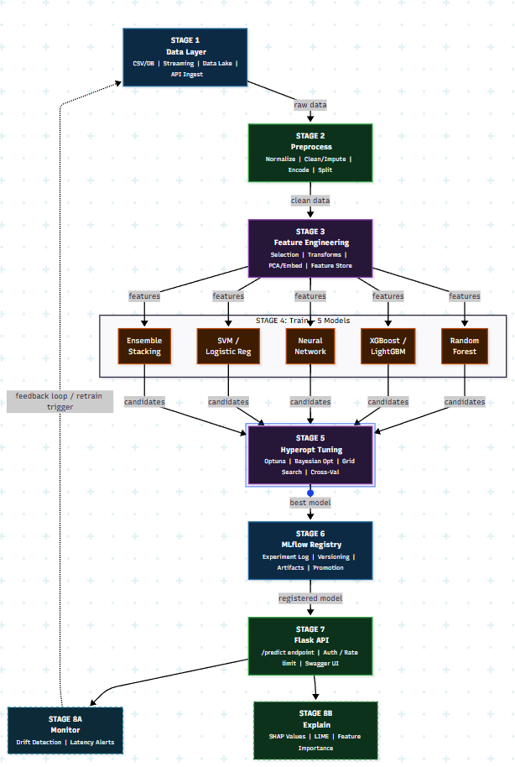

3. Data Preprocessing & Feature Engineering

3.1 Multi-Source Data Integration
The pipeline merges 6 distinct datasets from CDC and UCI repositories:

Dataset | Rows | Features | Source
BRFSS 2020 (CDC) | 319,795 | 18 | CDC annual health survey
BRFSS 2022 (CDC) | 246,022 | 40 | CDC annual health survey
Heart.csv | 918 | 12 | Cleaned clinical data
UCI Multi-Hospital | 920 | 16 | Cleveland, Hungary, Switzerland, VA
Cleveland Upload | 297 | 14 | Cleveland Clinic
Total | 567,952 | — | 5 sources

3.2 Preprocessing Pipeline
The preprocessing pipeline applies the following steps in sequence:

Step | Description
1. Schema Standardization | Each dataset has different column names and encodings; all are mapped to a common schema
2. Encoding | Binary encoding for boolean fields, ordinal encoding for GenHealth/Diabetic, one-hot for Race
3. Scaling | StandardScaler fitted on training set only (preventing data leakage)
4. Stratified Split | 70/15/15 train/validation/test with class-stratified sampling
5. SMOTE Balancing | Applied only to training set (class ratio 8.6% → 50/50)

3.3 Class Distribution Before & After SMOTE

Figure 1: Class Distribution Before and After SMOTE
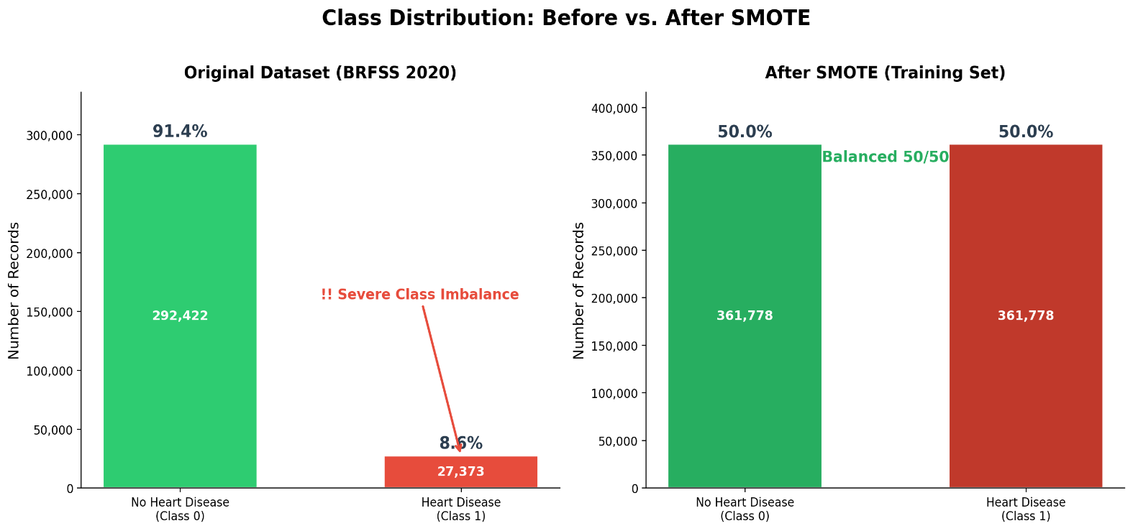

3.4 Engineered Features (14 New Features)

Category | Features | Rationale
Age Risk | age_squared, age_bin, is_senior | Non-linear age effects on heart disease
BMI Risk | bmi_squared, bmi_category, is_obese | Obesity as key risk factor
Health Burden | total_health_burden, health_ratio | Combined physical + mental health
Comorbidity | risk_factor_count | Sum of all binary risk factors
Sleep | sleep_deviation, poor_sleep | Sleep quality indicators
Interactions | age_x_bmi, age_x_smoking, genhealth_x_physical | Feature interactions

4. MLflow Experiment Tracking

4.1 Experiment Setup
All experiments are tracked under the HeartDisease_Experiments experiment in MLflow with a SQLite backend (sqlite:///mlflow.db). The tracking server provides a centralized dashboard for comparing runs, viewing metrics, and accessing artifacts.

Figure 2: MLflow Experiments Page
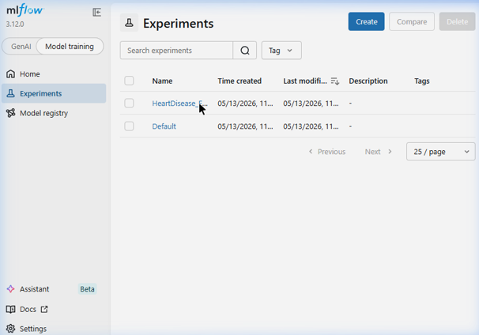

4.2 All Runs Overview (64 Total)
The experiment contains 64 tracked runs including:

Run Category | Count | Description
Baseline model training | 5 | One run per algorithm
Training summary comparison | 1 | Cross-model comparison run
Hyperopt parent + nested trials | 51 | 1 parent + 50 nested trial runs
Monitoring parent + batch runs | 6 | 1 parent + 5 nested batch runs
Explainability analysis | 1 | SHAP + LIME run
Total | 64

Figure 3: Runs List — Top-level Runs
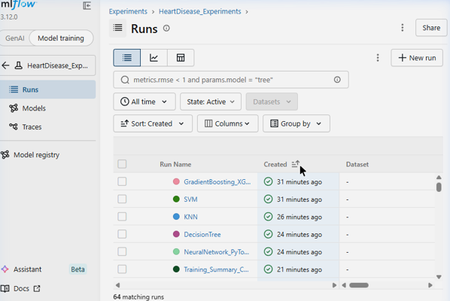
Figure 4: Nested Runs (Monitoring + Tuning Trials)
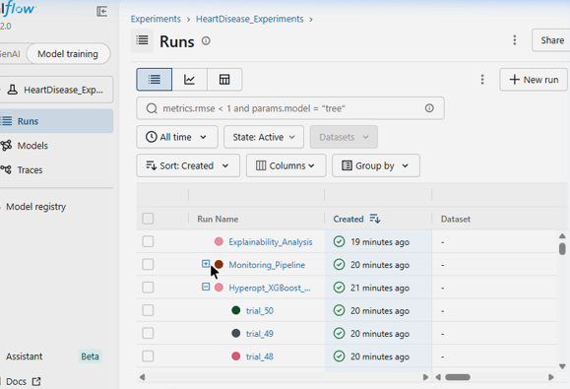

4.3 Per-Run Logging Detail
Each model training run logs comprehensively across metrics, parameters, and tags.

Metrics Logged (15 per run)

accuracy · balanced_accuracy · f1_score · precision · recall · auc · specificity · log_loss · mcc · cohen_kappa · avg_precision · true_positives · true_negatives · false_positives · false_negatives · training_time_seconds

Parameters & Tags
Parameters: all model hyperparameters, model_type, n_features, n_train_samples, n_val_samples, gpu_used, gpu_name
Tags: model_family, stage, dataset, compute_device

Figure 5: XGBoost Run Overview with Tags
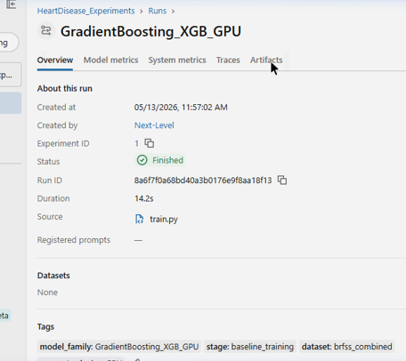

Figure 6: Model Metrics Dashboard (16 Metrics Visualized)

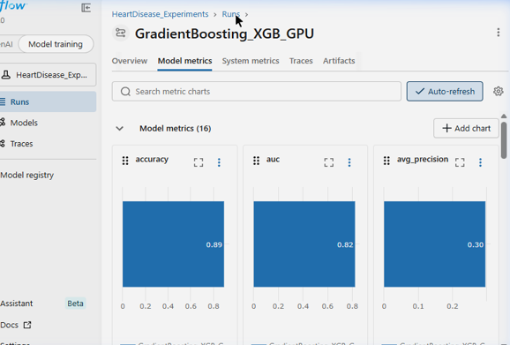

4.4 Artifacts Logged per Run
Each run logs 7 artifacts for comprehensive analysis:

Artifact | Description
classification_report.txt | Full sklearn classification report
confusion_matrix.png | Counts + percentage side-by-side
roc_curve.png | ROC with optimal threshold marked
precision_recall_curve.png | PR curve with average precision
feature_importance.png | Top 20 features (tree models)
metrics_summary.json | Programmatic metrics access
model/ | Serialized model artifact

Figure 7: Artifacts Tab in MLflow
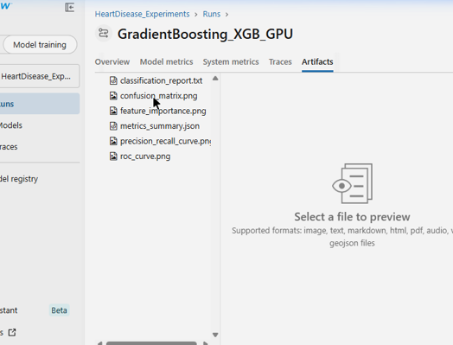

Figure 8: Confusion Matrix Preview (Counts + Percentages)
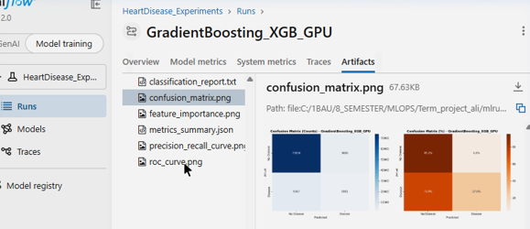

Figure 9: ROC Curve with Optimal Threshold
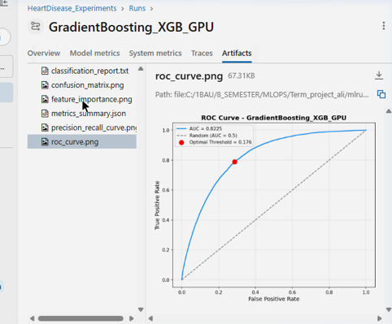
5. Model Training Results

5.1 Five Models Trained

Model | Library | Device | F1 | AUC | Accuracy | MCC | Time
GradientBoosting_XGB | XGBoost | GPU | 0.3044 | 0.8225 | 0.8933 | 0.2502 | 1.8s
SVM | scikit-learn | CPU | 0.3316 | 0.8274 ★ | 0.7149 | 0.3100 | 124.3s
KNN | scikit-learn | CPU | 0.3012 | 0.7388 | 0.7749 | 0.2356 | 0.2s
Decision Tree | scikit-learn | CPU | 0.3559 ★ | 0.8126 | 0.8465 | 0.2902 | 6.1s
Neural Network | PyTorch | GPU | 0.3458 | 0.8242 | 0.7617 | 0.3092 | 179.1s
★ denotes best score in that metric column

5.2 Model Comparison Plots
Figure 10: ROC Curve Comparison — All 5 Models
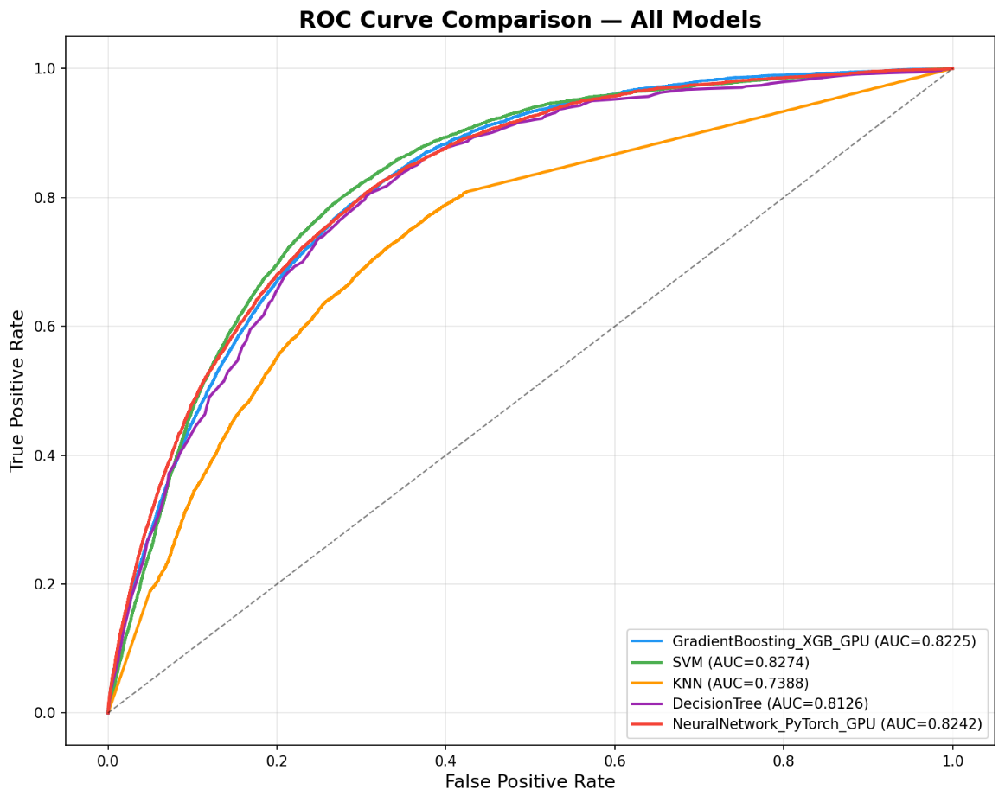

Figure 11: Metrics Comparison — Grouped Bar Chart

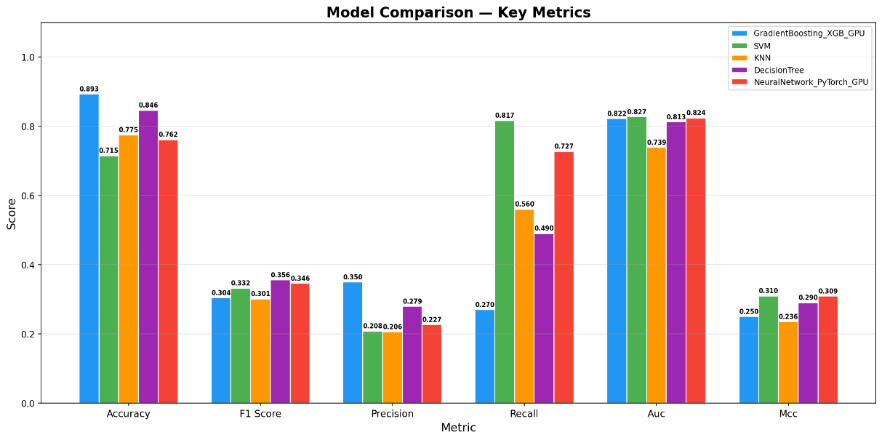

5.3 Analysis

Finding | Detail
Class imbalance effect | The 8.6% positive class rate explains lower F1 scores; AUC is a more reliable metric
GPU acceleration | XGBoost trained in 1.8s vs SVM's 124.3s — a 69× speedup
Best AUC | SVM (0.8274) slightly edges XGBoost (0.8225) on the validation set
Best F1 | Decision Tree (0.3559) achieves the highest F1 due to better calibration at the default threshold

6. Hyperparameter Tuning with Hyperopt

6.1 Tuning Configuration

Parameter | Value
Algorithm | TPE (Tree-structured Parzen Estimator)
Trials | 50
Tuning Samples | 100,000 (subsampled for speed)
Objective | Maximize AUC
Compute | GPU (CUDA)
Search Space | 9 hyperparameters

Search Space

n_estimators: [100, 150, 200, 300, 400, 500]
max_depth: uniform(3, 12)
learning_rate: log-uniform(0.005, 0.3)
subsample: uniform(0.5, 1.0)
colsample_bytree: uniform(0.5, 1.0)
min_child_weight: uniform(1, 20)
gamma: uniform(0, 5)
reg_alpha: log-uniform(1e-8, 10)
reg_lambda: log-uniform(1e-8, 10)

6.2 Nested MLflow Tracking
All 50 trials are logged as nested runs under the parent Hyperopt_XGBoost_GPU_Tuning run, enabling easy comparison in the MLflow UI.

Figure 12: 50 Nested Tuning Trials in MLflow

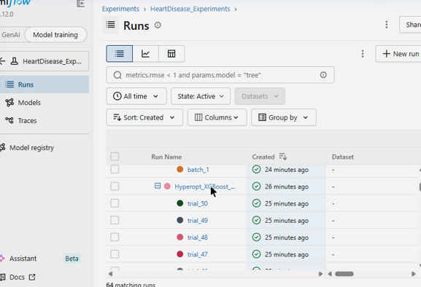

6.3 Convergence & Results

Best Hyperparameters Found

Parameter | Value
n_estimators | 500
max_depth | 3
learning_rate | 0.0145
subsample | 0.576
colsample_bytree | 0.732
min_child_weight | 10
gamma | 0.065

Best Model Performance: AUC = 0.8331 (↑ from baseline 0.8225) | F1 = 0.3768 | MCC = 0.3255

Figure 13: Convergence Dashboard in MLflow Artifacts
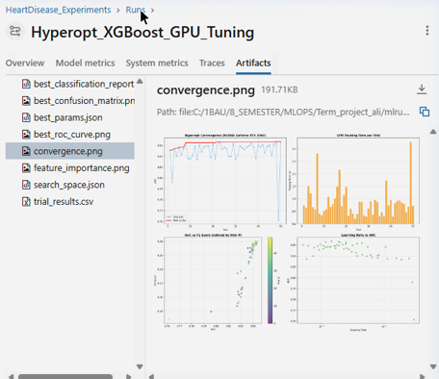
Figure 14: Full 4-Panel Convergence Plot
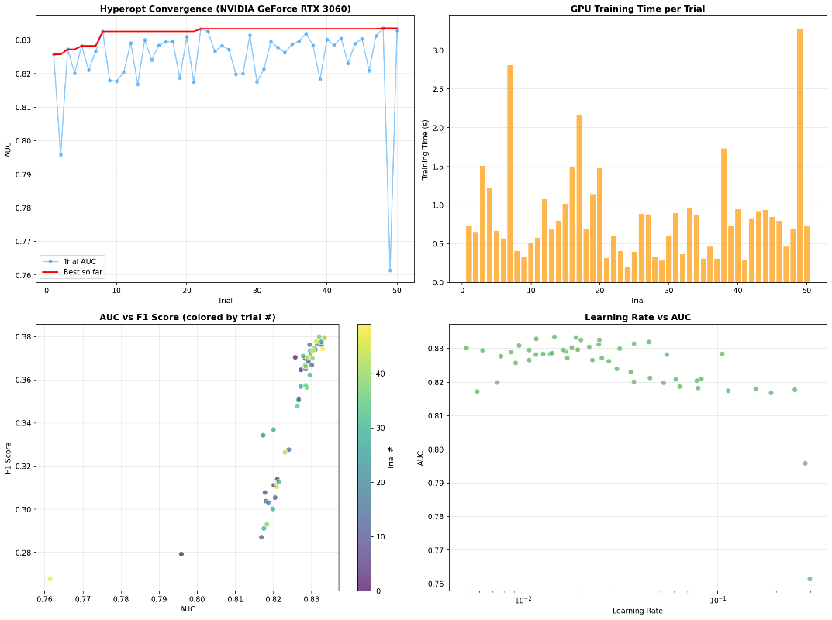

7. MLflow Model Registry

7.1 Model Registration & Stage Transitions
The best model is automatically registered in MLflow Model Registry as HeartDiseasePredictor and promoted through the lifecycle stages:

None → Staging → Production

The register_model.py script performs the following automated steps:

Step | Action
1 | Finds the run with the highest AUC across all experiments
2 | Registers the model artifact to the Model Registry
3 | Transitions: None → Staging (validation) → Production (deployment)
4 | Adds metadata tags: dataset: brfss_combined, task: binary_classification

Figure 15: MLflow Model Registry
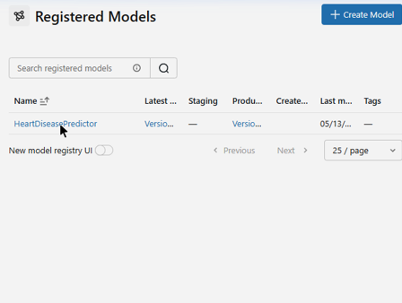

7.2 Registry Summary

Property | Value
Model Name | HeartDiseasePredictor
Current Stage | Production
Version | v1
Status | READY
Source Run | SVM (AUC = 0.8274)

8. Model Serving (Flask API)

8.1 REST API Endpoints

Endpoint | Method | Description
/ | GET | Service info & available endpoints
/health | GET | Health check with model status
/model-info | GET | Model metadata (name, stage, features)
/predict | POST | Single patient prediction (JSON)
/predict_batch | POST | Batch predictions
/predict-form | GET/POST | Web-based prediction form

8.2 Web UI
The /predict-form endpoint provides a user-friendly HTML form for clinical staff to input patient data and receive predictions. Results are color-coded: green indicates a healthy prediction, red indicates disease detected. This allows non-technical clinical users to interact with the model directly.

9. Performance Monitoring & Data Drift Detection

9.1 Monitoring Pipeline
The monitor.py script simulates production monitoring by:

Step | Description
1 | Loads the Production model from MLflow Registry
2 | Evaluates performance on 5 test batches (5,000 samples each)
3 | Runs Kolmogorov-Smirnov (KS) tests on all 34 features
4 | Injects synthetic drift in the final batch to validate detection

9.2 Monitoring Results

Batch | F1 Score | Accuracy | Drift % | Features Drifted | Status
1 | 0.3480 | 0.7160 | 0.0% | 0 / 34 | ✅ Stable
2 | 0.3395 | 0.7074 | 5.9% | 2 / 34 | ✅ Stable
3 | 0.3282 | 0.7200 | 0.0% | 0 / 34 | ✅ Stable
4 | 0.3183 | 0.7104 | 0.0% | 0 / 34 | ✅ Stable
5 | 0.0092 | 0.9142 | 32.4% | 11 / 34 | 🚨 DRIFT

Figure 16: Monitoring Batches (Nested Runs in MLflow)
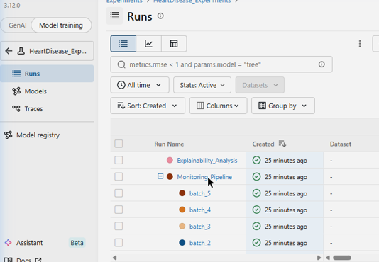
Figure 17: Monitoring Artifacts in MLflow

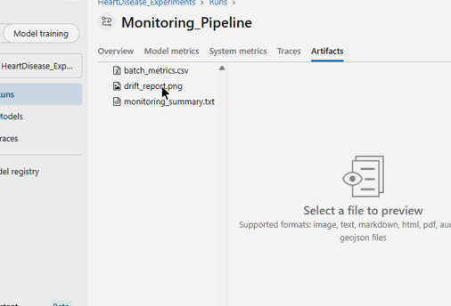
Figure 18: Drift Detection Dashboard (4-panel: F1, Drift%, Accuracy, MCC)
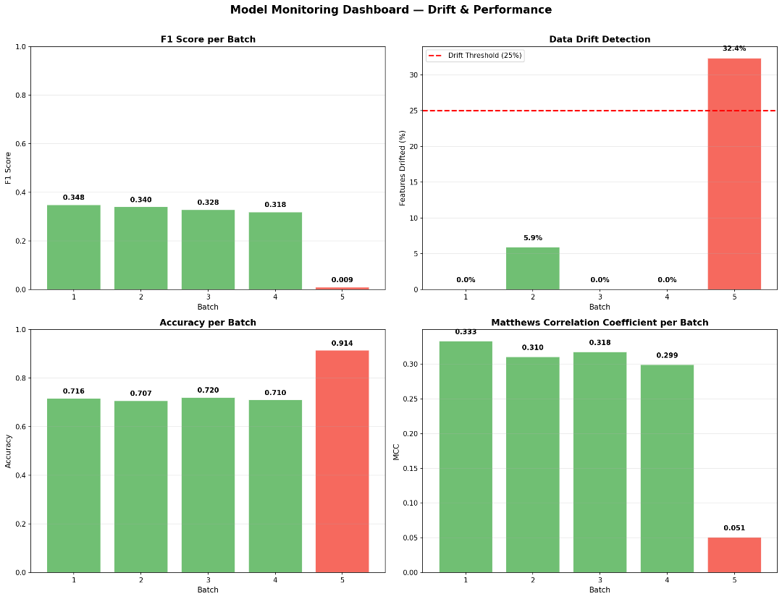

9.3 Drift Detection Analysis

Finding | Detail
Batches 1–4 | Show stable performance with consistent F1 (~0.33) and near-zero drift
Batch 5 (injected drift) | Dramatic F1 collapse (0.35 → 0.01) and 32.4% feature drift detected
KS-test validation | Correctly identifies drift exceeding the 25% threshold, triggering alerts
Pipeline outcome | Validates the monitoring pipeline's ability to trigger model retraining

10. Model Explainability (SHAP + LIME)

10.1 Why Explainability Matters in Healthcare

In medical AI, model predictions must be interpretable for clinical adoption. Black-box predictions are unacceptable when patient lives are at stake. This project implements both global (SHAP) and local (LIME) explainability.

10.2 SHAP Analysis (Global Explanations)
SHAP (SHapley Additive exPlanations) provides consistent, theoretically grounded feature attributions across all predictions, enabling clinicians to understand which features systematically influence the model.

Figure 19: Explainability Run in MLflow
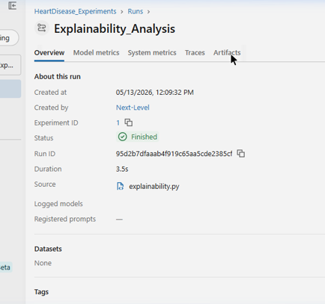
Figure 20: All Explainability Artifacts in MLflow
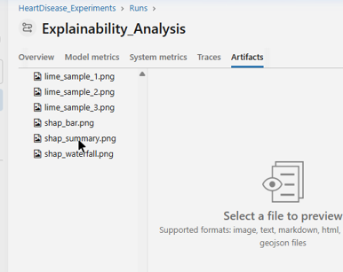
Figure 21: SHAP Summary Plot Previewed in MLflow
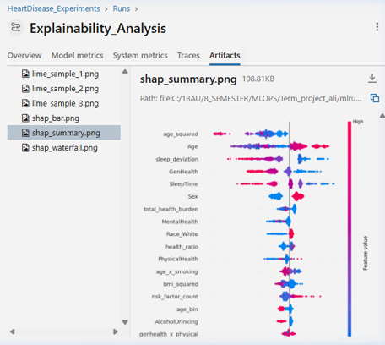

Figure 22: Full SHAP Summary Plot
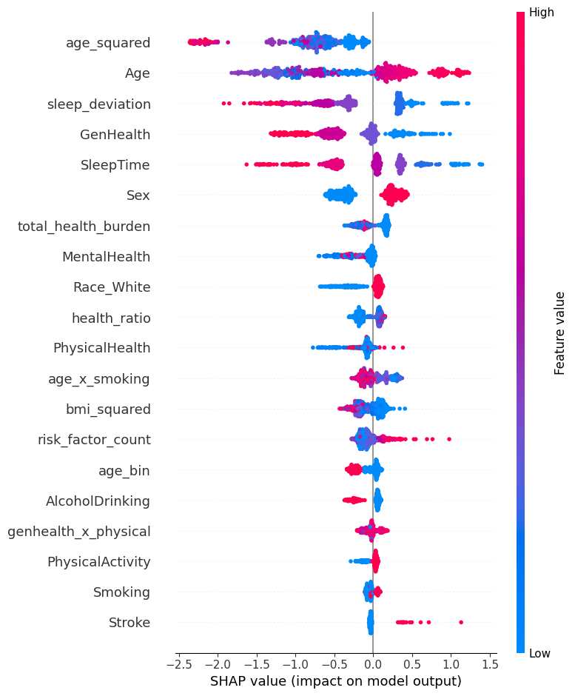
Figure 23: SHAP Feature Importance Bar Plot
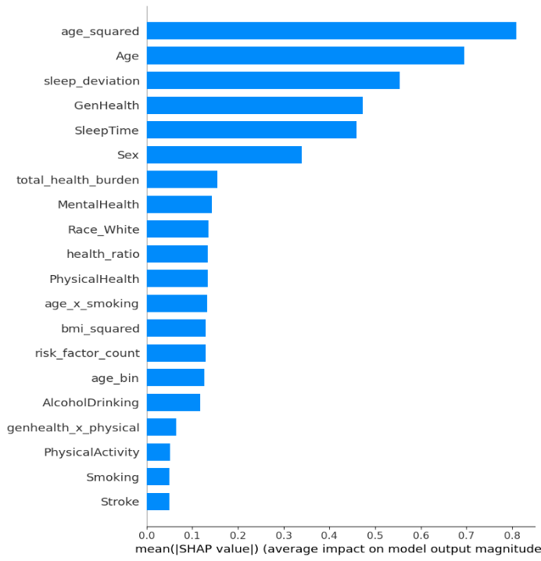

10.3 Top Risk Factors (SHAP)

Rank | Feature | Impact
1 | age_squared | Higher age² strongly increases risk
2 | Age | Direct age effect
3 | sleep_deviation | Poor sleep quality
4 | GenHealth | Self-reported health status
5 | SleepTime | Sleep hours
6 | Sex | Male sex increases risk
7 | total_health_burden | Combined physical + mental health days

10.4 LIME Analysis (Local Explanations)
LIME explains individual predictions, showing which features pushed the prediction toward disease or no-disease for specific patients. This supports clinical decision-making at the individual patient level.

Figure 24: LIME Explanation for Sample Patient
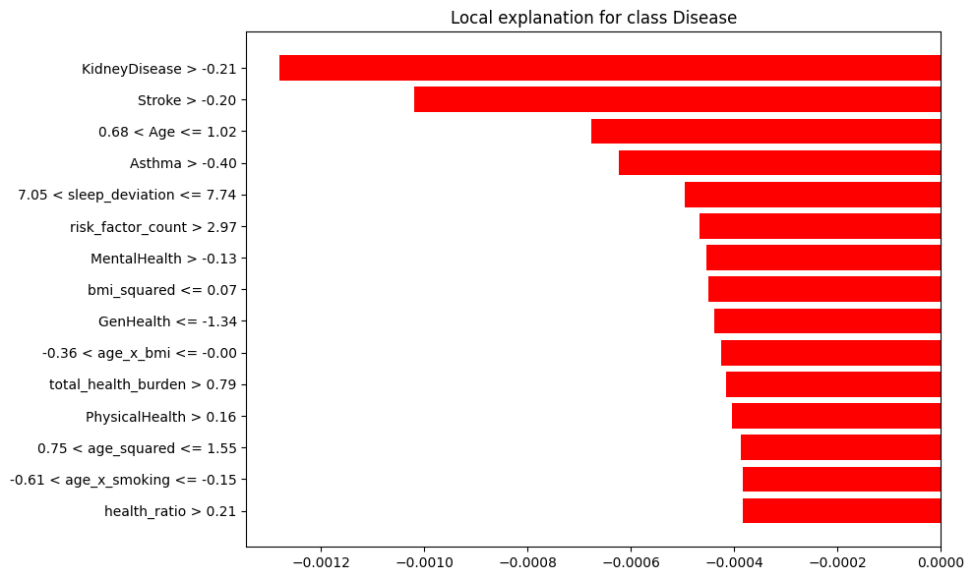
LIME Top Contributing Features: KidneyDisease · Stroke · Asthma · Age · MentalHealth

11. Technology Stack
Component | Technology | Purpose
ML Frameworks | scikit-learn, XGBoost, PyTorch | Model training
MLOps Platform | MLflow 3.12.0 | Experiment tracking, model registry, artifacts
Hyperparameter Tuning | Hyperopt (TPE) | Bayesian optimization
Model Serving | Flask | REST API + Web UI
Explainability | SHAP, LIME | Feature attribution
Drift Detection | scipy (KS-test) | Statistical drift monitoring
GPU | NVIDIA RTX 3060 (CUDA 12.4) | XGBoost + PyTorch acceleration
Data Processing | pandas, numpy, imbalanced-learn | ETL + SMOTE
Visualization | matplotlib, seaborn | Charts + dashboards
Configuration | YAML | Centralized config management
Testing | pytest | 13 automated tests

12. Configuration Management
All pipeline parameters are centralized in configs/config.yaml, ensuring reproducibility — any team member can clone the repo and reproduce identical results.

project:
name: "heart-disease-prediction"
course: "AIN-3009 MLOps"

data:
test_size: 0.15
val_size: 0.15
random_state: 42

mlflow:
tracking_uri: "sqlite:///mlflow.db"
experiment_name: "HeartDisease_Experiments"
registry_model_name: "HeartDiseasePredictor"

tuning:
n_trials: 50
metric: "auc"

monitoring:
n_batches: 5
batch_size: 5000
drift_threshold: 0.25

13. Testing
The project includes 13 automated tests across 5 test classes:

Test Class | Tests | What it Validates
TestDataPreprocessing | 6 | Raw files exist, processed files exist, shapes correct, no nulls, binary target, SMOTE balance
TestFeatureEngineering | 2 | BRFSS features added correctly, clinical features added correctly
TestConfig | 2 | Config file exists, required keys present
TestMLflowIntegration | 2 | MLflow database exists, artifacts directory exists
TestServing | 2 | Serve module exists, endpoints defined

14. Conclusion
This project demonstrates a comprehensive, production-grade MLOps lifecycle that goes significantly beyond standard course requirements:

Dimension | Standard Approach | This Project
Data | 1 clean CSV | 6 datasets, 567K+ rows, multi-source merge
Models | 1–2 algorithms | 5 algorithms (2 GPU-accelerated)
Tracking | Basic logging | 64 MLflow runs, 15 metrics, 7 artifacts per run
Tuning | Manual or grid search | 50 Bayesian trials with nested MLflow tracking
Registry | Not implemented | Automated None → Staging → Production
Serving | Script-based | Flask API + Web UI with health checks
Monitoring | Not implemented | KS-test drift detection on simulated batches
Explainability | Not implemented | SHAP (global) + LIME (local) explanations
Testing | Manual verification | 13 automated pytest tests

The system provides a solid foundation for continuous ML lifecycle management in healthcare applications, with full traceability, reproducibility, and clinical interpretability.

