Quick Sort

Some useful resources for explaining how the sort works:

* Quick sort in 4 minutes - <https://www.youtube.com/watch?v=Hoixgm4-P4M>

# Quicksort algorithm - <https://www.youtube.com/watch?v=COk73cpQbFQ&t=1s>

Detailed explanation of Insertion sort: by

In Quick Sort first, we need to choose a value, called pivot (preferably the last element of the array). Then, we arrange the smaller values towards the left side of the pivot and higher values towards the right side of the pivot. These two operations are performed recursively until there is only one element left at both the side of the pivot.

(This explaination was taken from <https://appdividend.com/2019/05/02/quick-sort-in-c-tutorial-with-example-c-quick-sort-program/>. I like this explanation.)

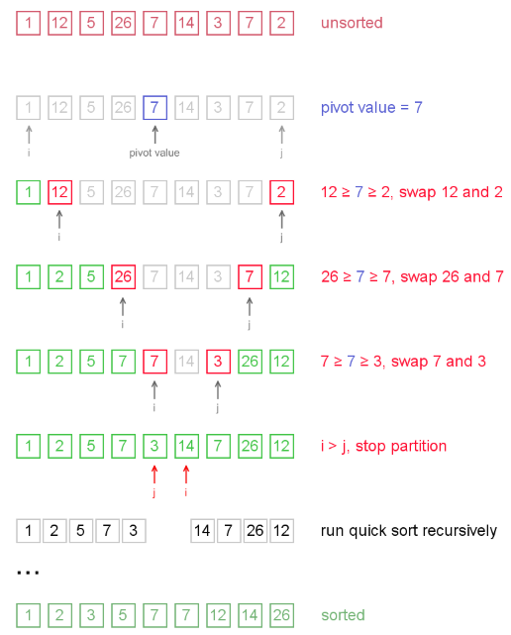

The above visual of Quick sort is found at <http://www.algolist.net/Algorithms/Sorting/Quicksort>

