2024-12-17 - App ConMon - Field

Change Requests
This Change is a fix for Internal IP disclosure in the Location header in field-management service
Change request numbers | Change Description | Contact/sponsor | Notes
CHG0046364 | Hosts: field-docker-app1/2 in all app vpcs (fppa, usdod, usdoddr)  - Fix for Web Server HTTP Header Internal IP Disclosure - Application Hosts  - CEHC-5708 - [Due Dec. 05] Low - Web Server HTTP Header Internal IP Disclosure - Application Hosts - Field Staging Test - Web Server HTTP Header Internal IP Disclosure - Application Hosts - Field | Aconex Field Dev team:  Amit Samanta  Aconex Field Dev Manager:  Mohan Seemakurthi

Tickets
Key | Summary | T | Created | Updated | Due | Assignee | Reporter | P | Status | Resolution
CEHC-5708 | [Due Dec. 05] Low - Web Server HTTP Header Internal IP Disclosure - Application Hosts - Field |  | Jun 11, 2024 | Dec 15, 2024 | Dec 04, 2024 | Raghavendra Kasinadhuni | Azeez Zackriah |  | Staging Test | Unresolved
1 issue

Exceptions
No smoke or regression test - There isn't a way to test Field until Field supports Opensearch. Additionally, these are the reference tickets for the turn off period & Research Spike CEHC-5859 - Research Spike – Turn Off Field Containers To Do & CEHC-4763 - Research spike: Provision / Create Field specific AWS Open Search creds Done - will happen after 3PAO pentest.
All field releases need the step 'Make OracleDB read/writable' in DR as they have a table that needs to be updated in their PDB as the application is being brought up.

Rationale for an exception for addressing the Trivy Scan findings
In the current conmon release, it wouldn't be viable to address the trivy scan vulnerabilities as the current Major version of Field (23.2.6) is more than 1.5 years old and changing the library versions to address the vulnerabilities in the older Field version will have a huge impact and bring in compatibility issues with the other services.

Trivy Scan findings remediation plan
Plan or Jira tickets for the remediation of Trivy scan findings are given for tracking purpose.
The findings of Trivy scan will be resolved in the release along with Opensearch migration / JDK17 upgrade / Spring upgrade

Key | Summary | T | Created | Updated | Due | Assignee | Reporter | P | Status | Resolution
ACONEX-312465 | Aconex Field Web | Field Daily Reports | Fix Trivy Scan vulnerabilities |  | Nov 14, 2024 | Dec 03, 2024 |  | Mohan Seemakurthi | Mohan Seemakurthi |  | Done | Done
ACONEX-312464 | Aconex Field Web | Custom Fields | Fix Trivy Scan vulnerabilities |  | Nov 14, 2024 | Dec 11, 2024 |  | Devraj Kumar | Mohan Seemakurthi |  | Done | Done
ACONEX-312463 | Aconex Field Web | Field API | Fix Trivy Scan vulnerabilities |  | Nov 14, 2024 | Dec 16, 2024 |  | Mohan Seemakurthi | Mohan Seemakurthi |  | In Progress | Unresolved
ACONEX-312462 | Aconex Field Web | Field Filestore | Fix Trivy Scan vulnerabilities |  | Nov 14, 2024 | Dec 05, 2024 |  | Devraj Kumar | Mohan Seemakurthi |  | Done | Done
ACONEX-312461 | Aconex Field Web | Field Reports | Fix Trivy Scan vulnerabilities |  | Nov 14, 2024 | Dec 03, 2024 |  | Mohan Seemakurthi | Mohan Seemakurthi |  | Done | Done
ACONEX-312366 | Aconex Field Web | Field management | resolve trivy scan vulnerabilities |  | Nov 12, 2024 | Nov 27, 2024 |  | Amit Samanta | Amit Samanta |  | Done | Done
ACONEX-312342 | Aconex Field Web | Field Comments | Fix Trivy Scan vulnerabilities |  | Nov 12, 2024 | Nov 18, 2024 |  | Mohan Seemakurthi | Mohan Seemakurthi |  | Done | Done
ACONEX-312341 | Aconex Field Web | Field Checklists | Fix Trivy Scan vulnerabilities |  | Nov 12, 2024 | Nov 28, 2024 |  | Devraj Kumar | Mohan Seemakurthi |  | Done | Done
8 issues

Manifests
Manifest Path | Artifacts | Docker Image ID (when appropriate) / Artifact Description
meta/jenkins/jobs/nexus/prepare-manifest/2839/manifest.txt | Artifacts related to Field Management:  aconex-docker-images/field_management/field_23.2.6-2.20241212.0801.r84df587354a14e336085b2280df12358b0a9d010.tar  aconex-docker-images/field_management/field-database_23.2.6-2.20241212.0801.r84df587354a14e336085b2280df12358b0a9d010.tar  aconex-deploy/field_management/field_deploy_scripts_23.2.6-2.20241212.0801.r84df587354a14e336085b2280df12358b0a9d010.tar.gz | c5763328

Sync Multi Manifest String
meta/jenkins/jobs/nexus/prepare-manifest/2839/manifest.txt

Pre Deployment
Primary VPC Only  Run Maintenance Enable job | Prod: Not required for Pre-Prod or Prod-DR  Non Prod: Not required for Stage-DR  Dashboard → platform-jobs → patching → maintenance-enable  URL:  platform-jobs/job/patching/job/maintenance-enable  - Click on Build with Parameters  - vpc_name: <app-vpc> e.g. sentqa304 / gstg004 / usdod / fppa / usdoddr  - stop_babylon_web_app: true  - stop_babylon_indexer: true  - stop_all_services: true  - aconex_pp_version: v24.12.content or latest  - Click Build | Job completes successfully. Maintenance page for users.
https://localhost:10081/job/platform-jobs/job/patching/job/maintenance-enable/909/parameters/
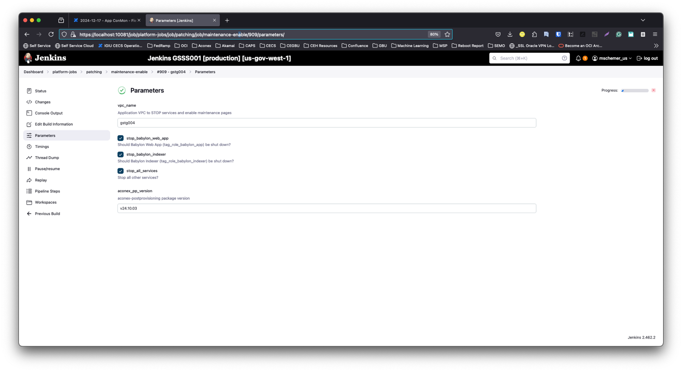
https://localhost:10081/job/platform-jobs/job/patching/job/maintenance-enable/909/console
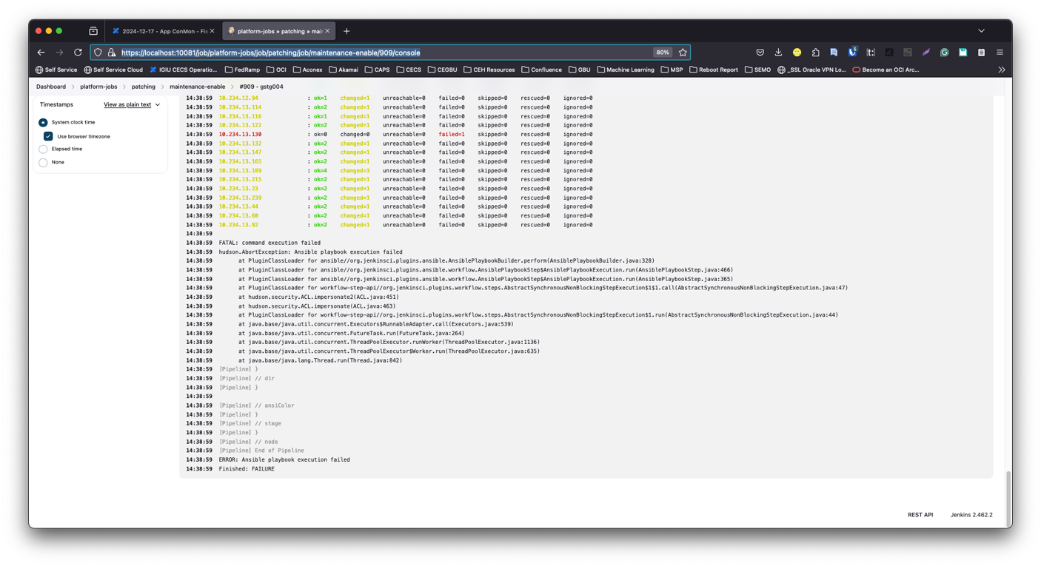

Sync Manifests | Dashboard → platform-jobs → nexus → sync-manifest-file  URL:  platform-jobs/job/nexus/job/sync-manifest-file  - Click on Build with parameters  - manifest_path:<take-paths-from-manifest-table-above>  - repo_type :raw  - utils_version: v24.04 or latest  - Click on Build
https://localhost:10081/job/platform-jobs/job/nexus/job/sync-manifest-file/3505/parameters/
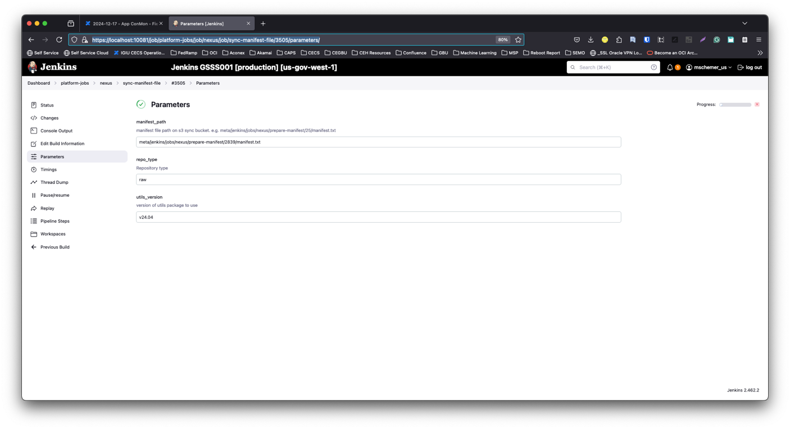
https://localhost:10081/job/platform-jobs/job/nexus/job/sync-manifest-file/3505/console
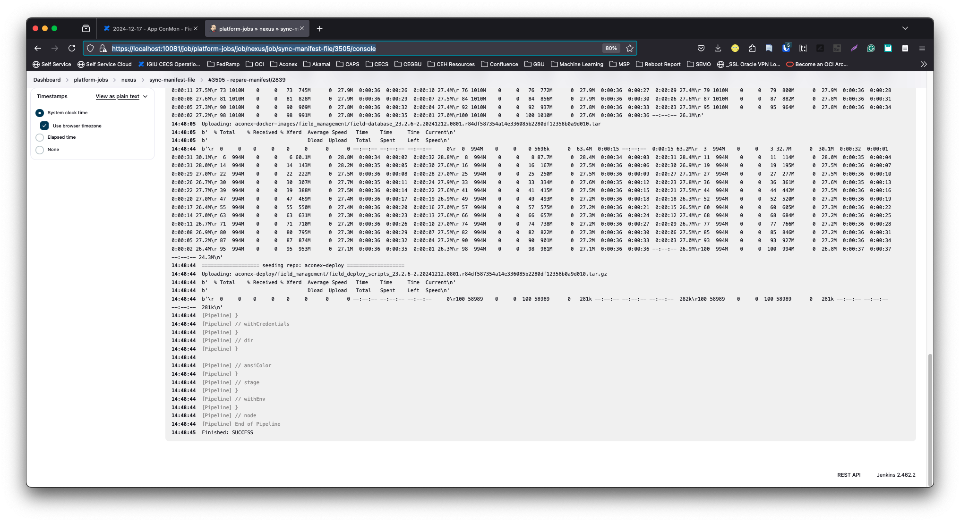

Import the docker image | Dashboard → platform-jobs → nexus → import-docker-image  URL:  platform-jobs/job/nexus/job/import-docker-image  image_file strip_registry  aconex-docker-images/field_management/field_23.2.6-2.20241212.0801.r84df587354a14e336085b2280df12358b0a9d010.tar checked  aconex-docker-images/field_management/field-database_23.2.6-2.20241212.0801.r84df587354a14e336085b2280df12358b0a9d010.tar checked | All jobs should complete successfully
https://localhost:10081/job/platform-jobs/job/nexus/job/import-docker-image/1113/parameters/
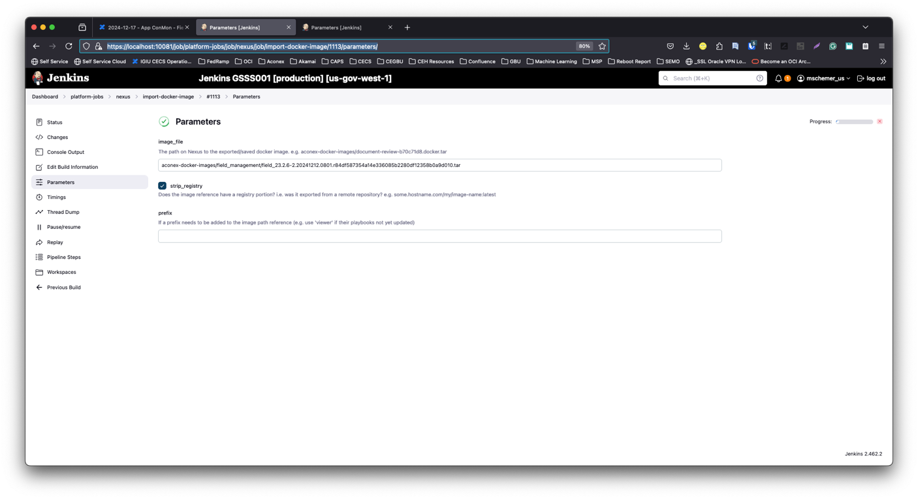

https://localhost:10081/job/platform-jobs/job/nexus/job/import-docker-image/1113/console

https://localhost:10081/job/platform-jobs/job/nexus/job/import-docker-image/1114/parameters/
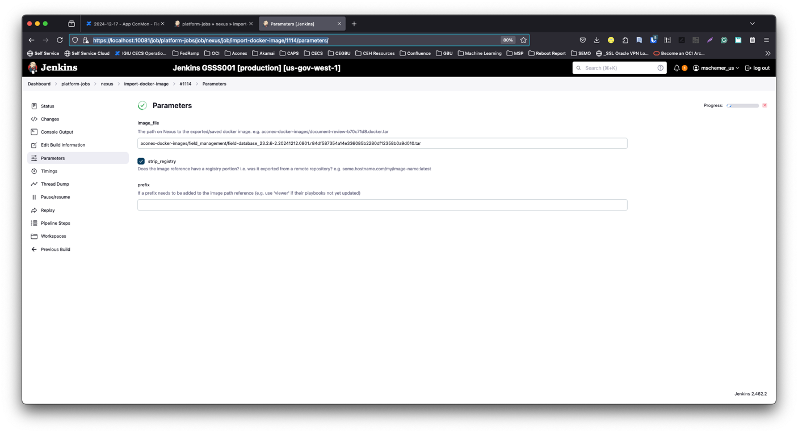

https://localhost:10081/job/platform-jobs/job/nexus/job/import-docker-image/1114/console

Stage DR and Prod DR deploys only!  Make the db1 database writable so that the schema changes to the DB part of the deploy do not fail. Permanent Link. | Disable transaction log processing  - Log on to database host using your Active Directory user name and password.  - Right mouse click on the Start menu and select Computer Management  - Expand the Task Scheduler and select the first folder (Library)  - Select "Download 5 minute transaction logs" job and disable it  Enable the database  - Log on to Jenkins  - Navigate to platform-jobs / disaster-recovery / make-db-writeable  - Parameters:  - dbhost: db1  - vpc_name: Select the appropriate app vpc  - acx_instance: Select the appropriate app vpc  - aconex_pp: v24.10.02 or latest  - Domain_Join_User: this is your user name, used to log on to the host  - Domain_Join_Password: your password for this environment  - Build the job | 5 minute download job will NOT run. These will fail as the next step makes the database writable. Once turned back on post deploy, it will catch up.
DR Only | Make OracleDB read/writable for the application deployment  Oracle DB - Make DR Writable  Section "Bring DR up in Read/Write Mode"  Oracle DB - Make DR Writable | Note  The steps below are manual steps to get the Oracle Database (oracle-db1) into read/write mode to allow changes to happen.  Note: This should not be left in read/write mode for extended periods of time or the log transport will fall too far behind and will need manual intervention to get it back in sync and working again.  In order to get this done, you will need to login to both the DR oracle-db1 host as well as the Primary oracle-db1 host.  For reference, the DR oracle-db1 (target) host will be referred to below as the Standby Database. The Primary oracle-db1 (Source) will be referred to as the Primary Database  Oracle DB - Make DR Writable | Bring DR up in Read/Write Mode  Bring DR up in Read/Write Mode  On Standby Database, execute the following:  Step One) Login to the Oracle user on the Standby DB1 host  sudo su - oracle  Step Two) Login to SQL Plus as the sys user  sqlplus / as sysdba  Step Three) Cancel Auto log application  ALTER DATABASE RECOVER MANAGED STANDBY DATABASE CANCEL;  Step Four) Create a Guaranteed restore point  CREATE RESTORE POINT Standby_flashback_testing GUARANTEE FLASHBACK DATABASE;  On Primary Database, Execute the following:  Step One) Login to the Oracle user on the Primary DB1 host  sudo su - oracle  Step Two) Login to SQL Plus as the sys user  sqlplus / as sysdba  Step Three) Archive the current log file  ALTER SYSTEM ARCHIVE LOG CURRENT;  Step Four) Pause the log shipping to the standby database:  ALTER SYSTEM SET LOG_ARCHIVE_DEST_STATE_3=DEFER;  On the Standby Database, Execute the Following:  Step One) Login to the Oracle user on the Standby DB1 host  sudo su - oracle  Step Two) Login to SQL Plus as the sys user  sqlplus / as sysdba  Step Three) Activate the standby database - (make it primary)  ALTER DATABASE ACTIVATE STANDBY DATABASE;  Step Four) Open the database  ALTER DATABASE SET STANDBY DATABASE TO MAXIMIZE PERFORMANCE;  ALTER DATABASE OPEN;  Step Five) Ensure the PDB's are open  alter pluggable database all open;  You can double check to ensure all PDB's are open by running the following:  show pdbs  Expected output should be this:  19:23:10 sys@GSTG004D:ORACLE-DB1> show pdbs  CON_ID CON_NAME OPEN MODE RESTRICTED  ---------- ------------------------------ ---------- ----------  2 PDB$SEED READ ONLY NO  3 GSTG004DB1 READ WRITE NO  4 ACXNAV READ WRITE NO  5 FIELD_CHECKLISTS READ WRITE NO  6 FIELD_COMMENTS READ WRITE NO  7 FIELD_FILESTORE READ WRITE NO  8 FIELD_MANAGEMENT READ WRITE NO  9 FIELD_REPORTS READ WRITE NO  You can double check to ensure the database is read/write mode by executing the following query  select open_mode from v$database;  Expected output should be this:  SQL> select open_mode from v$database;  OPEN_MODE  --------------------  READ WRITE

Change Tasks - Platform Tasks

Change Tasks/Steps
Task No | Task Name | Steps / Actions |  | Validation | Notes
1 | Deploy Field Management Service | Dashboard → aconex-jobs → ACX-Field → field-management  URL:  aconex-jobs/job/ACX-Field/job/field-management  - Click on Build with parameters  - vpc_name: <app-vpc-name>  - rpm_version: 23.2.6-2.20241212.0801.r84df587354a14e336085b2280df12358b0a9d010  - deployment_artifact: field_deploy_scripts_23.2.6-2.20241212.0801.r84df587354a14e336085b2280df12358b0a9d010.tar.gz  - Click on build |  | Job should complete successfully

Post Validation Step
Run Maintenance disable job | Prod: Not required for Pre-Prod or Prod-DR  Dashboard → platform-jobs → patching → maintenance disable  URL:  platform-jobs/job/patching/job/maintenance-disable  - Click on Build with Parameters  - vpc_name: <app-vpc>  - aconex_pp_version: v24.12.content or latest  - Click on Build

Validation Steps
Note: Validation can be done only after maintenance mode is off i.e. once Babylon application is up.
Post steps
Task No. | Task Name | Steps / Actions | Validation
1 | Vary the response of the curl command for the each of the services | Please run below command on their respective host, replace hostname with respective hostname were deployment is done.  Field Management:  field-docker-app1.<app vpc>  curl -k https://localhost:8080/field/api/healthcheck  field-docker-app2.<app vpc>  curl -k https://localhost:8080/field/api/healthcheck | Api Should return the below response for each of the services  Field Management  {"databaseHealthCheck":{"healthy":true}}
2 | Basic smoke test of the Field modules | Go to Aconex UI and navigate around the Field modules likes Issues/Inspections/Daily Reports/Punchlists. Observe the pages are loading without any errors.
3 | DR ONLY  must do | Put OracleDB back to Standby after the application deployment  Oracle DB - Make DR Writable  Section "Reset DR back to Read Only Mode"  Oracle DB - Make DR Writable | Reset DR back to Read Only Mode  Reset DR back to Read Only Mode  On Standby Database, execute the following:  Step One) Login to the Oracle user on the Standby DB1 host  sudo su - oracle  Step Two) Login to SQL Plus as the sys user  sqlplus / as sysdba  Step Three) Shut down the database  shutdown immediate;  Step Four) Startup the database in Mount mode  STARTUP MOUNT FORCE;  Step Five) Flashback the database to the restore point (note: we can't have long gap between making the database read/write and standby)  FLASHBACK DATABASE TO RESTORE POINT Standby_flashback_testing;  Step Six) Convert the database back to a Standby database  ALTER DATABASE CONVERT TO PHYSICAL STANDBY;  Step Seven) Put the standby database in Managed Recover Mode  ALTER DATABASE RECOVER MANAGED STANDBY DATABASE DISCONNECT;  Step Eight) Open the database in Read Only Mode  ALTER DATABASE OPEN READ ONLY;  The Last step is to cleanup the restore point built to get us back to this point. It is recommended that you first enable log shipping on the Primary side and double check to ensure everything is working correctly using the instructions below then execute this step on the Standby Database oracle-db1:  DROP RESTORE POINT Standby_flashback_testing ;  You can double check to ensure the database is in read/write mode by executing the following query  select open_mode from v$database;  Expected output should be this: (Note: It's possible that the open mode may only say "READ ONLY". This is also acceptable)  SQL> select open_mode from v$database;  OPEN_MODE  --------------------  READ ONLY WITH APPLY  On Primary Database, Execute the following:  Step One) Login to the Oracle user on the Primary DB1 host  sudo su - oracle  Step Two) Login to SQL Plus as the sys user  sqlplus / as sysdba  Step Three) Re-enable log shipping  ALTER SYSTEM ARCHIVE LOG CURRENT;  ALTER SYSTEM SET LOG_ARCHIVE_DEST_STATE_3=ENABLE;  To ensure that log shipping is working correctly, you can execute the following two queries on the Primary and Standby databases  First, get the latest archived log number from the Primary Database  select max(SEQUENCE#) from v$archived_log;  Expected outcome would be something similar to this:  22:14:45 sys@GSTG004D:ORACLE-DB1> select max(SEQUENCE#) from v$archived_log;  MAX(SEQUENCE#)  --------------  6737  1 row selected.  Next, See what log number was last received and applied from the Standby Database  SELECT al.thrd "Thread", almax "Last Seq Received", lhmax "Last Seq Applied"  FROM (select thread# thrd, MAX(sequence#) almax FROM v$archived_log WHERE resetlogs_change#=(SELECT resetlogs_change# FROM v$database) GROUP BY thread#) al, (SELECT thread# thrd, MAX(sequence#) lhmax FROM v$log_history WHERE resetlogs_change#=(SELECT resetlogs_change# FROM v$database) GROUP BY thread#) lh  WHERE al.thrd = lh.thrd;  Expected outcome would be similar to this. If both numbers match the query above from the Primary Database, the log shipping has been successfully put back and there are no issues.  22:13:00 sys@GSTG004D:ORACLE-DB1> SELECT al.thrd "Thread", almax "Last Seq Received", lhmax "Last Seq Applied" FROM (select thread# thrd, MAX(sequence#) almax FROM v$archived_log WHERE resetlogs_change#=(SELECT resetlogs_change# FROM v$database) GROUP BY thread#) al, (SELECT thread# thrd, MAX(sequence#) lhmax FROM v$log_history WHERE resetlogs_change#=(SELECT resetlogs_change# FROM v$database) GROUP BY thread#) lh WHERE al.thrd = lh.thrd;  Thread Last Seq Received Last Seq Applied  ---------- ----------------- ----------------  1 6737 6737  1 row selected.
4 | Stage DR and Prod DR deploys only!  Return db1 database back to a replication target. Permanent Link. | - Log on to Jenkins  - Navigate to platform-jobs / disaster-recovery / restore-to-standby  - Parameters:  - dbhost: db1  - vpc_name: Select the appropriate app vpc  - acx_instance: Select the appropriate app instance  - aconex_pp_version: v24.10.02 or latest  - Domain_Join_User: this is your user name, used to log on to the host  - Domain_Join_Password: your password for this environment  Enable transaction log processing  - Log on to database host using your Active Directory user name and password.  - Right mouse click on the Start menu and select Computer Management  - Expand the Task Scheduler and select the first folder (Library)  - Select "Download 5 minute transaction logs" job and enable it | This job will find the latest full back from S3 and download it. Then drop the database, apply the latest backup, and restart transaction log processing as appropriate.  To validate, log on to the host and check the babylon database. It should be in "Standby / Readonly" mode.  If this job fails:  Run Maintenance enable first.

