Data for data visualization

**Accompanying document for task specification**

* Data tasks/topics incl. contact person: see Excel overview.
* Individual data packages contain short description and data

**Must-have’s:**

* Correct specification of data source, time, etc.
* If considered useful, text boxes for data description with the graphs quite possible.
* Further use of the visualizations (import of new data at a later point in time) should be possible (corresponding description may be necessary).)

**Country classification - possible selection for groupings/averages/etc.:**

* **EPO countries**: Albania, Austria, Belgium, Bulgaria, Croatia, Cyprus, Czech Republic, Denmark, Estonia, Germany, Finland, France, Greece, Hungary, Iceland, Ireland, Italy, Latvia, Liechtenstein, Lithuania, Luxembourg, Malta, Monaco, Montenegro, Netherlands, North Macedonia, Norway, Poland, Portugal, Romania, San Marino, Serbia, Slovenia, Slovakia, Spain, Sweden, Switzerland, Turkey and United Kingdom
* **EU 27**
* **Innovation Leader**: Sweden, Finland, Denmark, the Netherlands, and Belgium
* **Strong Innovators:** Ireland, Luxembourg, Austria, Germany, Cyprus, and France
* **Country classification by income:** according to[Worldbank](https://blogs.worldbank.org/opendata/new-world-bank-country-classifications-income-level-2022-2023#:~:text=The%20World%20Bank%20assigns%20the,the%20previous%20year%20(2021))

**Colors**

The following colors can be used for highlighting: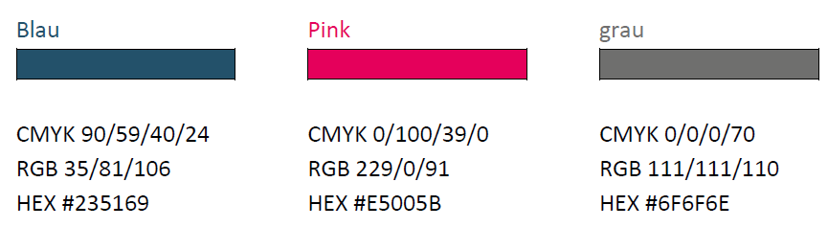

**Fonts:** In principle, the Calibri and Open Sans fonts are used.

**Logo (for possible use)**

