Max Schrader

2/10/2021

# HW 1

## Problem 1

#### DAQ Code:

function y = daq(v_ref_high, v_ref_low, n_bits, signal_v)

v_ref_high = v_ref_high - v_ref_low;

resolution = 2^n_bits;

delta = v_ref_high / resolution;

binary = zeros(resolution, 1);

signal_v = signal_v - v_ref_low;

for i=1:resolution

comparator = v_ref_high - (i - 1) * delta;

bit = signal_v >= comparator;

binary(i) = bit * comparator;

if bit

signal_v = signal_v - comparator;

end

end

y = sum(binary) + v_ref_low;

#### Simulink Model:

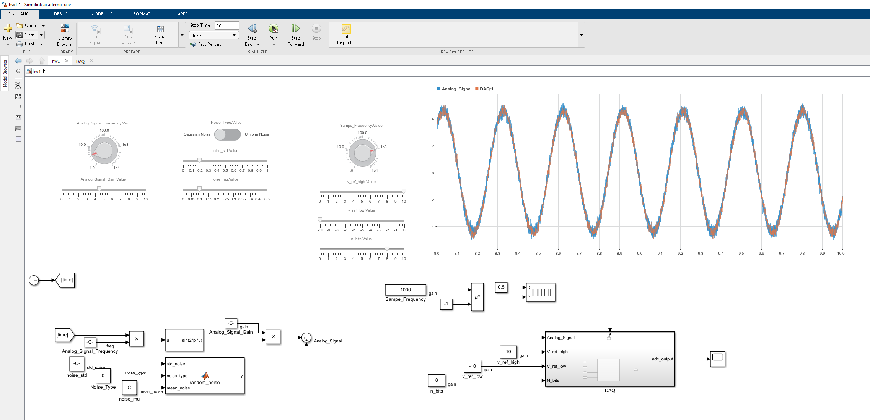

#### 4 Bit, -10V to 10V @100Hz Sampling Frequency

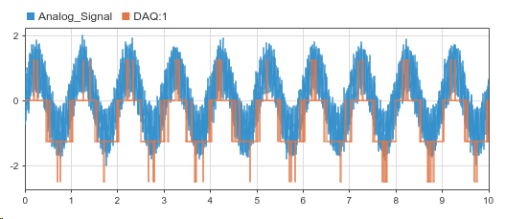

#### 8 Bit, -10V to10V @100Hz Sampling Frequency

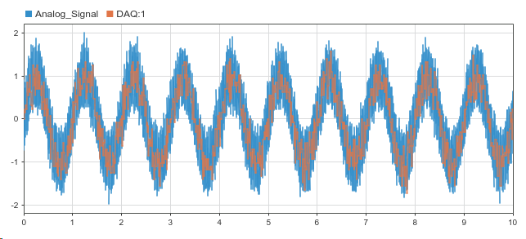

#### 4 Bit, -2V to 2V @100Hz Sampling Frequency

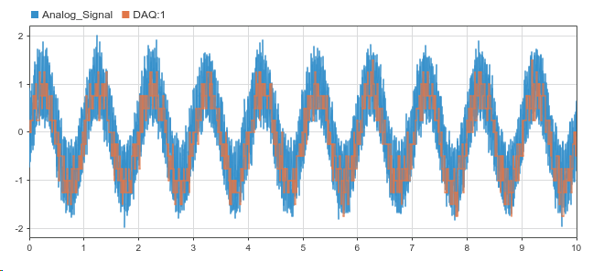

#### 8 Bit, -2V to 2V @100Hz Sampling Frequency

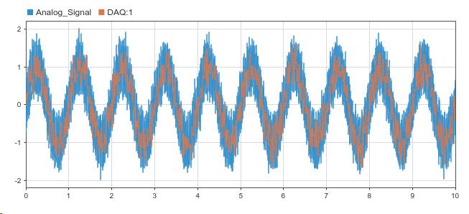

## Problem 2

See problem 3

## Problem 3

#### Simulink Model

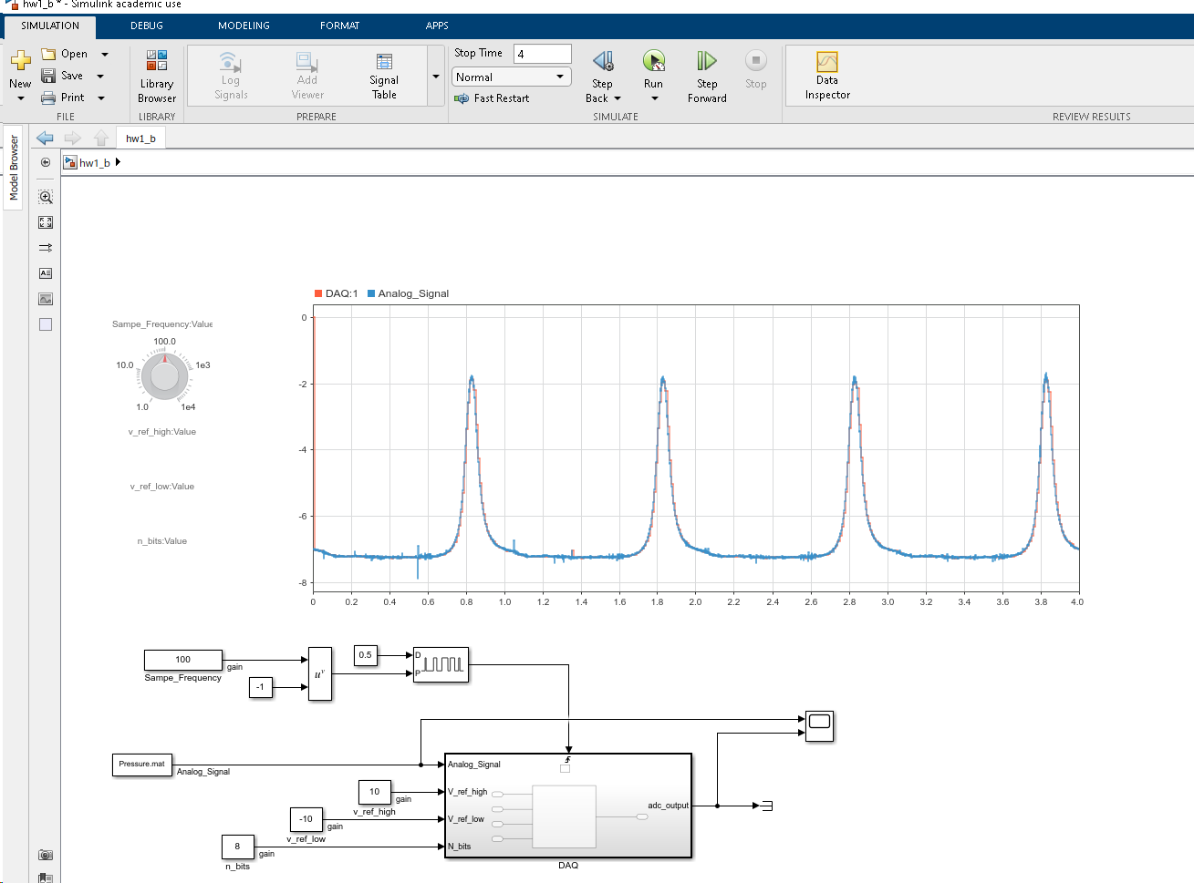

#### 10 bit, -10V to 10V @100Hz Sampling Frequency

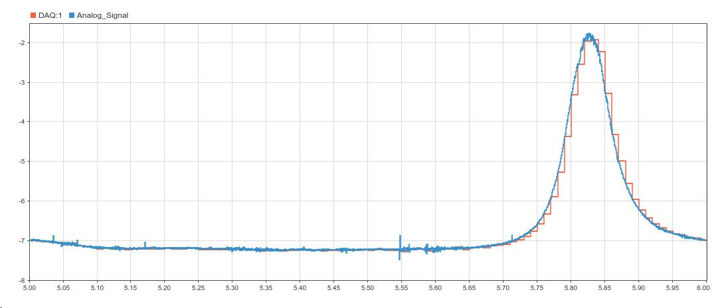

#### 14 bit, -10V to 10V @1000Hz Sampling Frequency

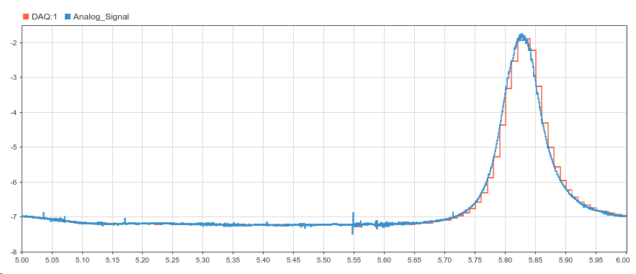

#### Difference between 10 & 14 bit resolution

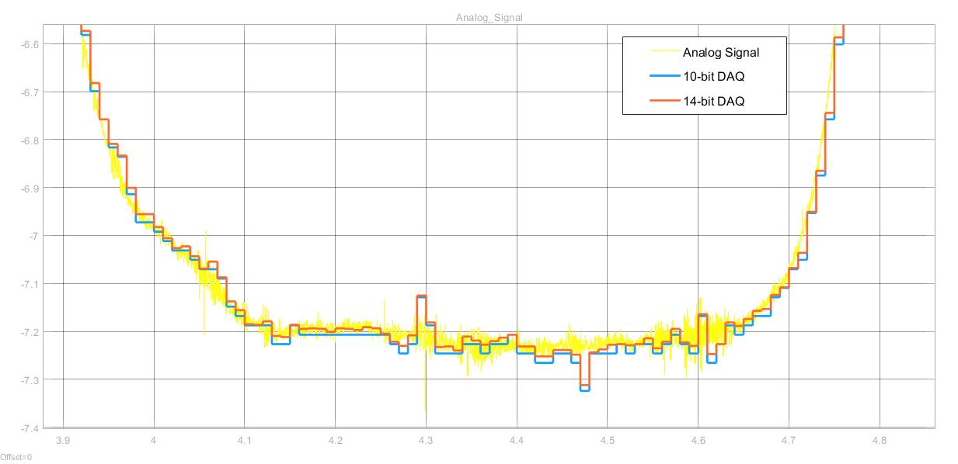

## Problem 4

To calculate the bit resolution of the In-Cylinder Pressure measurement, the minimum (non-zero) $ΔVoltage$ from one reading to another was calculated. I shifted the array by 1 and subtracted it from itself. Then,

$${ΔV}_{min}=\min\left(ΔV\left[ΔV !=0\right]\right)= 3.0500e-04$$

$$bit resolution= \log_{2}\left(\frac{V_{full scale}}{{ΔV}_{min}}\right)=\log_{2}\left(\frac{20V}{3.0500e-04}\right)=16 bit resolution$$