Margaret Schrader

Z1025295

**Exercise 1-1 Email List**

1. Start Page



1. Click on Join

3.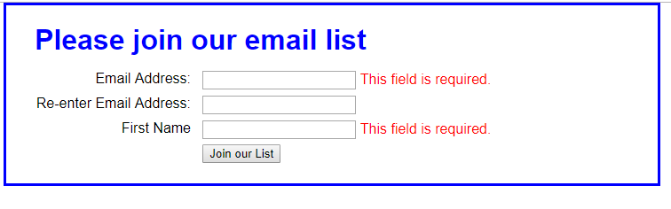

3. Input good email in first line and bad info in second line.

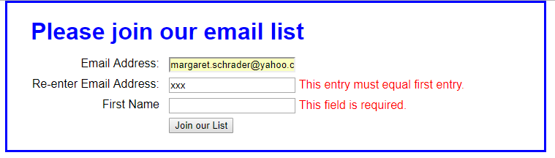

1. Input all good info and click on Join

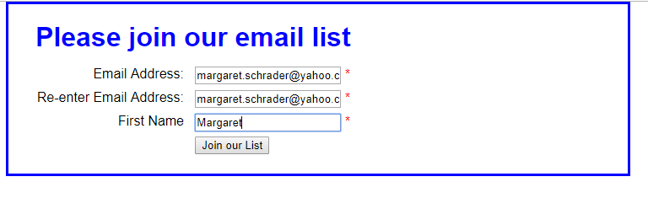

1. After Join email as added to email list

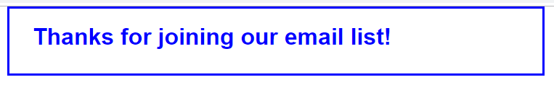

5. Click on back button and click on reload

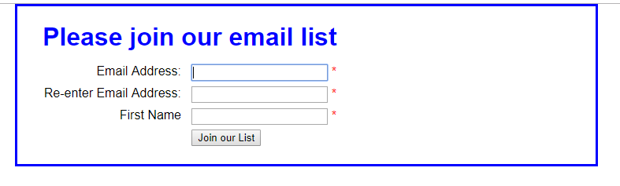

6. Enter email in 1st line

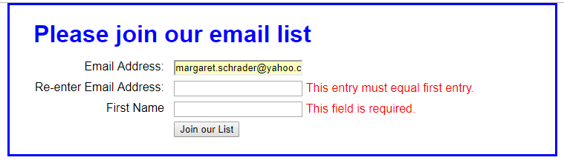

Pf12 to display console

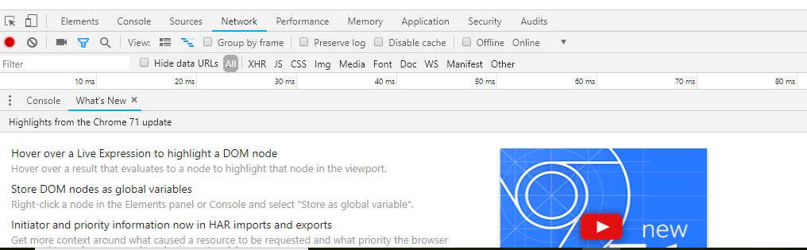

7. Click on the sources tab

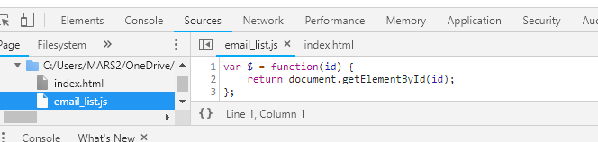

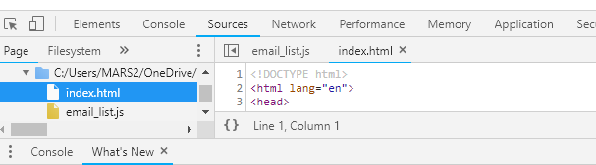

8. Click on Elements tab

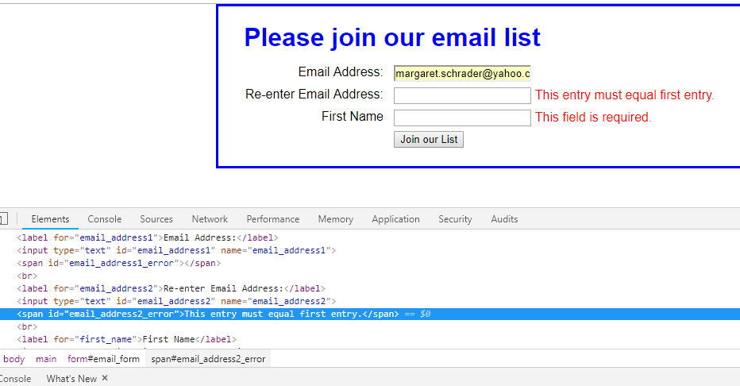

9. Pf12 tool is closed

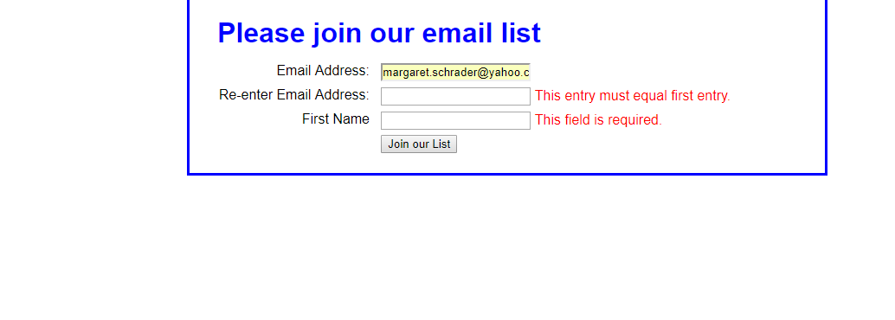

**Exercise 1-2 FAQS and SWAP**

1. Open FAQs file

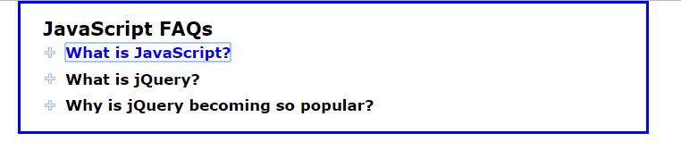

1. Click on first line and open text

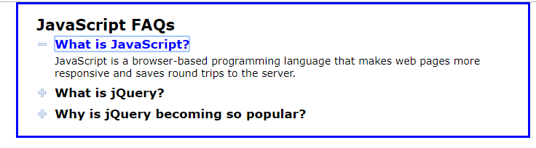

Then close text



1. Tab and open second line of text

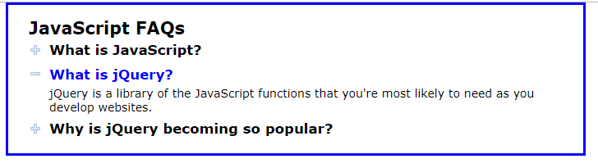

Close line

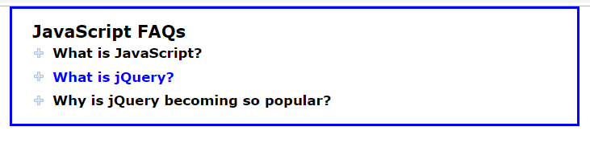

1. Open Swap file



1. Click on Second image and show



1. Click on 3rd image and show

