SEAforth download instructions

Download SEAforth.exe to the folder in which you want this to install and run it.
SEAforth.exe will self extract creating a folder SEAforth, containing t18, bios and apps.

The t18 directory contains the fixed set of tools required to support the SEAforth-24A

The bios directory contains source code that specifies the chips ROM content

The apps file contains a set of sample applications. User applications may also be put into this directory.

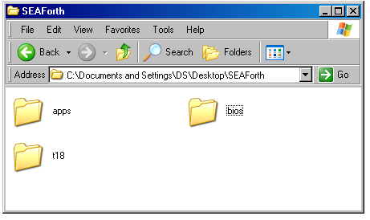

Running SEAforth
An ANSI forth compiler is required to run SEAforth. SwiftForth runs on windows only. Gforth runs on either Windows, Macintosh or Linux environments. This document only describes installation of SwiftForth and Gforth, for Windows. For installation of Gforth for the Macintosh or Linux refer to http://www.complang.tuwien.ac.at/forth/gforth/. Other ANSI forth compilers have not been tested.

Swift forth installation instructions
SwiftForth is available as either an evaluation edition or as a full licensed edition. The licensed version of SwiftForth has both cross reference and locate. The evaluation edition only has locate and has a licensing reminder at load.

SwiftForth downloads are available through the following links:

Evaluation edition: http://www.forth.com/swiftforth/trial-system.html
Enter name company and email address in to form and click submit. Your link and password will be sent via email. After download, install to the default directory “C:\Program Files\ForthInc”.

Licensed edition: http://www.forth.com/catalog/index.php?cPath=23
Install to default directory “C:\Program Files\ForthInc”

Gforth installation instructions
Gforth contains neither locate nor cross reference but may run faster depending on your system. Click on http://www.complang.tuwien.ac.at/forth/gforth/gforth-0.6.2.exe Download and run from your computer. Chose the default install directory “C:\Program Files\Gforth” and install with all defaults.

Running User Programs and Crawler
Use windows explorer to view the apps directory. Right click the main file of your program or crawler and select open with. If open with does not exist double click and skip to next step. If SwiftForth or Gforth is in the list of files select it and the simulator will start running. If neither are on the menu, click on “choose program”.

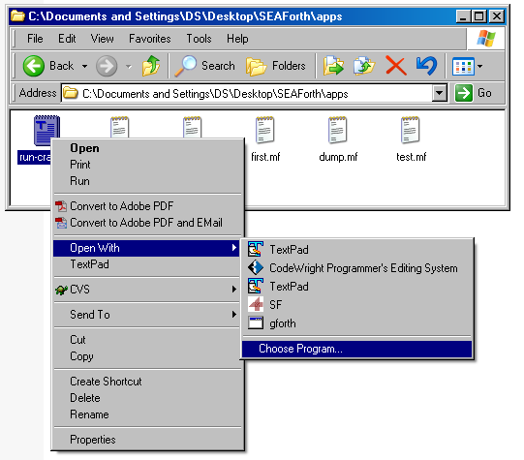

On the “Open With” screen select either SwiftForth or Gforth. If neither are present click Browse.
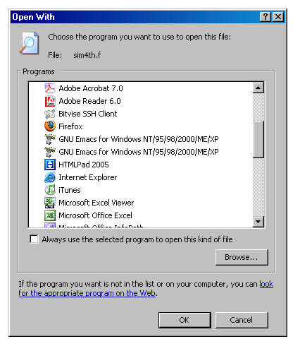

If you have SwiftForth installed Select
“C:\Program Files\ForthInc\Swiftforth\Bin\SF.EXE”
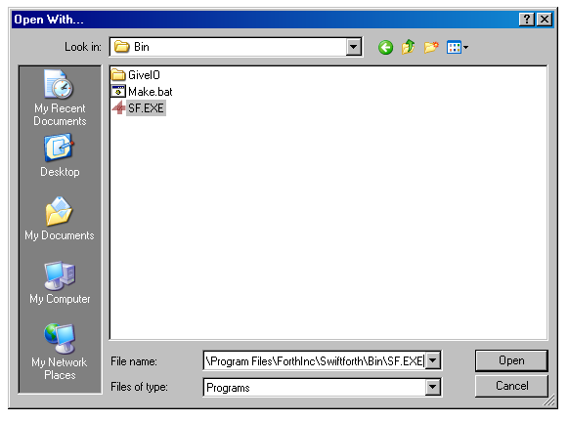

If you are using Gforth select C:\Program Files\Gforth\Gforth.exe
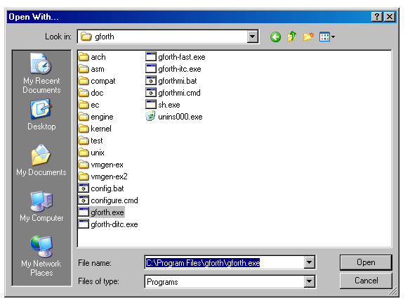
In Swift forth you can also click on File and select Include.

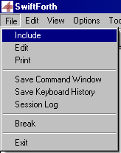

Go to the apps directory and open your file or the crawler..

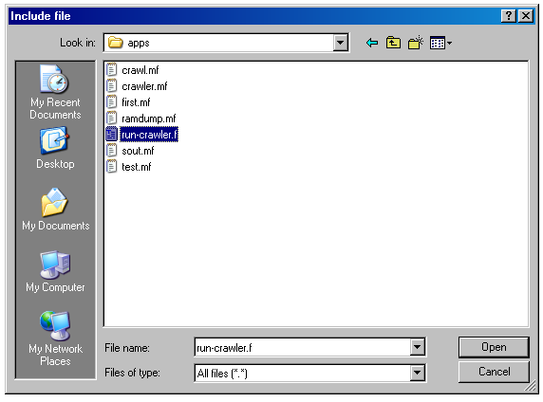

GO2D

Maximize the forth window

type go2d <ENTER>

The state of each node is displayed and the program will step each time <SPACE BAR> is pressed. Pressing <ENTER> will return to the interpreter.

In order to run a number of cycles before single stepping. Type <INTEGER> to max-cnt <ENTER>
go2d <ENTER> If max-cnt is set to 0. go2d will step and display continuously until either <SPACE BAR> or <ENTER> is pressed, after which <SPACE BAR> single steps and <ENTER> will return to the interpreter.

Each node is represented by its own block. All active nodes are in red and sleeping nodes are in black. At start-up all nodes are active.
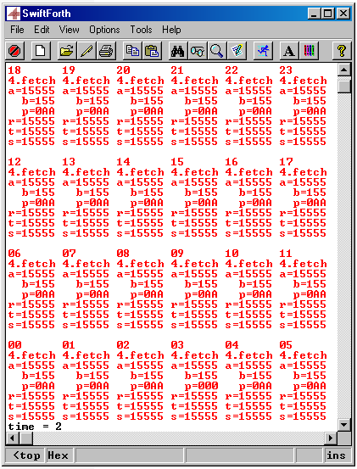
“time ” represents the count, in cycles, since boot. Count is represented in decimal.

Anatomy of Multi Node Status Displays

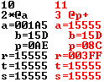
Node number is represented in decimal. All other numbers are represented in hex.
For each node the contents of registers a, b p, r, t and s are shown.
Operation that is about to execute. All registers show contents prior to execution.
Slot of next operation.
Active

Sleeping

Program counter is post-incremented. and advanced by any literal accesses.

.ADRS

To view the contents of location $8C in ram on node 11 type

decimal
11 node! <ENTER>
hex
$8C 4 .adrs <ENTER>

