ASSIGNMENT 4: Practice 4-1: Using Conversion Functions

1) Create a report that produces the following for each employee: <employee last name> earns <salary> monthly but wants <3 times salary.>. Label the column Dream Salaries.

SELECT last_name || ' earns ' || TO_Char( salary, 'fm$99,999.00')

|| ' monthly but wants ' || TO_CHAR(salary * 3, 'fm$99,999.00') || '.' "Dream Salaries"

FROM EMPLOYEES;

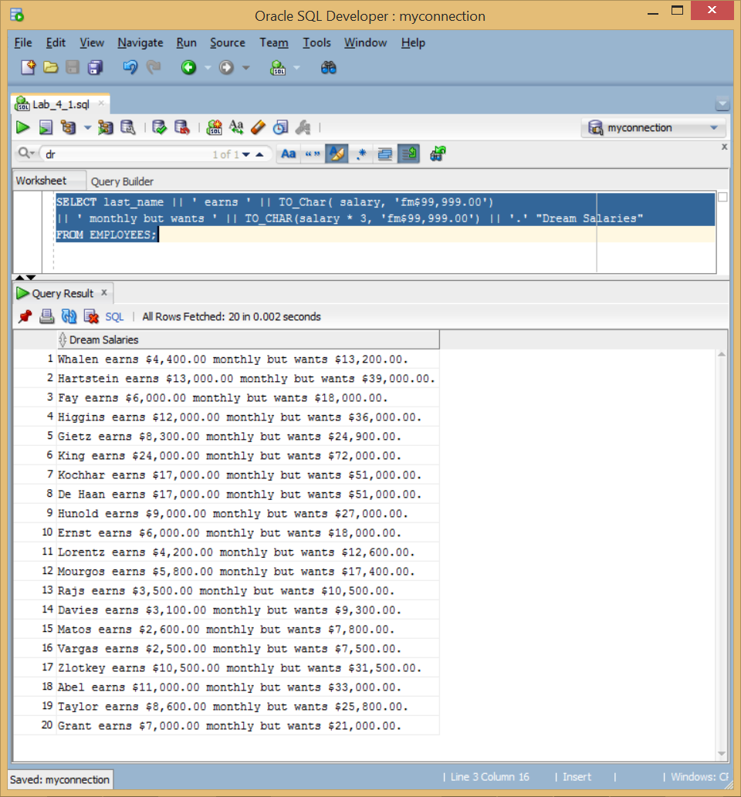

2) Display each employee’s last name, hire date, and salary review date, which is the first Monday after six months of service. Label the column REVIEW. Format the dates to appear in the format similar to “Monday, the Thirty-First of July, 2000.”

SELECT LAST_NAME, HIRE_DATE,

TO_CHAR(NEXT_DAY(ADD_MONTHS(hire_date, 6),'MONDAY'),'fmDay, "the" Ddspth "of" Month, YYYY') "REVIEW"

FROM EMPLOYEES;

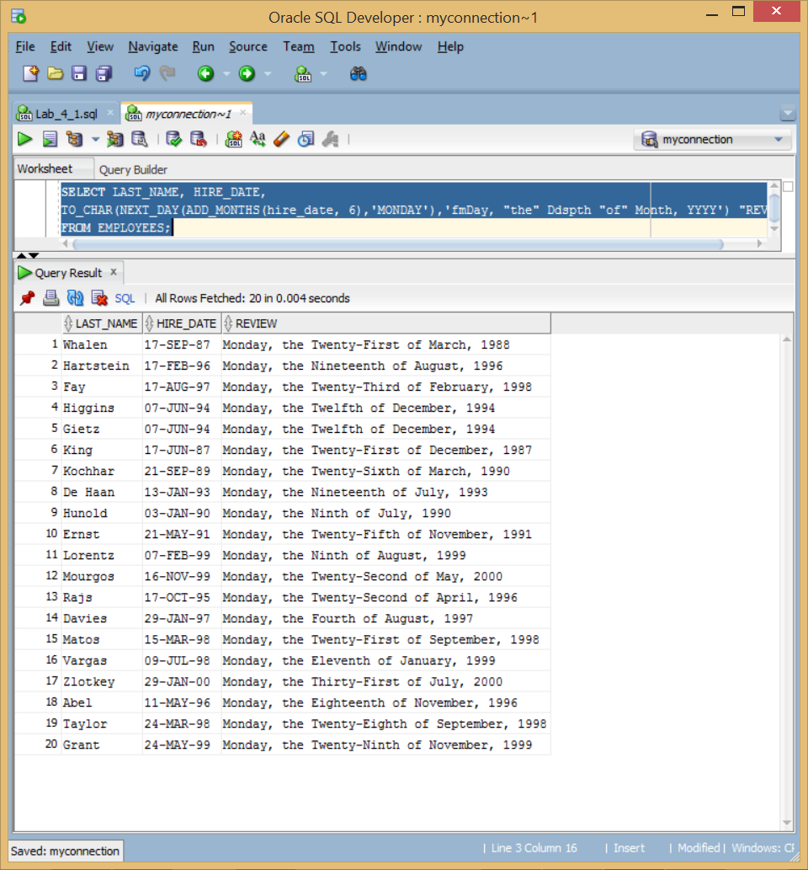

3) Display the last name, hire date, and day of the week on which the employee started. Label the column DAY. Order the results by the day of the week, starting with Monday.

SELECT LAST_NAME, HIRE_DATE, TO_CHAR(HIRE_DATE,'day') "DAY"

FROM EMPLOYEES

ORDER BY TO_CHAR(HIRE_DATE -1, 'd');

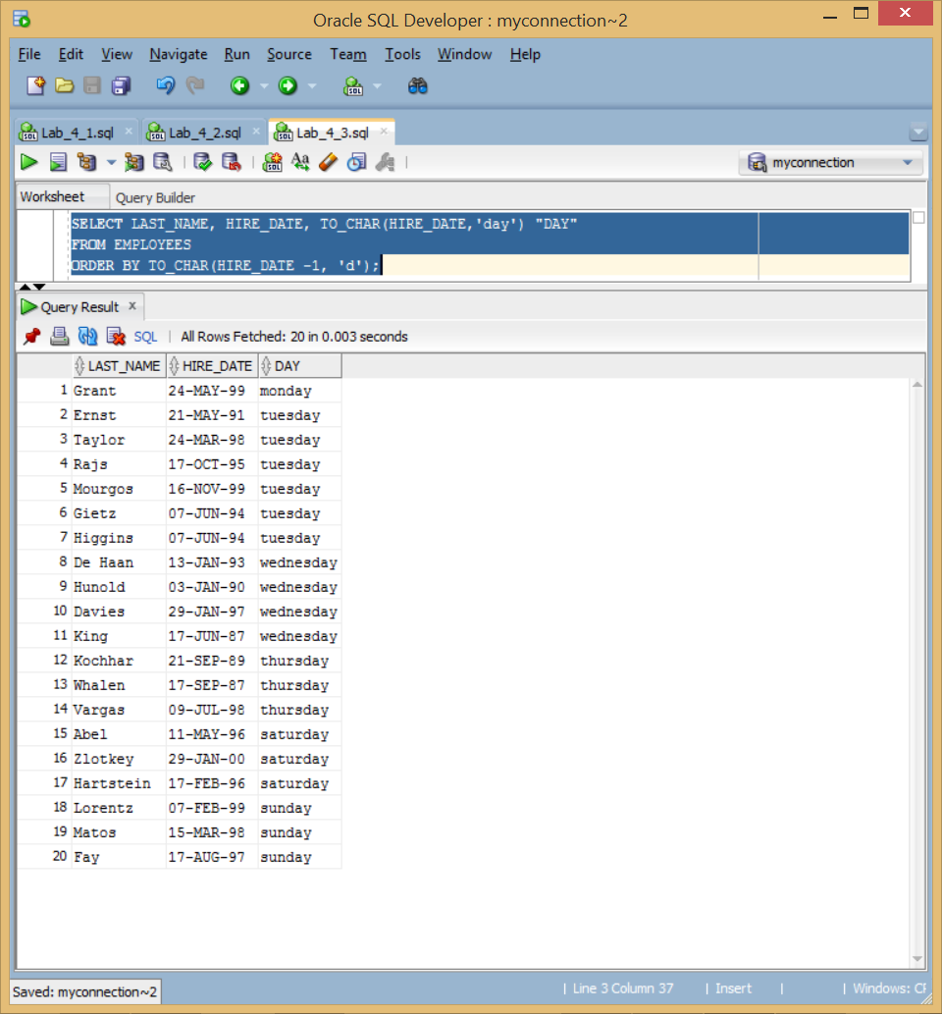

4) Create a query that displays the employees’ last names and commission amounts. If an employee does not earn commission, show “No Commission.” Label the column COMM.

SELECT LAST_NAME, NVL(TO_CHAR(commission_pct),'No Commission') "COMM"

FROM EMPLOYEES;

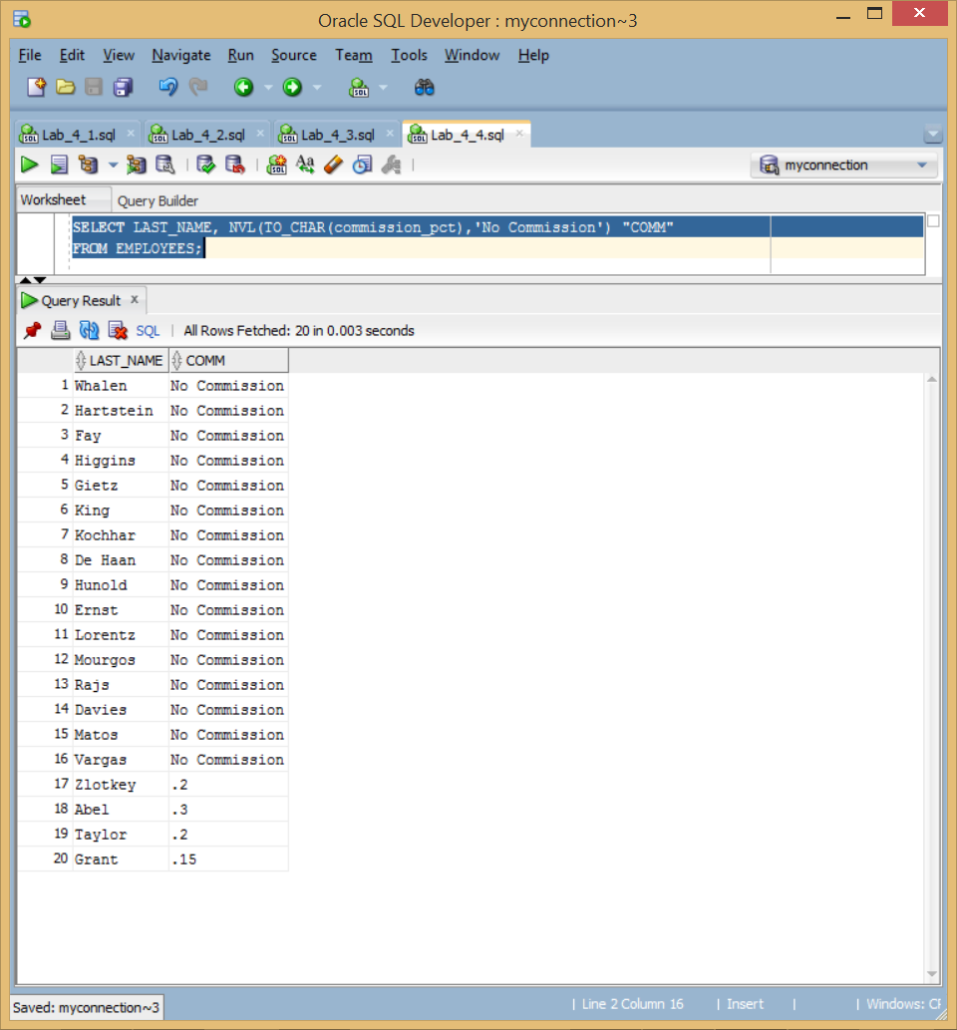

5) Using the DECODE function, write a query that displays the grade of all employees based on the value of the column JOB_ID, using the following data:

Job Grade

AD_PRES A

ST_MAN B IT_PROG C

SA_REP D

ST_CLERK E

None of the above 0

SELECT JOB_ID, DECODE(JOB_ID,

'AD_PRES', 'A','ST_MAN', 'B', 'IT_PROG', 'C', 'SA_REP', 'D', 'ST_CLERK', 'E', '0') "GRADE"

FROM EMPLOYEES;

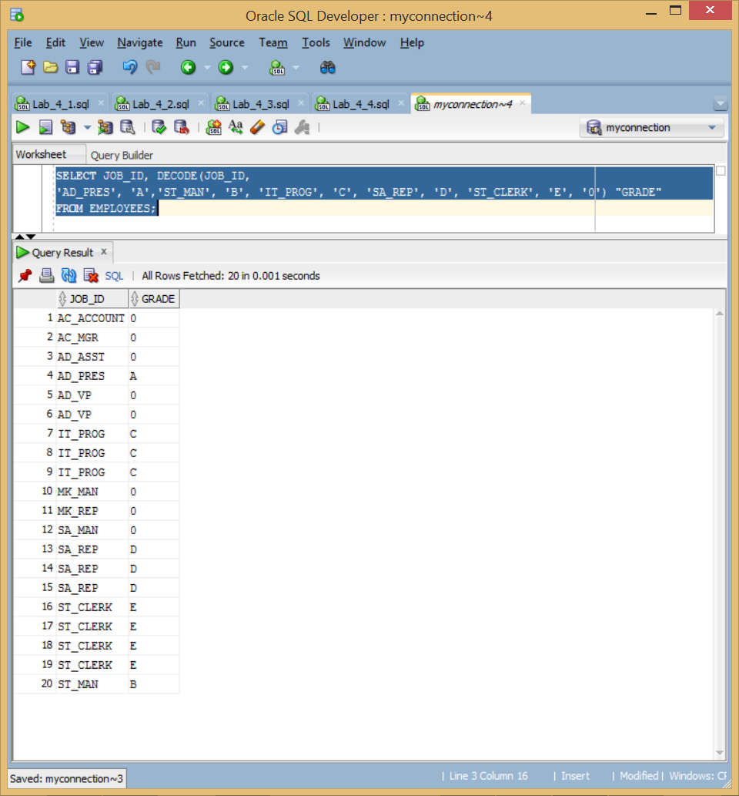

6) Rewrite the statement in the preceding exercise by using the CASE syntax.

SELECT JOB_ID, CASE JOB_ID

WHEN 'AD_PRES' THEN 'A'

WHEN 'ST_MAN' THEN 'B'

WHEN 'IT_PROG' THEN 'C'

WHEN 'SA_REP' THEN 'D'

WHEN'ST_CLERK' THEN 'E'

ELSE '0' END "GRADE"

FROM EMPLOYEES;

