1) Group functions work across many rows to produce one result per group.

**True**

2) Group functions include nulls in calculations.

**False**

3) The WHERE clause restricts rows before inclusion in a group calculation.

**True**

4) Find the highest, lowest, sum, and average salary of all employees. Label the columns Maximum, Minimum, Sum, and Average, respectively. Round your results to the nearest whole number. Save your SQL statement as lab_05_04.sql. Run the query.

SELECT ROUND(MAX(salary),0) "Maximum", ROUND(MIN(salary),0) "Minimum",

ROUND(SUM(salary),0) "Sum", ROUND(AVG(SALARY),0) "Average"

FROM EMPLOYEES;

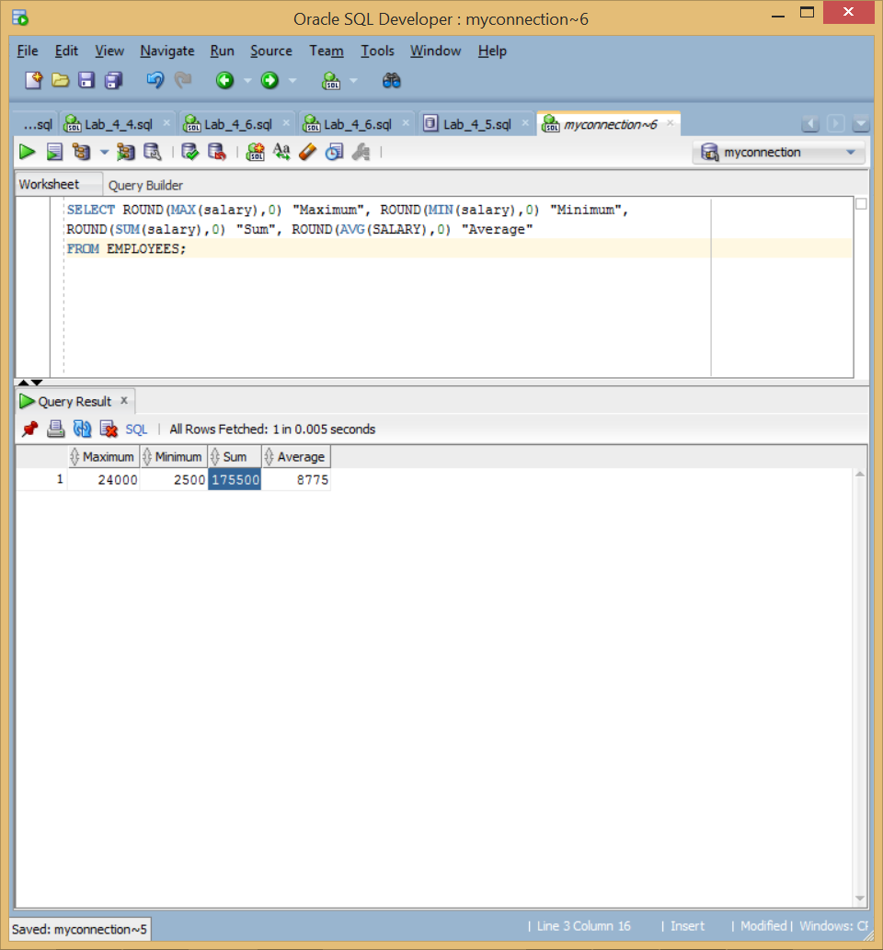

5) Modify the query in lab_05_04.sql to display the minimum, maximum, sum, and average salary for each job type. Save lab_05_04.sql as lab_05_05.sql again. Run the statement in lab_05_05.sql.

SELECT JOB_ID,

ROUND(MAX(salary),0) "Maximum", ROUND(MIN(salary),0) "Minimum",

ROUND(SUM(salary),0) "Sum", ROUND(AVG(SALARY),0) "Average"

FROM EMPLOYEES

Group BY JOB_ID;

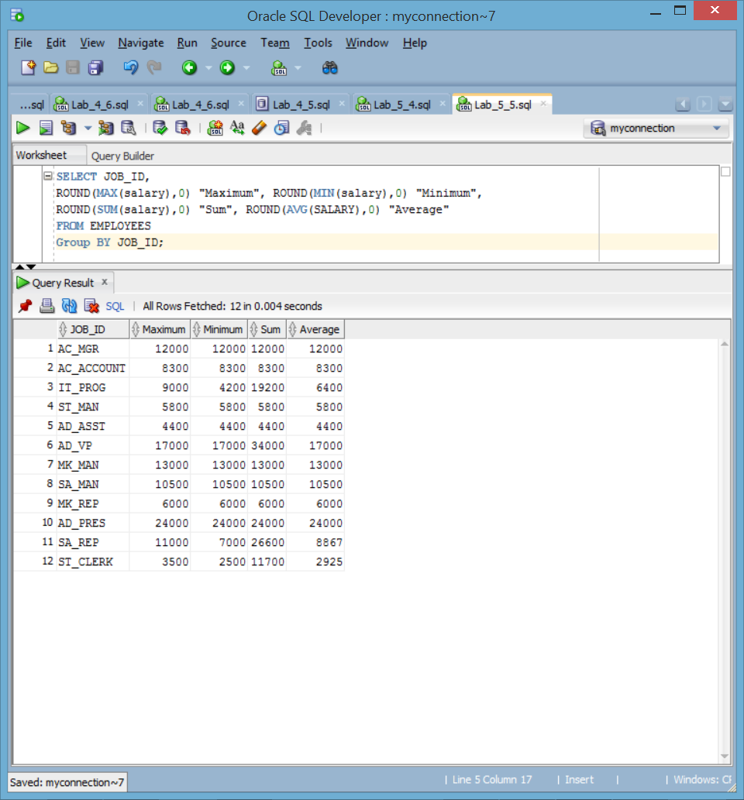

6) Write a query to display the number of people with the same job.

SELECT JOB_ID, COUNT( JOB_ID )

FROM EMPLOYEES

Group BY JOB_ID;

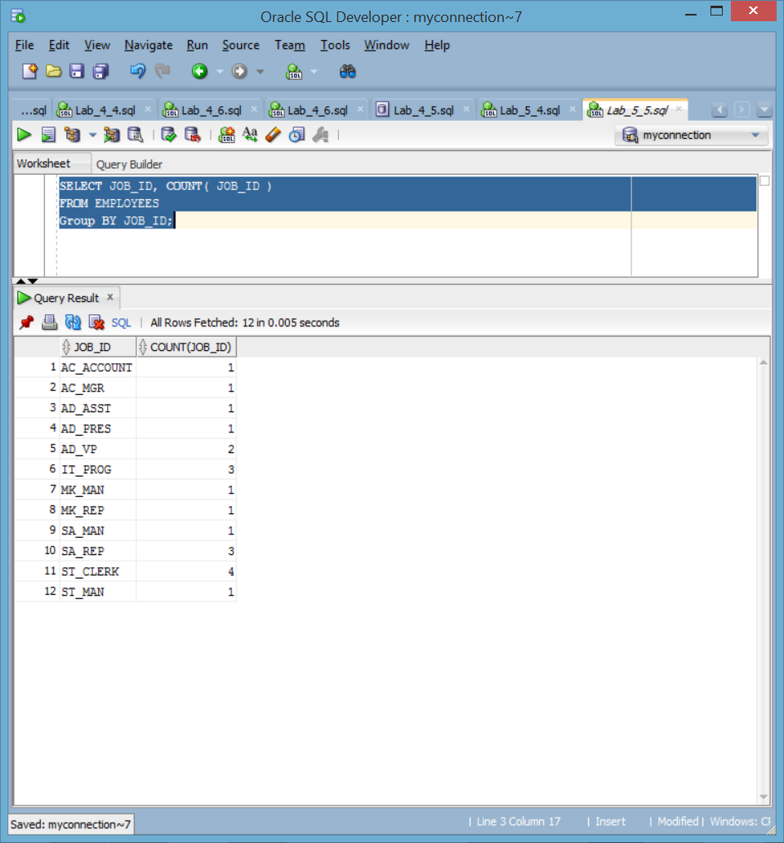

Generalize the query so that the user in the HR department is prompted for a job title. Save the script to a file named lab_05_06.sql. Run the query. Enter IT_PROG when prompted.

SELECT JOB_ID, COUNT( JOB_ID )

FROM EMPLOYEES

WHERE JOB_ID = '&Job_ID'

Group BY JOB_ID;

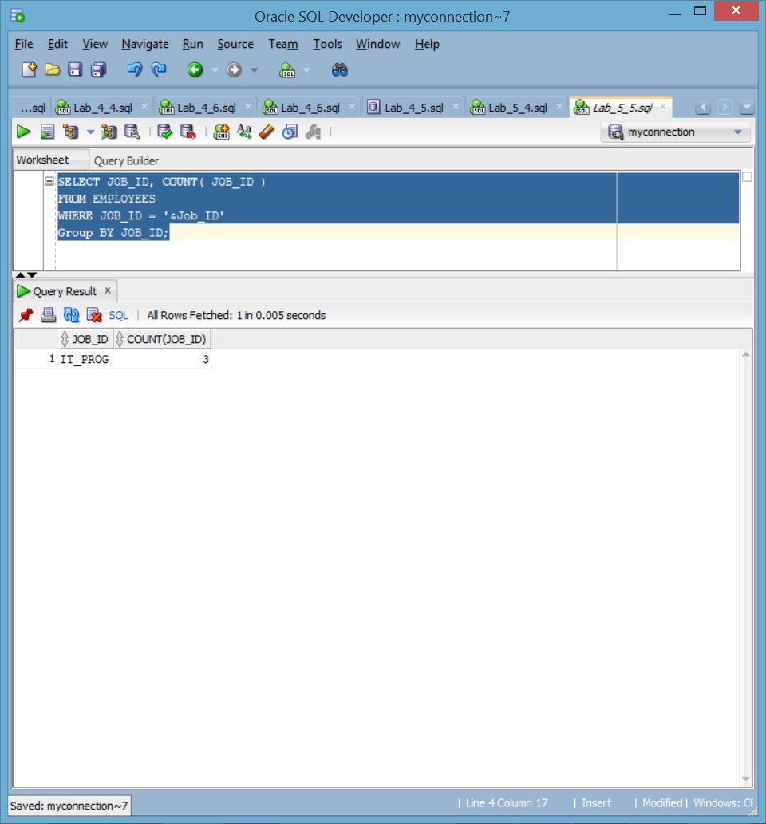

7) Determine the number of managers without listing them. Label the column Number of Managers . Hint: Use the MANAGER_ID column to determine the number of managers.

SELECT COUNT(DISTINCT(MANAGER_ID))"Number of Managers"

FROM EMPLOYEES;

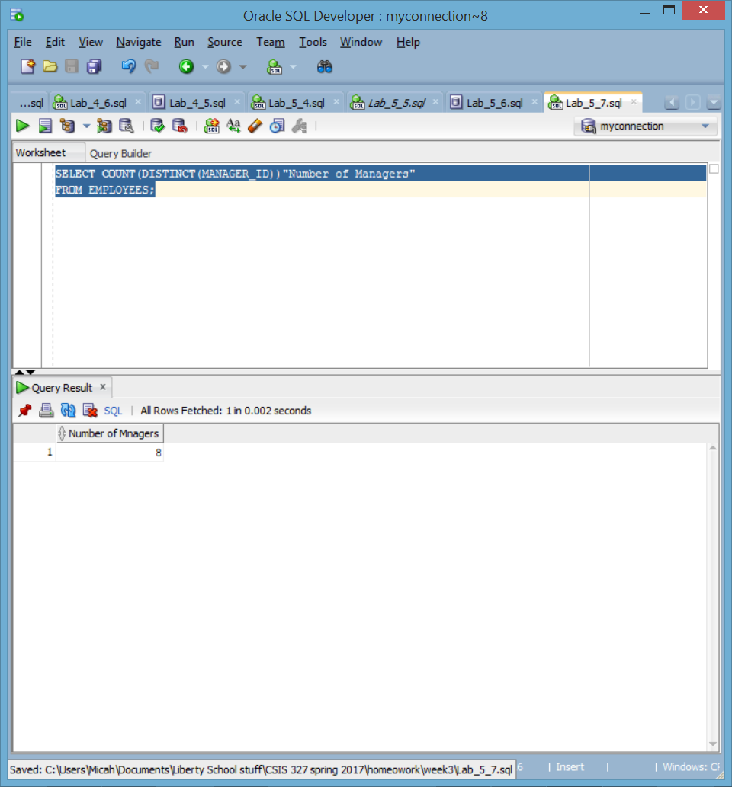

8) Find the difference between the highest and lowest salaries. Label the column DIFFERENCE.

SELECT MAX(salary) - MIN(salary) DIFERENCE

FROM EMPLOYEES;

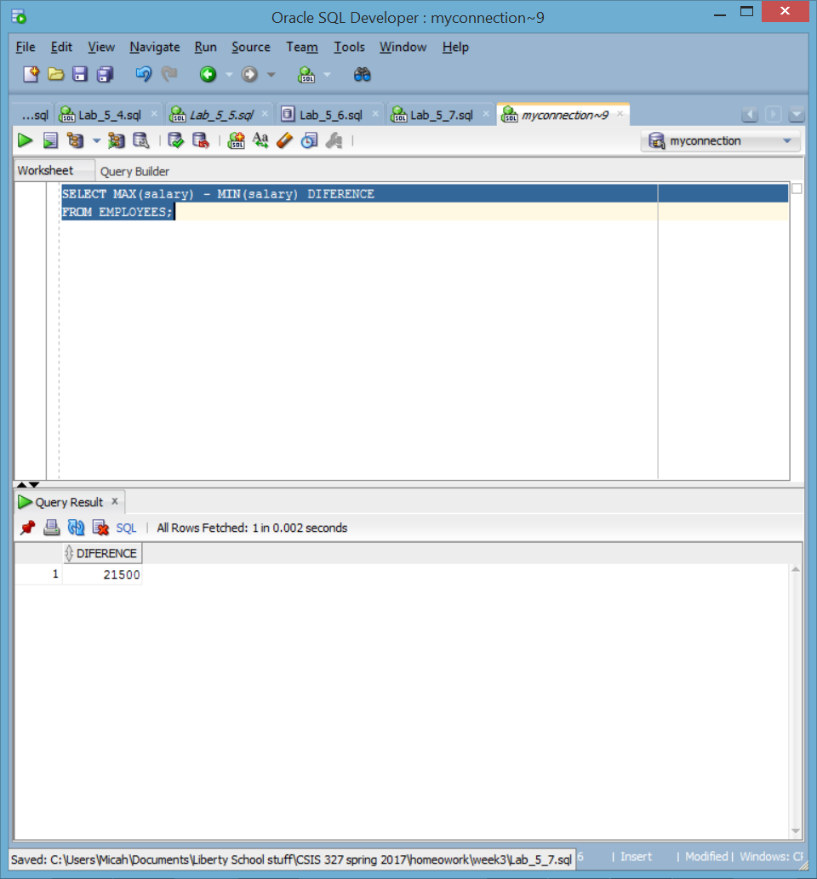

9) Create a report to display the manager number and the salary of the lowest-paid employee for that manager. Exclude anyone whose manager is not known. Exclude any groups where the minimum salary is $6,000 or less. Sort the output in descending order of salary.

SELECT manager_id, MIN(salary)

from EMPLOYEES

where MANAGER_ID is not null

GROUP BY MANAGER_ID

HAVING MIN(salary) > 6000

ORDER BY min(SALARY) DESC;

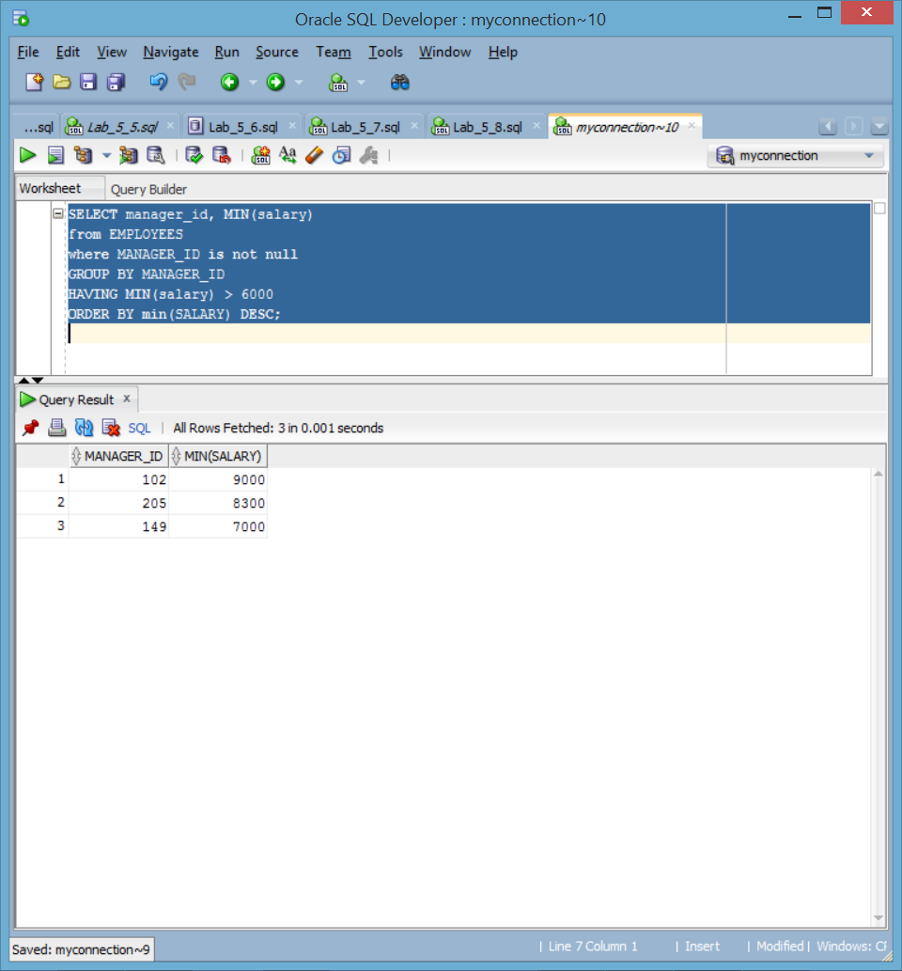

10) Create a query to display the total number of employees and, of that total, the number of employees hired in 1995, 1996, 1997, and 1998. Create appropriate column headings.

SELECT COUNT(*),

SUM(DECODE(TO_CHAR(hire_date, 'YYYY'),1995,1,0))"1995",

SUM(DECODE(TO_CHAR(hire_date, 'YYYY'),1996,1,0))"1996",

SUM(DECODE(TO_CHAR(hire_date, 'YYYY'),1997,1,0))"1997",

SUM(DECODE(TO_CHAR(hire_date, 'YYYY'),1998,1,0))"1998"

FROM EMPLOYEES;

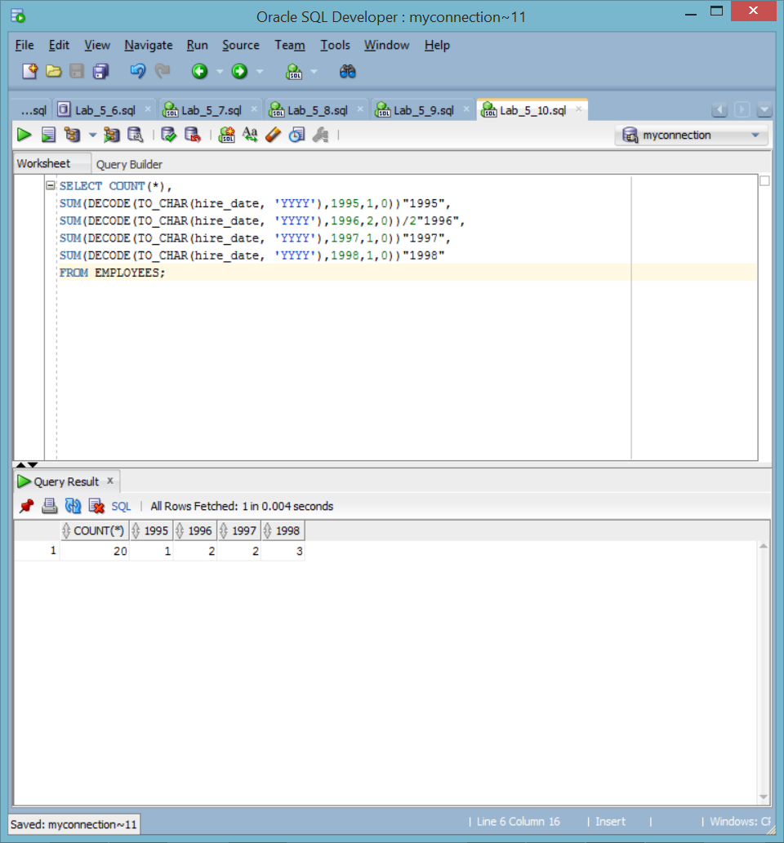

11) Create a matrix query to display the job, the salary for that job based on department number, and the total salary for that job, for departments 20, 50, 80, and 90, giving each column an appropriate heading.

SELECT job_id "Job",

SUM(DECODE(department_id , 20, salary)) "Department 20",

SUM(DECODE(department_id , 50, salary)) "Department 50",

SUM(DECODE(department_id , 80, salary)) "Department 80",

SUM(DECODE(department_id , 90, salary)) "Department 90",

SUM(salary) "Total"

FROM employees

GROUP BY job_id;

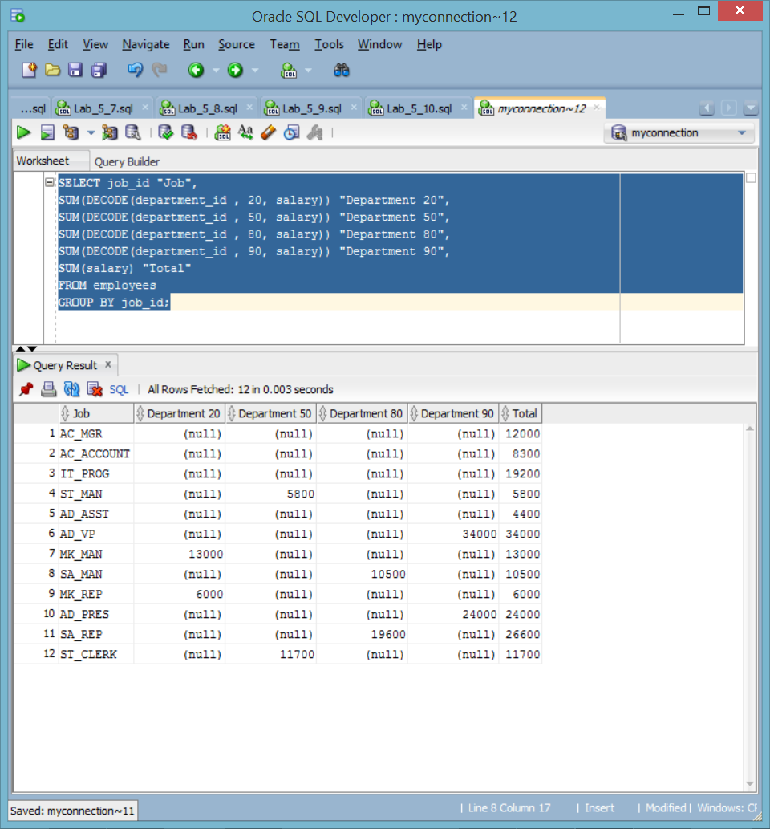

12) Create a query to display the salary of each employee and the subsequent minimum and maximum salary for their position.

SELECT e.FIRST_NAME, e.LAST_NAME, j.JOB_TITLE, e.SALARY ,j.MIN_SALARY, j.MAX_SALARY

FROM EMPLOYEES e join JOBs j on e.JOB_ID = j.JOB_ID

order by e.LAST_NAME;

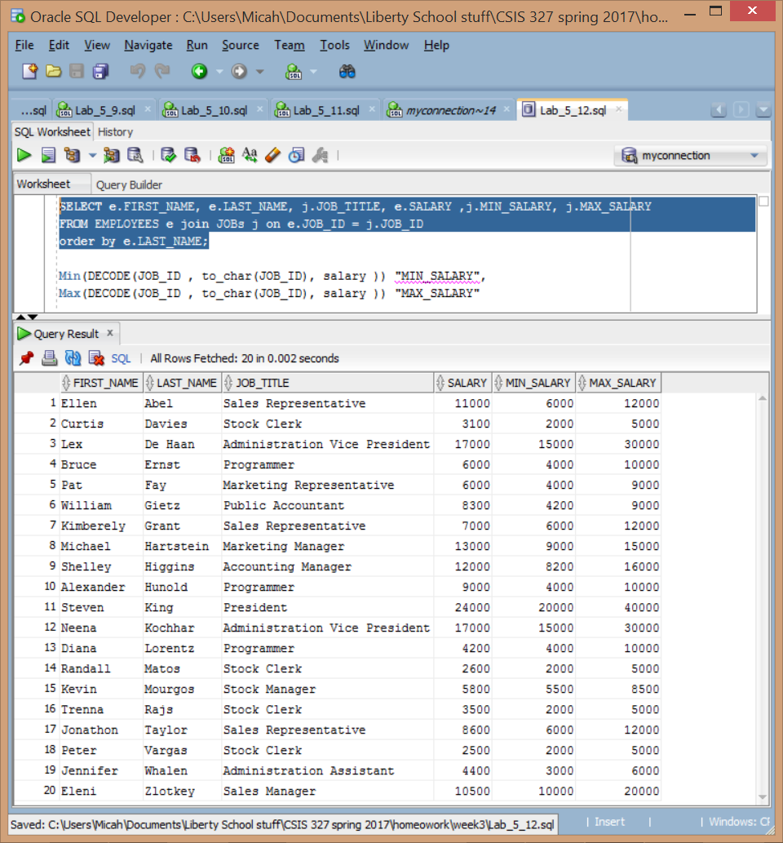

13) Using your own version, create a matrix query that shows whether an employee’s salary is within the job title range that they occupy. The output should have at least one column named “Within range” that displays a “yes” or “no” to depict whether the employee’s salary is within the range.

SELECT e.FIRST_NAME, e.LAST_NAME, j.JOB_TITLE, e.SALARY ,j.MIN_SALARY, j.MAX_SALARY,

CASE WHEN e.salary BETWEEN j.MIN_SALARY and j.MAX_SALARY THEN 'yes'

ELSE 'no' END Within_range

FROM EMPLOYEES e join JOBs j on e.JOB_ID = j.JOB_ID

order by e.LAST_NAME;

