1) The HR department needs a query that prompts the user for an employee last name. The query then displays the last name and hire date of any employee in the same department as the employee whose name they supply (excluding that employee). For example, if the user enters Zlotkey, find all employees who work with Zlotkey (excluding Zlotkey).

**UNDEFINE name**

**SELECT last_name, hire_date**

**FROM employees**

**WHERE department_id = (SELECT department_id**

**FROM employees**

**WHERE last_name = '&&name')**

**AND last_name != '&name';**

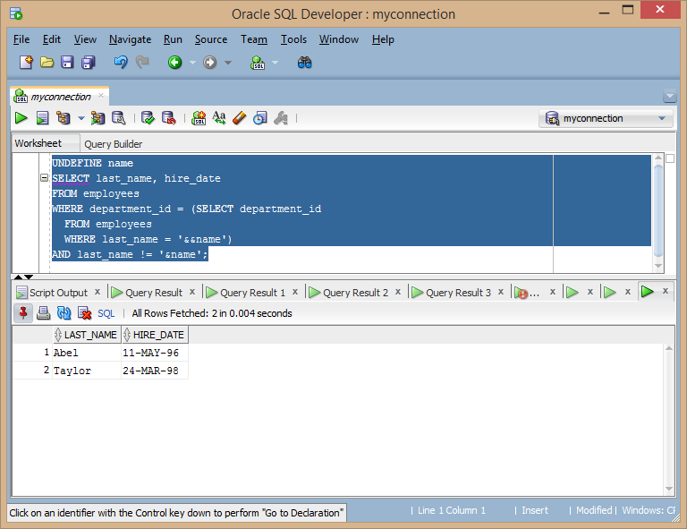

2) Create a report that displays the employee number, last name, and salary of all employees who earn more than the average salary. Sort the results in order of ascending salary.

**Select EMPLOYEE_ID, LAST_NAME, SALARY**

**from EMPLOYEES**

**where SALARY > (SELECT AVG(SALARY) FROM EMPLOYEES)**

**order by SALARY ASC;**

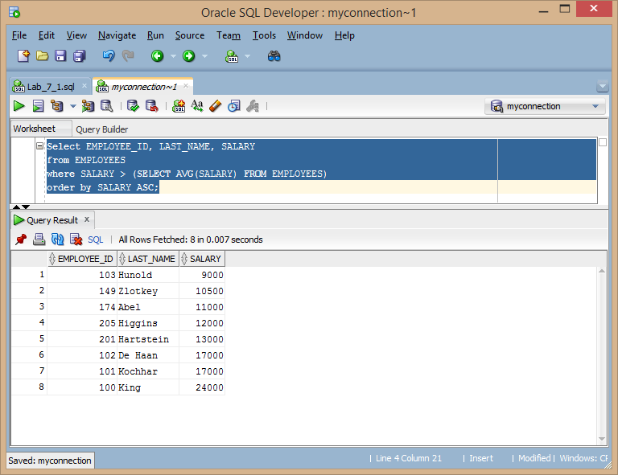

3) Write a query that displays the employee number and last name of all employees who work in a department with any employee whose last name contains the letter “u.” Save your SQL statement as lab_07_03.sql. Run your query.

**SELECT EMPLOYEE_ID, LAST_NAME**

**FROM EMPLOYEES**

**where DEPARTMENT_ID in**

**(SELECT DEPARTMENT_ID from EMPLOYEES WHERE LAST_NAME like '%u%');**

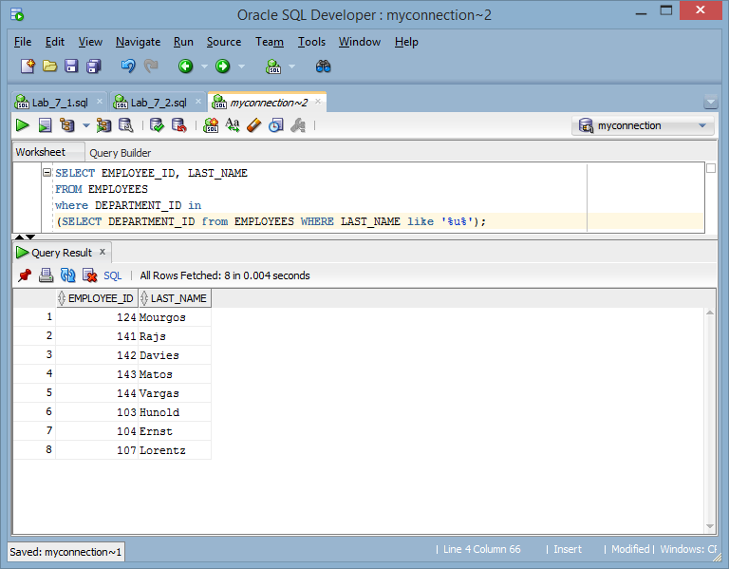

4) The HR department needs a report that displays the last name, department number, and job ID of all employees whose department location ID is 1700.

**SELECT e.LAST_NAME, e.DEPARTMENT_ID, e.JOB_ID**

**FROM EMPLOYEES e join DEPARTMENTS d on e.DEPARTMENT_ID = d.DEPARTMENT_ID**

**where d.LOCATION_ID = '1700';**

Modify the query so that the user is prompted for a location ID. Save this to a file named lab_07_04.sql.

**SELECT e.LAST_NAME, e.DEPARTMENT_ID, e.JOB_ID**

**FROM EMPLOYEES e join DEPARTMENTS d on e.DEPARTMENT_ID = d.DEPARTMENT_ID**

**where d.LOCATION_ID = '&Department';**

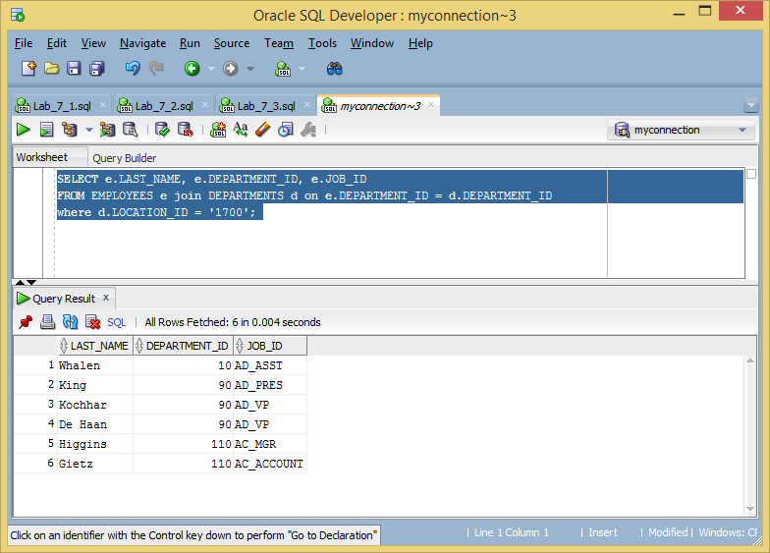

5) Create a report for HR that displays the last name and salary of every employee who reports to King.

**SELECT LAST_NAME, SALARY**

**FROM EMPLOYEES**

**WHERE MANAGER_ID = (SELECT EMPLOYEE_ID**

**from EMPLOYEES where LAST_NAME = 'King');**

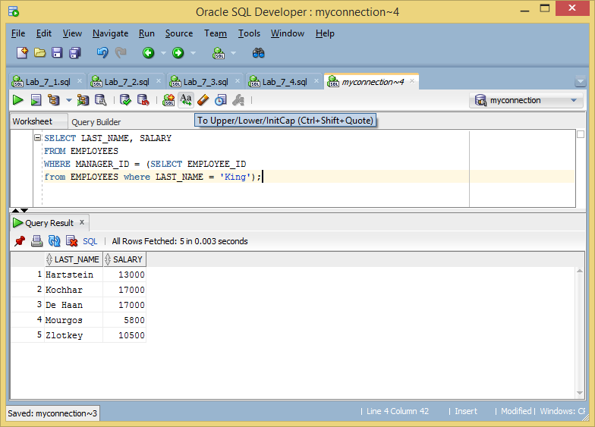

6) Create a report for HR that displays the department number, last name, and job ID for every employee in the Executive department.

**SELECT DEPARTMENT_ID, LAST_NAME, JOB_ID**

**FROM EMPLOYEES**

**WHERE DEPARTMENT_ID in**

**(SELECT DEPARTMENT_ID FROM DEPARTMENTS**

**WHERE DEPARTMENT_NAME = 'Executive');**

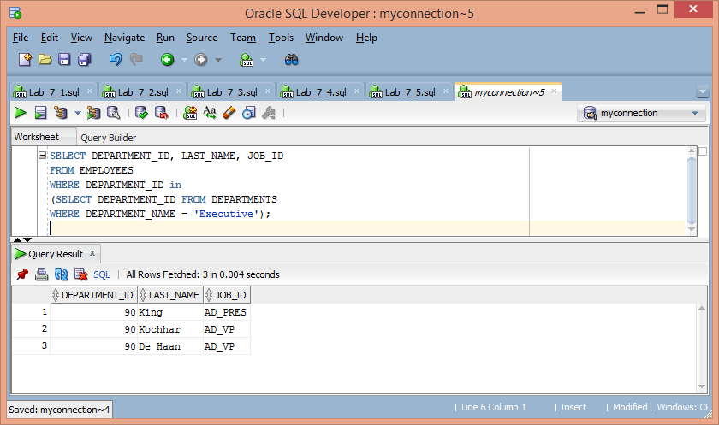

7) Create a report that displays a list of all employees whose salary is more than the salary of any employee from department 60.

**SELECT LAST_NAME, SALARY**

**FROM EMPLOYEES**

**WHERE SALARY > ANY (SELECT SALARY from EMPLOYEES WHERE department_id = 60);**

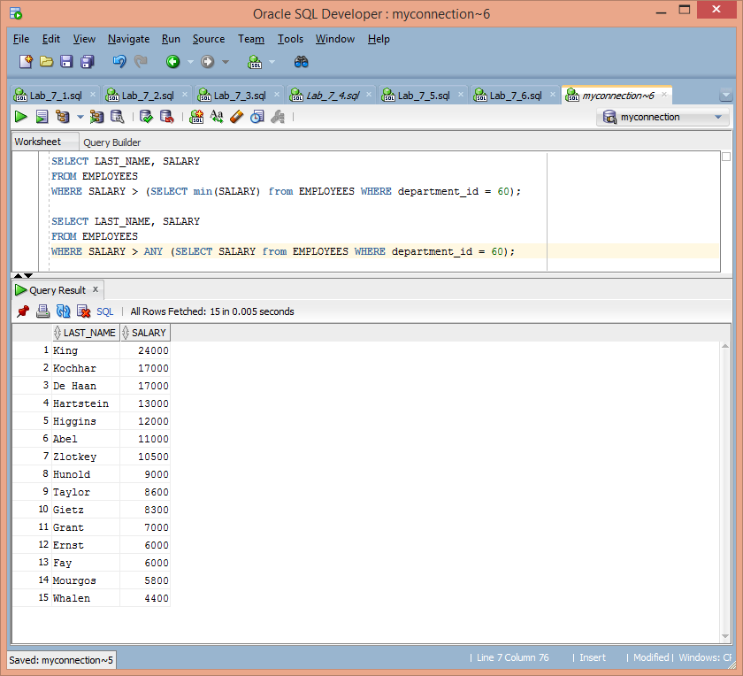

8) Modify the query in lab_07_03.sql to display the employee number, last name, and salary of all employees who earn more than the average salary, and who work in a department with any employee whose last name contains a “u.” Save lab_07_03.sql as lab_07_08.sql again. Run the statement in lab_07_08.sql.

**SELECT EMPLOYEE_ID, LAST_NAME, SALARY**

**FROM EMPLOYEES**

**where DEPARTMENT_ID in**

**(SELECT DEPARTMENT_ID from EMPLOYEES WHERE LAST_NAME like '%u%')**

**AND SALARY > (SELECT AVG(SALARY) from EMPLOYEES);**

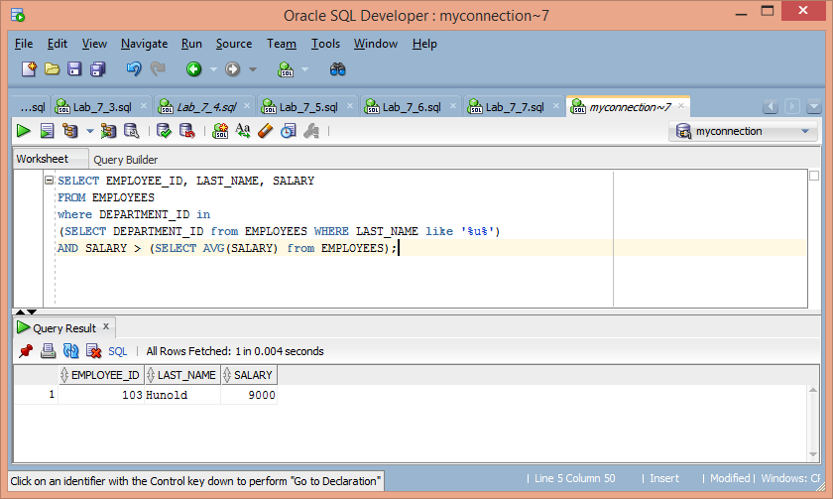

9) What are the primary properties of subqueries? When are subqueries necessary as opposed to alternative query approaches?

**A subquery is a query nested inside another query. Subqueries can be necessary when the tables in question do not necessarily have a direct relationship.**

10) Using justification of a viable business report, create two (2) useful subqueries using the minimum entities of regions, countries, locations, and departments. Provide two (2) screenshots that depict each subquery.

**Select COUNT(LOCATION_ID) "locations not in us"**

**FROM locations**

**WHERE COUNTRY_ID = any (SELECT COUNTRY_ID from countries**

**WHERE COUNTRY_NAME != 'United States of America');**

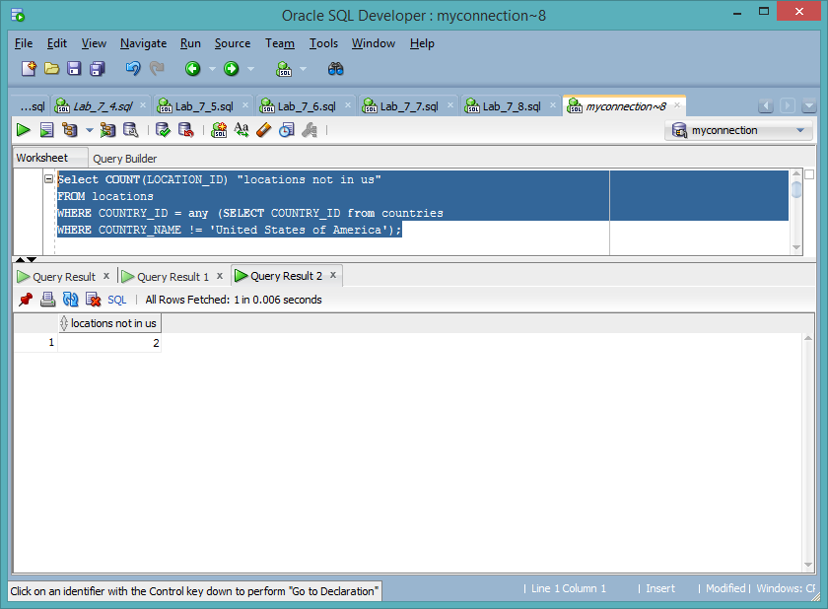

**SELECT DEPARTMENT_NAME "Departments not in the US"**

**FROM DEPARTMENTS**

**WHERE LOCATION_ID = any**

**(SELECT LOCATION_ID FROM LOCATIONS**

**WHERE COUNTRY_ID = any**

**(SELECT COUNTRY_ID FROM COUNTRIES**

**WHERE country_name != 'United States of America'));**

