The HR department wants you to create SQL statements to insert, update, and delete employee data. As a prototype, you use the MY_EMPLOYEE table before giving the statements to the HR department.

1) Run the statement in the lab_09_01.sql script to build the MY_EMPLOYEE table used in this practice.

**CREATE TABLE my_employee**

**(id NUMBER(4) CONSTRAINT my_employee_id_nn NOT NULL,**

**last_name VARCHAR2(25),**

**first_name VARCHAR2(25),**

**userid VARCHAR2(8),**

**salary NUMBER(9,2));**

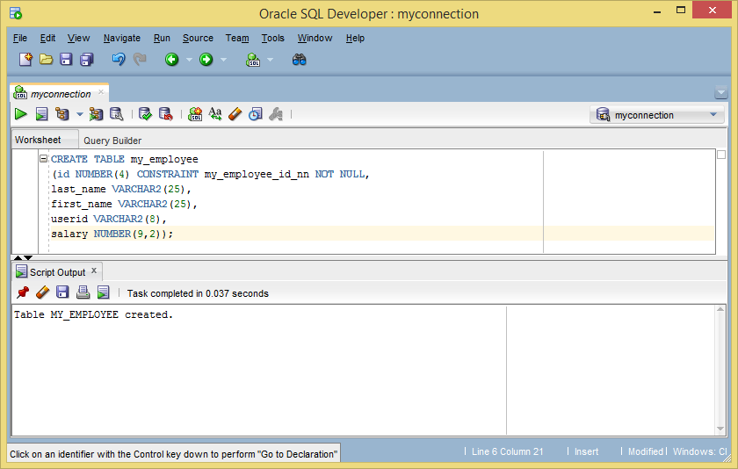

2) Describe the structure of the MY_EMPLOYEE table to identify the column names.

**DESCRIBE my_employee;**

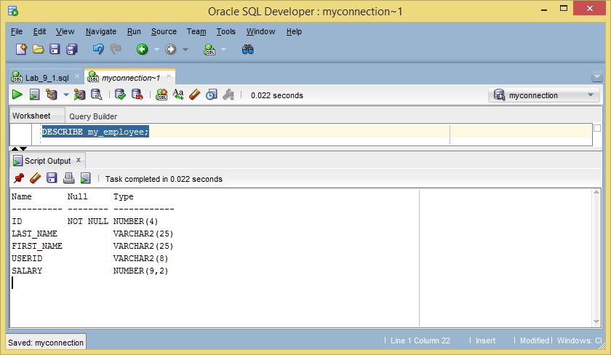

3) Create an INSERT statement to add the first row of data to the MY_EMPLOYEE table from the following sample data. Do not list the columns in the INSERT clause. Do not enter all rows yet.

**INSERT INTO my_employee**

**VALUES (1, 'Patel', 'Ralph', 'rpatel', 895);**

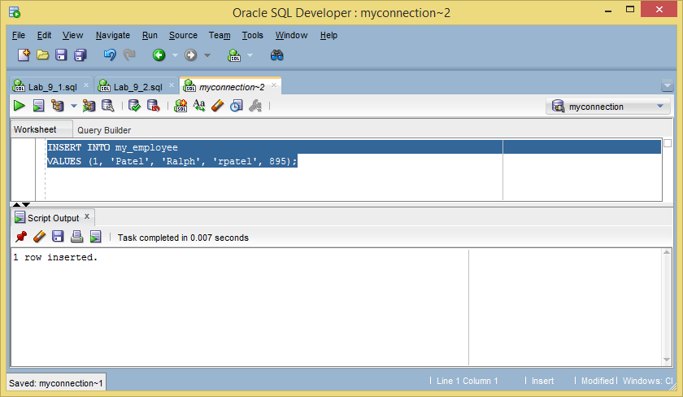

4) Populate the MY_EMPLOYEE table with the second row of the sample data from the preceding list. This time, list the columns explicitly in the INSERT clause.

**INSERT INTO my_employee (id, last_name, first_name, userid, salary)**

**VALUES (2, 'Dancs', 'Betty', 'bdancs', 860);**

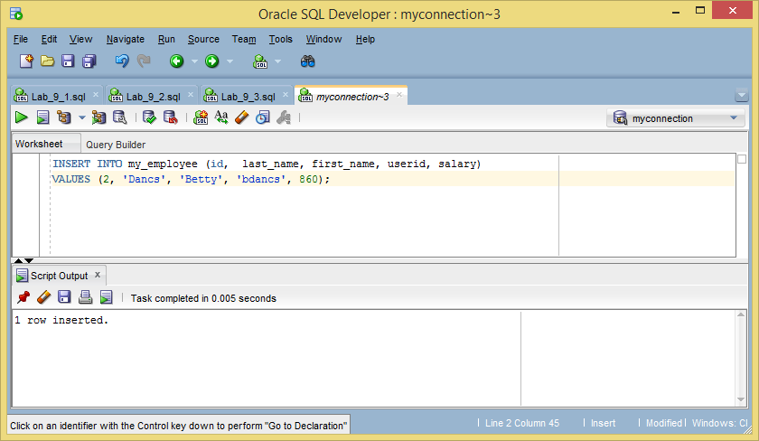

5) Confirm your addition to the table.

**SELECT * FROM my_employee;**

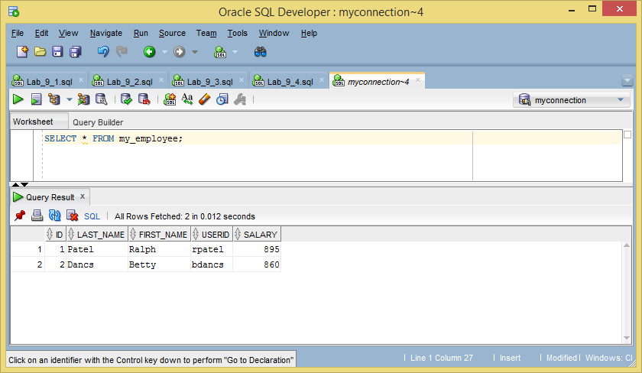

6) Write an INSERT statement in a dynamic reusable script file to load the remaining rows into the MY_EMPLOYEE table. The script should prompt for all the columns (ID, LAST_NAME, FIRST_NAME, USERID, and SALARY). Save this script to a lab_09_06.sql file.

**INSERT INTO my_employee (id, last_name, first_name, userid, salary)**

**VALUES (&id, '&last_name', '&first_name', '&userid', &salary);**

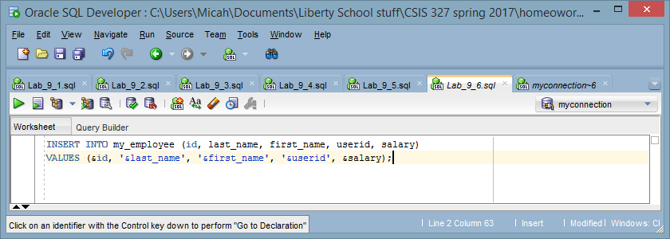

7) Populate the table with the next two rows of the sample data listed in step 3 by running the INSERT statement in the script that you created.

**INSERT INTO my_employee (id, last_name, first_name, userid, salary)**

**VALUES (&id, '&last_name', '&first_name', '&userid', &salary);**

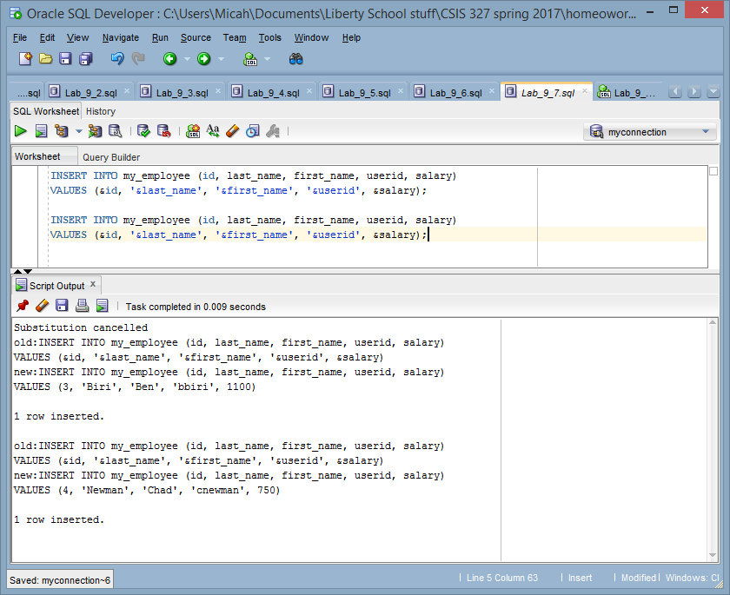

8) Confirm your additions to the table.

**SELECT * FROM my_employee;**

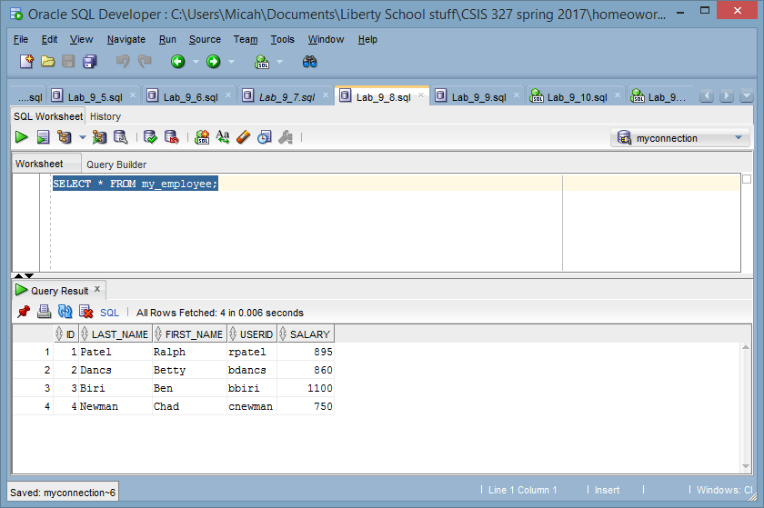

9) Make the data additions permanent. Update and delete data in the MY_EMPLOYEE table.

**COMMIT;**

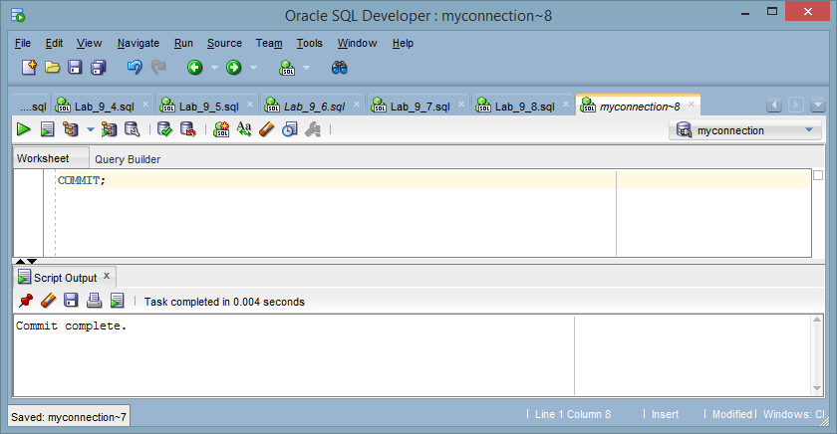

10) Change the last name of employee 3 to Drexler.

**UPDATE my_employee**

**SET last_name = 'Drexler'**

**WHERE id = 3;**

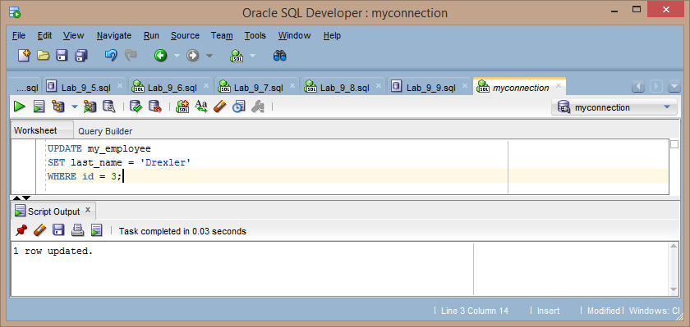

11) Change the salary to $1,000 for all employees who have a salary less than $900.

**UPDATE MY_EMPLOYEE**

**SET salary = 1000**

**WHERE SALARY < 900;**

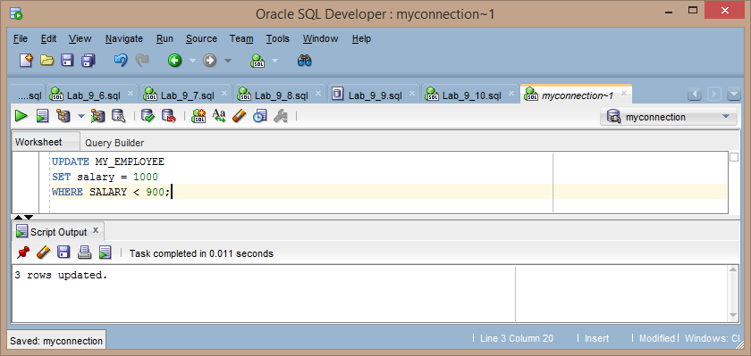

12) Verify your changes to the table.

**SELECT * FROM my_employee;**

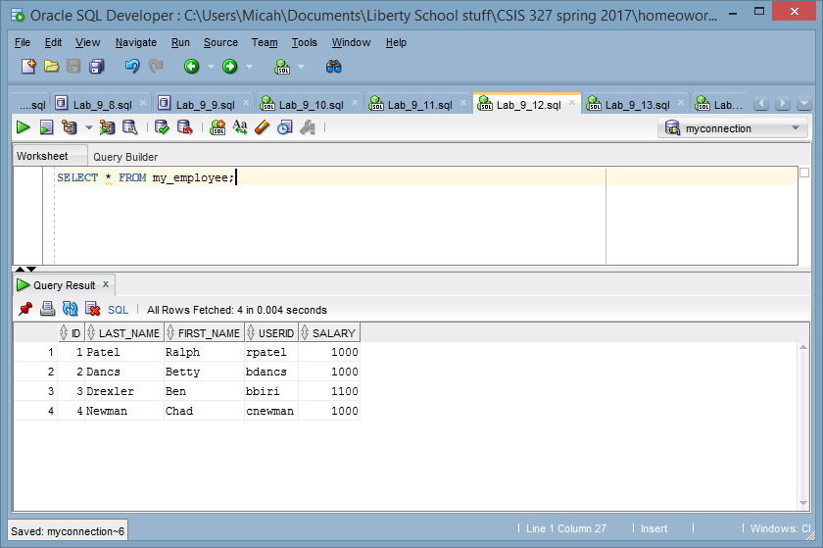

13) Delete Betty Dancs from the MY_EMPLOYEE table.

**DELETE**

**FROM MY_EMPLOYEE**

**WHERE FIRST_NAME = 'Betty' and LAST_NAME = 'Dancs';**

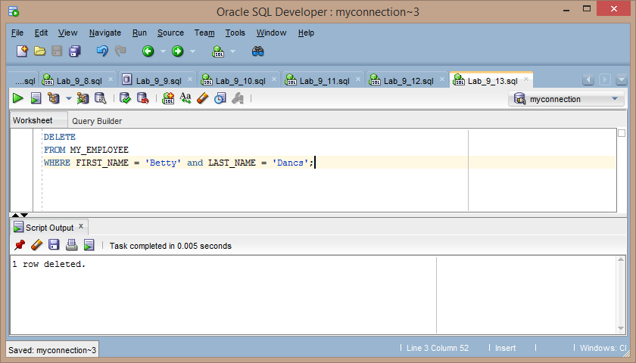

14) Confirm your changes to the table.

**SELECT * FROM MY_EMPLOYEE;**

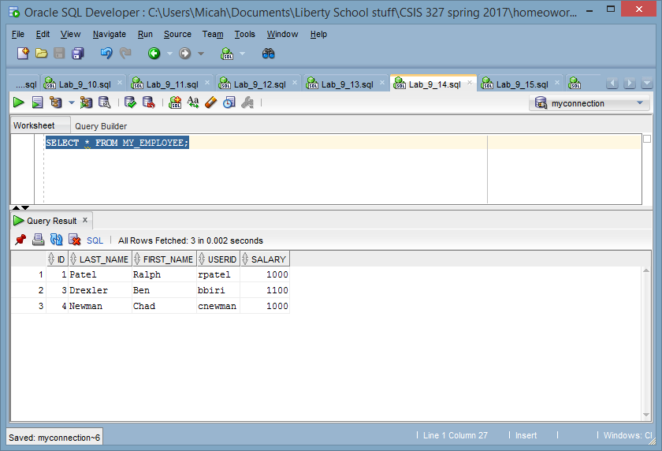

15) Commit all pending changes. Control data transaction to the MY_EMPLOYEE table.

**COMMIT;**

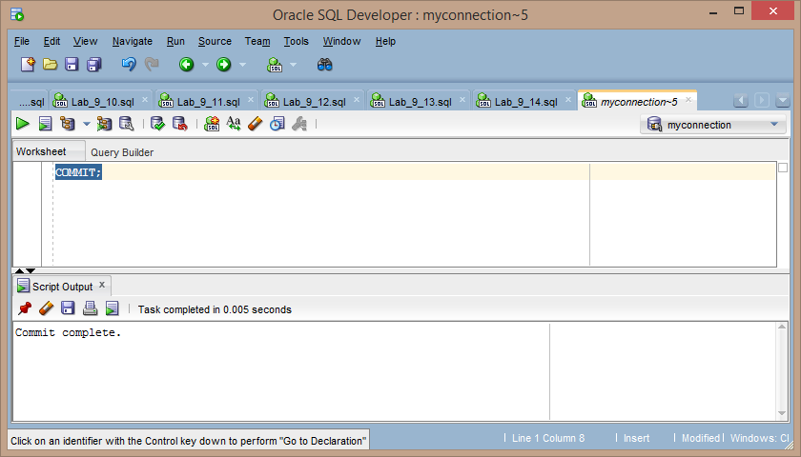

16) Populate the table with the last row of the sample data listed in step 3 by using the statements in the script that you created in step 6. Run the statements in the script.

**INSERT INTO my_employee (id, last_name, first_name, userid, salary)**

**VALUES (&id, '&last_name', '&first_name', '&userid', &salary);**

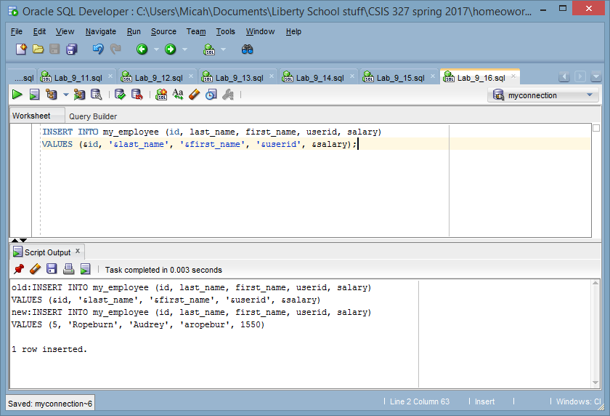

17) Confirm your addition to the table.

**SELECT * FROM MY_EMPLOYEE;**

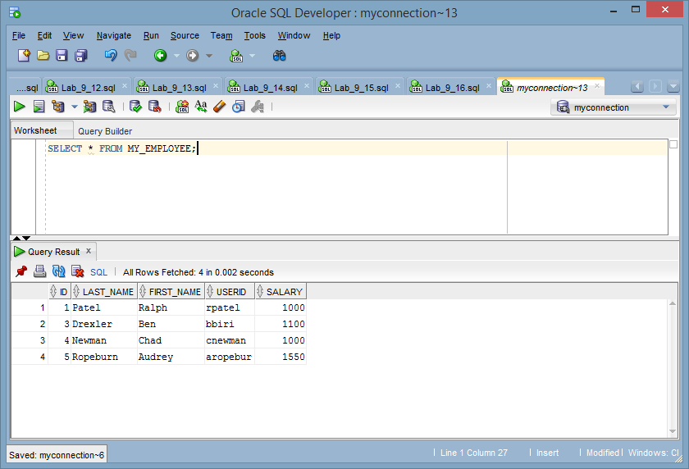

18) Mark an intermediate point in the processing of the transaction.

**SAVEPOINT step18;**

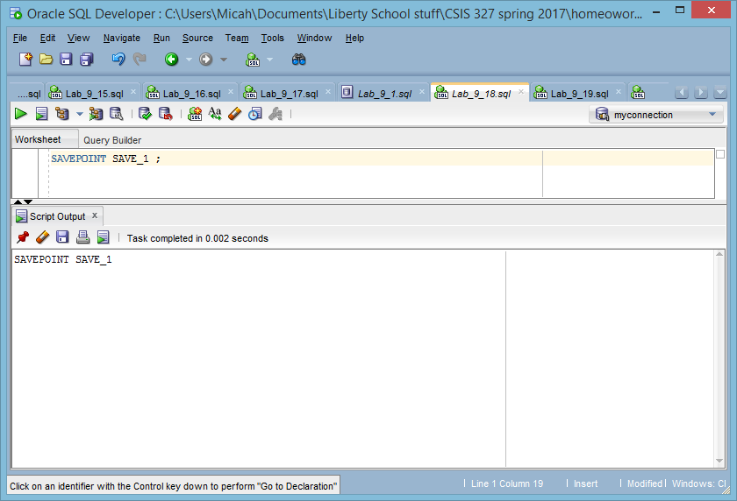

19) Delete all the rows from the MY_EMPLOYEE table.

**DELETE FROM MY_EMPLOYEE;**

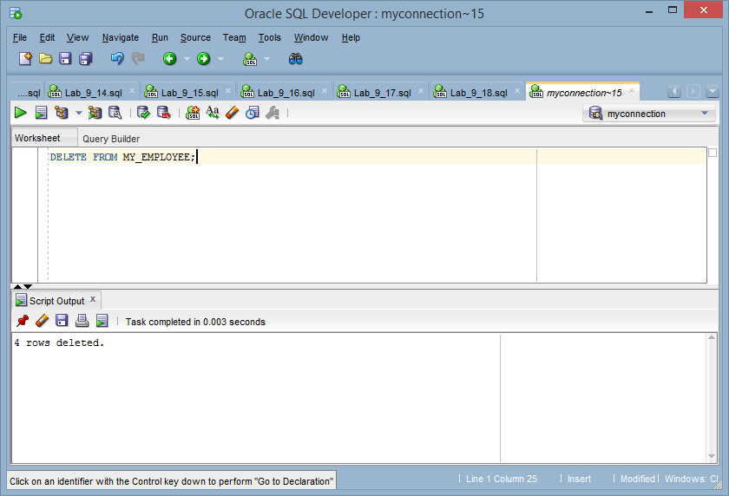

20) Confirm that the table is empty.

**SELECT * FROM MY_EMPLOYEE;**

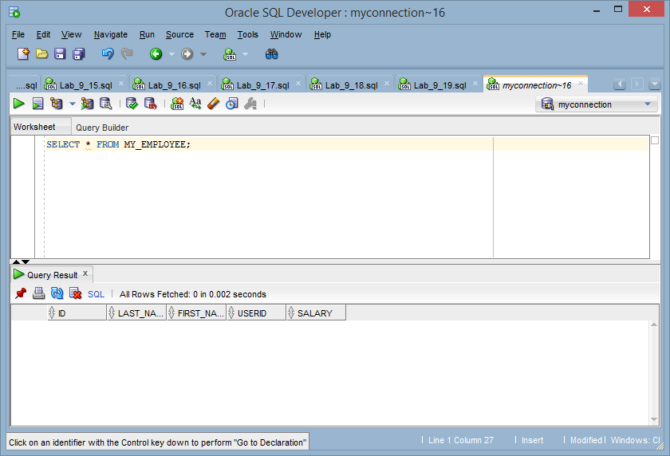

21) Discard the most recent DELETE operation without discarding the earlier INSERT operation.

**ROLLBACK TO SAVEPOINT SAVE_1;**

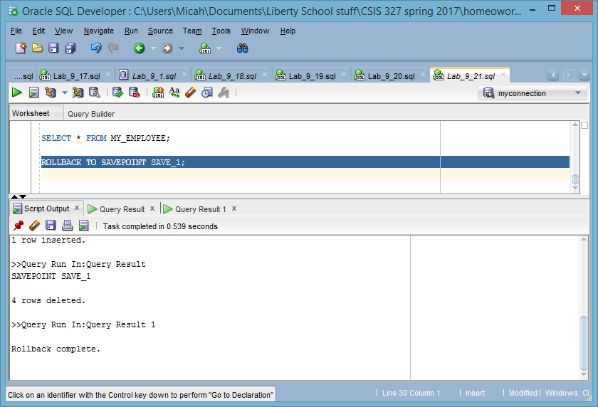

22) Confirm that the new row is still intact.

**SELECT * FROM MY_EMPLOYEE;**

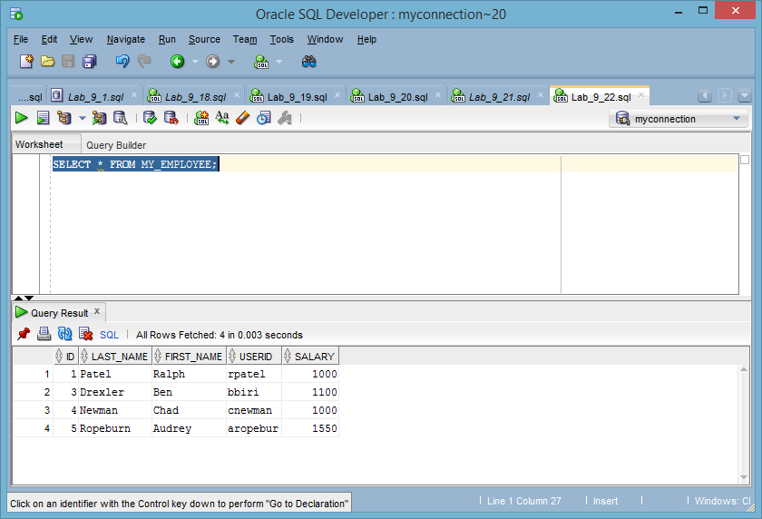

23) Make the data addition permanent.

**COMMIT;**

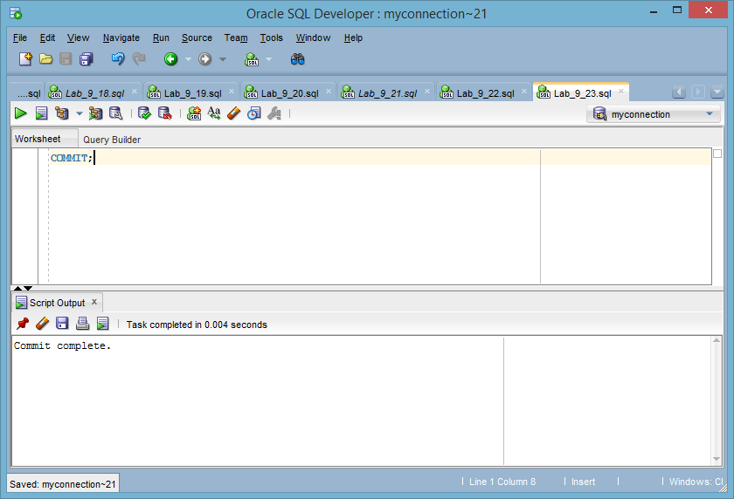

24) Make a copy of the employees table and name it employees_yourname. Replace “yourname” with your actual name. Use the employees_yourname table for the subsequent exercises. Insert five (5) new rows. You can use any appropriate real or figurative people. Show a screenshot of the new individuals only.

**DROP TABLE employees_micah;**

**CREATE TABLE employees_micah**

**(id NUMBER(4) CONSTRAINT employees_micah_id_nn NOT NULL,**

**last_name VARCHAR2(25),**

**first_name VARCHAR2(25),**

**userid VARCHAR2(8),**

**salary NUMBER(9,2));**

**INSERT INTO employees_micah**

**SELECT * FROM MY_EMPLOYEE ;**

**INSERT INTO my_employee (id, last_name, first_name, userid, salary)**

**VALUES (6, 'Shmoe', 'Joe', 'jshmoe', 5);**

**INSERT INTO my_employee (id, last_name, first_name, userid, salary)**

**VALUES (7, 'Sam', 'Sammy', 'ssam', 9999);**

**INSERT INTO my_employee (id, last_name, first_name, userid, salary)**

**VALUES (8, 'Mad', 'Vlad', 'vmad', 1234);**

**INSERT INTO my_employee (id, last_name, first_name, userid, salary)**

**VALUES (9, 'Shelps', 'Micah', 'mshelps', 2551);**

**INSERT INTO my_employee (id, last_name, first_name, userid, salary)**

**VALUES (10, 'Redman', 'Rob', 'rredman', 3);**

**SELECT * FROM EMPLOYEES_MICAH**

**WHERE ID > 5;**

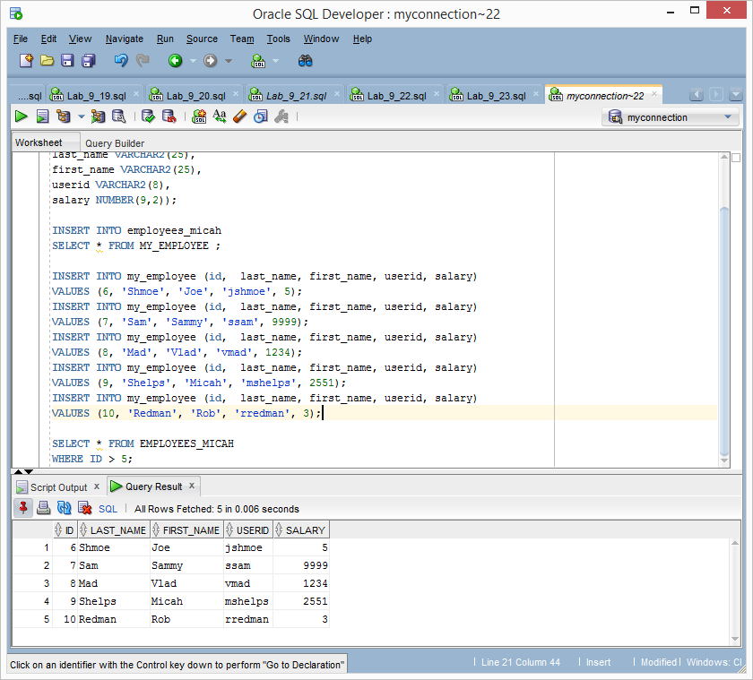

25) Create a new savepoint of the table. Delete only the new rows. Subsequently, rollback the transaction. Show a minimum of three (3) screenshots of the successful savepoint, confirmation of the removal of the rows using proper SQL, and the restoration following removal to the original savepoint.

**SAVEPOINT micah;**

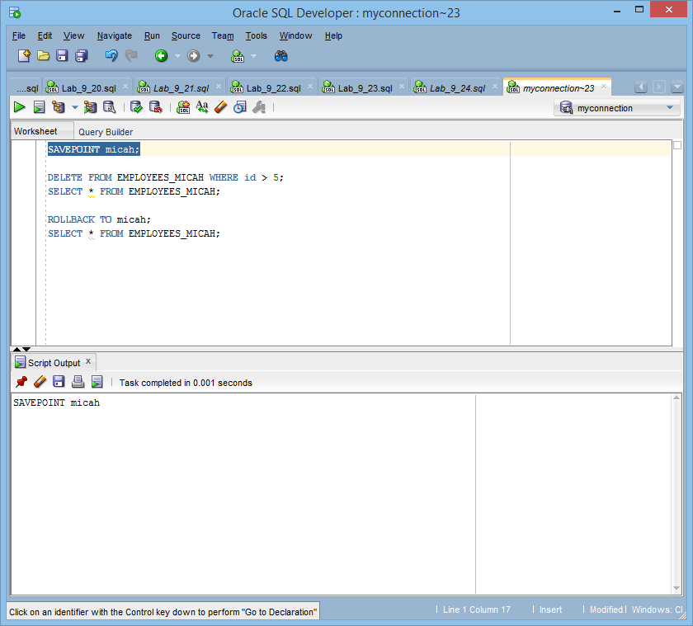

**DELETE FROM EMPLOYEES_MICAH WHERE id > 5;**

**SELECT * FROM EMPLOYEES_MICAH;**

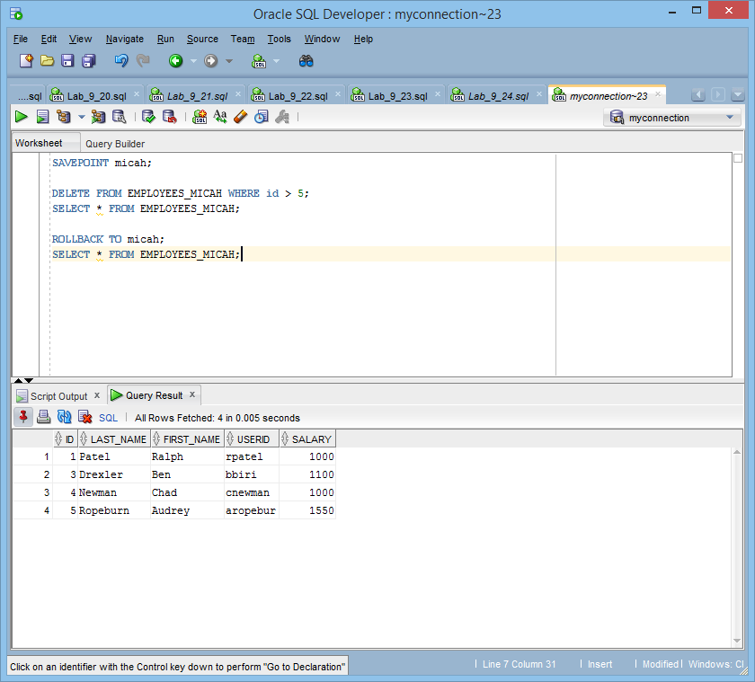

**ROLLBACK TO micah;**

**SELECT * FROM EMPLOYEES_MICAH;**

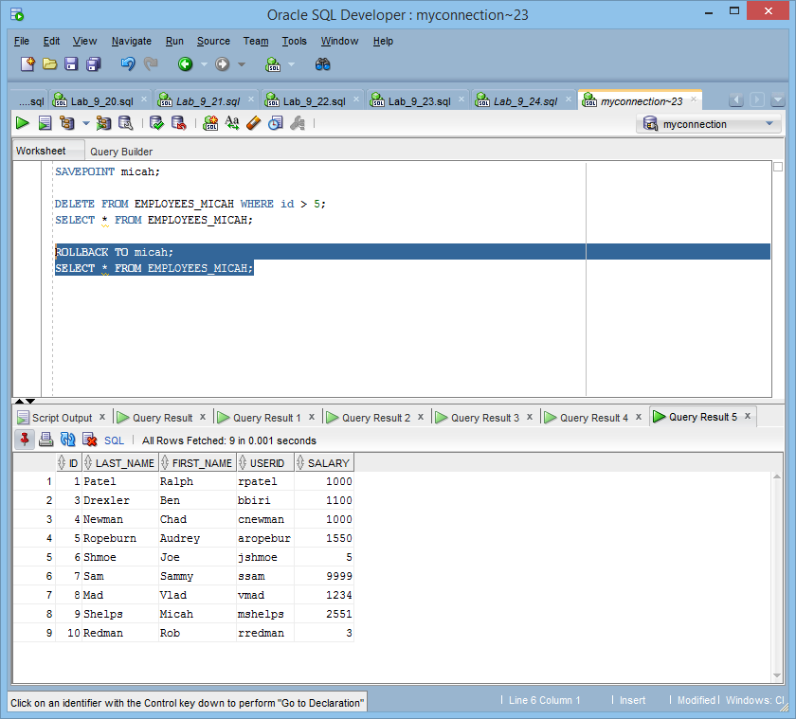

26) Using the crow’s foot methodology, design an entity relationship diagram in third normal form (3NF). Follow appropriate ERD notation rules. This should include entities, attributes, relationships, descriptions, inside and outside cardinality, primary keys, and foreign keys. At the minimum, the business is requesting that the following data be stored for a new cookbook application:

* Management of kitchen inventory
* Management of cooking recipes
* Comparison of cooking recipes to necessary inventory to fulfill the recipe’s requirements

