1) Create the DEPT table based on the following table instance chart. Save the statement in a script called lab_10_01.sql, and then execute the statement in the script to create the table. Confirm that the table is created.

|  |  |  |
| --- | --- | --- |
| **Column Name** | ID | NAME |
| **Key Type** | Primary key |  |
| **Nulls/Unique** |  |  |
| **FK Table** |  |  |
| **FK Column** |  |  |
| **Data type** | NUMBER | VARCHAR2 |
| **Length** | 7 | 25 |

**CREATE TABLE DEPT**

**(ID NUMBER(7)CONSTRAINT DEPT_pk PRIMARY KEY,**

**NAME VARCHAR2(25));**

**DESCRIBE DEPT**

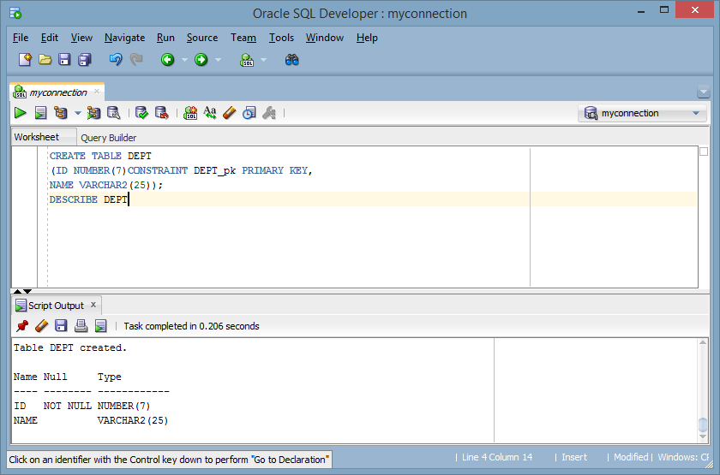

2) Populate the DEPT table with data from the DEPARTMENTS table. Include only columns that you need.

**INSERT INTO DEPT**

**SELECT DEPARTMENT_ID, DEPARTMENT_NAME**

**FROM DEPARTMENTS;**

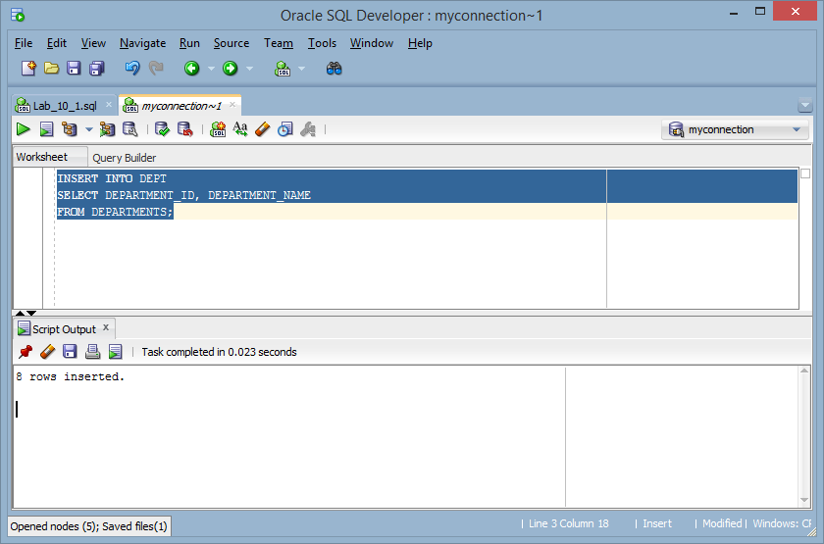

3) Create the EMP table based on the following table instance chart. Save the statement in a script called lab_10_03.sql, and then execute the statement in the script to create the table. Confirm that the table is created.

|  |  |  |  |  |
| --- | --- | --- | --- | --- |
| **Column Name** | ID | LAST_NAME | FIRST_NAME | DEPT_ID |
| **Key Type** |  |  |  |  |
| **Nulls/Unique** |  |  |  |  |
| **FK Table** |  |  |  | DEPT |
| **FK Column** |  |  |  | ID |
| **Data type** | NUMBER | VARCHAR2 | VARCHAR2 | NUMBER |
| **Length** | 7 | 25 | 25 | 7 |

**CREATE TABLE EMP**

**(ID NUMBER(7),**

**LAST_NAME VARCHAR2(25),**

**FIRST_NAME VARCHAR2(25),**

**DEPT_ID NUMBER(7) CONSTRAINT fk_DEPT_ID REFERENCES dept (id));**

**DESCRIBE EMP**

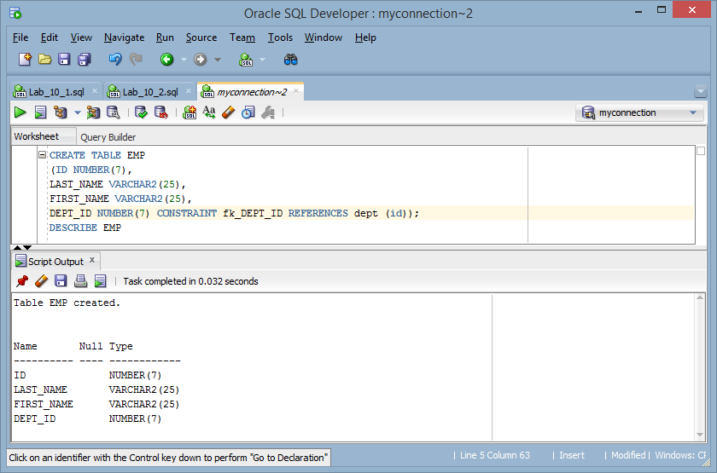

4) Create the EMPLOYEES2 table based on the structure of the EMPLOYEES table. Include only the EMPLOYEE_ID, FIRST_NAME, LAST_NAME, SALARY, and DEPARTMENT_ID columns. Name the columns in your new table ID, FIRST_NAME, LAST_NAME, SALARY, and DEPT_ID, respectively.

**CREATE TABLE EMPLOYEES2 AS**

**SELECT employee_id id, first_name, last_name, salary,**

**department_id dept_id**

**FROM employees;**

**DESCRIBE EMPLOYEES2;**

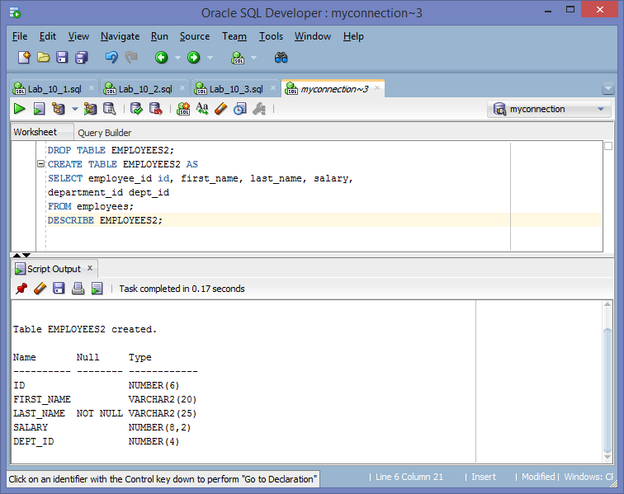

5) Alter the EMPLOYEES2 table status to read-only.

**ALTER TABLE EMPLOYEES2 READ ONLY;**

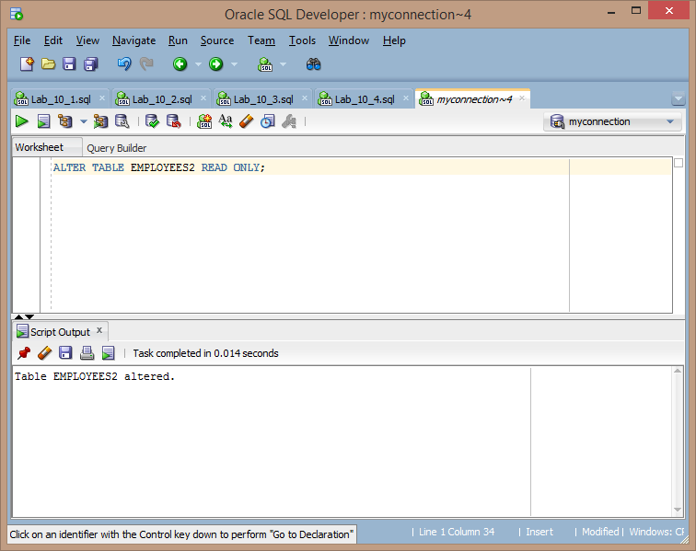

6) Try to insert the following row in the EMPLOYEES2 table:

|  |  |  |  |  |
| --- | --- | --- | --- | --- |
| **ID** | FIRST_NAME | LAST_NAME | SALARY | DEPT_ID |
| **34** | Grant | Marcie | 5678 | 10 |

You get the following error message:

**INSERT INTO EMPLOYEES2 (ID, FIRST_NAME, LAST_NAME, SALARY, DEPT_ID)**

**VALUES (34, 'Grant', 'Marcie', 5678, 10);**

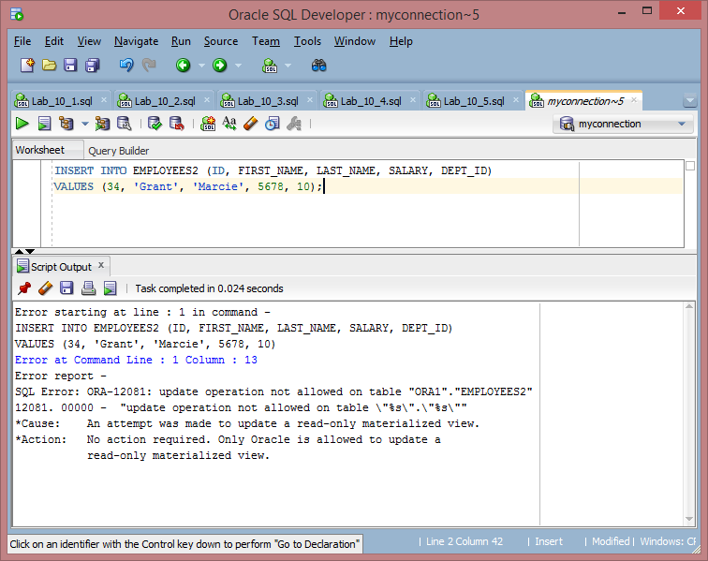

7) Revert the EMPLOYEES2 table to the read/write status. Now, try to insert the same row again. You should get the following messages:

**ALTER TABLE EMPLOYEES2 READ WRITE;**

**INSERT INTO EMPLOYEES2 (ID, FIRST_NAME, LAST_NAME, SALARY, DEPT_ID)**

**VALUES (34, 'Grant', 'Marcie', 5678, 10);**

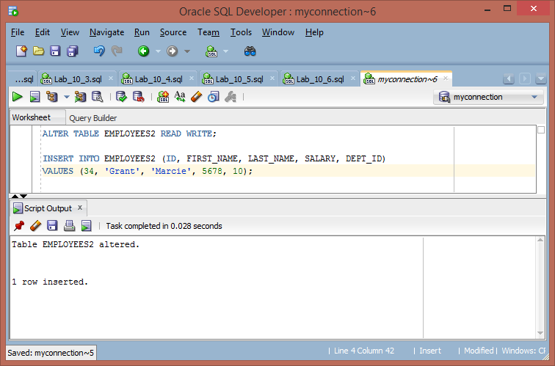

8) Drop the EMPLOYEES2 table.

**DROP TABLE EMPLOYEES2;**

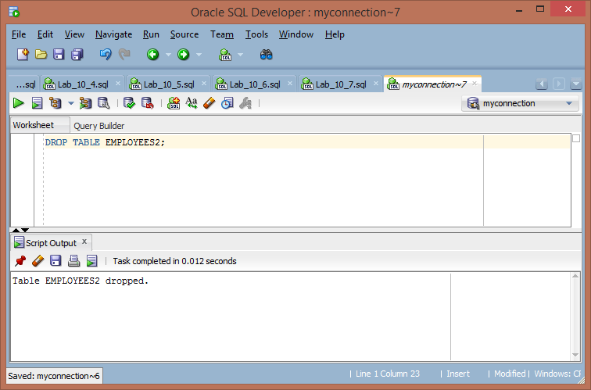

9) In this exercise, you will use the ERD diagram from your previous Cookbook assignment to implement your design into actual tables and columns. The tables and attributes should be logically created and parallel the third normal form design. In other words, appropriate constraints should exist given the primary and foreign keys, proper field types and length should occur, and appropriate naming conventions should be used.

Once the proper DDL code has been written, run the code in your Oracle database. Screenshots are required for each DDL statement and subsequent table created. When complete, the final Cookbook tables should track:

• Management of kitchen inventory

• Management of cooking recipes

• Comparison of cooking recipes to necessary inventory to fulfill the recipe’s requirements

**CREATE TABLE KITCHENINVENTORY**

**(InventoryID INT CONSTRAINT Inventory_fk PRIMARY KEY,**

**Inv_name VARCHAR2(45),**

**Inv_type VARCHAR2(45),**

**Inv_quantity FLOAT);**

**DESCRIBE KITCHENINVENTORY;**

**CREATE TABLE COOKINGRECIPES**

**(RecipeID INT CONSTRAINT Recipe_fk PRIMARY KEY,**

**Rec_name VARCHAR2(45),**

**Rec_steps VARCHAR2(500));**

**DESCRIBE COOKINGRECIPES;**

**CREATE TABLE INGREDIENTS**

**(RecipeID_fk INT,**

**InventoryID_fk INT,**

**Ing_quantity FLOAT,**

**FOREIGN KEY (RecipeID_fk) REFERENCES COOKINGRECIPES(RecipeID),**

**FOREIGN KEY (InventoryID_fk) REFERENCES KITCHENINVENTORY(InventoryID));**

**DESCRIBE INGREDIENTS;**

