

iLab Service Broker Bootstrapping and Time Of Day Test Lab Guide

Author: Kirky DeLong, Sardis Harward and Antonia Harward
Last Modified: August 2010
Version: 11

iLab Service Broker Bootstrapping and Time Of Day Test Lab Guide 1
Service Broker Requirements 4
iLab Process Agents 4
Grants and Qualifiers 5
Resource Mapping 5
What is a GUID 6
Installing iLab Servers 7
Requirements 7
iLab Installation Directory 7
.NET 2.0 Framework 8
Building from the SDK 8
Opening the Visual Studio Project 8
Installing from the Pre-built Binaries 9
General Installation Process 9
iLabs Installation Check List 10
Installing Process Agents 11
iLab Service Broker (ISB) 11
Service Broker Web Site 11
Create the Database 14
Grant Access to the Database 15
Service Broker Database Scripts 17
Web.Config 20
Testing Your Service Broker Installation 22
iLab Service Broker Self Registration 22
Error Messages 24
Experiment Storage Service (ESS) 24
ESS Web Site 24
Create the Database 25
Grant Access to the Database 26
ESS Database Scripts 26
Web.Config 28
Test the Experiment Storage Service: 29
ESS Self Registration 29
Userside Scheduling Services (USS) 31
USS Web Site 31
Create the Database 32
Grant Access to the Database 32
USS Database Scripts 33
Web.Config 34
Test the Scheduling Services: 35
USS Self Registration 36
Labside Scheduling Service (LSS) 37
LSS Web Site 37
Create the Database 38
Grant Access to the Database 38
LSS Database Scripts 39
Web.Config 41
Test the Scheduling Services: 42
LSS Self Registration 42
Time Of Day Lab Server (TOD) 43
TimeOfDay Web Site 43
Create the Database 44
Grant Access to the Database 45
TOD Database Scripts 45
Web.Config 47
Test the Time Of Day Server: 48
TOD Self Registration 49
Bootstrapping 51
Users and Groups 51
Process Agents 53
Service Broker 54
Experiment Storage Service (ESS) 55
Userside Scheduling Server (USS) 56
Labside Scheduling Server (LSS) 58
Time Of Day Lab Server (LS) 58
Time Of Day Lab Client 59
Lab Client Record 59
Client Loader Script 60
Associate the Lab Server 60
Associate the ESS and USS 61
Associate Groups 62
Create a Test User 62
Group Membership 62
Setup Time Of Day Experiment 63
Manage USS 63
Manage LSS 64
Running the Time Of Day Experiment 66
Troubleshooting 68

Overview
This document describes the steps necessary to get an iLab Service Broker and the necessary Process Agents installed and functioning correctly in the single domain scenario. This document also contains instructions on how to install and configure the Time Of Day Interactive Experiment (to test your iLab Service Broker).

Service Broker Requirements
You should have already installed and configured one or more computers to run the iLab Service Broker and Process Agents. This document will assume that you have at least one server computer installed and configured. Since the iLab architecture uses web services you can run all servers on a single machine or each service on a separate machine. If you are working with Windows Server 2003, see iLab document “iLabs Service Broker Windows 2003 Install Guide” for instructions on installing and configuring the operating system and database. The latest version of this document can be downloaded from the developer section of the http://ilab.mit.edu/wiki website.
For those using Windows Server 2008 and SQL Server 2008, there is no specific step by step operating system installation guide. Since there are many variations and versions (Datacenter, Enterprise, Standard, Express, R1 or R2, x86 or x64) it is no longer feasible to write installation guides for each one. Microsoft has install guides for each version on their website. We make the assumption that you have a computer with Windows server 2008 and SQL Server 2008 installed. You will also need to turn on and configure the mail server.
This document assumes that you have the following software installed and configured.
- Windows Server 2003 or 2008 Enterprise Edition
- SQL Server 2000 with Service Pack 3a, 2005 or SQL server 2008
- Visual Studio.NET 2005 Professional and Library
It is also assumed that your computer(s) are connected to the Internet and have valid IP addresses and domain names. In order for the web services in iLab Architecture to communicate with each other, the service will need to communicate over the Internet. This document does not address network connectivity issues. Please contact your local systems administrator to make sure that your computer(s) are connected to the Internet and can communicate with each other correctly.
This document assumes that you are using Windows Server Enterprise Edition and SQL Server Enterprise. There is a help document called “iLabs Service Broker XP notes.doc” with some configuration suggestions and notes about installing the iLab Service Broker under Windows XP with SQL Server Express. This document is not an install guide but a set of notes about the issues that can arise when installing under Windows XP with Microsoft SQL Express. We recommend and support the use of Windows Server Enterprise Edition and SQL Server Enterprise.
In SQL Server 2005, the Enterprise Manager has been replaced with the SQL Server Management Studio. There is a version called SQL Server Management Studio Express Edition that is a free download that you should be able to use.

iLab Process Agents
A process agent in the iLab architecture is a web service that implements the ProcessAgent interface. A process agent can be a web service or a web server. In addition to having the physical machines correctly installed and configured, you will need to have downloaded and installed the code or pre-built iLab services.
The iLab architecture has four types of services; ISB, ESS, USS, LSS. This bootstrapping guide will assume that your iLab domain will have one Service Broker and at least one of each of the servers. Also included in this release is a test experiment called the Interactive Time Of Day Experiment, designed to confirm that the Service Broker and its components are installed correctly. The Interactive Lab Server (ILS) with LabVIEW is not configured in this document but under a separate document called iLabs InteractiveLabServer with LabVIEW Setup and Configuration.
Services you will find in this release:
- iLab Service Broker (ISB)
- Experiment Storage Server (ESS)
- User-side Scheduling Server (USS)
- Lab-side Scheduling Server (LSS)
- Interactive Time of Day Experiment (TOD)
- Interactive Lab Server (ILS) with LabVIEW (this server is not configured in this document, but under a separate document called iLabs InteractiveLabServer with LabVIEW Setup and Configuration.
One important item to remember about Process Agents is that service (USS, ESS, and LSS) can have only one Administration group, but may have many Management groups.

Grants and Qualifiers
Grants are the permissions given to an agent (either a group or user). Qualifiers are the resources (services or servers) that Agents are allowed to perform actions on.
Grants have three parts: Group, Function, and Qualifier.
- Groups
- Functions are the permissions or TicketType that a group has on a particular qualifier.
- Qualifiers are resources or resource mappings.

Resource Mapping
- Resources such as scheduling and storage are associated with clients, process agents or groups.
- Resource Mappings are resource associations with one key to many values.
- Authorizations come from the Grant table not the Resource Mapping table.
- In the case of a single domain, resource mappings will be used to map client -> USS, client -> LSS and LS -> LSS. Mapping_id’s are unique. TicketTypes needed for each resource are stored in the grants information.

Map_ID | KeyType | KeyValue (DB) | ValueType | ValueValue (DB)
11 | “client” | Client_object (client_id) | “ResourceType” | “ESS”
 |  |  | “ProcessAgent” | ESS_Object (pa_id)
 |  |  | “TicketType” | “Manage Experiment”
12 | “client” | Client_object (client_id) | “ResourceType” | “USS”
 |  |  | “ProcessAgent” | USS_Object (pa_id)
 |  |  | “TicketType” | “Schedule session”
13 | “LabServer” | LS_Object (pa_id) | “ResourceType” | “LSS”
 |  |  | “ProcessAgent” | LSS_Object (pa_id)
 |  |  | “TicketType” | “Manage LS”

What is a GUID
A Globally Unique Identifier or GUID is a special type of identifier used in software applications in order to provide a unique string for referencing. It is typically a string of letters and numbers separated by hyphens. iLab uses GUIDs to ensure the Process Agent IDs are unique. Since Process Agents such as the Service Broker, Experiment Storage Service, User-Side Scheduling and Lab-Side Scheduling exchange credentials, it is very important that their identifiers be unique. This ensures the correct service is accessed when needed.
There are several free, on-line, easy to use GUID generators available, or you can use the GUID generator provided with Visual Studio .NET. If you have installed Visual Studio.NET 2003, GuidGen.exe is available in the C:\Program Files\Microsoft Visual Studio.NET 2003\Common7\Tools directory. To create a GUID, select Registry Format, Click the Copy button, and paste the resulting GUID between the quote marks following the value field. Edit out the bracket and hyphen characters ({-}).
WARNING: The Service Broker GUID needs to be 35 characters or less due to some legacy code in the batched architecture.

Installing iLab Servers

The standard distribution of the iLab Service Broker contains both the SDK and a pre-built set of web sites. In addition, there is a Builds only version available for separate download. If you intend to set up a development environment with full source code, use the code in the services directory for compiling. Note: Visual Studio 2005 is the recommended install, since you will need to build the local installation.

Requirements
You should have the following software already installed and configured before you begin to set up the iLab Service Broker.
- Windows Server 2003 or 2008 Enterprise
- SQL Server 2000 with SP3a, 2005 or 2008
- Microsoft .Net 2.0 Framework
- Visual Studio.NET 2005 Professional and Library (optional, but required for compiling the SDK version)
The installation and configuration of the server computers is described in the iLabs Service Broker OS and Database Install Guide.

iLab Installation Directory
- Create a folder called iLabs
- Unzip the iLabs Distribution archive into this folder.
  - Right-click on the zip file
  - Select Extract All…
  - Click Next>
  - Edit the extract directory to so that it simply reads “D:\iLabs” if you installed on the D drive. You can install the code in the directory of your choice. For notation purposes, this document will use \*local_path*\ to represent the directory on your local computer where the code is installed.
  - Click Next>
  - Click Finish
You can install the code in the directory of your choice. For notation purposes, this document will use \*local_path*\ to represent the directory on your local computer where the Service Broker code is installed.

.NET 2.0 Framework
The iLabs Architecture needs the .NET 2.0 framework to be installed. This is not installed when you installed Windows Server but is a separate download and install.
Download the Microsoft .NET framework from http://www.microsoft.com/downloads/ there should be a link to the .NET Framework Version 2.0 Redistributable Package (x86).
This document assumes that you will be installing each service separately or on separate machines. This document is organized by service. If you are installing all the services on a single machine, a more efficient way to set up the services is by activity; i.e., all the databases at once. This document is not configured to follow this method, but you can use the included checklist to install by activity.

Building from the SDK
Most developers prefer to run from their own compiled versions of the software. To do this you will need to use the SDK version of the iLab software located in the Services directory, if not, please use the pre-built version located in the Builds directory.

To build the files locally you must first create virtual directories for each of the services as defined in the solution file. The different site directories are located in the Services directory of the iLabs installation.

- http://machine.name.edu/ExperimentStorage
- http://machine.name.edu/iLabServiceBroker
- http://machine.name.edu/InteractiveTimeOfDay
- http://machine.name.edu/LabSideScheduling
- http://machine.name.edu/UserSideScheduling
- http://machine.name.edu/InteractiveLabServer
- http://machine.name.edu/ilab_WSDLl

Opening the Visual Studio Project
Now, create the Visual Studio project.
- Start->Run->Microsoft Visual Studio.NET 2005- Microsoft Visual Studio.NET 2005
- Click on the Projects tab
- Click Open Project
- Browse to \*local_path*\iLabs\projects\ iLabProject_wLabView.sln
- Click OK
- Wait while Visual Studio loads the code. If you get an error message saying that VS cannot find the directory, browse to the location where the code in question currently resides.
- Do a Test Build: Build->Build Solution. If it builds without errors, your installation is a success. There may be a few warnings.
Note: You cannot develop in Visual Studio against a website that is running SSL. If you have problems, check to make sure that SSL is not turned on in web.config.

Problems under XP
- Under the virtual directory properties, make sure that Default.aspx is in the documents section
- Make sure that the .NET framework is installed
- Run the .Net framework-iis installation aspnet_regiis.exe from the command prompt (C:\WINDOWS\Microsoft.NET\Framework)
There is a help document titled “iLabs Service Broker XP notes.doc” with some configuration and notes about installing the iLab Service Broker under Windows XP with SQL Server Express. This is not an install guide, but notes about the issues that can arise when installing under Windows XP with Microsoft SQL Express.

Installing from the Pre-built Binaries
If you do not want to build the project locally, please use the pre-built version of the code included in the distribution’s Builds directory. To use the pre-built version, when creating the virtual directories, set the directory location to the Builds directory for each service rather than the services directory.

General Installation Process
A more detailed description of each installation process will follow. Each service installation will follow the same general process:
- Create a virtual directory
- Create the database (tables and stored procedures)
- Edit Web.config file as necessary
- Complete self-registration
After a service is installed the Service Broker needs to create a trusted relationship with the service. This is done in the bootstrapping section of this document.
WARNING: This document assumes that you have compiled the iLab code and will be using the Services directory for the IIS virtual directories and editing the web.config files. If you are using the pre-compiled version in the Builds directory you will need be aware and make the necessary changes so that the IIS virtual directories point to the correct prebuilt locations and that you edit the correct web.config files.

iLabs Installation Check List

iLab Service Broker
- Create Virtual Web Site
- Create Database
- Database Permissions
- Database Process Agent scripts
- Database Ticketing scripts
- Database Interactive Service Broker scripts
- Edit Web.Config file
- Test service
- Register domain services
Experiment Storage Server
- Create Virtual Web Site
- Create Database
- Database Permissions
- Database Process Agent scripts
- Database ESS scripts
- Edit Web.Config file
- Test service
- ESS self registration
UserSide Scheduling Service
- Create Virtual Web Site
- Create Database
- Database Permissions
- Database Process Agent scripts
- Database USS scripts
- Edit Web.Config file
- Test service
- USS self registration
LabSide Scheduling Service
- Create Virtual Web Site
- Create Database
- Database Permissions
- Database Process Agent scripts
- Database LSS scripts
- Edit Web.Config file
- Test service
- LSS self registration
Interactive Time Of Day Server
- Create Virtual Web Site
- Create Database
- Database Permissions
- Database Process Agent scripts
- Edit Web.Config file
- Test service
- ToD self registration

Installing Process Agents

iLab Service Broker (ISB)

Service Broker Web Site
For Windows Server 2003, create a virtual directory in IIS.
- Right-Click on My Computer
- Click Manage
- Expand Services and Applications
- Expand Internet Information Services
- Expand Web Sites
- Expand Default Web Site
- Right-click on Default Web Site
- Select New->Virtual Directory
- Click Next to start the Virtual Directory Creation Wizard
- In the Alias box, type iLabServiceBroker
- Click Next
- Click the Browse button and navigate to the location where your Service Broker code is located. The path should resemble \*local_path*\iLabs\Services\ iLabServiceBroker directory. In addition, there is a set of precompiled builds located in \*local_path*\iLabs\Builds\iLabServiceBroker. Use the Service directory if you compiled the code yourself and the builds directory to use the pre-build versions.
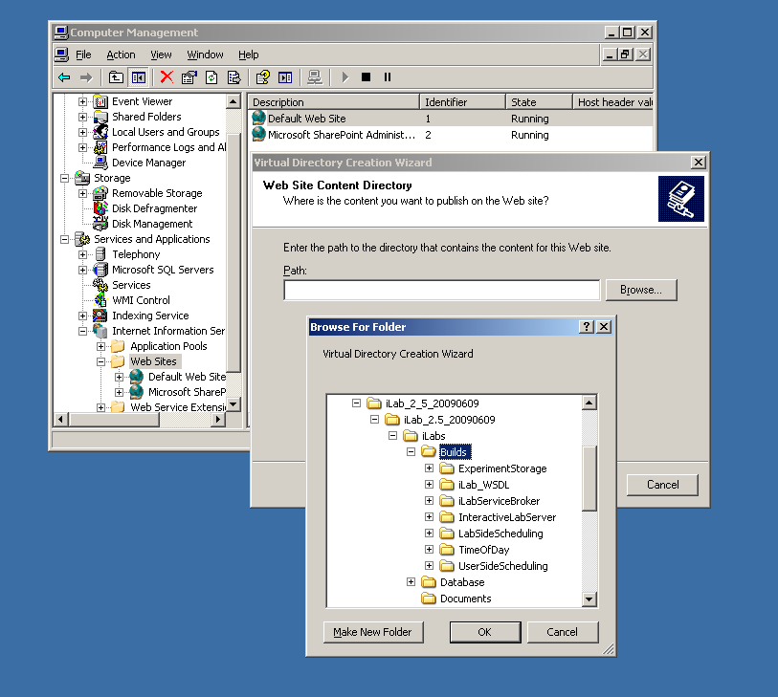
NOTE: For notational purposes we will use \*local_path*\ to represent the directory on your local computer where the code is unzipped.

- Click Next
- Access Permissions: make sure you check the Run Scripts, Execute and Read permission boxes
- Click Next
- Click Finish
- You should see the Service Broker site listed under the Default Web Site
- Right click on the iLabServiceBroker website and select Properties
- Select the ASP.NET tab
- Use the pull-down list for the ASP.NET version and select 2.0.xxx. Where xxx is the current release version.
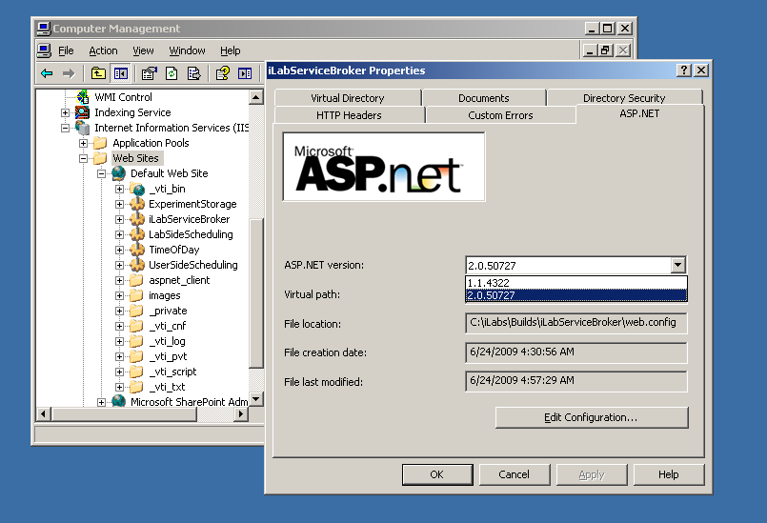
- Select OK and close the properties window
- Close the Computer Management Window

For Windows Server 2008, create an application using the IIS Manager.
- Start -> Administrative Tools
- Open the Internet Information Service (ISS) Manager
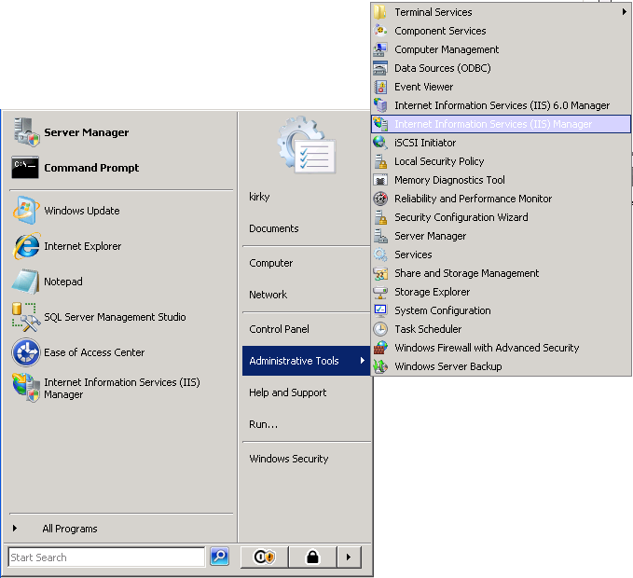
- Expand IIS Server (typically the machine name)
- Expand Sites
- Right-click on Default Web Site and select Add Application
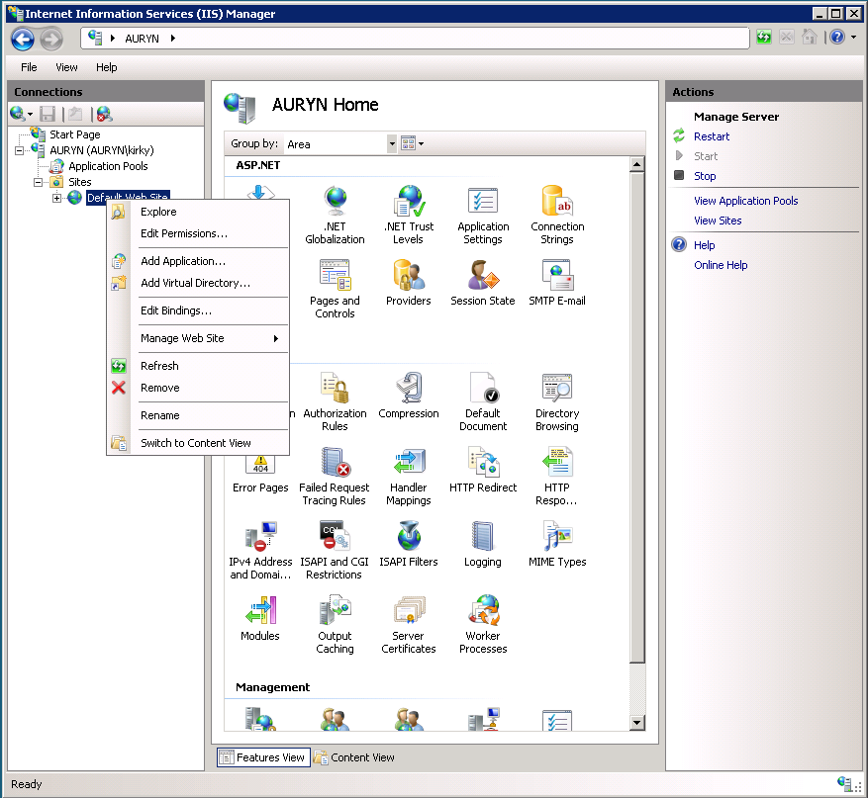
- In the Alias field, type iLabServiceBroker
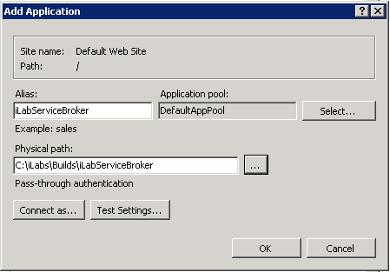
- Click the Browse button and navigate to the location where your Service Broker code is located. The path should resemble \*local_path*\iLabs\Services\ iLabServiceBroker directory. In addition, there is a set of precompiled builds located in \*local_path*\iLabs\Builds\iLabServiceBroker. Use the Service directory if you compiled the code yourself and the builds directory to use the pre-build versions.
NOTE: For notational purposes we will use \*local_path*\ to represent the directory on your local computer where the code is unzipped.

- Click OK
- You should see the iLabServiceBroker site listed under the Default Web Site

Create the Database
For Windows Server 2003, open the Enterprise Manager and navigate through the tree Console Root->Microsoft SQL Servers->SQL Server Group->(local)->Databases
For Windows Server 2008, open the Microsoft SQL Server Management Studio and navigate to Databases
- Right-Click on Databases
- New Database…
- Enter iLab_ISB into the database name field. (This is the default. You can use any name you would like but you must update the web.config file to use the different name)
- Click OK

WARNING: Microsoft SQL Server database names are case sensitive.

Grant Access to the Database
In Windows Server 2003:
- Expand the Security folder in Enterprise Manager.
- Right-click Logins, select New Login…
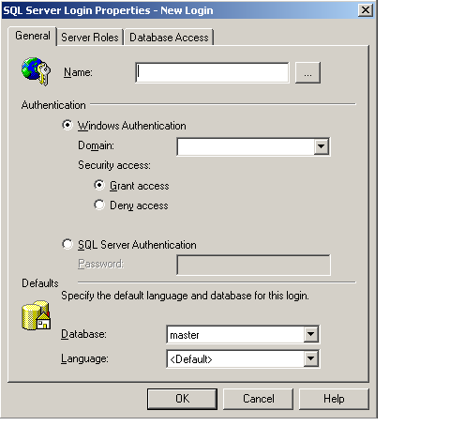
- In the Name box, type NT AUTHORITY\NETWORK SERVICE
  - Note: if you already have a login for NT AUTHORITY\NETWORK SERVICE, double-click on it and continue with the next step. If you are installing under Windows XP, please check the Windows XP notes guide for the proper security name to use.
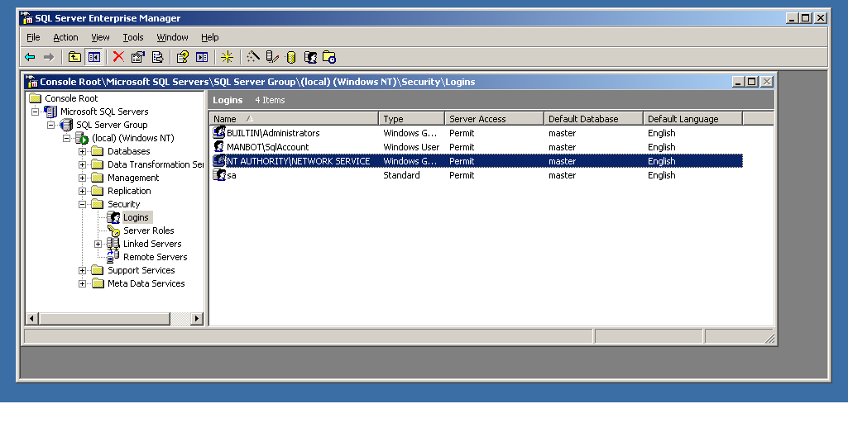
- Click the Database Access tab
- Check the box next to ilab_ISB (or the database name you used above)
- In the box below, click the box next to db_owner
- Click OK

In Windows Server 2008:
- Expand the Security folder in Microsoft SQL Server Management Studio.
- Right-click Logins, select New Login…
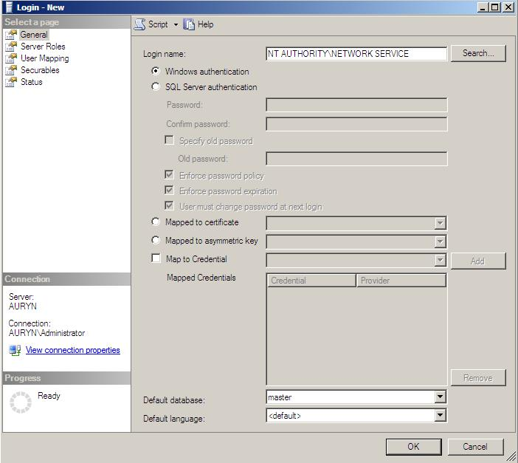
- In the Name box, type NT AUTHORITY\NETWORK SERVICE
  - Note: if you already have a login for NT AUTHORITY\NETWORK SERVICE, double-click on it and continue with the next step. If you are installing under Windows XP, please check the Windows XP notes guide for the proper security name to use.
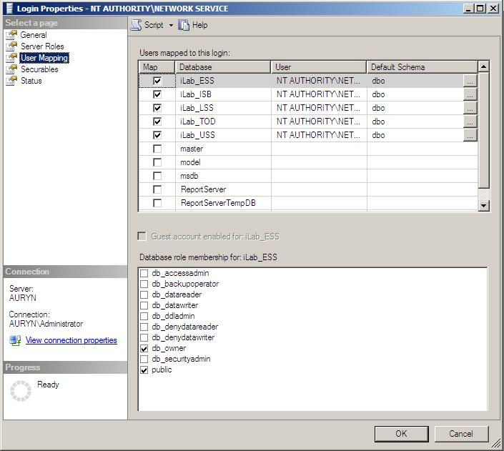
- Click the User Management page
- Check the box next to iLab_ISB (or the database name you used above)
- In the box below, click the box next to db_owner
- Click OK

Service Broker Database Scripts
For each Process Agent created (ISB, USS, LSS, ESS, and TOD), you will need to run Process Agent scripts that are generic for all process agents, and specific scripts for the particular Process Agent you are creating. The generic process agent scripts are in a directory called ProcessAgent and specific database scripts will be in named directories, for example ServiceBroker.
This document contains instructions for two different ways to run the database scripts for Microsoft SQL server; from within the SQL Query Analyzer or from the loader scripts that are in the DB_Scripts directory. Which method you use is determined by your operating system. Do NOT attempt both methods.

Operating system Use Method
Windows Server 2008 Method 1
Windows Server 2003 Method 2
Windows XP (not supported) Method 1

METHOD 1: Using SQL Query (Windows 2008)
- In the Microsoft SQL Server Management Studio, expand the database list.
- Select the iLab_ISB database (or what you named it).
- Click the New Query icon in the tool bar.
- Click File->Open…
- Browse to database scripts directory typically (\*local_path*\iLabs\ Database\DB_Scripts\ProcessAgent)
- In the ProcessAgent directory select and open the ProcessAgentTables.sql
This directory contains the database scripts for all of the Process Agents. You will set up and run the ProcessAgent database scripts before running the service-specific database scripts. This is important because there is a key from the iLab Service Broker foreign to the Process Agents table.
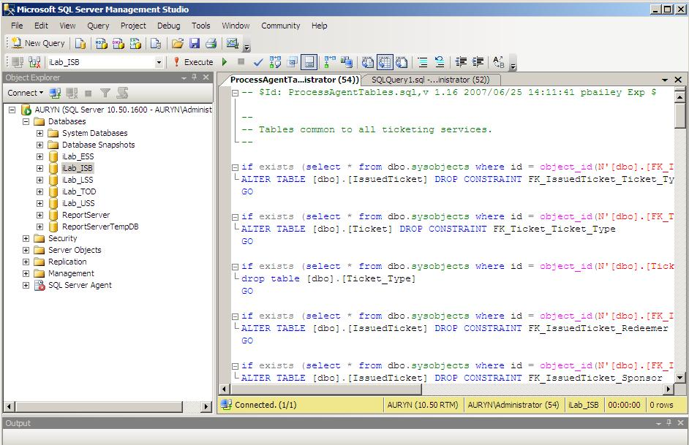
New Query Button
Database Selection
Execute Button

- You may be asked to reconnect to the server before proceeding.
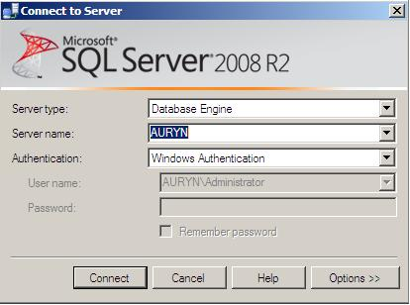
- Again make sure the correct database, ilab_ISB, is the selected database in the dropdown menu at the top of the window. This defaults to Master when the dataset reconnects. This is very important because the scripts will be installed in the database specified by this pull-down menu.
- Click the Execute button to run the script
- You should see a message: “The command(s) completed Successsfully.”
- Follow the same procedure, File → Open, to open and run the ProcessAgentProcedures.sql script.
- You should see the same message: “The command(s) completed Successsfully.”
- Open and run the SetDefaultsPA.sql script.
- You should see several messages: “1 row(s) affective.” and “Checking Identity Information ….”.
Next, set up and run the Interactive Service Broker-specific database scripts (typically located in \*local_path*\iLabs\ Database\DB_Scripts\ServiceBroker).
- In Query Analyzer, click File->Open…
- Browse to database scripts directory, typically (\*local_path*\iLabs\ Database\DB_Scripts\ServiceBroker)
- Open and run the TIssuerTables.sql script.
- Open and run the TIssuerProcedures.sql scripts.
- Open and run the ServiceBrokerCoreTables.sql script.
- Again you should see the message: “The command(s) completed Successsfully.”
- Open and run ServiceBrokerCoreProcedures.sql, as above
- Open and run ServiceBrokerCoreDefaultValues.sql as above
- You should see several messages: “1 row(s) affective.” and “Checking Identity Information ….”.
- Close SQL Query Manager and Enterprise Manager

METHOD 2: Using the SQL loader scripts (Windows 2003)
- Open a Command Prompt window. Start -> Programs -> Accessories -> Command Prompt.
- A DOS window should open.
- Change the directory to the DBscripts directory.
- Type: “cd \*local_path*\iLabs\ Database\DB_Scripts\”
- Type: “LoadISB iLab_ISB” where ilab_ISB is the name of your database.
- You should see something similar to the following with your directory path and database name.
D:\iLabs\Database\DB_Scripts>loadISB iLab_ISB
D:\iLabs\Database\DB_Scripts>echo populating iLab_ISB
populating InteractiveSB InteractiveSB
D:\iLabs\Database\DB_Scripts>call ISB_tables.bat iLab_ISB
D:\iLabs\Database\DB_Scripts>echo InteractiveSB Tables: iLab_ISB
InteractiveSB Tables: ilab_ISB
D:\iLabs\Database\DB_Scripts>isqlw -E -d iLab_ISBeSB -i .\Ticketing\ProcessAgentTables.sql -o isbBuild0.log
D:\iLabs\Database\DB_Scripts>isqlw -E -d iLab_ISB -i .\Ticketing\SetdefaultsTicketing.sql -o isbBuild1.log
D:\iLabs\Database\DB_Scripts>isqlw -E -d iLab_ISB
-i .\Ticketing\TIssuerTables.sql -o isbBuild2.log
D:\iLabs\Database\DB_Scripts>isqlw -E -d iLab_ISB
-i .\InteractiveSB\ServiceBrokerCoreTables.sql -o isbBuild3.log
D:\iLabs\Database\DB_Scripts>isqlw -E -d iLab_ISB
-i .\InteractiveSB\ServiceBrokerCoreDefaultValues.sql -o isbBuild4.log
D:\iLabs\Database\DB_Scripts>call ISB_procedures.bat iLab_ISB
D:\iLabs\Database\DB_Scripts>echo InteractiveLS Procedures: iLab_ISB
InteractiveLS Procedures: iLab_ISB
D:\iLabs\Database\DB_Scripts>isqlw -E -d iLab_ISB -i .\Ticketing\ProcessAgentProcedures.sql -o isbBuild1.log -r
D:\iLabs\Database\DB_Scripts>isqlw -E -d iLab_ISB -i .\Ticketing\TIssuerProcedures.sql -o isbBuild4.log -r
D:\iLabs\Database\DB_Scripts>isqlw -E -d iLab_ISB -i .\InteractiveSB\ServiceBrokerCoreProcedures.sql -o isbBuild6.log -r

- Be sure to check the log files in the DB_Scripts directory for any errors.

Web.Config
Web.config is a text file containing configuration information in an XML format. It resides in the root of the Service Broker web site (typically in the \*local_path*\iLabs\Services\iLabServiceBroker directory). Web.config.template ships with this release.
If this is a new installation of the Service Broker, delete any existing copy of the Web.Config file. Copy web.config.template and paste the file into the same directory. Rename the copy “web.config” and edit it using notepad.
Using the self-registration webpage supplied as part of the installation package is the best way to update most of these fields. Please note that not all fields can be configured using the self-registration web pages; there are several fields (database name and email addresses) that can only be edited in the web.config file. Changes made on the self-registration pages are not reflected in the web.config file.

Update the Database Name
Update the database connection variable in the web.config file to use the name you chose when you created the database. Note the default database name is set to ilab_ISB. If you used a different database name, update the catalog value in the key. This name MUST match the name of your database exactly including capitalization.
<add key=”sqlConnection”
value="data source=(local);initial catalog=ilab_ISB;Integrated Security = SSPI" />

Update Email Addresses
Do not forget to update the email address keys or else users will encounter errors when registering and sending bugs.
<add key="supportMailAddress" value=" your_email@your_machine.edu " />
<add key="registrationMailAddress" value=" your_email@your_machine.edu " />
<add key="genericFromMailAddress" value="your_email@your_machine.edu"/>

Update Default Passkey
The default Pass Key is a simple string used by process agents to exchange credential information the first time only. This can be any string you would like. We recommend that you not change this.

<add key="defaultPasskey" value="" /> Set to “Let me in!” by default

Web.Config Parameters to be aware of:
There are several other parameters that you should be aware of in web.config, for example, bugreportMailAddress which is the email address that bug reports will be sent.
serviceType SERVICE BROKER (do not change this)
serviceName A default name - should be changed in selfRegister
serviceGuid Must be created in selfRegister
codebaseURL SB application URL, change to DNS name in selfRegister
serviceURL SB’s service URL, change to DNS name in selfRegister
defaultPassKey Initial Passkey for credential exchange
sqlConnection Database name, default ilab_ISB
bugReportingMailAddress Enter a local email address or leave ilab-bug@mit.edu you may add comma delimited additional addresses
supportMailAddress Enter a local email address
registrationMailAddress Enter a local email address
genericFromMailAddress Enter a local email address

Testing Your Service Broker Installation
- Open Internet Explorer
- Browse to http://machine.name.edu/iLabServiceBroker/iLabServiceBroker.asmx
- The iLab Service Broker service description page should be displayed
- Browse to http://machine.name.edu/iLabServiceBroker
- Log in as follows:
  - Username: SuperUser
  - Password: ilab
The iLab architecture is designed to use fully qualified URLs, and unexpected things can happen when using localhost if you need to test, use 127.0.0.1 but recognize that internet cross registration is not possible.
Most of the setup information like the serviceName, serviceGUID and codebaseURL is now entered on the Service Broker self-registration page when you first login to the Service Broker.

Each Service Broker and Process Agent must have a unique GUID (Globally Unique Identifier) which will identify this particular Service Broker to all lab servers and Process Agents. This GUID will be supplied to the Lab Server(s) administrator so that the Lab Server can be configured to communicate with this Service Broker. We use a GUID produced on the Service Broker's machine with all the '-', '{', and '}' characters stripped out. You can generate your own GUID and enter it in the web.config, or use the “Generate GUID” button on the Service Broker’s self registration page and then remove the hyphens (this is the preferred method).
NOTE: Use fully qualified URLs for all registrations. It is important that your registration URLs be consistent. Do not mix the use of fully qualified URLs and IP addresses within a single service setup. Mixing registration URLs will cause problems with web service communications.

iLab Service Broker Self Registration
In order for process agents to exchange credentials, their information needs to be entered into the Process Agents table. There is a self-registration web service included with each process agent. You cannot register a process agent until after you have created and edited the corresponding web.config file.
- Open Internet Explorer
- Browse to http://machinename.edu/iLabServiceBroker/
- Login as SuperUser
- Click on the “Services & Clients” tab
- Click on the “Self Registration” tab in the sub-menu
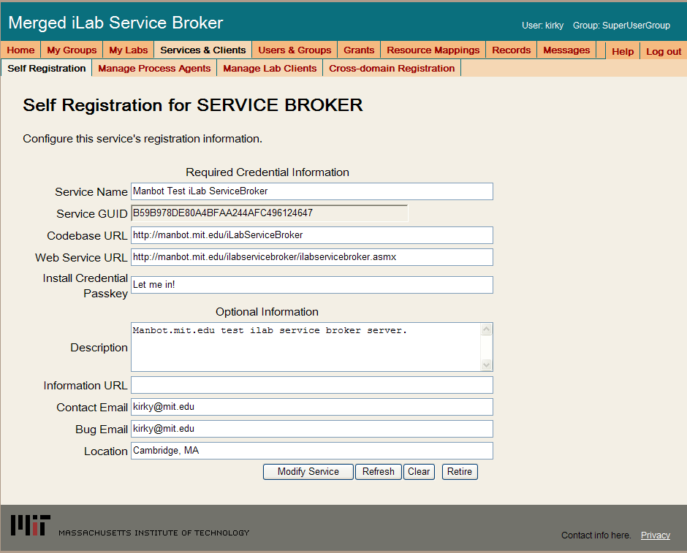
- Modify Service Name, CodeBase & Webservice URLs as needed. Please make sure that the Service Name is unique. Be sure to use fully qualified URLs.
  - Codebase URL: http://machinename.edu/iLabServiceBroker
  - Web Service URL: http://machinename.edu/iLabServiceBroker/iLabServiceBroker.asmx
- Use the “Create GUID” button to generate a new GUID and remove the hyphens to make sure that the GUID is less than 35 characters.
WARNING: The Service Broker GUID needs to be 35 characters or less due to some legacy code in the batched architecture. If you enter a GUID into the web.config file directly, please make sure that it is less than 35 characters long including dashes and/or underscores.

- Update the optional fields (Description, Information URL, Contact Email, Bug Email and Location) as needed.
- Click the Save Service button

Error Messages
When testing your installation of the Service Broker you may see one of the following error messages:
- “Cannot open database requested in login 'ilab_ISB'. Login fails. Login failed for user 'NT AUTHORITY\NETWORK SERVICE'.”
- Edit the web.config and enter the correct database name.
- “The page cannot be displayed. You have attempted to execute a CGI, ISAPI, or other executable program from a directory that does not allow programs to be executed.” The Virtual Directory in IIS does not have the correct permissions. Remove the virtual directory and recreate it with the correct permissions.
- In the System News and Messages section of the login page you may see one of the following messages:
  - An Administrator needs to edit web.config and add a value for registrationMailAddress. This is the default email address where requests for membership in a group are sent.
  - An Administrator needs to add a value for supportMailAddress. This is the email address where help requests are sent.
To remove error or warning messages from the System News and Message area,
- Login as SuperUser
- Select the Messages tab from the top menu
- Click on the system bullet in the message type area
- Select a message to delete and click remove.

Experiment Storage Service (ESS)

ESS Web Site
For Windows Server 2003,, create a virtual directory in IIS.
- Right-Click on My Computer (renamed to your computer name)
- Click Manage
- Expand Services and Applications
- Expand Internet Information Services
- Expand Web Sites
- Expand Default Web Site
- Right-click on Default Web Site
- Select New->Virtual Directory
- Click Next to enter the Virtual Directory Creation Wizard
- In the Alias box, type ExperimentStorage
- Click Next
- Enter \*local_path*\iLabs\Services\ExperimentStorage in the Directory box (or click the Browse button, and navigate to the location where the code is located.) If you are using the pre-built code, please use the “Builds” directory, \*local_path*\iLabs\Builds\iLabServiceBroker.
- Click Next
- Access Permissions: make sure you check the Run Scripts, Execute and Read permission boxes
- lick Next
- Click Finish
- You should see the ExperimentStorage site listed under the Default Web Site
- Right click on the ExperimentStorage website and select Properties
- Select the ASP.NET tab
- Use the pull-down list for the ASP.NET version and select 2.0.xxx. Where xxx is the current release version.
- Select OK and close the properties window
- Close the Computer Management Window
For Windows Server 2008, create an application using the IIS Manager.
- Start -> Administrative Tools
- Open the Internet Information Service (ISS) Manager
- Expand Services and Applications
- Expand IIS Server (typically the machine name)
- Expand Sites
- Right-click on Default Web Site and select Add Application
- In the Alias field, type ExperimentStorage
- Click the Browse button and navigate to the location where your Service Broker code is located. The path should resemble \*local_path*\iLabs\Services\ ExperimentStorage directory. In addition, there is a set of precompiled builds located in \*local_path*\iLabs\Builds\ ExperimentStorage. Use the Service directory if you compiled the code yourself and the builds directory to use the pre-build versions. Click Next
- Click OK
- You should see the ExperimentStorage site listed under the Default Web Site

Create the Database
For Windows Server 2003, open the Enterprise Manager and navigate through the tree Console Root->Microsoft SQL Servers->SQL Server Group->(local)->Databases
For Windows Server 2008, open the Microsoft SQL Server Management Studio and navigate to Databases
- Right-Click on Databases
- New Database…
- Name: iLab_ESS (You can use any name you would like but you must update the web.config file if you change the default name)
- Click OK

Grant Access to the Database
In Windows Server 2003:
- Expand the Security folder in Enterprise Manager.
- Double-click on the NT AUTHORITY\NETWORK SERVICE under Logins.
- Click the Database Access tab
- Check the box next to iLab_ESS (or the database name you used above)
- In the box below, click the box next to db_owner
- Click OK
In Windows Server 2008:
- Expand the Security folder in Microsoft SQL Server Management Studio.
- Right-click Logins, select New Login…
- In the Name box, type NT AUTHORITY\NETWORK SERVICE
  - Note: if you already have a login for NT AUTHORITY\NETWORK SERVICE, double-click on it and continue with the next step. If you are installing under Windows XP, please check the Windows XP notes guide for the proper security name to use.
- Click the User Management page
- Check the box next to iLab_ESS (or the database name you used above)
- In the box below, click the box next to db_owner
- Click OK

ESS Database Scripts
This document contains instructions for two different ways to run the database scripts for Microsoft SQL server; from within the SQL Query Analyzer or from the loader scripts that are in the DB_Scripts directory. Which method you use is determined by your operating system. Do NOT attempt both methods.

Operating system Use Method
Windows Server 2008 Method 1
Windows Server 2003 Method 2
Windows XP (not supported) Method 1

METHOD 1: Using the SQL Query Analyzer (Windows 2008)
- Open the Microsoft SQL Management Studio
- Expand the Database
- Select the iLab_ESS database (or what you named it)
- On the menu bar, click the SQL Query button
- Click File -> Open…
- Browse to \*local_path*\iLabs\ Database\DB_Scripts\ProcessAgent
Every service must have its own Process Agent information. These tables should exist before the service-specific tables are added to the database.
- In the ProcessAgent directory select and open the ProcessAgentTables.sql
- You may be asked to reconnect to the database.
- Make sure the correct database is the selected database in the dropdown menu at the top of the window- *This is very important, because the scripts will be installed in the database specified by this pull-down menu.
- Click the Execute button to run the script
- You should see a message: “The command(s) completed Successsfully.”
- Follow the same procedure, File→Open, to open and run the ProcessAgentProcedures.sql script.
- You should see the same message: “The command(s) completed Successsfully.”
- Open and run the SetDefaultsPA.sql script.
Next, set up and run the ESS database script.
- In Query Analyzer, click File -> Open…
- Browse to database scripts directory typically \*local_path*\iLabs\ Database\DB_Scripts\ESS
- In the ESS directory select and open the Ess_Tables.sql
- Make sure the correct database is the selected database in the dropdown at the top, then click the Execute button to run the script
- You should see the message: “The command(s) completed Successsfully.”
- Follow the same procedure to open and run the Ess_Procedures.sql script.
- Again, you should see the message: “The command(s) completed Successsfully.”
- Close SQL Query Manager and Enterprise Manager
METHOD 2: Using the SQL loader scripts (Windows 2003)
- Open a Command Prompt window. Start -> Programs -> Accessories -> Command Prompt.
- A DOS window should open.
- Change the directory to the DBscripts directory.
- Type: “cd \*local_path*\iLabs\ Database\DB_Scripts\”
- Type: “LoadESS iLab_ESS” where ilab_ESS is the name of your database.
- You should see something similar to the following with your directory path and database name.
D:\iLabs\Database\DB_Scripts>loadESS iLab_ESS
D:\iLabs\Database\DB_Scripts>echo populating ESS iLab_ESS
populating ESS ESSdb
D:\iLabs\Database\DB_Scripts>call ESS_tables.bat iLab_ESS
D:\iLabs\Database\DB_Scripts>echo creating ESS Tables: iLab_ESS
creating ESS Tables: iLab_ESS
D:\iLabs\Database\DB_Scripts>isqlw -E -d iLab_ESS -i .
\Ticketing\ProcessAgentTables.sql -o essBuild.log
D:\iLabs\Database\DB_Scripts>isqlw -E -d iLab_ESS -i .
\Ticketing\SetdefaultsTicketing.sql -o essBuild.log
D:\iLabs\Database\DB_Scripts>isqlw -E -d iLab_ESS -i .
\ESS\Ess_tables.sql -o essBuild.log
D:\iLabs\Database\DB_Scripts>call ESS_procedures.ba
t iLab_ESS
D:\iLabs\Database\DB_Scripts>echo Creating StoredPr
ocedures ESS: ESSdb
Creating StoredProcedures ESS: iLab_ESS
D:\iLabs\Database\DB_Scripts>isqlw -E -d iLab_ESS -i .
\Ticketing\ProcessAgentProcedures.sql -o essBuild.log
D:\iLabs\Database\DB_Scripts>isqlw -E -d iLab_ESS -i .
\ESS\ESS_Procedures.sql -o essBuild.log
D:\iLabs\Database\DB_Scripts>

Web.Config
Web.config is a text file containing configuration information in an XML format, residing in the root of the ESS Services web site (typically in the \*local_path*\iLabs\Services\ExperimentStorage directory). Web.config.template ships with this release. If a web.config already exists, please delete it. Copy web.config.template and paste the file into the same directory. Rename the copy “web.config” and edit it using notepad. Please be sure to use only fully qualified URLs.
Update the Database Name
Update the database connection variable in the web.config file to use the name you chose when you created the database. Note the default database name is set to iLab_ESS. If you used a different database name, update the catalog value in the key.
<add key=”sqlConnection”
value="data source=(local);initial catalog=iLab_ESS;Integrated Security = SSPI" />

Update Default Passkey
The default Pass Key is a simple string used by process agents to exchange credential information the first time only. This can be any string you would like. We recommend that you not change this.

<add key="defaultPasskey" value="ESS" />

Web.Config Parameters to be aware of:
serviceType | EXPERIMENT STORAGE SERVER – Do not Change
serviceName | ESS unique name for this service
serviceGuid | ESS GUID - Set during self Registration
codebaseURL | ESS application URL - Set during self Registration
serviceURL | ESS’s service URL - Set during self Registration
defaultPassKey | Initial Passkey for credential exchange
sqlConnection | Database Connection string;

WARNING: The Service Broker GUID needs to be 35 characters or less due to some legacy code in the batched architecture. If you enter a GUID into the web.config file directly, please make sure that it is less than 35 characters long including dashes and/or underscores.

Test the Experiment Storage Service:
- Open Internet Explorer
- Browse to http://machine.name.edu/ExperimentStorage/ExperimentStorage.asmx
The iLab architecture is designed to use fully qualified URLs, and unexpected things can happen when using localhost.

ESS Self Registration
In order for process agents to exchange credentials, their information needs to be entered into the Process Agents table. There is a self-registration web service included with each process agent. You cannot register a process agent until after you have created and edited the corresponding web.config file.
Currently, there is no CSS associated with the Experiment Storage self-registration page.

Self-Registration Fields
Most of the setup information like the serviceName, serviceGUID and codebaseURL is now entered on the self-registration page.
Each Process Agent must have a unique GUID (Globally Unique Identifier) which will identify this particular Process Agent to all lab servers. This GUID will be supplied to the Lab Server(s) administrator so that the Lab Server can be configured to communicate with this Service Broker. We use a GUID produced on with all the '{', and '}' characters stripped out. You can generate your own GUID and enter it in the web.config or use the “Generate GUID” button on the Service Broker’s self registration page (this is the preferred method).

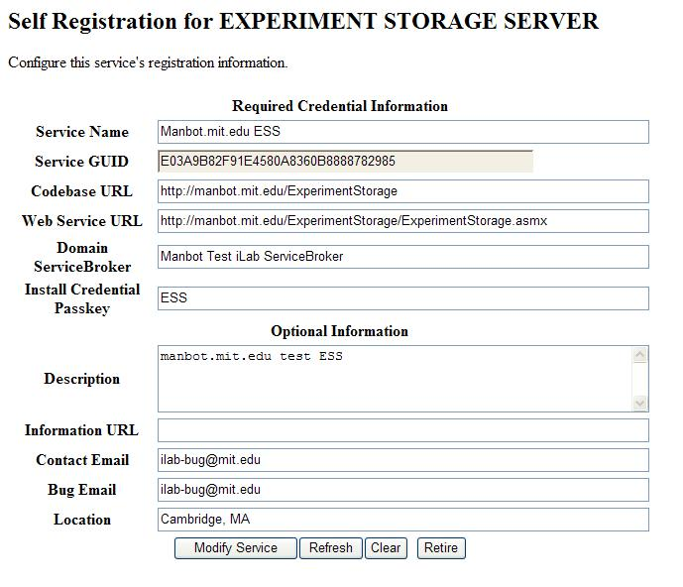
- Open Internet Explorer
- Browse to http://machinename.edu/ExperimentStorage/selfRegistration.aspx
- Modify ESS Service Name, CodeBase & Webservice URLs as needed. Please make sure that the Service Name is unique.
  - Codebase URL: http://machinename.edu/ExperimentStorage
  - Web Service URL: http://machinename.edu/ExperimentStorage/ ExperimentStorage.asmx
- Use the “Create GUID” button to generate a new GUID. Please remove the ‘-‘ from the GUID and make sure it is less than 35 characters.
- Update the optional fields (Description, Information URL, Contact Email, Bug Email and Location) as needed.
- Click the Save Service button

Userside Scheduling Services (USS)

USS Web Site
For Windows Server 2003, create a virtual directory in IIS.
- Right-Click on My Computer (renamed to your computer name)
- Click Manage
- Expand Services and Applications
- Expand Internet Information Services
- Expand Web Sites
- Expand Default Web Site
- Right-click on Default Web Site
- Select New->Virtual Directory
- Click Next to enter the Virtual Directory Creation Wizard
- In the Alias box, type UserSideScheduling
- Click Next
- Enter \*local_path*\iLabs\Services\UserSideScheduling in the Directory box (or click the Browse button, and navigate to the location where your Service Broker code is). If you are using the pre-built code, please use the builds directory.
- Click Next
- Access Permissions: make sure you check the Run Scripts, Execute and Read permission boxes
- Click Next
- Click Finish
- You should see the UserSideScheduling site listed under the Default Web Site
- Right click on the UserSideScheduling website and select Properties
- Select the ASP.NET tab
- Use the pull-down list for the ASP.NET version and select 2.0.xxx. Where xxx is the current release version.
- Select OK and close the properties window
- Close the Computer Management Window
For Windows Server 2008, create an application using the IIS Manager.
- Start -> Administrative Tools
- Open the Internet Information Service (ISS) Manager
- Expand Services and Applications
- Expand IIS Server (typically the machine name)
- Expand Sites
- Right-click on Default Web Site and select Add Application
- In the Alias field, type UserSideScheduling
- Click the Browse button and navigate to the location where your Service Broker code is located. The path should resemble \*local_path*\iLabs\Services\ UserSideScheduling directory. In addition, there is a set of precompiled builds located in \*local_path*\iLabs\Builds\ UserSideScheduling. Use the Service directory if you compiled the code yourself and the builds directory to use the pre-build versions. Click Next
- Click OK
- You should see the UserSideScheduling site listed under the Default Web Site

Create the Database
For Windows Server 2003, open the Enterprise Manager and navigate through the tree Console Root->Microsoft SQL Servers->SQL Server Group->(local)->Databases
For Windows Server 2008, open the Microsoft SQL Server Management Studio and navigate to Databases
- New Database…
- Name: iLab_USS (You can use any name you would like but you must update the web.config file if you change this name)
- Click OK

Grant Access to the Database
In Windows Server 2003:
- Expand the Security folder in Enterprise Manager.
- Double-click on the NT AUTHORITY\NETWORK SERVICE under Logins
- Click the Database Access tab
- Check the box next to iLab_USS (or the database name you used above)
- In the box below, click the box next to db_owner
- Click OK
In Windows Server 2008:
- Expand the Security folder in Microsoft SQL Server Management Studio.
- Right-click Logins, select New Login…
- In the Name box, type NT AUTHORITY\NETWORK SERVICE
  - Note: if you already have a login for NT AUTHORITY\NETWORK SERVICE, double-click on it and continue with the next step. If you are installing under Windows XP, please check the Windows XP notes guide for the proper security name to use.
- Click the User Management page
- Check the box next to iLab_USS (or the database name you used above)
- In the box below, click the box next to db_owner
- Click OK

USS Database Scripts
This document contains instructions for two different ways to run the database scripts for Microsoft SQL server; from within the SQL Query Analyzer or from the loader scripts that are in the DB_Scripts directory. Which method you use is determined by your operating system. Do NOT attempt both methods.

Operating system Use Method
Windows Server 2008 Method 1
Windows Server 2003 Method 2
Windows XP (not supported) Method 1

METHOD 1: Using the SQL Query Analyzer (Windows 2008)
- Open the Microsoft SQL Management Studio
- Expand the database list
- Select the iLab_USS database (or what you named it) in Enterprise Manager.
- On the menu bar, select the New Query button
- Click File -> Open…
- Browse to \*local_path*\iLabs\Database\DB_Scripts\ProcessAgent
Every service must have its own Process Agent information. These tables should exist before the service-specific tables are added to each database.
- In the ProcessAgent directory select and open the ProcessAgentTables.sql
- You may be asked to reconnect to the database.
- Make sure the correct database is the selected database in the dropdown menu at the top - *This is very important, because the scripts will be installed in the database specified by this pull-down menu.
- Click the Execute button to run the script
- You should see a message: “The command(s) completed Successsfully.”
- Follow the same procedure, File→Open, to open and run the ProcessAgentProcedures.sql script.
- You should see the same message: “The command(s) completed Successsfully.”
- Open and run the SetDefaultsPA.sql script.
Next, set up and run the USS database script.
- In Query Analyzer, Click File -> Open…
- Browse to database scripts directory typically \*local_path*\iLabs\ Database\DB_Scripts\Scheduling
- In the Scheduling directory select and open the USS_Tables.sql
- Make sure the correct database is the selected database in the dropdown at the top, then click Execute button to run the script
- You should see the message: “The command(s) completed Successsfully.”
- Follow the same procedure to open and run the USS_Procedures.sql script.
- Again you should see the message: “The command(s) completed Successsfully.”
- Close SQL Query Manager and Enterprise Manager
METHOD 2: Using the SQL loader scripts (Windows 2003)
- Open a Command Prompt window. Start -> Programs -> Accessories -> Command Prompt.
- A DOS window should open.
- Change the directory to the DBscripts directory.
- Type: “cd \*local_path*\iLabs\ Database\DB_Scripts\”
- Type: “LoadUSS iLab_USS” where ilab_USS is the name of your database.
- You should see something similar to the following with your directory path and database name.
D:\iLabs\Database\DB_Scripts>loadUSS iLab_USS
D:\iLabs\Database\DB_Scripts>echo loading USS: USSdb
loading USS: iLab_USS
D:\iLabs\Database\DB_Scripts>call USS_tables.bat USSdb
D:\iLabs\Database\DB_Scripts>echo USS Tables: Ilab_USS
USS Tables: iLab_USS
D:\iLabs\Database\DB_Scripts>isqlw -E -d iLab_USS -i .
\Ticketing\ProcessAgentTables.sql -o ussBuild.log
D:\iLabs\Database\DB_Scripts>isqlw -E -d iLab_USS -i .
\Ticketing\SetdefaultsTicketing.sql -o ussBuild.log
D:\iLabs\Database\DB_Scripts>isqlw -E -d iLab_USS -i .
\Scheduling\USS_Tables.sql -o ussBuild.log
D:\iLabs\Database\DB_Scripts>call USS_procedures.bat iLab_USS
D:\iLabs\Database\DB_Scripts>echo USS Procedures: USSdb
USS Procedures: iLab_USS
D:\iLabs\Database\DB_Scripts>isqlw -E -d iLab_USS -i .
\Ticketing\ProcessAgentProcedures.sql -o lssBuild.log
D:\iLabs\Database\DB_Scripts>isqlw -E -d iLab_USS -i .
\Scheduling\USS_Procedures.sql -o lssBuild.log
D:\iLabs\Database\DB_Scripts>

Web.Config
Web.config is a text file containing configuration information in an XML format, residing in the root of the USS Services web site (typically in the \*local_path*\iLabs\ Services\ UserSideScheduling directory). Web.config.template ships with this release. If the web.config file already exists, delete it. Copy web.config.template and paste the file into the same directory. Rename the copy “web.config” and edit it using notepad.
<?xml version="1.0"?>
<configuration>
<appSettings>
<!--
LabSideScheduling Web.Config -->

<!--
ProcessAgent required Keys -->
<!-- THE FOLLOWING MUST BE SET FOR ALL SERVICES, used to define the service -->
<!-- The following keys specify the WebService required Values -->
<!-- They are used by the SelfRegistration page to generate the ProcessAgent's
Bootstrap ProcessAgent Record, which must be created before installing domain credientials -->
<!-- The Service Type - Do Not Change -->
<add key="serviceType" value="SCHEDULING SERVER"/>
<!-- The name of the Service displayed for the user, please change -->
<add key="serviceName" value="Default UserScheduling Server"/>
<!-- This Service's GUID You must supply a vaild GUID, see createGUID.exe, may be any string, 50 characters or less. -->
<add key="serviceGUID" value=""/>
<add key="codebaseURL" value="http://localhost/UserSideScheduling"/>
<add key="serviceURL" value="http://localhost/UserSideScheduling/UserScheduling.asmx"/>
<add key="defaultPasskey" value="USS"/>

<!-- the database connection information
NOTE: You Must set the database catalog to the database name that you created as part of the instalation process -->
<add key="sqlConnection" value="data source=(local);initial catalog=iLab_USS;Integrated Security=SSPI"/>
……………………………………..

Update the Database Name
Update the database connection variable in the web.config file to use the name you chose when you created the database. Note the default database name is set to iLab_USS. If you used a different database name, update the catalog value in the key.
<add key=”sqlConnection”
value="data source=(local);initial catalog=iLab_USS;Integrated Security = SSPI" />

Update Default Passkey
The default Pass Key is a simple string used by process agents to exchange credential information the first time only. This can be any string you would like. We recommend that you not change this.

<add key="defaultPasskey" value="USS" />

Web.Config Parameters to be aware of:
ServiceType | SCHEDULING SERVER – Do not Change
service Name | USS unique name – Change in selfRegister (later)
serviceGuid | USS GUID - Set in selfRegister (later)
codebaseURL | USS’s applicaiton URL – Change in selfRegister (later)
serviceURL | USS’s service URL– Change in selfRegister (later)
DefaultPassKey | Initial Passkey for credential exchange
sqlConnection | Database name – default ilab_USS

Test the Scheduling Services:
- Open Internet Explorer
- Browse to http://machine.name.edu/UserSideScheduling/UserScheduling.asmx
The iLab architecture is designed to use fully qualified URLs, and unexpected things can happen when using localhost.

USS Self Registration
In order for process agents to exchange credentials, their information needs to be entered into the Process Agents table. There is a self-registration web service included with each process agent. You cannot register a process agent until after you have created and edited the corresponding web.config file.
Most of the setup information like the serviceName, serviceGUID and codebaseURL is now entered on the self-registration page. Make sure to use fully qualified URLs in the self-registration page.
Each Process Agent must have a unique GUID (Globally Unique Identifier) which will identify this particular Process Agent to all lab servers. This GUID will be supplied to the Lab Server(s) administrator so that the Lab Server can be configured to communicate with this Service Broker. We use a GUID produced on with all the '{', and '}' characters stripped out. You can generate your own GUID and enter it in the web.config or use the “Generate GUID” button on the Service Broker’s self registration page (this is the preferred method).

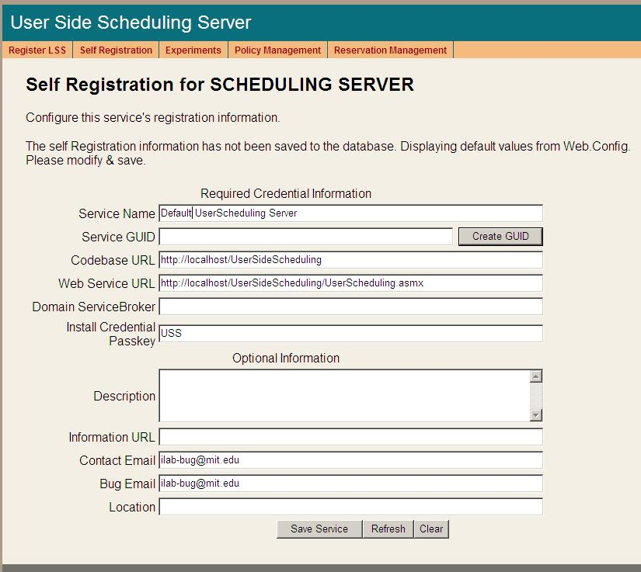
- Open Internet Explorer
- Browse to http://machinename.edu/UserSideScheduling/selfRegistration.aspx
- Modify the USS Service Name, CodeBase & Webservice URLs as needed. Please make sure that the Service Name is unique. Make sure to use fully qualified URLs.
  - Codebase URL: http://machinename.edu/UserSideScheduling
  - Web Service URL: http://machinename.edu/UserSideScheduling/UserScheduling.asmx
- Use the “Create GUID” button to generate a new GUID and remove the extra dashes so that the GUID is less than 35 characters.
- Update the optional fields (Description, Information URL, Contact Email, Bug Email and Location) as needed.
- Click the Save Service button

Labside Scheduling Service (LSS)

LSS Web Site
For Windows Server 2003, create a virtual directory in IIS.
- Right-Click on My Computer (renamed to your computer name)
- Click Manage
- Expand Services and Applications
- Expand Internet Information Services
- Expand Web Sites
- Expand Default Web Site
- Right-click on Default Web Site
- Select New->Virtual Directory
- Click Next to enter the Virtual Directory Creation Wizard
- In the Alias box, type LabSideScheduling
- Click Next
- Enter \*local_path*\iLabs\Services\LabSideScheduling in the Directory box (or click the Browse button, and navigate to the location where your Service Broker code is). If you used the pre-built code please use the builds directory.
- Click Next
- Access Permissions: make sure you check the Run Scripts, Execute and Read permission boxes
- Click Next
- Click Finish
- You should see the LabSideScheduling site listed under the Default Web Site
- Right click on the LabSideScheduling website and select Properties
- Select the ASP.NET tab
- Use the pull-down list for the ASP.NET version and select 2.0.xxx. Where xxx is the current release version.
- Select OK and close the properties window
- Close the Computer Management Window
For Windows Server 2008, create an application using the IIS Manager.
- Start -> Administrative Tools
- Open the Internet Information Service (ISS) Manager
- Expand Services and Applications
- Expand IIS Server (typically the machine name)
- Expand Sites
- Right-click on Default Web Site and select Add Application
- In the Alias field, type LabSideScheduling
- Click the Browse button and navigate to the location where your Service Broker code is located. The path should resemble \*local_path*\iLabs\Services\ LabSideScheduling directory. In addition, there is a set of precompiled builds located in \*local_path*\iLabs\Builds\ LabSideScheduling. Use the Service directory if you compiled the code yourself and the builds directory to use the pre-build versions. Click Next
- Click OK
- You should see the LabSideScheduling site listed under the Default Web Site

Create the Database
For Windows Server 2003, open the Enterprise Manager and navigate through the tree Console Root->Microsoft SQL Servers->SQL Server Group->(local)->Databases
For Windows Server 2008, open the Microsoft SQL Server Management Studio and navigate to Databases
- New Database…
- Name: iLab_LSS (You can use any name you would like but you must update the web.config file if you change this name)
- Click OK

Grant Access to the Database
In Windows Server 2003:
- Expand the Security folder in Enterprise Manager.
- Double-click on the NT AUTHORITY\NETWORK SERVICE under Logins
- Click the Database Access tab
- Check the box next to iLab_LSS (or the database name you used above)
- In the box below, click the box next to db_owner
- Click OK
In Windows Server 2008:
- Expand the Security folder in Microsoft SQL Server Management Studio.
- Right-click Logins, select New Login…
- In the Name box, type NT AUTHORITY\NETWORK SERVICE
  - Note: if you already have a login for NT AUTHORITY\NETWORK SERVICE, double-click on it and continue with the next step. If you are installing under Windows XP, please check the Windows XP notes guide for the proper security name to use.
- Click the User Management page
- Check the box next to iLab_LSS (or the database name you used above)
- In the box below, click the box next to db_owner
- Click OK

LSS Database Scripts
This document contains instructions for two different ways to run the database scripts for Microsoft SQL server; from within the SQL Query Analyzer or from the loader scripts that are in the DB_Scripts directory. Which method you use is determined by your operating system. Do NOT attempt both methods.

Operating system Use Method
Windows Server 2008 Method 1
Windows Server 2003 Method 2
Windows XP (not supported) Method 1

METHOD 1: Using the SQL Query Analyzer (Windows 2008)
- Open the Microsoft SQL Management Studio
- Expand the Database
- Select the iLab_LSS database (or what you named it)
- On the menu bar, click the SQL Query button
- Click File -> Open…
- Browse to database scripts directory typically \*local_path*\iLabs\ Database\DB_Scripts\ProcessAgent
Every service must have its own Process Agent information. These tables should exist before the service-specific tables are added to each database.
- In the ProcessAgent directory select and open the ProcessAgentTables.sql
- You may be asked to reconnect to the database.
- Make sure the correct database is the selected database in the dropdown menu at the top - *This is very important, because the scripts will be installed in the database specified by this pull-down menu.
- Click the button to run the script
- You should see a message: “The command(s) completed Successsfully.”
- Follow the same procedure, File→Open, to open and run the ProcessAgentProcedures.sql script.
- You should see the same message: “The command(s) completed Successsfully.”
- Open and run the SetDefaultsPA.sql script.
Next, set up and run the LSS database scripts, typically located in \*local_path*\iLabs\ Database\DB_Scripts\Scheduling.
- In Query Analyzer, click File -> Open…
- In the Scheduling directory select and open the LSS_Tables.sql
- Make sure the correct database is the selected database in the dropdown at the top, then click the Exectuebutton to run the script
- You should see the message: “The command(s) completed Successsfully.”
- Follow the same procedure to open and run the LSS_Procedures.sql script.
- Again, you should see the message: “The command(s) completed Successsfully.”
- Close SQL Query Manager and Enterprise Manager

METHOD 2: Using the SQL loader scripts (windows 2003)
- Open a Command Prompt window. Start -> Programs -> Accessories -> Command Prompt.
- A DOS window should open.
- Change the directory to the DBscripts directory.
- Type: “cd :\*local_path*\iLabs\ Database\DB_Scripts\”
- Type: “LoadLSS iLab_LSS” where ilab_LSS is the name of your database.
- You should see something similar to the following with your directory path and database name.
D:\iLabs\Database\DB_Scripts>loadLSS iLab_LSS
D:\iLabs\Database\DB_Scripts>echo populating LSS iLab_LSS
populating LSS iLab_LSS
D:\iLabs\Database\DB_Scripts>call LSS_tables.bat iLab_LSS
D:\iLabs\Database\DB_Scripts>echo LSS Tables: iLab_LSS
LSS Tables: iLab_LSS
D:\iLabs\Database\DB_Scripts>isqlw -E -d iLab_LSS -i .
\Ticketing\ProcessAgentTables.sql -o lssBuild.log
D:\iLabs\Database\DB_Scripts>isqlw -E -d iLab_LSS -i .
\Ticketing\SetdefaultsTicketing.sql -o lssBuild.log
D:\iLabs\Database\DB_Scripts>isqlw -E -d iLab_LSS -i
\Scheduling\LSSCreateTableScript.sql -o lssBuild.log
D:\iLabs\Database\DB_Scripts>echo LSS Procedures: iLab_LSS
LSS Procedures: iLab_LSS
D:\iLabs\Database\DB_Scripts>isqlw -E -d iLab_LSS -i .
\Ticketing\ProcessAgentProcedures.sql -o lssBuild.log
D:\iLabs\Database\DB_Scripts>isqlw -E -d iLab_LSS -i .
\Scheduling\LSSstoreprocedure.sql -o lssBuild.log

Web.Config
Web.config is a text file containing configuration information in XML format, residing in the root of the LSS Services web site (typically in the \*local_path*\iLabs\ Services\LabSideScheduling directory). Web.config.template ships with this release. If a web.config file already exists, please delete it. Copy web.config.template and paste the file into the same directory. Rename the copy “web.config” and edit it using notepad.

<?xml version="1.0"?>
<configuration xmlns="http://schemas.microsoft.com/.NetConfiguration/v2.0">
<appSettings>
<!--
LabSideScheduling Web.Config -->
<!--
ProcessAgent required Keys -->
<!-- THE FOLLOWING MUST BE SET FOR ALL SERVICES, used to define the service -->
<!-- The following keys specify the WebService required Values -->
<!-- They are used by the SelfRegistration page to generate the ProcessAgent's
Bootstrap ProcessAgent Record, which must be created before installing domain credientials -->

<add key="serviceType" value="LAB SCHEDULING SERVER"/>
<!-- The name of the Service displayed for the user, please change -->
<add key="serviceName" value="Default LabScheduling Server"/>
<!-- This Service's GUID You must supply a vaild GUID, see createGUID.exe, may be any string, 50 characters or less. -->
<add key="serviceGUID" value=""/>
<add key="codebaseURL" value="http://localhost/LabSideScheduling"/>
<add key="serviceURL" value="http://localhost/LabSideScheduling/LabScheduling.asmx"/>
<add key="defaultPasskey" value="LSS"/>

<!-- the database connection information
NOTE: You Must set the database catalog to the database name that you created as part of the instalation process -->
<add key="sqlConnection" value="data source=(local);initial catalog=iLab_LSS;Integrated Security=SSPI"/>
……………………………………..

Update the Database Name
Update the database connection variable in the web.config file to use the name you chose when you created the database. Note the default database name is set to iLab_LSS. If you used a different database name, update the catalog value in the key.
<add key=”sqlConnection”
value="data source=(local);initial catalog=iLab_LSS;Integrated Security = SSPI" />

Update Default Passkey
The default Pass Key is a simple string used by process agents to exchange credential information the first time only. This can be any string you would like. We recommend that you not change this.

<add key="defaultPasskey" value="LSS" />

Web.Config Parameters to be aware of:
ServiceType | LAB SCHEDULING SERVER –Do Not Change
serviceName | LSS unique name – change in selfRegister (later)
serviceGuid | This is the LSS’s Guid – change in selfRegister (later)
codebaseURL | LSS application URL – change in selfRegister (later)
serviceURL | LSS’s service URL
DefaultPassKey | Initial Passkey for credential exchange
sqlConnection | Database name – default ilab_LSS

Test the Scheduling Services:
- Open Internet Explorer
- Browse to http://machine.name.edu/LabSideScheduling/LabScheduling.asmx
The iLab architecture is designed to use fully qualified URLs, and unexpected things can happen when using localhost.

LSS Self Registration
In order for process agents to exchange credentials, their information needs to be entered into the Process Agents table. There is a self-registration web service included with each process agent. You should not self register a process agent until after you have created and edited the corresponding web.config file.
Most of the setup information like the serviceName, serviceGUID and codebaseURL is now entered on the self-registration page. Use fully qualified URLs.

Each Process Agent must have a unique GUID (Globally Unique Identifier) which will identify this particular Process Agent to all lab servers. This GUID will be supplied to the Lab Server(s) administrator so that the Lab Server can be configured to communicate with this Service Broker. We use a GUID produced on with all the '{', and '}' characters stripped out. You can generate your own GUID and enter it in the web.config use the “Generate GUID” button on the Service Broker’s self registration page (this is the preferred method).

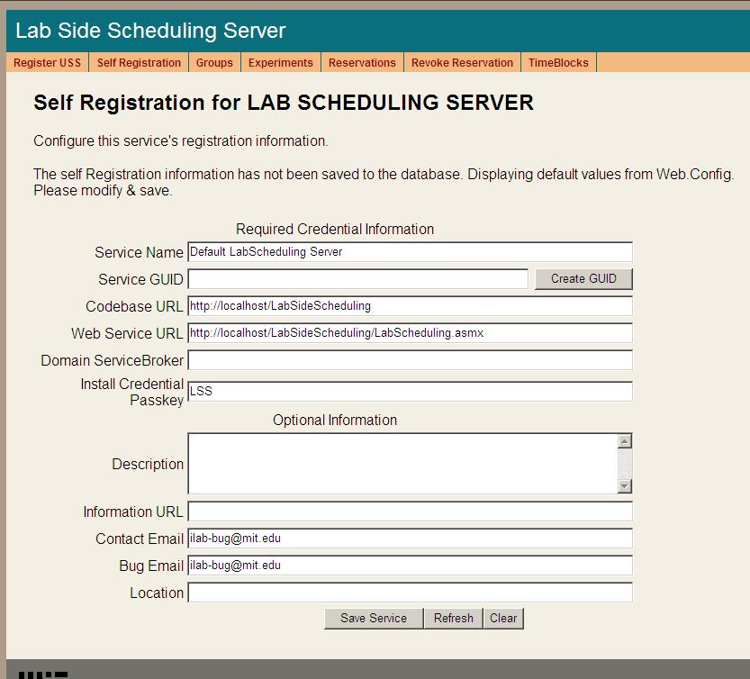
- Open Internet Explorer
- Browse to http://machine.name.edu/LabSideScheduling/selfRegistration.aspx
- Modify Service Name, CodeBase & Webservice URLs as needed. Please make sure that the Service Name is unique. Be sure to use fully qualified URLs.
  - Codebase URL: http://machinename.edu/LabSideScheduling
  - Web Service URL: http://machinename.edu/LabSideScheduling/LabScheduling.asmx
- Use the “Create GUID” button to generate a new GUID and remove the dashes so that it is less than 35 character.
- Update the optional fields (Description, Information URL, Contact Email, Bug Email and Location) as needed.
- Click the Save Service button

Time Of Day Lab Server (TOD)

TimeOfDay Web Site
For Windows Server 2003, create a virtual directory in IIS.
- Right-Click on My Computer (renamed to your computer name)
- Click Manage
- Expand Services and Applications
- Expand Internet Information Services
- Expand Web Sites
- Expand Default Web Site
- Right-click on Default Web Site
- Select New->Virtual Directory
- Click Next to enter the Virtual Directory Creation Wizard
- In the Alias box, type TimeOfDay
- Click Next
- Enter \*local_path*\iLabs\Services\TimeOfDay in the Directory box (or click the Browse button, and navigate to the location where your Service Broker code is). If you used the pre-built code, please use the builds directory.
- Click Next
- Access Permissions: make sure you check the Run Scripts, Execute and Read permission boxes
- Click Next
- Click Finish
- You should see the TimeOfDay site listed under the Default Web Site
- Right click on the TimeOfDay website and select Properties
- Select the ASP.NET tab
- Use the pull-down list for the ASP.NET version and select 2.0.xxx. Where xxx is the current release version.
- Select OK and close the properties window
- Close the Computer Management Window
For Windows Server 2008, create an application using the IIS Manager.
- Start -> Administrative Tools
- Open the Internet Information Service (ISS) Manager
- Expand Services and Applications
- Expand IIS Server (typically the machine name)
- Expand Sites
- Right-click on Default Web Site and select Add Application
- In the Alias field, type TimeOfDay
- Click the Browse button and navigate to the location where your Service Broker code is located. The path should resemble \*local_path*\iLabs\Services\ TimeOfDay directory. In addition, there is a set of precompiled builds located in \*local_path*\iLabs\Builds\ TimeOfDay. Use the Service directory if you compiled the code yourself and the builds directory to use the pre-build versions. Click Next
- Click OK
- You should see the TimeOfDay site listed under the Default Web Site

Create the Database
For Windows Server 2003, open the Enterprise Manager and navigate through the tree Console Root->Microsoft SQL Servers->SQL Server Group->(local)->Databases
For Windows Server 2008, open the Microsoft SQL Server Management Studio and navigate to Databases
- Right-Click on Databases
- New Database…
- Name: iLab_TOD (You can use any name you would like but you must update the web.config file if you change this name)
- Click OK

Grant Access to the Database
In Windows Server 2003:
- Expand the Security folder in Enterprise Manager.
- Double-click on the NT AUTHORITY\NETWORK SERVICE under Logins
- Click the Database Access tab
- Check the box next to iLab_TOD (or the database name you used above)
- In the box below, click the box next to db_owner
- Click OK
In Windows Server 2008:
- Expand the Security folder in Microsoft SQL Server Management Studio.
- Right-click Logins, select New Login…
- In the Name box, type NT AUTHORITY\NETWORK SERVICE
  - Note: if you already have a login for NT AUTHORITY\NETWORK SERVICE, double-click on it and continue with the next step. If you are installing under Windows XP, please check the Windows XP notes guide for the proper security name to use.
- Click the User Management page
- Check the box next to iLab_TOD (or the database name you used above)
- In the box below, click the box next to db_owner
- Click OK

TOD Database Scripts
This document contains instructions for two different ways to run the database scripts for Microsoft SQL server; from within the SQL Query Analyzer or from the loader scripts that are in the DB_Scripts directory. Which method you use is determined by your operating system. Do NOT attempt both methods.

Operating system Use Method
Windows Server 2008 Method 1
Windows Server 2003 Method 2
Windows XP (not supported) Method 1

METHOD 1: Using the SQL Query Analyzer (Windows 2008)
- Open the Microsoft SQL Management Studio
- Expand the Database
- Select the iLab_TOD database (or what you named it)
- On the menu bar, click the SQL Query button
- Click File -> Open…
- Browse to database scripts directory typically (\*local_path*\iLabs\ Database\DB_Scripts\ProcessAgent)
Every service must have its own Process Agent information. These tables should exist before the service-specific tables are added to each database.
- In the ProcessAgent directory select and open the ProcessAgentTables.sql
- You may be asked to reconnect to the database
- Make sure the correct database is the selected database in the dropdown at the top - *This is very important, because the scripts will be installed in the database specified by this pull-down menu.
- Click the Exectuebutton to run the script
- You should see a message: “The command(s) completed Successsfully.”
- Follow the same procedure, File→Open, to open and run the ProcessAgentProcedures.sql script.
- You should see the same message: “The command(s) completed Successsfully.”
- Open and run the SetDefaultsPA.sql script.
- Close SQL Query Manager and Enterprise Manager
For the Time Of Day Server, there are no process agent-specific database scripts that need to be run.
METHOD 2: Using the SQL loader scripts (Windows 2003)
- Open a Command Prompt window. Start -> Programs -> Accessories -> Command Prompt.
- A DOS window should open.
- Change the directory to the DBscripts directory.
- Type: “D:” to change the disk if you need to
- Type: “cd :\*local_path*\iLabs\ Database\DB_Scripts\”
- Type: “LoadTOD iLab_TOD” where ilab_TOD is the name of your database.
- You should see something similar to the following with your directory path and database name.
D:\iLabs\Database\DB_Scripts>loadTOD iLab_TOD
D:\iLabs\Database\DB_Scripts>echo populating TOD TODdb
populating TOD iLab_TOD
D:\iLabs\Database\DB_Scripts>call TOD_tables.bat TODdb
D:\iLabs\Database\DB_Scripts>echo populating TOD TODdb
populating TOD iLab_TOD
D:\iLabs\Database\DB_Scripts>isqlw -E -d iLab_TOD -i .
\Ticketing\ProcessAgentTables.sql -o TODBuild.log
D:\iLabs\Database\DB_Scripts>isqlw -E -d iLab_TOD -i .
\Ticketing\SetdefaultsTicketing.sql -o TODBuild.log
D:\iLabs\Database\DB_Scripts>call TOD_procedures.bat iLab_TOD
D:\iLabs\Database\DB_Scripts>echo TOD Procedures: TODdb
TOD Procedures: iLab_TOD
D:\iLabs\Database\DB_Scripts>isqlw -E -d Ilab_TOD -i .
\Ticketing\ProcessAgentProcedures.sql -o TODBuild.log
D:\iLabs\Database\DB_Scripts>loadTOD iLab_TOD
D:\iLabs\Database\DB_Scripts>echo populating TOD TODdb
populating TOD iLab_TOD
D:\iLabs\Database\DB_Scripts>echo populating TOD TODdb
populating TOD iLab_TOD
D:\iLabs\Database\DB_Scripts>isqlw -E -d iLab_TOD -i .
\Ticketing\ProcessAgentTables.sql -o TODBuild.log
D:\iLabs\Database\DB_Scripts>isqlw -E -d iLab_TOD -i .
\Ticketing\SetdefaultsTicketing.sql -o TODBuild.log
D:\iLabs\Database\DB_Scripts>call TOD_procedures.bat iLab_TOD
D:\iLabs\Database\DB_Scripts>echo TOD Procedures: TODdb
TOD Procedures: iLab_TOD
D:\iLabs\Database\DB_Scripts>isqlw -E -d iLab_TOD -i .
\Ticketing\ProcessAgentProcedures.sql -o TODBuild.log

Web.Config
An overview of editing the web.config
Web.config is a text file containing configuration information in XML format, residing in the root of the InterctiveTimeOfDay web site (typically in the \*local_path*\iLabs\ Services\InteractiveTimeOfDay directory). Web.config.template ships with this release. If a web.config already exists, please delete it. Copy web.config.template and paste the file into the same directory. Rename the copy “web.config” and edit it using notepad. Use only fully qualified URLs in the web.config file.
<?xml version="1.0"?>
<configuration>
<appSettings>
<!--
Interactive TimeOfDay Web.Config -->

<!--
ProcessAgent required Keys -->
<!-- THE FOLLOWING MUST BE SET FOR ALL SERVICES, used to define the service -->
<!-- The following keys specify the WebService required Values -->
<!-- They are used by the SelfRegistration page to generate the ProcessAgent's
Bootstrap ProcessAgent Record, which must be created before installing domain credientials -->

<add key="serviceType" value="LAB SERVER"/>
<!-- The name of the Service displayed for the user, please change -->
<add key="serviceName" value="Default TimeOfDay Server"/>
<!-- This Service's GUID You must supply a vaild GUID, see createGUID.exe, may be any string, 50 characters or less. -->
<add key="serviceGUID" value=""/>
<add key="codebaseURL" value="http://localhost/TimeOfDay"/>
<add key="serviceURL" value="http://localhost/TimeOfDay/TimeOfDayWebService.asmx"/>
<add key="defaultPasskey" value="TOD"/>

<!-- the database connection information
NOTE: You Must set the database catalog to the database name that you created as part of the instalation process -->
<add key="sqlConnection" value="data source=(local);initial catalog=iLab_TOD;Integrated Security=SSPI"/>

Update the Database Name
Update the database connection variable in the web.config file to use the name you chose when you created the database. Note the default database name is set to iLab_TOD. If you used a different database name, update the catalog value in the key.
<add key=”sqlConnection”
value="data source=(local);initial catalog=iLab_TOD;Integrated Security = SSPI" />

Note: there is an mistake in the web.config file in the release … check the database name in the web.config file and make sure that the database name you used to create the database matches exactly including capitalization.

Update Default Passkey
The default Pass Key is a simple string used by process agents to exchange credential information the first time only. This can be any string you would like. We recommend that you not change this.

<add key="defaultPasskey" value="TOD" />

Web.Config Parameters to be aware of:
serviceType | LAB SERVER – Do Not Change
serviceName | Lab Server unique name – Change in selfRegistration
serviceGuid | This is the LSS’s Guid name – Set in selfRegistration
codebaseURL | Lab Server URL – Change in selfRegistration
serviceURL | Lab Server’s service URL – Change in selfRegistration
DefaultPassKey | Initial Passkey for credential exchange
sqlConnection | Database name – default ilab_TOD

Test the Time Of Day Server:
- Open Internet Explorer
- Browse to http://machine.name.edu/TimeOfDay/TimeOfDayWebService.asmx
The iLab architecture is designed to use fully qualified URLs, and unexpected things can happen when using localhost.

TOD Self Registration
In order for process agents to exchange credentials, their information needs to be entered into the Process Agents table. There is a self-registration webservice included with each process agent. You cannot register a process agent until after you have created and edited the corresponding web.config file.
Most of the setup information like the serviceName, serviceGUID and codebaseURL is now entered on the web service self-registration page.

Each Process Agent must have a unique GUID (Globally Unique Identifier) which will identify this particular Process Agent to all lab servers. This GUID will be supplied to the Lab Server(s) administrator so that the Lab Server can be configured to communicate with this Service Broker. We use a GUID produced on with all the '{', and '}' characters stripped out. You can generate your own GUID and enter it in the web.config or use the “Generate GUID” button on the Service Broker’s self registration page (this is the preferred method).

- Open Internet Explorer
- Browse to http://machine.name.edu/TimeOfDay/selfRegistration.aspx
- Modify Service Name, CodeBase & Webservice URLs as needed. Please make sure that the Service Name is unique. Be sure to use fully qualified URLs.
  - Codebase URL: http://machinename.edu/TimeOfDay
  - Web Service URL: http://machinename.edu/TimeOfDay/ TimeOfDayWebService.asmx
- Use the “Create GUID” button to generate a new GUID and remove the dashes so that the GUID is less than 35 characters long.
- Update the optional fields (Description, Information URL, Contact Email, Bug Email and Location) as needed.
- Click the Save Service button
Currently, there is no CSS associated with the Time Of Day Interactive Experiment self-registration page.

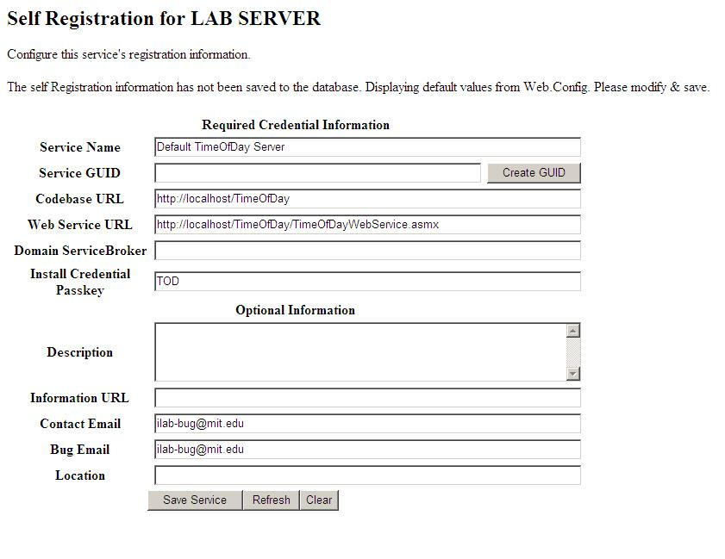

Bootstrapping

Bootstrapping is the process of enabling the various iLab services to recognize each other and exchange credentials. This initial bootstrapping process will assume that you are logged into the iLab Service Broker as a SuperUser and that all servers are in the same domain. To manage the USS and LSS directly, you will need to be logged in as the correct management group – not as SuperUser
This document will set up and configure the different services for the Service Broker, and configure the Time Of Day (TOD) test lab.
NOTE: This document assumes that you will replace your computer’s name and fully qualified URL where ever you see “machinename.edu”.

Users and Groups
At the time of installation, the database script creates one default user and group called “SuperUser”. This user is the Service Broker’s administrator and has full permissions. Any user added to this group will also have full administration permissions on the Service Broker.
In addition to the SuperUser group, you will need administrator groups for Process Agent services such as the USS and LSS, and a management group for each user group. Members of the administration groups will have SuperUser permissions on the specified Process Agent; typically these are the lab or department administrators. Members of the management groups will have control over a particular group of students; typically these are the class TAs.
Create an administrator group for administering the Userside Scheduling Server (USS) called USS_admin
- Navigate to http://machinename.edu/ilabservicebroker
- Log in as SuperUser
- Click on the Users & Groups tab on the main menu of the Service Broker.
- In the sub-menu, select the Administer Groups tab.
- Click on the Add Service Admin Group button. A popup window should appear.
- Enter the Group Name “USS_admin”.
- Enter a Description, “Administration group for the USS”.
- Enter the administrator’s contact email address.
- This service does not need a request group, so do not click on Need Request group.
- This is a Administer group, so you do not need to add or change the Direct Group Membership area.
- Click on the Save Changes button. The new group should be listed on the Administer Groups page.
Create an Administrator group for administering the Labside Scheduling Server (LSS) called LSS_admin
- On the Administer Groups page, click on the Add Service Admin Group button. A popup window should appear.
- Enter the Group Name “LSS_admin”.
- Enter a Description, “Administration group for the LSS”.
- Enter the administrator’s contact email address.
- Click on the Save Changes button. The new LSS_admin group should be listed on the Administer Groups page.
Create a management group for managing the Lab Server (LS) configurations on the Labside Scheduling Server (LSS). In our case we will be managing the Time Of Day Lab Server configuration on the LSS, but this group will manage all the Lab Servers using this LSS.
- On the Administer Groups page, click on the Add Service Admin Group button. A popup window should appear.
- Enter the Group Name “Manage_LS_on_LSS”.
- Enter a Description, “Managers group for managing the Lab Servers using the LSS”.
- Enter the administrator’s contact email address.
- Click on the Save Changes button. The new group should be listed on the Administer Groups page.
Create a management group for managing the Time Of Day users group on the Userside Scheduling Server (USS)
- On the Administer Groups page, click on the Add Service Admin Group button. A popup window should appear.
- Enter the Group Name “Manage_Users_on_USS”.
- Enter a Description, “Managers group for managing the Time of Day lab users on the USS”.
- Enter the administrator’s contact email address.
- Click on the Save Changes button. The new group should be listed on the Administer Groups page.
Create a group for users of the Time Of Day Experiment
- On the Administer Groups page, click on the Add Group button. A popup window should appear.
- Enter the Group Name “Experiment_Group”.
- Enter a Description, “User Experiment Group for running and testing Experiments”.
- Enter the administrator’s contact email address.
- The Time Of Day Interactive Lab service does not need any additional groups, so do not click on Need Request group or Need course Staff Group.
- Click on the Save Changes button. The new Experiment_Group group should be listed on the Administer Groups page.
- Next, we need to give this group permission to create and store experiments. Click on the Edit button for the Experiment_Group. A popup window will appear.
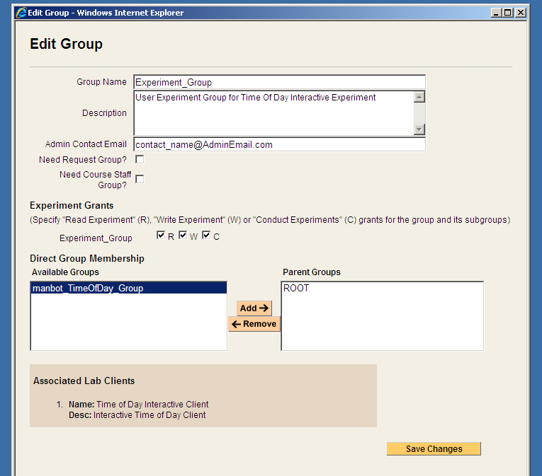
- In the Experiment Grants area under Experiment_Group click on the R, W and C boxes.

Process Agents
Process Agents are services (web servers or web service calls) that that the Service Broker can use. Setting up a new Process Agent is a two step process. We have tried to automate this process as much as possible to eliminate the need for human data entry. For each Process Agent (except the Service Broker) you will need to contact the Process Agent administrator via email and get the web services URL and an initial passkey. With these two items (web services URL and passkey) you should be able to install domain credentials.

Service Broker
The Service Broker Information page can be found on the Self Registration tab in the Service & Clients sub-menu. Make sure this information is correct before beginning the bootstrapping process. The self registration information is used to create process agent credentials and cannot be changed once process agents are registered. We recommend using fill qualified URLs at all times.
Complete the Service Broker information in the Process Agent’s table
- Click on the Services & Clients tab
- Click on the Manage Process Agents tab
- Use the Services pull-down menu to select the Service Broker.
- Enter your University Name and Service Broker name into the description field, if it is not already entered.
- Enter a URL for service information in the info_URL box, if available
- Enter a contact email into the correct box.
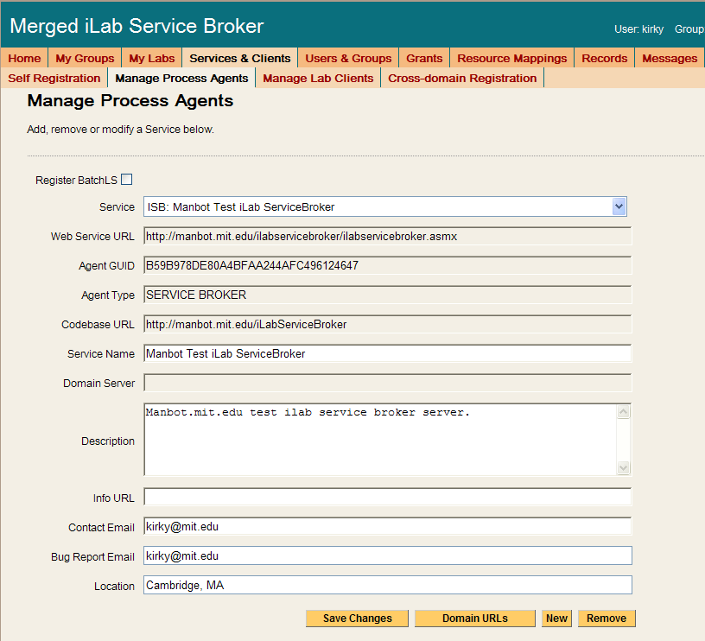
- Click Save Changes. You should see a green box at the top of the page stating that the record has been modified.
For the Service Broker, there are no additional Domain URLs that need to be entered.

Experiment Storage Service (ESS)
To add the Experiment Storage Service to the Service Broker, you will need the web service URL and an initial passkey for the ESS. This should be exchanged via email if you are not the owner of these services. For this document, we will assume that you are the administrator for all services and that you will be using the default initial passkey values.
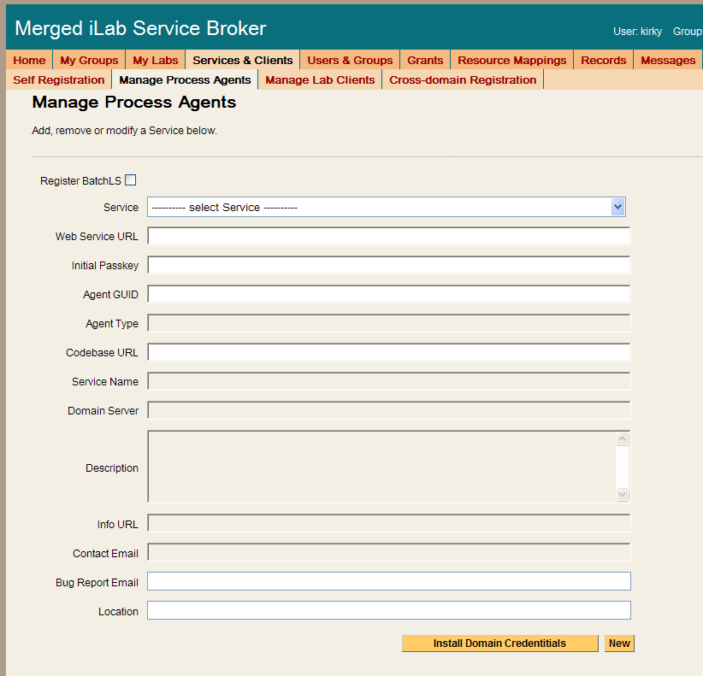
Add the ESS to the Service Broker and exchange credentials.
- Click on the Manage Process Agents page.
- Enter ESS info (web services URL & passkey) into the correct fields. Default Web Services URL: http://machinename.edu/ExperimentStorage/ExperimentStorage.asmx Default Passkey: ESS
- Click on the Install domain credentials button.
- A register web service call is made using the web services URL and initial passkey to get the Process Agent’s information and credentials.
- You should see a green message bar at the top of the page stating that a “Relationship has been created and saved.”
Complete the information record for the ESS.
- You can use the description area to make notes about the process agent as needed. Make any other necessary changes to fields like info URL, contact email, bug email, and location.
- For the ESS, you do not need to select an Admin Group pull down list.
- Click Save Changes. You should see a green box at the top of the page stating that the record has been successfully updated.
The ESS does not need to have any Domain URLs entered.

Userside Scheduling Server (USS)
To add the User-side Scheduling Service to the Service Broker, you will need the web service URL and an initial passkey for the USS.
Add the USS to the Service Broker and exchange credentials.
- Click on the Manage Process Agents tab
- Enter USS info (web services URL & passkey) into the correct fields. Default Web Services URL: http://machinename.edu/UserSideScheduling/UserScheduling.asmx
- Default Passkey: USS
- Click on the Install domain credentials button.
- A register web service call is made using the web services URL and initial passkey, to get the process Agents information and credentials.
- You should see a green message bar at the top of the page stating that a “Relationship has been created and saved.”

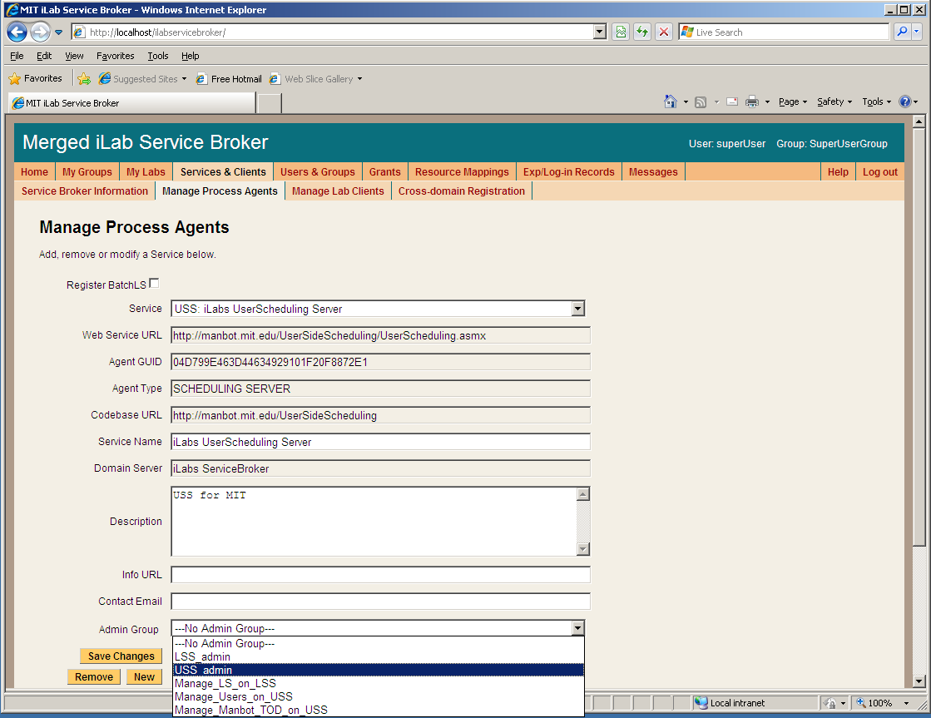

Associate the USS Administration Group with the USS.
- Still on the “Manage Process Agents” page, select the “USS_admin” group from the Admin Group pull down list. (This is the administrator group that will manage the USS that was created earlier.)
- You can use the description area to make notes about the process agent as needed. Enter “USS for your_university name” into the description area.
- Click Save Changes. You should see a green message bar at the top of the page stating that the record has been successfully modified.

Domain URLs are needed for administering and managing the USS. These URLs are automatically generated and entered into the database. To check the domain URLs:
- Click on the Domain URLs button. The domain URLs will be displayed in the Existing URL area.
- For the USS, there should be three domain URLs. Administer_USS, Manage_USS_Group, and Schedule_Session
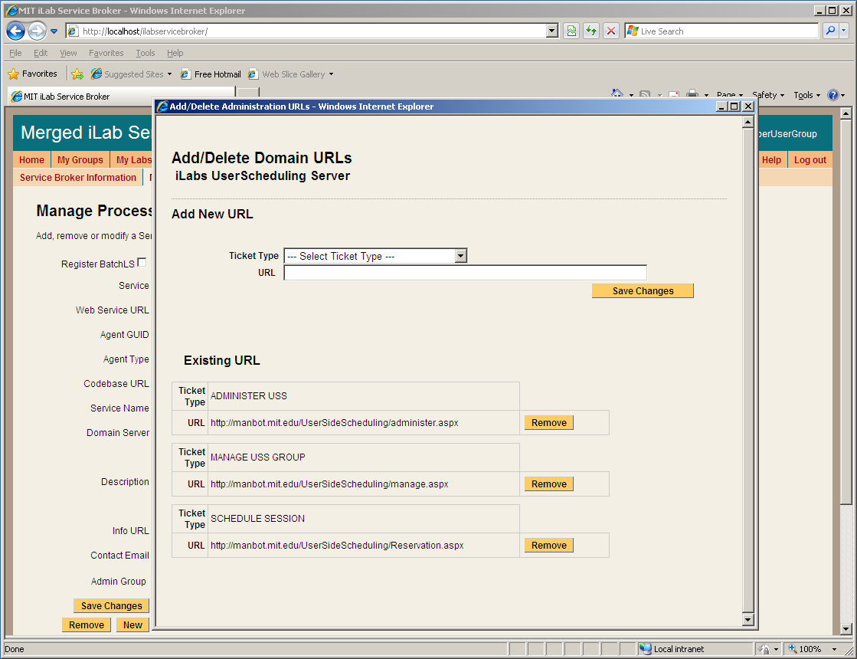
- Close the Domain URLs popup window.

Labside Scheduling Server (LSS)
To add the Labside Scheduling Service to the Service Broker, you will need the web service URL for the LSS and an initial passkey. This should be exchanged via email if you are not the owner of these services. For this document, we will assume that you are the administrator for all services and that you will be using the default initial passkey values.
Add the LSS to the Service Broker and exchange credentials.
- Click on the Manage Process Agents tab
- Enter LSS info (web services URL & passkey) into the correct fields.
- Default Web Services URL: http://machinename.edu/LabSideScheduling/LabScheduling.asmx
- Default Passkey: LSS
- Click on the Install domain credentials button.
- A register web service call is made using the web services URL and initial passkey, to get the process Agents information and credentials.
- You should see a green message bar at the top of the page stating that a “Relationship has been created and saved.”
Associate the LSS Administration Group with the USS.
- Select the “LSS_admin” group from the Admin Group pull down list. (This is the administration group that will manage the LSS.)
- You can use the description area to make notes about the process agent as necessary. Enter “LSS for your_university name” into the description area.
- Click Save Changes. You should see a green message bar at the top of the page stating that the record has been successfully updated.
Domain URLs are needed for administering and managing the USS. These URLs are automatically generated and entered into the database. To check the domain URLs:
- Click on the Domain URLs button. The domain URLs will be displayed in the Existing URL area.
- For the USS, there should be two domain URLs: Administer_LSS and Manage_Lab.
- Close the Domain URLs popup window.

Time Of Day Lab Server (LS)
To add the Lab Server to the Service Broker, you will need the web service URL and an initial passkey for the Lab Server. This should be exchanged via email if you are not the owner of these services. For this document, we will assume that you are the administrator for all services and that you will be using the default initial passkey values.
Add the ToD Lab Server to the Service Broker and exchange credentials.
- Click on the Manage Process Agents tab
- Enter LS info (web services URL & passkey) into the correct fields.
- Default Web Services URL: http://machinename.edu/TimeOfDay/TimeOfDayWebService.asmx
- Default Passkey: TOD
- Click on the Install domain credentials button.
- A register web service call is made using the web services URL and initial passkey, to get the process Agents information and credentials.
- You should see a green message bar at the top of the page stating that a “Relationship has been created and saved.”
Associate the LSS and management group with this Lab Server.
- Select the LSS to associate with this Lab Server from the pull-down list
- Select a Management group (Manage_LS_on_LSS) from the pull-down list
- Click the Associate button
The Lab Server does not need an Admin Group nor does it have any Domain URLs entered.

Time Of Day Lab Client

Lab Client Record
Create a Time Of Day Lab Client record.
- Click the Manage Lab Clients tab.
- Lab Client Name: Time Of Day Interactive Client
- Click the Make Guid button to generate a new GUID for this client. GUIDs can not be changed once the client record is saved.
- Version: 1.5
- Short Description: Interactive Time Of Day Client
- Long Description: Interactive Time Of Day Client with elephant image.
- Contact First Name: Your Name
- Contact Last Name: Your Name
- Contact Email: your@email_address
- Click on the box next to Needs Scheduling
- Click on the box next to Needs ESS
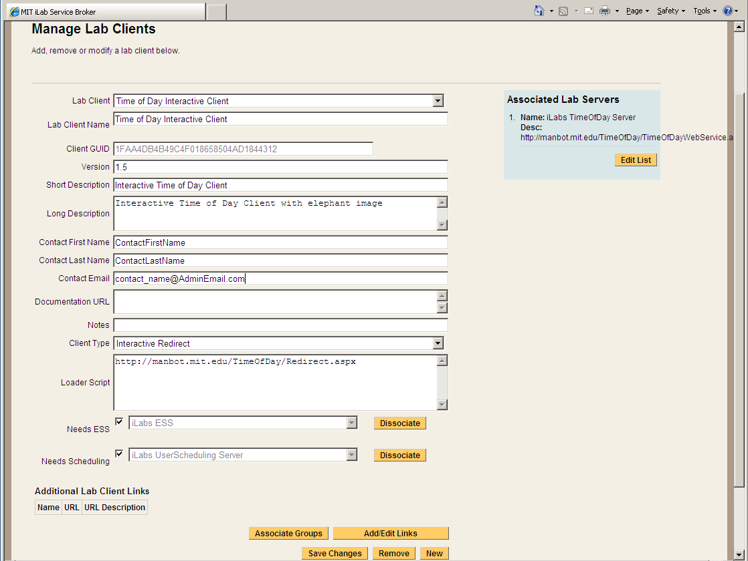

Client Loader Script
The Time Of Day Interactive Client is an HTML redirect client. Make sure to use fully qualified URLs.
Set up the Client loader scripts.
You should still be on the Manage Lab Clients page.
- On the Time Of Day Interactive Clients page, select “Interactive Redirect” from the Client Type pull-down list.
- Enter the redirect URL “http://machinename.edu/TimeOfDay/Redirect.aspx” into Loader Script area.
- Click Save Changes
- You should see a green message bar at the top of the page stating that the record has been modified.

Associate the Lab Server
You should still be on the Manage Lab Clients page.
Associate the Time Of Day Lab Server with the Time Of Day Client.
- Click the Edit List button under Associated Lab Servers in the upper right column. A popup window will appear.
- In the popup window, notice the Time Of Day Server web service URL in the left hand box labeled Available Lab Server.
- Select the Time of Day Lab Server web service URL so it is highlighted, then select the Add >> button.
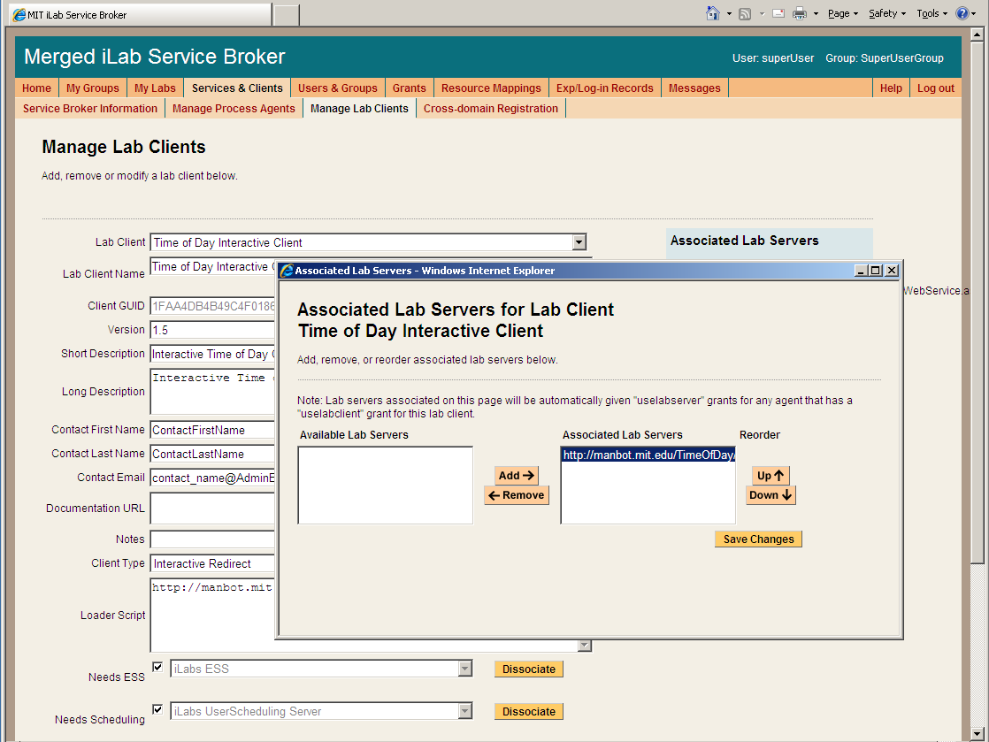
- Click the Save Changes.
- The Time Of Day Lab server should now appear in the blue box labeled Associated Lab Servers.

Associate the ESS and USS
The Time Of Day experiment uses both the USS and the ESS. Before the experiment can be run, the USS and the ESS must be associated with the client.
- From the Manage Lab Clients page, use the Needs ESS pull-down list to select which ESS this client will use.
- Click the Associate button.
- You should see a green message bar at the top of the page stating that the record has been successfully associated.

- Use the Needs Scheduling pull-down list to select which USS this client will use.
- Click the Associate button.
- You should see a green message bar at the top of the page stating that record has been successfully associated.

Associate Groups
Associate the Time Of Day Interactive client with the user and management groups.
- Click the Associate groups button at the bottom of the Manage Lab clients page.
- The Time Of Day interactive client should already be selected.
- The associated services (USS, ESS, Lab Server) should contain the correct information.
- Select the group that will use this client. In this case, select the Experiment_Group from the pull-down list.
- Use the pull-down list to select the management group for the Experiment_Group. In this case, select the Manage_Users_on_ USS group.
- Click the Save Changes button. The associated groups and manager should now be listed.
- A green bar should appear at the top of the window indicating a successful update.
- Close the popup window and return to the Manage Lab Clients Page.

Create a Test User
You will need a new user for testing.
Create a test user.
- Click the Users & Groups Tab.
- Click the Manage Users tab.
- Enter the user information for a test account. Use any username, information and password that you want.
- Select the Save Change button.
- A green bar at the top of the page should indicate that you have successfully created a new user.

Group Membership
Now that there is a test user, it needs to be given the correct group memberships. For testing purposes, the user needs to be part of five groups.
Add the user to the LSS_admin, Manage_LS_on_LSS, USS_admin, Manage_Users_on_USS, and Experiment_Group groups.
- Click the Group Membership Tab.
- In the left hand “Users and Groups” tree, click the + sign next to the NewUserGroup.
- You should see your test user listed.
- Click the box next to your test username to select it.
- Click on the right side “Target Groups” tree, select the group(s) you would like to join. For this user, select the Manage_LS_on_LSS, the Manage_Users_on_USS and the Experiment_Group boxes.
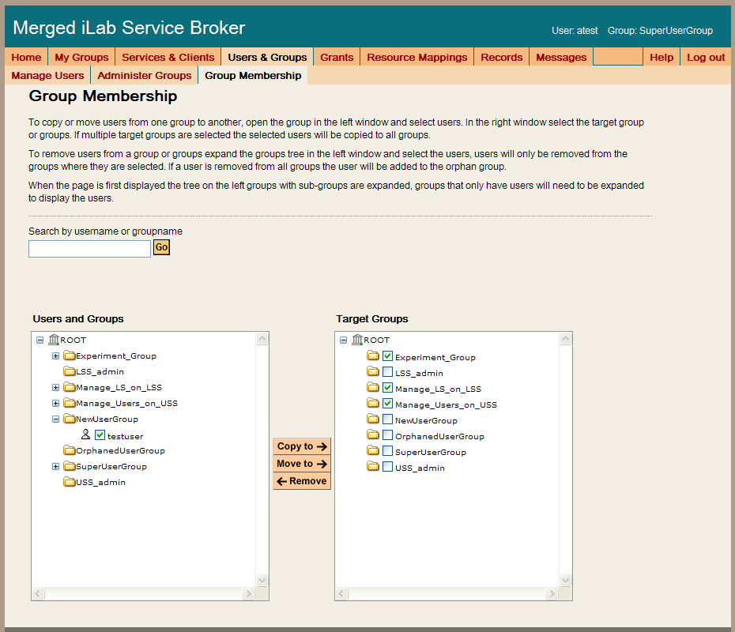
- Click on the Move To -> button
- In the left hand “Users and Groups” tree, the test user should now appear under the Experiment_Group, Manage_LS_on_LSS and the Manage_Users_on_USS Groups.
- The test user should now be in 3 groups.

Setup Time Of Day Experiment
Log out of the SuperUser account and log in as your test user.

Manage USS
Manage the TimeOfDay users on the USS
- Select Manage_Users_on_USS as your group.
- In the Service Administration page, use the – Select Process Agent - pull down list to select your USS.
- Click the USS Manage Group button
- The User Side Scheduling Server should load.
- Click on the Policy Management tab.
- Use the pull down list to select the Experiment
- The group should automatically fill in.
- Enter the Minimum Time Required: 1
- Enter the Maximum Reservation Time: 5
- Click the Save Changes button
- Click the Back to Service Broker tab.
- Click on the My Groups tab.

Manage LSS
Manage the TimeOfDay server on the LSS
- Select Manage_LS_on_LSS as your group.
- In the Service Administration page, use the – Select Process Agent - pull down list to select your LSS.
- Click the Manage Lab button
- The Lab Side Scheduling Server should load.
- Click on the Experiment tab.
- Select the Lab Client “TimeOfDay Interactive Client, 1.5” from the list on the left.
- The client information should automatically populate the fields.
- Update the fields as follows:
- Enter Minimum Time (min): 1
- Enter Prepare Time (min): 0
- Enter Recover Time (min): 0
- Enter Early Arrive Time (min): 0
- Click the Save Changes button.

- Click on the TimeBlocks tab.
- Click New.
- Use the Lab Server Resource pull down list to select your Time of Day Server.
- In Recurrence Type: select Single Block
- In the Date Span field, use the calendar icons to set the Begin Date and End Date.
- Set the Quantum to 1
- Leave the Start Time set to 12:00 AM
- Leave the End Time set to 12:00 AM
- Click Save
- In the TimeBlock tab, select the time block you just created.
- In the left column of the Select Experiment block, select the TimeOfDay Interactive Client
- Click on the Permit button
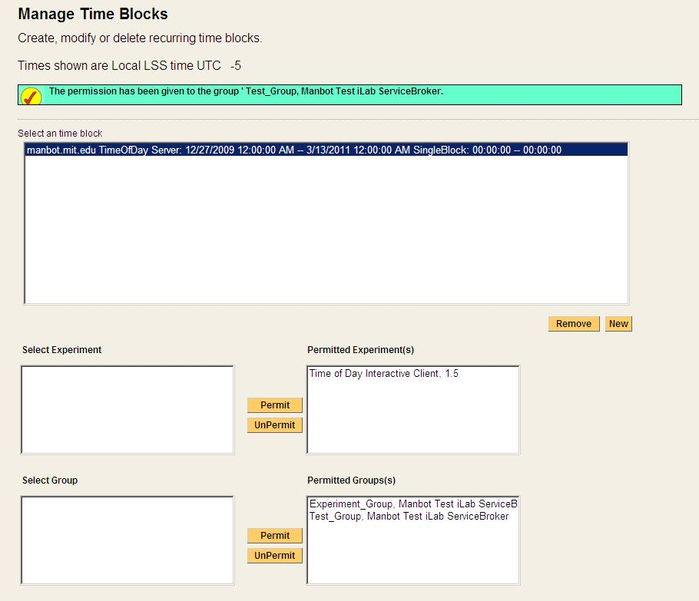
- A green bar at the top of the page should state that permissions have been granted to the experiment.
- In the left column of the Select Group block, select the Experiment_Group
- Click on the Permit button
- A green bar at the top of the page should state that permissions have been granted to the group.
- Click the Back to Service Broker tab.
- Click on the My Groups tab.
The following experiment is just for confirmation of a clean install, no administration or configuration is needed.

Running the Time Of Day Experiment
Make sure that you have logged out of the SuperUser account and log in as your test user.
Scheduling and Running the Time of Day Experiment
- Select Experiment_Group as your effective group.
- From the My Labs page, click on the Schedule/Redeem Session button.
- In the scheduling window, the highlighted date should be set to today.
- Click on today’s date in the calendar area – if your browser has popup blocker turned on, you will need to hold the ctrl-key down and click on the date.
- In the scheduling popup window, the available times are identified in green and the reserved times are red. Click on the first green area.
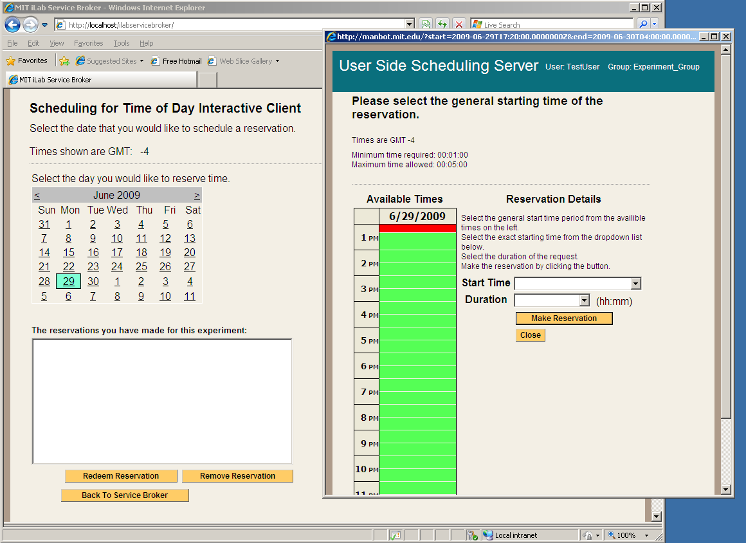
- In the Reservation Details area, use the Start Time pull down to select your start time and the Duration pull down to select your reservation length. In this case select 5 minutes for your duration.
- Click on the Make Reservation button.
- You will see a message in a green bar at the top of the window that says “The reservation is confirmed successfully”.
- Click on the Close button
- The reservation should appear in the reservation window.
- Click on the reservation to highlight it.
- Click on the Redeem Reservation button.
- Depending on the computers clock a small green bar may appear at the top of the page letting you know how long until the reservation is valid. If this happens, wait the allotted time and click the Redeem Reservation button again.
- On the My Labs page, click the Launch Client button.
- The Time Of Day Interactive Lab Client will load. (not very exciting)
- Click on the Get Time of Day Button.
- The date and time is returned and a blob is stored in the database with the Date and Time.
  - Click the Request Blob Access button to see the elephant image with the Date and Time stamp. (Cute Elephant!)
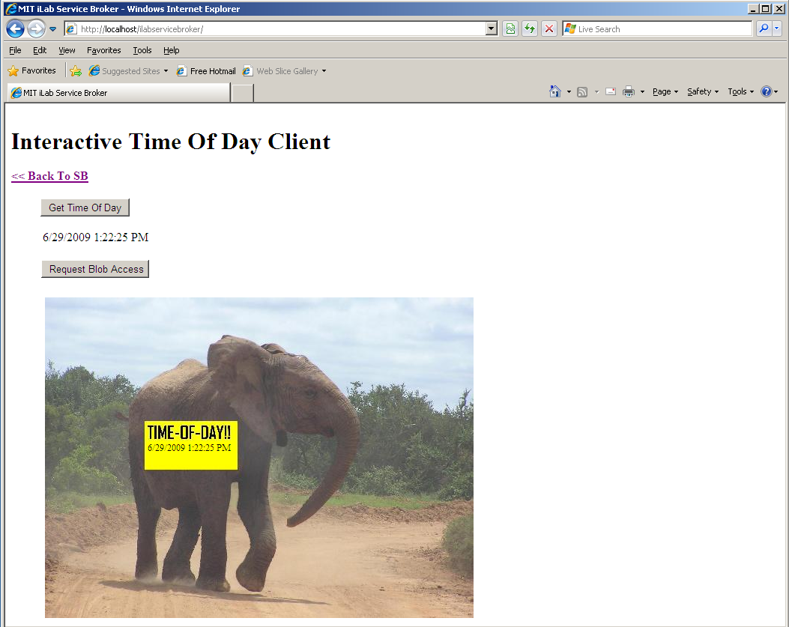
- Use the << Back To SB link to return to the Service Broker.

Troubleshooting

Grants
Currently, the bootstrapping process does not automatically give the managers of the LSS the correct permissions to manage the lab server on the LSS. This will be fixed in the next release.
- Give the Managers of the LSS permission to manage the LS.
  - Click on the Grant tab in the main menu.
  - In the Users & Groups tree on the left side, click on Manage_LS_on_LSS group to highlight it.
  - Under functions, click on Manage Lab.
  - Under Qualifiers, select the resource mapping between the Interactive Lab Sever and the LSS; Look for a resource mapping where the Process Agent: ILS and the ResourceType: LSS
  - Click the Add Grant button.
  - A green message bar should appear at the top of the screen indicating a successful update.

  - Note: You may get this error message: “Unable to find script library ‘/aspnet_client…WebUIValidation.js’ If you see this, do the following:
  - Open a command prompt with Start->Run-CMD
  - Type CD\Windows\Microsoft.NET\Framework\v1.1.4322
  - Type aspnet_regiis –c
  - You should see a message that says “Start copying the ASP.NET client side script files for this version (1.1.4322.0)…Finished copying the ASP.NET client side script files for this version (1.1.4322.0)”
  - Type Exit to close the command prompt
  - Click OK on the “Unable to find script library” error message

Web.config issue
There is a problem with the specified service’s web.config file. Please delete the current web.config file from the service’s directory and copy the web.config.template to create a new web.config file.
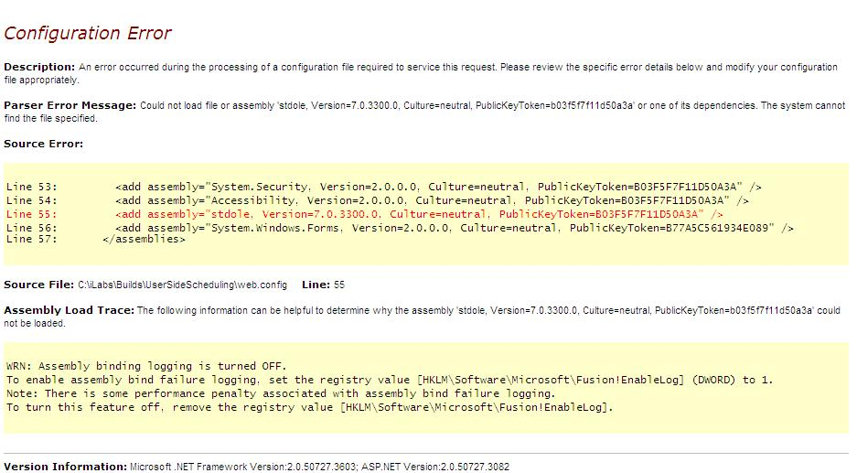

Incorrect Password
Incorrect password was supplied when trying to install domain credentials. Check the web.config file for the service or the database for the correct password.
