**HNCut plug-in**

**Description:**

The purpose of this plugin is to detect and quantify biomarkers in histopathology images by allowing the users to select just a few representative pixels (swatch) from the color region of interest.

This algorithm is developed by CCIPD at Case Western Reserve University.

Paper on HNCut:

Janowczyk A., Chandran S. Singh R., Sasaroli D., Coukos G., Feldman M.D., Madabhushi A. “High-Throughput Biomarker Segmentation on Ovarian Cancer Tissue Microarrays via Hierarchical Normalized Cuts.” Trans Biomed Eng, 2012

**Installation:**

1. Install Matlab Runtime R2015a (8.5) 64 bit version:

<http://www.mathworks.com/supportfiles/downloads/R2015a/deployment_files/R2015a/installers/win64/MCR_R2015a_win64_installer.exe>

1. Copy HNCut.dll to C:\Programs Files (x86)\Sedeen Viewer\plugins\
2. Copy HNCut.exe to C:\Programs Files (x86)\Sedeen Viewer
3. Open Sedeen, load an image and select “HNCut” from the algorithm menu.

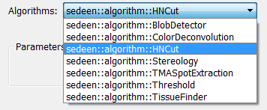

1. Click “Run”
2. In the pop-up image, select a few representative pixels (<10) from the color region of interest and press “Enter” when finish selection.
3. The user will see the HNCut result.