Lab 6 Summary

Schuster, Mark

Section 1540

11/05/2017

**B)** Pre-Lab Answers:

1. 10 MHz, thus we must use a prescaler of 4 to set the input CLK to 8MHz.
2. MSB as stated in the write/read cycle section of the datasheet
3. They are enabled by setting the sampling rate in the CTRL_REG5_A register, whereas the gyroscope is enabled by setting the GYRO_ENABLE pin on port A.
4. Because SPI works by shifting the data out and simultaneously into the data register. Thus to receive data, dummy data must first be present to by shifted out.
5. Because this minimizes time spent inside the interrupt. Prolonged time spent inside an interrupt can limit the amount of time available to other potential interrupts, and slow the program down.

**C)** Problems encountered:

The graph was not plotting the correct data, and the accelerometer was not taking samples. I asked two TAs but neither were able to help. It wasn’t until the .gif was posted that I realized I had to use “Serial Port” control scheme under “External Connection” instead of the USART configuration immediately present upon connection to the device.

**D)** Future Work/Applications:

I enjoyed working with SPI and I look forward to using it in high throughput applications.

**E)** Schematics:

Not applicable for this lab.

**F)** Pseudocode/Flowcharts:

Lab6a flow diagram:

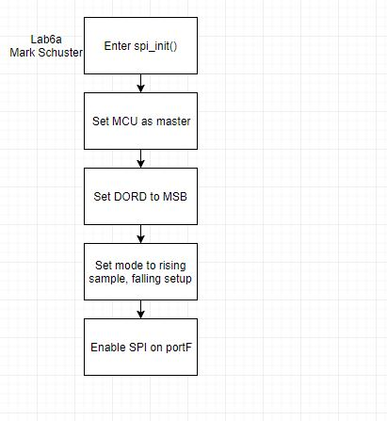

Lab6b flow diagram:

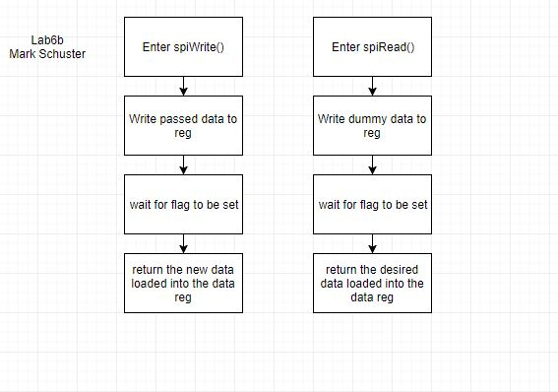

Lab6c flow diagram:

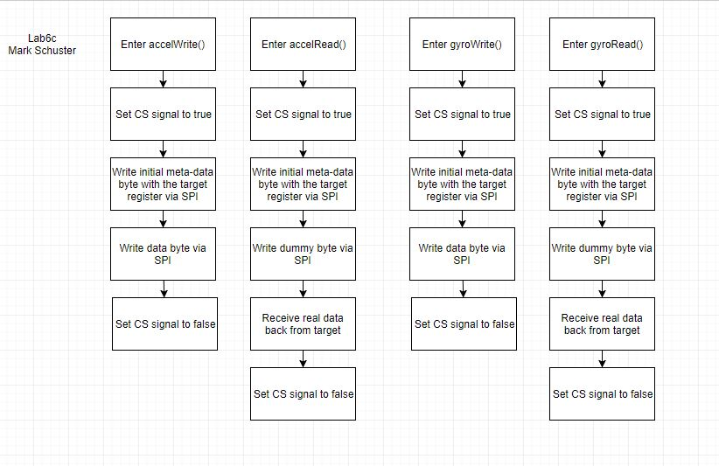

Lab6d flow diagram:

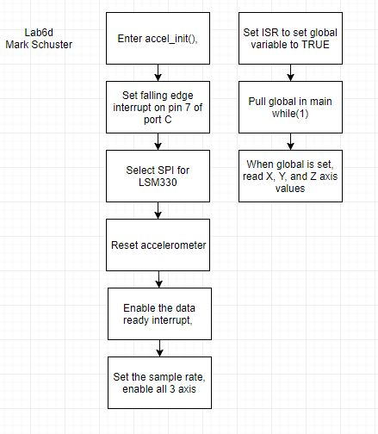

Lab6e flow diagram:



Lab6f flow diagram:

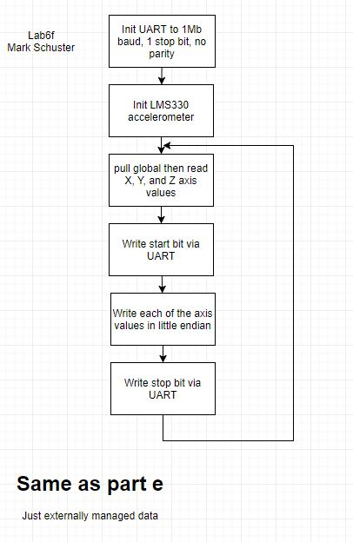

Lab6g flow diagram:

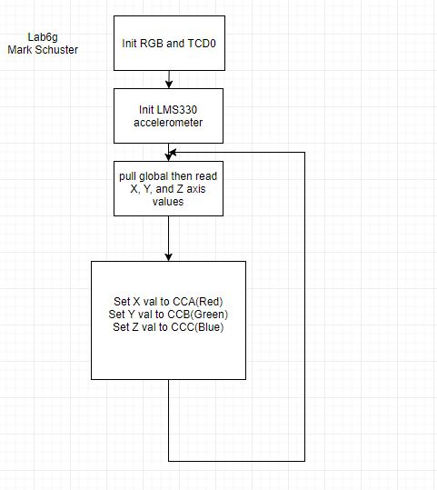

**G)** Program Code:

**Lab6 part a spi_init():**

/**********************FUNCTIONS***************************************/

// Subroutine Name: spi_init

// Configure the SPI peripheral

// Inputs: None

// Outputs: None

// Affected: None

void spi_init(void){

PORTF_DIRSET = 0b10111100;

PORTF_DIRCLR = 0b01000011;

// Master, MSB DORD, LE:RS, TE:FS, SYS_CLK/4 = 8MHz

SPIF_CTRL = SPI_ENABLE_bm | SPI_MASTER_bm | SPI_MODE_0_gc | SPI_PRESCALER_DIV4_gc;

return;

}

**Lab6 part b spiWrite():**

/**********************FUNCTIONS***************************************/

// Subroutine Name: spiWrite

// Write a byte of data using SPI

// Inputs: data - data to be sent

// Outputs: None

// Affected: None

*uint8_t* spiWrite(*uint8_t* data){

SPIF_DATA = data;

while(!(SPIF_STATUS & SPI_IF_bm));

return SPIF_DATA;

}

**Lab6 part b spiRead():**

/**********************FUNCTIONS***************************************/

// Subroutine Name: spiRead

// Reads the return value of spiWrite.

// Inputs: None

// Outputs: Return value of spiWrite.

// Affected: None

*uint8_t* spiRead(void){

return spiWrite(0xFF);

}

**Lab6b.c:**

// Lab 6 part B

// Name: Mark L. Schuster

// Section #: 1540

// TA Name: Christopher Crary

// Description: Send 0x53 over spi forever.

#include <avr/io.h>

#include "spi.h"

#define CLK_PRESCALER CLK_PSADIV_1_gc

void INIT_CLK(void);

void INIT_ADC(void);

int main(void)

{

// Init CLK, pin dir, and ADC.

INIT_CLK();

spi_init();

while (1){

spiWrite(0x53);

}

}

/**********************FUNCTIONS***************************************/

// Subroutine Name: INIT_CLK

// Init the CLK to 32MHz.

// Inputs: None

// Outputs: None

// Affected: None

void INIT_CLK(void){

// Enable 32Mhz CLK.

OSC_CTRL = OSC_RC32MEN_bm;

// Wait for 32Mhz flag to be set.

while( !(OSC_STATUS & OSC_RC32MRDY_bm) );

// Write to restriction register to allow writing

// to the CLK CTRL, then sel the 32MHz CLK.

CPU_CCP = CCP_IOREG_gc;

CLK_CTRL = CLK_SCLKSEL_RC32M_gc;

// Write to restriction register to allow writing

// to the CLK PSCTRL, then set the prescaler.

CPU_CCP = CCP_IOREG_gc;

CLK_PSCTRL = CLK_PRESCALER;

}

**Lab6 part c accelWrite():**

/**********************FUNCTIONS***************************************/

// Subroutine Name: accelWrite

// Write a byte to the accelerometer.

// Inputs: Byte to be written.

// Outputs: None

// Affected: None

void accelWrite(*uint8_t* targetReg, *uint8_t* data){

*uint8_t* spiVal = 0x00 | targetReg;

PORTF_OUTCLR = RBB_SSA;

spiWrite(spiVal);

spiWrite(data);

PORTF_OUTSET = RBB_SSA;

}

**Lab6 part c accelRead():**

/**********************FUNCTIONS***************************************/

// Subroutine Name: accelRead

// Read a byte from the accelerometer.

// Inputs: None

// Outputs: Byte read from accelerometer.

// Affected: None

*uint8_t* accelRead(*uint8_t* targetReg){

*uint8_t* spiVal = 0x80 | targetReg;

*uint8_t* result;

PORTF_OUTCLR = RBB_SSA;

spiWrite(spiVal);

result = spiRead();

PORTF_OUTSET = RBB_SSA;

return result;

}

**Lab6 part c gyroWrite():**

/**********************FUNCTIONS***************************************/

// Subroutine Name: accelWrite

// Write a byte to the gyroscope.

// Inputs: Byte to be written.

// Outputs: None

// Affected: None

void gyroWrite(*uint8_t* targetReg, *uint8_t* data){

*uint8_t* spiVal = 0x00 | targetReg;

PORTF_OUTCLR = RBB_SSG;

spiWrite(spiVal);

spiWrite(data);

PORTF_OUTSET = RBB_SSG;

}

**Lab6 part c gyroWrite():**

/**********************FUNCTIONS***************************************/

// Subroutine Name: gyroRead

// Read a byte from the gyroscope.

// Inputs: None

// Outputs: Byte read from gyroscope.

// Affected: None

*uint8_t* gyroRead(*uint8_t* targetReg){

*uint8_t* spiVal = 0x80 | targetReg;

*uint8_t* result;

PORTF_OUTCLR = RBB_SSG;

spiWrite(spiVal);

result = spiRead();

PORTF_OUTSET = RBB_SSG;

return result;

}

**Lab6 part d accel_init():**

/**********************FUNCTIONS***************************************/

// Subroutine Name: accel_init

// Init the accelerometer.

// Inputs: None

// Outputs: None

// Affected: None

void accel_init(void){

PORTA_DIRSET = RBB_PROTOCOL_SEL;

PORTA_OUTCLR = RBB_PROTOCOL_SEL;

PORTF_OUTSET = RBB_SSA | RBB_SSG | RBB_SENSOR_SEL_ACCEl_bp;

spi_init();

accelWrite(CTRL_REG4_A, CTRL_REG4_A_STRT);

PORTC_DIRCLR = RBB_INT1A;

PORTC_PIN7CTRL = PORT_ISC_FALLING_gc;

PORTC_INT0MASK = RBB_INT1A;

PORTC_INTCTRL = PORT_INT0LVL_LO_gc;

*uint8_t* reg4AInitData = CTRL_REG4_A_DR_EN | CTRL_REG4_A_IEA | CTRL_REG4_A_INT1_EN;

accelWrite(CTRL_REG4_A, reg4AInitData);

*uint8_t* reg5AInitData = CTRL_REG5_A_ODR3 | CTRL_REG5_A_ODR0 | CTRL_REG5_A_ZEN | CTRL_REG5_A_YEN | CTRL_REG5_A_XEN;

accelWrite(CTRL_REG5_A, reg5AInitData);

}

**Lab6 part e USART out function:**

/**********************FUNCTIONS***************************************/

// Subroutine Name: STREAM_DATA

// Send axis data over UART.

// Inputs: accelXData, accelYData, accelZData

// Outputs: None

// Affected: None

void STREAM_DATA(*uint16_t* accelXData, *uint16_t* accelYData, *uint16_t* accelZData){

OUT_CHAR(0x03);

OUT_CHAR((*uint8_t*)(accelXData));

OUT_CHAR((*uint8_t*)(accelXData >> 8));

OUT_CHAR((*uint8_t*)(accelYData));

OUT_CHAR((*uint8_t*)(accelYData >> 8));

OUT_CHAR((*uint8_t*)(accelZData));

OUT_CHAR((*uint8_t*)(accelZData >> 8));

OUT_CHAR(0xfc);

return;

}

**Lab6f.c:**

// Lab 6 part C

// Name: Mark L. Schuster

// Section #: 1540

// TA Name: Christopher Crary

// Description:

#include <avr/io.h>

#include <avr/interrupt.h>

#include "roboticsBackPack.h"

#include "LSM330.h"

#define CLK_PRESCALER CLK_PSADIV_1_gc

typedef enum{

FALSE,

TRUE

}bool;

void INIT_CLK(void);

void INIT_INTS(void);

void INIT_USART(void);

void OUT_CHAR(char);

void OUT_STRING(char*);

void STREAM_DATA(*uint16_t*,*uint16_t*,*uint16_t*);

volatile bool accelDataReady = FALSE;

int main(void)

{

// Init CLK, pin dir, and ADC.

volatile *uint16_t* accelXData;

volatile *uint16_t* accelYData;

volatile *uint16_t* accelZData;

INIT_CLK();

INIT_USART();

INIT_INTS();

accel_init();

while (1){

if(accelDataReady){

accelXData = (accelRead(OUT_X_H_A) << 8) | accelRead(OUT_X_L_A);

accelYData = (accelRead(OUT_Y_H_A) << 8) | accelRead(OUT_Y_L_A);

accelZData = (accelRead(OUT_Z_H_A) << 8) | accelRead(OUT_Z_L_A);

STREAM_DATA(accelXData, accelYData, accelZData);

accelDataReady = FALSE;

}

}

}

/**********************FUNCTIONS***************************************/

// Subroutine Name: INIT_CLK

// Init the CLK to 32MHz.

// Inputs: None

// Outputs: None

// Affected: None

void INIT_CLK(void){

// Enable 32Mhz CLK.

OSC_CTRL = OSC_RC32MEN_bm;

// Wait for 32Mhz flag to be set.

while( !(OSC_STATUS & OSC_RC32MRDY_bm) );

// Write to restriction register to allow writing

// to the CLK CTRL, then sel the 32MHz CLK.

CPU_CCP = CCP_IOREG_gc;

CLK_CTRL = CLK_SCLKSEL_RC32M_gc;

// Write to restriction register to allow writing

// to the CLK PSCTRL, then set the prescaler.

CPU_CCP = CCP_IOREG_gc;

CLK_PSCTRL = CLK_PRESCALER;

}

/**********************FUNCTIONS***************************************/

// Subroutine Name: INIT_USART

// Init the USART regs.

// Inputs: None

// Outputs: None

// Affected: None

void INIT_USART(void){

// Set the direction of the Tx & Rx pins.

PORTD_DIRSET = USART_TXEN_bm;

PORTD_DIRCLR = USART_RXEN_bm;

// Set the baud rate.

USARTD0_BAUDCTRLA = 1;

USARTD0_BAUDCTRLB = 0;

// Set the data size and the mode.

USARTD0_CTRLC = USART_CHSIZE_8BIT_gc;

USARTD0_CTRLB = 0b00011000;

}

/**********************FUNCTIONS***************************************/

// Subroutine Name: OUT_CHAR

// Send a char over USART.

// Inputs: char c = input char

// Outputs: None

// Affected: None

void OUT_CHAR(char c){

// Wait for the data buffer to be ready for

// input, load the character, finally wait until

// transmission is complete.

while(!(USARTD0_STATUS & USART_DREIF_bm));

USARTD0_DATA = c;

while(!(USARTD0_STATUS & USART_TXCIF_bm));

return;

}

/**********************FUNCTIONS***************************************/

// Subroutine Name: OUT_STRING

// Send a string over USART.

// Inputs: char* s = input string

// Outputs: None

// Affected: None

void OUT_STRING(char* s){

// Wait for the data buffer to be ready for

// input, load the character, finally wait until

// transmission is complete. Loop until the

// NULL terminator is reached.

for(*uint8_t* i=0; s[i]!='\0'; i++){

while(!(USARTD0_STATUS & USART_DREIF_bm));

USARTD0_DATA = s[i];

while(!(USARTD0_STATUS & USART_TXCIF_bm));

}

return;

}

/**********************FUNCTIONS***************************************/

// Subroutine Name: INIT_INTS

// Init interrupts.

// Inputs: None

// Outputs: None

// Affected: None

void INIT_INTS(void){

// Set the PMIC to enable low level interrupts.

PMIC_CTRL = PMIC_LOLVLEN_bm;

// Set the interrupt enable bit.

CPU_SREG |= 0x80;

}

/**********************FUNCTIONS***************************************/

// Subroutine Name: STREAM_DATA

// Send axis data over UART.

// Inputs: accelXData, accelYData, accelZData

// Outputs: None

// Affected: None

void STREAM_DATA(*uint16_t* accelXData, *uint16_t* accelYData, *uint16_t* accelZData){

OUT_CHAR(0x03);

OUT_CHAR((*uint8_t*)(accelXData));

OUT_CHAR((*uint8_t*)(accelXData >> 8));

OUT_CHAR((*uint8_t*)(accelYData));

OUT_CHAR((*uint8_t*)(accelYData >> 8));

OUT_CHAR((*uint8_t*)(accelZData));

OUT_CHAR((*uint8_t*)(accelZData >> 8));

OUT_CHAR(0xfc);

return;

}

/*********************INTERUPT****************************************/

// Sets up an interrupt to be triggered by rising edge on port C's pin 7.

//

// Inputs: None

// Outputs: None

// Affected: None

ISR(PORTC_INT0_vect){

accelDataReady = TRUE;

return;

}

**Lab6g.c:**

// Lab 6 part G

// Name: Mark L. Schuster

// Section #: 1540

// TA Name: Christopher Crary

// Description:

#include <avr/io.h>

#include <avr/interrupt.h>

#include "roboticsBackPack.h"

#include "LSM330.h"

#define CLK_PRESCALER CLK_PSADIV_1_gc

typedef enum{

FALSE,

TRUE

}bool;

void INIT_CLK(void);

void INIT_RGB(void);

void INIT_INTS(void);

void setRGB(*uint16_t*, *uint16_t*, *uint16_t*);

volatile bool accelDataReady = FALSE;

int main(void)

{

// Init CLK, pin dir, and ADC.

volatile *uint16_t* accelXData;

volatile *uint16_t* accelYData;

volatile *uint16_t* accelZData;

INIT_CLK();

INIT_RGB();

INIT_INTS();

accel_init();

while (1){

if(accelDataReady){

*uint8_t* accelXLData = accelRead(OUT_X_L_A);

*uint8_t* accelXHData = accelRead(OUT_X_H_A);

accelXData = (accelXHData << 8) | accelXLData;

*uint8_t* accelYLData = accelRead(OUT_Y_L_A);

*uint8_t* accelYHData = accelRead(OUT_Y_H_A);

accelYData = (accelYHData << 8) | accelYLData;

*uint8_t* accelZLData = accelRead(OUT_Z_L_A);

*uint8_t* accelZHData = accelRead(OUT_Z_H_A);

accelZData = (accelZHData << 8) | accelZLData;

accelXData = (accelXData < 0) ? (0-accelXData) : accelXData;

accelYData = (accelYData < 0) ? (0-accelYData) : accelYData;

accelZData = (accelZData < 0) ? (0-accelZData) : accelZData;

setRGB(accelXData, accelYData, accelZData);

accelDataReady = FALSE;

}

}

}

/**********************FUNCTIONS***************************************/

// Subroutine Name: INIT_CLK

// Init the CLK to 32MHz.

// Inputs: None

// Outputs: None

// Affected: None

void INIT_CLK(void){

// Enable 32Mhz CLK.

OSC_CTRL = OSC_RC32MEN_bm;

// Wait for 32Mhz flag to be set.

while( !(OSC_STATUS & OSC_RC32MRDY_bm) );

// Write to restriction register to allow writing

// to the CLK CTRL, then sel the 32MHz CLK.

CPU_CCP = CCP_IOREG_gc;

CLK_CTRL = CLK_SCLKSEL_RC32M_gc;

// Write to restriction register to allow writing

// to the CLK PSCTRL, then set the prescaler.

CPU_CCP = CCP_IOREG_gc;

CLK_PSCTRL = CLK_PRESCALER;

}

/**********************FUNCTIONS***************************************/

// Subroutine Name: INIT_RGB

// Init the RGB LED.

// Inputs: None

// Outputs: None

// Affected: None

void INIT_RGB(void){

PORTD_DIRSET = 0b01110000;

PORTD_REMAP = 0b00000111;

// Value to set the prescaler of the TC to be 1 times the sys CLK.

TCD0_CTRLA = 0b00000001;

// Sets the PWM mode of the TC to single slope.

TCD0_CTRLB = 0b01110011;

TCD0_PER = 0xFFFF;

PORTD_OUTSET = 0x00;

}

/**********************FUNCTIONS***************************************/

// Subroutine Name: setRGB

// Sets the value of the RGB LED.

// Inputs: None

// Outputs: None

// Affected: None

void setRGB(*uint16_t* redVal, *uint16_t* greenVal, *uint16_t* blueVal){

TCD0_CCA = ~redVal;

TCD0_CCB = ~greenVal;

TCD0_CCC = ~blueVal;

}

/**********************FUNCTIONS***************************************/

// Subroutine Name: INIT_INTS

// Init interrupts.

// Inputs: None

// Outputs: None

// Affected: None

void INIT_INTS(void){

// Set the PMIC to enable low level interrupts.

PMIC_CTRL = PMIC_LOLVLEN_bm;

// Set the interrupt enable bit.

CPU_SREG |= 0x80;

}

/*********************INTERUPT****************************************/

// Sets up an interrupt to be triggered by rising edge on port C's pin 7.

//

// Inputs: None

// Outputs: None

// Affected: None

ISR(PORTC_INT0_vect){

accelDataReady = TRUE;

return;

}

**Spi.c:**

// spi.c

// Name: Mark L. Schuster

// Section #: 1540

// TA Name: Christopher Crary

// Description: Definitions of SPI functions.

#include "spi.h"

/**********************FUNCTIONS***************************************/

// Subroutine Name: spi_init

// Configure the SPI peripheral

// Inputs: None

// Outputs: None

// Affected: None

void spi_init(void){

PORTF_DIRSET = 0b10111100;

PORTF_DIRCLR = 0b01000011;

// Master, MSB DORD, LE:RS, TE:FS, SYS_CLK/4 = 8MHz

SPIF_CTRL = SPI_ENABLE_bm | SPI_MASTER_bm | SPI_MODE_0_gc | SPI_PRESCALER_DIV4_gc;

return;

}

/**********************FUNCTIONS***************************************/

// Subroutine Name: spiWrite

// Write a byte of data using SPI

// Inputs: data - data to be sent

// Outputs: None

// Affected: None

*uint8_t* spiWrite(*uint8_t* data){

SPIF_DATA = data;

while(!(SPIF_STATUS & SPI_IF_bm));

return SPIF_DATA;

}

/**********************FUNCTIONS***************************************/

// Subroutine Name: spiRead

// Reads the return value of spiWrite.

// Inputs: None

// Outputs: Return value of spiWrite.

// Affected: None

*uint8_t* spiRead(void){

return spiWrite(0xFF);

}

**Spi.h:**

// spi.h

// Name: Mark L. Schuster

// Section #: 1540

// TA Name: Christopher Crary

// Description: Declarations of SPI functions.

#include <avr/io.h>

#ifndef SPI_H_

#define SPI_H_

void spi_init(void);

*uint8_t* spiWrite(*uint8_t* data);

*uint8_t* spiRead(void);

#endif /* SPI_H_ */

**roboticsBackpack.c:**

// roboticsBackpack.c

// Name: Mark L. Schuster

// Section #: 1540

// TA Name: Christopher Crary

// Description: Definitions of robotics backpack functions.

#include <avr/io.h>

#include "LSM330.h"

#include "spi.h"

#include "roboticsBackpack.h"

/**********************FUNCTIONS***************************************/

// Subroutine Name: accel_init

// Init the accelerometer.

// Inputs: None

// Outputs: None

// Affected: None

void accel_init(void){

PORTA_DIRSET = RBB_PROTOCOL_SEL;

PORTA_OUTCLR = RBB_PROTOCOL_SEL;

PORTF_OUTSET = RBB_SSA | RBB_SSG | RBB_SENSOR_SEL_ACCEl_bp;

spi_init();

accelWrite(CTRL_REG4_A, CTRL_REG4_A_STRT);

PORTC_DIRCLR = RBB_INT1A;

PORTC_PIN7CTRL = PORT_ISC_FALLING_gc;

PORTC_INT0MASK = RBB_INT1A;

PORTC_INTCTRL = PORT_INT0LVL_LO_gc;

*uint8_t* reg4AInitData = CTRL_REG4_A_DR_EN | CTRL_REG4_A_IEA | CTRL_REG4_A_INT1_EN;

accelWrite(CTRL_REG4_A, reg4AInitData);

*uint8_t* reg5AInitData = CTRL_REG5_A_ODR3 | CTRL_REG5_A_ODR0 | CTRL_REG5_A_ZEN | CTRL_REG5_A_YEN | CTRL_REG5_A_XEN;

accelWrite(CTRL_REG5_A, reg5AInitData);

}

/**********************FUNCTIONS***************************************/

// Subroutine Name: accelRead

// Read a byte from the accelerometer.

// Inputs: None

// Outputs: Byte read from accelerometer.

// Affected: None

*uint8_t* accelRead(*uint8_t* targetReg){

*uint8_t* spiVal = 0x80 | targetReg;

*uint8_t* result;

PORTF_OUTCLR = RBB_SSA;

spiWrite(spiVal);

result = spiRead();

PORTF_OUTSET = RBB_SSA;

return result;

}

/**********************FUNCTIONS***************************************/

// Subroutine Name: accelWrite

// Write a byte to the accelerometer.

// Inputs: Byte to be written.

// Outputs: None

// Affected: None

void accelWrite(*uint8_t* targetReg, *uint8_t* data){

*uint8_t* spiVal = 0x00 | targetReg;

PORTF_OUTCLR = RBB_SSA;

spiWrite(spiVal);

spiWrite(data);

PORTF_OUTSET = RBB_SSA;

}

/**********************FUNCTIONS***************************************/

// Subroutine Name: gyroRead

// Read a byte from the gyroscope.

// Inputs: None

// Outputs: Byte read from gyroscope.

// Affected: None

*uint8_t* gyroRead(*uint8_t* targetReg){

*uint8_t* spiVal = 0x80 | targetReg;

*uint8_t* result;

PORTF_OUTCLR = RBB_SSG;

spiWrite(spiVal);

result = spiRead();

PORTF_OUTSET = RBB_SSG;

return result;

}

/**********************FUNCTIONS***************************************/

// Subroutine Name: accelWrite

// Write a byte to the gyroscope.

// Inputs: Byte to be written.

// Outputs: None

// Affected: None

void gyroWrite(*uint8_t* targetReg, *uint8_t* data){

*uint8_t* spiVal = 0x00 | targetReg;

PORTF_OUTCLR = RBB_SSG;

spiWrite(spiVal);

spiWrite(data);

PORTF_OUTSET = RBB_SSG;

}

**roboticsBackpack.h:**

// roboticsBackpack.h

// Name: Mark L. Schuster

// Section #: 1540

// TA Name: Christopher Crary

// Description: Declarations of robotics backpack functions.

#include <avr/io.h>

#ifndef ROBOTICSBACKPACK_H_

#define ROBOTICSBACKPACK_H_

// PORTF CONTROL SIGNALS

#define RBB_SDA (0x01<<0)

#define RBB_SCL (0x01<<1)

#define RBB_SENSOR_SEL (0x01<<2)

#define RBB_SSA (0x01<<3)

#define RBB_SSG (0x01<<4)

#define RBB_MOSI (0x01<<5)

#define RBB_MISO (0x01<<6)

#define RBB_SCK (0x01<<7)

// PORTC CONTROL SIGNALS

#define RBB_PWMA (0x01<<0)

#define RBB_PWMB (0x01<<1)

#define RBB_AIN2 (0x01<<2)

#define RBB_AIN1 (0x01<<3)

#define RBB_BIN2 (0x01<<4)

#define RBB_BIN1 (0x01<<5)

#define RBB_INT2A (0x01<<6)

#define RBB_INT1A (0x01<<7)

// PORTA CONTROL SIGNALS

#define RBB_STBY (0x01<<0)

#define RBB_INT2G (0x01<<1)

#define RBB_INT1G (0x01<<2)

#define RBB_GYRO_ENABLE (0x01<<3)

#define RBB_PROTOCOL_SEL (0x01<<4)

#define RBB_PA5 (0x01<<5)

#define RBB_PA6 (0x01<<6)

#define RBB_PA7 (0x01<<7)

#define RBB_SENSOR_SEL_GYRO_bm 0

#define RBB_SENSOR_SEL_GYRO_bp (0x01<<2)

#define RBB_SENSOR_SEL_ACCEl_bm 1

#define RBB_SENSOR_SEL_ACCEl_bp (0x01<<2)

#define RBB_PROTOCOL_SEL_SPI_bm 0

#define RBB_PROTOCOL_SEL_SPI_bp (0x01<<4)

#define RBB_PROTOCOL_SEL_I2C_bm 1

#define RBB_PROTOCOL_SEL_I2C_bp (0x01<<4)

// FUNCTIONS

void accel_init(void);

*uint8_t* accelRead(*uint8_t*);

void accelWrite(*uint8_t*, *uint8_t*);

*uint8_t* gyroRead(*uint8_t*);

void gyroWrite(*uint8_t*, *uint8_t*);

#endif /* ROBOTICSBACKPACK_H_ */

**H)** Appendix:

Files:

* Lab6.pdf
* Lab6b.c
* Lab6f.c
* Lab6g.c
* spi.c
* spi.h
* roboticsBackpack.c
* roboticsBackpack.h

Screenshots:

Spi frame:

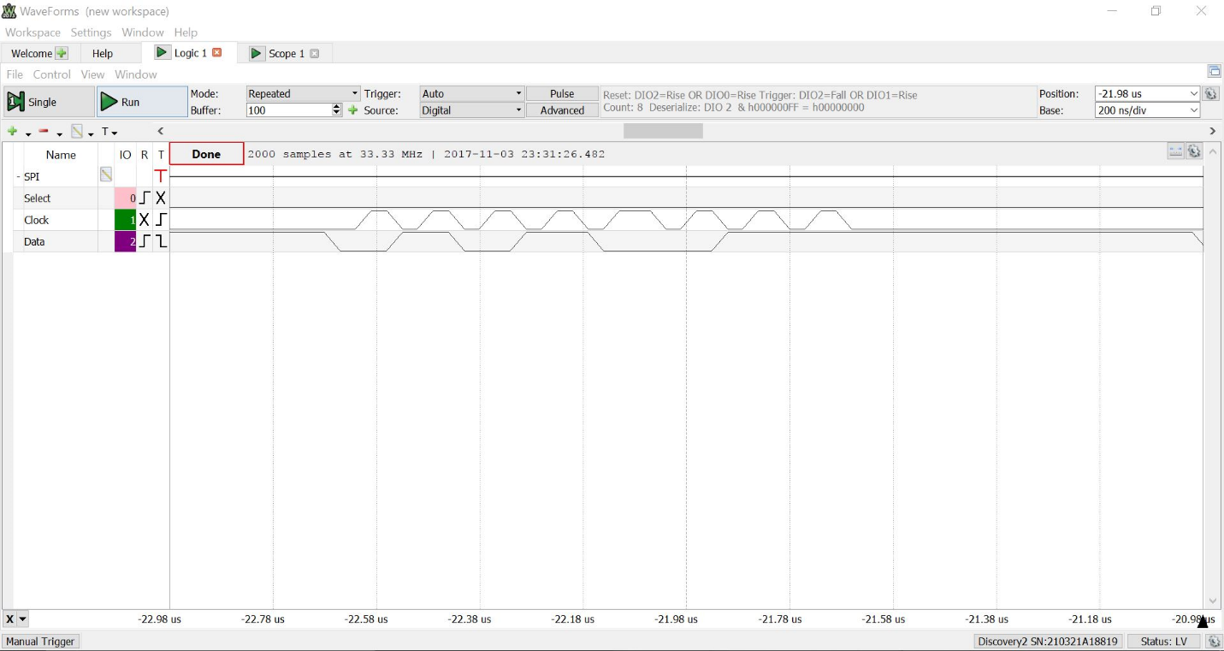

Accelerometer graph:

