Lab 7 Summary

Schuster, Mark

Section 1540

11/22/2017

**B)** Pre-Lab Answers:

1. The greater the number of discrete points or “samples” the greater the quality or “integrity” of the signal.
2. There are 4 DMA channels.
3. 26 different base trigger values.

**C)** Problems encountered:

I was struggling to get the DMA to work for several hours. I read through the entire manual entry and the additional documentation provided by Atmel. After much trial and error, I realized that the DMA channel must be enabled before the rest of the settings can be set.

**D)** Future Work/Applications:

I enjoyed working with the DMA module and its use has parallels some topics in my operating systems class.

**E)** Schematics:

Not applicable for this lab.

**F)** Pseudocode/Flowcharts:

Lab7a flow diagram:

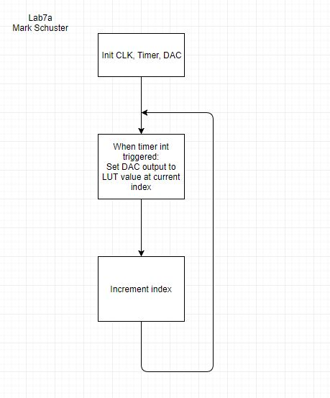

Lab7b flow diagram:

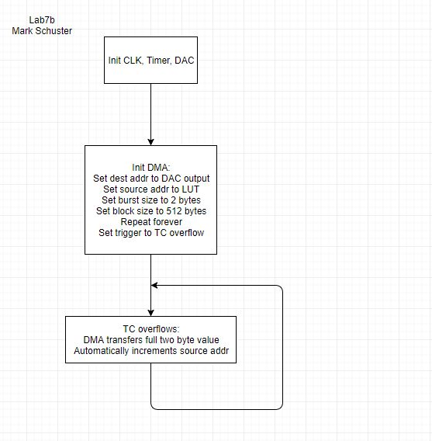

Lab7d flow diagram:

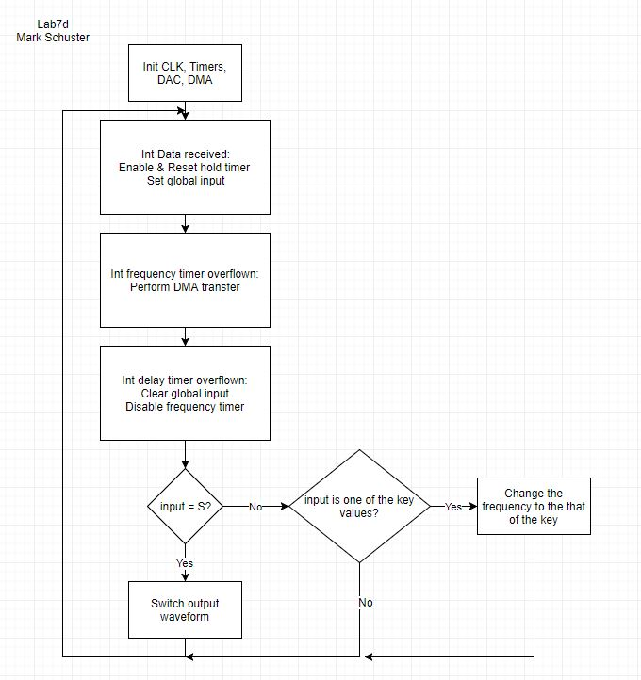

**G)** Program Code:

**Lab7a.c:**

// Lab 7 part A

// Name: Mark L. Schuster

// Section #: 1540

// TA Name: Christopher Crary

// Description: Output a sine wave from a LUT.

#include <avr/io.h>

#include <avr/interrupt.h>

#define CLK_PRESCALER CLK_PSADIV_1_gc

void INIT_CLK(void);

void INIT_INTS(void);

void INIT_DAC(void);

void setTimers(void);

*uint16_t* sineLUTData[256] ={

0x800,0x832,0x864,0x896,0x8c8,0x8fa,0x92c,0x95e,

0x98f,0x9c0,0x9f1,0xa22,0xa52,0xa82,0xab1,0xae0,

0xb0f,0xb3d,0xb6b,0xb98,0xbc5,0xbf1,0xc1c,0xc47,

0xc71,0xc9a,0xcc3,0xceb,0xd12,0xd39,0xd5f,0xd83,

0xda7,0xdca,0xded,0xe0e,0xe2e,0xe4e,0xe6c,0xe8a,

0xea6,0xec1,0xedc,0xef5,0xf0d,0xf24,0xf3a,0xf4f,

0xf63,0xf76,0xf87,0xf98,0xfa7,0xfb5,0xfc2,0xfcd,

0xfd8,0xfe1,0xfe9,0xff0,0xff5,0xff9,0xffd,0xffe,

0xfff,0xffe,0xffd,0xff9,0xff5,0xff0,0xfe9,0xfe1,

0xfd8,0xfcd,0xfc2,0xfb5,0xfa7,0xf98,0xf87,0xf76,

0xf63,0xf4f,0xf3a,0xf24,0xf0d,0xef5,0xedc,0xec1,

0xea6,0xe8a,0xe6c,0xe4e,0xe2e,0xe0e,0xded,0xdca,

0xda7,0xd83,0xd5f,0xd39,0xd12,0xceb,0xcc3,0xc9a,

0xc71,0xc47,0xc1c,0xbf1,0xbc5,0xb98,0xb6b,0xb3d,

0xb0f,0xae0,0xab1,0xa82,0xa52,0xa22,0x9f1,0x9c0,

0x98f,0x95e,0x92c,0x8fa,0x8c8,0x896,0x864,0x832,

0x800,0x7cd,0x79b,0x769,0x737,0x705,0x6d3,0x6a1,

0x670,0x63f,0x60e,0x5dd,0x5ad,0x57d,0x54e,0x51f,

0x4f0,0x4c2,0x494,0x467,0x43a,0x40e,0x3e3,0x3b8,

0x38e,0x365,0x33c,0x314,0x2ed,0x2c6,0x2a0,0x27c,

0x258,0x235,0x212,0x1f1,0x1d1,0x1b1,0x193,0x175,

0x159,0x13e,0x123,0x10a,0xf2,0xdb,0xc5,0xb0,

0x9c,0x89,0x78,0x67,0x58,0x4a,0x3d,0x32,

0x27,0x1e,0x16,0xf,0xa,0x6,0x2,0x1,

0x0,0x1,0x2,0x6,0xa,0xf,0x16,0x1e,

0x27,0x32,0x3d,0x4a,0x58,0x67,0x78,0x89,

0x9c,0xb0,0xc5,0xdb,0xf2,0x10a,0x123,0x13e,

0x159,0x175,0x193,0x1b1,0x1d1,0x1f1,0x212,0x235,

0x258,0x27c,0x2a0,0x2c6,0x2ed,0x314,0x33c,0x365,

0x38e,0x3b8,0x3e3,0x40e,0x43a,0x467,0x494,0x4c2,

0x4f0,0x51f,0x54e,0x57d,0x5ad,0x5dd,0x60e,0x63f,

0x670,0x6a1,0x6d3,0x705,0x737,0x769,0x79b,0x7cd,

};

int main(void)

{

// Init CLK, inturrpts, DAC, and timers.

INIT_CLK();

INIT_INTS();

INIT_DAC();

setTimers();

while (1);

return 0;

}

/**********************FUNCTIONS***************************************/

// Subroutine Name: INIT_CLK

// Init the CLK to 32MHz.

// Inputs: None

// Outputs: None

// Affected: None

void INIT_CLK(void){

// Enable 32Mhz CLK.

OSC_CTRL = OSC_RC32MEN_bm;

// Wait for 32Mhz flag to be set.

while( !(OSC_STATUS & OSC_RC32MRDY_bm) );

// Write to restriction register to allow writing

// to the CLK CTRL, then sel the 32MHz CLK.

CPU_CCP = CCP_IOREG_gc;

CLK_CTRL = CLK_SCLKSEL_RC32M_gc;

// Write to restriction register to allow writing

// to the CLK PSCTRL, then set the prescaler.

CPU_CCP = CCP_IOREG_gc;

CLK_PSCTRL = CLK_PRESCALER;

return;

}

/**********************FUNCTIONS***************************************/

// Subroutine Name: INIT_INTS

// Init interrupts.

// Inputs: None

// Outputs: None

// Affected: None

void INIT_INTS(void){

// Set the PMIC to enable low level interrupts.

PMIC_CTRL = PMIC_LOLVLEN_bm;

// Set the interrupt enable bit.

CPU_SREG |= 0x80;

return;

}

/**********************FUNCTIONS***************************************/

// Subroutine Name: INIT_DAC

// Init the DAC.

// Inputs: None

// Outputs: None

// Affected: None

void INIT_DAC(void){

// Set the direction of the DAC output.

PORTA_DIRSET = 0x08;

// Set to single channel mode.

DACA.CTRLB = DAC_CHSEL0_bm; // Header conflicts with doc3881. This value enables channel 1.

// Set PortB as the external reference.

DACA.CTRLC = 0b00011000;

// Set the persistent data for 0.7V out.

DACA.CH1DATA= 0x0000;

// Enable channel 0 and the DAC.

DACA.CTRLA = (DAC_CH1EN_bm | DAC_ENABLE_bm);

return;

}

/**********************FUNCTIONS***************************************/

// Subroutine Name: setTimers

// Inits the timers.

// Inputs: None

// Outputs: None

// Affected: None

void setTimers(void){

//Set the period.

TCC0_PER = 214;

// Enable the interrupt and then the timer.

TCC0_INTCTRLA = TC_OVFINTLVL_LO_gc;

TCC0_CTRLA = TC_CLKSEL_DIV2_gc;

return;

}

/*********************INTERUPT****************************************/

// Sets up an interrupt to be triggered by TC0 being overflown.

// Inputs: None

// Outputs: None

// Affected: None

ISR(TCC0_OVF_vect)

{

static *uint8_t* index = 0;

DACA.CH1DATA = sineLUTData[index++];

return;

}

**Lab7b.c:**

// Lab 7 part B

// Name: Mark L. Schuster

// Section #: 1540

// TA Name: Christopher Crary

// Description: Output a sine wave via DAC using 256 samples using DMA.

#include <avr/io.h>

#include <avr/interrupt.h>

#define CLK_PRESCALER CLK_PSADIV_1_gc

void INIT_CLK(void);

void INIT_INTS(void);

void INIT_ADC(void);

void INIT_DAC(void);

void setTimers(void);

void INIT_DMA(void);

*uint16_t* sineLUTData[256] ={

0x10,0x20,0x30,0x40,0x50,0x60,0x70,0x80,

0x90,0xa0,0xb0,0xc0,0xd0,0xe0,0xf0,0x100,

0x110,0x120,0x130,0x140,0x150,0x160,0x170,0x180,

0x190,0x1a0,0x1b0,0x1c0,0x1d0,0x1e0,0x1f0,0x200,

0x210,0x220,0x230,0x240,0x250,0x260,0x270,0x280,

0x290,0x2a0,0x2b0,0x2c0,0x2d0,0x2e0,0x2f0,0x300,

0x310,0x320,0x330,0x340,0x350,0x360,0x370,0x380,

0x390,0x3a0,0x3b0,0x3c0,0x3d0,0x3e0,0x3f0,0x400,

0x410,0x420,0x430,0x440,0x450,0x460,0x470,0x480,

0x490,0x4a0,0x4b0,0x4c0,0x4d0,0x4e0,0x4f0,0x500,

0x510,0x520,0x530,0x540,0x550,0x560,0x570,0x580,

0x590,0x5a0,0x5b0,0x5c0,0x5d0,0x5e0,0x5f0,0x600,

0x610,0x620,0x630,0x640,0x650,0x660,0x670,0x680,

0x690,0x6a0,0x6b0,0x6c0,0x6d0,0x6e0,0x6f0,0x700,

0x710,0x720,0x730,0x740,0x750,0x760,0x770,0x780,

0x790,0x7a0,0x7b0,0x7c0,0x7d0,0x7e0,0x7f0,0x800,

0x80f,0x81f,0x82f,0x83f,0x84f,0x85f,0x86f,0x87f,

0x88f,0x89f,0x8af,0x8bf,0x8cf,0x8df,0x8ef,0x8ff,

0x90f,0x91f,0x92f,0x93f,0x94f,0x95f,0x96f,0x97f,

0x98f,0x99f,0x9af,0x9bf,0x9cf,0x9df,0x9ef,0x9ff,

0xa0f,0xa1f,0xa2f,0xa3f,0xa4f,0xa5f,0xa6f,0xa7f,

0xa8f,0xa9f,0xaaf,0xabf,0xacf,0xadf,0xaef,0xaff,

0xb0f,0xb1f,0xb2f,0xb3f,0xb4f,0xb5f,0xb6f,0xb7f,

0xb8f,0xb9f,0xbaf,0xbbf,0xbcf,0xbdf,0xbef,0xbff,

0xc0f,0xc1f,0xc2f,0xc3f,0xc4f,0xc5f,0xc6f,0xc7f,

0xc8f,0xc9f,0xcaf,0xcbf,0xccf,0xcdf,0xcef,0xcff,

0xd0f,0xd1f,0xd2f,0xd3f,0xd4f,0xd5f,0xd6f,0xd7f,

0xd8f,0xd9f,0xdaf,0xdbf,0xdcf,0xddf,0xdef,0xdff,

0xe0f,0xe1f,0xe2f,0xe3f,0xe4f,0xe5f,0xe6f,0xe7f,

0xe8f,0xe9f,0xeaf,0xebf,0xecf,0xedf,0xeef,0xeff,

0xf0f,0xf1f,0xf2f,0xf3f,0xf4f,0xf5f,0xf6f,0xf7f,

0xf8f,0xf9f,0xfaf,0xfbf,0xfcf,0xfdf,0xfef,0xfff

};

int main(void)

{

// Init CLK, inturrpts, DAC, DMA, and timers.

INIT_CLK();

INIT_DAC();

INIT_DMA();

setTimers();

INIT_INTS();

while (1);

return 0;

}

/**********************FUNCTIONS***************************************/

// Subroutine Name: INIT_CLK

// Init the CLK to 32MHz.

// Inputs: None

// Outputs: None

// Affected: None

void INIT_CLK(void){

// Enable 32Mhz CLK.

OSC_CTRL = OSC_RC32MEN_bm;

// Wait for 32Mhz flag to be set.

while( !(OSC_STATUS & OSC_RC32MRDY_bm) );

// Write to restriction register to allow writing

// to the CLK CTRL, then sel the 32MHz CLK.

CPU_CCP = CCP_IOREG_gc;

CLK_CTRL = CLK_SCLKSEL_RC32M_gc;

// Write to restriction register to allow writing

// to the CLK PSCTRL, then set the prescaler.

CPU_CCP = CCP_IOREG_gc;

CLK_PSCTRL = CLK_PRESCALER;

return;

}

/**********************FUNCTIONS***************************************/

// Subroutine Name: INIT_INTS

// Init interrupts.

// Inputs: None

// Outputs: None

// Affected: None

void INIT_INTS(void){

// Set the PMIC to enable low level interrupts.

PMIC_CTRL = PMIC_LOLVLEN_bm;

// Set the interrupt enable bit.

CPU_SREG |= 0x80;

return;

}

/**********************FUNCTIONS***************************************/

// Subroutine Name: INIT_DAC

// Init the DAC.

// Inputs: None

// Outputs: None

// Affected: None

void INIT_DAC(void){

// Set the direction of the DAC output.

PORTA_DIRSET = 0x08;

// Set to single channel mode.

DACA.CTRLB = DAC_CHSEL0_bm; // Header conflicts with doc3881. This value enables channel 1.

// Set PortB as the external reference.

DACA.CTRLC = 0b00011000;

// Set the persistent data for 0.7V out.

DACA.CH1DATA= 0x0000;

// Enable channel 0 and the DAC.

DACA.CTRLA = (DAC_CH1EN_bm | DAC_ENABLE_bm);

return;

}

/**********************FUNCTIONS***************************************/

// Subroutine Name: INIT_DMA

// Init DMA.

// Inputs: None

// Outputs: None

// Affected: None

void INIT_DMA(void){

DMA.CTRL = 0;

DMA.CTRL = DMA_RESET_bm;

while ((DMA.CTRL & DMA_RESET_bm) != 0);

DMA.CTRL = DMA_ENABLE_bm;

DMA.CH0.CTRLA = DMA_CH_ENABLE_bm | DMA_CH_BURSTLEN0_bm | DMA_CH_REPEAT_bm | DMA_CH_SINGLE_bm ;

DMA.CH0.ADDRCTRL = DMA_CH_SRCRELOAD_BLOCK_gc | DMA_CH_SRCDIR_INC_gc | DMA_CH_DESTRELOAD_BURST_gc | DMA_CH_DESTDIR_INC_gc;

DMA.CH0.TRIGSRC = DMA_CH_TRIGSRC_TCC0_OVF_gc;

DMA.CH0.TRFCNT = 512; // Sample num * bytes per smaple.

DMA.CH0.REPCNT = 0x00; // Repeat endlessly.

DMA.CH0.SRCADDR0 = ( (*uint16_t*) &sineLUTData[0]) >> 0;

DMA.CH0.SRCADDR1 = ( (*uint16_t*) &sineLUTData[0]) >> 8;

DMA.CH0.SRCADDR2 = 0x00;

DMA.CH0.DESTADDR0 = (( (*uint16_t*) &DACA.CH1DATA) >> 0) &0xFF;

DMA.CH0.DESTADDR1 = ( (*uint16_t*) &DACA.CH1DATA) >> 8;

DMA.CH0.DESTADDR2 = 0x00;

return;

}

/**********************FUNCTIONS***************************************/

// Subroutine Name: setTimers

// Used to created a delay.

// Inputs: None

// Outputs: None

// Affected: None

void setTimers(void){

//Set the period.

TCC0_PER = 213;

// Enable the interrupt and then the timer.

TCC0_INTCTRLA = TC_OVFINTLVL_LO_gc;

// Set a prescaler of 2 for greater accuracy.

TCC0_CTRLA = TC_CLKSEL_DIV2_gc;

return;

}

/*********************INTERUPT****************************************/

// Sets up an interrupt to be triggered by TCC0 being overflown.

// Inputs: None

// Outputs: None

// Affected: None

ISR(TCC0_OVF_vect)

{

return;

}

**Lab7d.c:**

// Lab 7 part D

// Name: Mark L. Schuster

// Section #: 1540

// TA Name: Christopher Crary

// Description: Make a basic piano keyboard with input via UART.

#include <avr/io.h>

#include <avr/interrupt.h>

#define CLK_PRESCALER CLK_PSADIV_1_gc

#define PERIOD_300HZ 426.0

enum{

SINE,

SAW

};

void INIT_CLK(void);

void INIT_INTS(void);

void INIT_ADC(void);

void INIT_DAC(void);

void setTimers(void);

void INIT_DMA(void);

void INIT_USART(void);

void switchWaveform(void);

void playFrequency(double);

*uint16_t* roundDouble(double);

*uint16_t* sineLUTData[256] ={

0x800,0x832,0x864,0x896,0x8c8,0x8fa,0x92c,0x95e,

0x98f,0x9c0,0x9f1,0xa22,0xa52,0xa82,0xab1,0xae0,

0xb0f,0xb3d,0xb6b,0xb98,0xbc5,0xbf1,0xc1c,0xc47,

0xc71,0xc9a,0xcc3,0xceb,0xd12,0xd39,0xd5f,0xd83,

0xda7,0xdca,0xded,0xe0e,0xe2e,0xe4e,0xe6c,0xe8a,

0xea6,0xec1,0xedc,0xef5,0xf0d,0xf24,0xf3a,0xf4f,

0xf63,0xf76,0xf87,0xf98,0xfa7,0xfb5,0xfc2,0xfcd,

0xfd8,0xfe1,0xfe9,0xff0,0xff5,0xff9,0xffd,0xffe,

0xfff,0xffe,0xffd,0xff9,0xff5,0xff0,0xfe9,0xfe1,

0xfd8,0xfcd,0xfc2,0xfb5,0xfa7,0xf98,0xf87,0xf76,

0xf63,0xf4f,0xf3a,0xf24,0xf0d,0xef5,0xedc,0xec1,

0xea6,0xe8a,0xe6c,0xe4e,0xe2e,0xe0e,0xded,0xdca,

0xda7,0xd83,0xd5f,0xd39,0xd12,0xceb,0xcc3,0xc9a,

0xc71,0xc47,0xc1c,0xbf1,0xbc5,0xb98,0xb6b,0xb3d,

0xb0f,0xae0,0xab1,0xa82,0xa52,0xa22,0x9f1,0x9c0,

0x98f,0x95e,0x92c,0x8fa,0x8c8,0x896,0x864,0x832,

0x800,0x7cd,0x79b,0x769,0x737,0x705,0x6d3,0x6a1,

0x670,0x63f,0x60e,0x5dd,0x5ad,0x57d,0x54e,0x51f,

0x4f0,0x4c2,0x494,0x467,0x43a,0x40e,0x3e3,0x3b8,

0x38e,0x365,0x33c,0x314,0x2ed,0x2c6,0x2a0,0x27c,

0x258,0x235,0x212,0x1f1,0x1d1,0x1b1,0x193,0x175,

0x159,0x13e,0x123,0x10a,0xf2,0xdb,0xc5,0xb0,

0x9c,0x89,0x78,0x67,0x58,0x4a,0x3d,0x32,

0x27,0x1e,0x16,0xf,0xa,0x6,0x2,0x1,

0x0,0x1,0x2,0x6,0xa,0xf,0x16,0x1e,

0x27,0x32,0x3d,0x4a,0x58,0x67,0x78,0x89,

0x9c,0xb0,0xc5,0xdb,0xf2,0x10a,0x123,0x13e,

0x159,0x175,0x193,0x1b1,0x1d1,0x1f1,0x212,0x235,

0x258,0x27c,0x2a0,0x2c6,0x2ed,0x314,0x33c,0x365,

0x38e,0x3b8,0x3e3,0x40e,0x43a,0x467,0x494,0x4c2,

0x4f0,0x51f,0x54e,0x57d,0x5ad,0x5dd,0x60e,0x63f,

0x670,0x6a1,0x6d3,0x705,0x737,0x769,0x79b,0x7cd

};

*uint16_t* sawLUTData[256] = {

0x10,0x20,0x30,0x40,0x50,0x60,0x70,0x80,

0x90,0xa0,0xb0,0xc0,0xd0,0xe0,0xf0,0x100,

0x110,0x120,0x130,0x140,0x150,0x160,0x170,0x180,

0x190,0x1a0,0x1b0,0x1c0,0x1d0,0x1e0,0x1f0,0x200,

0x210,0x220,0x230,0x240,0x250,0x260,0x270,0x280,

0x290,0x2a0,0x2b0,0x2c0,0x2d0,0x2e0,0x2f0,0x300,

0x310,0x320,0x330,0x340,0x350,0x360,0x370,0x380,

0x390,0x3a0,0x3b0,0x3c0,0x3d0,0x3e0,0x3f0,0x400,

0x410,0x420,0x430,0x440,0x450,0x460,0x470,0x480,

0x490,0x4a0,0x4b0,0x4c0,0x4d0,0x4e0,0x4f0,0x500,

0x510,0x520,0x530,0x540,0x550,0x560,0x570,0x580,

0x590,0x5a0,0x5b0,0x5c0,0x5d0,0x5e0,0x5f0,0x600,

0x610,0x620,0x630,0x640,0x650,0x660,0x670,0x680,

0x690,0x6a0,0x6b0,0x6c0,0x6d0,0x6e0,0x6f0,0x700,

0x710,0x720,0x730,0x740,0x750,0x760,0x770,0x780,

0x790,0x7a0,0x7b0,0x7c0,0x7d0,0x7e0,0x7f0,0x800,

0x80f,0x81f,0x82f,0x83f,0x84f,0x85f,0x86f,0x87f,

0x88f,0x89f,0x8af,0x8bf,0x8cf,0x8df,0x8ef,0x8ff,

0x90f,0x91f,0x92f,0x93f,0x94f,0x95f,0x96f,0x97f,

0x98f,0x99f,0x9af,0x9bf,0x9cf,0x9df,0x9ef,0x9ff,

0xa0f,0xa1f,0xa2f,0xa3f,0xa4f,0xa5f,0xa6f,0xa7f,

0xa8f,0xa9f,0xaaf,0xabf,0xacf,0xadf,0xaef,0xaff,

0xb0f,0xb1f,0xb2f,0xb3f,0xb4f,0xb5f,0xb6f,0xb7f,

0xb8f,0xb9f,0xbaf,0xbbf,0xbcf,0xbdf,0xbef,0xbff,

0xc0f,0xc1f,0xc2f,0xc3f,0xc4f,0xc5f,0xc6f,0xc7f,

0xc8f,0xc9f,0xcaf,0xcbf,0xccf,0xcdf,0xcef,0xcff,

0xd0f,0xd1f,0xd2f,0xd3f,0xd4f,0xd5f,0xd6f,0xd7f,

0xd8f,0xd9f,0xdaf,0xdbf,0xdcf,0xddf,0xdef,0xdff,

0xe0f,0xe1f,0xe2f,0xe3f,0xe4f,0xe5f,0xe6f,0xe7f,

0xe8f,0xe9f,0xeaf,0xebf,0xecf,0xedf,0xeef,0xeff,

0xf0f,0xf1f,0xf2f,0xf3f,0xf4f,0xf5f,0xf6f,0xf7f,

0xf8f,0xf9f,0xfaf,0xfbf,0xfcf,0xfdf,0xfef,0xfff

};

static char input = '0';

int main(void)

{

// Init CLK, pin dir, and ADC.

INIT_CLK();

INIT_USART();

INIT_DAC();

INIT_DMA();

setTimers();

INIT_INTS();

PORTC_DIRSET = 0x80;

PORTC_OUT = 0x80;

while (1){

// Manage the input.

if( (input == 'S') | (input == 's') ) {

switchWaveform();

input =0;

}else if( (input == 'W') | (input == 'w') ){

TCC0_CTRLA = TC_CLKSEL_DIV1_gc;

playFrequency(1046.5);

}else if( (input == '3') ){

TCC0_CTRLA = TC_CLKSEL_DIV1_gc;

playFrequency(1108.73);

}else if( (input == 'E') | (input == 'e') ){

TCC0_CTRLA = TC_CLKSEL_DIV1_gc;

playFrequency(1174.66);

}else if( (input == '4') ){

TCC0_CTRLA = TC_CLKSEL_DIV1_gc;

playFrequency(1244.51);

}else if( (input == 'R') | (input == 'r') ){

TCC0_CTRLA = TC_CLKSEL_DIV1_gc;

playFrequency(1318.51);

}else if( (input == 'T') | (input == 't') ){

TCC0_CTRLA = TC_CLKSEL_DIV1_gc;

playFrequency(1396.91);

}else if( (input == '6') ){

TCC0_CTRLA = TC_CLKSEL_DIV1_gc;

playFrequency(1479.98);

}else if( (input == 'Y') | (input == 'y') ){

TCC0_CTRLA = TC_CLKSEL_DIV1_gc;

playFrequency(1567.98);

}else if( (input == '7') ){

TCC0_CTRLA = TC_CLKSEL_DIV1_gc;

playFrequency(1661.22);

}else if( (input == 'U') | (input == 'u') ){

TCC0_CTRLA = TC_CLKSEL_DIV1_gc;

playFrequency(1760.00);

}else if( (input == '8') ){

TCC0_CTRLA = TC_CLKSEL_DIV1_gc;

playFrequency(1864.66);

}else if( (input == 'I') | (input == 'i') ){

TCC0_CTRLA = TC_CLKSEL_DIV1_gc;

playFrequency(1975.53);

}else if( (input == 'O') | (input == 'o') ){

TCC0_CTRLA = TC_CLKSEL_DIV1_gc;

playFrequency(2093.00);

}else if( (input == '9') ){

TCC0_CTRLA = TC_CLKSEL_DIV1_gc;

playFrequency(2217.46);

}else

// If the input is not one of the defined above output nothing.

DACA.CH1DATA = 0x00;

}

return 0;

}

/**********************FUNCTIONS***************************************/

// Subroutine Name: INIT_CLK

// Init the CLK to 32MHz.

// Inputs: None

// Outputs: None

// Affected: None

void INIT_CLK(void){

// Enable 32Mhz CLK.

OSC_CTRL = OSC_RC32MEN_bm;

// Wait for 32Mhz flag to be set.

while( !(OSC_STATUS & OSC_RC32MRDY_bm) );

// Write to restriction register to allow writing

// to the CLK CTRL, then sel the 32MHz CLK.

CPU_CCP = CCP_IOREG_gc;

CLK_CTRL = CLK_SCLKSEL_RC32M_gc;

// Write to restriction register to allow writing

// to the CLK PSCTRL, then set the prescaler.

CPU_CCP = CCP_IOREG_gc;

CLK_PSCTRL = CLK_PRESCALER;

return;

}

/*********************FUNCTIONS**************************************/

// Subroutine Name: INIT_USART

// Init the USART regs.

// Inputs: None

// Outputs: None

// Affected: None

void INIT_USART(void){

// Set the direction of the Tx & Rx pins.

PORTD_DIRSET = USART_TXEN_bm;

PORTD_DIRCLR = USART_RXEN_bm;

// Set the baud rate.

USARTD0_BAUDCTRLA = 1;

USARTD0_BAUDCTRLB = 0;

// Set the data size and the mode.

USARTD0_CTRLC = USART_CHSIZE_8BIT_gc;

USARTD0_CTRLB = 0b00011000;

USARTD0_CTRLA = USART_RXCINTLVL_LO_gc;

return;

}

/**********************FUNCTIONS***************************************/

// Subroutine Name: INIT_INTS

// Init interrupts.

// Inputs: None

// Outputs: None

// Affected: None

void INIT_INTS(void){

// Set the PMIC to enable low level interrupts.

PMIC_CTRL = PMIC_LOLVLEN_bm;

// Set the interrupt enable bit.

CPU_SREG |= 0x80;

return;

}

/**********************FUNCTIONS***************************************/

// Subroutine Name: INIT_DAC

// Init the DAC.

// Inputs: None

// Outputs: None

// Affected: None

void INIT_DAC(void){

// Set the direction of the DAC output.

PORTA_DIRSET = 0x08;

// Set to single channel mode.

DACA.CTRLB = DAC_CHSEL0_bm; // Header conflicts with doc3881. This value enables channel 1.

// Set PortB as the external reference.

DACA.CTRLC = 0b00011000;

// Set the persistent data for 0.7V out.

DACA.CH1DATA= 0x0000;

// Enable channel 0 and the DAC.

DACA.CTRLA = (DAC_CH1EN_bm | DAC_ENABLE_bm);

}

/**********************FUNCTIONS***************************************/

// Subroutine Name: INIT_DMA

// Init DMA.

// Inputs: None

// Outputs: None

// Affected: None

void INIT_DMA(void){

DMA.CTRL = 0;

DMA.CTRL = DMA_RESET_bm;

while ((DMA.CTRL & DMA_RESET_bm) != 0);

DMA.CTRL = DMA_ENABLE_bm;

DMA.CH0.CTRLA = DMA_CH_ENABLE_bm | DMA_CH_BURSTLEN0_bm | DMA_CH_REPEAT_bm | DMA_CH_SINGLE_bm ;

DMA.CH0.ADDRCTRL = DMA_CH_SRCRELOAD_BLOCK_gc | DMA_CH_SRCDIR_INC_gc | DMA_CH_DESTRELOAD_BURST_gc | DMA_CH_DESTDIR_INC_gc;

DMA.CH0.TRIGSRC = DMA_CH_TRIGSRC_TCC0_OVF_gc;

DMA.CH0.TRFCNT = 512; // Sample num * bytes per smaple.

DMA.CH0.REPCNT = 0x00; // Repeat endlessly.

DMA.CH0.SRCADDR0 = ( (*uint16_t*) &sineLUTData[0]) >> 0;

DMA.CH0.SRCADDR1 = ( (*uint16_t*) &sineLUTData[0]) >> 8;

DMA.CH0.SRCADDR2 = 0x00;

DMA.CH0.DESTADDR0 = (( (*uint16_t*) &DACA.CH1DATA) >> 0) &0xFF;

DMA.CH0.DESTADDR1 = ( (*uint16_t*) &DACA.CH1DATA) >> 8;

DMA.CH0.DESTADDR2 = 0x00;

return;

}

/**********************FUNCTIONS***************************************/

// Subroutine Name: setTimers

// Inits the two timers used.

// Inputs: None

// Outputs: None

// Affected: TCC0_PER, TCC1_PER, TCC0_INTCTRLA, TCC1_INTCTRLA, TCC0_INTCTRLA,

// TCC1_INTCTRLA

void setTimers(void){

//Set the period.

TCC0_PER = PERIOD_300HZ;

// Enable the interrupt and then the timer.

TCC0_INTCTRLA = TC_OVFINTLVL_LO_gc;

// Set a prescaler of 2 for greater accuracy.

TCC0_CTRLA = TC_CLKSEL_OFF_gc;

//Set the period.

TCC1_PER = 0x1000;

// Enable the interrupt and then the timer.

TCC1_INTCTRLA = TC_OVFINTLVL_LO_gc;

// Set a prescaler of 2 for greater accuracy.

TCC1_CTRLA = TC_CLKSEL_DIV1024_gc;

return;

}

/**********************FUNCTIONS***************************************/

// Subroutine Name: switchWaveform

// Used to swtich the waveform to be outputted.

// Inputs: None

// Outputs: None

// Affected: DMA.CH0.CTRLA, DMA.CH0.SRCADDR(0/1/2), DMA.CH0.TRFCNT

void switchWaveform(void){

// Set state to determine the current waveform.

static *uint8_t* waveState = SAW;

// Disable the DMA.

DMA.CH0.CTRLA &= ~DMA_CH_ENABLE_bm;

while(!(DMA.CH0.CTRLA | DMA_CH_ENABLE_bm));

// Update the DMA source depending on the state.

if(waveState == SINE){

DMA.CH0.SRCADDR0 = ( (*uint16_t*) sineLUTData) >> 0;

DMA.CH0.SRCADDR1 = ( (*uint16_t*) sineLUTData) >> 8;

DMA.CH0.SRCADDR2 = 0x00;

waveState = SAW;

}else if(waveState == SAW){

DMA.CH0.SRCADDR0 = ( (*uint16_t*) sawLUTData) >> 0;

DMA.CH0.SRCADDR1 = ( (*uint16_t*) sawLUTData) >> 8;

DMA.CH0.SRCADDR2 = 0x00;

waveState = SINE;

}

// Re-enable the DMA and reset its block size.

DMA.CH0.CTRLA |= DMA_CH_ENABLE_bm;

DMA.CH0.TRFCNT = 512;

return;

}

/**********************FUNCTIONS***************************************/

// Subroutine Name: playFrequency

// Change the output frequncy to the passed frequency.

// Inputs: double frequency - Frequency to be outputted.

// Outputs: None

// Affected: TCC0_PER

void playFrequency(double frequency){

double newPeriod = (PERIOD_300HZ * 300.0) / frequency;

*uint16_t* newIntPeriod = roundDouble(newPeriod);

TCC0_PER = newIntPeriod;

return;

}

/**********************FUNCTIONS***************************************/

// Subroutine Name: roundDouble

// Change the output frequncy to the passed frequency.

// Inputs: double d - Double to be rounded.

// Outputs: uint16_t - Rounded integer value of the passed double.

// Affected: None

*uint16_t* roundDouble(double d){

return d < 0 ? d - 0.5 : d + 0.5;

}

/*********************INTERUPT****************************************/

// Sets up an interrupt to be triggered by TCC0 being overflown.

// Inputs: None

// Outputs: None

// Affected: None

ISR(TCC0_OVF_vect)

{

return;

}

/*********************INTERUPT****************************************/

// Sets up an interrupt to be triggered by TCC1 being overflown.

// Inputs: None

// Outputs: None

// Affected: TCC0_CTRLA, input

ISR(TCC1_OVF_vect){

input = 0;

TCC0_CTRLA = TC_CLKSEL_OFF_gc;

return;

}

/*********************INTERUPT****************************************/

// Sets up an interrupt to be triggered by a character being

// over UART.

// Inputs: None

// Outputs: None

// Affected: TCC1_CNT, input

ISR(USARTD0_RXC_vect){

TCC1_CNT = 0;

input = USARTD0_DATA;

return;

}

**H)** Appendix:

Files:

* Lab7.pdf
* Lab7a.c
* Lab7b.c
* Lab7d.c

Screenshots:

Non-DMA Sinusoid:

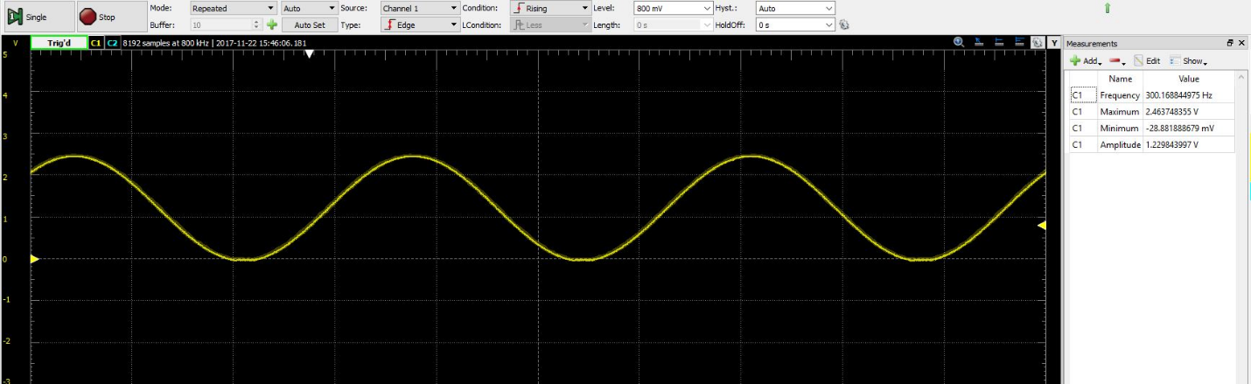

DMA Sinusoid:

