EEL4511C

Schuster, Mark

Lab 2

01/11/2018

Minimum flowchart:

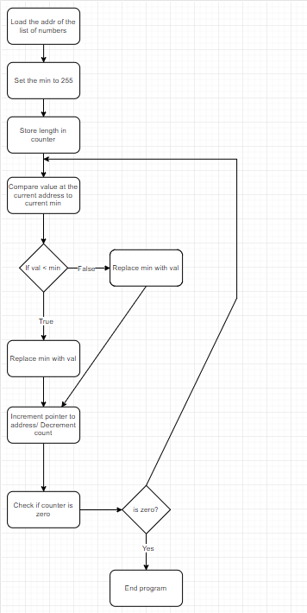

Problems encountered:

I struggled with getting the GPIO and LCD to work, but a combination of incorrect wire rapping and bad timing were the source of my struggles.