EEL4511C

Schuster, Mark

Lab 3

02/12/2018

**1.1 Flowcharts:**

Min flowchart:

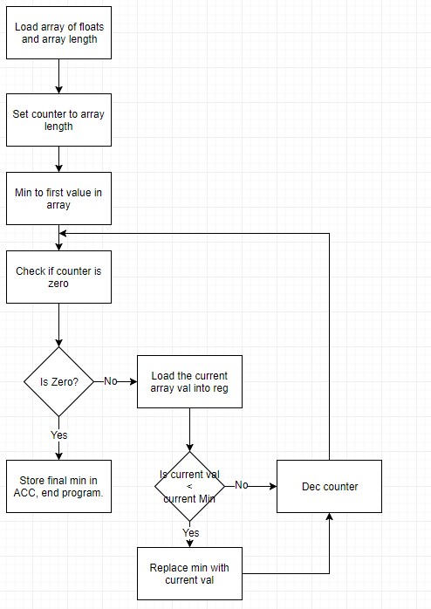

Max flowchart:

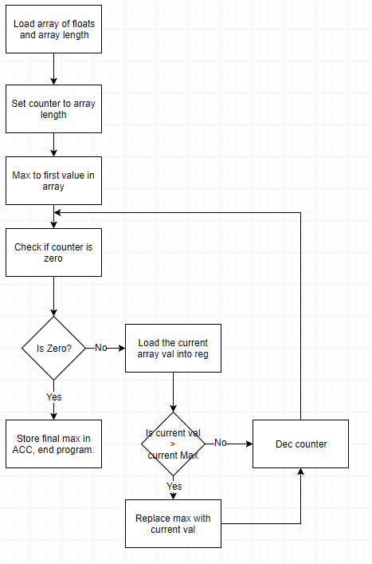

Average flowchart:

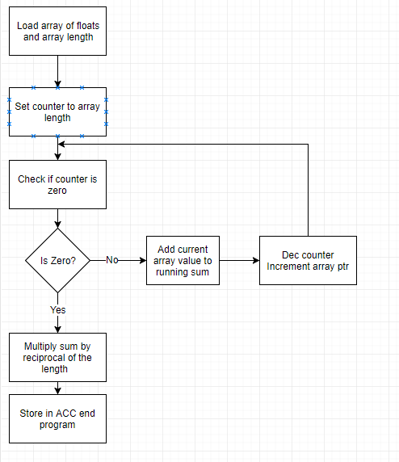

SRAM flowchart:

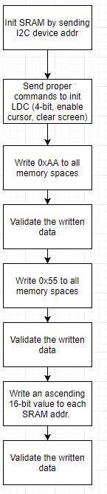

**1.2 Schematics/Decoding Logic:**

None for this lab.

**1.3 Problems Encountered:**

In this lab I had no major problems. My SRAM worked on the first try, and the FPU portion was easy enough given the documentation and example code.

**1.4 Program Code:**

Submitted on Canvas.

**1.5 Program Description;**

fpuStats.asm: Harbors the three subroutines discussed in the FPU portion of the prompt. The min subroutine works by using a single iteration of bubble sort, to bubble the min value to the to the top of the array (held in memory). The max is the exact same, just comparing if the current max is less than the current value instead of greater than. The average just sums all the elements of the array and multiplies by the reciprocal of the length to obtain the average.

sram.asm: Initializes the SRAM and LCD, then proceeds to run the tests described in the prompt. The first being writing 0xAA to all SRAM addresses then validating the data and sending either a success or error message to the LCD. The second test is the exact same with the exception of writing 0x55 instead of 0xAA. The final test writes and ascending 16-bit number to all the addresses in the SRAM and then also validates them, sending a message to the LCD accordingly.