INFORMATION TECHNOLOGY
Grade 11
Study Reference
Ms Coetzee · CAPS-aligned · Practical & Theory
Contents

1D Arrays
Imagine you need to store 30 student marks. Without arrays you would need 30 separate variables — iMark1, iMark2, … iMark30. With an array, one name stores them all: arrMarks[1..30]. Arrays are a Grade 11 Term 1 topic.

Why Use Arrays?
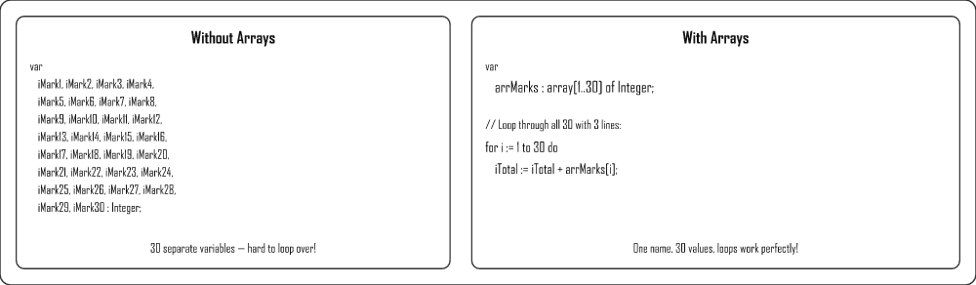

What is a 1D Array?
A one-dimensional array holds an ordered list of values. Think of it like a train — each carriage (box) holds one value and has a number (index). The index tells you where to find the value.
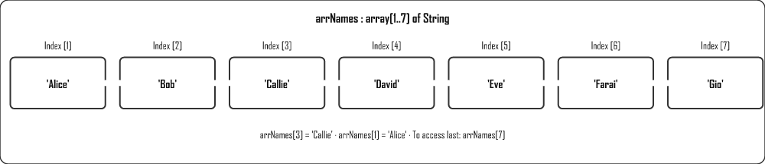

Declaring an Array
Syntax
arrName : array [lowerIndex..upperIndex] of DataType;
Examples
var
arrNames : array [1..30] of String;
arrMarks : array [1..30] of Integer;
arrPrices : array [0..9] of Real;

Arrays of Unknown Length — use a constant
You don't always know in advance exactly how many items you will store. A common trick is to declare a constant for the maximum size, then use it as the upper index. If the size needs to change later, you only edit one line.
DECLARE THE CONSTANT BEFORE THE ARRAY
The constant must be declared above the array declaration (it can go just above type in the interface section), otherwise Delphi won't know what Max means yet.
Delphi
const
Max = 100; // maximum possible learners
var
arrNames : array [1..Max] of String;
iCount : Integer; // how many are ACTUALLY used
Keep a separate counter (iCount) for how many elements are really in use, and loop 1 to iCount instead of 1 to Max.

Dynamic Arrays
A dynamic array has no fixed size when declared — you set (and can later change) its length while the program runs with SetLength. This is perfect when the number of items is only known at runtime (e.g. after reading a file).
DYNAMIC ARRAYS START AT INDEX 0
Unlike array[1..30], a dynamic array is always 0-based. If you SetLength(arr, 5) the valid indexes are 0,1,2,3,4. Use Low(arr) for the first index (0) and High(arr) for the last (length − 1).
Routine | Purpose
SetLength(arr, n) | Sets (or changes) the array to hold n elements
Length(arr) | Returns the current number of elements
Low(arr) | First valid index (always 0 for dynamic arrays)
High(arr) | Last valid index (Length − 1)
Delphi — dynamic array
var
arrNum : array of Integer; // note: NO index range given
i : Integer;
begin
SetLength(arrNum, 5); // now holds 5 ints, index 0..4

for i := Low(arrNum) to High(arrNum) do
arrNum[i] := i * 2; // 0, 2, 4, 6, 8

SetLength(arrNum, 8); // grow to 8 — existing values are kept
end;

Populating an Array

Method 1: Fixed values
Delphi
arrNames[1] := 'Alice';
arrNames[2] := 'Bob';
arrNames[3] := 'Callie';

Method 2: Constant array (known at compile time)
Delphi
const
arrDays : array [1..7] of String =
('Mon', 'Tue', 'Wed', 'Thu', 'Fri', 'Sat', 'Sun');

Method 3: User input with a loop
Delphi
for i := 1 to 30 do
arrNames[i] := InputBox('Name', 'Enter name:', '');

Displaying & Calculating
Delphi
// Display all
for i := 1 to Length(arrMarks) do
memOut.Lines.Add(IntToStr(arrMarks[i]));

// Sum and average
iTotal := 0;
for i := 1 to Length(arrMarks) do
iTotal := iTotal + arrMarks[i];
rAvg := iTotal / Length(arrMarks);

Linear Search
Delphi
bFound := False;
for i := 1 to Length(arrNames) do
if arrNames[i] = sSearch then
begin
ShowMessage('Found at position ' + IntToStr(i));
bFound := True;
Break;
end;
if not bFound then
ShowMessage('Not found');

Binary Search (sorted array)
Binary search is much faster than linear — it halves the search range each step. The array must be sorted first. We are searching for 23 in the array [2, 5, 8, 12, 16, 23, 38, 56, 72, 91].
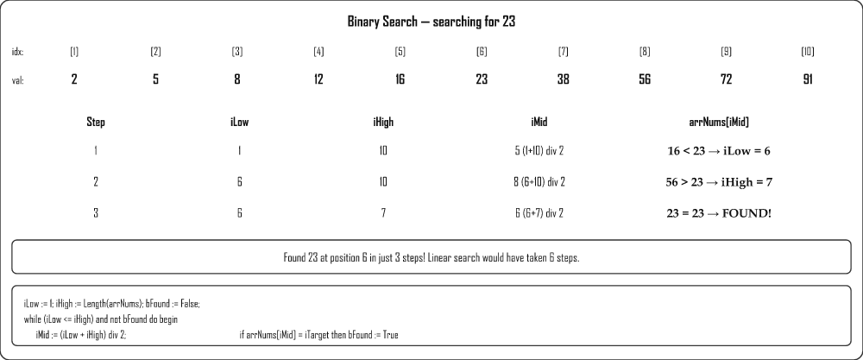
Delphi — binary search
iLow := 1;
iHigh := Length(arrNums);
bFound := False;
while (iLow <= iHigh) and not bFound do
begin
iMid := (iLow + iHigh) div 2;
if arrNums[iMid] = iTarget then
bFound := True
else if arrNums[iMid] < iTarget then
iLow := iMid + 1
else
iHigh := iMid - 1;
end;
if bFound then
ShowMessage('Found at position ' + IntToStr(iMid));

Bubble Sort — Pass by Pass
Bubble sort compares adjacent elements and swaps them if they are in the wrong order. After each full pass, the largest unsorted value "bubbles" to its correct position at the end. Array: [5, 3, 8, 1, 9] — sorting ascending.
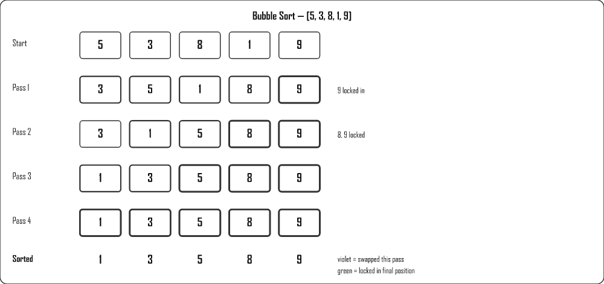
Delphi — Bubble Sort
for i := Length(arrNums) - 1 downto 1 do
for j := 1 to i do
if arrNums[j] > arrNums[j + 1] then
begin
iTemp := arrNums[j];
arrNums[j] := arrNums[j + 1];
arrNums[j + 1] := iTemp;
end;

Selection Sort — Pass by Pass
Selection sort finds the smallest remaining element and swaps it into its correct position. Same array: [5, 3, 8, 1, 9].
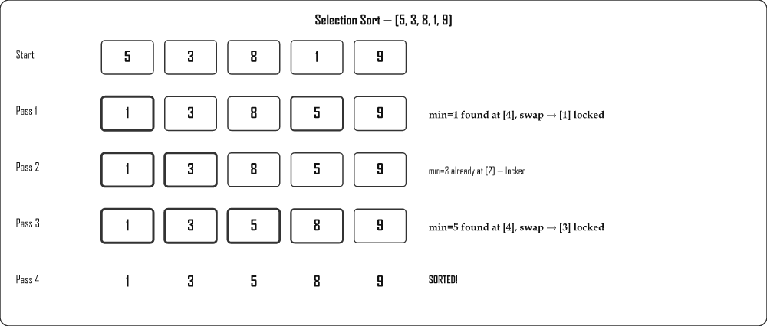
Delphi — Selection Sort
for i := 1 to Length(arrNums) - 1 do
for j := i + 1 to Length(arrNums) do
if arrNums[j] < arrNums[i] then
begin
iTemp := arrNums[i];
arrNums[i] := arrNums[j];
arrNums[j] := iTemp;
end;

Parallel Arrays
Two arrays are parallel when the same index refers to the same "record" — e.g. arrNames[3] and arrMarks[3] both belong to the same student. When you sort one, you must sort both to keep them in sync.
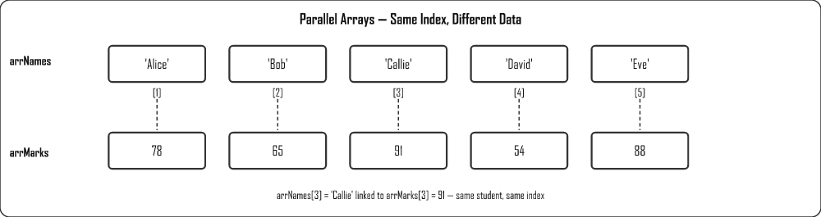
Delphi — parallel sort (names & marks together)
for i := 1 to Length(arrNames) - 1 do
for j := i + 1 to Length(arrNames) do
if arrNames[i] > arrNames[j] then
begin
// Swap both arrays at the same time
sTemp := arrNames[i]; arrNames[i] := arrNames[j]; arrNames[j] := sTemp;
iTemp := arrMarks[i]; arrMarks[i] := arrMarks[j]; arrMarks[j] := iTemp;
end;

Date Methods (Grade 11)
Delphi has built-in functions for working with dates — required for Grade 11 Term 1.
Function | Returns | Example & Output
Now | Current date & time (TDateTime) | lblDate.Caption := DateToStr(Now) → '2025/05/30'
DateToStr(d) | Date as formatted string | DateToStr(dtpBirth.Date) → '2008/03/15'
TimeToStr(t) | Time as formatted string | TimeToStr(Now) → '14:32:07'
StrToDate(s) | String → TDateTime | StrToDate('2024/05/01')
IsLeapYear(y) | Boolean (True/False) | IsLeapYear(2024) → True
YearOf(d) | Integer year | YearOf(dtpDate.Date) → 2025
MonthOf(d) | Integer month (1–12) | MonthOf(Now) → 5
DayOf(d) | Integer day (1–31) | DayOf(Now) → 30
Delphi — Date examples with output
// Display today's date
lblToday.Caption := DateToStr(Now); // '2025/05/30'

// Calculate age in years
iAge := YearOf(Now) - YearOf(dtpBirth.Date); // e.g. 17

// Check leap year
if IsLeapYear(YearOf(Now)) then
ShowMessage('This is a leap year')
else
ShowMessage('Not a leap year');

Text Files
Text files allow your Delphi program to save and load data that persists between runs. Learn the four operations: reading, writing, appending, and checking existence.

What Is a Text File?
A text file is a file that stores plain, readable characters with no special formatting — just letters, numbers and line breaks, exactly as you would type them into Notepad. There are no fonts, colours, or hidden layout codes like you would find in a Word document; it is simply text, one line after another.
ANALOGY
Think of a text file as a plain notepad. You can open it, read what is written, add a new line at the bottom, or tear out the page and start fresh. There is nothing fancy inside — just the words you wrote.

Why Do We Use Files?
The variables in your program only live in memory (RAM) while the program is running. The moment you close the program, everything in those variables is gone. A file gives your data persistence — it is saved onto the disk so that it survives after the program closes and is still there the next time you run it.
Example: a marks program that lets a teacher capture results is useless if every mark vanishes when she closes it. By writing the marks to a text file, the data is safely stored and can be read back tomorrow.

Physical vs Logical Filename
When working with files in Delphi there are two "names" to keep straight:
- Physical filename – the real name of the file as it exists on the disk, for example 'Data.txt'. This is what you would see in File Explorer.
- Logical filename – the file variable inside your program (of type TextFile), for example F. Your code talks to this variable, not directly to the disk.
The AssignFile command is what links the two together — it tells Delphi "whenever I use the logical variable F, I really mean the physical file Data.txt on the disk".
ANALOGY
Think of a postbox. The physical filename is the actual postbox standing in the street with a real street address. The logical filename is the label F you stick on your desk that says "this drawer represents that postbox". AssignFile is the act of writing the street address onto your label so the two are connected.

What Each File Command Does
Before looking at the table, here is each command explained in plain words:
- AssignFile(F, 'file.txt') – links your file variable to the real file on disk. Always the very first step.
- Reset(F) – opens an existing file so you can read from it, starting at the very beginning.
- Rewrite(F) – creates a brand-new empty file for writing. If the file already exists, its old contents are wiped out, so use it with care.
- Append(F) – opens an existing file and moves to the very end, so new lines are added without destroying what is already there.
- ReadLn(F, S) – reads one whole line from the file into the variable S, then moves on to the next line.
- WriteLn(F, S) – writes the contents of S into the file as one line.
- CloseFile(F) – saves and properly closes the file. Like shutting and locking the postbox so nothing is lost.
- Eof(F) – short for "End Of File". Returns True once you have read the last line, so your loop knows when to stop.

Key Procedures and Functions
Command | Purpose
AssignFile(F, 'file.txt') | Links the file variable F to a file on disk
Reset(F) | Opens existing file for reading (from beginning)
Rewrite(F) | Creates/overwrites a file for writing
Append(F) | Opens existing file for writing — adds to end
CloseFile(F) | Saves and closes the file
ReadLn(F, S) | Reads one line from file into variable S
WriteLn(F, S) | Writes variable S as one line to the file
EOF(F) | Returns True when the end of the file is reached
FileExists('file.txt') | Returns True if the file exists on disk

Reading a Text File
Delphi — read all lines
var
F: TextFile;
S: string;
begin
if FileExists('Data.txt') then
begin
AssignFile(F, 'Data.txt');
Reset(F); // open for reading
while not EOF(F) do
begin
ReadLn(F, S);
memOut.Lines.Add(S); // process each line
end;
CloseFile(F);
end
else
ShowMessage('File not found!');
end;

Writing to a Text File (Overwrite)
Delphi — create / overwrite
var
F: TextFile;
begin
AssignFile(F, 'Output.txt');
Rewrite(F); // creates or overwrites
WriteLn(F, sName + ',' + sSurname + ',' + IntToStr(iAge));
CloseFile(F);
end;

Appending to a Text File
Delphi — add to end
var
F: TextFile;
begin
AssignFile(F, 'Data.txt');
Append(F); // adds to existing file
WriteLn(F, 'New data line');
CloseFile(F);
end;

Reading CSV Data into Arrays
Delphi — read Name,Mark pairs
var
F: TextFile;
sLine, sName: string;
iMark, iCount, iPos: Integer;
begin
iCount := 0;
AssignFile(F, 'marks.txt');
Reset(F);
while not EOF(F) do
begin
ReadLn(F, sLine);
iPos := Pos(',', sLine);
Inc(iCount);
arrNames[iCount] := Copy(sLine, 1, iPos - 1);
arrMarks[iCount] := StrToInt(Copy(sLine, iPos + 1, Length(sLine)));
end;
CloseFile(F);
end;
ALWAYS CLOSEFILE!
Forgetting CloseFile(F) means the file remains locked and data may not be saved properly.

Procedures & Functions
User-defined procedures and functions let you break code into reusable, named blocks. This makes programs easier to read, maintain and debug.

What Is a Method?
A method is a named block of code that performs a specific task. Instead of writing the same instructions over and over inside your event handlers, you write them once, give that block a name, and then simply call that name whenever you need the task done. In Delphi we build methods in two forms: procedures and functions.
Think of a method like a recipe card in a cookbook. The recipe is written down once. Whenever you want that dish, you don't rewrite the steps from scratch — you just fetch the card and follow it. A method works exactly the same way: write the steps once, then "fetch" them by name as often as you like.

What Is a Procedure?
A procedure is a named block of code that does a task but does not send a value back to where it was called. It simply carries out its instructions — showing a message, clearing some boxes, drawing on a canvas — and then control returns to the program.
ANALOGY
A procedure is like asking someone to "switch off the lights". They go and do the job. You don't expect them to hand you anything back — you just expect the task to be done.

What Is a Function?
A function is a named block of code that does a task and then returns exactly one value back to where it was called. Inside the function you store the answer in the special variable Result, and that answer is handed back so you can use it — store it, display it, or calculate further with it.
ANALOGY
A function is like asking someone "How much is the bread?" They go, check, and come back with an answer you can use. A function always brings something back; a procedure does not have to.

Why Do We Break Code Into Methods?
When you are starting out it can feel like extra work to split your program into little named blocks. But experienced programmers do it for very good reasons:
- DRY (Don't Repeat Yourself) – if the same instructions appear in three places and you copy-paste them, you now have to fix bugs in three places. Put them in one method and you fix it once.
- Readability – a well-named method like CalcAverage tells the reader exactly what is happening, far better than ten lines of arithmetic.
- Easier testing and debugging – you can test one small method on its own instead of hunting through a giant block of code.
- Reuse – once written, a method can be called from many different buttons and events.
IMPORTANT RULE
Each method should do only one job. If a method is trying to do several things at once, that is usually a sign it should be split into smaller methods.

Parameters vs Arguments
A parameter is a placeholder name listed in the method's declaration — it stands for a value the method will receive. An argument is the actual value you pass in when you call the method. In short: parameters live in the declaration; arguments are the real values you supply at the call.
ANALOGY
Think of a parameter as a labelled jar called "sName" sitting empty on the shelf when the recipe is written. The argument is the actual "Ms Coetzee" you scoop into that jar when you finally cook. The jar's label is the parameter; what you put in it is the argument.
Example: in DisplayGreeting(sMessage, sName: string) the names sMessage and sName are parameters. When you call DisplayGreeting('Good morning', 'Ms Coetzee'), the strings 'Good morning' and 'Ms Coetzee' are the arguments.

Value Parameters
A value parameter means the method receives a copy of the argument. The method can change that copy freely inside itself, but the original variable back in the calling code stays untouched. This is the default and safest kind of parameter, because the caller never has to worry about its variables being changed unexpectedly.
ANALOGY
A value parameter is like giving someone a photocopy of a document. They can scribble all over their copy, but your original is safe at home.

Procedures vs Functions
 | Procedure | Function
Returns a value? | No (or modifies var parameters) | Yes — always returns exactly one value
Called how? | Alone as a statement | As part of another statement (assigned)
Keyword | procedure | function

Procedures

Without Parameters
Delphi — declare and call
// Declaration (above the event handlers)
procedure ShowHello;
begin
ShowMessage('Hello!');
end;

// Calling it
procedure TForm1.btnShowClick(Sender: TObject);
begin
ShowHello; // called alone
end;

With Parameters
Delphi
procedure DisplayGreeting(sMessage, sName: string);
begin
ShowMessage(sMessage + ' ' + sName);
end;

// Call with arguments
DisplayGreeting('Good morning', 'Ms Coetzee');

Functions

Without Parameters
Delphi
function GetAnswer: Integer;
begin
Result := 42;
end;

// Must be assigned
iVal := GetAnswer;

With Parameters
Delphi
function AddNumbers(num1, num2: Integer): Integer;
begin
Result := num1 + num2;
end;

// Call
iAnswer := AddNumbers(5, 3); // = 8
lblResult.Caption := IntToStr(AddNumbers(iA, iB));

Function Example — Calculate Average
Delphi
function CalcAverage(iTotal, iCount: Integer): Real;
begin
if iCount = 0 then
Result := 0
else
Result := iTotal / iCount;
end;

// Use it
rAvg := CalcAverage(iSum, iNumStudents);
lblAvg.Caption := FloatToStr(rAvg);

Why Use Procedures and Functions?
To bring it all together, here are the practical benefits you gain every time you reach for a method instead of writing one long block of code:
- Break large programs into manageable pieces
- Reuse code from multiple event handlers — no duplication
- Easier to find and fix bugs
- Easier to update — change in one place, works everywhere
- Each method should perform only one task

Databases in Delphi
In Grade 11 you learn how to connect a Delphi program to a Microsoft Access database, display its data on screen, and add, edit or delete records using code — without SQL (SQL comes in Grade 12).
GRADE 11 VS GRADE 12
In Grade 11 you use TADOTable and write code (loops, IF statements) to work with records.
In Grade 12 you switch to TADOQuery and use SQL statements to do the same things — faster and more powerful.

The Big Picture — How the Pieces Connect
Think of connecting to a database like setting up a water supply to a tap:
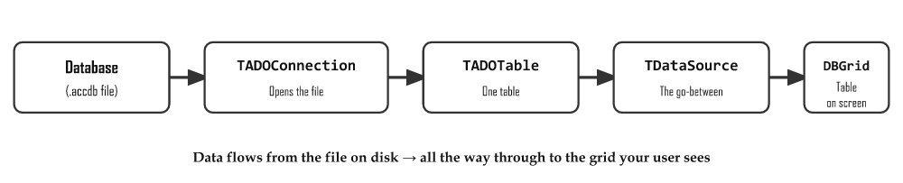

Understanding Each Component

TADOConnection — The Door to the Database
Imagine the database file (.accdb) is locked inside a room. The TADOConnection is the key that unlocks the door so Delphi can get in. You tell it where the file is on your computer.
WHERE IT GOES
Place TADOConnection on a Data Module (a special form-like container for database components). Go to File → New → Data Module to create one.
Key properties to set in Object Inspector
ConnectionString → Build... → Choose "Microsoft Jet 4.0 OLE DB Provider"
→ Browse to your .accdb file
LoginPrompt → False (stops the "Enter password" popup appearing)

TADOTable — One Table from the Database
A database can have many tables (Students, Subjects, Classes…). A TADOTable represents one of those tables. You need one TADOTable for each table you want to work with.
Key properties
Connection → select your ADOConnection (dm.conDB)
TableName → choose the table from the dropdown (e.g. "tblStudents")
Active → True (this "opens" the table so data loads)

TDataSource — The Go-Between
This is the part students find confusing. Why do we need it?
Think of it this way: your TADOTable is like a water tank (holds all the data). Your DBGrid is the tap (where the data comes out on screen). The TDataSource is the pipe connecting the tank to the tap. Without the pipe, no water flows.
You cannot connect a DBGrid directly to a TADOTable. Every visual display component (DBGrid, DBEdit, DBLabel) must connect through a TDataSource. These display components are called data-aware controls — controls that are aware of database data.
Key property
DataSet → select your TADOTable (dm.tblStudents)

TDBGrid — The Table You See on Screen
The DBGrid is a component you drop onto your main form (not the Data Module). It displays the database records as rows and columns — just like a spreadsheet. It updates automatically as you navigate through records.
Key property
DataSource → select your TDataSource (dm.dsStudents)

Step-by-Step Setup
- Create a Data Module: File → New → Data Module. Save it as DataModule_u.pas.
- Drop TADOConnection onto the Data Module. Set up the connection string (browse to your .accdb file). Set LoginPrompt = False.
- Drop TADOTable onto the Data Module. Set Connection to the ADOConnection. Set TableName. Set Active = True.
- Drop TDataSource onto the Data Module. Set DataSet to the TADOTable.
- On your main form: add the Data Module name to the uses clause at the top of your unit.
- Drop TDBGrid onto your main form. Set its DataSource to the DataSource you created in the Data Module.
- The grid should now show your database records!
NAMING CONVENTION
Name components so you know what they are at a glance:
conStudents (TADOConnection) • tblStudents (TADOTable) • dsStudents (TDataSource) • dbgStudents (TDBGrid)

Accessing Field Values in Code
Once connected, you can read the value of any field in the current record using this syntax:
Syntax
variable := DataModuleName.TableName['FieldName'];
Delphi — examples
sName := dm.tblStudents['Name']; // reads the Name field
sSurname := dm.tblStudents['Surname']; // reads the Surname field
iGrade := dm.tblStudents['Grade']; // reads the Grade field

// Display in a label
lblInfo.Caption := dm.tblStudents['Name'] + ' ' + dm.tblStudents['Surname'];

Navigating Records
Think of records as pages in a book. These methods let you turn pages:
Method | What it does
tblStudents.First | Jump to the very first record
tblStudents.Last | Jump to the last record
tblStudents.Next | Move forward one record
tblStudents.Prior | Move back one record
tblStudents.Eof | Returns True when you have gone past the last record (End Of File). Use in a WHILE loop to process all records.
Delphi — loop through ALL records
dm.tblStudents.First; // start at record 1
while not dm.tblStudents.Eof do // keep going until past last
begin
memOut.Lines.Add(dm.tblStudents['Name']); // do something with this record
dm.tblStudents.Next; // move to next record
end;
NEVER FORGET .NEXT INSIDE THE LOOP!
If you forget tblStudents.Next inside the loop, the program will be stuck on the first record forever — an infinite loop that will crash Delphi.

Searching for a Record
To find a specific record, loop through all records and check each one:
Delphi — find a student by surname
dm.tblStudents.First;
while not dm.tblStudents.Eof do
begin
if dm.tblStudents['Surname'] = edtSearch.Text then
begin
ShowMessage('Found: ' + dm.tblStudents['Name']);
Break; // stop searching once found
end;
dm.tblStudents.Next;
end;

Inserting a New Record
Adding a new record is a 3-step process: prepare → fill in values → save.
Delphi
dm.tblStudents.Insert; // Step 1: prepare a blank new record
dm.tblStudents['Name'] := edtName.Text; // Step 2: fill in the fields
dm.tblStudents['Surname'] := edtSurname.Text;
dm.tblStudents['Grade'] := sedGrade.Value;
dm.tblStudents.Post; // Step 3: save to the database

Editing an Existing Record
Delphi
// First navigate to the record you want to change, then:
dm.tblStudents.Edit; // Step 1: put the record into edit mode
dm.tblStudents['Grade'] := 12; // Step 2: change the value
dm.tblStudents.Post; // Step 3: save the change

Deleting a Record
Delphi
// Navigate to the record first, then:
dm.tblStudents.Delete; // removes the current record permanently
DELETION IS PERMANENT
There is no undo. Always confirm with the user before deleting: if MessageDlg('Delete this record?', mtConfirmation, mbYesNo, 0) = mrYes then dm.tblStudents.Delete;

Sorting Records
Delphi
dm.tblStudents.Sort := 'Surname ASC'; // A to Z by surname
dm.tblStudents.Sort := 'Mark DESC'; // highest mark first
dm.tblStudents.Sort := 'Grade ASC, Surname ASC'; // by grade, then surname

Complete Example — Finding the Highest Mark
Delphi — find highest mark in tblStudents
var
iHighest : Integer;
sTopName : String;
begin
iHighest := 0;
sTopName := '';
dm.tblStudents.First;
while not dm.tblStudents.Eof do
begin
if dm.tblStudents['Mark'] > iHighest then
begin
iHighest := dm.tblStudents['Mark'];
sTopName := dm.tblStudents['Name'];
end;
dm.tblStudents.Next;
end;
lblResult.Caption := sTopName + ' scored the highest: ' + IntToStr(iHighest);
end;

Connecting a Database Dynamically (in Code)
Everything above used components dropped onto a Data Module at design time. You can also build the whole connection at runtime with code — no components needed. This is called a dynamic connection, and it is useful when the database path is only known while the program runs (e.g. the user browses to the file).
ADD THESE UNITS TO USES
Dynamic database objects live in two units. Add ADODB and DB to the uses clause before you can create them in code.
Declare the three objects (usually under public in the Data Module, or in the form):
Delphi — declaration
public
conDB : TADOConnection;
tblStudents : TADOTable;
dsStudents : TDataSource;
Create and wire them together — build the connection string, point the table at the connection, then link the DataSource:
Delphi — create the connection in code
procedure TdmData.DataModuleCreate(Sender: TObject);
begin
// 1. Create the connection object
conDB := TADOConnection.Create(Self);
conDB.LoginPrompt := False; // don't ask for a password
conDB.ConnectionString :=
'Provider=Microsoft.ACE.OLEDB.12.0;' +
'Data Source=' + ExtractFilePath(Application.ExeName) + 'Students.accdb;';
conDB.Connected := True;

// 2. Create the table and link it to the connection
tblStudents := TADOTable.Create(Self);
tblStudents.Connection := conDB;
tblStudents.TableName := 'tblStudents';
tblStudents.Active := True;

// 3. Create the DataSource and link it to the table
dsStudents := TDataSource.Create(Self);
dsStudents.DataSet := tblStudents;
end;
Finally, link your on-screen TDBGrid to the DataSource. Do this in the main form's OnShow event:
Delphi — link the grid (in FormShow)
procedure TfrmMain.FormShow(Sender: TObject);
begin
dbgStudents.DataSource := dmData.dsStudents;
end;
WHY FORMSHOW AND NOT FORMCREATE?
The Data Module is usually created after the main form. If you try to link the grid in the main form's OnCreate event, the Data Module does not exist yet and you get an access violation error. Use OnShow, which fires later, once everything exists.
OLDER .MDB FILES
For older Access .mdb databases the provider is Microsoft Jet 4.0 OLE DB Provider (Provider=Microsoft.Jet.OLEDB.4.0;). Newer .accdb files use the ACE provider shown above.

Motherboard & Hardware
A deeper look at what is inside the system unit — the motherboard, its components, buses, expansion cards, and how data flows between parts.

The Motherboard
The motherboard is a large printed circuit board that connects and provides power to all hardware components. It is the central hub of the computer.

Key Motherboard Components
Component | Description
BIOS chip | Basic Input/Output System — first instructions when PC starts. Stored on ROM. Performs POST.
CPU socket (ZIF) | Connects the CPU to the motherboard
DIMM slots | RAM slots
PCI / PCIe slots | Add expansion cards (GPU, sound card, NIC)
SATA ports | Connect internal storage (HDD, SSD)
Power connector | Supplies power from PSU to all components
RAM (DIMM) | Volatile short-term memory for active programs
ROM | Read-Only Memory — stores BIOS firmware permanently

BIOS Functions
- Performs the POST (Power-On Self-Test) — checks RAM, keyboard, storage
- Identifies and initialises hardware devices
- Locates the bootloader and hands control to the OS
- Provides low-level system settings

Motherboard Buses
A bus is a set of wires that transfers data between components.
Bus type | Purpose
Data bus | Transfers data and instructions between components
Address bus | Carries the physical memory address of data
Control bus | CPU sends signals to coordinate actions
Power bus | Delivers electricity to components
Internal bus | Links CPU and main memory
External bus | Interface for peripherals (USB, SATA, PCIe)

Data Flow Between Components
Storage → RAM → CPU: Data is loaded from slow storage into fast RAM, then the CPU fetches from RAM for processing.
RAM → VRAM → GPU: Graphics data is moved from RAM to VRAM so the GPU can render images without burdening the CPU.

Cache Memory
Cache is a very small, very fast memory located close to (or inside) the CPU. It stores frequently used instructions so the CPU does not have to wait for slower RAM.
Level | Speed | Size
L1 | Fastest | Smallest (inside each core)
L2 | Fast | Larger
L3 | Moderate | Largest (shared across cores)

Modular Design
Motherboards use a modular design — individual components (RAM, CPU, GPU) can be upgraded or replaced without replacing the whole computer.

Processing Techniques
Modern computers can execute multiple tasks simultaneously using multitasking, multithreading and multiprocessing. This page also covers virtual memory, compilers and interpreters.

Processing Techniques
A processing technique is a method the operating system and CPU use to handle more than one job at a time so the computer feels fast and responsive. In the early days a computer could only do one thing from start to finish before moving on. Today we expect to type an email, listen to music and download a file all at once — and these techniques are what make that possible.

Why Do We Need This?
A CPU is incredibly fast, but a human is slow. While you pause to think about your next sentence, the CPU is sitting idle for millions of cycles. Processing techniques let the computer fill those gaps with other work, so no time is wasted and every program feels like it is running "at the same time".
THINK OF A CHEF IN A KITCHEN
Imagine one chef preparing several dishes. Multitasking is the chef stirring one pot, then quickly turning to chop onions, then back to the pot — one pair of hands switching between jobs so fast it looks simultaneous. Multithreading is one big recipe (say a curry) broken into steps that move along together — the sauce simmers while the rice cooks, all part of the same dish. Multiprocessing is hiring several chefs (CPU cores), each cooking a whole dish at the same moment in real parallel.
Technique | Description | Example
Multitasking | OS rapidly switches between multiple programs, giving the illusion of simultaneous execution | Listening to music while browsing the web
Multithreading | A single program is divided into threads that run concurrently | Browser: separate threads for UI, downloads, rendering, scripts
Multiprocessing | Multiple CPU cores execute tasks truly in parallel | A quad-core CPU running 4 tasks simultaneously
- Multitasking – running several programs at once by switching rapidly between them. Only one task truly runs at any instant, but the switching is so quick it feels simultaneous.
- Multithreading – splitting a single program into smaller "threads" that progress together, so one slow part (like a download) does not freeze the rest of the program.
- Multiprocessing – using two or more CPU cores to genuinely execute different tasks at the same time. This is real parallelism, not an illusion.
Note: The key difference to remember is that multitasking and multithreading share one processor by taking turns, while multiprocessing uses multiple processors to do work truly at the same moment.

Virtual Memory
Virtual memory is storage space on the hard drive that the operating system uses as if it were extra RAM. When the real RAM fills up, the OS borrows a slice of the much larger (but much slower) hard drive to keep programs running instead of crashing.

Why Do We Need This?
RAM is expensive and limited. Without virtual memory, the moment your RAM filled up the computer would simply refuse to open the next program. Virtual memory acts as a safety valve so you can keep working even when memory is tight.
A DESK AND A FILING CABINET
Picture your RAM as the top of your desk — small, but everything on it is right in front of you and instantly reachable. The hard drive is a big filing cabinet across the room — it holds far more, but you must get up and fetch things from it. When your desk overflows, you move papers you are not using right now into the cabinet (virtual memory) and fetch them back when you need them. It works, but every trip to the cabinet wastes time.
When RAM is full, the OS uses a section of the hard drive as temporary RAM — called virtual memory.
- Programs not currently in use are swapped from RAM to virtual memory
- When needed again, they are swapped back into RAM
- Allows more programs to run than physical RAM would normally allow
- Much slower than real RAM — heavy use causes thrashing (performance crash)
Thrashing is what happens when the computer spends more time swapping data back and forth between RAM and virtual memory than it spends doing actual useful work. The hard drive light stays on constantly, the mouse stutters, and everything slows to a crawl. In our desk analogy, thrashing is when your desk is so small that you are constantly running to the filing cabinet and back, never getting anything done.

Solutions when thrashing occurs:
- Close unnecessary background apps
- Increase physical RAM
- Upgrade to 64-bit OS

Compilers vs Interpreters
Computers only understand machine code (binary 1s and 0s), but humans write in readable programming languages. A translator is needed to bridge that gap. There are two main kinds, and the difference is all about when the translation happens.
- Compiler – a translator that converts the entire source code into machine code in one go, before the program ever runs, producing a standalone executable file.
- Interpreter – a translator that reads and runs the code one line at a time, translating each line just as it is about to be executed.
TWO KINDS OF TRANSLATOR
Think of translating a book. A compiler is like a translator who sits down and translates the whole book into a finished printed copy — slow to prepare, but afterwards anyone can read it instantly. An interpreter is like a live human interpreter standing next to a speaker, translating each sentence out loud as it is spoken — you can start immediately, but it is slower overall because translation happens during the conversation.
 | Compiler | Interpreter
How it works | Translates entire source code to machine code at once | Reads and executes one line at a time
Speed | Slower to open program, faster once running | Faster to open, slower while running
On error | Stops completely — program never opens | Runs until error is hit, then crashes
Examples | Delphi, C++ | Python, JavaScript

Virtualisation
Virtualisation is the technique of using software to create a "virtual" computer — called a virtual machine — that runs inside your real computer as if it were a separate physical machine with its own operating system.

Why Do We Need This?
One powerful computer can be split into several virtual machines, so a single server can do the work of many. This saves money, electricity and space, and lets you safely test risky software in a sealed-off environment without endangering your real system.
A BUILDING WITH SEPARATE FLATS
Imagine one large building (your physical computer). Virtualisation divides it into several self-contained flats (virtual machines). Each flat has its own front door, kitchen and tenants (its own operating system and programs), and what happens in one flat does not affect the others — yet they all share the same building, plumbing and electricity (the real hardware).
Example: Running Windows on a Mac, or a single cloud server hosting dozens of separate websites, each in its own virtual machine.

Programming Languages
Type | Description | Examples
Low-level | Close to machine code; fast and efficient; hard to read | Assembly language
High-level | English-like; easier to write and understand; compiled or interpreted | Delphi, Python, Java, C++

Types of Errors
Error Type | Description
Syntax | Code typed incorrectly — won't compile
Runtime | Crashes while running (e.g. divide by zero)
Logical | Runs but gives wrong output
Overflow | Calculation result too large for the data type

Database Management
A database is like a highly organised digital filing cabinet — instead of papers stuffed into folders, your data is stored in neat tables with rows and columns, so you can find, sort and filter it in seconds. A DBMS (Database Management System) is the software that manages it all.

Key Terms
Term | Definition
Database | An organised collection of data stored in tables
Table | Rows and columns storing one type of entity (e.g. Students)
Record | One complete row — all data about one item
Field | One column — a specific attribute (e.g. Surname, Age)
Primary key | Unique field that identifies each record (e.g. StudentID)
Foreign key | A field that links to the primary key of another table
DBMS | Database Management System — software to create, manage and query databases

What a Database Table Looks Like
A table in a database looks exactly like a spreadsheet grid. The table has a name, column headers (fields), and rows of data (records).
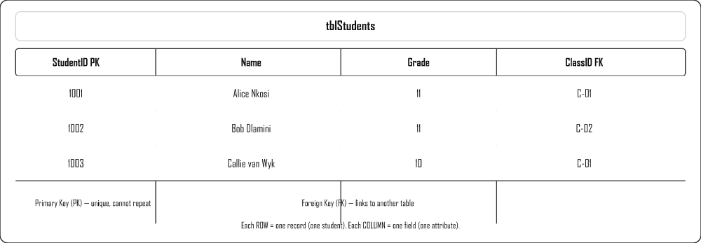

Primary Key vs Foreign Key
Keys are what make databases powerful — they link tables together so you do not repeat data.
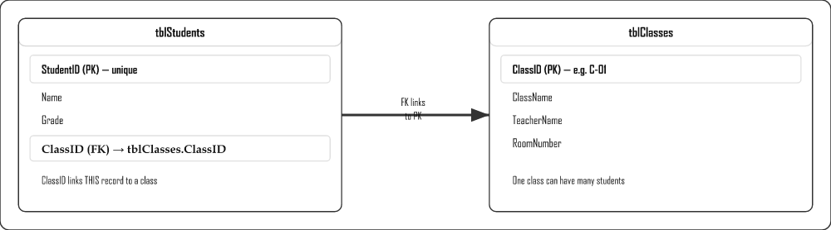
Key Type | Description | Example
Primary Key (PK) | Uniquely identifies each record. Cannot be NULL. Cannot repeat. | StudentID = 1001
Foreign Key (FK) | A field in one table that refers to the PK of another table. | ClassID in tblStudents → ClassID in tblClasses
Composite Key | Two or more fields combined to form a unique identifier. | StudentID + SubjectCode

Entity Relationship Diagram (ERD)
An ERD shows the tables in a database and how they are related. The line between tables shows the type of relationship (one-to-many, etc.).
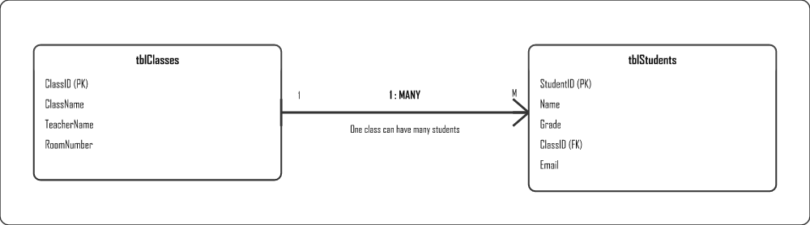

Database Field Data Types
Each field in a table has a data type that controls what kind of data can be stored.
Data Type | Also Called | Description | SA School Example
Text / Short Text | VARCHAR, String | Letters, numbers, symbols — max 255 chars | Student name, school name
Number | Integer, Long Integer | Whole numbers or decimals (for calculations) | Mark out of 100, age
Date/Time | DateTime | Dates and/or times stored as numeric values internally | Date of birth, test date
Yes/No | Boolean | Only two values: True/False, Yes/No, 1/0 | Has paid school fees, is a prefect
AutoNumber | Identity, Auto-increment | Automatically assigns the next unique integer — ideal for PK | StudentID, RecordID
Currency | Money, Decimal | Monetary values with fixed decimal precision | Fee amount, textbook cost
Memo / Long Text | Text (large) | Longer text — more than 255 characters | Teacher comments, notes
OLE Object | Blob | Stores files — images, documents, audio | Student photo, report PDF

Common DBMS Software
DBMS | Type | Cost | Use Case
Microsoft Access | Desktop | Paid (MS Office) | Small databases, school/office, learning, Grade 11–12 IT practicals
MySQL | Open-source server | Free | Web applications, websites (used with PHP)
Oracle | Enterprise server | Very expensive | Banks, airlines, hospitals — mission-critical systems
PostgreSQL | Open-source server | Free | Advanced queries, large datasets, analytics
Microsoft SQL Server | Enterprise server | Paid | Large corporate databases, Windows environments

Table Relationships
Relationship | Description | Example
One-to-One | One record in Table A links to exactly one record in Table B | Student ↔ Locker (each student has one locker)
One-to-Many | One record in Table A links to many records in Table B | Class → Students (one class has many students)
Many-to-Many | Many records in A link to many records in B (needs a linking table) | Students ↔ Subjects (students take many subjects; subjects have many students)

Data Quality Characteristics
Data quality means the data is fit for purpose. Poor quality data leads to wrong decisions.
Characteristic | Meaning | SA School Example
Accuracy | Data is correct and free from errors | A learner's mark recorded as 78, not 87 (transposition error)
Correctness | Data conforms to defined rules and constraints | Grade field only contains values 8–12
Currency | Data is up to date — not outdated | A learner's address updated after they move house
Completeness | All required data is present — no blank fields where required | Every learner record has a valid ID number and grade
Relevance | Only data that is needed is stored | A school database does not need to store a learner's favourite colour

Data Integrity
Data integrity ensures data is accurate, consistent and reliable over its entire lifetime.
- Physical integrity — protection from hardware failure using RAID, backups, and UPS.
- Logical integrity — data follows rules: input validation, referential integrity, access control.
- Referential integrity — a FK value must exist as a PK in the related table (no orphan records).

Validation Types
Validation checks that data entered is reasonable and in the correct format — it does not check if data is true, just if it is acceptable.
Check | Description | SA School Example
Format check | Data matches required pattern or structure | Email must contain @ and a dot — alice@school.co.za
Range check | Value falls within acceptable minimum and maximum | Test mark must be between 0 and 100
Type check | Data entered is the correct data type | Age field must be a number, not text
Presence check | The field must not be blank (required) | Surname cannot be empty — every learner must have a surname
Check digit | A calculated digit is appended and re-calculated to verify correctness | SA ID number: last digit is a check digit
Lookup check | Value must match an item in a predefined list | Province field: only one of the 9 SA province names allowed
Consistency check | Two or more fields must be logically consistent | If Grade = 10, Year must be after 2005 (15-year-old)

Database Types by Usage
Type | Description | Example
Desktop / Personal | Single user, stored locally on one computer | MS Access for a school IT project
Server / Centralised | Multi-user, stored on a server, accessed over a network | School administration system accessed by teachers and admin
Distributed | Spread across multiple locations/servers, synchronised | A national learner database accessed from all provinces

Database Careers
- DBA (Database Administrator) — maintains security, backups, performance tuning
- Database Programmer / Developer — writes queries, stored procedures, applications
- Database Analyst — designs structure, models relationships, plans migrations
- Data Scientist — analyses large datasets to find patterns and insights
- Project Manager — manages database projects, budgets and teams

Networks & Protocols
Building on Grade 10 networks — this page covers topologies, network devices in depth, protocols, VoIP, VPN and acceptable use.

Network Topologies
A network topology is the layout or "shape" of a network — it describes how the computers and devices are physically or logically arranged and connected to one another. The topology you choose affects how easy the network is to set up, how it copes with a fault, and how easy it is to add new devices later.

Star Topology
In a star topology every device connects to one central point — usually a switch. Nothing connects directly to anything else; all traffic passes through the middle.
ANALOGY
Picture a bicycle wheel: the hub in the centre is the switch, and each spoke is a cable running out to one computer. If a single spoke breaks the rest of the wheel is fine — but if the hub itself fails, the whole wheel falls apart. That is exactly why a star network keeps working when one PC fails, yet goes completely down if the central switch fails.
Topology | Layout | Advantages | Disadvantages
Star | All devices connect to a central switch | One failure doesn't affect others; easy to add devices | If switch fails, entire network fails
Ring | Devices in a closed loop | Equal opportunity to transmit; no collision | One break can down the whole network

Thin vs Thick Client
 | Thin Client | Thick (Fat) Client
Processing | Done mostly on server | Done on local computer
Storage | Minimal local storage | Large local storage
Cost | Cheaper | More expensive
Example | School lab PC connected to server | Personal desktop PC

Key Protocols
Protocol | Purpose
HTTP | Transfer web pages (unencrypted)
HTTPS | Secure web transfer (SSL/TLS encryption)
SMTP | Send emails
POP3 | Download emails to device
IMAP | Access emails online without downloading
FTP | Transfer large files between computers
VoIP | Voice calls over the Internet

VoIP
Voice over Internet Protocol allows phone/video calls using the Internet instead of traditional phone lines.
Your voice is broken into tiny digital packets, sent across the internet just like any other data, and reassembled at the other end. Because it rides on your existing internet connection, calls to other VoIP users are usually free no matter how far away they are — which makes it far cheaper than a traditional long-distance phone call.
- Examples: WhatsApp calls, Skype, Discord, Zoom
- Requires: stable internet, low latency, sufficient bandwidth

VPN
A Virtual Private Network creates an encrypted "tunnel" over the Internet.
- Allows remote users to access a private network securely
- Hides IP address and encrypts all data in transit
- Used by companies for remote workers

Internet vs Intranet vs Extranet
Network | Access | Description
Internet | Public | Global network open to all
Intranet | Private | Internal company/school network
Extranet | Controlled external | Intranet accessible from outside (VPN)

Acceptable Use Policies (AUP)
Rules governing how ICT resources may be used in an organisation. Key rules:
- No downloading illegal content
- Use computers for educational/work purposes
- No cyberbullying or harassment
- Respect copyright laws

Mobile Technology
Mobile devices have transformed communication and computing. This page covers smartphones, tablets, wireless technologies, and location-based services.

What Is Mobile Technology?
Mobile technology is any portable, wireless technology that lets you communicate, compute and access information while on the move, without being tied to a desk or a cable. The key idea is mobility: the device travels with you, connects wirelessly, and runs off its own battery.
In South Africa mobile technology is especially important. Many people first reach the internet not through a desktop PC but through a smartphone, because data on a phone is often cheaper and more accessible than a fixed-line connection at home. This makes the smartphone the main computer in millions of households.

Common Mobile Devices Explained
- Smartphone – a pocket-sized computer that combines a phone, camera, GPS, web browser and thousands of apps. It connects through Wi-Fi and the cellular network and is by far the most common mobile device in South Africa.
- Tablet – a larger touchscreen device, ideal for reading, watching media and light productivity. The bigger screen makes it more comfortable than a phone, but it is less pocket-friendly.
- Wearables – devices worn on the body, such as smartwatches and fitness bands. They track health data like heart rate and steps, and show notifications from your phone.
- GPS – the Global Positioning System uses signals from satellites to work out exactly where a device is on Earth, which is what powers navigation apps.
- Bluetooth – a short-range wireless technology (about 10m) used to connect devices to each other, such as wireless earphones, keyboards or a car's hands-free system.
- Wi-Fi – a wireless technology that connects devices to the internet through a router or hotspot over a medium range, usually inside a home, school or office.
- 4G and 5G – generations of mobile cellular internet. 4G gave us reliable mobile browsing and video; 5G is far faster and more responsive, enabling things like real-time video and large numbers of connected smart devices.

Advantages and Limitations of Mobile Technology
Advantages – you can work, bank, learn and communicate from anywhere; devices are convenient and always with you; and a single phone replaces many separate gadgets (camera, torch, calculator, GPS).
Limitations – small screens and keyboards are harder to work on for long periods; battery life is limited; mobile data can be expensive in South Africa; and the constant connection raises privacy, security and "always-on" distraction concerns.

Mobile Device Types
Device | Key Features
Smartphone | High-res touchscreen, app store, camera, Wi-Fi, cellular, GPS
Tablet | Larger screen (7"+), touch input, iOS/Android, media and productivity apps
Smartwatch / Wearable | Fitness tracking, heart rate, notifications, GPS
eReader | E-ink display, long battery, sunlight readable, primarily for books
GPS device | Satellite navigation, location tracking

Wireless Technologies
Technology | Range | Speed | Use
Bluetooth | ~10m | Low–medium | Headphones, keyboards, file sharing
Wi-Fi | 10–100m | High | Internet access via router/hotspot
4G/LTE | Nationwide | 5–100 Mbps | Mobile internet on the go
5G | Nationwide | 50 Mbps–10 Gbps | IoT, real-time VR, autonomous vehicles
NFC | ~4cm | Low | Contactless payments, tap-to-share

Location-Based Computing (LBC)
Software that uses your device's location (via GPS, Wi-Fi, cellular) to provide customised services.

Examples
- Weather apps showing your local forecast
- Uber/Bolt finding the nearest driver
- Food delivery apps delivering to your address
- Google Maps navigation

Social Implications of LBC
Benefit | Risk
Navigation and route planning | Privacy — organisations track your movements
Emergency services can locate you | Stalking risk
Personalised services | Targeted advertising without consent
Find lost/stolen devices | Data sold to third parties

Connection Speed — Shaping and Throttling
- Shaping — ISP prioritises certain traffic types (e.g. video gets priority over downloads)
- Throttling — ISP intentionally slows your speed after you exceed a data cap

Computer Management
Safeguarding a computer system requires understanding threats, knowing how malware works, and applying the right remedies.

Human Error Threats
- Sharing sensitive information with wrong people
- Writing down or reusing passwords
- Clicking links without verifying them
- Leaving devices unlocked / unattended
- Accidentally deleting valuable data

Physical Threats
- Theft of devices or storage media
- Hard drive mechanical failure (moving parts)
- Power surges or outages damaging hardware
- Water/liquid spills causing short circuits

Malware
Type | Description
Virus | Attaches to files; replicates when file is run; causes damage
Worm | Spreads across networks without user action
Trojan | Disguised as useful software; gives attacker back-door access
Rootkit | Hides in OS; gives remote attacker control; avoids detection
Ransomware | Encrypts data; demands payment to restore access
Spyware | Secretly monitors activity and steals data
Adware | Displays unwanted pop-up advertisements

Network Vulnerabilities
Attack | Description
Phishing | Fake official-looking emails to steal credentials
Pharming | Redirects users to fake websites
Spoofing | Forges sender addresses to impersonate someone
SQL Injection | Malicious SQL commands entered via web forms

Remedies and Protection
Remedy | Purpose
Antivirus | Detects, removes and prevents malware infections
Firewall | Filters all incoming and outgoing network traffic
Strong passwords | 8+ chars; mix of uppercase, lowercase, numbers, symbols; unique per site
User access rights | Users only access files they are authorised for
Encryption | Scrambles data so it cannot be read if intercepted
UPS | Keeps computer running during power failure
Software updates | Patches fix known security vulnerabilities
2FA / MFA | Requires additional verification beyond just a password

Backups
Type | Description | Restore speed
Full backup | Copy all files every time | Fastest
Incremental | Only files changed since last backup (any type) | Slowest to restore
Differential | Files changed since last full backup | Moderate

Backup Locations
- Local — external HDD at same location (fast, but vulnerable to fire/theft)
- Off-site — physical device at another location (protects against local disaster)
- Cloud — Google Drive, OneDrive (automatic, accessible anywhere)
3-2-1 BACKUP RULE
3 copies, on 2 different media types, 1 stored off-site or in the cloud.

E-Communications
Mobile and wireless communication forms — blogs, podcasts, VoIP, instant messaging, video conferencing and webinars.

What Are E-Communications?
E-communication (electronic communication) is any way of sending and receiving information using electronic devices and the internet, instead of paper or face-to-face talking. It covers everything from a short WhatsApp message to a live video meeting with people on different continents.

The Communication Forms Explained
- Blogging – a blog is a regularly updated online journal where one person or organisation publishes articles ("posts"), with the newest post at the top. It is mostly one-way: the author writes, readers read. Think of it as a public diary anyone can visit.
- Microblogging – the same idea as blogging but with very short posts, like on X (Twitter). It is designed for quick, frequent updates shared with followers rather than long articles.
- SMS – a Short Message Service text message sent over the cellular network. Its great strength is that it needs no internet, which is why banks still use it for one-time PINs.
- Instant Messaging (IM) – real-time text and media chat over the internet, such as WhatsApp. Messages arrive instantly and you can chat one-on-one or in groups.
- VoIP – Voice over Internet Protocol carries your voice (and video) over the internet instead of the old telephone network, so calls between VoIP users are usually free.
- Video Conferencing – a live meeting where several people see and hear each other on video at the same time, such as on Zoom or Teams. Because you can see faces, it captures nonverbal cues that a phone call cannot.
- Podcasting – an audio series you can download and listen to offline, like a radio show on demand. Listeners subscribe and new episodes arrive automatically.
ANALOGY
A blog is like a public diary, microblogging is like shouting a quick headline across a crowd, and a podcast is like your own radio station that listeners can tune into whenever they choose.

Mobile/Wireless E-Communication Forms
Form | Description | Examples
Blogging | Online journal; one-way content; new posts appear at top | WordPress, Blogger, Medium
Microblogging | Very short posts (text/image/video) shared with followers | X/Twitter (280 chars)
SMS | 140-char text via mobile network; no internet needed | Cell provider; bank OTPs
Instant Messaging | Free real-time text/media over internet; group chats | WhatsApp, Telegram, Signal
Vlogging / Videocasting | Video content; pre-recorded or live-streamed | YouTube, TikTok
Podcasting | Audio-only series; downloadable for offline listening | Spotify Podcasts, Apple Podcasts
VoIP | Voice/video calls over internet; free to other VoIP users | WhatsApp calls, Skype, Discord
Video Conferencing | Live multi-person video; includes nonverbal communication | Zoom, Google Meet, MS Teams
Webinar | Online seminar with interactive features (polls, Q&A) | Zoom Webinars, Teams Live

Advantages and Disadvantages of Key Forms

Instant Messaging
Advantages | Disadvantages
Free to send; delivery confirmation | Not permanently backed up by default
Group conversations and media sharing | Too informal for professional use
Works globally instantly | Can be a distraction; creates pressure to respond

Video Conferencing
Advantages | Disadvantages
Free calls; shows nonverbal cues | Requires fast, stable internet
Enables remote education and work | High data consumption
Can be recorded for later viewing | All participants must be available simultaneously

VoIP Requirements
- Stable, high-speed internet connection
- Low latency (minimal delay)
- Sufficient bandwidth for voice/video packets
- Microphone and speakers/headset

Data Security in E-Communications
Because e-communications travel across networks that strangers also use, keeping your messages private and your accounts safe is essential. A few key ideas help here: HTTPS encrypts the link between your browser and a website; end-to-end encryption scrambles a message so that only the sender and the intended receiver can read it — not even the service in the middle; and multi-factor authentication (MFA) adds a second proof of identity (like a code on your phone) on top of your password, so a stolen password alone is not enough to break in.
- Use HTTPS for all web communication
- End-to-end encryption (only sender and receiver can read)
- Strong, unique passwords per account
- Multi-factor authentication (MFA)
- Avoid public Wi-Fi for sensitive communications

Internet & Multimedia
The evolution of the web, Big Data concepts, streaming vs downloading, multimedia formats and compression technologies.

Evolution of the Web
Era | Name | Characteristics
Web 1.0 | Read-only Web | Static HTML pages; users can only read, not interact. (1990s)
Web 2.0 | Read-Write Web | Interactive content; user-generated content; social media; blogs; wikis. (2000s–present)
Web 3.0 | Semantic / Intelligent Web | AI-driven; understands meaning; personalised; decentralised (blockchain). (Emerging)

Big Data Concepts
Big Data refers to extremely large and complex datasets that traditional software cannot process effectively.

The 3 Vs of Big Data
V | Meaning
Volume | Massive amounts of data generated every second
Velocity | Speed at which data is created and must be processed
Variety | Data comes in many forms: text, images, video, sensor data, etc.

Uses of Big Data
- Healthcare: predict patient risk and personalise treatment
- Retail: recommend products based on browsing and purchase history
- Banking: detect fraud in real time
- Government: optimise traffic, predict crime

Multimedia on the Internet

Download vs Streaming
 | Downloading | Streaming
How it works | Entire file transferred before playback | Plays in real time as data arrives
Storage | Saves a local copy | No local copy stored
Internet required | Only during download | Continuously during playback
Examples | Downloading a movie file | Netflix, YouTube, Spotify

Live Broadcasts
Content streamed in real time as it happens — no pre-recording. Examples: live sport, news, gaming streams, webinars, online concerts.

VOD and IPTV
- VOD (Video on Demand): watch any content at any time — Netflix, Showmax, Disney+
- IPTV: TV over the internet; allows pausing live TV, time-shifting, catch-up TV

Compression Technology
Compression reduces file size to speed up transfer and save storage. The trade-off: higher compression = smaller file but lower quality.
Format | Type | Used for
MP3 | Lossy audio | Music — removes sounds humans can barely hear
JPEG | Lossy image | Photos — removes fine detail to reduce size
PNG | Lossless image | Logos, screenshots — no quality loss
MPEG-4 (MP4) | Lossy video | Online streaming — high quality, smaller file
MPEG-2 | Lossy video | DVDs and early digital TV (older standard)
ZIP / RAR | Lossless general | Files and folders — full recovery on decompression
LOSSY VS LOSSLESS
Lossy: permanently removes data to get smaller files. Cannot fully recover original.
Lossless: compresses without losing data. Decompressed file is identical to original.

Internet Services
Types of websites, supporting web technologies, security services, and internet-related careers.

Internet Services
An internet service is any facility the internet provides that lets people find, share, communicate or transact online — from browsing websites to streaming video to online banking. The websites you visit are the most visible internet service, and they come in many types depending on their purpose.

Types of Websites
Type | Purpose | Examples
E-commerce | Sell goods or services online | Takealot, Amazon
Informational | Provide reference information | Wikipedia, government sites
Educational | Online courses and learning | Khan Academy, Siyavula
Entertainment | Videos, music, games | Netflix, YouTube, Spotify
News | Daily current events | News24, BBC
Social networking | User profiles, sharing, interaction | Facebook, Instagram, X
Search engine | Find information on the web | Google, Bing

Static vs Dynamic Websites
Not all websites are built the same way. A static website shows the same fixed pages to everyone, and only changes when the developer manually edits the HTML files. A dynamic website builds its pages on the spot, pulling fresh content out of a database every time you visit, so what you see can differ from what the next person sees.
A PRINTED POSTER VS A DIGITAL NOTICEBOARD
A static site is like a printed poster on a wall — it says exactly the same thing to everyone until someone takes it down and pins up a new one. A dynamic site is like a digital noticeboard wired to a computer — it can greet you by name, show your shopping cart, and update prices automatically because it fetches the latest information each time.
 | Static | Dynamic
Content | Fixed HTML; only changes when developer edits | Generated from a database on demand
Database | No | Yes
Speed | Faster (no processing needed) | Slightly slower
Security risk | Lower | Higher (SQL injection, data breaches)
Examples | Simple portfolio, info page | Online shops, social media, news sites

HTTP vs HTTPS
HTTP (HyperText Transfer Protocol) is the set of rules browsers and web servers use to send web pages to each other. HTTPS is the same protocol with an added layer of security (the "S" stands for Secure) that encrypts the data so nobody can read it while it travels across the internet.

Why Does the "S" Matter?
When you log in to your bank or type in your password, that information passes through many computers on its way across the internet. With plain HTTP, anyone who intercepts it can read it. HTTPS scrambles it into nonsense that only the destination can unlock.
A POSTCARD VS A LOCKED ENVELOPE
Sending data over HTTP is like writing your message on a postcard — every postal worker who handles it can read it along the way. Sending data over HTTPS is like sealing it inside a locked envelope that only the person you are writing to has the key to open. Always look for the padlock and "https://" before typing anything personal.
 | HTTP | HTTPS
Encryption | None — plain text | SSL/TLS — encrypted
Browser padlock | No | Yes
Use for | Non-sensitive public pages | Login, banking, any personal data

Security Services

Multi-Factor Authentication (MFA)
Requires more than one proof of identity. Examples: password + SMS code; password + fingerprint.
- Advantages: much harder for attackers to access accounts
- Limitations: requires additional device; SMS can be intercepted

One-Time PIN (OTP)
A code sent to your device, valid for one login only. Prevents replay attacks even if code is intercepted later.

Security Token
A hardware device or app that generates a new code every 30–60 seconds. More secure than SMS-based OTPs.

Internet-Related Careers
Career | Role
Web Designer | Designs visual layout and user experience of websites (colours, fonts, layout)
Web Developer / Author | Writes HTML, CSS and JavaScript to build and maintain websites
Graphics & Multimedia Designer | Creates logos, icons, animations, videos and interactive media
Database Administrator | Manages website databases, security, backups and performance
SEO Specialist | Optimises websites to rank higher in search results
Cybersecurity Analyst | Monitors and protects systems from attacks

Social Implications
The impact of technology on society — covering IoT, Big Data, the Fourth Industrial Revolution, cybercrime, and digital ethics.

Internet of Things (IoT)
A network of physical devices embedded with sensors and internet connectivity that collect and exchange data automatically.
Category | Examples
Smart home | Smart fridges, thermostats, security cameras
Connected cars | Real-time traffic, remote diagnostics
Healthcare | Remote patient monitoring, smart wearables
Agriculture | Soil sensors, weather monitoring for crop yields
Smart cities | Adaptive lighting, smart bins, traffic management

Big Data
Extremely large and complex datasets that traditional software cannot handle. Characteristics: Volume, Velocity, Variety.
- Healthcare: track vitals, predict illnesses
- Marketing: personalised advertising
- Banking: fraud detection
- Risk: privacy erosion, data breaches, discrimination

Blockchain
A distributed digital ledger where data is stored in linked, tamper-resistant "blocks".
- Decentralised — no single owner
- Highly secure — changing one block breaks the chain
- Used for: cryptocurrency (Bitcoin), smart contracts, supply chain tracking

Digitalisation and the 4IR
Effect | Positive | Negative
Employment | New IT-related jobs created | Many routine jobs automated away
Efficiency | Faster, more accurate processes | Over-reliance on technology
Access | Global connectivity and knowledge sharing | Digital divide widens
Privacy | Better security systems | Constant surveillance and data collection

Cybercrime
Crime | Description
Identity theft | Stealing personal info to commit fraud
Business data theft | Stealing company secrets or customer databases
Ransomware | Encrypting company data and demanding ransom
SQL Injection | Inserting malicious SQL into web forms to access databases

Crowdsourcing
Crowdsourcing is getting ideas, content, services or funding by asking a large group of people (the "crowd"), usually online, rather than from traditional employees or suppliers. The internet makes it possible to reach huge numbers of contributors quickly.
Type | Example
Crowdfunding (raising money) | Kickstarter, BackaBuddy, GoFundMe
Knowledge / content | Wikipedia, Stack Overflow, OpenStreetMap
Reviews & ratings | Google Maps reviews, TripAdvisor
Problem solving / micro-tasks | Citizen-science projects, design competitions
Benefit: taps into a wide range of skills and ideas cheaply and quickly. Risk: contributions may be inaccurate, biased or unverified.

Digital Footprint
The trail of data you leave online. Active: data you intentionally share (posts, forms). Passive: data collected without your knowledge (cookies, browsing history).
Implications: affects reputation, privacy, can be used by employers or cybercriminals.

Grade 11 — Study by Term
Based on the 2026 IT CAPS. Grade 11 introduces 1D arrays, text files, user-defined methods and databases. Note: SQL, OOP and 2D Arrays are Grade 12 topics.

T1 — Term 1 • January – March
1D arrays, nested loops, date methods; hardware depth, processing & networks
🔬 Practical (Paper 1)
- 1D arrays: concept, declaration, population
- Nested FOR loops with arrays
- Array calculations (sum, average, min, max)
- Linear search
- Binary search (sorted array)
- Bubble sort & selection sort
- Parallel arrays
- Extend string methods from Grade 10
- Date methods: DateToStr, TimeToStr, IsLeapYear
- Binary number ↔ decimal conversions in code
📘 Theory (Paper 2)
- Motherboard: components, slots, buses
- BIOS/UEFI & POST
- Cache memory (L1/L2/L3) & caching
- RAM vs ROM in depth; HDD vs SSD
- Computer performance factors
- OS types (stand-alone, embedded, network)
- Compilers vs interpreters
- Multitasking, multithreading, multiprocessing
- Virtual memory & virtualisation/VMs
- Network topology (star), NIC, modem, switch, router
- VoIP, Intranet/Extranet, VPN, location-based computing
- Social: LBC implications, AUP, capabilities & limitations
- Computer management: threats, malware, remedies, backups

T2 — Term 2 • April – June (incl. mid-year exam)
Text files & user-defined methods; e-communications, digitalisation & databases intro
🔬 Practical (Paper 1)
- Text files: physical vs logical file names
- AssignFile, Reset, Rewrite, Append, CloseFile
- ReadLn, WriteLn, EOF
- FileExists check & exception handling
- Reading multiple lines; populating arrays from file
- Writing/appending; generating text reports
- User-defined procedures (no parameters)
- Procedures with value parameters
- User-defined functions (return values)
- Functions with parameters
- Input validation using methods
📘 Theory (Paper 2)
- Microblogging, SMS, instant messaging, social media
- Video casting, podcasting, VoIP, video conferencing
- Mobile devices, browsers, apps
- GPS, 4G/5G, Bluetooth, Wi-Fi, access points
- Shaping, throttling, protocols (POP3, SMTP, IMAP, VoIP)
- Data security: passwords, encryption, multi-layer verification
- Blockchain: definition & purpose
- Digitalisation effects, gig economy
- Online services, video conferencing, social media & influencing
- Future careers: digital forensics, 3D printing, privacy consultant
- Remote work, office automation, robotics, AI overview
- DBMS: definition, functions, examples
- Database types (desktop, server, distributed)
- Database careers (DBA, programmer, analyst)

T3 — Term 3 • July – September
Databases in Delphi (NO SQL yet); database design & data integrity
🔬 Practical (Paper 1)
- Connect to a database by path in code
- TADOConnection, TADOTable, DataSource, DBGrid
- Navigate records (First, Next, Eof)
- Access field values with code
- Insert, Edit, Delete, Post records
- Search/filter records using code (no SQL)
- Multi-form GUI design
📘 Theory (Paper 2)
- Data quality: accuracy, correctness, currency, completeness
- Data validation: format, type, range, check digit
- Records, fields & field types
- Tables & relationships (1:1, 1:M, M:M)
- Referential integrity & ERDs
- Creating a simple database (design, maintain, query)
- Effects of computer & human error on data
- Effects of cybercrime (identity theft, ransomware, SQL injection)

T4 — Term 4 • October – November (PAT due + exams)
Internet/IoT/Big Data theory; PAT finalization
🔬 Practical (Paper 1)
- PAT finalization
- Revision of all T1–T3 practical
📘 Theory (Paper 2)
- Evolution of internet (IoT characteristics & uses, 4IR & 5IR)
- Big Data (Volume, Variety, Velocity, Value)
- Download vs streaming, live broadcasts, VOD, IPTV
- Compression: lossy vs lossless (MP3, JPEG, MPEG-4)
- Static vs dynamic websites
- Location-based services, HTTP vs HTTPS
- MFA, OTP, security tokens
- Internet careers (web designer, developer, multimedia designer)
- Social implications of Big Data, IoT & globalisation
- 4IR & 5IR: effects on employment & society
- Protecting online identity & digital footprint

Exam Extras
These topics are not explicitly required by CAPS but have appeared in NSC past papers (2015–2024). Knowing them can mean the difference between a pass and a distinction.
HOW TO USE THIS PAGE
Items marked P1 appear in Paper 1 (practical/Delphi), P2 in Paper 2 (theory), and Both in either paper. These are supplementary — master your CAPS content first.

Practical Extras — Paper 1 (Delphi)
These Delphi functions, components and techniques are not listed in CAPS but appear regularly in exam questions or are needed to solve exam problems efficiently.
[P1] StringReplace()
Replaces all or first occurrence of a substring within a string.
s := StringReplace(s, 'old', 'new', [rfReplaceAll]);
[P1] TStringList
A powerful list of strings — very useful for loading file lines into memory.
sl := TStringList.Create; sl.LoadFromFile('data.txt'); sl.Free;
[P1] Format() function
Formats numbers/strings with precise control — Format('%.2f', [rVal]) gives 2 decimal places. More powerful than FloatToStrF.
[P1] Random() & Randomize()
Generate random integers. Always call Randomize; first to seed the generator. Random(100) returns 0–99.
[P1] TOpenDialog / TSaveDialog
Let users browse for files at runtime.
if OpenDialog1.Execute then sFile := OpenDialog1.FileName;
[P1] DateToStr() & StrToDate()
Convert between TDate values and string representation. Used with TDateTimePicker.
sDate := DateToStr(dtpDate.Date);
[P1] Try…Except…End (Exception Handling)
Catch runtime errors gracefully — e.g. invalid StrToInt input.
try iNum := StrToInt(edtNum.Text); except ShowMessage('Invalid'); end;
[P1] Memo.Lines.Count
Returns the number of lines in a Memo. Often used in loops to process all memo lines.
for i := 0 to Memo1.Lines.Count - 1 do
[P1] SameText() / CompareText()
Case-insensitive string comparison — avoids problems when user types 'yes', 'YES' or 'Yes'.
if SameText(sInput, 'yes') then
[P1] IntToHex() & HexToInt()
Convert integers to hexadecimal strings and back. Sometimes tested in conjunction with number systems theory.
sHex := IntToHex(255, 4); // = '00FF'
[P1] Odd() & Even() functions
Built-in boolean checks — cleaner than MOD 2.
if Odd(iNum) then // true if iNum is odd
[P1] Break & Continue in loops
Break exits the loop immediately. Continue skips to the next iteration. Both appear in exam solutions — know the difference.

Theory Extras — Paper 2
These theory topics have appeared in NSC Theory papers but sit at the edge of or outside the formal CAPS scope. They typically appear in social implications or "current technology" questions.
[P2] Artificial Intelligence (AI) & Machine Learning
AI appears regularly in social implications questions — automation of jobs, AI decision-making, bias in AI, chatbots. Not deeply technical — understand the concept and its social effects.
[P2] Blockchain Technology
A distributed digital ledger of linked blocks. Used in cryptocurrency, supply chain, and secure records. Appeared in Gr12 theory papers. Know: what it is, how it works, and 2 uses.
[P2] Deep Fakes
AI-generated fake videos or audio that appear authentic. Social implications question topic — impacts on trust, truth, and politics. Know the definition and two risks.
[P2] Dark Web
A part of the internet not indexed by search engines, accessed via special software (Tor). Used for anonymity — legal and illegal uses. Appeared in theory cybercrime questions.
[P2] Net Neutrality
The principle that all internet traffic should be treated equally — ISPs cannot throttle or prioritise certain content. A social/political IT topic.
[P2] IPv6
The successor to IPv4 — uses 128-bit addresses (vs 32-bit) to solve address exhaustion. Format: 2001:0db8:85a3::8a2e:0370:7334. Know why it was introduced.
[P2] RAID Levels (0, 1, 5)
RAID 0: speed (striping, no redundancy). RAID 1: mirroring (exact copy). RAID 5: striping with parity (balance of speed + fault tolerance). CAPS only mentions RAID in general — exams go deeper.
[P2] Steganography
Hiding secret information within ordinary files (images, audio) without detection. Different from encryption — encryption scrambles data; steganography hides its existence. Appeared in theory questions.
[P2] Smart Contracts
Self-executing contracts where terms are written in code on a blockchain. No middlemen needed. Related to blockchain technology — appeared in Gr12 social implications.
[P2] Edge Computing
Processing data close to where it is generated (the "edge" of the network) rather than sending it all to a central cloud server. Reduces latency — important for IoT and 5G.
[P2] Bus Network Topology
All devices share a single communication line (the bus). Not in the current CAPS but appeared in older papers. Advantage: cheap. Disadvantage: single point of failure; performance drops with more devices.
[P2] Social Engineering
Manipulating people (rather than systems) to reveal confidential information. Includes pretexting, baiting, tailgating. Appears in cybercrime theory questions.
[Both] Number System Conversions
Exams frequently ask you to convert values — not just explain systems. Practise: decimal↔binary, decimal↔hex, binary↔hex. Know the place values (powers of 2 and 16).
[P2] POPIA (Protection of Personal Information Act)
South African law governing how personal data must be collected, stored, and protected. Appears in privacy and legal implications questions. Know: what it is, who it protects, and 2 requirements.
[P2] Cybercrimes Act (2020)
SA legislation that criminalises hacking, ransomware, online fraud, and malicious communications. Often referenced in cybercrime theory questions for Gr12.
[P2] Digital Twins
A virtual replica of a physical object or system, updated in real time from sensor data. Used in engineering, manufacturing, and smart cities. Appeared in 4IR/IoT questions.

Complete Delphi Functions Quick Reference
A comprehensive reference of all Delphi functions you need to know — both CAPS-required and commonly appearing in exams.

String Functions
Function/Procedure | What it does | Example
Length(s) | Returns number of characters | Length('Hello') = 5
Pos(find, source) | Position of substring (0 if not found) | Pos('lo','Hello') = 4
Copy(source, start, len) | Extract substring | Copy('Hello',2,3) = 'ell'
Insert(text, var s, pos) | Insert text into string at position | Insert('!','Hello',6) → 'Hello!'
Delete(var s, pos, len) | Remove characters from string | Delete(s,1,3)
UpperCase(s) | All uppercase | UpperCase('hi') = 'HI'
LowerCase(s) | All lowercase | LowerCase('HI') = 'hi'
Trim(s) | Remove leading/trailing spaces | Trim(' Hi ') = 'Hi'
StringReplace(s,old,new,flags) | Replace substring(s) | StringReplace(s,'a','e',[rfReplaceAll])
SameText(s1,s2) | Case-insensitive comparison (boolean) | SameText('Yes','yes') = True
Concat(s1,s2) | Join two strings (same as +) | Concat('Hel','lo')
s[i] | Character at index i (1-based) | s[1] = first character

Math Functions
Function | What it does | Example
Sqr(x) | x squared (x²) | Sqr(4) = 16
Sqrt(x) | Square root | Sqrt(16) = 4
Power(base, exp) | base to the power of exp | Power(2,8) = 256
Round(x) | Round to nearest integer | Round(4.6) = 5
Trunc(x) | Remove decimal (truncate toward zero) | Trunc(4.9) = 4
Ceil(x) | Round UP to integer | Ceil(4.1) = 5
Floor(x) | Round DOWN to integer | Floor(4.9) = 4
Abs(x) | Absolute value | Abs(-5) = 5
Random(n) | Random integer 0 to n-1 | Random(6)+1 simulates a die
Randomize | Seed the random generator (call once) | Call before Random()
Inc(x) / Inc(x,n) | Increment by 1 or n | Inc(i) ≡ i := i+1
Dec(x) / Dec(x,n) | Decrement by 1 or n | Dec(i,3) ≡ i := i-3
Odd(n) | True if n is odd | Odd(3) = True
Pi | Returns π (3.14159…) | rArea := Pi * Sqr(r)

Type Conversion Functions
Function | Converts | Example
StrToInt(s) | String → Integer | StrToInt('42') = 42
StrToFloat(s) | String → Real | StrToFloat('3.14')
StrToIntDef(s, default) | String → Integer (safe — returns default if invalid) | StrToIntDef(edtNum.Text, 0)
IntToStr(n) | Integer → String | IntToStr(42) = '42'
FloatToStr(r) | Real → String | FloatToStr(3.14)
FloatToStrF(r, fmt, digits, dec) | Formatted real → String | FloatToStrF(r, ffFixed, 6, 2)
Ord(c) | Char → Integer (ASCII value) | Ord('A') = 65
Chr(n) | Integer → Char | Chr(65) = 'A'
UpCase(c) | Single char to uppercase | UpCase('a') = 'A'
IntToHex(n, digits) | Integer → Hex string | IntToHex(255,2) = 'FF'
DateToStr(d) | TDate → String | DateToStr(Now)
FormatFloat(fmt, r) | Real → formatted string | FormatFloat('#,##0.00', 1234.5)

Past Paper Patterns & Tips

Paper 1 (Practical) — What Always Appears
Section | What to expect | Common traps
Q1: General programming | Strings, loops, decisions, calculations (~30–40 marks) | Off-by-one errors in loops; forgetting to initialise variables
Q2: Arrays & files | 1D/2D arrays, text file reading/writing (~20–25 marks) | Using wrong index (0 vs 1-based); not closing file
Q3: OOP | Class with constructor, accessors, mutators, toString (~25–30 marks) | Calling Create on the object var (not class name); forgetting Result in functions
Q4: Database/SQL | TADOQuery, SQL statements including JOIN (~20–25 marks) | Not calling qry.Close before changing SQL; wrong JOIN ON condition
Recursion (Gr12) | Write a recursive function; trace it (~10–15 marks) | Missing base case; not returning Result

Paper 2 (Theory) — What Always Appears
Topic | Typical mark allocation | What examiners look for
Hardware & software | 15–20 marks | Specific advantages/disadvantages; real-world examples
Networks & internet | 20–25 marks | Correct terminology; topology advantages/disadvantages
Databases & normalisation | 20–30 marks | Correct normal form identification; proper primary/foreign key use
Social implications | 20–25 marks | Balance of positive AND negative effects; specific examples
Cybercrime | 10–15 marks (Gr12) | Correct crime type names; effects on both victim and business
Current technology (IoT, AI, VR) | 10–15 marks (Gr12) | Practical application examples; social implications

General Exam Advice
TOP 5 MARK-SAVING HABITS
- Read the question twice — "list" means bullet points, "explain" means a sentence or two
- Never leave a practical question blank — partial marks are awarded for correct structure
- In SQL: always check your WHERE condition matches the question's criteria exactly
- In OOP: write the constructor first — it sets up all the attributes you'll use elsewhere
- In theory: "advantage AND disadvantage" means you need both for full marks

