INFORMATION TECHNOLOGY
Grade 12
Study Reference
Ms Coetzee · CAPS-aligned · Practical & Theory
Contents

SQL — Structured Query Language
SQL (pronounced "S-Q-L" or "sequel") is the language used to communicate with a database. It lets you retrieve, add, update and delete records. In Delphi, SQL is added to a TADOQuery component.
WHAT IS SQL?
Think of a database as a massive spreadsheet with thousands of rows. SQL is how you ask the database a question: "Give me all students in Grade 12 with a mark above 80, sorted by surname." Without SQL, you would have to scroll through every row manually.

Anatomy of a SQL Statement
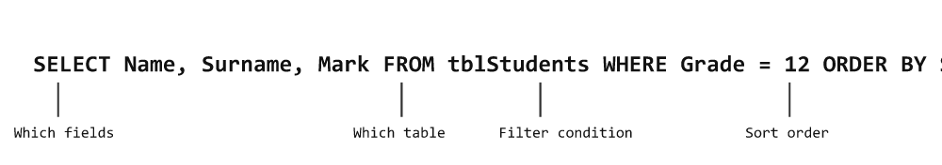

Using SQL in Delphi
SQL goes into the SQL property of a TADOQuery component. Always close the query before changing the SQL, then open it again.
Delphi — two ways to run a query
// Method 1: assign as one string
qryStudents.Close;
qryStudents.SQL.Text := 'SELECT * FROM tblStudents WHERE Grade = 12';
qryStudents.Open;

// Method 2: build line-by-line (easier to read for long queries)
qryStudents.Close;
qryStudents.SQL.Clear;
qryStudents.SQL.Add('SELECT Name, Surname, Mark');
qryStudents.SQL.Add('FROM tblStudents');
qryStudents.SQL.Add('WHERE Grade = 12');
qryStudents.SQL.Add('ORDER BY Surname ASC');
qryStudents.Open;

SELECT — Choosing What to Display
SQL
SELECT * FROM tblCD; -- all fields, all records
SELECT CDName, Artist FROM tblCD; -- only these two fields
SELECT DISTINCT Genre FROM tblCD; -- each genre shown once only
SELECT TOP 5 * FROM tblCD; -- first 5 records only

WHERE — Filtering Records
The WHERE clause is how you filter — like asking "show me only the records that match this condition."
SQL — comparison operators
WHERE Genre = "Rock" -- exact match (text in double quotes)
WHERE Price < 100 -- numbers (no quotes)
WHERE Grade <> 11 -- not equal
WHERE Mark >= 50 -- greater than or equal
WHERE Genre = "Pop" AND Price < 100 -- both must be true
WHERE Genre = "Pop" OR Genre = "Rock" -- either can be true

Special WHERE Operators
Operator | Meaning | Example
LIKE | Pattern match. % = any chars, _ = one char | WHERE Name LIKE "S%" — starts with S
IN | Match any value in a list | WHERE Genre IN ("Rock","Pop","Jazz")
BETWEEN | Within a range (inclusive for numbers) | WHERE Price BETWEEN 50 AND 150
IS NULL | Field is empty/blank | WHERE CellNo IS NULL
IS NOT NULL | Field has a value | WHERE CellNo IS NOT NULL
#date# | Date values use # symbols | WHERE OrderDate = #2024-05-01#
LIKE wildcard examples
WHERE CDName LIKE "S%" -- starts with S
WHERE CDName LIKE "%love%" -- contains the word "love"
WHERE CDName LIKE "%s" -- ends with s
WHERE Code LIKE "A__" -- starts with A followed by exactly 2 chars

ORDER BY — Sorting Results
SQL
SELECT * FROM tblCD ORDER BY Artist; -- ascending (default)
SELECT * FROM tblCD ORDER BY Price DESC; -- most expensive first
SELECT * FROM tblCD ORDER BY Genre, CDName ASC; -- sort by genre, then name

Calculated Fields & Aliases
You can do maths inside a SELECT and give the result a name using AS.
SQL
SELECT Name, Price, Price * 1.15 AS PriceWithVAT FROM tblProducts;
SELECT Name, Mark, ROUND(Mark / 2, 0) AS HalfMark FROM tblStudents;

Aggregate Functions — Calculating Summaries
Function | What it calculates | Example
COUNT(*) | Number of records | SELECT COUNT(*) FROM tblStudents
SUM(field) | Total of numeric field | SELECT SUM(Mark) FROM tblResults
AVG(field) | Average of numeric field | SELECT AVG(Mark) FROM tblResults
MIN(field) | Lowest value | SELECT MIN(Price) FROM tblProducts
MAX(field) | Highest value | SELECT MAX(Price) FROM tblProducts
SQL — GROUP BY and HAVING
-- Count students per grade
SELECT Grade, COUNT(*) AS Total
FROM tblStudents
GROUP BY Grade;

-- Only show groups with more than 10 students
SELECT Grade, COUNT(*) AS Total
FROM tblStudents
GROUP BY Grade
HAVING COUNT(*) > 10;
WHERE VS HAVING
WHERE filters individual records before grouping. HAVING filters groups after GROUP BY. If you have both, WHERE runs first.

SQL String & Math Functions
Function | Returns | Example
LEN(field) | Character count | SELECT LEN(Name) FROM tblStudents
LEFT(field, n) | First n characters | LEFT(Surname, 3) → first 3 letters
RIGHT(field, n) | Last n characters | RIGHT(IDNo, 4)
MID(field, start, n) | Substring from position | MID(IDNo, 3, 2) → year of birth
ROUND(field, dec) | Rounded value | ROUND(Avg, 2) → 2 decimal places
INT(field) | Integer part (no decimal) | INT(75.8) = 75
FORMAT(field, "0.00") | Formatted string | FORMAT(Price, "R0.00")

Date Functions
SQL — date examples
SELECT Name, YEAR(BirthDate) AS BirthYear FROM tblStudents;
SELECT * FROM tblOrders WHERE MONTH(OrderDate) = 12; -- December orders
SELECT * FROM tblStudents WHERE YEAR(BirthDate) = 2008;

INSERT, UPDATE, DELETE
SQL — modifying data
-- Add a new record
INSERT INTO tblStudents (Name, Surname, Grade)
VALUES ("Alice", "Smith", 12);

-- Change existing data
UPDATE tblStudents
SET Grade = 12
WHERE StudentID = 45;

-- Remove a record
DELETE FROM tblStudents
WHERE StudentID = 45;
ALWAYS USE WHERE WITH UPDATE AND DELETE
Without a WHERE clause, UPDATE changes every record and DELETE removes every record in the table. Always double-check your condition.

Parameterised Queries
Instead of hardcoding a value, use a parameter that is filled in by the user at runtime.
Delphi — parameterised query (by name method)
qryStudents.Close;
qryStudents.SQL.Clear;
qryStudents.SQL.Add('SELECT * FROM tblStudents');
qryStudents.SQL.Add('WHERE Grade = :pGrade'); // :pGrade is the parameter
qryStudents.Parameters.ParamByName('pGrade').Value := sedGrade.Value;
qryStudents.Open;

SQL in Delphi — Reading Field Values
Delphi
// Read a field value from the current record
sName := qryStudents['Name'];
iGrade := qryStudents['Grade'];
rMark := qryStudents['Average'];

// Loop through all records
qryStudents.First;
while not qryStudents.Eof do
begin
memOut.Lines.Add(qryStudents['Name'] + ' ' + qryStudents['Surname']);
qryStudents.Next;
end;

SQL — Joining Tables
In SA IT CAPS, joining two tables is done using the WHERE clause method — listing both tables in FROM and linking them with a matching condition in WHERE. This is the only join method required for CAPS.
CAPS METHOD: WHERE CLAUSE — NOT INNER JOIN
The official SA IT CAPS specifies the WHERE method for single joins. The CAPS document states: “Create a join query (single joins) using WHERE”. Do NOT use the INNER JOIN keyword in exams.

Why Join Tables?
A relational database splits related data across tables. For example, a student record stores a ClassID but the class name lives in a separate table. To display both together, you join the tables.

Syntax
SQL — WHERE join syntax
SELECT TableA.Field1, TableB.Field2
FROM TableA, TableB
WHERE TableA.KeyField = TableB.KeyField;
Both tables appear in FROM, separated by a comma. The WHERE clause links the tables on their shared key field.

Examples

Example 1 — Students with their class names
SQL
SELECT tblStudents.Name, tblStudents.Surname, tblClasses.ClassName
FROM tblStudents, tblClasses
WHERE tblStudents.ClassID = tblClasses.ClassID;

Example 2 — With extra filtering and sorting
SQL
SELECT tblStudents.Name, tblStudents.Surname, tblClasses.ClassName
FROM tblStudents, tblClasses
WHERE tblStudents.ClassID = tblClasses.ClassID
AND tblStudents.Grade = 12
ORDER BY tblStudents.Surname ASC;
ADDING EXTRA CONDITIONS
Use AND after the join condition to filter results further. The join condition always comes first in WHERE.

Example 3 — Join with GROUP BY and COUNT
SQL — count students per class
SELECT tblClasses.ClassName, COUNT(tblStudents.StudentID) AS Total
FROM tblStudents, tblClasses
WHERE tblStudents.ClassID = tblClasses.ClassID
GROUP BY tblClasses.ClassName
ORDER BY Total DESC;

Example 4 — Using LIKE with a join
SQL
SELECT tblBooks.Title, tblAuthors.AuthorName, tblBooks.Price
FROM tblBooks, tblAuthors
WHERE tblBooks.AuthorID = tblAuthors.AuthorID
AND tblBooks.Title LIKE "IT%"
ORDER BY tblBooks.Price DESC;

Using a Join in Delphi (TADOQuery)
Delphi
qryData.Close;
qryData.SQL.Clear;
qryData.SQL.Add('SELECT tblStudents.Name, tblStudents.Surname, tblClasses.ClassName');
qryData.SQL.Add('FROM tblStudents, tblClasses');
qryData.SQL.Add('WHERE tblStudents.ClassID = tblClasses.ClassID');
qryData.SQL.Add('AND tblStudents.Grade = 12');
qryData.Open;

Cartesian Product Warning
NEVER FORGET THE JOIN CONDITION
If you list two tables in FROM but omit the WHERE link condition, SQL returns every possible combination of rows (a Cartesian product). For two tables with 100 rows each, this produces 10,000 rows — all incorrect. Always include WHERE TableA.Key = TableB.Key.

Common Mistakes
Mistake | Effect | Fix
Missing join condition in WHERE | Cartesian product (massive wrong result) | Always link: WHERE tblA.Key = tblB.Key
Ambiguous field name (e.g. just Name when both tables have it) | SQL error | Always prefix: tblStudents.Name
Not calling qryData.Close before changing SQL | Runtime error | Always close first

Object-Oriented Programming (OOP)
OOP lets you model real-world things as objects in code. Think of a class as a blueprint (like architectural plans for a house) and an object as the actual building made from that plan. One blueprint, many buildings — one class, many objects.

Core OOP Concepts
Term | Definition
Class | A blueprint or template that describes what an object looks like and can do
Object | A specific instance of a class (like one particular cat — Whiskers)
Attribute | A variable that stores data about the object (e.g. fName, fAge)
Method | A procedure or function that belongs to the class (e.g. GetName, SetAge)
Constructor | Special method Create that creates an instance and sets initial values
Encapsulation | Hiding private data inside a class; only accessible through public methods
Inheritance | A new class inherits all attributes and methods of an existing (parent) class
Polymorphism | The same method name behaves differently in different classes
YOU ALREADY USE OOP!
In Delphi, every component is an object. TButton is a class; btnOK is an object. TForm is a class; Form1 is an object. OOP lets you create your own custom classes.

One Class, Many Objects
A class is defined once. You can create as many objects (instances) from it as you need — each with its own data.
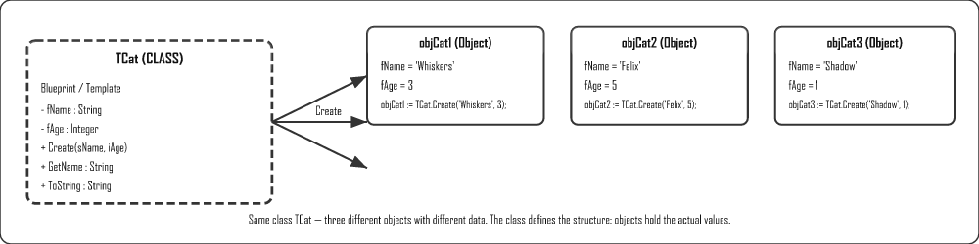

UML Class Diagram
Before coding a class, design it using a UML (Unified Modeling Language) diagram — a rectangle divided into 3 sections.
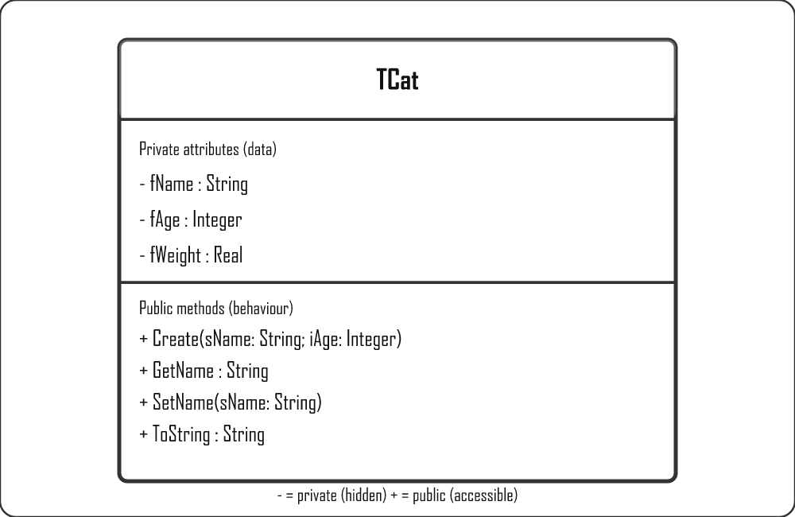

Encapsulation
Keep attributes private — hidden from the outside world. Only expose them through controlled public methods (getters and setters). This protects data from accidental or invalid changes.
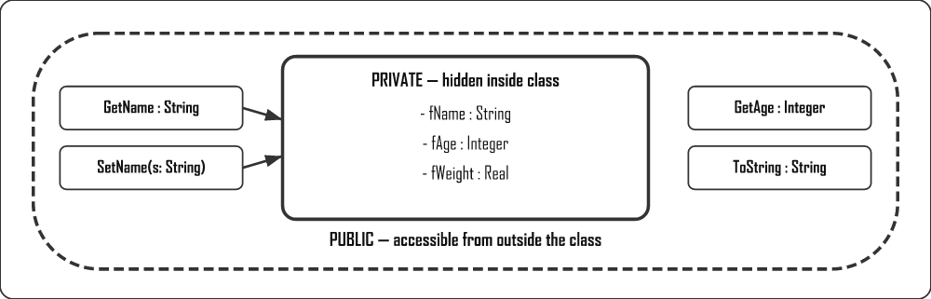
Delphi — encapsulation
private
fName: string; // hidden from outside — direct access blocked
public
procedure SetName(s: string); // controlled write access (can include validation)
function GetName: string; // controlled read access

Inheritance
A child class inherits all attributes and methods from a parent class, and can add or override its own. This avoids repeating code.
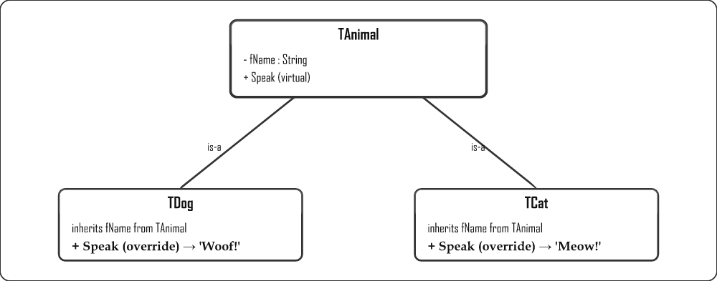
Delphi — inheritance
type
TAnimal = class
procedure Speak; virtual; // can be overridden in child classes
end;

TDog = class(TAnimal) // inherits everything from TAnimal
procedure Speak; override; // replaces TAnimal.Speak
end;

TCat = class(TAnimal)
procedure Speak; override;
end;

Polymorphism
The same method name (Speak) behaves differently depending on the type of object. "Many forms" — poly = many, morph = form.
Object | Method Called | Result
objAnimal.Speak | TAnimal.Speak | 'Animal sound...'
objDog.Speak | TDog.Speak (overridden) | 'Woof!'
objCat.Speak | TCat.Speak (overridden) | 'Meow!'
Delphi — polymorphism
procedure TAnimal.Speak;
begin
ShowMessage('Animal sound...');
end;

procedure TDog.Speak;
begin
ShowMessage('Woof!');
end;

procedure TCat.Speak;
begin
ShowMessage('Meow!');
end;

Types of Methods
Method Type | Keyword | Description
Constructor | constructor | Creates the object and sets initial attribute values. Called on the class name: TCat.Create(...)
Accessor (getter) | function | Returns the value of a private attribute. Read-only access.
Mutator (setter) | procedure | Updates the value of a private attribute. Can include validation.
ToString | function | Returns a string representation of the object's state — used for display.
Auxiliary | private | Internal helper methods used by other methods, not accessible from outside.

How to Create a Class in Delphi
- Go to File → New → Unit – Delphi to create a new blank unit.
- Save it in the same folder as your project (e.g. UCar.pas).
- Type the class structure in the interface section (see template below).
- Press Ctrl+Shift+C — Delphi auto-generates the method bodies in the implementation section.
- Fill in the code inside each method body.
- In your main form unit, add the unit name to the uses clause (e.g. uses ..., UCar;).
CTRL+SHIFT+C IS YOUR BEST FRIEND!
After writing the class declaration in the interface section, press Ctrl+Shift+C and Delphi automatically creates all the empty method implementations in the implementation section. You just fill in the code.

Complete Class Example — TCat
Delphi — TCat unit (UCat.pas)
unit UCat;

interface

type
TCat = class
private
fName : string;
fAge : integer;
fWeight : real;
public
constructor Create(sName: string; iAge: integer; rWeight: real);
function GetName : string;
function GetAge : integer;
function GetWeight : real;
procedure SetName(sNew: string);
function ToString : string;
end;

implementation

constructor TCat.Create(sName: string; iAge: integer; rWeight: real);
begin
fName := sName;
fAge := iAge;
fWeight := rWeight;
end;

function TCat.GetName : string;
begin
Result := fName;
end;

function TCat.GetAge : integer;
begin
Result := fAge;
end;

function TCat.GetWeight : real;
begin
Result := fWeight;
end;

procedure TCat.SetName(sNew: string);
begin
fName := sNew;
end;

function TCat.ToString : string;
begin
Result := fName + ', Age: ' + IntToStr(fAge)
+ ', Weight: ' + FloatToStr(fWeight) + 'kg';
end;

end.

Practice Example — TCar Class
This is the kind of class you will write in a Grade 12 exam. Study the pattern carefully — constructor, accessors, mutator, ToString.
Delphi — UCar.pas (complete working class)
unit UCar;

interface

type
TCar = class
private
fMake : string; // e.g. 'Toyota'
fYear : integer; // e.g. 2022
public
constructor Create(sMake: string; iYear: integer);
function GetMake : string;
function GetYear : integer;
procedure SetMake(sNewMake: string);
function ToString : string;
end;

implementation

constructor TCar.Create(sMake: string; iYear: integer);
begin
fMake := sMake;
fYear := iYear;
end;

function TCar.GetMake : string;
begin
Result := fMake;
end;

function TCar.GetYear : integer;
begin
Result := fYear;
end;

procedure TCar.SetMake(sNewMake: string);
begin
fMake := sNewMake; // could add validation here (e.g. check not empty)
end;

function TCar.ToString : string;
begin
Result := fMake + ' (' + IntToStr(fYear) + ')';
// Output example: 'Toyota (2022)'
end;

end.

Using TCar in the Main Form
Delphi — main form unit
// 1. Add UCar to uses clause of the main form
uses
..., UCar;

// 2. Declare object variable (global or local)
var
objCar : TCar;

// 3. Create the object — in a button click or FormCreate
objCar := TCar.Create('Toyota', 2022);

// 4. Read values using accessors
lblMake.Caption := objCar.GetMake; // 'Toyota'
lblYear.Caption := IntToStr(objCar.GetYear); // '2022'
memOut.Lines.Add(objCar.ToString); // 'Toyota (2022)'

// 5. Update a value using mutator
objCar.SetMake('Honda');
lblMake.Caption := objCar.GetMake; // 'Honda'
ALWAYS CREATE BEFORE USE!
Always call Create before using any other method. The object does not exist until it is created. Also make sure the class unit name is in the uses clause of your main form.

Using a Class in the Main Form
Delphi — main form (TCat example)
uses
..., UCat;

var
objCat : TCat;

// Create the object
objCat := TCat.Create('Whiskers', 3, 4.2);

// Use its accessors
lblName.Caption := objCat.GetName; // 'Whiskers'
lblAge.Caption := IntToStr(objCat.GetAge); // '3'
memOut.Lines.Add(objCat.ToString); // 'Whiskers, Age: 3, Weight: 4.2kg'

// Update via mutator
objCat.SetName('Felix');
lblName.Caption := objCat.GetName; // 'Felix'

Dynamic Components — Creating Controls at Runtime
You already know that every Delphi control is an object of a class (a button is a TButton, a label is a TLabel). Because they are classes, you can create them in code while the program is running using the same Create constructor you use for your own classes — instead of dragging them onto the form at design time.
This is called creating a dynamic component. It is useful when you don't know in advance how many controls you need (e.g. one button per record loaded from a file).

The Four Steps
- Create the object from its class, passing the owner (usually the form).
- Set the Parent so Delphi knows where to draw it (which form/panel).
- Set properties like position, size and caption.
- Assign an event handler so it actually does something when clicked.
Delphi — create a button at runtime
var
btnDynamic : TButton;
begin
// 1. Create the object (Form1 is the owner – frees it automatically)
btnDynamic := TButton.Create(Form1);

// 2. Set the Parent so it appears on the form
btnDynamic.Parent := Form1;

// 3. Set properties
btnDynamic.Left := 50;
btnDynamic.Top := 50;
btnDynamic.Width := 100;
btnDynamic.Height := 30;
btnDynamic.Caption := 'Click Me';

// 4. Assign an event handler (a procedure you wrote)
btnDynamic.OnClick := btnDynamicClick;
end;

// The handler the button will run when clicked
procedure TForm1.btnDynamicClick(Sender: TObject);
begin
ShowMessage('Dynamic button clicked!');
end;
OWNER VS PARENT — WHAT'S THE DIFFERENCE?
Owner (the argument to Create) is responsible for freeing the component from memory when the form closes. Parent decides where on screen the component is drawn. They are usually the same form, but not always (e.g. Owner = Form, Parent = a Panel on that form).
AVOID MEMORY LEAKS
If you create a component with Create(nil) (no owner), you must free it yourself with btnDynamic.Free; when you are done, otherwise it stays in memory. Passing the form as the owner lets Delphi clean up for you automatically.

2D Arrays
A two-dimensional array stores data in a grid of rows and columns — like a table or spreadsheet. Each element is accessed using two indices: [row, column].

What is a 2D Array?
A two-dimensional (2D) array is a single variable that stores many values arranged in a grid of rows and columns. Where an ordinary (one-dimensional) array is like a single shopping list running down the page, a 2D array is like a whole spreadsheet — a block of cells where every value sits at the crossing point of a row and a column.
Analogy: think of a spreadsheet such as Excel. To find a cell you give a column letter and a row number — for example C5. A 2D array works exactly the same way, except we use two numbers: the first for the row and the second for the column. So myArray[2,3] means "the value in row 2, column 3", just like clicking one cell in a grid.
PURPOSE
We use 2D arrays to store tables of data that naturally have rows and columns — for example a class register of marks where each row is a learner and each column is a subject, a seating plan, a noughts-and-crosses board, or temperatures recorded for each day across several weeks. One neat variable holds the whole table instead of dozens of separate variables.

Why Do We Use 2D Arrays?
- Related data stays together – instead of mark1, mark2, mark3 … you keep every mark in one organised grid.
- Rows and columns have meaning – a row can represent one learner and a column one subject, so the position itself tells you what the value is.
- Loops do the heavy lifting – because the data is regular, two nested loops can fill, display or total the entire table in a few lines.

Declaration
Before you can use a 2D array you must declare it, telling Delphi how many rows and columns it has and what type of data each cell holds. You give two ranges in the square brackets: the first range is the rows and the second is the columns.
Syntax
var
arrName : array [rowStart..rowEnd, colStart..colEnd] of DataType;
Delphi — 2x3 integer array
var
myArray : array [1..2, 1..3] of Integer;
The example above creates a grid with 2 rows and 3 columns, giving 6 integer cells in total. Note: the ranges can start at any number, but in CAPS we almost always start at 1 so that "row 1" really is the first row.

Visualising a 2D Array
The table below shows how the index numbers map onto the grid. Read it like a spreadsheet: pick a row down the side and a column across the top, and the cell where they meet is the array element you are referring to.
 | Col 1 | Col 2 | Col 3
Row 1 | myArray[1,1] | myArray[1,2] | myArray[1,3]
Row 2 | myArray[2,1] | myArray[2,2] | myArray[2,3]

Populating a 2D Array
Populating means putting values into the cells. There are two common ways: assigning each cell one by one (fine for a few known values), or using nested loops to fill the whole grid quickly.

Fixed values
Here we set each cell directly by naming its row and column. This is clear but tedious — imagine doing it for a 30 × 6 register. Use it only when you have a handful of specific values to place.
Delphi
myArray[1,1] := 10; myArray[1,2] := 20; myArray[1,3] := 30;
myArray[2,1] := 40; myArray[2,2] := 50; myArray[2,3] := 60;

Nested FOR loops (most common)
This is the technique you will use most often. The outer loop moves through the rows; for each row the inner loop moves through every column. The result is that the inner loop runs completely for each turn of the outer loop, so the code visits every cell, one full row at a time — exactly like reading a spreadsheet left-to-right, then dropping down to the next line.
Delphi
var
myArray : array [1..3, 1..4] of Integer;
r, c : Integer;
begin
for r := 1 to 3 do
for c := 1 to 4 do
myArray[r, c] := r * c; // e.g. row 2, col 3 = 6
end;

Displaying a 2D Array
To show the grid neatly we again use nested loops, but this time we build up one line of text per row. For each row we start with an empty string, add every column value to it (padding each so the columns line up), and only then add the finished line to the memo. Important Rule: the line is built inside the inner loop but written out in the outer loop — that is what keeps each row on its own line.
Delphi — display as table in memo
var
sLine: string;
r, c: Integer;
begin
memOut.Clear;
for r := 1 to 3 do
begin
sLine := '';
for c := 1 to 4 do
sLine := sLine + IntToStr(myArray[r,c]).PadLeft(5);
memOut.Lines.Add(sLine);
end;
end;

Calculations on 2D Arrays
A big reason for using a grid is to add things up. The trick is knowing which index to fix and which to vary. If you think of the class register again: a row total is one learner's marks added across all subjects, while a column total is one subject's marks added across all learners.

Row total
To total a single row we fix the row number (here row 1) and let the column index c change. The loop walks across that one row, adding each cell to a running total. This answers "what is everything in this row added together?" — for example one learner's total mark.
Delphi — total of row 1
iTotal := 0;
for c := 1 to 4 do
iTotal := iTotal + myArray[1, c];

Column total
Now we do the opposite: we fix the column number (here column 2) and let the row index r change. The loop runs straight down that one column, adding each cell. This answers "what is everything in this column added together?" — for example the total of all learners' marks for one subject.
Delphi — total of column 2
iTotal := 0;
for r := 1 to 3 do
iTotal := iTotal + myArray[r, 2];

Grand total of all elements
To add up every cell in the whole grid we need nested loops again — the outer loop for rows, the inner loop for columns — so the running total picks up each cell exactly once. This is how you would work out the grand total of all marks for the entire class across all subjects.
Delphi
iTotal := 0;
for r := 1 to 3 do
for c := 1 to 4 do
iTotal := iTotal + myArray[r, c];

Recursion in Delphi
Recursion is when a function or procedure calls itself repeatedly until a base condition is met. It is a powerful technique for problems that can be broken down into smaller versions of the same problem.

What is Recursion?
Recursion is when a function calls itself to solve a smaller version of the same problem, again and again, until the problem becomes so small it can be answered directly.
Analogy: picture a set of Russian nesting dolls. You open the biggest doll and find a smaller doll inside, open that and find a smaller one still, and you keep going until you reach the tiny doll that does not open. Recursion works the same way — each call opens up a slightly smaller version of the problem, and the smallest doll (the one that does not open) is the point where you stop.
A recursive routine is one that calls itself. Every recursive solution must have two parts:
- Base case — the condition that stops the recursion (essential — without it you get infinite recursion)
- Recursive case — the part where the function calls itself with a simpler input
ALWAYS HAVE A BASE CASE
A recursive function without a base case will call itself forever, causing a stack overflow error and crashing the program.

Example 1 — Factorial
Factorial of n (written n!) = n × (n-1) × (n-2) × … × 1. Example: 5! = 5 × 4 × 3 × 2 × 1 = 120
Delphi — recursive factorial
function Factorial(n: Integer): Integer;
begin
if n <= 1 then // base case: factorial of 0 or 1 is 1
Result := 1
else // recursive case
Result := n * Factorial(n - 1);
end;

// Calling it:
lblResult.Caption := IntToStr(Factorial(5)); // = 120

Trace — how Factorial(4) executes
Trace
Factorial(4)
= 4 * Factorial(3)
= 3 * Factorial(2)
= 2 * Factorial(1)
= 1 ← base case reached
= 2 * 1 = 2
= 3 * 2 = 6
= 4 * 6 = 24

Example 2 — Sum of 1 to N
Delphi — recursive sum
function SumToN(n: Integer): Integer;
begin
if n <= 0 then
Result := 0 // base case
else
Result := n + SumToN(n - 1); // recursive case
end;

// SumToN(4) = 4 + 3 + 2 + 1 + 0 = 10

Example 3 — Power (x to the power of n)
Delphi
function PowerOf(base, exp: Integer): Integer;
begin
if exp = 0 then
Result := 1 // base case: x^0 = 1
else
Result := base * PowerOf(base, exp - 1); // recursive
end;

// PowerOf(2, 4) = 2*2*2*2 = 16

Example 4 — Fibonacci Sequence
Each number is the sum of the previous two: 0, 1, 1, 2, 3, 5, 8, 13…
Delphi
function Fibonacci(n: Integer): Integer;
begin
if n <= 1 then
Result := n // base cases: F(0)=0, F(1)=1
else
Result := Fibonacci(n - 1) + Fibonacci(n - 2);
end;

Recursion vs Iteration
 | Recursion | Iteration (loop)
How it works | Function calls itself | Loop repeats a block
Code clarity | Often more elegant for naturally recursive problems | Usually easier to trace and debug
Memory use | Uses call stack (risk of stack overflow for large n) | Constant memory use
Speed | Can be slower due to function call overhead | Generally faster
Best for | Tree traversal, divide-and-conquer algorithms | Simple counting and totalling

Key Rules for Writing Recursive Functions
- Always define a base case that returns a value without calling itself
- Each recursive call must move toward the base case (e.g. decrease n by 1)
- Test with small values first — trace through manually
- Use a function (not procedure) so it can return a value

Data Collection & Warehousing
Modern databases are fed by many automated data collection methods. Large organisations store historical data in warehouses for analysis and decision-making.

Methods of Data Collection
Data collection is the process of gathering raw facts and figures from many different sources so that they can be stored, processed and turned into useful information. In the old days a person sat with a clipboard and wrote everything down by hand. Today most data is collected automatically — every time you swipe a card, drive under an e-toll gantry or tap a website, data is being captured about you without anyone writing a single thing.
WHY THIS MATTERS
A database is only as good as the data inside it. The more accurate, complete and up-to-date the collected data is, the better the decisions an organisation can make. Automated collection means more data, collected faster, with fewer human mistakes.
Example: When you scan your Pick n Pay Smart Shopper card at the till, the shop instantly records what you bought, when, where and for how much — that single swipe feeds a database that the shop later uses to send you targeted specials.
Method | Description | Example
Forms (manual) | User types data directly into a form | School registration, job application
Web forms | Online interactive pages with GUI components (dropdowns, checkboxes) | Online survey, account sign-up
RFID tags | Wireless chips store ID data, read without contact | Library books, inventory, e-toll, access cards
Digital sensors | Gather environmental data automatically | Temperature sensors, motion detectors
Cookies | Small files stored by websites to record browsing behaviour and preferences | Login sessions, shopping carts, ad targeting
Transaction tracking | Records each purchase: date, time, location, product, amount | Credit card transactions, loyalty cards
Mobile apps | Collect app usage, location, device data | Uber location tracking, fitness app steps

Static vs Dynamic Location Data
Type | Description | Example
Static | Fixed, does not change once recorded | Address of a shop, GPS coordinates of a landmark
Dynamic | Changes as the object moves, updated continuously | Uber driver location, delivery truck tracking

Data Warehousing
A data warehouse is a large central storage system that collects and consolidates historical data from many separate source databases into one single place, so that it can be analysed for trends and decision-making.
Think of it like this: a normal database is like the till at one Pick n Pay branch — it records today's sales as they happen. A data warehouse is like head office in Cape Town, where the sales from every branch in the country, going back many years, are all poured into one giant store. Head office does not use this to ring up a sale; they use it to spot the big picture — which products sell best in winter, which branches are growing, where to open the next store.
KEY CHARACTERISTICS
Central – one single store that brings many sources together.
Historical – it keeps years of old data, not just today's transactions.
Read-mostly – data is loaded in and then read for reports; it is not constantly changed.
Subject-oriented – organised around topics like "sales" or "customers" for easy analysis.
Note: Because a warehouse holds so much data from so many sources, the data must first be cleaned and put into a consistent format before it is loaded in — otherwise the same customer might appear three different ways and the analysis would be wrong.
 | Database | Data Warehouse
Purpose | Day-to-day transactions | Historical analysis and reporting
Data | Current transactions only | Historical data from many sources
Operations | Read + write (INSERT, UPDATE, DELETE) | Mostly read (SELECT, reports)
Used by | Operational staff | Analysts, management, BI tools

Data Mining
Data mining is the process of analysing very large datasets to discover hidden patterns, trends and useful relationships that a human could never spot by eye. The name is a good clue: just as a gold miner digs through tonnes of rock to find a few grams of gold, data mining digs through millions of records to find the valuable nuggets of knowledge buried inside.

Why Do Companies Mine Data?
Companies collect enormous amounts of data, but raw data on its own is useless — it is just numbers and words. Data mining turns that raw data into insight they can act on. For example, Pick n Pay's Smart Shopper data might reveal that customers who buy nappies on a Friday evening also tend to buy snacks — so the shop places those products near each other and increases sales. Nobody told the computer to look for that link; the pattern was mined out of the data.

Process
- Extract relevant data — use SQL to pull only the required subset
- Look for patterns — analyse for trends, correlations, anomalies
- Discover knowledge — turn patterns into actionable insights

Applications
- Marketing: target campaigns based on customer age, interests, behaviour
- Healthcare: predict patient risk factors from historical data
- Government: determine social grant thresholds
- Social media: Facebook mines your likes to suggest friends and content

Caring for Data
Caring for data means protecting the accuracy, security and availability of an organisation's data throughout its life. Data is one of the most valuable assets a company owns — often worth more than its buildings or equipment — because decisions, money and reputations all depend on it. Poor data leads to poor decisions, and lost data can shut a business down completely.
IMPORTANT RULE
"Garbage in, garbage out." If incorrect data goes into the system, only incorrect information can come out — no matter how clever your analysis is. This is why validation and verification at the point of capture are so important.
Below are the main ways an organisation looks after its data. Notice how each one protects against a different danger — wrong data, lost data, or stolen data.
- Validation — ensure entered data meets rules (format, range, type)
- Verification — ensure data is correct and intentional (double entry, confirmation)
- Logging — audit trail recording who changed what and when
- Access control — passwords, user rights, encryption
- Parallel data sets — duplicate copies in separate locations for disaster recovery

Relational Databases & Normalisation
A relational database stores data in structured tables linked together. Normalisation is the process of cleaning up a database design to remove repetition and prevent errors.

What is a Relational Database?
A relational database stores data in tables (also called relations). Each table represents one type of thing — for example, a table for students, a separate table for subjects. Tables are then linked together using key fields.
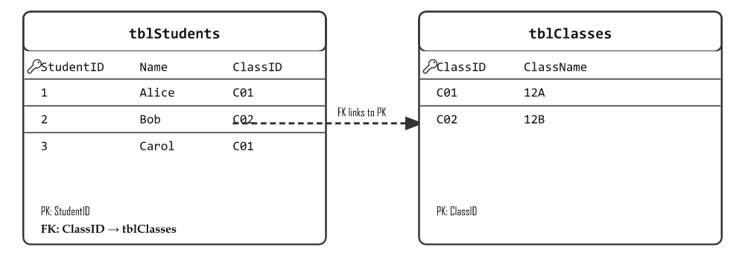

Key Fields
Key Type | Description | Example
Primary Key (PK) | Uniquely identifies each record. No duplicates, no blanks. | StudentID in tblStudents
Foreign Key (FK) | A field that links to the primary key of another table. Creates the relationship. | ClassID in tblStudents → links to tblClasses
Composite Key | Two or more fields combined to create a unique identifier | StudentID + SubjectID in tblMarks
Alternate Key | Could be a primary key but wasn't chosen as one | Email address (also unique, but ID was chosen as PK)

Referential Integrity
Referential integrity is a rule that ensures relationships between tables remain consistent. It means: a foreign key value must always match an existing primary key value in the related table.
EXAMPLE OF VIOLATING REFERENTIAL INTEGRITY
If ClassID C03 doesn't exist in tblClasses, you cannot add a student with ClassID = C03. The database will reject this to prevent orphan records (records with no matching parent).

Entity Relationship Diagram (ERD)
An ERD is a diagram that shows the entities (tables) in a database and the relationships between them. Each box is a table; the line between boxes shows how they relate. You are often asked to draw one in the exam, so practise the crow's-foot notation below.
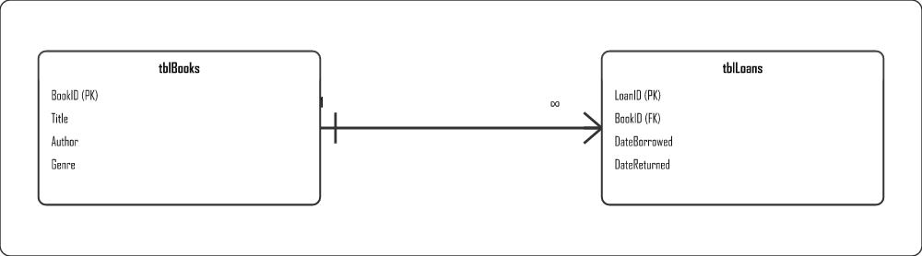
The relationship is created by putting the primary key of the "one" table into the "many" table as a foreign key (here BookID links tblBooks to tblLoans).

Types of Relationships
Relationship | Meaning | Example
One-to-One (1:1) | One record links to exactly one record in the other table | One person ↔ one ID number
One-to-Many (1:∞) | One record links to many records in the other table | One book can appear in many loans
Many-to-Many (∞:∞) | Many records link to many records — resolved with a third "link" table | Students ↔ Activities (via a link table)
MANY-TO-MANY NEEDS A LINK TABLE
A relational database can't store a many-to-many relationship directly. You break it into two one-to-many relationships using a junction/link table (e.g. tblLoans links books and borrowers).

Physical vs Logical Integrity
Type | What it protects | How it is ensured
Physical integrity | The data is not lost or damaged by hardware failure, power loss or disaster | RAID, UPS, regular backups, off-site storage
Logical integrity | The data stays correct, consistent and valid within the database | Validation rules, referential integrity, record locking
RECORD LOCKING
Record locking temporarily "locks" a record while one user is editing it, so that a second user cannot change the same record at the same time. This prevents two users overwriting each other's changes and keeps the data consistent (a key way to protect logical integrity in a multi-user database).

Database Anomalies
When a database is poorly designed (not normalised), three types of errors can occur when working with data:
Anomaly | When it happens | Example
Insertion anomaly | You can't add new data without first adding other unrelated data | Can't add a new class until at least one student enrols in it
Deletion anomaly | Deleting one record accidentally removes other important data | Deleting the only student in a class also deletes the class's information
Modification anomaly | Changing one value means updating many rows — and missing some creates inconsistency | A teacher's name appears in 50 student records; update one and the others are wrong
THE FIX: NORMALISATION
Normalisation splits large, messy tables into smaller, focused tables and links them properly. This eliminates all three anomalies.

Normalisation — The Three Normal Forms

First Normal Form (1NF)
A table is in 1NF when:
- Every cell contains a single value (no lists of values in one cell)
- There are no repeating groups of columns
- Every record is unique (has a primary key)

Not in 1NF:
StudentID | Name | Subjects
1 | Alice | Maths, IT, English
❌ Problem: Three values in one cell (Subjects column)

In 1NF:
StudentID | Name | Subject
1 | Alice | Maths
1 | Alice | IT
1 | Alice | English

Second Normal Form (2NF)
A table is in 2NF when it is in 1NF AND every non-key field depends on the whole primary key (not just part of it). This only matters when the primary key is a composite key.

Example violation:
StudentID (PK) | SubjectID (PK) | StudentName | Mark
1 | IT | Alice | 85
❌ Problem: StudentName only depends on StudentID, not on (StudentID + SubjectID) together

In 2NF — split the table:
StudentID (PK) | StudentName
1 | Alice
StudentID (PK+FK) | SubjectID (PK) | Mark
1 | IT | 85

Third Normal Form (3NF)
A table is in 3NF when it is in 2NF AND no non-key field depends on another non-key field (no transitive dependency).

Example violation:
StudentID (PK) | Name | GradeLevel | GradeDescription
1 | Alice | 12 | Matric
❌ Problem: GradeDescription depends on GradeLevel (a non-key field), not on StudentID

In 3NF — split it:
StudentID (PK) | Name | GradeLevel (FK)
1 | Alice | 12
GradeLevel (PK) | GradeDescription
12 | Matric

Quick Normalisation Checklist
Normal Form | Check for | Fix by
1NF | Multiple values in one cell? Repeating columns? | Split into separate rows; add PK
2NF | Non-key field depends on only PART of the composite PK? | Move that field to its own table
3NF | Non-key field depends on another non-key field? | Move the dependency to its own table

Good Database Characteristics
Characteristic | Meaning
Data integrity | Data is accurate, consistent and complete throughout its lifecycle
Data independence | Changing the database structure doesn't break the programs that use it
Data redundancy | Minimum — the same data should not be stored in multiple places
Data security | Only authorised users can access or modify data
Ease of maintenance | The database design makes it simple to insert, update and delete without causing problems

Hardware & Performance
Mobile device hardware, factors that affect computer performance, and choosing the right system for a user's needs.

Mobile Technology Hardware
Smartphones have similar hardware to desktops but in miniaturised form. Key differences:
Component | Desktop | Smartphone
CPU | Separate chip; very powerful; many cores | SoC (System on a Chip) — CPU+GPU+modem+RAM in one chip
Input | Keyboard and mouse | Touchscreen; virtual keyboard
Display | Large external monitor | Small built-in touchscreen
Connectivity | Wired NIC or Wi-Fi card | Built-in Bluetooth, Wi-Fi, 4G/5G, GPS, NFC
Battery | Plugged in; no battery constraint | Limited battery; performance vs battery trade-off

Mobile Constraints
- Battery life: limited capacity must last the whole day; processing power directly affects battery drain
- Form factor: miniaturised components mean less cooling and tighter power limits
- Screen size: limited display area affects usability for complex tasks
- Input limitations: touchscreen less precise than physical keyboard/mouse for complex input

Factors Influencing Computer Performance
Factor | How it affects performance
CPU clock speed (GHz) | Higher = more instructions per second; faster processing
CPU cores | More cores = better multitasking and parallel processing
RAM amount and speed | More RAM = more programs running simultaneously; higher speed = faster data transfer to CPU
Cache size (L1/L2/L3) | Larger cache = CPU waits less for data from RAM
GPU clock speed | Higher GPU speed = faster graphics rendering; important for gaming and video
Storage type (HDD vs SSD) | SSD dramatically faster boot times and application loading
NIC speed (Mbps) | Faster NIC = faster downloads, streaming, network file transfers
Operating system | Outdated OS causes compatibility issues, security risks and slower operation

HDD vs SSD — Summary
Feature | HDD | SSD
Speed | Slow (mechanical) | Very fast
Durability | Fragile (moving parts) | Durable (no moving parts)
Noise | Audible spinning | Silent
Cost per GB | Cheaper | More expensive
Boot time | Long (30–60 seconds) | Very short (5–15 seconds)

Motivating a Computer System for a User
When recommending a computer, match the components to the user's needs:
User type | Recommended specs
Office/admin worker | Moderate CPU, 8GB RAM, SSD, integrated graphics
Graphic designer / video editor | Fast multi-core CPU, 16–32GB RAM, dedicated GPU, large SSD
Gamer | Fast CPU, 16GB+ RAM, high-end dedicated GPU, fast SSD
Student | Mid-range CPU, 8GB RAM, SSD, Wi-Fi, long battery (laptop)
Server / database host | Many cores, large ECC RAM, RAID storage, redundant power

Cloud Computing, AI, VR & AR
Grade 12 Term 2 theory: cloud computing, Artificial Intelligence, Virtual Reality, Augmented Reality, Mixed Reality and virtualisation — all new Software topics in the updated CAPS.

Artificial Intelligence (AI)
AI refers to computer systems that can perform tasks that normally require human intelligence — such as learning, reasoning, decision-making and pattern recognition.

What is AI used for?
- Virtual assistants (Siri, Google Assistant, Alexa)
- Recommendations (Netflix, Spotify, YouTube suggest content)
- Fraud detection in banking
- Medical diagnosis support
- Autonomous vehicles (self-driving cars)
- Chatbots for customer service
- Image and facial recognition

Advantages of AI
- Processes vast amounts of data faster than humans
- Works 24/7 without breaks or fatigue
- Reduces human error in repetitive tasks
- Enables automation of complex processes

Disadvantages and Limitations of AI
- Can be biased if trained on biased data
- Job displacement — automating roles previously done by humans
- No true understanding or common sense — only pattern matching
- Security risks — AI can be used to create deepfakes or power cyberattacks
- Expensive to develop and maintain
- Privacy concerns with data collection required for AI training

Cloud Computing
Software, storage and computing power delivered as a service over the Internet, rather than installed locally.
Advantage | Disadvantage
Scalable — capacity grows automatically | Requires internet connection
Affordable — pay only for what you use | Downtime affects all users
Accessible from any device anywhere | Security and privacy concerns
Maintained by experts; always updated | Ongoing subscription costs
Easy collaboration between users | Limited control over infrastructure

SaaS — Software as a Service
Applications accessed via browser with no local installation. Examples: Google Docs, Microsoft 365, Gmail.

Effect on Hardware
Cloud reduces the need for powerful local hardware — thin clients and low-spec devices can run complex software via the cloud. Businesses no longer need to buy expensive servers.

Virtualisation
Running multiple virtual machines on a single physical computer. Each VM has its own OS, RAM, storage and apps, isolated from others.

Benefits
- Cost savings — fewer physical servers needed
- Test operating systems safely without affecting main computer
- Disaster recovery — VM images can be backed up and restored
- Green IT — fewer machines, less power and cooling

Virtual Reality (VR)
A fully artificial, immersive 3D environment created by software. The user is completely cut off from the real world.
Use Case | Example
Training | Military simulations, surgical training
Education | Virtual field trips, interactive lessons
Entertainment | VR gaming, virtual cinemas
Healthcare | Phobia treatment, pain management
Engineering | Virtual prototypes, architectural walkthroughs

Hardware Requirements for VR
- VR headset (e.g. Meta Quest, PlayStation VR)
- Powerful GPU for real-time 3D rendering
- Motion controllers / tracking sensors
- High-speed processor and sufficient RAM

Augmented Reality (AR)
Overlays computer-generated content on the real world — you still see reality, with digital elements added.
Use Case | Example
Retail | Preview furniture in your room before buying
Training | Step-by-step repair instructions overlaid on equipment
Navigation | AR arrows overlaid on road view
Marketing | Interactive product advertisements

Limitations of AR
- Rendering meaningful, realistic graphics is challenging
- Scaling digital objects to the correct perspective is difficult
- Smartphones have limited storage, processing power and battery

Internet Technologies
How the web works under the hood — search technologies, web technologies, online applications, and how data is stored and processed online.

Search Technologies
Type | Description
Keyword search | Matches exact words in the query
Semantic search | Understands meaning and context behind words — interprets user intent, not just keywords
Mediated search | A middleman system filters results for a specific database or organisation (e.g. Google Scholar)
SEO | Search Engine Optimisation — techniques to make websites rank higher in search results (keywords, speed, mobile-friendly, backlinks)

Static vs Dynamic Websites
 | Static | Dynamic
Content | Fixed HTML — changes only if developer edits files | Generated on demand from a database
Database | No | Yes
Examples | Simple portfolio, business info page | Online shop, social media, news sites
Security risk | Low | Higher (SQL injection, data breaches)

Web Technologies
Technology | Role | Example
HTML | Structure and content of web pages | Headings, paragraphs, links, images
CSS | Visual styling — colours, fonts, layout | Blue buttons, responsive grid
JavaScript | Client-side interactivity; runs in the browser | Form validation, dropdown menus, AJAX
PHP | Server-side scripting; processes forms, talks to databases | Login authentication, database queries
SQL | Query and manage database data | SELECT user data, INSERT orders
XML | Structured data exchange between systems | Product data feeds between websites

Storing Data Online
- Cookies — small text files stored on the user's device by a website. Remember preferences, login sessions, shopping carts.
- Online databases — data stored on remote servers. Examples: Gmail messages, your social media posts.

Running Instructions
 | Client-side (browser) | Server-side (web server)
Language | JavaScript, AJAX | PHP, Python, Node.js
Purpose | Real-time page updates, validation, animations | Authentication, database access, processing
AJAX | Updates parts of a page without reloading | —

HTTP vs HTTPS
 | HTTP | HTTPS
Encryption | None — data sent in plain text | SSL/TLS encryption
Padlock | No padlock in browser | Padlock icon shown
Use | Non-sensitive public pages | Login, banking, shopping — any sensitive data

Networks & Remote Access
Essential network components, internet connection methods, file sharing, and remote access technologies.

Essential Network Hardware
Component | Function
NIC | Network Interface Card — hardware that connects a device to a network (wired or wireless)
Switch | Central hub of a LAN; forwards data only to the intended device (not broadcast)
Router | Connects different networks; routes packets; assigns IP addresses; acts as gateway to ISP
Modem | Converts digital signals to analogue for telephone lines (and back); connects to ISP
Wireless access point | Enables wireless devices to connect to a wired network via Wi-Fi
All-in-one home router | Combines modem + router + switch + Wi-Fi access point in one device

Wired Communication Media
Medium | Speed | Range | Notes
UTP cable (Ethernet) | Up to 10 Gbps | 100m per segment | Common in offices and schools; easy to install
Fibre optic | Up to Tbps | Kilometres | Uses light; most secure; expensive to install
Coaxial | Moderate | Hundreds of meters | Older standard; still used in some broadband

Connecting to the Internet
Technology | Description | Speed
ADSL | Uses telephone copper lines; download faster than upload | Up to ~20 Mbps
Fibre | Light through fibre optic cables; fastest and most reliable | 100 Mbps–1 Gbps+
WiMAX | Long-range wireless; used in rural/remote areas | Moderate
4G/LTE | Mobile broadband; widely available | 5–100 Mbps
5G | New generation mobile; very low latency; supports IoT | 50 Mbps–10 Gbps

File and Folder Sharing
On a network, users can share resources. Access can be restricted by permission level:
Permission Level | What the user can do
No access | Cannot see the shared resource
Read-only | Can view/copy files but not modify or delete
Read/Write | Can view, copy, modify files
Full control (Admin) | Can do everything including change permissions

Remote Access
Accessing a device or network from a physically different location.
Type | Description | Example
LAN remote access | Access another computer in the same building | Shared folder on school server
Internet remote access | Access home/work resources from anywhere | Google Drive, OneDrive, Remote Desktop
VPN | Encrypted tunnel over internet; secure remote access to private network | Employee working from home via company VPN

Cloud Storage and Sharing
- Store and access files from any device, anywhere
- Automatic backup and version history
- Collaboration: multiple users edit the same file simultaneously
- Examples: Google Drive, OneDrive, Dropbox

BitTorrent (Peer-to-Peer Sharing)
Files are split into small pieces and downloaded simultaneously from many peers.
- Legal uses: distributing Linux distros, large software updates
- Risks: often used for piracy; your IP is visible to all peers

Communication Technologies
Internet access technologies, network hardware, remote access, VPNs, encryption and security services.

Internet Access Technologies
Technology | Description | Speed
ADSL | Uses telephone copper lines; download faster than upload | Moderate (up to ~20 Mbps)
Fibre | Light signals through fibre optic cables; very fast and stable | Very fast (100 Mbps–1 Gbps+)
WiMAX | Long-range wireless broadband; used in rural/remote areas | Moderate
4G/LTE | Mobile data network; widely available | 5–100 Mbps
5G | Newest mobile network; very low latency; supports IoT, VR, autonomous vehicles | 50 Mbps–10 Gbps

Network Hardware Summary
Device | Function
Switch | Connects devices in a LAN; sends data only to the intended device
Router | Connects networks; routes data between them; assigns IP addresses
Modem | Converts digital ↔ analogue; connects to ISP
All-in-one | Home devices that combine modem + router + switch + Wi-Fi access point
NIC | Hardware in each device that connects it to the network

Remote Access
Accessing a device or network from another physical location.
- LAN remote access: access shared folders from another PC in the same building
- Internet remote access: access home/work files from anywhere (Google Drive, remote desktop)

VPN — Virtual Private Network
Creates an encrypted tunnel over the Internet, allowing secure remote access to a private network.
- Hides your IP address and location
- All data is encrypted — safe on public Wi-Fi
- Used by companies for remote workers to securely access internal systems

Encryption & Security
Concept | Description
Encryption | Converts readable data into unreadable code. Only someone with the correct key can decrypt it.
SSL/TLS | Protocol securing communication between browser and server (HTTPS). Uses public/private key pairs.
Digital certificate | Issued by a trusted Certificate Authority. Verifies the website is legitimate.
Firewall | Filters incoming and outgoing traffic based on security rules
MFA | Multi-Factor Authentication — requires password + second factor (OTP, fingerprint)
OTP | One-Time PIN — valid for one login only; prevents replay attacks

BitTorrent (Peer-to-Peer Sharing)
A protocol that splits large files into pieces shared between many users simultaneously.
- Benefits: very fast for large files, efficient bandwidth use
- Risks: often used for illegal (pirated) content; potential malware; your IP is visible
- Legal uses: Linux distribution downloads, game updates, large software releases

Cybercrime & Safeguards
Types of cybercrime, the people who commit them, their effects on individuals and organisations, and the safeguards used to prevent them.

Computer Criminals
Type | Description
Hacker | Gains unauthorized access to systems. White hat (ethical) vs Black hat (malicious).
Cracker | Breaks software protection or encryption for illegal access or distribution
Script kiddie | Uses pre-written tools without understanding them; less skilled
Insider threat | Current or former employee who misuses access privileges
Cybercriminal | Commits crime for financial gain (fraud, ransomware, identity theft)

Types of Cybercrime
Crime | Description
Identity theft | Stealing personal information to impersonate someone (open accounts, get loans)
Phishing | Fake emails that look official to steal credentials
Pharming | Redirecting users to fake websites to steal information
Ransomware | Encrypts victim's data; demands payment to restore access
Business data theft | Stealing trade secrets, customer databases, or financial records
SQL Injection | Inserting malicious SQL via web forms to manipulate or steal database data
DDoS attack | Distributed Denial of Service — overwhelming a server with traffic to take it offline
Online fraud | Scams, fake auctions, advance-fee fraud (419 scams)
Cyberbullying | Harassment, threats or humiliation via digital channels
Piracy | Illegally copying, distributing or using copyrighted software/media

Effects of Cybercrime

On Individuals
- Financial loss — stolen money or fraudulent accounts opened in your name
- Emotional distress and reputational damage
- Legal complications if identity is used for crimes
- Loss of private data (photos, documents)

On Businesses
- Financial loss from stolen funds, ransom payments, or system recovery
- Loss of competitive advantage if trade secrets are stolen
- Reputational damage and loss of customer trust
- Legal penalties for failing to protect customer data
- Operational downtime while systems are restored

Safeguards Against Cybercrime
Safeguard | How it protects
Antivirus / Antimalware | Detects and removes malicious software
Firewall | Filters unauthorised network traffic
Encryption | Scrambles data so intercepted data is unreadable
Strong passwords + MFA | Makes accounts much harder to compromise
Regular backups | Allows recovery after ransomware or data loss
Software updates / patches | Fixes known vulnerabilities before criminals exploit them
User training / awareness | Educated users are less likely to click phishing links
Access control | Least-privilege principle: users only access what they need
Input validation | Prevents SQL injection by sanitising user input
Digital certificates + HTTPS | Verifies website legitimacy; encrypts all data in transit

SA Legal Context
In South Africa, cybercrime is covered by:
- Cybercrimes Act, 2020: criminalises hacking, ransomware, online fraud, malicious communications
- POPIA (Protection of Personal Information Act): governs how personal data must be collected, stored and protected
- Electronic Communications and Transactions (ECT) Act: regulates e-commerce and online transactions

Social Implications
How Big Data, data warehousing, globalisation and the 4IR affect society — privacy, employment, social media and the evolution of the web.

Social Implications of Big Data & Data Mining
Big Data is the term for datasets so enormous, fast-moving and varied that ordinary database tools cannot store or process them — think of every Facebook post, every WhatsApp message and every e-toll swipe in the country, all at once. When companies and governments mine this Big Data, the results affect real people's lives, and that brings both wonderful benefits and serious dangers.

Why Should We Care?
The same data that lets a hospital predict and prevent illness can also let an insurance company refuse you cover because your shopping habits suggest you eat unhealthily. The technology is neutral — it is how the data is used that creates the social problem. As IT students you must be able to argue both sides.
Positive | Negative
Healthcare: predict and prevent illness | Privacy erosion — habits tracked without full consent
Fraud detection in banking | Discrimination based on data profiles
Personalised education programmes | Security breaches expose millions of records
Better government services | Data sold to third parties without user knowledge

Globalisation and the 4IR
Aspect | Effect
Globalisation | World interconnected economically and culturally; faster trade; outsourcing; cultural exchange; increased competition
4IR technologies | AI, machine learning, IoT, robotics, automation, biotechnology, AR/VR, Big Data
Jobs | Routine jobs replaced by machines; new careers in data science, AI, cybersecurity
Workers | Must reskill constantly; digital literacy essential

Computer Management (Gr 12)
Key factors affecting computer performance and maintenance:
- Software: outdated software causes security risks and slower performance
- Security: antivirus, firewall, strong passwords
- Housekeeping: disk cleanup, defragmentation, archiving, compression
- Hard drive space: insufficient space causes performance issues (virtual memory relies on it)
- Corrupt files: use SMART scan / Disk Check to detect and fix errors

Evolution of Social Media and its Effects
- Information overload: constant exposure to content makes it hard to focus or verify facts
- Personal data exposure: users voluntarily share location, habits, preferences
- Social engineering: attackers use social platforms to manipulate users into revealing information
- Wikis: collaborative knowledge (e.g. Wikipedia) — useful but reliability varies
- Cultural effects: global connectivity promotes exchange but can dilute local traditions

Privacy and Information Sharing
Concept | Privacy implication
Cookies | Track browsing behaviour; can be used for targeted advertising
Anonymity | Enables free expression; also enables cyberbullying and illegal activity
GUIDs | Global Unique Identifiers track behaviour across websites and apps
Location data | Apps continuously track movement; risk of stalking and profiling
File sharing | Piracy is illegal and harms creators; but sharing also enables legal distribution

Protecting Your Online Identity
- Use strong, unique passwords for every account
- Enable Two-Factor Authentication (2FA)
- Avoid posting sensitive personal information publicly
- Verify links before clicking — beware of phishing
- Keep software and antivirus updated
- Only connect to trusted Wi-Fi networks
- Periodically search your own name to see your digital footprint

Grade 12 — Study by Term
Based on the 2026 IT CAPS. Grade 12 introduces SQL (Term 1), OOP & 2D arrays (Term 2). Paper 2 is cumulative across all Grades 10–12.
GRADE 12 EXAM STRUCTURE
Paper 1 (3 hrs): Delphi programming — SQL, OOP, 2D arrays, recursion, file handling, arrays, general programming.
Paper 2 (3 hrs): All theory from Gr10–12.

T1 — Term 1 • January – March
SQL (all statements + WHERE join); data management & database design theory
🔬 Practical (Paper 1)
- SELECT, FROM, WHERE, ORDER BY, DISTINCT
- Calculated fields, aliases (AS)
- LIKE, IN, BETWEEN, IS NULL, wildcards, dates (#)
- Aggregate: SUM, MIN, MAX, AVG, COUNT, TOP
- GROUP BY and HAVING
- INSERT, UPDATE, DELETE
- SQL functions: ROUND, INT, LENGTH, LEFT, RIGHT, MID, FORMAT
- Date functions: DAY, MONTH, YEAR, DATE
- Joining tables using WHERE (single join)
- Parameterised queries (one parameter)
- All SQL via TADOQuery in Delphi
📘 Theory (Paper 2)
- Data collection: forms, RFID, cookies, transactions, loyalty cards
- Data warehousing vs databases
- Data mining: processes & practical examples
- Caring for data: validation, verification, integrity, access control
- Characteristics of a good database
- Referential integrity
- Database anomalies (insertion, deletion, modification)
- Normalisation: 1NF, 2NF, 3NF
- Mobile hardware & performance factors
- Mobile tech privacy implications (personal & business)
- Big Data, warehousing & mining: social implications

T2 — Term 2 • April – June (incl. mid-year exam)
OOP & 2D arrays; cloud/AI/VR/AR, cybercrime
🔬 Practical (Paper 1)
- OOP concepts: class, object, instance
- Non-parameterised & parameterised constructors
- Private attributes vs public methods
- Accessor (Get) methods
- Mutator (Set) methods
- Auxiliary methods
- ToString method
- Correct instantiation of objects
- 2D arrays: declaration & syntax
- Populating with nested FOR loops
- Row totals, column totals, element access
📘 Theory (Paper 2)
- Computer management: housekeeping, integrity, system protection
- Cloud computing: SaaS, advantages, hardware effects
- Artificial Intelligence (AI): uses, advantages, limitations
- VR: uses, hardware/software requirements, limitations
- AR & Mixed Reality: uses, hardware, limitations
- Virtualisation: uses & benefits
- Computer criminals: hackers, crackers, cyber gangs
- Types of cybercrime: identity theft, ransomware, phishing, botnets
- Effects of cybercrime
- Safeguards against cybercrime

T3 — Term 3 • July – September (prelim + PAT due)
Consolidation; internet services, networks, communication security & social implications
🔬 Practical (Paper 1) — Consolidation
- Past paper practice: full Paper 1 (2019–2025)
- Complex SQL (join + aggregate + GROUP BY)
- OOP multi-class scenarios
- 2D array exam scenarios
- Recursion varied problems & tracing
- File handling & CSV processing
- 1D array sort/search/parallel
📘 Theory (Paper 2)
- Semantic search, mediated search, SEO
- Online apps: cookies, PHP/JS/XML, CSS, AJAX
- Switch, cables, wireless base station
- Internet connections: fibre, Wi-Fi, 4G/5G, satellite
- Sharing files/folders, user rights, BitTorrent
- Remote access (LAN, Internet, VPN)
- SSL, public/private keys, digital certificates, firewall
- Review Gr11 data security (blockchain, encryption, MFA)
- Computers solving national/global problems
- Social networking evolution & its effects
- Privacy: cookies, anonymity, GUIDs, file sharing

T4 — Term 4 • September – November — Final Exams
No new content — case studies, exam revision
🔬 Paper 1 High-Priority Areas
- Q1: General programming (strings, loops, decisions)
- Q2: Arrays & text file handling
- Q3: OOP with multiple method types
- Q4: SQL + database programming (incl. join)
📘 Paper 2 High-Priority Areas
- Hardware, networks, internet (cumulative Gr10–12)
- Normalisation (1NF/2NF/3NF) — always appears
- Social implications & cybercrime
- Check Exam Extras for out-of-CAPS questions

Exam Extras
These topics are not explicitly required by CAPS but have appeared in NSC past papers (2015–2024). Knowing them can mean the difference between a pass and a distinction.
HOW TO USE THIS PAGE
Items marked P1 appear in Paper 1 (practical/Delphi), P2 in Paper 2 (theory), and Both in either paper. These are supplementary — master your CAPS content first.

Practical Extras — Paper 1 (Delphi)
These Delphi functions, components and techniques are not listed in CAPS but appear regularly in exam questions or are needed to solve exam problems efficiently.
[P1] StringReplace()
Replaces all or first occurrence of a substring within a string.
s := StringReplace(s, 'old', 'new', [rfReplaceAll]);
[P1] TStringList
A powerful list of strings — very useful for loading file lines into memory.
sl := TStringList.Create; sl.LoadFromFile('data.txt'); sl.Free;
[P1] Format() function
Formats numbers/strings with precise control — Format('%.2f', [rVal]) gives 2 decimal places. More powerful than FloatToStrF.
[P1] Random() & Randomize()
Generate random integers. Always call Randomize; first to seed the generator. Random(100) returns 0–99.
[P1] TOpenDialog / TSaveDialog
Let users browse for files at runtime.
if OpenDialog1.Execute then sFile := OpenDialog1.FileName;
[P1] DateToStr() & StrToDate()
Convert between TDate values and string representation. Used with TDateTimePicker.
sDate := DateToStr(dtpDate.Date);
[P1] Try…Except…End (Exception Handling)
Catch runtime errors gracefully — e.g. invalid StrToInt input.
try iNum := StrToInt(edtNum.Text); except ShowMessage('Invalid'); end;
[P1] Memo.Lines.Count
Returns the number of lines in a Memo. Often used in loops to process all memo lines.
for i := 0 to Memo1.Lines.Count - 1 do
[P1] SameText() / CompareText()
Case-insensitive string comparison — avoids problems when user types 'yes', 'YES' or 'Yes'.
if SameText(sInput, 'yes') then
[P1] IntToHex() & HexToInt()
Convert integers to hexadecimal strings and back. Sometimes tested in conjunction with number systems theory.
sHex := IntToHex(255, 4); // = '00FF'
[P1] Odd() & Even() functions
Built-in boolean checks — cleaner than MOD 2.
if Odd(iNum) then // true if iNum is odd
[P1] Break & Continue in loops
Break exits the loop immediately. Continue skips to the next iteration. Both appear in exam solutions — know the difference.

Theory Extras — Paper 2
These theory topics have appeared in NSC Theory papers but sit at the edge of or outside the formal CAPS scope. They typically appear in social implications or "current technology" questions.
[P2] Artificial Intelligence (AI) & Machine Learning
AI appears regularly in social implications questions — automation of jobs, AI decision-making, bias in AI, chatbots. Not deeply technical — understand the concept and its social effects.
[P2] Blockchain Technology
A distributed digital ledger of linked blocks. Used in cryptocurrency, supply chain, and secure records. Appeared in Gr12 theory papers. Know: what it is, how it works, and 2 uses.
[P2] Deep Fakes
AI-generated fake videos or audio that appear authentic. Social implications question topic — impacts on trust, truth, and politics. Know the definition and two risks.
[P2] Dark Web
A part of the internet not indexed by search engines, accessed via special software (Tor). Used for anonymity — legal and illegal uses. Appeared in theory cybercrime questions.
[P2] Net Neutrality
The principle that all internet traffic should be treated equally — ISPs cannot throttle or prioritise certain content. A social/political IT topic.
[P2] IPv6
The successor to IPv4 — uses 128-bit addresses (vs 32-bit) to solve address exhaustion. Format: 2001:0db8:85a3::8a2e:0370:7334. Know why it was introduced.
[P2] RAID Levels (0, 1, 5)
RAID 0: speed (striping, no redundancy). RAID 1: mirroring (exact copy). RAID 5: striping with parity (balance of speed + fault tolerance). CAPS only mentions RAID in general — exams go deeper.
[P2] Steganography
Hiding secret information within ordinary files (images, audio) without detection. Different from encryption — encryption scrambles data; steganography hides its existence. Appeared in theory questions.
[P2] Smart Contracts
Self-executing contracts where terms are written in code on a blockchain. No middlemen needed. Related to blockchain technology — appeared in Gr12 social implications.
[P2] Edge Computing
Processing data close to where it is generated (the "edge" of the network) rather than sending it all to a central cloud server. Reduces latency — important for IoT and 5G.
[P2] Bus Network Topology
All devices share a single communication line (the bus). Not in the current CAPS but appeared in older papers. Advantage: cheap. Disadvantage: single point of failure; performance drops with more devices.
[P2] Social Engineering
Manipulating people (rather than systems) to reveal confidential information. Includes pretexting, baiting, tailgating. Appears in cybercrime theory questions.
[Both] Number System Conversions
Exams frequently ask you to convert values — not just explain systems. Practise: decimal↔binary, decimal↔hex, binary↔hex. Know the place values (powers of 2 and 16).
[P2] POPIA (Protection of Personal Information Act)
South African law governing how personal data must be collected, stored, and protected. Appears in privacy and legal implications questions. Know: what it is, who it protects, and 2 requirements.
[P2] Cybercrimes Act (2020)
SA legislation that criminalises hacking, ransomware, online fraud, and malicious communications. Often referenced in cybercrime theory questions for Gr12.
[P2] Digital Twins
A virtual replica of a physical object or system, updated in real time from sensor data. Used in engineering, manufacturing, and smart cities. Appeared in 4IR/IoT questions.

Complete Delphi Functions Quick Reference
A comprehensive reference of all Delphi functions you need to know — both CAPS-required and commonly appearing in exams.

String Functions
Function/Procedure | What it does | Example
Length(s) | Returns number of characters | Length('Hello') = 5
Pos(find, source) | Position of substring (0 if not found) | Pos('lo','Hello') = 4
Copy(source, start, len) | Extract substring | Copy('Hello',2,3) = 'ell'
Insert(text, var s, pos) | Insert text into string at position | Insert('!','Hello',6) → 'Hello!'
Delete(var s, pos, len) | Remove characters from string | Delete(s,1,3)
UpperCase(s) | All uppercase | UpperCase('hi') = 'HI'
LowerCase(s) | All lowercase | LowerCase('HI') = 'hi'
Trim(s) | Remove leading/trailing spaces | Trim(' Hi ') = 'Hi'
StringReplace(s,old,new,flags) | Replace substring(s) | StringReplace(s,'a','e',[rfReplaceAll])
SameText(s1,s2) | Case-insensitive comparison (boolean) | SameText('Yes','yes') = True
Concat(s1,s2) | Join two strings (same as +) | Concat('Hel','lo')
s[i] | Character at index i (1-based) | s[1] = first character

Math Functions
Function | What it does | Example
Sqr(x) | x squared (x²) | Sqr(4) = 16
Sqrt(x) | Square root | Sqrt(16) = 4
Power(base, exp) | base to the power of exp | Power(2,8) = 256
Round(x) | Round to nearest integer | Round(4.6) = 5
Trunc(x) | Remove decimal (truncate toward zero) | Trunc(4.9) = 4
Ceil(x) | Round UP to integer | Ceil(4.1) = 5
Floor(x) | Round DOWN to integer | Floor(4.9) = 4
Abs(x) | Absolute value | Abs(-5) = 5
Random(n) | Random integer 0 to n-1 | Random(6)+1 simulates a die
Randomize | Seed the random generator (call once) | Call before Random()
Inc(x) / Inc(x,n) | Increment by 1 or n | Inc(i) ≡ i := i+1
Dec(x) / Dec(x,n) | Decrement by 1 or n | Dec(i,3) ≡ i := i-3
Odd(n) | True if n is odd | Odd(3) = True
Pi | Returns π (3.14159…) | rArea := Pi * Sqr(r)

Type Conversion Functions
Function | Converts | Example
StrToInt(s) | String → Integer | StrToInt('42') = 42
StrToFloat(s) | String → Real | StrToFloat('3.14')
StrToIntDef(s, default) | String → Integer (safe — returns default if invalid) | StrToIntDef(edtNum.Text, 0)
IntToStr(n) | Integer → String | IntToStr(42) = '42'
FloatToStr(r) | Real → String | FloatToStr(3.14)
FloatToStrF(r, fmt, digits, dec) | Formatted real → String | FloatToStrF(r, ffFixed, 6, 2)
Ord(c) | Char → Integer (ASCII value) | Ord('A') = 65
Chr(n) | Integer → Char | Chr(65) = 'A'
UpCase(c) | Single char to uppercase | UpCase('a') = 'A'
IntToHex(n, digits) | Integer → Hex string | IntToHex(255,2) = 'FF'
DateToStr(d) | TDate → String | DateToStr(Now)
FormatFloat(fmt, r) | Real → formatted string | FormatFloat('#,##0.00', 1234.5)

Past Paper Patterns & Tips

Paper 1 (Practical) — What Always Appears
Section | What to expect | Common traps
Q1: General programming | Strings, loops, decisions, calculations (~30–40 marks) | Off-by-one errors in loops; forgetting to initialise variables
Q2: Arrays & files | 1D/2D arrays, text file reading/writing (~20–25 marks) | Using wrong index (0 vs 1-based); not closing file
Q3: OOP | Class with constructor, accessors, mutators, toString (~25–30 marks) | Calling Create on the object var (not class name); forgetting Result in functions
Q4: Database/SQL | TADOQuery, SQL statements including JOIN (~20–25 marks) | Not calling qry.Close before changing SQL; wrong JOIN ON condition
Recursion (Gr12) | Write a recursive function; trace it (~10–15 marks) | Missing base case; not returning Result

Paper 2 (Theory) — What Always Appears
Topic | Typical mark allocation | What examiners look for
Hardware & software | 15–20 marks | Specific advantages/disadvantages; real-world examples
Networks & internet | 20–25 marks | Correct terminology; topology advantages/disadvantages
Databases & normalisation | 20–30 marks | Correct normal form identification; proper primary/foreign key use
Social implications | 20–25 marks | Balance of positive AND negative effects; specific examples
Cybercrime | 10–15 marks (Gr12) | Correct crime type names; effects on both victim and business
Current technology (IoT, AI, VR) | 10–15 marks (Gr12) | Practical application examples; social implications

General Exam Advice
TOP 5 MARK-SAVING HABITS
- Read the question twice — "list" means bullet points, "explain" means a sentence or two
- Never leave a practical question blank — partial marks are awarded for correct structure
- In SQL: always check your WHERE condition matches the question's criteria exactly
- In OOP: write the constructor first — it sets up all the attributes you'll use elsewhere
- In theory: "advantage AND disadvantage" means you need both for full marks

