INFORMATION TECHNOLOGY
Grade 10
Study Reference
Ms Coetzee · CAPS-aligned · Practical & Theory
Contents

Algorithms & Problem Solving
Before writing a single line of code, good programmers plan their solution. This page covers algorithms, pseudocode, flowcharts, IPO tables and trace tables — the thinking tools of programming.

What is an Algorithm?
Imagine you want to make a cup of tea. You don't just randomly pour hot water and hope for the best — you follow steps: boil water, put teabag in cup, pour water, wait, add milk. That ordered list of steps is an algorithm.
In computing, an algorithm is a precise, step-by-step set of instructions used to solve a problem or complete a task. Every program you write starts as an algorithm in your head (or on paper) before it becomes code.
TIP
Think of an algorithm like a recipe. A recipe tells you exactly what ingredients to use, in what order, and what to do with them. A computer program is just a recipe written in a language the computer understands.

Key Characteristics of a Good Algorithm
Property | Meaning | Example of failure
Clear | Every step is unambiguous — only one interpretation | "Do something with the number" — too vague
Finite | It must end after a certain number of steps | A loop that never stops
Correct | It must produce the right answer every time | Adding instead of multiplying
Ordered | Steps must follow a logical sequence | Calculating average before calculating total
Efficient | No unnecessary steps or wasted resources | Calculating the same total three times

Why Do Algorithms Matter?
Before writing code, planning with an algorithm helps you:
- Spot logical errors before they become code bugs
- Save time — plan once, code faster
- Communicate your solution to others
- Prove your solution is correct
REAL WORLD
In 1999, NASA's Mars Climate Orbiter crashed because one team used metric units and another used imperial in their calculations. A clear algorithm with defined units would have caught this. The mistake cost $327 million. Accurate algorithms matter.

The Problem-Solving Cycle
- Understand the problem — State it in your own words. What is given? What must be produced?
- Plan the solution — Write pseudocode or draw a flowchart. Use an IPO table.
- Implement — Convert your plan into Delphi code.
- Test — Run the program and check output against expected results using a trace table.
- Fix errors — Debug and correct any mistakes, then retest.

IPO Tables (Input – Process – Output)
An IPO table is the first planning tool you use. It forces you to identify three things before writing any code: what data goes in, what happens to it (process), and what comes out.
Input | Process | Output
Length, Width | Area = Length × Width  Perimeter = 2 × (Length + Width) | Area, Perimeter of rectangle
Mark1, Mark2, Mark3 | Total = Mark1 + Mark2 + Mark3  Average = Total ÷ 3 | Total marks, Average mark
A number (num) | IF num MOD 2 = 0 THEN "Even" ELSE "Odd" | "Even" or "Odd"
Temperature in Celsius (C) | F = (C × 9/5) + 32 | Temperature in Fahrenheit (F)
EXAM TIP
In exams you may be asked to complete an IPO table. Always write the Process column as a formula or decision — not just "calculate it". Show your working: Area = Length × Width, not just "work out the area".

Pseudocode
Pseudocode is fake code written in plain English that describes the logic of a program. It is not real Delphi code — it is for planning only. Anyone who understands programming should be able to read your pseudocode, even if they don't know Delphi.

Pseudocode Rules
- Use CAPITALS for keywords: IF, THEN, ELSE, ENDIF, WHILE, FOR, INPUT, OUTPUT
- Indent inside structures to show what is inside a block
- Use := or = for assignment (both are accepted)
- Keep it short and clear — no Delphi syntax needed
- Start with START and end with END
Pseudocode – Basic Statements
SET total TO 10 // assignment
INPUT age // get data from user
OUTPUT total // show result
SET area TO length * width // calculation

IF age >= 18 THEN
OUTPUT "May vote"
ELSE
OUTPUT "Too young to vote"
ENDIF

Example: Find the Average of Three Marks
Pseudocode
START
INPUT mark1
INPUT mark2
INPUT mark3
SET total TO mark1 + mark2 + mark3
SET average TO total / 3
OUTPUT "Total: ", total
OUTPUT "Average: ", average
END

Example: Even or Odd
Pseudocode
START
INPUT num
IF num MOD 2 = 0 THEN
OUTPUT num, " is Even"
ELSE
OUTPUT num, " is Odd"
ENDIF
END

Flowcharts
A flowchart shows the steps of an algorithm as a picture using standard symbols connected by arrows. It is easier to spot errors in a diagram than in written text, which is why flowcharts are so useful.

Flowchart Symbol Reference
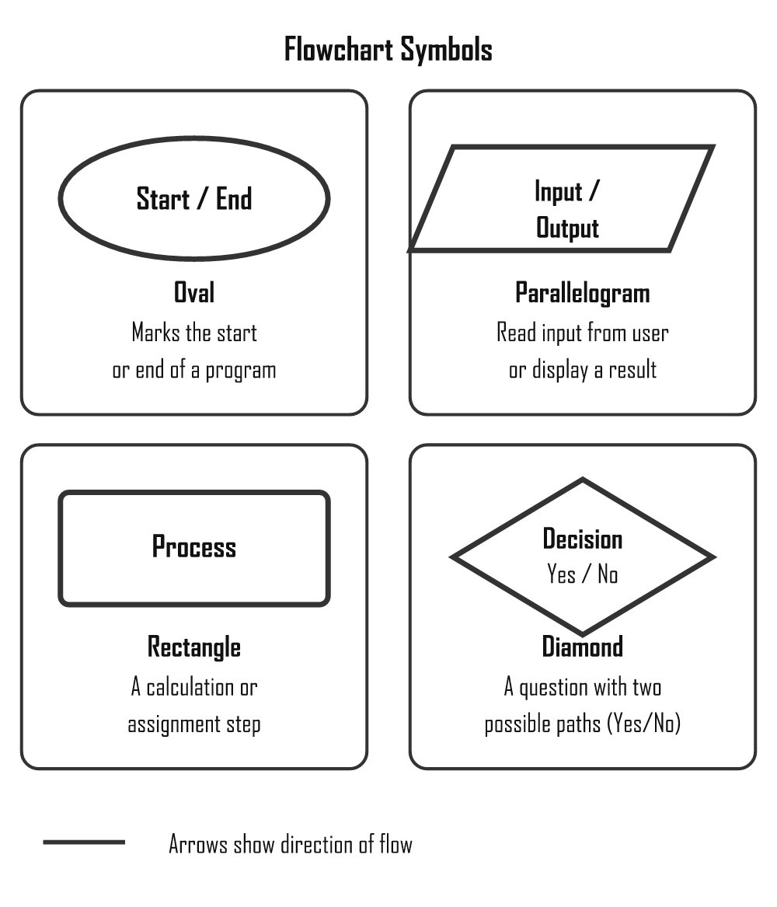
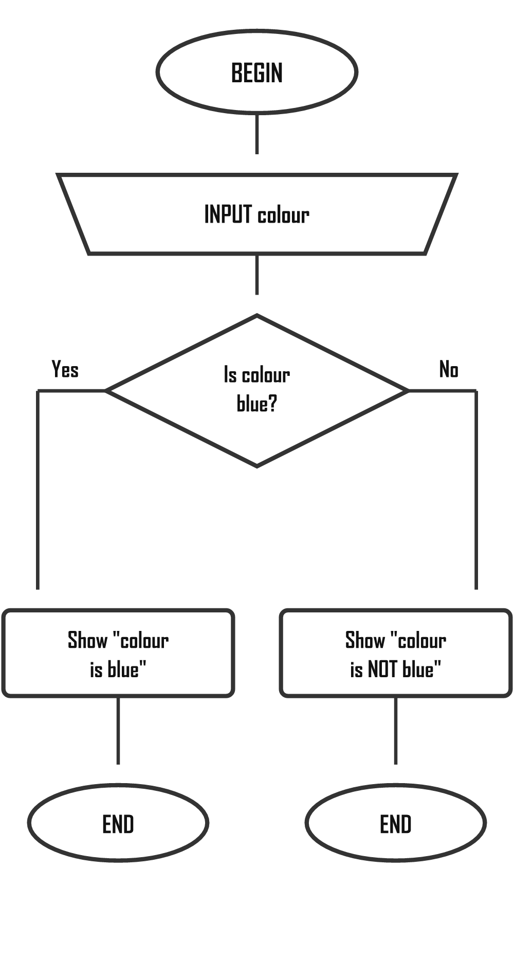

Worked Example: Is a Number Even or Odd?
This flowchart takes a number as input, checks if it divides evenly by 2, and displays "Even" or "Odd" before ending.
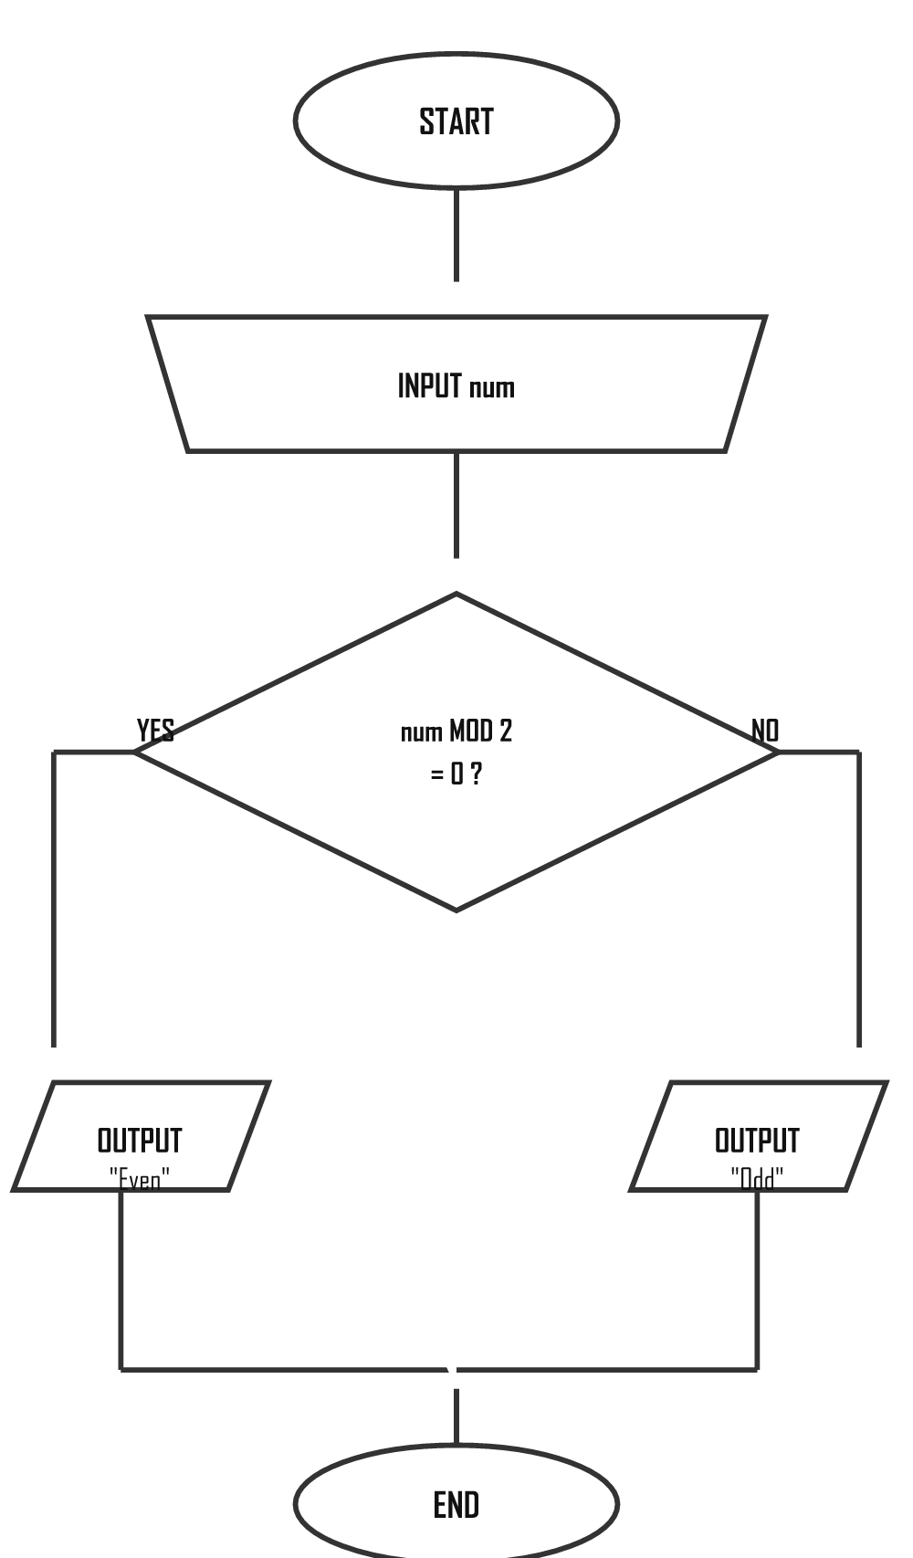

Worked Example: Nested Decisions
Here one decision sits inside another. First we check the age; only if that is True do we ask the second question about the licence.
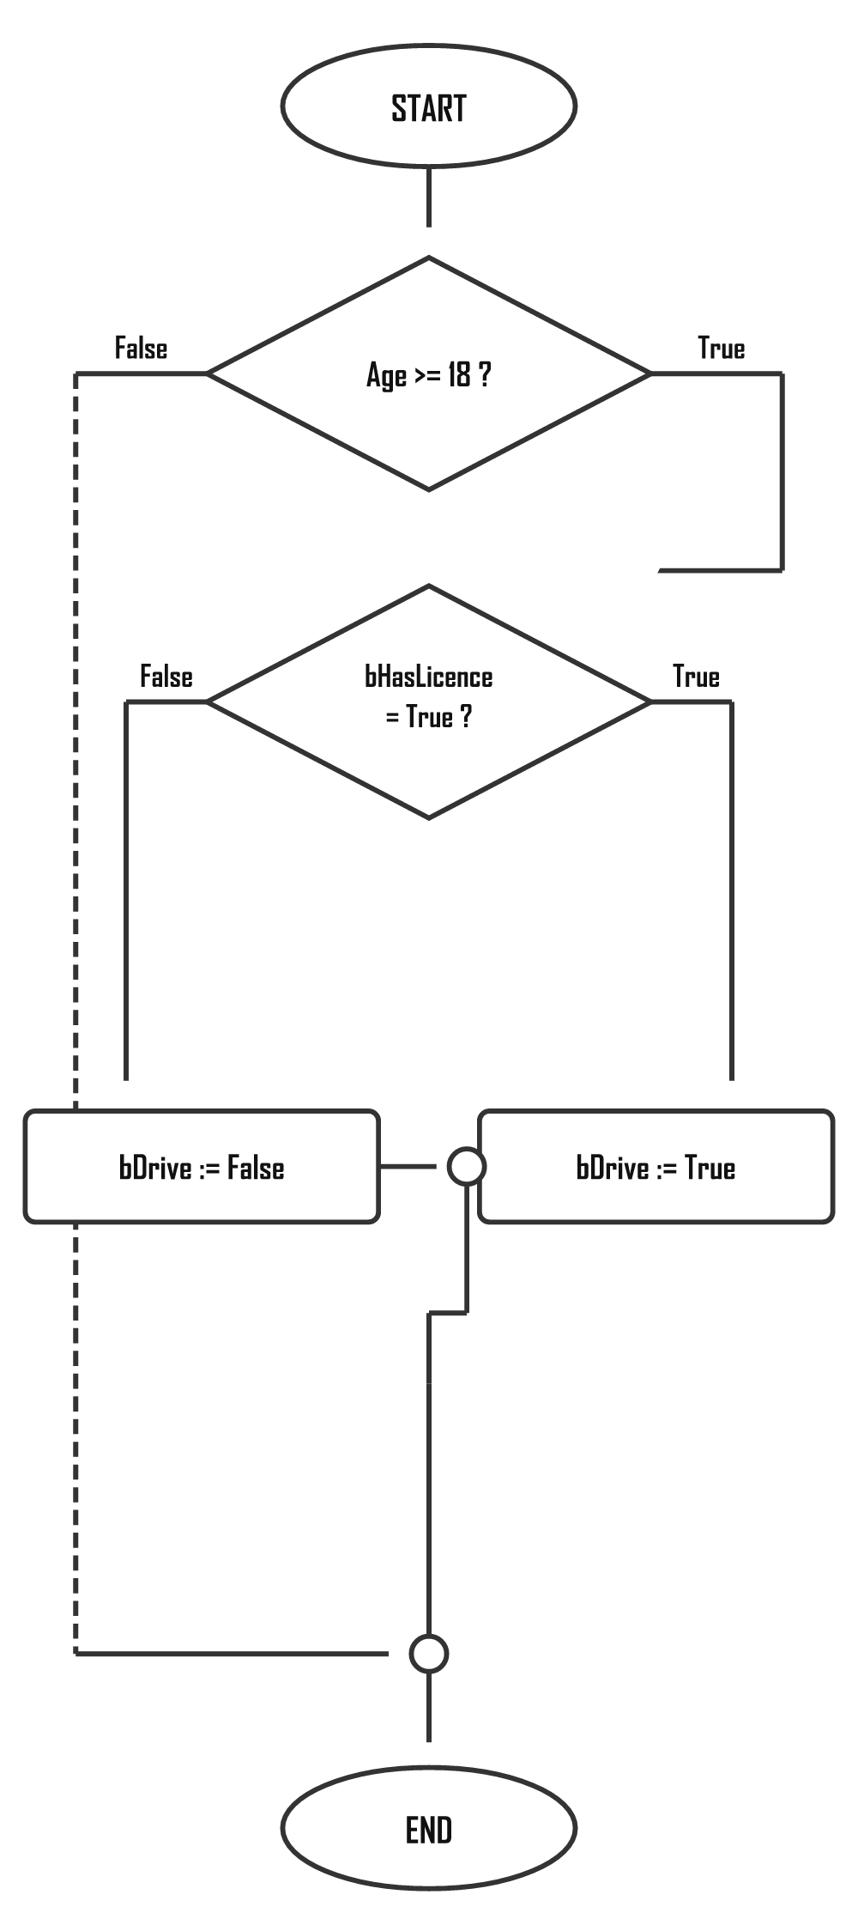
TIP
The diamond shape always asks a Yes/No question. The two arrows leaving the diamond are labelled YES and NO. Both paths must eventually reach the END oval.

Trace Tables
A trace table is used to test an algorithm by hand. You pick a test value, then track every variable as you step through the algorithm line by line. This helps you check whether the algorithm produces the correct output.

Trace Table Example: Even or Odd (num = 7)
Step | Instruction | num | num MOD 2 | Output
1 | START | — | — | —
2 | INPUT num | 7 | — | —
3 | IF num MOD 2 = 0? | 7 | 1 | —
4 | Condition FALSE → ELSE branch | 7 | 1 | —
5 | OUTPUT "Odd" | 7 | 1 | "Odd"
6 | END | — | — | —

Trace Table Example: Average of Three Marks (90, 70, 80)
Step | Instruction | mark1 | mark2 | mark3 | total | average
1 | INPUT mark1 | 90 | — | — | — | —
2 | INPUT mark2 | 90 | 70 | — | — | —
3 | INPUT mark3 | 90 | 70 | 80 | — | —
4 | total = mark1+mark2+mark3 | 90 | 70 | 80 | 240 | —
5 | average = total / 3 | 90 | 70 | 80 | 240 | 80
6 | OUTPUT total, average | — | — | — | 240 | 80

Comparing Algorithms
When two algorithms solve the same problem, we compare them. Three key criteria matter in CAPS exams:
Criterion | What it means | Poor example | Better example
Sequence | Steps must be in the correct order | Calculate average BEFORE total | Calculate total first, THEN average
Precision | Each step must have one clear meaning | "Calculate the answer" | SET total TO mark1 + mark2 + mark3
Efficiency | No unnecessary steps or repeated work | Calculate total three separate times | Calculate total once and reuse the variable

Common Algorithm Patterns in Delphi

Finding Smallest and Largest Values
The trick: assume the first value is both smallest and largest, then compare the rest one by one.
Delphi
var
iNum1, iNum2, iNum3: Integer;
iSmallest, iLargest: Integer;
begin
iNum1 := StrToInt(edtNum1.Text);
iNum2 := StrToInt(edtNum2.Text);
iNum3 := StrToInt(edtNum3.Text);

iSmallest := iNum1; // assume first is smallest
iLargest := iNum1; // assume first is largest

if iNum2 < iSmallest then iSmallest := iNum2;
if iNum3 < iSmallest then iSmallest := iNum3;
if iNum2 > iLargest then iLargest := iNum2;
if iNum3 > iLargest then iLargest := iNum3;

lblResult.Caption := 'Smallest: ' + IntToStr(iSmallest)
+ ' Largest: ' + IntToStr(iLargest);
end;

Swapping Two Values
IMPORTANT RULE
You always need a temporary variable to swap values. Without it, one value gets overwritten before it can be saved — like trying to swap two glasses of water without a third empty glass.
Delphi
var
iA, iB, iTemp: Integer;
begin
iA := StrToInt(edtA.Text);
iB := StrToInt(edtB.Text);

iTemp := iA; // step 1: save A into temp
iA := iB; // step 2: overwrite A with B
iB := iTemp; // step 3: put saved A into B

edtA.Text := IntToStr(iA);
edtB.Text := IntToStr(iB);
end;

Even or Odd
Delphi
var
iNum: Integer;
begin
iNum := StrToInt(edtNum.Text);
if iNum MOD 2 = 0 then
lblResult.Caption := 'Even number'
else
lblResult.Caption := 'Odd number';
end;

Factor Check
A number is a factor if it divides another with no remainder (MOD = 0). For example, 3 is a factor of 12 because 12 ÷ 3 = 4 with remainder 0.
Delphi
if iNum2 MOD iNum1 = 0 then
lblResult.Caption := IntToStr(iNum1) + ' is a factor of ' + IntToStr(iNum2)
else
lblResult.Caption := IntToStr(iNum1) + ' is NOT a factor of ' + IntToStr(iNum2);

Introduction to Delphi
Delphi is a visual programming environment — you design the screen AND write the code. You drag components onto a form to build the interface, then write Pascal code to make it all work. This page covers the IDE layout, components, naming, events, and your first program.

The Delphi IDE — What You See When You Open It
When you open Delphi, this is what you will see. It might look overwhelming at first — but each area has one clear job:
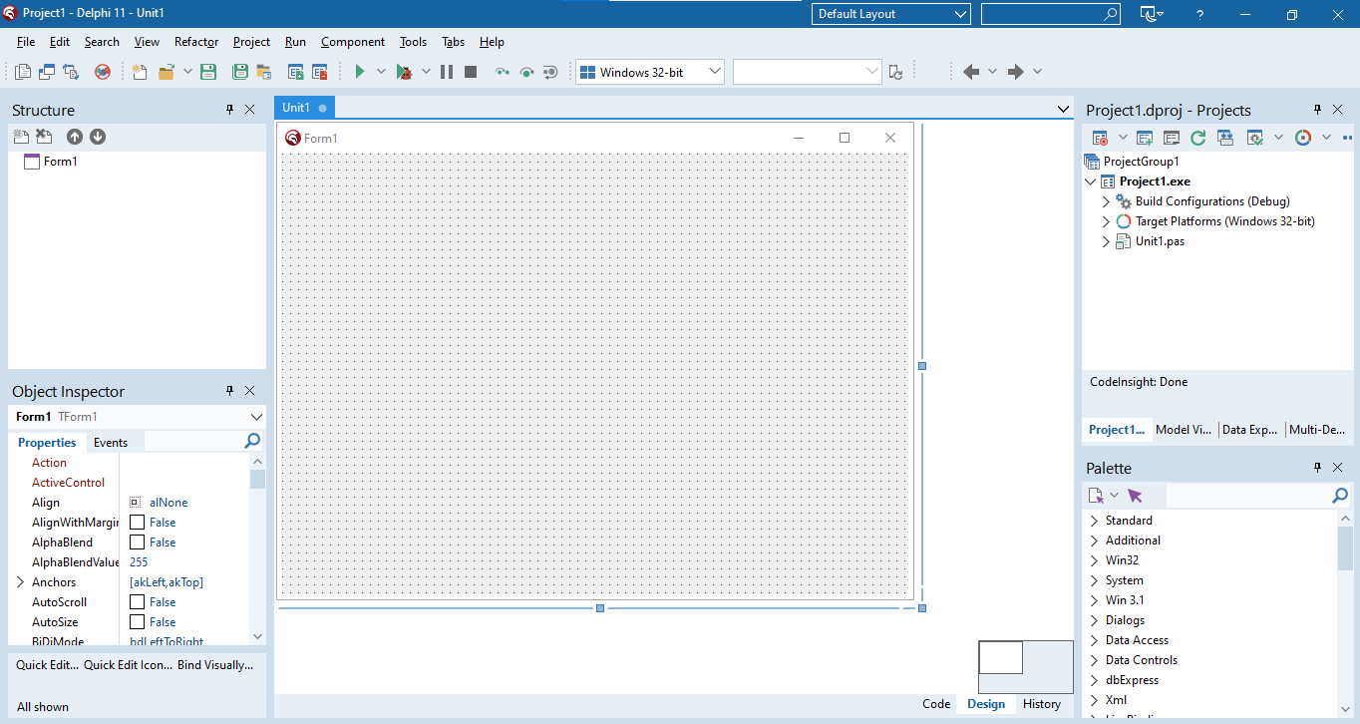
Delphi 11 — Design View (this is where you build the form your user will see)
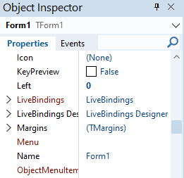
Object Inspector — set properties like Name, Caption, Color
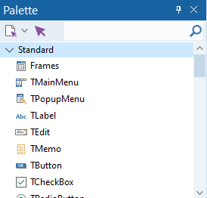
Tool Palette — drag components from here onto the form

Switching to Code View
Press F12 to toggle between the Design View (what you see above) and the Code View (where you type your Delphi code).
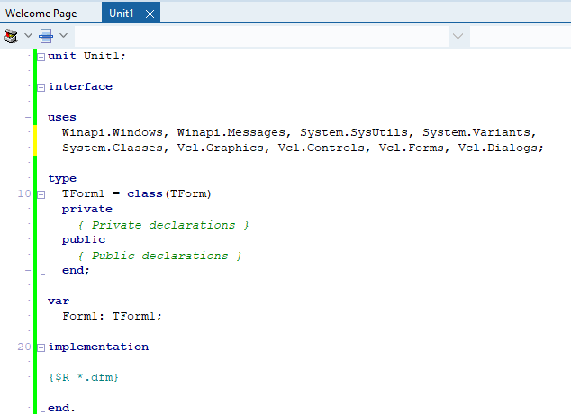
Code View — this is the Delphi code structure that is automatically created for you

The Delphi IDE Layout
The Integrated Development Environment (IDE) is where you write, design and run your programs. Think of it as your workshop — every tool you need is right there.
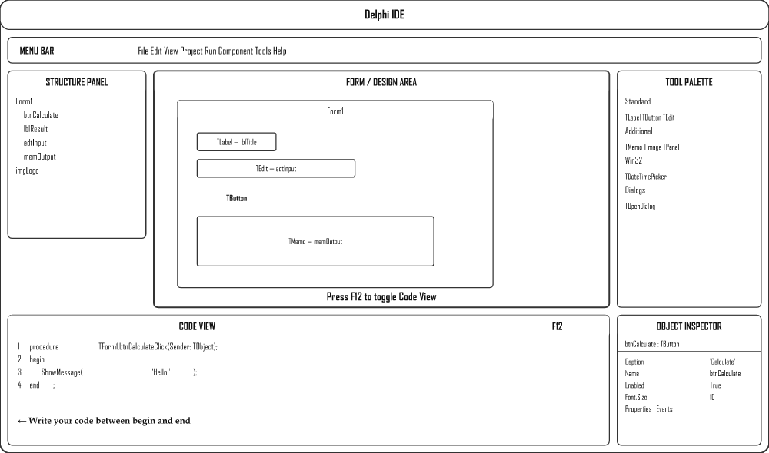

Key IDE Panels
Panel | Purpose
Menu Bar | Top menu — File, Edit, View, Project, Run, Tools etc.
Tool Palette | All Delphi components grouped by category. Click a component, then click on the form to place it.
Object Inspector | Sets the initial properties and events of a selected component.
Structure Panel | Quick reference showing all objects on the current form.
Form / Design Area | The visual canvas — drag and drop components here to build the UI.
Code View | Where you write Pascal code. Toggle with F12.

Step-by-Step: Creating Your First Project
- File → New → Windows VCL Application — creates a blank Form (TForm).
- Place components by clicking them in the Tool Palette, then clicking on the form.
- Set properties in the Object Inspector (e.g. change a button's Caption).
- Double-click a button to go to Code View and write the event handler.
- File → Save All (Ctrl+Shift+S) — save in a NEW dedicated folder.
- Press F9 to compile and run.
SAVE IN ITS OWN FOLDER — ALWAYS!
Each project must be saved in its own dedicated folder. Save the Unit file as FileName_u.pas and the Project file as FileName_p.dproj. Never mix two projects in one folder.

Visual Component Reference
Components are the building blocks placed on a form. Each is an object with properties and events. Here is what the most common ones look like:
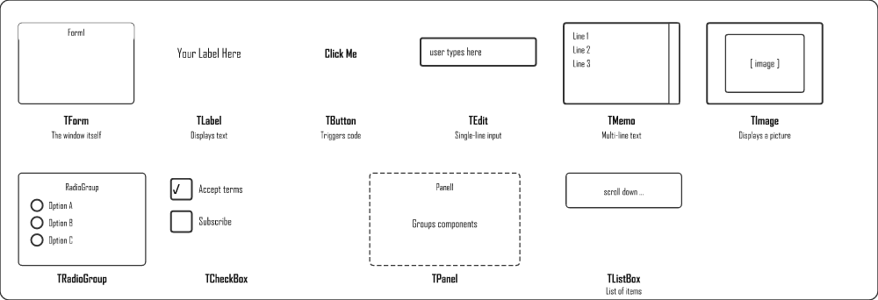

Naming Convention
Every component gets a prefix that indicates its type, followed by a meaningful name. This makes code readable.
Prefix | Component Type | Example
btn | TButton | btnCalculate
lbl | TLabel | lblResult
edt | TEdit | edtName
mem | TMemo | memOutput
img | TImage | imgLogo
pnl | TPanel | pnlHeader
sed | TScrolledEdit | sedNotes
cbo | TComboBox | cboGrade
lst | TListBox | lstNames
rgp | TRadioGroup | rgpGender
chk | TCheckBox | chkAgree
tmr | TTimer | tmrClock

Event-Driven Programming
Delphi programs are event-driven — code only runs when something HAPPENS (an event), like pressing a button, typing in a box, or a timer ticking.
VENDING MACHINE ANALOGY
Think of a vending machine. It just sits there doing nothing — until you push a button. That press is the event. The machine then dispenses the item — that is the event handler (your code). If no button is pressed, nothing happens. Delphi works exactly like this.
Event | When it fires | Common use
OnClick | User clicks a button / component | Calculate, submit, navigate
OnChange | Text in an edit box changes | Live validation, update display
OnKeyPress | A key is pressed while component has focus | Accept only numbers
OnCreate | Form loads / opens | Initialise variables, load data
OnTimer | Timer interval elapses | Countdown, clock display

How to Create an Event Handler
- In Design View, double-click a button to create its OnClick handler automatically.
- For other events, go to the Events tab in the Object Inspector and double-click next to the event name.
- Delphi creates a skeleton procedure. Write your code between begin and end.
- Never change the procedure header — only add code inside.
Delphi — Button Click Event
procedure TForm1.btnCalculateClick(Sender: TObject);
begin
// Your code goes here
ShowMessage('Button clicked!');
end;

ShowMessage and InputBox
ShowMessage displays a pop-up with a message. InputBox pops up a window asking the user to type something. Both are modal — the program pauses until the user responds.
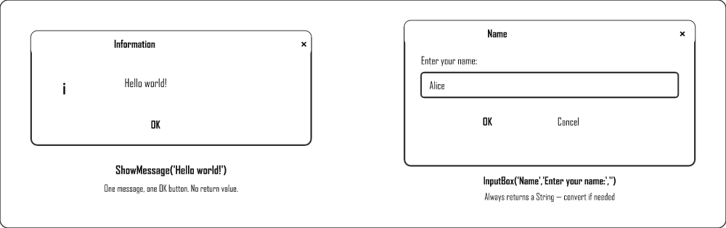
Delphi — ShowMessage
ShowMessage('Hello world!');
ShowMessage('Result: ' + IntToStr(iAnswer));
Delphi — InputBox (returns String, convert as needed)
// Returns a string
sName := InputBox('Name', 'Enter your name:', '');

// Convert to integer
iNum := StrToInt(InputBox('Number', 'Enter a number:', ''));

// Convert to real
rAmount := StrToFloat(InputBox('Amount', 'Enter amount:', ''));

// Get first character only
cClass := InputBox('Class', 'Enter class:', '')[1];

Components — Properties
Properties control how a component looks and behaves. Set them in the Object Inspector or through code.
Property | Description | Example Value
Name | Unique identifier used in code | btnCalculate
Caption | Text shown on labels, buttons, forms | 'Calculate'
Text | Text in a TEdit box | edtName.Text
Height | Component height in pixels | 30
Width | Component width in pixels | 150
Font.Size | Text size | 14
Font.Color | Text colour (note: Color not Colour) | clRed
Visible | Whether component is shown | True / False

Setting Properties in Code
Format: ComponentName.Property := Value;
Delphi
Form1.Height := 500;
Button1.Caption := 'Register';
Label1.Font.Color := clGreen;
Shape1.Brush.Color := clRed;
Shape1.Top := 20;
Shape1.Left := 20;

Methods
Methods are pre-written operations that perform tasks on components. Format: ComponentName.Method;
Method | Effect
Button1.Hide; | Makes the button invisible
Button1.Show; | Makes the button visible again
Edit1.SetFocus; | Moves the cursor into the edit box
Memo1.Clear; | Clears all text in the memo
Form1.Close; | Closes the form / program
RichEdit1.Lines.Add('text'); | Adds a new line to a RichEdit or Memo

Syntax Rules
SYNTAX ERRORS
Every statement ends with a semicolon ;. Missing one causes a syntax error. There is never a semicolon before else. Begin/end pairs must always match.

Delphi Components & Events
Beyond buttons and labels — these components are used in most IT practical exams. Know each one's key property and how to use it in code.

Input Components
Component | Key Property/Event | How to use in code
TEdit | .Text | edtName.Text — read or write as string
TSpinEdit (sedNum) | .Value | sedNum.Value — returns Integer directly
TComboBox | .Text or .ItemIndex | cboMonth.Text or cboMonth.ItemIndex (0-based)
TListBox | .ItemIndex, .Items | lstNames.Items.Add('Alice'); lstNames.ItemIndex
TRadioGroup | .ItemIndex | if rgpGender.ItemIndex = 0 then (0 = first item)
TCheckBox | .Checked | if chkAgree.Checked then
TTrackBar | .Position | trkVolume.Position — Integer
TDateTimePicker | .Date | dtpBirth.Date — TDate value

Output Components
Component | Key Property | Code example
TLabel | .Caption | lblResult.Caption := 'Done';
TMemo | .Lines | memOut.Lines.Add('Hello');
TRichEdit | .Lines | Same as Memo; supports formatting
TListBox | .Items | lstOut.Items.Add('Alice');
TImage | .Picture | imgPhoto.Picture.LoadFromFile('face.jpg');
TProgressBar | .Position | pbrLoad.Position := 75;
TPanel | .Caption, .Color | pnlInfo.Caption := 'Ready';

PageControl (Tabbed Forms)
A TPageControl creates tabbed pages on a form. Each tab is a TTabSheet.

Creating tabs
- Add TPageControl to the form
- Right-click → New Page to add tabs
- Set each TTabSheet.Caption in the Object Inspector
- Drop other components onto each tab — they belong to that tab

Controlling tabs in code
Delphi
// Show a tab
TabSheet2.TabVisible := True;

// Hide a tab
TabSheet2.TabVisible := False;

// Jump to a specific tab
pgcMain.ActivePage := TabSheet3;

Timer Component
A TTimer fires its OnTimer event at regular intervals without user input.
Property | Meaning
Interval | Milliseconds between triggers (1000 = 1 second)
Enabled | True/False — starts or stops the timer
Delphi — countdown timer
var
iSeconds: Integer; // global variable

// OnTimer event (fires every 1000ms)
procedure TForm1.tmrCountTimer(Sender: TObject);
begin
Dec(iSeconds);
lblTime.Caption := IntToStr(iSeconds) + ' seconds left';
if iSeconds <= 0 then
begin
tmrCount.Enabled := False;
ShowMessage('Time is up!');
end;
end;

ComboBox — Adding Items
Delphi
// At design time: use Items property in Object Inspector
// At runtime:
cboMonth.Items.Add('January');
cboMonth.Items.Add('February');
cboMonth.ItemIndex := 0; // select first item

// Reading selected item
sSelected := cboMonth.Text;
iIndex := cboMonth.ItemIndex;

ListBox — Adding, Clearing, Accessing Items
Delphi
lstNames.Items.Add('Alice'); // add item
lstNames.Items.Clear; // remove all
lstNames.Items.Delete(0); // remove first item
iCount := lstNames.Items.Count; // number of items
sItem := lstNames.Items[2]; // access item at index 2
sSelected := lstNames.Items[lstNames.ItemIndex]; // selected item

Resetting a Selection — the -1 Trick
The ItemIndex property tells you which item is selected, counting from 0 (the first item). When nothing is selected, ItemIndex is -1.
This works in reverse too: setting ItemIndex := -1 deselects everything and visually clears the box. This is the standard way to reset a TComboBox, TListBox or TRadioGroup — for example when a user clicks a "Clear form" button.
Delphi — clearing selections
cboMonth.ItemIndex := -1; // ComboBox: no month selected (box appears empty)
rgpGender.ItemIndex := -1; // RadioGroup: no radio button filled in
lstNames.ItemIndex := -1; // ListBox: nothing highlighted
ALWAYS CHECK FOR -1 BEFORE READING A SELECTION
If the user has not chosen anything, ItemIndex is -1. Reading cboMonth.Items[cboMonth.ItemIndex] while it is -1 causes a runtime error (list index out of bounds). Guard it first:

Naming Convention for Components
Prefix | Component
btn | TButton
lbl | TLabel
edt | TEdit
mem | TMemo
sed | TSpinEdit
cbo | TComboBox
lst | TListBox
rgp | TRadioGroup
chk | TCheckBox
pgc | TPageControl
tmr | TTimer
img | TImage

Data Types & Variables
Every value in Delphi has a data type. Variables are the containers that hold these values while your program runs. Constants hold values that never change.

Data Types
Data Type | What it stores | Examples | Quotes?
Integer | Whole numbers (positive & negative, no decimals) | 3, -15, 1250 | No
Real | Numbers with decimals (floating point) | 3.14, -13.24, 125.89 | No
String | One or more characters — text | 'Banana', '23.45', '@!jkl' | Single quotes '…'
Char | A single character only | 'S', '!', 'a' | Single quotes '…'
Boolean | Only True or False | True, False | No

Variables
A variable is a named storage location that holds a value during program execution. Think of it as a labelled box — you can put something in, use it, and swap it out.
Variables must be: Declared → Populated → Used.

Naming Convention — Prefixes
Prefix | Data Type | Example
i | Integer | iAge
r | Real | rPrice
s | String | sName
c | Char | cGrade
b | Boolean | bFound

Declaring Variables
Declared in the var section using: variableName : DataType;

Local Declaration (inside a procedure)
Delphi — Local
procedure TForm1.btnClickClick(Sender: TObject);
var
sName: string;
iNumber: integer;
begin
// code here
end;

Global Declaration (available to all procedures)
Delphi — Global
var
Form1: TForm1;
sName: string; // declared here, below existing var block
iNumber: integer;

Populating (Assigning) Variables
Use the assignment operator := to put a value into a variable.
Delphi
sName := 'Jannie';
sName := edtName.Text; // from a text box
iNumber := 15;
iNumber := sedNum.Value; // from a spin edit
bFlag := True;

Initialising Variables
ALWAYS INITIALISE
Set a starting value before using a variable, especially counters and totals — otherwise Delphi may assign a random garbage value.
Delphi
i := 0;
iTotal := 0;
sReverse := '';
cLetter := '';

Using Variables
Delphi
lblFullName.Caption := sName + ' ' + sSurname;
memOut.Lines.Add(sName + ' ' + sSurname);
iAnswer := iNum1 + iNum2;
memOut.Lines.Add(IntToStr(iNum1) + ' + ' + IntToStr(iNum2)
+ ' = ' + IntToStr(iAnswer));

Constants
A constant holds a value that is known before the program runs and cannot change while it runs. Use const instead of var. No data type is needed, and use = not :=.
Delphi
const
VAT = 0.15;
MAX_ITEMS = 100;

// Using a constant — exactly like a variable
rVatAmount := rCostPrice * VAT;
rTotal := rCostPrice + rVatAmount;

Type Conversion
Components like TEdit only hold strings. You must convert to the right type before using in calculations.
Function | Converts | Example
StrToInt() | String → Integer | iAge := StrToInt(edtAge.Text);
StrToFloat() | String → Real | rPrice := StrToFloat(edtPrice.Text);
IntToStr() | Integer → String | lblOut.Caption := IntToStr(iTotal);
FloatToStr() | Real → String | lblOut.Caption := FloatToStr(rAverage);
THE VAL PROCEDURE — CONVERTING SAFELY
StrToInt crashes (runtime error) if the text isn't a valid number. The Val procedure converts a string to a number without crashing: it gives back the converted value AND an error code that tells you whether the conversion worked (0 = success, otherwise the position of the first bad character).

Formatting Real Numbers
Delphi
// FloatToStrF(value, format, totalDigits, decimals)
lblPrice.Caption := FloatToStrF(rPrice, ffCurrency, 4, 2); // → R24.50
lblPrice.Caption := FloatToStrF(rPrice, ffFixed, 4, 2); // → 24.50

Types of Errors
Error Type | When it occurs | Example
Syntax Error | Code is typed incorrectly — won't compile | Missing semicolon, missing end
Runtime Error | Crashes while the program is running | Dividing by zero
Logical Error | Runs, but gives wrong answer | Calculating average before total, infinite loop

Operators & Functions
Operators perform calculations. Delphi also has a rich library of built-in functions for maths, string handling, and more.

Arithmetic Operators
Operator | Symbol | Description | Example | Result
Addition | + | Add values | 5 + 3 | 8
Subtraction | - | Subtract | 10 - 4 | 6
Multiplication | * | Multiply | 4 * 3 | 12
Division | / | Divide (returns Real) | 7 / 2 | 3.5
Integer Division | DIV | Whole part only (no remainder) | 7 DIV 2 | 3
Modulus | MOD | Remainder only | 7 MOD 2 | 1

MOD and DIV Examples
Calculation | Working | MOD result | DIV result
5 MOD/DIV 2 | 5 ÷ 2 = 2 remainder 1 | 1 | 2
25 MOD/DIV 5 | 25 ÷ 5 = 5 remainder 0 | 0 | 5
17 MOD/DIV 3 | 17 ÷ 3 = 5 remainder 2 | 2 | 5
COMMON USES OF MOD
Even/Odd check: n MOD 2 = 0 → even
Factor check: b MOD a = 0 → a is a factor of b
Last digit: n MOD 10 → last digit of n

Operator Precedence (Order of Operations)
Priority | Operators
1st (highest) | Brackets ( )
2nd | * / DIV MOD (left to right)
3rd (lowest) | + - (left to right)
Example
result := 2 + 3 * 4; // = 14 (3*4 first)
result := (2 + 3) * 4; // = 20 (brackets first)
result := 10 DIV 2 + 3; // = 8 (DIV first)

Mathematical Functions
Add Math to your uses section to access power, floor, ceil etc.
Function | Description | Example | Result
sqr(x) | x squared (x²) | sqr(4) | 16
sqrt(x) | Square root | sqrt(16) | 4.0
power(x,n) | x to the power of n | power(5,3) | 125
round(x) | Round to nearest integer | round(5.68) | 6
trunc(x) | Remove decimal (truncate) | trunc(5.68) | 5
floor(x) | Round DOWN | floor(3.76) | 3
ceil(x) | Round UP | ceil(3.76) | 4
abs(x) | Absolute value (remove negative) | abs(-12) | 12
frac(x) | Fractional part only | frac(12.75) | 0.75
pi | Value of π | pi | 3.14159…
random(n) | Random number from 0 to n-1 | random(10) | 0–9
RoundTo(x,-n) | Round to n decimal places | RoundTo(12.3456,-2) | 12.35

Inc and Dec
Procedure | Effect | Example | Result
Inc(x) | Increment by 1 | Inc(5) | 6
Inc(x, n) | Increment by n | Inc(5, 3) | 8
Dec(x) | Decrement by 1 | Dec(5) | 4
Dec(x, n) | Decrement by n | Dec(6, 4) | 2

Ord and Chr
Ord and Chr convert between characters and their ASCII numeric codes.
Function | Description | Example | Result
Ord(c) | Character → ASCII integer | Ord('A') | 65
Chr(n) | ASCII integer → Character | Chr(65) | 'A'

Caesar Cipher Example
Delphi — Shift characters by a number
var
sInput, sOutput: string;
i, iShift: Integer;
begin
sInput := InputBox('Text', 'Enter text:', 'ABC');
iShift := StrToInt(InputBox('Shift', 'Enter shift (1-25):', '3'));
sOutput := '';
for i := 1 to Length(sInput) do
sOutput := sOutput + Chr(Ord(sInput[i]) + iShift);
ShowMessage('Shifted: ' + sOutput); // ABC → DEF
end;

Upcase and Trim
Function | Description | Example | Result
UpCase(c) | Convert single char to uppercase | UpCase('a') | 'A'
Trim(s) | Remove spaces from both ends | Trim(' Hello ') | 'Hello'
TrimLeft(s) | Remove leading spaces | TrimLeft(' Hi') | 'Hi'
TrimRight(s) | Remove trailing spaces | TrimRight('Hi ') | 'Hi'

Decision Making — IF & CASE
Decision structures let your program choose different paths based on conditions. Delphi uses if…then…else and case for this.

What is Decision Making?
Decision-making (also called conditional logic) is when a program tests whether something is true or false and then chooses what to do next based on the answer. A condition is any question that can only be answered with true or false — for example, "is the age 18 or more?".
Everyday analogy: A robot (traffic light) at an intersection makes a decision for you. If the light is green you go; else you stop. Your program does the same thing — it looks at a condition and takes one path or another.

Why Do Programs Need to Make Decisions?
Without decisions, a program could only ever do the exact same thing every single time it runs. Decisions make a program react to its data and its user.
- React to input – an age-check on a website: if you are old enough it lets you in, otherwise it blocks you.
- Validate data – if a mark is below 0 or above 100, warn the user it is invalid.
- Choose an outcome – if a learner scored 50 or more, display "Passed", otherwise display "Failed".
- Stay safe – if the password matches, grant access; otherwise deny it.

The IF Statement
Evaluates a condition (true/false) and executes code accordingly.
The IF statement is the most common decision in programming. In plain words it says: "If this is true, then do that; otherwise (else) do something else." Everyday analogy: "If it is raining, take an umbrella, else wear a cap." The "if it is raining" part is the condition that is checked first.

IF … THEN (one-way)
Syntax
if condition then
statement;

IF … THEN … ELSE (two-way)
NO SEMICOLON BEFORE ELSE
Never put a ; on the line before else — it ends the if statement too early.
Syntax
if condition then
statement
else
statement;

Multiple Statements — use BEGIN…END
Delphi
if iAge >= 18 then
begin
lblResult.Caption := 'Adult';
btnVote.Enabled := True;
end
else
begin
lblResult.Caption := 'Minor';
btnVote.Enabled := False;
end;

Examples
Delphi
if iNum1 > iNum2 then
ShowMessage(IntToStr(iNum1) + ' is larger');

if age >= 18 then
ShowMessage('Old enough to vote');

if username <> 'admin' then
ShowMessage('Access denied')
else
ShowMessage('Welcome, administrator!');

Comparison Operators
Operator | Meaning | Example
= | Equal to | iAge = 18
<> | Not equal to | sName <> 'Admin'
> | Greater than | iScore > 50
< | Less than | iAge < 18
>= | Greater than or equal to | iMark >= 30
<= | Less than or equal to | rPrice <= 100.0

Boolean Operators
Combine multiple conditions in one statement.
Boolean operators let you ask more than one question at the same time. Everyday analogy: to get into a club you might need to be 18 AND have an ID — both must be true. To qualify for a discount you might need to be a student OR a pensioner — either one is enough. NOT simply flips an answer around, like saying "if it is not a holiday, school is open".
Operator | Rule | Example
AND | Both conditions must be true | (iAge >= 18) AND (bHasID = True)
OR | At least one condition must be true | (sGender = 'M') OR (sGender = 'F')
NOT | Inverts the condition | NOT (iScore > 50)
Delphi — AND and OR examples
if (iAge >= 18) AND (bHasLicense = True) then
bCanDrive := True;

if (iScore >= 30) OR (bHasSymbol = True) then
lblResult.Caption := 'Passed';

Nested IF
An IF inside another IF.
Delphi
if iAge >= 18 then
begin
if bHasLicense = True then
bDrive := True
else
bDrive := False;
end
else
bDrive := False;

Decision Components

RadioGroup
Uses an ItemIndex property — first item is index 0.
Delphi
if rgpGender.ItemIndex = 0 then
sGender := 'Male'
else
sGender := 'Female';

CheckBox
Uses the Checked property — True or False.
Delphi
if chkInsurance.Checked = True then
rCost := rCost + rInsuranceAmount;

The IN Operator
Tests if a value is in a set. Cleaner than multiple OR conditions.
Delphi
// Check for specific values
if iNumber IN [1, 3, 5, 7] then
ShowMessage('Odd single digit found');

// Range using ..
if iMark IN [0..49] then
lblSymbol.Caption := 'F';

// Works with Char too
if cLetter IN ['A', 'E', 'I', 'O', 'U'] then
ShowMessage('Vowel');

The CASE Statement
Cleaner alternative to multiple IF…ELSE when testing one variable against many values. Works with Integer and Char only.
Use CASE when one variable could take many possible values and each value leads to a different outcome — like turning a mark into a grade symbol. Everyday analogy: a vending machine. You press one button (the value), and depending on which button it was, a different snack drops out. Writing that as a long chain of IF…ELSE statements works, but CASE lays it out neatly so it is much easier to read.
Syntax
case expression of
value1: statement1;
value2: statement2;
value3: statement3;
else
statementDefault;
end;
REMEMBER
CASE has no begin, but always has end. You can use ranges with ..
Delphi — Grade symbol example
case iMark of
80..100: lblSymbol.Caption := '7 — Outstanding';
70..79: lblSymbol.Caption := '6 — Meritorious';
60..69: lblSymbol.Caption := '5 — Substantial';
50..59: lblSymbol.Caption := '4 — Adequate';
40..49: lblSymbol.Caption := '3 — Moderate';
30..39: lblSymbol.Caption := '2 — Elementary';
else
lblSymbol.Caption := '1 — Not Achieved';
end;

MessageDlg
A pop-up dialog that asks the user a yes/no question and returns a result.
Delphi
if MessageDlg('Are you sure?', mtConfirmation, mbYesNo, 0) = mrYes then
// execute if user clicked Yes
ShowMessage('Confirmed!');
Parameter | Options
Message type | mtConfirmation, mtInformation, mtWarning, mtError
Buttons | mbYesNo, mbOKCancel, mbYesNoCancel
Result | mrYes, mrNo, mrOK, mrCancel

Loops
Loops repeat a block of code multiple times. Delphi has three loop types — choose based on whether you know how many times to repeat.

What is a Loop?
A loop is a programming structure that repeats a block of code over and over until a certain point is reached. Instead of writing the same instruction many times, you write it once and tell the computer how often, or until when, to repeat it.
Everyday analogy: Think of doing push-ups. The coach does not shout "do a push-up" fifty separate times. He says "do fifty push-ups." That single instruction, repeated until you reach fifty, is a loop. The action (one push-up) is the loop body, and "fifty" is the condition that tells you when to stop.

Why Do We Use Loops?
Loops save us from repeating ourselves and let programs handle any amount of work with the same short piece of code.
- Less code – printing the numbers 1 to 100 takes three lines with a loop instead of one hundred lines without one.
- Fewer mistakes – you write the instruction once, so there is only one place where a typo could hide.
- Flexibility – the same loop can run 5 times or 5 000 times just by changing one number, so your program copes with any size of data.
- Processing collections – loops let you visit every item in a list, every learner in a class, or every character in a string, one at a time.

The Three Loop Types in Plain Words
Choosing the right loop comes down to one question: do you know in advance how many times to repeat?
- FOR – use it when you know the exact number of repeats. Analogy: climbing a staircase with a known number of steps — you count "step 1, step 2…" up to the top.
- WHILE – use it when you do not know how many times, and you must check first before doing anything. Analogy: filling a glass of water — you keep checking "is it full yet?" before each pour, and if the glass was already full you never pour at all.
- REPEAT…UNTIL – use it when you do not know how many times, but you must do the action at least once and check afterwards. Analogy: asking someone for their PIN — you always ask once, then check if it was right, and ask again only if it was wrong.

Types of Loops
Loop | Type | Use when…
for … do | Unconditional (fixed) | You know exactly how many times
while … do | Conditional (pre-test) | Repeat WHILE a condition is true — check first
repeat … until | Conditional (post-test) | Repeat UNTIL a condition is true — always runs at least once

FOR Loop (Fixed / Unconditional)
Runs a set number of times. The counter increments or decrements automatically.
We call it fixed or unconditional because the number of repeats is decided before the loop even starts and cannot change while it runs. You give it a start value and an end value, and Delphi handles the counting for you — you never have to add 1 to the counter yourself.
WHEN TO USE
Reach for a FOR loop whenever you can finish the sentence "do this exactly ___ times" with a number — printing 1 to 10, working through all 30 learners in a class, or drawing 12 rows of a table.
Syntax — counting UP
for counter := lowest to highest do
begin
// code repeated each iteration
end;
Delphi — print 1 to 5
for i := 1 to 5 do
begin
memOut.Lines.Add(IntToStr(i));
end;

FOR … DOWNTO (counting down)
Delphi — countdown 5 to 1
for i := 5 downto 1 do
begin
memOut.Lines.Add(IntToStr(i));
end;

FOR Loop — Running Total
Delphi — sum 1 to 10
var
i, iTotal: Integer;
begin
iTotal := 0; // initialise!
for i := 1 to 10 do
iTotal := iTotal + i;
lblTotal.Caption := 'Sum = ' + IntToStr(iTotal);
end;

WHILE … DO Loop (Pre-Conditional)
Checks the condition before each iteration. If the condition is false from the start, the loop body never runs.
We call it pre-conditional ("pre" = before) because it tests the condition first, and only then decides whether to run the body. This makes it the safe choice when there is a chance the loop should not run at all.
WHEN TO USE
Use WHILE when you do not know how many repeats you need and it might be zero — for example, "keep reading numbers while the user hasn't typed 0". If they type 0 immediately, you correctly do nothing.
Syntax
while condition do
begin
// code
end;
AVOID INFINITE LOOPS
The counter must be initialised before the loop and incremented inside the loop — otherwise it runs forever and crashes your program.
Delphi — while counter ≤ 5
var
Counter: Integer;
begin
Counter := 1; // initialise BEFORE loop
while Counter <= 5 do
begin
memOut.Lines.Add('Counter: ' + IntToStr(Counter));
Inc(Counter); // increment INSIDE loop
end;
end;

WHILE — Reading user input until sentinel
Delphi — keep adding until user enters 0
var
iNum, iTotal: Integer;
begin
iTotal := 0;
iNum := StrToInt(InputBox('Input', 'Enter number (0 to stop):', ''));
while iNum <> 0 do
begin
iTotal := iTotal + iNum;
iNum := StrToInt(InputBox('Input', 'Enter number (0 to stop):', ''));
end;
lblTotal.Caption := 'Total: ' + IntToStr(iTotal);
end;

REPEAT … UNTIL Loop (Post-Conditional)
Runs the body first, then checks the condition. Guaranteed to run at least once. Loop continues while condition is false; stops when it becomes true.
We call it post-conditional ("post" = after) because it does the work first and asks the question afterwards. That is the opposite of the WHILE loop, and it is exactly what you want when the action must happen at least one time no matter what.
WHEN TO USE
Use REPEAT…UNTIL when the body must run at least once — like showing a menu and asking the user to choose, or asking for a valid mark and re-asking until they get it right. You always ask once, then keep asking until the answer is acceptable.
Syntax
repeat
// code
until condition;
Delphi — repeat until i = 10
var
i: Integer;
begin
i := 1;
repeat
memOut.Lines.Add(IntToStr(i));
i := i + 1;
until i > 10;
end;

REPEAT — Validate input
Delphi — keep asking until valid mark
var
iMark: Integer;
begin
repeat
iMark := StrToInt(InputBox('Mark', 'Enter mark (0-100):', ''));
if (iMark < 0) OR (iMark > 100) then
ShowMessage('Invalid! Enter 0-100');
until (iMark >= 0) AND (iMark <= 100);
end;

Comparison: Which Loop to Use?
Situation | Best Loop
Print numbers 1 to 100 | for
Read until user types "stop" | while or repeat
Must run at least once (e.g. menu) | repeat
Unknown number of iterations | while or repeat
Process each element in an array | for

String Manipulation
Strings are sequences of characters. Delphi provides built-in functions and procedures to analyse, extract, and modify strings.

What is String Manipulation?
String manipulation is the process of working with text inside a program — searching it, pulling pieces out of it, changing it and measuring it. A string is simply a piece of text: a name, an ID number, an email address or a whole sentence are all strings.
Everyday analogy: Think of a string like a row of bead letters on a piece of string, exactly like a beaded keyring that spells a name. Each bead is one character and it sits in a fixed position. String manipulation is what you do when you slide beads off the end, count how many there are, swap a small to a capital bead, or read which bead is sitting in position 3.
WHY IT MATTERS
Almost every real program handles text. When you log in, the computer compares the string you typed against the stored one. When a website greets you by your first name only, it has extracted that name out of your full name. When a form checks that an email contains an "@", it is searching a string. Learning these functions means you can validate input, format output neatly, and pull useful data out of messy text — skills you will use in every program from here on.
Note: In Delphi, the very first character of a string sits at position 1 (not 0). This is why the reference string below numbers its letters starting at 1.
REFERENCE STRING
All examples on this page use: sSourceText := 'Andre is cute';
Positions: A=1, n=2, d=3, r=4, e=5, (space)=6, i=7, s=8, (space)=9, c=10, u=11, t=12, e=13

Quick Reference
Name | Type | What it does | Returns
Pos | Function | Position of a substring in a string | Integer
Index [ ] | — | Character at a specific position | String (1 char)
Copy | Function | Extract part of a string | String
Insert | Procedure | Insert text into a string | Modifies original
Delete | Procedure | Remove part of a string | Modifies original
Length | Function | Number of characters in a string | Integer
UpperCase | Function | Convert to all capitals | String
LowerCase | Function | Convert to all lowercase | String

Group 1 — Searching a String
Searching means asking "is this smaller piece of text in there, and if so, where?" The answer you get back is a position number. This is the first thing you do before you can extract or change part of a string, because you usually need to know where something is first.
Everyday analogy: It is like using Find (Ctrl+F) in a document. You type a word, and the computer jumps to the spot where it appears and tells you where it is. Pos is Delphi's version of that "Find".

Pos — Find Position
Returns the integer position of the first occurrence of a substring. Returns 0 if not found.
Syntax
IntegerVariable := Pos(StrToBeFound, SourceText);
Delphi
iX := Pos('e', sSourceText); // = 5 (first 'e' in 'Andre')
iX := Pos('is', sSourceText); // = 7
iX := Pos('xyz', sSourceText); // = 0 (not found)

Index [ ] — Character at Position
Access a single character using square brackets and a position number.
Syntax
StringVariable := SourceText[CharacterPosition];
Delphi
sNewText := sSourceText[2]; // = 'n'
sNewText := sSourceText[5]; // = 'e'

Group 2 — Extracting Part of a String
Extracting means taking a copy of a piece of the string without changing the original. You decide where to start and how many characters to grab. This is how you pull a first name out of a full name, a year out of a date, or an area code out of a phone number.
Everyday analogy: Think of cutting a slice out of a loaf of bread. The loaf (the original string) stays whole; you just take a slice from a chosen spot of a chosen thickness. Copy takes the slice, and Index [ ] takes a single thin slice — just one character.

Copy — Extract Substring
Extracts a section of text starting at a position for a given number of characters.
Syntax
StringVariable := Copy(SourceText, BeginPosition, Length);
Delphi
sNewText := Copy(sSourceText, 10, 4); // = 'cute' (start at 10, take 4)
sNewText := Copy(sSourceText, 1, 5); // = 'Andre' (start at 1, take 5)

Group 3 — Changing a String
Changing a string means actually modifying it — adding text in, taking text out, or measuring it. Unlike extracting, these Insert and Delete procedures change the original string directly, so afterwards the string is different from before.
Everyday analogy: This is like editing a sentence in your exercise book. Insert squeezes a new word into the middle of the sentence; Delete rubs a few words out. Length is just counting how many letters the sentence now has.

Insert — Add Text
Inserts text into an existing string at a given position. Modifies the string directly.
Syntax
Insert(InsertText, SourceText, Position);
Delphi
Insert('very ', sSourceText, 10);
// sSourceText is now: 'Andre is very cute'

Delete — Remove Text
Removes a section of text from a string. Modifies the string directly.
Syntax
Delete(SourceText, Position, Length);
Delphi
Delete(sSourceText, 9, 5);
// sSourceText is now: 'Andre is' (removed ' cute')

Length — String Length
Syntax
IntegerVariable := Length(SourceText);
Delphi
iX := Length(sSourceText); // = 13 (length of 'Andre is cute')
iX := Length('Hello'); // = 5

Group 4 — Changing Case
Changing case means turning all the letters into capitals (UpperCase) or all into small letters (LowerCase). The most important reason we do this is to compare text fairly. The computer thinks 'YES', 'yes' and 'Yes' are three different strings, so if you force them all to lowercase first, they all match.
Everyday analogy: Imagine a teacher marking a one-word answer. Whether a learner wrote "Cape Town", "CAPE TOWN" or "cape town", it is the same correct answer. Lowercasing both the answer and the memo before comparing is how you make sure capitals do not unfairly mark someone wrong.
Important Rule: UpperCase and LowerCase return a new string — they do not change the original unless you store the result back into a variable.

UpperCase and LowerCase
Delphi
sResult := UpperCase(sSourceText);
// 'Andre is cute' → 'ANDRE IS CUTE'

sResult := LowerCase(sSourceText);
// 'Andre is cute' → 'andre is cute'

Practical Patterns

Reverse a String
Delphi
var
sInput, sReverse: string;
i: Integer;
begin
sInput := edtInput.Text;
sReverse := '';
for i := Length(sInput) downto 1 do
sReverse := sReverse + sInput[i];
lblResult.Caption := sReverse;
end;

Count Occurrences of a Character
Delphi — count vowels
var
sText: string;
i, iCount: Integer;
begin
sText := LowerCase(edtInput.Text);
iCount := 0;
for i := 1 to Length(sText) do
if sText[i] IN ['a','e','i','o','u'] then
Inc(iCount);
lblResult.Caption := 'Vowels: ' + IntToStr(iCount);
end;

Extract First Name from "Surname, Name"
Delphi — using Pos and Copy
var
sFullName, sName, sSurname: string;
iCommaPos: Integer;
begin
sFullName := edtInput.Text; // e.g. 'Smith, John'
iCommaPos := Pos(',', sFullName);
sSurname := Copy(sFullName, 1, iCommaPos - 1);
sName := Copy(sFullName, iCommaPos + 2, Length(sFullName));
lblOut.Caption := 'Name: ' + sName + ' Surname: ' + sSurname;
end;

Digital Technologies & ICT
Understanding what digital technology and ICT actually mean, how computers process information, and the basic model behind every computer system.

Digital Technologies
Digital technologies are electronic tools, systems and devices that use digital data (0s and 1s) to collect, process, store and communicate information.
Examples: computers, smartphones, networks, cloud computing, databases, AI systems, IoT devices.

ICT vs IT
Term | Stands for | Meaning
ICT | Information Communication Technology | All technologies that capture, transmit and display data electronically — people, hardware, software, procedures, data.
IT | Information Technology | A subset of ICT — the development, maintenance and use of computer systems, software and networks for processing and communicating data.

Data vs Information vs Knowledge
Term | Definition | Example
Data | Raw, unprocessed facts with no meaning on their own | 3, 5, 7, 1, 9
Information | Data that has been processed and given meaning | "Sorted list: 1, 3, 5, 7, 9"
Knowledge | Insight derived from understanding information | "These are odd numbers in ascending order"

Characteristics of a Computer
- Speed — performs millions of operations per second
- Accuracy — follows instructions exactly
- Diligence — does not get tired or distracted
- Storage — large amounts of data can be stored
- Automation — tasks can be executed automatically
- Versatility — can perform many different types of tasks

The Information Processing Cycle
All computer operations follow this cycle:
Stage | Description | Example
Input | Raw data is collected and entered | Typing on keyboard, scanning a barcode
Processing | CPU manipulates data using instructions | Calculating a total, sorting a list
Output | Results produced in usable format | Screen display, printout
Storage | Data saved for future use | Saving to HDD, cloud backup
Communication | Data transferred between systems | Email, network transfer

Benefits and Negative Impacts of ICT
Benefits | Negative Impacts
Improved communication | Cyberbullying
Automation of services | Addiction to digital devices
Access to information | Job displacement due to automation
Improved education and training | Privacy and security risks
Remote work possibilities | Digital divide

The Digital Divide
The digital divide is the growing gap between people with access to digital technology ("haves") and those without ("have-nots"). Factors include:
- Education — higher-educated households use technology more
- Income — lower-income areas lack infrastructure
- Location — rural areas have limited access

Hardware
Hardware is every physical component of a computer — the parts you can actually touch. Software is the instructions that tell hardware what to do. Together they make a complete computing system.
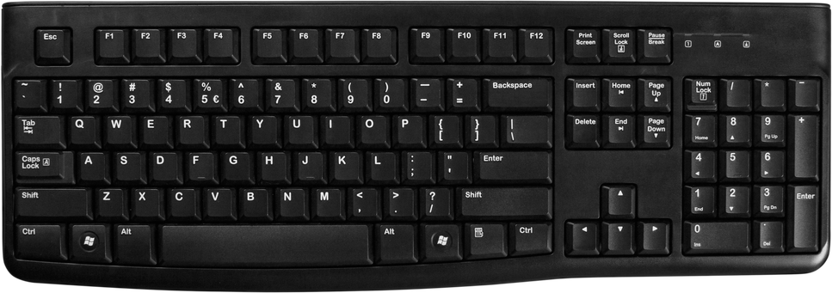  Keyboard  Most common input device for typing text and commands |   Mouse  Pointing device for navigating graphical interfaces | 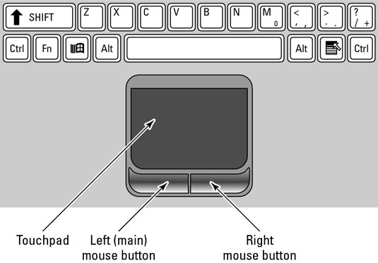  Touchpad  Built-in pointer control surface on laptops | 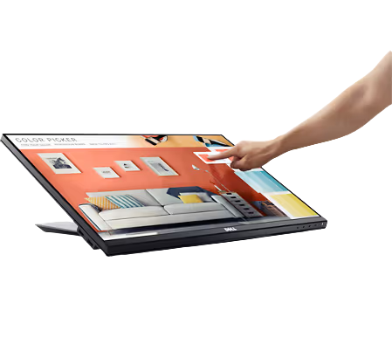  Touchscreen  Detects finger or stylus touch directly on the display

Hardware vs Software — The Body Analogy
ANALOGY
Think of your body: your brain, eyes, hands, heart are hardware — physical organs you can touch. The thoughts, decisions, and reflexes your brain generates are software — instructions that control what your body does. A computer works the same way: the physical parts are hardware, and the programs running on them are software.

The Computer System — Five Categories
Every hardware component falls into one of five categories. Data flows through the system in a loop: Input → Processing → Output, while Memory holds data temporarily and Storage saves it permanently. Communication devices connect the computer to other devices.
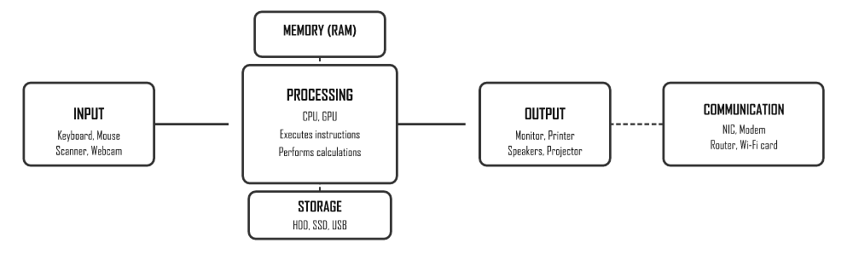

Hardware Categories
Category | Description | Examples | You use this when…
Input devices | Allow you to add data to the computer | Keyboard, mouse, touchscreen, scanner, microphone, webcam | You type, click, scan a document, or record a video
Output devices | Present results to the user | Monitor, printer, speakers, projector | You read text on screen, print a document, hear sound
Processing devices | Execute instructions and perform calculations | CPU, GPU | Any program runs — it's always using the CPU
Memory (RAM) | Temporary storage for data being processed | RAM, cache | You open a program — it loads into RAM
Storage devices | Permanently save data for later use | HDD, SSD, USB flash drive, memory card, optical disc | You save a file — it goes to storage
Communication devices | Allow computers to connect to networks | NIC, modem, router, Wi-Fi card | You browse the internet or share a printer

Input Devices in Detail

Keyboard
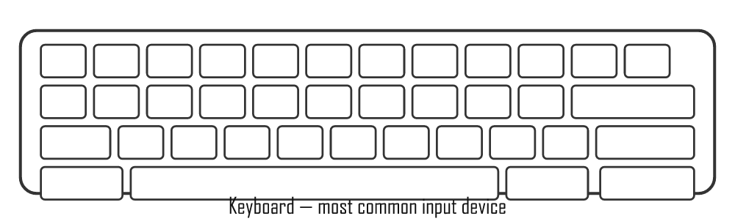
- Used to type letters, numbers, symbols, and commands
- Types: mechanical (tactile click), membrane (quiet, cheap), wireless, ergonomic
- Special keys: F1–F12 (function keys), Ctrl, Alt, Shift (modifier keys), shortcuts like Ctrl+C (copy)
- You use this when: typing a document, entering a password, coding in Delphi

Mouse
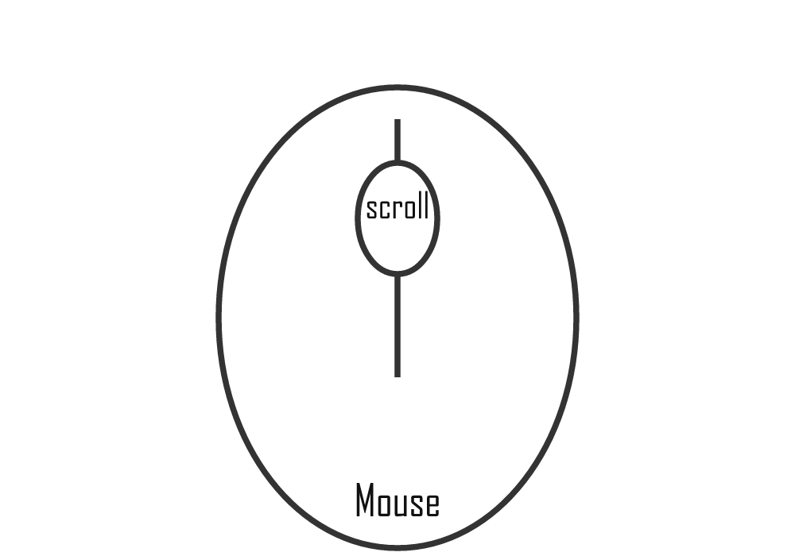
- Pointing device for graphical interfaces (GUI)
- Types: optical (uses LED light), laser (more precise), trackball, wireless
- Actions: left-click (select), double-click (open), right-click (context menu), drag-and-drop, scroll wheel
- You use this when: navigating a desktop, clicking buttons, drawing in a graphics program

Other Input Devices
Device | How it works | Common use
Touchscreen | Detects finger or stylus pressure on screen | Smartphones, tablets, POS tills at Pick n Pay
Scanner (flatbed) | Passes light over document, captures image | Scanning ID documents, photos
Barcode scanner | Reads black/white stripes with laser | Supermarket checkouts, library books
Webcam / camera | Captures video/still images | Google Meet, Teams calls, security cameras
Microphone | Converts sound waves into digital data | Voice commands, online calls, recordings
Stylus/graphics tablet | Pressure-sensitive pen on surface | Digital art, architect sketches

Output Devices

Monitors
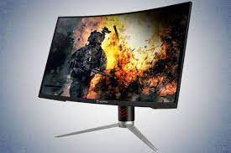
LCD/LED Monitor
Specification | Meaning | Example
Resolution | Number of pixels (dots) on screen. More = sharper image | 1920×1080 (Full HD), 3840×2160 (4K)
Refresh rate (Hz) | How many times the screen redraws per second | 60 Hz standard; 144 Hz for gaming
Screen size (inches) | Measured diagonally corner to corner | 24" desktop, 15.6" laptop
LCD | Liquid Crystal Display — uses fluorescent backlight | Older monitors and TVs
LED | Improved LCD with LED backlight — brighter, thinner, more energy efficient | Most modern monitors
OLED | Each pixel emits its own light — perfect blacks, best contrast | Premium phones, TVs

Printers
Type | How it works | Use case | Cost per page
Inkjet | Sprays microscopic ink droplets onto paper | Home or office colour printing, photos | Medium
Laser | Electrostatic drum attracts toner powder, fuses it with heat | Fast high-volume office printing | Low (bulk)
Ink-tank | Bulk refillable ink reservoir — no cartridges | Schools, high-volume printing (e.g. Epson EcoTank) | Very low
3D Printer | Layers material (plastic, resin) from a digital design | Prototypes, models, custom parts | Varies
DPI (dots per inch) = print quality (higher = sharper).
PPM (pages per minute) = print speed.

Storage Devices
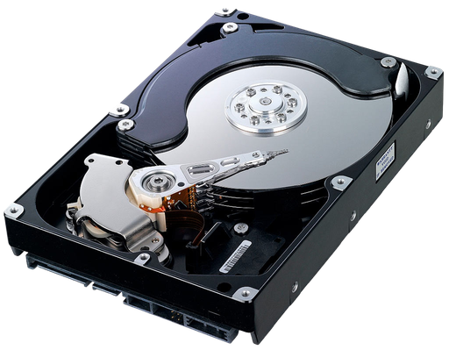  HDD  Hard Disk Drive — magnetic spinning platters, large capacity | 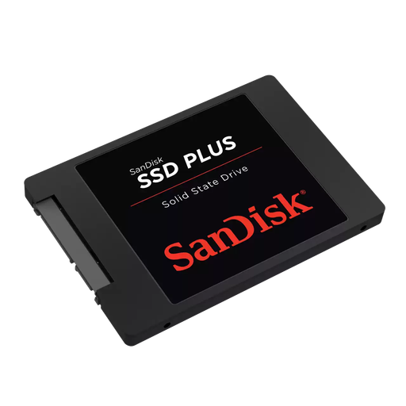  SSD  Solid State Drive — fast, silent, no moving parts | 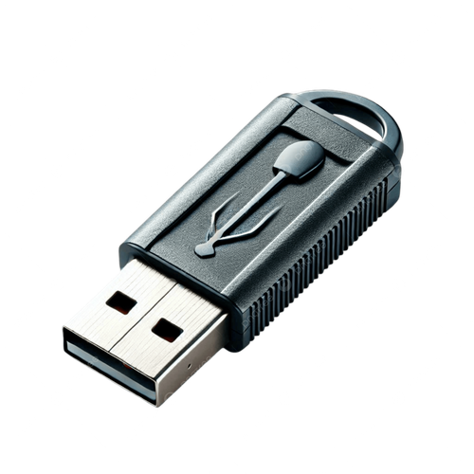  USB Flash Drive  Portable flash memory in a pocket-sized stick | 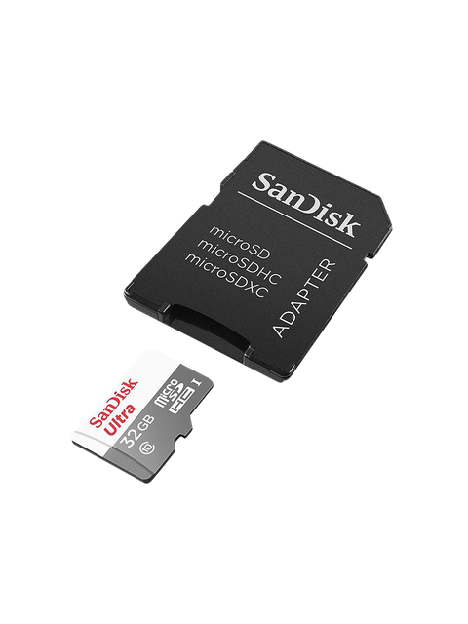  SD Card  Small flash memory card used in cameras and phones

Optical Disc — CD/DVD
Laser-read disc; mostly obsolete but still examined
Device | Technology | Speed | Notes
HDD | Magnetic spinning platters — a read/write head moves over them like a vinyl record | Slow (~120 MB/s) | Cheap per GB, large capacities (1–20 TB), fragile (moving parts)
SSD | Flash memory chips — no moving parts, like a giant USB drive | Very fast (~500 MB/s+) | Durable, silent, faster boot times, more expensive per GB
NVMe SSD | SSD connected directly to CPU via PCIe slot | Extremely fast (~3500 MB/s) | Found in high-end laptops and desktops
USB flash drive | Flash memory in a portable stick | Moderate | Easy to carry, easy to lose; 8 GB–512 GB common
Memory card | Flash (SD, microSD) | Moderate–fast | Used in cameras, phones, drones
Optical disc | Laser reads/writes pits and lands on a spinning disc | Slow | CD (700 MB), DVD (4.7 GB), Blu-ray (25 GB) — mostly obsolete

HDD vs SSD — Detailed Comparison
Feature | HDD | SSD
Speed | Slow (~80–160 MB/s read) | Fast (~400–3500 MB/s read)
Durability | Fragile — moving parts can break if dropped | Durable — no moving parts
Cost | Cheap (R500 for 1 TB) | More expensive (R800–R1200 for 1 TB)
Noise | Audible clicking/spinning sound | Completely silent
Power use | Uses more power — reduces laptop battery life | Uses less power — better for laptops
Boot time | ~45–60 seconds | ~8–15 seconds
Best use case | Bulk storage, backups, external drives | Operating system drive, main laptop drive

Types of Computers
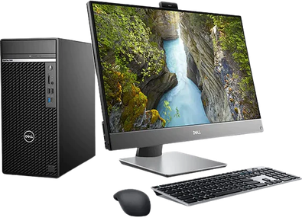  Desktop  Powerful, upgradeable, sits on a desk; separate tower and monitor | 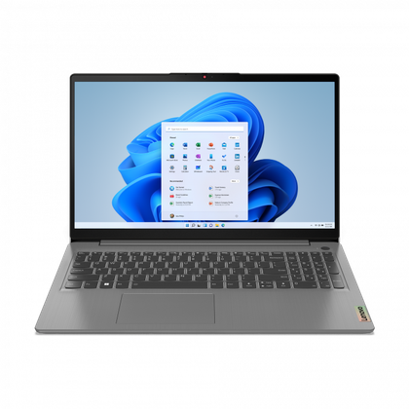  Laptop  Portable all-in-one computer with built-in screen and battery | 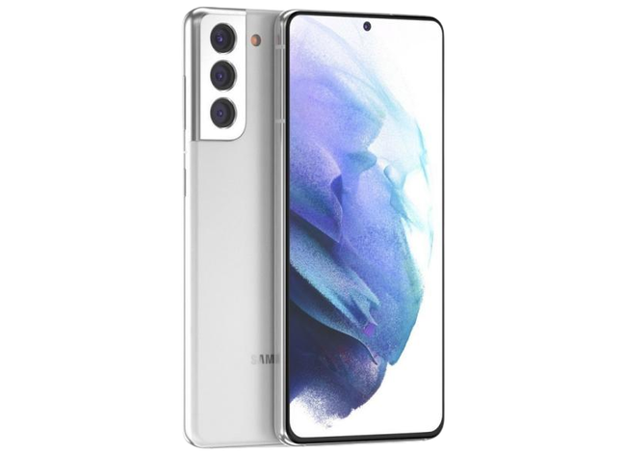  Smartphone  Pocket-sized computer with touchscreen, camera, and mobile apps | 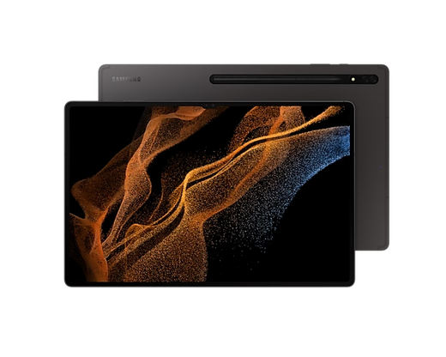  Tablet  Larger touchscreen device between a phone and laptop
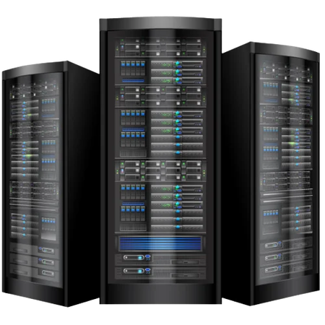
Server
High-performance computer that provides services to other computers on a network

Memory vs Storage
DESK ANALOGY
RAM = your desk workspace — only holds what you're actively working on right now. It's fast to access but clears when you switch off.
Storage (HDD/SSD) = the filing cabinet — stores everything long-term, even when the power is off. Slower to access than RAM.

Memory Hierarchy — Speed vs Capacity
The higher up the pyramid, the faster and more expensive the memory — but there's less of it.
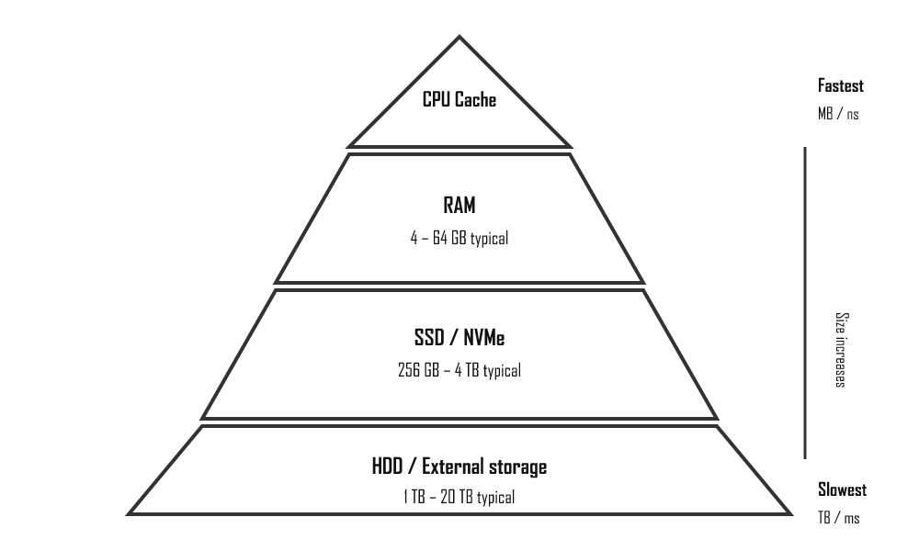
 | CPU Cache | RAM | SSD | HDD
Purpose | Holds the CPU's most-used data | Active programs and open files | Installed programs, OS | Bulk file storage
Volatile? | Yes — clears on power off | Yes — clears on power off | No — data stays | No — data stays
Speed | Extremely fast (nanoseconds) | Very fast | Fast | Slow
Typical size | 4–32 MB | 4–64 GB | 256 GB – 4 TB | 500 GB – 20 TB

Processing — CPU & GPU
- CPU (Central Processing Unit) — the "brain" of the computer. Fetches instructions from memory, decodes them, and executes them. Measured by: clock speed (GHz — higher = faster), number of cores (more cores = more tasks at once), and cache size. Example: Intel Core i5, AMD Ryzen 5.
- GPU (Graphics Processing Unit) — specialist processor for parallel tasks like rendering graphics, gaming, and AI. Can be integrated (built into the CPU — uses less power) or dedicated (separate card with its own memory, like NVIDIA GeForce). Example: your phone camera uses a GPU to apply filters in real-time.

Storage Units
Unit | Abbreviation | Size | Real-world example
Bit | b | Smallest unit — 0 or 1 | A single on/off switch
Byte | B | 8 bits | One character, e.g. the letter "A"
Kilobyte | KB | 1 024 bytes | ~One page of plain text
Megabyte | MB | 1 024 KB | A small photo, a 3-minute MP3 song
Gigabyte | GB | 1 024 MB | A 2-hour movie, a smartphone game
Terabyte | TB | 1 024 GB | A large hard drive, server storage
Petabyte | PB | 1 024 TB | Entire data centres, cloud storage

Software & Licensing
Software is the set of instructions that tells hardware what to do. Without software, a computer is just an expensive paperweight. Understanding the different types and how they are licensed is essential IT knowledge.

What is Software?
Software is a collection of programs and data that tells a computer how to perform tasks. You can't touch software — it only exists digitally. Hardware is the body; software is the brain telling the body what to do.
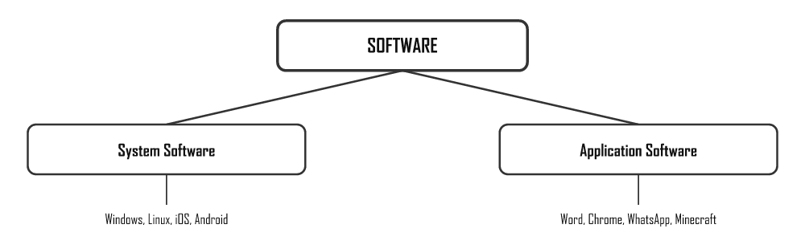

System Software
System software manages and controls the hardware. The most important type is the Operating System (OS).

Operating System (OS)
The OS is the boss of the computer. When you turn on a computer, the OS loads first. Everything else runs through it.
REAL-WORLD ANALOGY
Think of the OS as the manager of a restaurant. The manager organises the kitchen (hardware), assigns tasks to staff (processes), keeps everything running smoothly, and makes sure customers (users) get what they need.

What the OS does:
- User interface — provides the desktop, windows and menus you interact with
- Hardware management — controls how programs access the CPU, RAM and storage
- File management — organises files and folders on storage devices
- Process management — runs multiple programs at once (multitasking)
- Security — manages user accounts and access permissions
OS Type | Description | Examples
Stand-alone (desktop) | Installed on a single personal computer. Used for everyday tasks. | Windows 10/11, macOS, Ubuntu
Network (server) | Manages a network of computers. Controls who accesses what. | Windows Server, Red Hat Linux
Embedded | Built into a device to control one specific task. Very small. | Smart TV OS, ATM software, fridge firmware
Mobile | Designed for touchscreen devices. Efficient with battery. | Android, iOS

Utility Programs
Utility programs are small tools that help maintain the computer. They come with the OS or can be downloaded.
- Antivirus software (e.g. Avast, Windows Defender)
- Disk cleanup and defragmentation tools
- File compression tools (e.g. WinZip, 7-Zip)
- Backup software

Device Drivers
A device driver is a small program that allows the OS to communicate with a hardware device. Without the correct driver, hardware won't work properly.
Example: When you plug in a new printer, Windows downloads or installs the printer driver so it knows how to send data to that specific printer model.

Application Software
Application software lets you perform specific tasks — it uses the OS as its foundation.
Category | Purpose | Examples
Productivity | Create documents, spreadsheets, presentations | Microsoft Office, LibreOffice, Google Docs
Communication | Send messages, emails, make calls | WhatsApp, Outlook, Zoom, Teams
Education | e-learning, tutorials, reference | Khan Academy, Siyavula, Duolingo
Entertainment | Play games, watch media, listen to music | Netflix, Spotify, Steam
Creativity | Edit photos, videos, audio | Photoshop, Audacity, Canva
Web browsers | Access websites and web applications | Chrome, Firefox, Edge

Software Licensing
When you "buy" software, you're not actually buying the software — you're buying a licence to use it. The developer keeps ownership. Software licences define what you are and aren't allowed to do with the software.
Type | Cost | Can modify code? | Can share? | Examples
Proprietary | Paid | No | No (only on licensed devices) | Microsoft Office, Adobe Photoshop, Windows
Freeware | Free | No (source code hidden) | Yes (as-is) | Skype, Google Chrome, Adobe Acrobat Reader
Shareware | Free for trial period, then pay | No | Limited (trial version) | WinZip, many antivirus programs
Free Open-Source (FOSS) | Free | Yes — source code public | Yes (under same licence) | Linux, LibreOffice, Firefox, GIMP

EULA — End User Licence Agreement
The EULA is the legal agreement between you and the software developer. It's that long wall of text you click "I Agree" on when installing software.
It specifies: how many devices you can install on, what you're not allowed to do, and who owns the software.
Licence Type | Who it covers
Single-user licence | One user on one device only
Multi-user licence | A specific number of users or devices (e.g. 10 PCs)
Site licence | Unlimited use within one organisation (e.g. a school)

Software Piracy & Copyright
Copyright is the legal right that protects a creator's work. Software is automatically protected by copyright the moment it is created. You cannot copy, share or distribute software without the copyright holder's permission.
Piracy is the illegal copying or distribution of copyrighted software. It is a crime in South Africa and most countries.

Forms of software piracy:
- Softlifting: installing one licensed copy on multiple computers
- Counterfeiting: making and selling fake copies of licensed software
- Online piracy: downloading software illegally from the internet (torrents, crack sites)
- Hard disk loading: selling computers with pirated software pre-installed

Copyleft & Creative Commons
These are alternative licensing systems that allow sharing and collaboration while still giving creators some protection.
- Attribution (BY): You can use the work if you credit the creator
- Non-Commercial (NC): You can use it, but not for profit
- Share-Alike (SA / Copyleft): Any work you create from it must use the same licence
- No Derivatives (ND): You cannot modify the original work

Data Representation
Computers only understand two states: on (1) and off (0). Everything — text, images, sound, video — must first be converted to those 1s and 0s before a computer can process it. This page explains how that conversion works.

Why Only 1s and 0s?
Deep inside your computer, everything is built from tiny transistors — microscopic electronic switches. Each switch can only be in one of two states: on (1) or off (0). This is called binary because there are only two options.
A single 1 or 0 is called a bit (short for binary digit). On its own, one bit can only represent two things. But group 8 bits together into a byte, and suddenly you can represent 256 different values (28 = 256) — enough for every letter, digit, and common symbol.
ANALOGY
Think of a light switch: it is either ON or OFF — that's 1 bit. Now imagine a row of 8 light switches. Each combination of on/off gives a different pattern — 256 possible combinations. That's how a computer stores one character.

Bits and Bytes — Visual Diagram
Eight bits grouped together form one byte. The example below shows the byte 01000001 — the binary code for the letter A in ASCII.
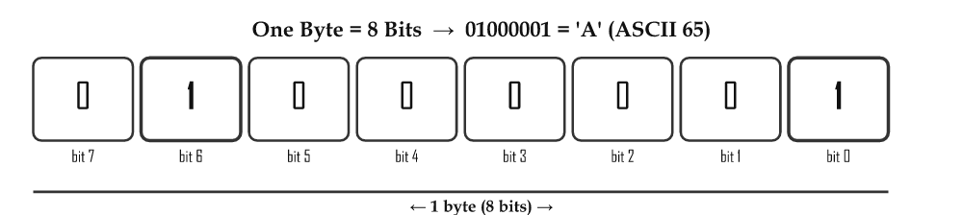

Number Systems Overview
System | Base | Digits used | Used for
Decimal | 10 | 0–9 | Everyday counting — the system humans naturally use
Binary | 2 | 0, 1 | Internal computer data — all data is stored this way
Hexadecimal | 16 | 0–9, A–F | Colour codes (#FF5733), memory addresses, shorter binary notation

Binary (Base 2)
In decimal, each column is worth 10× the column to its right (1, 10, 100, 1000…). In binary, each column is worth 2× the column to its right — these are the powers of 2.
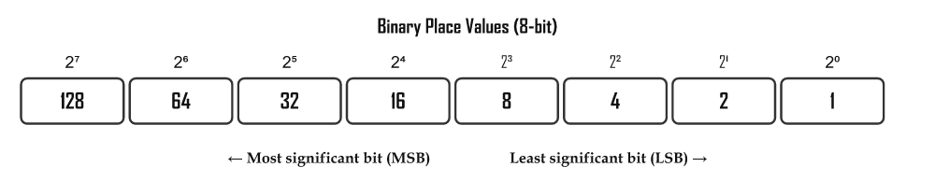
TIP — LEARN THESE!
Memorise the 8 place values: 128, 64, 32, 16, 8, 4, 2, 1. Every binary conversion uses these numbers. Notice each one doubles: 1×2=2, 2×2=4, 4×2=8, 8×2=16, and so on.

Step-by-Step Conversion Examples

Binary → Decimal
Multiply each bit by its place value, then add them all up. Only count the columns where the bit is 1.
Example: 00101101 in binary → decimal
Place value: 128 64 32 16 8 4 2 1
Bit: 0 0 1 0 1 1 0 1
Calculation: 0 + 0 + 32 + 0 + 8 + 4 + 0 + 1
= 45
Example: 10110 in binary → decimal
Place value: 16 8 4 2 1
Bit: 1 0 1 1 0
Calculation: 16 + 0 + 4 + 2 + 0
= 22

Decimal → Binary (Divide by 2 Method)
Divide the number by 2 repeatedly. Write down each remainder. Read the remainders from bottom to top.
Example: 25 in decimal → binary
25 ÷ 2 = 12 remainder 1 ← LSB (written last, read first from bottom)
12 ÷ 2 = 6 remainder 0
6 ÷ 2 = 3 remainder 0
3 ÷ 2 = 1 remainder 1
1 ÷ 2 = 0 remainder 1 ← MSB (written first, read last from bottom)

Read remainders bottom to top: 1 1 0 0 1
= 11001₂

Verify: 16 + 8 + 0 + 0 + 1 = 25 ✓
Example: 13 in decimal → binary
13 ÷ 2 = 6 remainder 1
6 ÷ 2 = 3 remainder 0
3 ÷ 2 = 1 remainder 1
1 ÷ 2 = 0 remainder 1

Read bottom to top: 1 1 0 1 = 1101₂

Verify: 8 + 4 + 0 + 1 = 13 ✓

Hexadecimal (Base 16)
Hexadecimal (hex) uses 16 symbols: the digits 0–9, then the letters A–F for values 10–15. Because one hex digit represents exactly 4 binary bits, hex is a much shorter way to write binary numbers. For example, 11111111 in binary is just FF in hex.

Hex Digit Table
Decimal | Binary (4-bit) | Hex
0 | 0000 | 0
1 | 0001 | 1
2 | 0010 | 2
3 | 0011 | 3
4 | 0100 | 4
5 | 0101 | 5
6 | 0110 | 6
7 | 0111 | 7
8 | 1000 | 8
9 | 1001 | 9
10 | 1010 | A
11 | 1011 | B
12 | 1100 | C
13 | 1101 | D
14 | 1110 | E
15 | 1111 | F

Hex → Decimal Conversion
Each position in hex is worth 16× the position to its right (just like binary uses powers of 2, hex uses powers of 16).
Example: 2A (hex) → decimal
2A₁₆ has two digits: 2 and A

Position: 16¹ 16⁰
Digit: 2 A (=10)
Value: 2×16 + 10×1
= 32 + 10
= 42₁₀
Example: 3F (hex) → decimal
3F₁₆:
3 × 16¹ = 3 × 16 = 48
F × 16⁰ = 15 × 1 = 15
----
63₁₀

Decimal → Hex Conversion (Divide by 16)
Example: 200 (decimal) → hex
200 ÷ 16 = 12 remainder 8 → 8
12 ÷ 16 = 0 remainder 12 → C (12 in hex = C)

Read remainders bottom to top: C 8 → C8₁₆

Verify: 12 × 16 + 8 = 192 + 8 = 200 ✓
WHERE YOU SEE HEX
Hex is everywhere in computing. Colour codes in web design use hex: #FF0000 = red (255 red, 0 green, 0 blue). Memory addresses in low-level programming are hex. Even Delphi lets you write hex literals with a dollar sign: $FF = 255.

ASCII — Storing Text
A computer stores text by mapping each character to a number. The most common mapping is ASCII (American Standard Code for Information Interchange). Each character has a unique number — a code — which is then stored in binary.

Key ASCII Values to Memorise
Character | ASCII decimal | Binary (8-bit) | Notes
Space | 32 | 00100000 | The space bar produces this
0 | 48 | 00110000 | The digit zero (not the letter O)
9 | 57 | 00111001 | Digits 0–9 = ASCII 48–57
A | 65 | 01000001 | First uppercase letter
B | 66 | 01000010
Z | 90 | 01011010 | Last uppercase letter
a | 97 | 01100001 | First lowercase — exactly 32 more than 'A'
z | 122 | 01111010 | Last lowercase letter
EXAM TIP — THE +32 RULE
The difference between an uppercase letter and its lowercase version is always 32 in ASCII. So Ord('A') = 65 and Ord('a') = 97 (65 + 32 = 97). This is how Delphi's UpCase() function works internally — it subtracts 32.

Unicode and UTF-8
Standard | Description | Example
ASCII | 7-bit (128 chars) or 8-bit (256). English letters, digits, symbols only. | 'A' = 65
UTF-8 | Variable length (1–4 bytes). Backward compatible with ASCII. Most common on the web. | Supports Zulu, Xhosa, Arabic, Chinese…
Unicode | Universal standard — 140 000+ characters including all world languages. | isiZulu characters, emoji

Data Representation in Delphi
Delphi — Ord and Chr with ASCII
// Ord: char → ASCII number
iCode := Ord('A'); // = 65
iCode := Ord('a'); // = 97

// Chr: ASCII number → char
cChar := Chr(65); // = 'A'
cChar := Chr(97); // = 'a'

// Convert lowercase to uppercase using the +32 rule:
cUpper := Chr(Ord(cLower) - 32);

// Print ASCII values of each character in a string
for i := 1 to Length(sText) do
memOut.Lines.Add(sText[i] + ' = ' + IntToStr(Ord(sText[i])));

Storage Units
Unit | Symbol | Size | Real-world example
Bit | b | Single 0 or 1 | One transistor state
Byte | B | 8 bits | One character, e.g. 'A'
Kilobyte | KB | 1 024 bytes | One page of plain text (~1 000 characters)
Megabyte | MB | 1 024 KB | A small JPEG photo, a 3-min MP3 song
Gigabyte | GB | 1 024 MB | A 2-hour HD movie, a mobile game
Terabyte | TB | 1 024 GB | A standard laptop hard drive
Petabyte | PB | 1 024 TB | Large data centres, cloud storage
TIP — WHY 1 024 NOT 1 000?
Computers work in binary (powers of 2). 210 = 1 024, which is close to 1 000 but not equal. So 1 KB = 1 024 bytes (not 1 000). Hard drive manufacturers sometimes use 1 000 to make drives sound bigger — that's why a "500 GB" drive shows as ~465 GB in Windows.

Networks
A computer network connects two or more devices so they can communicate and share resources. Networks are what make the internet, school computer labs, and your home Wi-Fi possible.

Why Would You Connect Computers Together?
Imagine your school has 30 computers but only 2 printers. Without a network, only the computers physically connected to a printer could print. With a network, every computer can send print jobs to either printer — that's sharing resources.
Networks make all of the following possible:
- Resource sharing — share printers, scanners, internet connections, and storage across multiple computers
- File sharing — send a document from one computer to another without a USB drive
- Communication — email, instant messaging, video calls (e.g. your school uses Microsoft Teams or Google Meet)
- Centralised data and backups — store all student data on one server so it's accessible from any computer in the lab
- Internet access — one router can give all devices in a building internet access
- Remote work — teachers can access school systems from home via a VPN (Virtual Private Network)
SA EXAMPLE
Your school's computer lab is a LAN (Local Area Network). Every computer connects through a switch to a router, which connects to your ISP (Internet Service Provider) — maybe Telkom, MWEB, or Vodacom. That router gives every computer in the lab access to the internet.

Network Size Classifications
Type | Full name | Coverage area | Typical speed | SA Examples
PAN | Personal Area Network | ~1–3 metres (arm's reach) | Low–medium | Bluetooth headphones, Apple Watch connected to phone, wireless keyboard
HAN | Home Area Network | Within one household | Medium–fast | Home Wi-Fi router (Telkom/Vodacom fibre), smart TV, gaming console, laptop all connected
LAN | Local Area Network | One building or campus | Fast (100 Mbps–10 Gbps) | School computer lab, office building network, university campus network
WAN | Wide Area Network | Cities, countries, continents | Varies widely | The Internet; MTN/Vodacom cellular network connecting towns across SA

Network Topologies — Star Topology
A topology describes the physical layout of how devices are connected in a network. The most common topology used in school labs and offices is the Star Topology: every device connects directly to a central switch or hub.
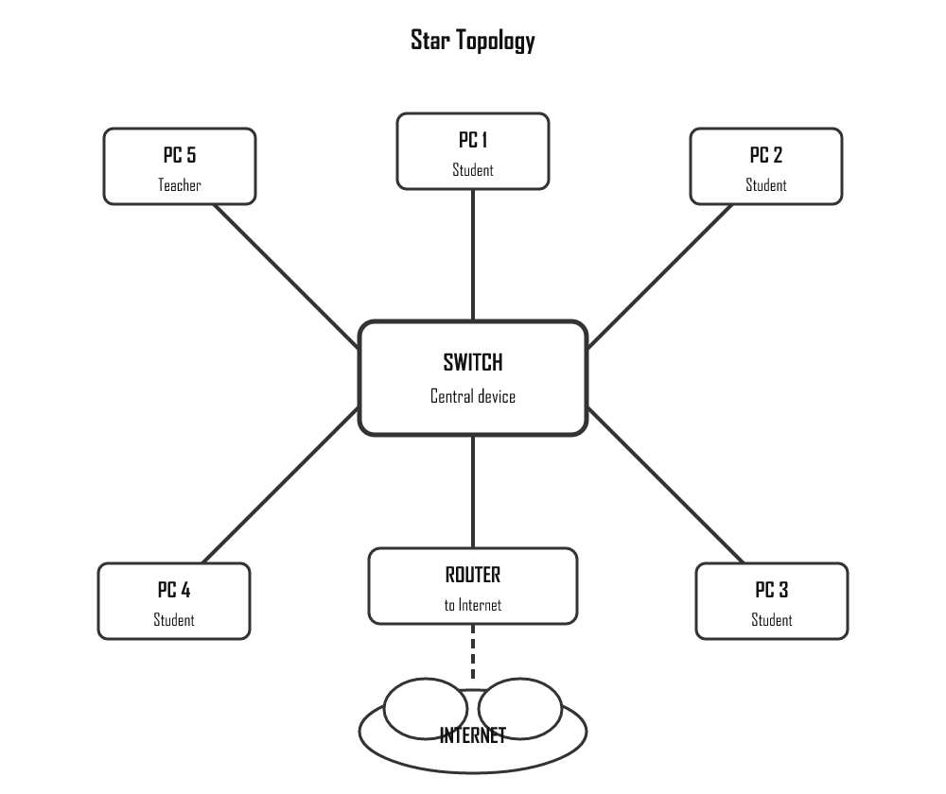

Star Topology — Advantages and Disadvantages
Advantages | Disadvantages
Easy to add new devices — just connect to the switch | If the central switch fails, the whole network goes down
One faulty cable only affects that one device | Requires more cable than some other topologies
Easy to diagnose faults — test one connection at a time | Cost of the switch adds to setup expense
Most widely used in schools and offices | Performance depends on the quality of the switch

Essential Network Components
Data from your computer travels through several devices before it reaches the internet. Here is how they connect:
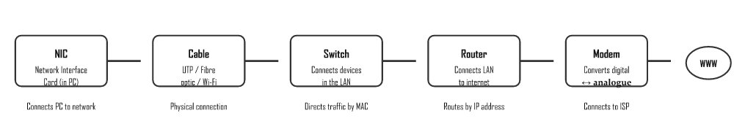

Network Hardware Reference
Component | Purpose | SA Example
NIC (Network Interface Card) | Connects a device to a network. Every computer has one, either built-in or as an add-on card. Assigns the device a unique MAC address. | Your laptop's built-in Ethernet port or Wi-Fi card
Switch | Connects multiple devices within a LAN. Smarter than a hub — sends data only to the specific device it's addressed to (using MAC addresses). | The network switch in your school's server room connecting all computers in the lab
Router | Connects two or more networks together. Routes data between your LAN and the internet using IP addresses. Usually also acts as a firewall. | The Telkom/Vodacom router in your home or school that gives Wi-Fi access
Modem | Converts digital computer data into a signal suitable for your internet line (ADSL, fibre, LTE), and vice versa. "Modulator-Demodulator". | Telkom ADSL modem, or LTE modem (like a Huawei Wifi router)
Access Point (Wi-Fi) | Extends wireless network coverage. Connects wirelessly to clients and wired to the switch/router. | Extra Wi-Fi routers placed in different classrooms of a large school

Network Types — Client-Server vs Peer-to-Peer

Client-Server Network
A central server provides services (files, printers, internet access, authentication) to multiple client computers. The server is a dedicated, powerful computer that is always on.

Peer-to-Peer (P2P) Network
All computers have equal status — any device can be both client and server. No single central machine is in charge. Common in small home networks.
Feature | Client-Server | Peer-to-Peer (P2P)
Cost | Expensive — dedicated server hardware needed | Cheap — any computer can participate
Security | Strong — administrator controls all access | Weak — each device manages its own security
Management | Centralised — easy to manage by one admin | Decentralised — hard to manage as network grows
Performance | Consistent — server is optimised for the job | Variable — depends on each computer's specs
Backups | Easy — all data is on the server | Difficult — data is spread across all machines
Failure point | If server fails, whole network is affected | One computer failing rarely affects others
Best for | Schools, businesses, organisations (10+ users) | Small home networks (2–5 devices)
SA Example | School lab with a Windows Server; bank branch | Two friends sharing files between laptops at home

Communication Media
The medium is the physical pathway over which data travels. Choosing the right medium depends on the required speed, distance, security, and budget.
Medium | How it works | Speed | Range | Security | Cost | SA Example
UTP Cable  (Ethernet, Cat5e/Cat6) | Electrical signals through 4 twisted copper pairs. RJ45 connectors. | 100 Mbps – 10 Gbps | Up to 100 m per segment | Good — hard to intercept without physical access | Low — cheapest option | School computer lab wiring; office desk connections
Fibre Optic | Light pulses through thin glass/plastic strands. Not affected by electrical interference. | 1 Gbps – 100+ Gbps | Kilometres (single-mode) | Very high — almost impossible to tap | Higher — more expensive to install | Openserve/Vumatel fibre to your home; undersea cables connecting SA to Europe
Wi-Fi  (802.11 radio waves) | Radio signals transmitted through air. No cable needed. | 54 Mbps – 9.6 Gbps (Wi-Fi 6) | 10–100 m indoors | Needs encryption (WPA3) — radio signals can be intercepted | Low — just a router; no cabling needed | Home routers; school library hotspots; coffee shops
LTE / 5G  (mobile broadband) | Radio signals through cell towers. Cellular network. | 10–100+ Mbps (LTE); up to 1 Gbps (5G) | Kilometres per tower | Moderate — carrier-managed encryption | Variable — data bundle costs | MTN, Vodacom, Cell C towers connecting rural SA; mobile data on phones
Infrared | Infrared light — requires line of sight, no obstacles. | Very slow | Very short (<1 m) | Line of sight only | Very low | TV remotes, old phone data transfers (largely obsolete)
SA CONTEXT
Many South African schools and homes are getting fibre connections through providers like Openserve (Telkom), Vumatel, and Frogfoot. Before fibre, most homes used ADSL over copper phone lines. In rural areas where fibre hasn't reached, LTE (4G) from MTN, Vodacom, or Rain is the main option for internet access.

Internet & WWW
The Internet and the World Wide Web are related but different. Learn how they work and how to use search engines effectively.

Internet vs World Wide Web
 | Internet | World Wide Web (WWW)
Definition | The global network of connected computers | A collection of websites accessible via the Internet
Technology | Physical infrastructure (cables, routers, servers) | HTML pages, URLs, HTTP protocol
Analogy | The road network | The shops and buildings on those roads

Key Concepts
Term | Meaning
IP Address | Unique address identifying a device on the Internet (e.g. 192.168.1.1)
Domain | Readable name linked to an IP address (e.g. google.com)
URL | Full web address of a specific page (e.g. https://www.school.co.za/it)
HTML | HyperText Markup Language — coding language used to build web pages
HTTP | Protocol for transferring web pages (unencrypted)
HTTPS | Secure HTTP with encryption — look for the padlock icon
ISP | Internet Service Provider — company that gives you internet access

Web Browsers
A web browser interprets HTML and displays web pages. Examples: Chrome, Firefox, Edge, Safari.

Search Engine Techniques
Technique | How to use | Example
Exact phrase | Use quotation marks | "fastest animal"
Exclude words | Minus sign before word | fastest animal -cheetah
Specific site | site: prefix | IT help site:wikipedia.org
Search social media | @ prefix | IT news @twitter
Filter by date | Tools → Any time | Past 24 hours

Common Internet Threats
Threat | Description | Protection
Phishing | Fake official emails stealing login details | Never click suspicious links; verify email address
Pharming | Fake websites stealing sensitive info | Check URL carefully before entering passwords
Spam | Unsolicited bulk emails | Use spam filter; don't open unknown attachments
Ransomware | Malware that encrypts your data and demands payment | Regular backups; don't open unknown attachments
Hoax | False information spread as if true | Verify with reputable sources before sharing

Internet Services
The internet provides far more than just web browsing. This page covers plug-in applications, common internet services, and the technologies that power them.

Plug-in Applications
A plug-in is additional software installed into an existing application (e.g. a browser) to extend its functionality.
Plug-in | Purpose
PDF converter/reader | Allows browsers to open and display PDF files
Flash Player | Allows browsers to display interactive animations and videos (mostly obsolete now)
Java | Allows Java programs to run within a web browser
QuickTime / RealPlayer | Stream and play audio/video directly from the browser
Silverlight | Enhanced interactivity for web pages (replaced by HTML5)
Ad blockers | Block advertising content from loading

Internet Services Technologies
Internet services technologies cover web development, web design, networking and e-commerce. They are used together to create functional, interactive websites.
Technology | Purpose
HTML | Structures and displays web page content
CSS | Controls the visual styling of web pages (colours, fonts, layout)
JavaScript | Adds interactivity to web pages (animations, form validation)
PHP / ASP.NET | Server-side scripting — processes forms and connects to databases
SQL | Queries and manages database data for websites
FTP | Transfers files between computers over a network

Common Internet Services
Service | Description
World Wide Web | Collection of web pages accessed via browser using HTTP/HTTPS
Email | Electronic mail — send and receive messages
FTP | File Transfer Protocol — upload and download large files
VoIP | Voice over IP — phone/video calls over the internet
Streaming | Audio and video delivered in real time without downloading first
Cloud storage | Store and access files on remote servers (Google Drive, OneDrive)
Online banking | Manage bank accounts and transfer money via the internet
E-commerce | Buy and sell goods and services online

W3C — World Wide Web Consortium
The W3C sets the standards that all web browsers and websites should follow to ensure web pages display correctly across all devices and browsers. Web designers follow these standards.

E-Communication
Electronic communication covers all methods of exchanging information digitally — from email and instant messaging to video calls and social media.

Forms of Electronic Communication
Form | Description | Examples
Email | Send/receive digital messages with attachments | Gmail, Outlook, Yahoo Mail
Instant Messaging | Real-time text communication | WhatsApp, Telegram, MS Teams
Video Conferencing | Live video and audio calls | Zoom, Google Meet, Skype
VoIP | Voice calls over the Internet | WhatsApp calls, Skype
Social Media | Platforms for sharing and interaction | Facebook, Instagram, X (Twitter)
Blogs | Online journal/informational website | WordPress, Blogger
Webinar | Online seminar or presentation | Zoom webinars, MS Teams
FTP | Transfer large files between computers | FileZilla, WinSCP

Email

Email Address Format
username@domain.co.za — e.g. student@school.co.za

Netiquette (Network Etiquette)
- Use a clear, descriptive subject line
- Begin with a greeting; end with a signature
- Keep messages short and professional
- AVOID ALL CAPS — it looks like shouting
- Proofread for spelling and grammar before sending
- Compress large attachments before sending
- Do not forward spam or chain emails
- Never send sensitive info (passwords, banking details) via email

E-Communication Factors
Factor | Effect
Speed | Almost instant delivery worldwide
Cost | Most digital communication is free (data costs may apply)
Distance | No physical distance limitations
Accuracy | Written messages reduce misunderstandings vs. verbal
Time | Asynchronous — recipient reads when convenient

Ergonomics and Health
- Sit upright; monitor at eye level
- Keyboard and mouse at comfortable arm height
- Take breaks every 30–60 minutes
- Use the 20-20-20 rule: every 20 min, look 20m away for 20 seconds

Social Issues
- Cyberbullying — harassment via digital channels
- Fake news — always verify with reputable sources
- Privacy — be careful what you share online; it leaves a digital footprint
- Green computing — turn off devices, reduce printing, recycle e-waste

Computer Management & Security
Keeping a computer running well and securely requires regular maintenance tasks and an understanding of common threats.

General Housekeeping Tasks
Task | Purpose
Disk Clean-up | Removes temporary files to free up storage space
Defragmentation | Reorganises fragmented files on HDD for faster access (not needed for SSD)
Task Scheduler | Automates tasks like backups and updates at set times
File compression | Reduces file size using mathematical algorithms (.zip)
Archiving | Moves inactive data to separate storage (long-term, not duplicated)
Backup | Creates copies of data on a different device for disaster recovery

Types of Backup
Type | Description
Full backup | Complete copy of all files. Slowest but easiest to restore.
Incremental backup | Only backs up files changed since last backup (any type). Fast, but restoring needs all increments.
Differential backup | Backs up files changed since last full backup. Compromise between full and incremental.

Backup Locations
- Local — external hard drive kept at same location
- Off-site — physical device kept at a different location
- Cloud/online — e.g. Google Drive, OneDrive — automatic, accessible anywhere

Common Malware Threats
Threat | Description
Virus | Replicates and spreads; performs harmful actions
Worm | Spreads across networks without user action
Trojan | Disguised as useful software; gives attackers back-door access
Ransomware | Encrypts your data; demands payment for the key
Spyware | Secretly tracks your activity
Adware | Displays unwanted advertisements (pop-ups)

Security Measures
Measure | Purpose
Antivirus | Detects, prevents and removes malware
Firewall | Monitors network traffic; blocks unauthorised connections
Strong password | 8+ chars, uppercase, lowercase, numbers, special characters
Access rights | Users only access files they are authorised for
UPS | Uninterruptible Power Supply — keeps computer running during power failure
Encryption | Scrambles data so only authorised parties can read it

Organising Files & Folders
A file is a collection of data stored as a single unit (a document, image, song, program). A folder (directory) is a container used to group related files. Organising files means storing them in a logical, meaningful way so they are easy to find later.

Anatomy of a File Path
A path describes exactly where a file lives on a storage device — the drive, the folders, the file name and its extension.
Part | Example | Meaning
Drive | C: | The storage device the file is on
Path (folders) | \Users\Mari\Documents\IT\ | The chain of folders leading to the file
File name | report | The name you gave the file
Extension | .docx | Tells the computer what type of file it is
Put together: C:\Users\Mari\Documents\IT\report.docx

Common File Extensions
The extension (the letters after the dot) tells the operating system which program should open the file.
Extension | File Type | Example
.txt | Plain text file | notes.txt
.docx | Microsoft Word document | report.docx
.xlsx | Microsoft Excel spreadsheet | budget.xlsx
.pdf | Portable Document Format | manual.pdf
.jpg / .png | Image files | photo.jpg
.mp3 / .mp4 | Audio / Video | song.mp3
.exe | Executable program | setup.exe
.accdb | Microsoft Access database | students.accdb

Why Use a Good File Structure?
- Makes files easier and faster to find
- Reduces duplication — you don't save the same file in many places
- Improves organisation and reduces clutter
- Makes backing up specific folders simpler
A File Manager (e.g. Windows File Explorer) is the software used to view, move, copy, rename and delete files and folders.

Save As vs Export
 | Save As | Export
Purpose | Save the file under a new name, location, or a different version/format of the same kind | Create a new output file in a different format for use elsewhere
Example | Save a .docx as an older Word version | Export a Word document to .pdf
Original | Replaced or copied | Stays open and unchanged

File Naming Best Practices
- Use meaningful file names: 2025_Term1_IT_Project.docx ✓, untitled2.docx ✗
- Organise files into logical folder structures
- Avoid special characters in file names: \ / : * ? " < > |
- Use underscores or dashes instead of spaces
- Back up regularly — at least weekly

Grade 10 — Study by Term
Based on the 2026 IT CAPS Annual Teaching Plan. Practical (Paper 1) and Theory (Paper 2) topics per term.

T1 — Term 1 • January – March
Foundations: computing, data representation, algorithms & intro to Delphi
🔬 Practical (Paper 1)
- Algorithms & problem solving (IPO tables, flowcharts, pseudocode)
- Trace tables & comparing algorithms
- Introduction to Delphi IDE & components
- Input, output, variables, data types
- Operators (+, -, *, /, MOD) & precedence
- Functions: random, round, sqrt
- Basic IF & IF…ELSE
📘 Theory (Paper 2)
- What are digital technologies & IT?
- General model of a computer (IPOS)
- Types of computers
- Data vs information, ICT systems
- Number systems: binary, decimal, hex
- Number system conversions
- ASCII & Unicode
- Bits, bytes, KB, MB, GB, TB
- Primitive data types
- File management & file structures
- Social implications: licensing, piracy, copyright, digital divide, POPIA

T2 — Term 2 • April – June (incl. mid-year exam)
Decisions; hardware, software & networks
🔬 Practical (Paper 1)
- IF…THEN…ELSE (full), nested IF
- Boolean operators: AND, OR, NOT, IN
- CASE statement
- MessageDlg
- Basic string methods: Length, UpperCase, UpCase, Trim
- Events: FormCreate, Activate
- Input validation (e.g. check for negative before sqrt)
📘 Theory (Paper 2)
- Input devices: keyboard, mouse, scanner, microphone, biometric
- Output devices: monitors (LCD/LED), printers, speakers
- Storage devices: HDD, SSD, USB, SD cards
- System unit: motherboard, CPU, RAM (general)
- Ports: USB, HDMI, NIC
- Operating systems: types, purpose, examples
- Utility programs & device drivers
- Networks overview: reasons, components, types (PAN/HAN/LAN/WAN)
- Client-server vs peer-to-peer
- E-communication tools overview
- Email, netiquette, ergonomics, green computing

T3 — Term 3 • July – September (PAT begins)
Loops & full string methods; computer management & internet
🔬 Practical (Paper 1)
- FOR loop (to / downto)
- WHILE…DO loop
- REPEAT…UNTIL loop
- String handling from first principles (no built-in: count chars, find, remove, replace)
- Full string methods: Copy, Delete, Insert, Pos, Left, Right
- Ord & Chr functions
- Prime numbers, LCM, GCD algorithms
- Timer component (simple animations)
- PAT: panels and/or tabbed panes (PageControl)
📘 Theory (Paper 2)
- Computer management tasks
- File management, housekeeping, disk cleanup, backup
- Security: firewall, antivirus, spyware, adware
- Internet overview, IP addresses, ISPs
- WWW, URLs, web browsers, search engines
- Email & internet threats: phishing, spam, hoaxes, POPIA
- Safe email and internet use

T4 — Term 4 • October – November (PAT due + exams)
Internet services, PAT file I/O & revision
🔬 Practical (Paper 1)
- PAT only: file I/O using LoadFromFile / SaveToFile
- Revision of all T1–T3 practical work
📘 Theory (Paper 2)
- Internet services: online storage, synchronisation, collaboration
- Online shopping & social media
- Revision of all T1–T3 theory

Exam Extras
These topics are not explicitly required by CAPS but have appeared in NSC past papers (2015–2024). Knowing them can mean the difference between a pass and a distinction.
HOW TO USE THIS PAGE
Items marked P1 appear in Paper 1 (practical/Delphi), P2 in Paper 2 (theory), and Both in either paper. These are supplementary — master your CAPS content first.

Practical Extras — Paper 1 (Delphi)
These Delphi functions, components and techniques are not listed in CAPS but appear regularly in exam questions or are needed to solve exam problems efficiently.
[P1] StringReplace()
Replaces all or first occurrence of a substring within a string.
s := StringReplace(s, 'old', 'new', [rfReplaceAll]);
[P1] TStringList
A powerful list of strings — very useful for loading file lines into memory.
sl := TStringList.Create; sl.LoadFromFile('data.txt'); sl.Free;
[P1] Format() function
Formats numbers/strings with precise control — Format('%.2f', [rVal]) gives 2 decimal places. More powerful than FloatToStrF.
[P1] Random() & Randomize()
Generate random integers. Always call Randomize; first to seed the generator. Random(100) returns 0–99.
[P1] TOpenDialog / TSaveDialog
Let users browse for files at runtime.
if OpenDialog1.Execute then sFile := OpenDialog1.FileName;
[P1] DateToStr() & StrToDate()
Convert between TDate values and string representation. Used with TDateTimePicker.
sDate := DateToStr(dtpDate.Date);
[P1] Try…Except…End (Exception Handling)
Catch runtime errors gracefully — e.g. invalid StrToInt input.
try iNum := StrToInt(edtNum.Text); except ShowMessage('Invalid'); end;
[P1] Memo.Lines.Count
Returns the number of lines in a Memo. Often used in loops to process all memo lines.
for i := 0 to Memo1.Lines.Count - 1 do
[P1] SameText() / CompareText()
Case-insensitive string comparison — avoids problems when user types 'yes', 'YES' or 'Yes'.
if SameText(sInput, 'yes') then
[P1] IntToHex() & HexToInt()
Convert integers to hexadecimal strings and back. Sometimes tested in conjunction with number systems theory.
sHex := IntToHex(255, 4); // = '00FF'
[P1] Odd() & Even() functions
Built-in boolean checks — cleaner than MOD 2.
if Odd(iNum) then // true if iNum is odd
[P1] Break & Continue in loops
Break exits the loop immediately. Continue skips to the next iteration. Both appear in exam solutions — know the difference.

Theory Extras — Paper 2
These theory topics have appeared in NSC Theory papers but sit at the edge of or outside the formal CAPS scope. They typically appear in social implications or "current technology" questions.
[P2] Artificial Intelligence (AI) & Machine Learning
AI appears regularly in social implications questions — automation of jobs, AI decision-making, bias in AI, chatbots. Not deeply technical — understand the concept and its social effects.
[P2] Blockchain Technology
A distributed digital ledger of linked blocks. Used in cryptocurrency, supply chain, and secure records. Appeared in Gr12 theory papers. Know: what it is, how it works, and 2 uses.
[P2] Deep Fakes
AI-generated fake videos or audio that appear authentic. Social implications question topic — impacts on trust, truth, and politics. Know the definition and two risks.
[P2] Dark Web
A part of the internet not indexed by search engines, accessed via special software (Tor). Used for anonymity — legal and illegal uses. Appeared in theory cybercrime questions.
[P2] Net Neutrality
The principle that all internet traffic should be treated equally — ISPs cannot throttle or prioritise certain content. A social/political IT topic.
[P2] IPv6
The successor to IPv4 — uses 128-bit addresses (vs 32-bit) to solve address exhaustion. Format: 2001:0db8:85a3::8a2e:0370:7334. Know why it was introduced.
[P2] RAID Levels (0, 1, 5)
RAID 0: speed (striping, no redundancy). RAID 1: mirroring (exact copy). RAID 5: striping with parity (balance of speed + fault tolerance). CAPS only mentions RAID in general — exams go deeper.
[P2] Steganography
Hiding secret information within ordinary files (images, audio) without detection. Different from encryption — encryption scrambles data; steganography hides its existence. Appeared in theory questions.
[P2] Smart Contracts
Self-executing contracts where terms are written in code on a blockchain. No middlemen needed. Related to blockchain technology — appeared in Gr12 social implications.
[P2] Edge Computing
Processing data close to where it is generated (the "edge" of the network) rather than sending it all to a central cloud server. Reduces latency — important for IoT and 5G.
[P2] Bus Network Topology
All devices share a single communication line (the bus). Not in the current CAPS but appeared in older papers. Advantage: cheap. Disadvantage: single point of failure; performance drops with more devices.
[P2] Social Engineering
Manipulating people (rather than systems) to reveal confidential information. Includes pretexting, baiting, tailgating. Appears in cybercrime theory questions.
[Both] Number System Conversions
Exams frequently ask you to convert values — not just explain systems. Practise: decimal↔binary, decimal↔hex, binary↔hex. Know the place values (powers of 2 and 16).
[P2] POPIA (Protection of Personal Information Act)
South African law governing how personal data must be collected, stored, and protected. Appears in privacy and legal implications questions. Know: what it is, who it protects, and 2 requirements.
[P2] Cybercrimes Act (2020)
SA legislation that criminalises hacking, ransomware, online fraud, and malicious communications. Often referenced in cybercrime theory questions for Gr12.
[P2] Digital Twins
A virtual replica of a physical object or system, updated in real time from sensor data. Used in engineering, manufacturing, and smart cities. Appeared in 4IR/IoT questions.

Complete Delphi Functions Quick Reference
A comprehensive reference of all Delphi functions you need to know — both CAPS-required and commonly appearing in exams.

String Functions
Function/Procedure | What it does | Example
Length(s) | Returns number of characters | Length('Hello') = 5
Pos(find, source) | Position of substring (0 if not found) | Pos('lo','Hello') = 4
Copy(source, start, len) | Extract substring | Copy('Hello',2,3) = 'ell'
Insert(text, var s, pos) | Insert text into string at position | Insert('!','Hello',6) → 'Hello!'
Delete(var s, pos, len) | Remove characters from string | Delete(s,1,3)
UpperCase(s) | All uppercase | UpperCase('hi') = 'HI'
LowerCase(s) | All lowercase | LowerCase('HI') = 'hi'
Trim(s) | Remove leading/trailing spaces | Trim(' Hi ') = 'Hi'
StringReplace(s,old,new,flags) | Replace substring(s) | StringReplace(s,'a','e',[rfReplaceAll])
SameText(s1,s2) | Case-insensitive comparison (boolean) | SameText('Yes','yes') = True
Concat(s1,s2) | Join two strings (same as +) | Concat('Hel','lo')
s[i] | Character at index i (1-based) | s[1] = first character

Math Functions
Function | What it does | Example
Sqr(x) | x squared (x²) | Sqr(4) = 16
Sqrt(x) | Square root | Sqrt(16) = 4
Power(base, exp) | base to the power of exp | Power(2,8) = 256
Round(x) | Round to nearest integer | Round(4.6) = 5
Trunc(x) | Remove decimal (truncate toward zero) | Trunc(4.9) = 4
Ceil(x) | Round UP to integer | Ceil(4.1) = 5
Floor(x) | Round DOWN to integer | Floor(4.9) = 4
Abs(x) | Absolute value | Abs(-5) = 5
Random(n) | Random integer 0 to n-1 | Random(6)+1 simulates a die
Randomize | Seed the random generator (call once) | Call before Random()
Inc(x) / Inc(x,n) | Increment by 1 or n | Inc(i) ≡ i := i+1
Dec(x) / Dec(x,n) | Decrement by 1 or n | Dec(i,3) ≡ i := i-3
Odd(n) | True if n is odd | Odd(3) = True
Pi | Returns π (3.14159…) | rArea := Pi * Sqr(r)

Type Conversion Functions
Function | Converts | Example
StrToInt(s) | String → Integer | StrToInt('42') = 42
StrToFloat(s) | String → Real | StrToFloat('3.14')
StrToIntDef(s, default) | String → Integer (safe — returns default if invalid) | StrToIntDef(edtNum.Text, 0)
IntToStr(n) | Integer → String | IntToStr(42) = '42'
FloatToStr(r) | Real → String | FloatToStr(3.14)
FloatToStrF(r, fmt, digits, dec) | Formatted real → String | FloatToStrF(r, ffFixed, 6, 2)
Ord(c) | Char → Integer (ASCII value) | Ord('A') = 65
Chr(n) | Integer → Char | Chr(65) = 'A'
UpCase(c) | Single char to uppercase | UpCase('a') = 'A'
IntToHex(n, digits) | Integer → Hex string | IntToHex(255,2) = 'FF'
DateToStr(d) | TDate → String | DateToStr(Now)
FormatFloat(fmt, r) | Real → formatted string | FormatFloat('#,##0.00', 1234.5)

Past Paper Patterns & Tips

Paper 1 (Practical) — What Always Appears
Section | What to expect | Common traps
Q1: General programming | Strings, loops, decisions, calculations (~30–40 marks) | Off-by-one errors in loops; forgetting to initialise variables
Q2: Arrays & files | 1D/2D arrays, text file reading/writing (~20–25 marks) | Using wrong index (0 vs 1-based); not closing file
Q3: OOP | Class with constructor, accessors, mutators, toString (~25–30 marks) | Calling Create on the object var (not class name); forgetting Result in functions
Q4: Database/SQL | TADOQuery, SQL statements including JOIN (~20–25 marks) | Not calling qry.Close before changing SQL; wrong JOIN ON condition
Recursion (Gr12) | Write a recursive function; trace it (~10–15 marks) | Missing base case; not returning Result

Paper 2 (Theory) — What Always Appears
Topic | Typical mark allocation | What examiners look for
Hardware & software | 15–20 marks | Specific advantages/disadvantages; real-world examples
Networks & internet | 20–25 marks | Correct terminology; topology advantages/disadvantages
Databases & normalisation | 20–30 marks | Correct normal form identification; proper primary/foreign key use
Social implications | 20–25 marks | Balance of positive AND negative effects; specific examples
Cybercrime | 10–15 marks (Gr12) | Correct crime type names; effects on both victim and business
Current technology (IoT, AI, VR) | 10–15 marks (Gr12) | Practical application examples; social implications

General Exam Advice
TOP 5 MARK-SAVING HABITS
- Read the question twice — "list" means bullet points, "explain" means a sentence or two
- Never leave a practical question blank — partial marks are awarded for correct structure
- In SQL: always check your WHERE condition matches the question's criteria exactly
- In OOP: write the constructor first — it sets up all the attributes you'll use elsewhere
- In theory: "advantage AND disadvantage" means you need both for full marks

