Maddox Scott

Ms. Sakthikumar

IB Computer Science, Period 5

20 March 2023

**Appendix**

**Appendix A: Citations**

Adrianto, Ivan. "Dart - Using Map, HashMap, LinkedHashMap, & SplayTreeMap Examples." *Woolha*, 4 Apr. 2019, Dart - Using Map, HashMap, LinkedHashMap, & SplayTreeMap Examples. Accessed 19 Mar. 2023.

"Advantages and Disadvantages of Recursion." *Educative*, www.educative.io/courses/recursion-for-coding-interviews-in-cpp/qAx1lwQYDNG. Accessed 19 Mar. 2023.

Darren. "How to save a file locally with Flutter." *Programming with Swift*, 17 Sept. 2020, programmingwithswift.com/how-to-save-a-file-locally-with-flutter/. Accessed 19 Mar. 2023.

"Flutter Google Maps API Tutorial | Markers, Polylines, & Directions API." *Youtube*, uploaded by Marcus, 2 Apr. 2021, youtube.com/watch?v=Zz5hMvgiWmY. Accessed 19 Mar. 2023.

"Flutter – Stateful Widget." *Geeks for Geeks*, 1 June 2022, www.geeksforgeeks.org/flutter-stateful-widget/.

"Introduction to Recursion – Data Structure and Algorithm Tutorials." *Geeks for Geeks*, 17 Mar. 2022, www.geeksforgeeks.org/introduction-to-recursion-data-structure-and-algorithm-tutorials/. Accessed 19 Mar. 2023.

"JSON Defined." *Oracle*, www.oracle.com/database/what-is-json/#:~:text=readable%20JSON%20file.-,Why%20JSON%20is%20popular%20with%20developers,no%20additional%20code%20for%20parsing. Accessed 19 Mar. 2023.

Minhas, Saadia. "The Eight Rules of Mobile Design." *Medium*, 10 Aug. 2019, uxdesign.cc/8-rules-of-mobile-design-1b8d9936c241. Accessed 19 Mar. 2023.

Nguyen, TruongSinh. "Level up your Flutter apps with autofill." *Medium*, 8 Aug. 2020, medium.com/flutter-community/level-up-your-flutter-apps-with-autofill-1418a02db2e0. Accessed 19 Mar. 2023.

"Part - 12 || Flutter Google Map Marker Custom Info window." *Youtube*, uploaded by The Tech Brothers, 28 Apr. 2022, www.youtube.com/watch?v=Zlzq8gKr5sA. Accessed 19 Mar. 2023.

Singh, Nitish Kumar. "How to load JSON data in Flutter?" *Medium*, 9 June 2018, nitishk72.medium.com/how-to-load-json-data-in-flutter-204c7bb1873c. Accessed 19 Mar. 2023.

Stonis, Michael. "Model-View-ViewModel." *Microsoft*, 4 Nov. 2022, learn.microsoft.com/en-us/dotnet/architecture/maui/mvvm. Accessed 19 Mar. 2023.

**Appendix B: Interactions with Client and Advisor**

1. **Initial Client Interaction, Text. 1/28/23**

Maddox: Hey Ethan. This is Maddox from robotics. For IB Computer Science, I have to make an application for a client that solves a problem they face. Because you’re part of the executive board on the robotics team, I was wondering if you had any insight into the problems the team faces, and whether or not they can be fixed through an application.

Ethan: I mean, we had a pretty good season last year and didn’t have too much trouble. I’m part of the build team so I’m not sure what problems software had with the robot. The biggest problem build had was that our CNC machine wasn’t big enough to cut the polycarbonate side panels on the robot and we had to borrow Issaquah High School’s machine. They didn’t really mind but it was a pain trying to plan a day where we could come and borrow their equipment. If you’re making an app, maybe an app for sharing tools would be useful. That way teams could coordinate better and spend less money overall. We were lucky Issaquah lended us their machine because we wouldn’t have had the budget to buy a larger CNC ourselves.

Maddox: Interesting idea! Would there be any specific features you would want to see in an app like this?

Ethan: If I could have a map with every robotics team in the area, that would be awesome. Each team could have a list of equipment that says what days you can come borrow it on. This doesn’t apply for things like CNCs but for smaller tools like drills and hammers, you could display the number of them that each team owns. Also if you need a tool but none of the other teams have one, there could be like a bulletin board in the app where people put out requests for tools.

Maddox: Sounds good. Is there anything else you think the app might benefit from having?

Ethan: We broke a bunch of tools last season so it would probably need a way to delete tools from teams also. If each team has their own profiles, it would need a sign-in too.

Maddox: What device would you use this app on?

Ethan: I have an iPhone, but the app wouldn’t be very useful unless lots of people from different teams could use it. So you’d probably need to make it cross-platform.

Maddox: Do you want the app to be named something?

Ethan: Doesn’t matter. You can name it something like “Tool Share.”

Maddox: Do you have any specific preferences or ideas for the design?

Ethan: You should make the color scheme green so it matches with our team’s colors. Don’t make the buttons too small or hard to read.

Maddox: Will do. I’ll send you some design stuff some time this week so you can give feedback on it.

Ethan: Cool.

1. **Initial Advisor Meeting, In Person. 1/29/23**

Maddox: I’m going to make an equipment lending and sharing app for the robotics team. Do you have any ideas for how to go about it?

Sean: Do you know how you are going to show a map in– what language are you coding in again?

Maddox: Flutter and Dart.

Sean: Do you know how you are going to display a map in Flutter?

Maddox: I have done some initial research and it looks like Flutter has a library for importing Google maps. I could show each team with a little text box all in one big map.

Sean: Do you have to pay some sort of a subscription to use Google’s APIs?

Maddox: Google doesn’t charge until you reach 1,000 API calls per month, so I won’t need to.

Sean: I’ve seen a few apps which use Google Maps that display icons as “places” rather than “markers.” Place icons are the ones that have the larger info windows and have the buttons for calling them or going to their website, and usually have a picture of the place. Markers are the small red dots for picking your destination or getting directions. You should research to see if you can display each team using a “place” instead of a marker.

Maddox: Good idea. I’ll look into it.

1. **Second Client Interaction: 2/13/23**

Maddox: Hey Ethan. I have made a wireframe of the application layout and a flowchart for using the app. I’ve also included a Unified Modeling Language diagram of the classes I am going to use to develop the app. Lastly is the use case diagram of how different demographics will interact with the app. Come take a look.

Ethan: I like the design. Very slick. The only change I would make would be to make each page’s back button part of the header or footer, because right now it's part of the actual pages and always at a different height.

Maddox: Good idea. I will do that in the final product.

Ethan: Also, it makes sense that the map for adding a new team’s location is a small square, but for the search page, you could make the map the entirety of the screen with just the search box at the top. You would be able to see a lot more if you did that. Oh and for picking the quantity of each tool, you could make it a slider instead of a textfield, so it's quicker for the user to enter information.

Maddox: Sounds good. I’ll see if I can make the width and height of the map change to fit the size of the device.

Ethan: I also had a question about how you are going to save the user data. Will it be on a server? Because Skyline High School doesn’t get much reception from the first floor where the robotics room is, so it might not work.

Maddox: For this project, I will make the data save locally to the device. Getting the app running on a server would be the logical next step though.

1. **Second Advisor Meeting, In Person. 3/16/23**

Maddox: Do you know anything about how I could save data to a local file on each phone?

Sean: Usually, if you are talking about saving objects to file, you would need to first convert them to a JSON which stands for JavaScript Object Notation. It is similar to calling toString() on an object, then you write the JSON string to file.

Maddox: But how would you then load everything back up next time you use the app?

Sean: Well, you’d have all of the JSONs of each team, so you would need a second constructor for instantiating them based on JSON strings.

Maddox: Is there an optimal place to keep the txt file where I save the JSONs to?

Sean: iOS doesn’t like it when apps use files located outside of the application directories, so you would have to find a way to have it inside the app instead of externally accessed.

Maddox: Ok. I will look into it. Thanks for the help.

1. **Final Client Interaction, In Person. 3/17/23.**

Using Testflight on iOS, I downloaded the Tool Share application onto Ethan’s phone. I guided Ethan through the application, then allowed him to experiment and test the app on his own for several minutes.

Maddox: This is my final iteration of the application. We originally set the success criterion based on our first meeting. Did the application achieve each criteria?

Ethan: I messed around and added ten different teams to the applications, all at different locations. When I went to the search screen, they were all there with their information. When I was inputting each Team’s information, it wouldn’t let me use a number that was already taken. That's a good touch.

Maddox: Did you try deleting any of the teams?

Ethan: I deleted a couple, they didn't show back up on the map after I deleted them. I like how you made the delete button have a confirmation message so I wouldn’t accidentally click it.

Maddox: How about adding tools?

Ethan: No issue either. I tried adding two tools with the same name to the same team and was surprised to see that you planned for the user to do that. I like the number picker that spins when I swipe. There could be a more elegant way to pick what days of the week tools can be borrowed, but the checkmark boxes got the job done.

Maddox: Did you try searching for tools on the map?

Ethan: Yes. It worked as I thought it would. The map was a little slow to load the first time I used it, but it was fine after. When there were a bunch of teams which had the tool I searched for, I liked how not just one team was highlighted but all of them were. I think that if each tool had a picture of it pop up when you searched for it, it would bring the application together nicely.

Maddox: Did you try submitting any emergency requests?

Ethan: I did. I like how the list of requests is not static and updates in real time. Whenever a request was met, a notification appeared. The only thing that might make the request process better is by combining the list of requests page and the add a new request page into a single page, but I understand why you separated them.

Maddox: Any other thoughts?

Ethan: All in all, I’m super impressed. I could see robotics teams really using this application in the future!

1. **Final Advisor Meeting, In Person. 3/17/23**

Maddox: I installed the app on Ethan’s phone and he said it met all of the success criteria. Do you also think it met all of the criteria?

Sean: The app accomplished everything it set out to do. I’m actually pretty impressed by how professional it looks too.

Maddox: Is there any major improvement that could be made to the app in the future?

Sean: The next logical step would be to get some form of cloud integration online instead of saving data locally. Local storage might work when the app is only on a few people’s phones, but if it is going to be legitimately used by other teams, data needs to be stored online.

Maddox: That sounds like a logical next step I should take. I’ll research how to do that!

**Appendix C: UI Design Progressions**

1. First Iteration: The application consists of eight pages. Both the “Add team” and “Search for too” pages possess Google Map Widgets for viewing the team’s locations. When adding new tools, Text Fields are used for entering in the tool’s name, quantity, and availability.

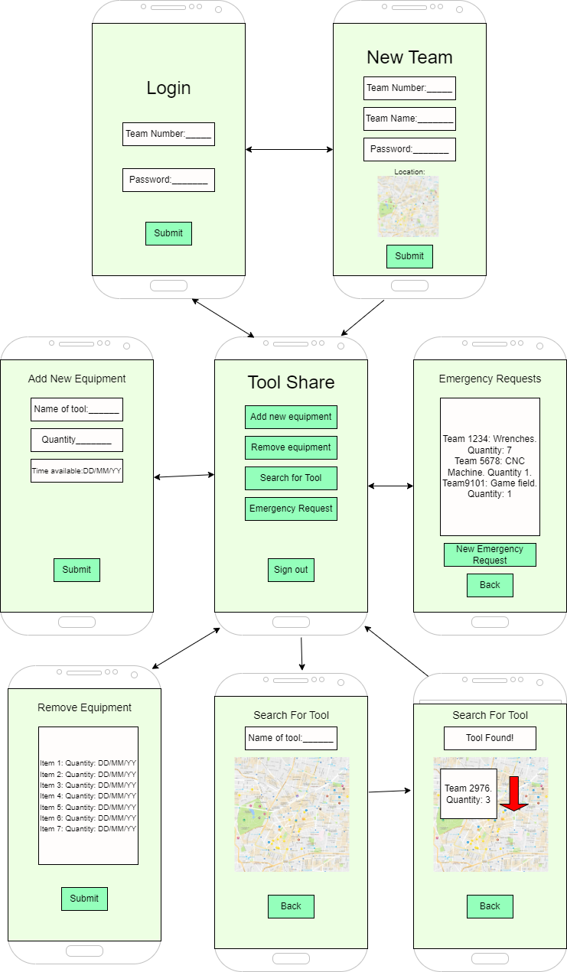

1. Second Iteration: The map on the “Search for tool” page has been enlarged to fit the width and height of the screen itself. Rather than using a text field to enter in the tool’s quantity, a radial number picker is used instead. The “Emergency requests” page has been split into two pages: one for viewing requests, and one for adding new requests. A button has been added to the home screen for deleting the currently logged in team. Also, every page’s back button has been moved to the page header.

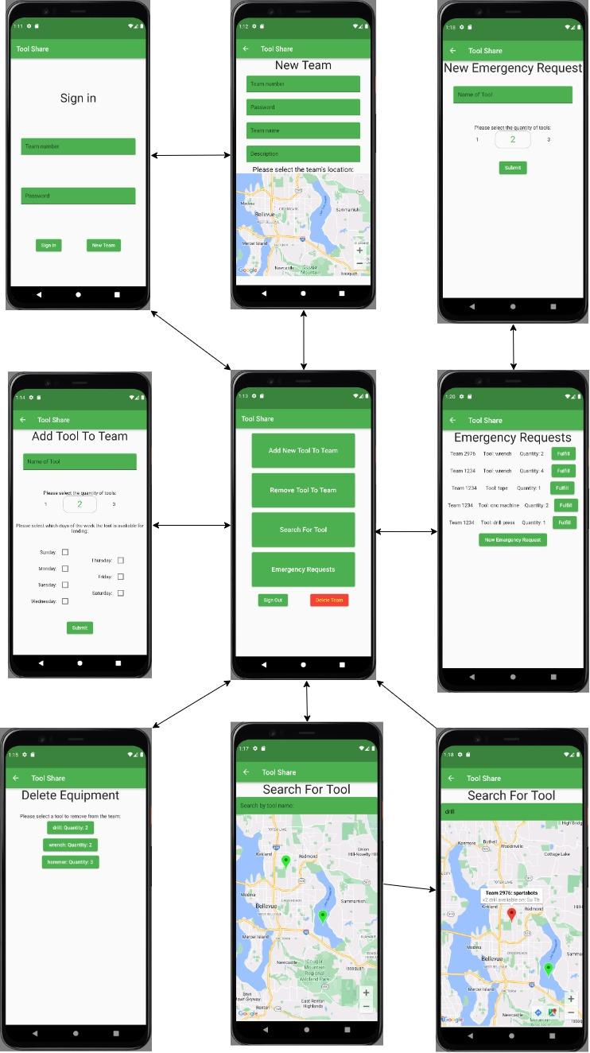

**Appendix D: App Design Progressions**

1. First iteration of the application’s flowchart:

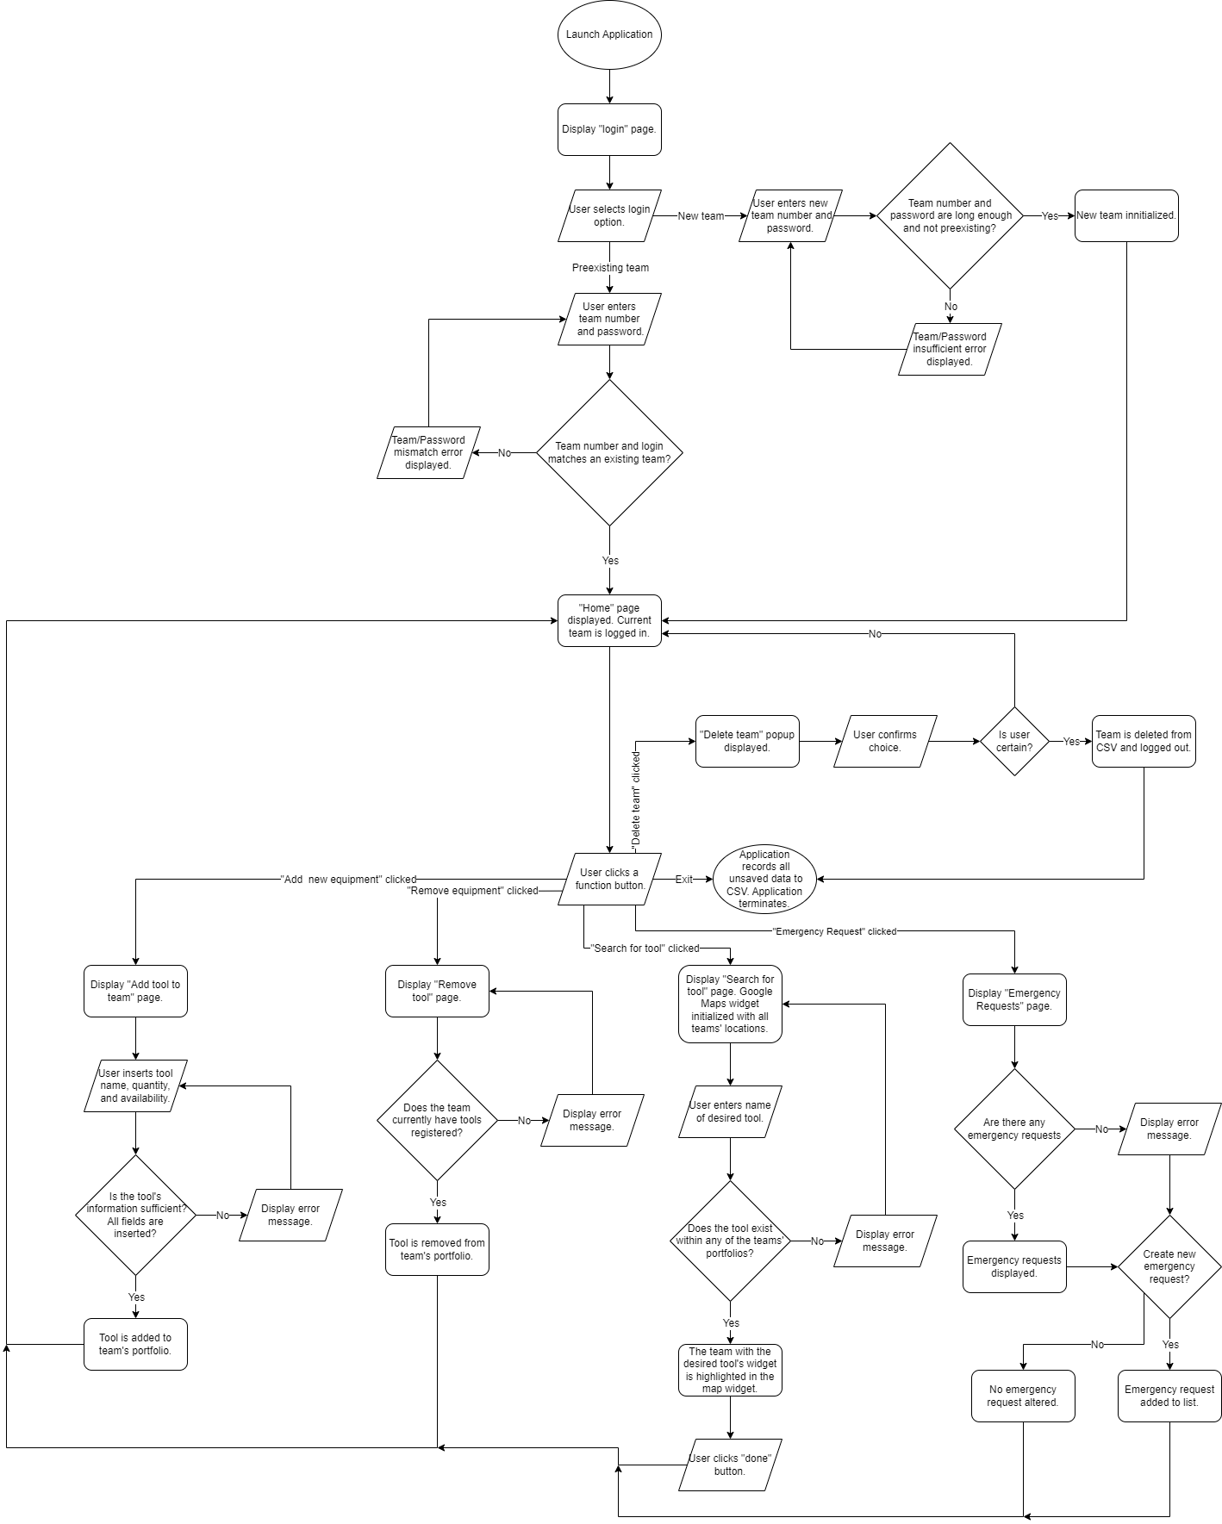

1. Second iteration of the application’s flowchart:

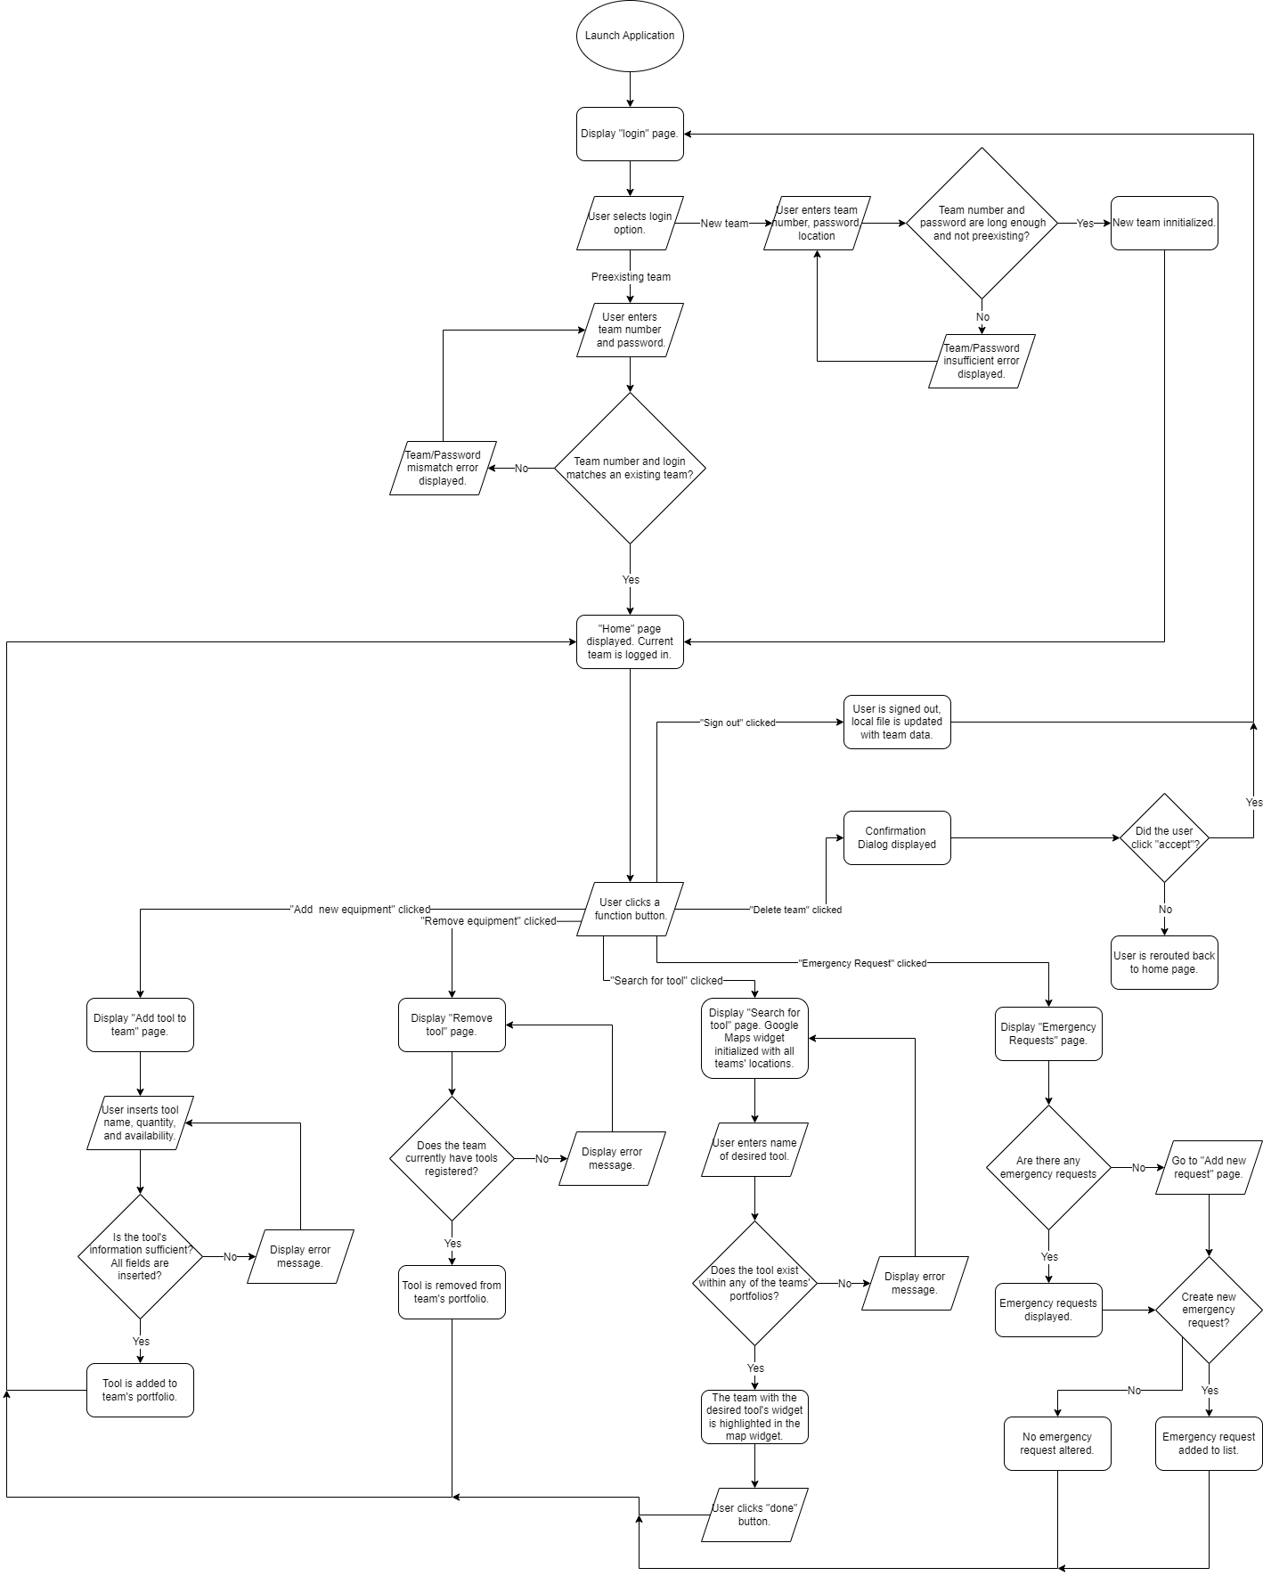

1. First Iteration of UML Diagram:

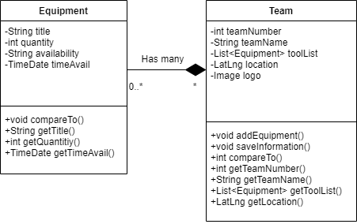

Second Iteration of UML Diagram:

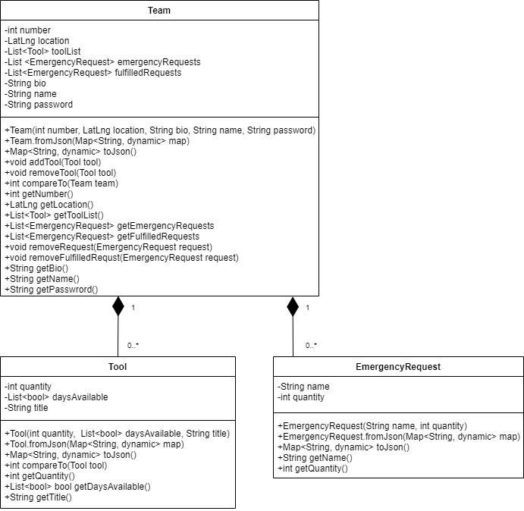

First Iteration of Use Case Diagram:

