
LET MONEY EARN · STUDY
NIFTY Supertrend Butterfly
A ten-year backtest on NSE F&O bhavcopy data
Daily and weekly Supertrend (10, 3) pick the side; a 1-2-1 NIFTY butterfly with 1000-point wings is bought on that side in an expiry two to six months out. Three ways of running a four-set position are compared: holding every set to the weekly flip or expiry, booking one set at each of ₹8,000, ₹10,000 and ₹12,000 of profit a set, and booking the whole position at ₹15,000 a set.
Backtest period | Sessions | Data
30 Sep 2016 to 30 Sep 2026 | 2,464 | NSE F&O bhavcopy (every NIFTY option, every day) and NIFTY index prices
Ratnesh Kumar Singh · Let Money Earn · letmoneyearn.in
30 Sep 2026 · All rupee figures at a NIFTY lot of 65
For education only. A backtest on past data, not a forecast or a recommendation. See the disclaimer at the end.
Contents
1. Summary 3
What the results say 3
2. The strategy 4
2.1 Signal 4
2.2 The butterfly 4
2.3 Expiry 4
2.4 Position size and the three ways of closing 4
3. How a set pays 6
4. Data and method 7
4.1 Data 7
4.2 Prices and fills 7
4.3 Rupees and lot size 7
4.4 Checks made along the way 7
5. Results 8
5.1 Profit over time 8
5.2 Drawdown 8
5.3 By year 9
5.4 Inside the scale-out (B) 9
5.5 Inside the ₹15,000 booking (C) 10
5.6 How positions ended (A) 10
6. Versions tested and dropped 11
7. Risks and limits 12
8. Position today and daily routine 13
8.1 As at 30 Sep 2026 13
8.2 Daily routine 13
Appendix A. Every position, A (all run) 14
Appendix B. Every position, B (book 3, last runs) 16
Appendix C. Every position, C (all run or all booked at ₹15,000) 18
Disclaimer and about the author 20
Important disclaimer 20
About Let Money Earn 20

1. Summary
Over ten years, the rule "trade when the daily and weekly Supertrend agree, close when the weekly changes colour" made money with a NIFTY butterfly. On a position of four sets it returned +₹6,73,061 when every set was held to the exit (A), +₹5,01,312 when three sets were booked early at ₹8,000, ₹10,000 and ₹12,000 a set (B), and +₹6,45,229 when the whole position was booked at ₹15,000 a set (C).
Four sets a position | A: all run | B: book 3, last runs | C: all run or all at ₹15k
Net profit (closed and open) | +₹6,73,061 | +₹5,01,312 | +₹6,45,229
Maximum drawdown | −₹3,87,803 | −₹2,48,443 | −₹4,11,671
Profit per ₹1 of drawdown | 1.74 | 2.02 | 1.57
Positions / won | 44 / 19 (43%) | 44 / 25 (57%) | 46 / 25 (54%)
Average position | +₹14,387 | +₹10,525 | +₹13,157
Best position | +₹1,90,177 | +₹1,29,870 | +₹1,71,704
Worst position | −₹1,08,316 | −₹1,08,316 | −₹1,22,707
Sets booked early | – | 61 | 68
Average cost of a position (the most it can lose) | ₹80,914 | ₹80,914 | ₹82,904
Average days held | 71.3 | 71.3 | 66.1

What the results say
- The signal works. All three ways of running it are profitable over the decade. The trades where every option leg actually traded (37 of 44 in A) made +₹7,71,199 by themselves, so the result does not lean on estimated prices.
- Holding every set (A) makes the most. The big winners come from trends that carry NIFTY to the middle strike and stay there; A keeps all four sets for those, and its best position made +₹1,90,177.
- Booking three sets early (B) is the smoothest. It makes ₹1,71,749 less than A and cuts the worst drawdown from ₹3,87,803 to ₹2,48,443, the best profit per rupee of drawdown of the three (2.02).
- Booking the whole position at ₹15,000 (C) does not help. It ends close to A (+₹6,45,229) but with the deepest drawdown (₹4,11,671): after a booking it often bought back in at a worse level and lost, for example −₹1,22,707 in 2019 and −₹1,17,754 in 2020.
- Losses come in runs. 2024 was the worst year for A (−₹2,86,663) and 2019 for C (−₹1,32,912). A trader needs capital to sit through a drawdown of this size.
- This is one rule tuned on one history. Several other versions were tried on the same ten years and dropped (section 6). Expect live results to be weaker than the backtest and paper trade it first.

2. The strategy

2.1 Signal
Supertrend (10, 3) is calculated on NIFTY daily bars and on weekly bars, with the average true range smoothed the way TradingView does it. The week in progress counts as a bar so far, exactly as a weekly chart shows it at each day's close. Each Supertrend is green (NIFTY above its line) or red (below).
Situation at a day's close | Action at the next session's close
Flat, daily and weekly both green | Buy the call butterfly
Flat, daily and weekly both red | Buy the put butterfly
Flat, daily and weekly different colours | Stay flat
In a position, weekly changes colour against it | Close all sets; if daily and weekly now agree on the other side, open that side at the same close
In a position, only the daily changes colour | Hold
A position reaches its expiry | It settles at intrinsic value; a new one opens that close only if daily and weekly still agree on the same side, otherwise wait flat

2.2 The butterfly
Each set is a 1-2-1 butterfly with 1000-point wings, bought for a debit. "Nearest in-the-money" means the 1000 strike just below NIFTY for calls and just above it for puts.
Side | Buy 1 (in the money) | Sell 2 | Buy 1 (the cover) | Example, NIFTY 22,620
Green: calls | Nearest ITM 1000 strike | 1000 higher | 2000 higher | +22000 CE, −2×23000 CE, +24000 CE
Red: puts | Nearest ITM 1000 strike | 1000 lower | 2000 lower | +23000 PE, −2×22000 PE, +21000 PE

2.3 Expiry
- Only expiries 60 to 190 days away are used, so a set has time to work and the strikes still trade.
- First choice: the nearest March, June, September or December expiry in that window, if all three strikes have open interest.
- Otherwise the nearest monthly expiry in the window that has open interest on all three; otherwise the nearest one listed (none of the backtest positions needed this).
- A price that makes the butterfly cost nothing or more than 1000 points is impossible for this structure; it means stale prices, so that expiry is skipped.

2.4 Position size and the three ways of closing
Every position is 4 sets bought together. A and B take exactly the same positions on the same days and differ only in when sets are closed; C books whole positions and so re-enters on different days.
- A. All run: all four sets are closed together at the weekly flip or at expiry.
- B. Book three, last runs: one set is sold at the close on which the open profit of a set first reaches ₹8,000, a second at ₹10,000 and a third at ₹12,000. The fourth set, and any not yet booked, close at the weekly flip or expiry as in A.
- C. All run, or all booked at ₹15,000: as A, but all four sets are sold at the close on which the open profit of a set reaches ₹15,000. The position then waits flat for the next entry signal and re-enters only in a later expiry than the one booked, 90 to 190 days out, with open interest on all three strikes.

3. How a set pays
At expiry a set is worth nothing if NIFTY is outside the wings, and most at the sold (middle) strike, where it is worth the full 1000 points (₹65,000 a set). Before expiry the set moves much less than this because time value is still in it; the backtest marks every leg at each day's traded price.
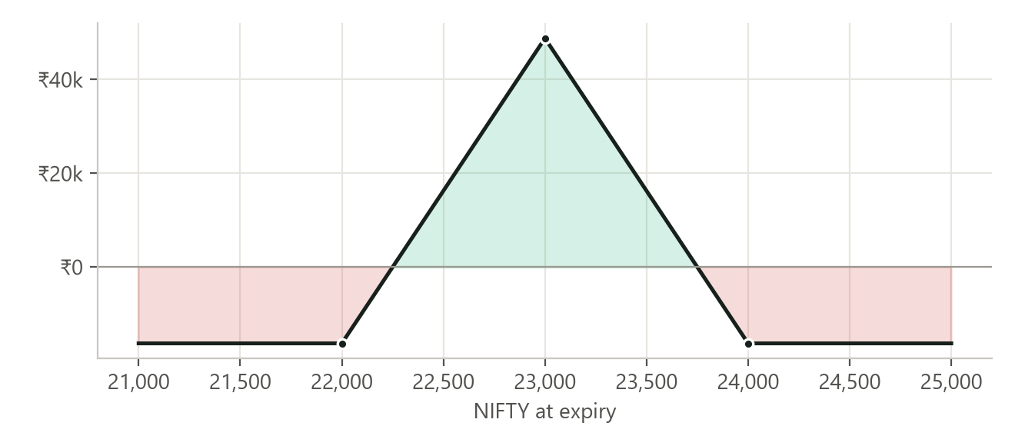
A call set 22000/23000/24000 bought for 250 points (₹16,250): profit or loss of one set at expiry.
At expiry, NIFTY is… | One set (call example above)
Below the bought strike (22,000) | Loses the cost: −₹16,250
Between 22,000 and 22,250 | Loses part of the cost
At the sold strike (23,000) | Best case: 1000 − 250 = 750 points, +₹48,750
Between 23,750 and 24,000 | Loses part of the cost
Above the cover (24,000) | Loses the cost: −₹16,250

Why it can lose in a strong trend. The set is bought on the side of the trend, so a move to the sold strike pays. A trend that keeps going past the cover takes the set back to zero at expiry. This is what produced most of the large losses, for example in 2024.

4. Data and method

4.1 Data
- Options: NSE's daily F&O bhavcopy for every session from 30 Sep 2016 to 30 Sep 2026 (2,464 sessions, about 1.7 GB of files). NSE changed the file format on 8 July 2024; both formats were read into one table.
- NIFTY: daily open, high, low and close of the index from Yahoo Finance (^NSEI), used for the Supertrend and for expiry settlement.
- Expiries: the monthly expiry is taken as the last expiry of each month listed on the day (weekly expiries are ignored). When NSE moved an expiry to the day before a holiday, or moved NIFTY expiry to Tuesday from September 2025 and re-dated open contracts, the position follows the contract to its new date.

4.2 Prices and fills
- A signal is read at a day's close and traded at the next session's close. There is no same-day look-ahead. Profit levels for booking (B and C) are checked at each day's close and booked at that close.
- A leg that traded that day is priced at its close. One that did not trade is priced at NSE's settlement price, a model price; 12 of A's leg prices came from it and are marked in the trade list.
- A set held to expiry is settled at intrinsic value on the NIFTY close.
- Costs: 1 point per option per trade (4 options each way) for brokerage, taxes and slippage together, i.e. ₹260 a set to open and again to close before expiry. Nothing at expiry settlement.

4.3 Rupees and lot size
All rupee figures use today's NIFTY lot of 65 for every year, so years can be compared. NSE's lot was 75 until mid-2021, then 50, 25 from April 2024 and 75 from late 2024; a real position in those years made or lost proportionally more or less.

4.4 Checks made along the way
Several data problems were found and fixed before the final numbers:
- Expiries moved for holidays (for example 29 March 2018 to 28 March) kept their original date in the files, which left positions open for years. Positions now settle on the last session on or before the listed date.
- NSE's September 2025 move to Tuesday expiries re-dated open contracts. Expiries are now read per day and a held contract follows its new date.
- Half-yearly contracts two to three years out have almost no trading, and their settlement prices produced impossible profits. Expiries are capped at 190 days.
- Two entries priced a butterfly as a credit, which cannot happen. Entries must now cost between 0 and 1000 points.

5. Results

5.1 Profit over time
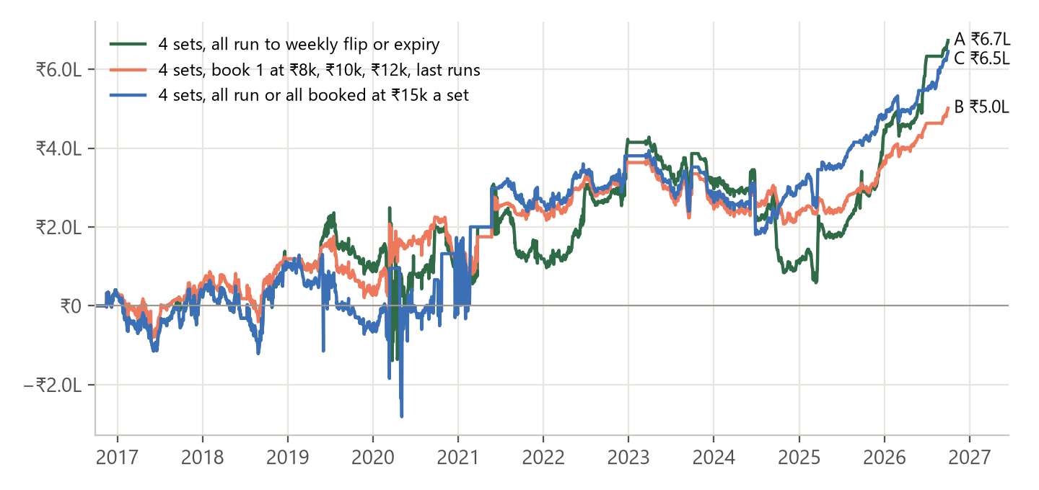
Cumulative profit of a 4-set position, open sets marked at each day's prices.
A and B move together while trades are small. B pulls ahead when a position reaches ₹8,000–₹12,000 a set and then gives it back, as in 2020–2021 and 2024; A pulls ahead in long, clean trends such as 2022, 2025 and 2026. C follows A except after its bookings, where it often re-entered at a worse level: it fell furthest of the three in 2019 and gained most in 2020, when it booked the put position before the Covid rebound.

5.2 Drawdown
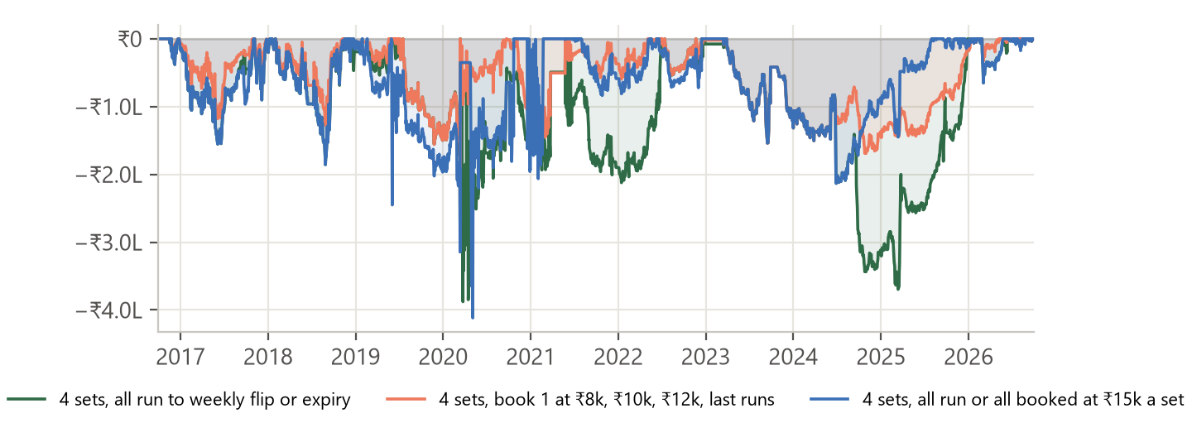
Fall from the highest profit reached so far.
A's worst drawdown was ₹3,87,803 and B's ₹2,48,443, both in March 2020. The Covid crash carried NIFTY far past the lower wing of the open put position within days: A went from +₹2.49 lakh on 13 March to −₹1.39 lakh on 24 March, before NIFTY recovered. B's low came on 12 March, at the end of a slide that began in July 2019; having booked sets earlier, it fell less. C's worst, ₹4,11,671, ran from 30 May 2019 to 4 May 2020 through a string of losing re-entries.
The longest run of losses in A was November 2023 to October 2024, when four call positions in a row lost ₹61,711 to ₹81,315 each: three expired with NIFTY past the cover, a trend running further than the set could use, and one was closed at the weekly flip.

5.3 By year
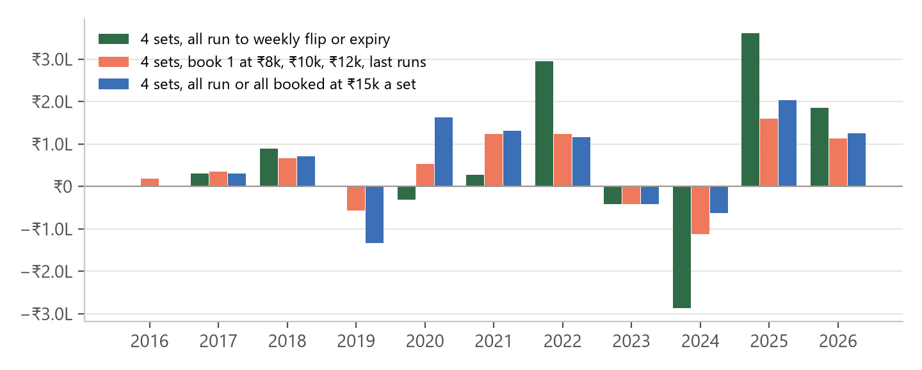
Year | A: all run | B: book 3, last runs | C: all at ₹15k
2016 | ₹0 | +₹17,787 | ₹0
2017 | +₹29,757 | +₹34,794 | +₹30,381
2018 | +₹89,414 | +₹66,559 | +₹71,747
2019 | +₹2,548 | −₹57,237 | −₹1,32,912
2020 | −₹30,706 | +₹53,643 | +₹1,62,968
2021 | +₹27,911 | +₹1,23,845 | +₹1,31,651
2022 | +₹2,95,750 | +₹1,23,997 | +₹1,16,649
2023 | −₹42,393 | −₹42,393 | −₹42,393
2024 | −₹2,86,663 | −₹1,12,044 | −₹62,127
2025 | +₹3,61,816 | +₹1,59,879 | +₹2,04,022
2026 | +₹1,85,601 | +₹1,12,460 | +₹1,25,216
Closed total | +₹6,33,035 | +₹4,81,290 | +₹6,05,202
Open position now | +₹40,026 | +₹20,022 | +₹40,027

5.4 Inside the scale-out (B)
B, all ten years | Sets | Result
Booked at ₹8,000 / ₹10,000 / ₹12,000 | 61 | +₹7,70,599
Closed at the weekly flip or expiry | 117 | −₹2,89,309

16 positions reached all three levels. The booked sets are all small wins by construction; the losses come from positions that never reach ₹8,000 a set, where all four sets ride the loss exactly as in A. The scale-out changes the winners, not the losers: it trims the best positions and rescues positions that ran into profit and then reversed.
Position opened | Side | A: all run | B: book 3 | B − A
24 May 2021 | Call | −₹75,998 | +₹54,962 | +₹1,30,960
2 Mar 2020 | Put | +₹4,368 | +₹1,29,870 | +₹1,25,502
27 Jun 2024 | Call | −₹71,773 | +₹16,019 | +₹87,792
9 Apr 2024 | Call | −₹71,864 | +₹14,963 | +₹86,827
5 Mar 2026 | Put | +₹1,90,177 | +₹78,572 | −₹1,11,605
25 Feb 2022 | Put | +₹1,72,133 | +₹74,731 | −₹97,402
10 Oct 2025 | Call | +₹1,58,093 | +₹70,769 | −₹87,324
4 Aug 2022 | Call | +₹1,45,223 | +₹70,872 | −₹74,351

5.5 Inside the ₹15,000 booking (C)
C booked 17 positions at ₹15,000 a set (68 sets), for +₹12,82,905 in all. The bookings themselves are fine; the cost comes after them. Once booked, C waits for the next signal and must use a later expiry, so it often buys back into the same trend at a worse level, just before it turns:
Booked | Result | Re-entered | Result | Exit
24 May 2019, call | +₹64,792 | 27 May 2019, call | −₹1,22,707 | weekly flip
13 Mar 2020, put | +₹1,71,704 | 24 Apr 2020, put | −₹1,17,754 | weekly flip

In A these were one position each and ran on. C's ₹15,000 level is high enough that it is reached mostly near the top of a move, which is exactly when a fresh position is most likely to lose.

5.6 How positions ended (A)
Exit | Positions
Weekly Supertrend changed colour | 24
Expiry, then wait for the next signal | 11
Expiry, rolled into a new position the same day | 9

Calls were bought 26 times (+₹3,36,063) and puts 18 times (+₹2,96,972), so both sides contributed. Every position in all three variants used a quarterly (March, June, September or December) expiry with open interest on all three strikes.

6. Versions tested and dropped
The final rule was reached step by step. Each version below was run on the same ten years; figures are for one set at a lot of 65. Some were run before the last price checks in section 4.4, so treat them as indicative.
Version | Net, one set | Max drawdown
Monthly Supertrend decides the exit, sets always rolled at expiry | −₹1,64,860 | −₹2,80,263
same, book at ₹8,000 and open a new set at once | −₹14,202 | −₹1,71,149
same, entry needs daily, weekly and monthly, book at ₹8,000 and wait | +₹18,541 | −₹1,04,091
Weekly flip exit (the final rule, one set) | +₹1,68,265 | −₹96,950
enter only within 2% of the weekly Supertrend line | −₹4,657 (2 trades) | −₹11,056
within 2% of the daily line, book at ₹8,000 and wait | +₹51,756 | −₹76,164
book at ₹8,000, wait, re-enter 90–190 days out | +₹66,264 | −₹94,146
book at ₹10,000, same | +₹16,266 | −₹1,10,383
book at ₹12,000, same | −₹852 | −₹1,10,383
at ₹12,000 profit, move the cover 500 points from the sold strike | +₹1,89,592 | −₹1,20,995
at ₹12,000 profit, move the cover onto the sold strike | +₹2,13,216 | −₹70,035

- Monthly exit: the monthly Supertrend barely changed colour after November 2020, so positions were rolled for years in one direction, including put sets through a bull market.
- 2% band on the weekly line: the weekly line sits about three weekly ATRs from price, a median 7% away on days daily and weekly agree, so NIFTY is almost never within 2% while the two agree.
- Profit targets with a wait: booking the whole position early cuts off the large winners that pay for the losers; C in this report is the same idea at ₹15,000 and shows the same weakness.
- Moving the cover inside: moving it onto the sold strike at ₹12,000 of profit tested best of all, but it was the best of six adjustment settings on the same data and adds a step to manage; it was set aside to keep the rule simple.
Why this matters: trying many versions on one history and keeping the best tends to overstate what a rule will do next. The final rule was chosen partly because it is simple, but its backtest profit should still be treated as an upper estimate.

7. Risks and limits
- Drawdowns: a 4-set position fell up to ₹3,87,803 (A), ₹2,48,443 (B) or ₹4,11,671 (C) from its high. The worst single position lost ₹1,22,707.
- Liquidity: quarterly options two to six months out at 1000-point strikes trade thinly, especially before 2020. Real fills can be wider than the 1 point a leg assumed; a larger cost cuts the result, most of all for B and C, which trade more often.
- Estimated prices: where a leg did not trade the backtest used NSE's settlement price (12 leg prices in A, 25 in B, 21 in C).
- Lot size: rupees use a lot of 65 throughout; with the real lot sizes of each year the rupee totals would differ.
- Next-day fills: the backtest trades at the close after the signal. Acting at the signal day's close, or intraday, would give different prices.
- One market, one decade: the results come from NIFTY between 2016 and 2026 and may not repeat.
- Margin: the two sold options need margin beyond the debit shown; this study does not model margin or the return on it.

8. Position today and daily routine

8.1 As at 30 Sep 2026
Item | Value
NIFTY close | 22,620.45
Daily Supertrend | Red (line 23,309)
Weekly Supertrend | Red (line 24,428)
Open position | Put side since 3 Sep 2026, expiry 29 Dec 2026
Strikes | +1× 24,000 · −2× 23,000 · +1× 22,000 PE
Cost / value now, one set | 136.90 / 294.85 points (open +₹10,007 a set)
A: all run | 4 sets open, +₹40,028
B: book 3, last runs | 2 sets booked (+₹18,174), 2 still open, +₹20,014
C: all at ₹15k | 4 sets open, +₹40,028; books all at ₹15,000 a set
Next session | Nothing to do
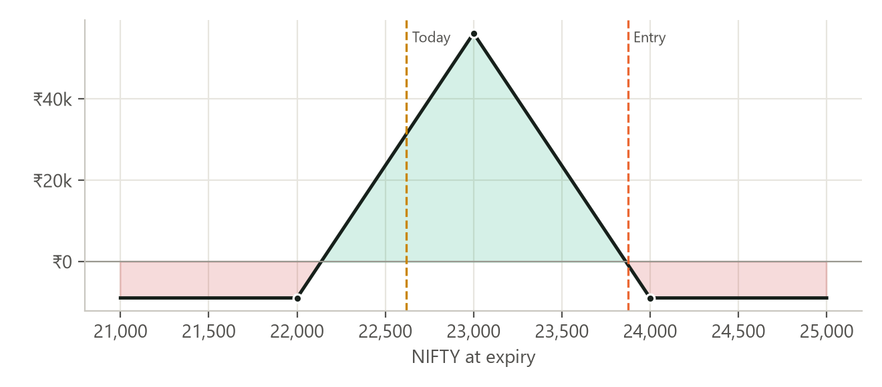
The open put set at expiry, one set: NIFTY at entry and today marked.

8.2 Daily routine
- After the close, download the day's bhavcopy: py study/fetch_fno_bhavcopy.py
- Rebuild the study and report: py study/fly_study.py
- Open study/fly_report.html and read the Today section: the colours, the open position and what to do at the next session's close.
- For B, check whether the open profit a set has reached the next booking level (₹8,000, ₹10,000, ₹12,000); for C, whether it has reached ₹15,000.

Appendix A. Every position, A (all run)
Opened | Closed | Side | Strikes | Expiry | Cost | Exit | Result | Why
15 Nov 2016 | 2 Feb 2017 | Put | 9000/8000/7000 | 30 Mar 2017 | 370.4 | 245.6 | −₹34,528 | weekly flip
2 Feb 2017 | 29 Jun 2017 | Call | 8000/9000/10000 | 29 Jun 2017 | 614.1 | 495.9 | −₹31,772 | expiry, rolled *
29 Jun 2017 | 28 Sep 2017 | Call | 9000/10000/11000 | 28 Sep 2017 | 525.5 | 769.0 | +₹62,257 | expiry *
13 Oct 2017 | 28 Dec 2017 | Call | 10000/11000/12000 | 28 Dec 2017 | 343.9 | 477.9 | +₹33,800 | expiry, rolled
28 Dec 2017 | 21 Feb 2018 | Call | 10000/11000/12000 | 28 Mar 2018 | 478.7 | 446.3 | −₹10,517 | weekly flip
21 Feb 2018 | 22 Feb 2018 | Put | 11000/10000/9000 | 28 Jun 2018 | 220.8 | 199.5 | −₹7,605 | weekly flip *
6 Mar 2018 | 14 Jun 2018 | Put | 11000/10000/9000 | 28 Jun 2018 | 317.4 | 199.9 | −₹32,617 | weekly flip *
14 Jun 2018 | 15 Jun 2018 | Call | 10000/11000/12000 | 27 Sep 2018 | 664.6 | 630.9 | −₹10,829 | weekly flip *
10 Jul 2018 | 25 Sep 2018 | Call | 10000/11000/12000 | 27 Sep 2018 | 576.6 | 836.6 | +₹65,533 | weekly flip
25 Sep 2018 | 27 Dec 2018 | Put | 12000/11000/10000 | 27 Dec 2018 | 447.2 | 779.8 | +₹85,449 | expiry
18 Feb 2019 | 13 Mar 2019 | Put | 11000/10000/9000 | 27 Jun 2019 | 193.9 | 116.4 | −₹22,230 | weekly flip
13 Mar 2019 | 27 Jun 2019 | Call | 11000/12000/13000 | 27 Jun 2019 | 357.7 | 841.6 | +₹1,24,761 | expiry, rolled
27 Jun 2019 | 2 Aug 2019 | Call | 11000/12000/13000 | 26 Sep 2019 | 519.7 | 251.3 | −₹71,864 | weekly flip *
2 Aug 2019 | 31 Oct 2019 | Put | 11000/10000/9000 | 26 Dec 2019 | 143.4 | 43.2 | −₹28,119 | weekly flip
31 Oct 2019 | 2 Mar 2020 | Call | 11000/12000/13000 | 26 Mar 2020 | 472.5 | 304.6 | −₹45,734 | weekly flip *
2 Mar 2020 | 25 Jun 2020 | Put | 12000/11000/10000 | 25 Jun 2020 | 268.1 | 288.9 | +₹4,368 | expiry
7 Jul 2020 | 9 Jul 2020 | Call | 10000/11000/12000 | 24 Sep 2020 | 379.5 | 365.4 | −₹5,746 | weekly flip
10 Jul 2020 | 24 Sep 2020 | Call | 10000/11000/12000 | 24 Sep 2020 | 321.9 | 805.6 | +₹1,24,722 | expiry
6 Oct 2020 | 31 Dec 2020 | Call | 11000/12000/13000 | 31 Dec 2020 | 412.6 | 0.0 | −₹1,08,316 | expiry, rolled
31 Dec 2020 | 25 Mar 2021 | Call | 13000/14000/15000 | 25 Mar 2021 | 253.7 | 675.1 | +₹1,08,537 | expiry
24 May 2021 | 30 Sep 2021 | Call | 15000/16000/17000 | 30 Sep 2021 | 288.3 | 0.0 | −₹75,998 | expiry, rolled
30 Sep 2021 | 7 Dec 2021 | Call | 17000/18000/19000 | 30 Dec 2021 | 297.0 | 345.4 | +₹10,504 | weekly flip
7 Dec 2021 | 8 Dec 2021 | Put | 18000/17000/16000 | 31 Mar 2022 | 192.5 | 174.9 | −₹6,656 | weekly flip
21 Dec 2021 | 23 Dec 2021 | Put | 17000/16000/15000 | 31 Mar 2022 | 224.0 | 199.4 | −₹8,476 | weekly flip
4 Jan 2022 | 15 Feb 2022 | Call | 17000/18000/19000 | 31 Mar 2022 | 291.7 | 332.8 | +₹8,619 | weekly flip
15 Feb 2022 | 16 Feb 2022 | Put | 18000/17000/16000 | 30 Jun 2022 | 168.9 | 190.4 | +₹3,523 | weekly flip
25 Feb 2022 | 30 Jun 2022 | Put | 17000/16000/15000 | 30 Jun 2022 | 114.2 | 780.3 | +₹1,72,133 | expiry, rolled
30 Jun 2022 | 4 Aug 2022 | Put | 16000/15000/14000 | 29 Sep 2022 | 173.0 | 51.2 | −₹33,748 | weekly flip
4 Aug 2022 | 29 Dec 2022 | Call | 17000/18000/19000 | 29 Dec 2022 | 246.5 | 809.0 | +₹1,45,223 | expiry
14 Mar 2023 | 29 May 2023 | Put | 18000/17000/16000 | 29 Jun 2023 | 262.7 | 32.2 | −₹62,010 | weekly flip
29 May 2023 | 28 Sep 2023 | Call | 18000/19000/20000 | 28 Sep 2023 | 343.5 | 476.5 | +₹33,527 | expiry
27 Oct 2023 | 30 Oct 2023 | Put | 20000/19000/18000 | 28 Dec 2023 | 376.7 | 355.8 | −₹7,514 | weekly flip
2 Nov 2023 | 3 Nov 2023 | Put | 20000/19000/18000 | 28 Mar 2024 | 222.7 | 206.1 | −₹6,396 | weekly flip
16 Nov 2023 | 28 Mar 2024 | Call | 19000/20000/21000 | 28 Mar 2024 | 308.8 | 0.0 | −₹81,315 | expiry
9 Apr 2024 | 27 Jun 2024 | Call | 22000/23000/24000 | 27 Jun 2024 | 272.4 | 0.0 | −₹71,864 | expiry, rolled
27 Jun 2024 | 26 Sep 2024 | Call | 24000/25000/26000 | 26 Sep 2024 | 272.1 | 0.0 | −₹71,773 | expiry, rolled
26 Sep 2024 | 28 Oct 2024 | Call | 26000/27000/28000 | 26 Dec 2024 | 284.0 | 54.6 | −₹61,711 | weekly flip
28 Oct 2024 | 27 Mar 2025 | Put | 25000/24000/23000 | 27 Mar 2025 | 119.3 | 592.0 | +₹1,21,849 | expiry
7 Apr 2025 | 24 Apr 2025 | Put | 23000/22000/21000 | 26 Jun 2025 | 170.5 | 60.7 | −₹30,628 | weekly flip
24 Apr 2025 | 28 Apr 2025 | Call | 24000/25000/26000 | 26 Jun 2025 | 295.0 | 303.1 | +₹26 | weekly flip
29 Apr 2025 | 30 Sep 2025 | Call | 24000/25000/26000 | 30 Sep 2025 | 174.5 | 611.1 | +₹1,12,476 | expiry
10 Oct 2025 | 30 Dec 2025 | Call | 25000/26000/27000 | 30 Dec 2025 | 326.8 | 938.9 | +₹1,58,093 | expiry, rolled
30 Dec 2025 | 5 Mar 2026 | Call | 25000/26000/27000 | 30 Mar 2026 | 256.7 | 247.1 | −₹4,576 | weekly flip
5 Mar 2026 | 30 Jun 2026 | Put | 25000/24000/23000 | 30 Jun 2026 | 130.3 | 865.8 | +₹1,90,177 | expiry
3 Sep 2026 | open | Put | 24000/23000/22000 | 29 Dec 2026 | 136.9 | 294.9 | +₹40,028 | still open

Appendix B. Every position, B (book 3, last runs)
Opened | Closed | Side | Strikes | Booked | Rest | B total | A total
15 Nov 2016 | 2 Feb 2017 | Put | 9000/8000/7000 | 2 · +₹17,787 | 2 · −₹17,264 | +₹523 | −₹34,528
2 Feb 2017 | 29 Jun 2017 | Call | 8000/9000/10000 | – | 4 · −₹31,772 | −₹31,772 | −₹31,772
29 Jun 2017 | 28 Sep 2017 | Call | 9000/10000/11000 | 3 · +₹30,384 | 1 · +₹15,564 | +₹45,948 | +₹62,257
13 Oct 2017 | 28 Dec 2017 | Call | 10000/11000/12000 | 2 · +₹20,982 | 2 · +₹16,900 | +₹37,882 | +₹33,800
28 Dec 2017 | 21 Feb 2018 | Call | 10000/11000/12000 | 1 · +₹8,365 | 3 · −₹7,888 | +₹477 | −₹10,517
21 Feb 2018 | 22 Feb 2018 | Put | 11000/10000/9000 | – | 4 · −₹7,605 | −₹7,605 | −₹7,605
6 Mar 2018 | 14 Jun 2018 | Put | 11000/10000/9000 | 1 · +₹8,106 | 3 · −₹24,463 | −₹16,357 | −₹32,617
14 Jun 2018 | 15 Jun 2018 | Call | 10000/11000/12000 | – | 4 · −₹10,829 | −₹10,829 | −₹10,829
10 Jul 2018 | 25 Sep 2018 | Call | 10000/11000/12000 | 3 · +₹32,122 | 1 · +₹16,383 | +₹48,505 | +₹65,533
25 Sep 2018 | 27 Dec 2018 | Put | 12000/11000/10000 | 3 · +₹31,006 | 1 · +₹21,362 | +₹52,368 | +₹85,449
18 Feb 2019 | 13 Mar 2019 | Put | 11000/10000/9000 | – | 4 · −₹22,230 | −₹22,230 | −₹22,230
13 Mar 2019 | 27 Jun 2019 | Call | 11000/12000/13000 | 3 · +₹33,786 | 1 · +₹31,190 | +₹64,976 | +₹1,24,761
27 Jun 2019 | 2 Aug 2019 | Call | 11000/12000/13000 | – | 4 · −₹71,864 | −₹71,864 | −₹71,864
2 Aug 2019 | 31 Oct 2019 | Put | 11000/10000/9000 | – | 4 · −₹28,119 | −₹28,119 | −₹28,119
31 Oct 2019 | 2 Mar 2020 | Call | 11000/12000/13000 | 1 · +₹7,793 | 3 · −₹34,301 | −₹26,508 | −₹45,734
2 Mar 2020 | 25 Jun 2020 | Put | 12000/11000/10000 | 3 · +₹1,28,778 | 1 · +₹1,092 | +₹1,29,870 | +₹4,368
7 Jul 2020 | 9 Jul 2020 | Call | 10000/11000/12000 | – | 4 · −₹5,746 | −₹5,746 | −₹5,746
10 Jul 2020 | 24 Sep 2020 | Call | 10000/11000/12000 | 3 · +₹33,163 | 1 · +₹31,180 | +₹64,343 | +₹1,24,722
6 Oct 2020 | 31 Dec 2020 | Call | 11000/12000/13000 | – | 4 · −₹1,08,316 | −₹1,08,316 | −₹1,08,316
31 Dec 2020 | 25 Mar 2021 | Call | 13000/14000/15000 | 3 · +₹32,396 | 1 · +₹27,134 | +₹59,530 | +₹1,08,537
24 May 2021 | 30 Sep 2021 | Call | 15000/16000/17000 | 3 · +₹73,962 | 1 · −₹19,000 | +₹54,962 | −₹75,998
30 Sep 2021 | 7 Dec 2021 | Call | 17000/18000/19000 | 2 · +₹19,233 | 2 · +₹5,252 | +₹24,485 | +₹10,504
7 Dec 2021 | 8 Dec 2021 | Put | 18000/17000/16000 | – | 4 · −₹6,656 | −₹6,656 | −₹6,656
21 Dec 2021 | 23 Dec 2021 | Put | 17000/16000/15000 | – | 4 · −₹8,476 | −₹8,476 | −₹8,476
4 Jan 2022 | 15 Feb 2022 | Call | 17000/18000/19000 | – | 4 · +₹8,619 | +₹8,619 | +₹8,619
15 Feb 2022 | 16 Feb 2022 | Put | 18000/17000/16000 | – | 4 · +₹3,523 | +₹3,523 | +₹3,523
25 Feb 2022 | 30 Jun 2022 | Put | 17000/16000/15000 | 3 · +₹31,698 | 1 · +₹43,033 | +₹74,731 | +₹1,72,133
30 Jun 2022 | 4 Aug 2022 | Put | 16000/15000/14000 | – | 4 · −₹33,748 | −₹33,748 | −₹33,748
4 Aug 2022 | 29 Dec 2022 | Call | 17000/18000/19000 | 3 · +₹34,566 | 1 · +₹36,306 | +₹70,872 | +₹1,45,223
14 Mar 2023 | 29 May 2023 | Put | 18000/17000/16000 | – | 4 · −₹62,010 | −₹62,010 | −₹62,010
29 May 2023 | 28 Sep 2023 | Call | 18000/19000/20000 | – | 4 · +₹33,527 | +₹33,527 | +₹33,527
27 Oct 2023 | 30 Oct 2023 | Put | 20000/19000/18000 | – | 4 · −₹7,514 | −₹7,514 | −₹7,514
2 Nov 2023 | 3 Nov 2023 | Put | 20000/19000/18000 | – | 4 · −₹6,396 | −₹6,396 | −₹6,396
16 Nov 2023 | 28 Mar 2024 | Call | 19000/20000/21000 | – | 4 · −₹81,315 | −₹81,315 | −₹81,315
9 Apr 2024 | 27 Jun 2024 | Call | 22000/23000/24000 | 3 · +₹32,929 | 1 · −₹17,966 | +₹14,963 | −₹71,864
27 Jun 2024 | 26 Sep 2024 | Call | 24000/25000/26000 | 3 · +₹33,962 | 1 · −₹17,943 | +₹16,019 | −₹71,773
26 Sep 2024 | 28 Oct 2024 | Call | 26000/27000/28000 | – | 4 · −₹61,711 | −₹61,711 | −₹61,711
28 Oct 2024 | 27 Mar 2025 | Put | 25000/24000/23000 | 3 · +₹30,032 | 1 · +₹30,462 | +₹60,494 | +₹1,21,849
7 Apr 2025 | 24 Apr 2025 | Put | 23000/22000/21000 | – | 4 · −₹30,628 | −₹30,628 | −₹30,628
24 Apr 2025 | 28 Apr 2025 | Call | 24000/25000/26000 | – | 4 · +₹26 | +₹26 | +₹26
29 Apr 2025 | 30 Sep 2025 | Call | 24000/25000/26000 | 3 · +₹31,099 | 1 · +₹28,119 | +₹59,218 | +₹1,12,476
10 Oct 2025 | 30 Dec 2025 | Call | 25000/26000/27000 | 3 · +₹31,246 | 1 · +₹39,523 | +₹70,769 | +₹1,58,093
30 Dec 2025 | 5 Mar 2026 | Call | 25000/26000/27000 | 2 · +₹18,002 | 2 · −₹2,288 | +₹15,714 | −₹4,576
5 Mar 2026 | 30 Jun 2026 | Put | 25000/24000/23000 | 3 · +₹31,028 | 1 · +₹47,544 | +₹78,572 | +₹1,90,177
3 Sep 2026 | open | Put | 24000/23000/22000 | 2 · +₹18,174 | 2 open · +₹20,014 | +₹38,188 | +₹40,028

Appendix C. Every position, C (all run or all booked at ₹15,000)
Opened | Closed | Side | Strikes | Expiry | Result | Why
15 Nov 2016 | 2 Feb 2017 | Put | 9000/8000/7000 | 30 Mar 2017 | −₹34,528 | weekly flip
2 Feb 2017 | 29 Jun 2017 | Call | 8000/9000/10000 | 29 Jun 2017 | −₹31,772 | expiry, rolled
29 Jun 2017 | 31 Aug 2017 | Call | 9000/10000/11000 | 28 Sep 2017 | +₹59,449 | booked at ₹15k
12 Sep 2017 | 28 Dec 2017 | Call | 10000/11000/12000 | 28 Dec 2017 | +₹37,232 | expiry, rolled
28 Dec 2017 | 21 Feb 2018 | Call | 10000/11000/12000 | 28 Mar 2018 | −₹10,517 | weekly flip
21 Feb 2018 | 22 Feb 2018 | Put | 11000/10000/9000 | 28 Jun 2018 | −₹7,605 | weekly flip
6 Mar 2018 | 14 Jun 2018 | Put | 11000/10000/9000 | 28 Jun 2018 | −₹32,617 | weekly flip
14 Jun 2018 | 15 Jun 2018 | Call | 10000/11000/12000 | 27 Sep 2018 | −₹10,829 | weekly flip
10 Jul 2018 | 24 Sep 2018 | Call | 10000/11000/12000 | 27 Sep 2018 | +₹67,015 | booked at ₹15k
25 Sep 2018 | 12 Dec 2018 | Put | 12000/11000/10000 | 27 Dec 2018 | +₹66,300 | booked at ₹15k
13 Dec 2018 | 13 Mar 2019 | Put | 11000/10000/9000 | 28 Mar 2019 | −₹46,878 | weekly flip
13 Mar 2019 | 24 May 2019 | Call | 11000/12000/13000 | 27 Jun 2019 | +₹64,792 | booked at ₹15k
27 May 2019 | 2 Aug 2019 | Call | 11000/12000/13000 | 26 Sep 2019 | −₹1,22,707 | weekly flip
2 Aug 2019 | 31 Oct 2019 | Put | 11000/10000/9000 | 26 Dec 2019 | −₹28,119 | weekly flip
31 Oct 2019 | 2 Mar 2020 | Call | 11000/12000/13000 | 26 Mar 2020 | −₹45,734 | weekly flip
2 Mar 2020 | 13 Mar 2020 | Put | 12000/11000/10000 | 25 Jun 2020 | +₹1,71,704 | booked at ₹15k
24 Apr 2020 | 7 Jul 2020 | Put | 10000/9000/8000 | 24 Sep 2020 | −₹1,17,754 | weekly flip
7 Jul 2020 | 9 Jul 2020 | Call | 10000/11000/12000 | 24 Sep 2020 | −₹5,746 | weekly flip
10 Jul 2020 | 21 Sep 2020 | Call | 10000/11000/12000 | 24 Sep 2020 | +₹94,458 | booked at ₹15k
6 Oct 2020 | 22 Oct 2020 | Call | 11000/12000/13000 | 25 Mar 2021 | +₹66,040 | booked at ₹15k
17 Dec 2020 | 22 Feb 2021 | Call | 13000/14000/15000 | 24 Jun 2021 | +₹68,042 | booked at ₹15k
24 May 2021 | 25 May 2021 | Call | 15000/16000/17000 | 30 Sep 2021 | +₹98,618 | booked at ₹15k
23 Jun 2021 | 7 Dec 2021 | Call | 15000/16000/17000 | 30 Dec 2021 | −₹19,877 | weekly flip
7 Dec 2021 | 8 Dec 2021 | Put | 18000/17000/16000 | 31 Mar 2022 | −₹6,656 | weekly flip
21 Dec 2021 | 23 Dec 2021 | Put | 17000/16000/15000 | 31 Mar 2022 | −₹8,476 | weekly flip
4 Jan 2022 | 15 Feb 2022 | Call | 17000/18000/19000 | 31 Mar 2022 | +₹8,619 | weekly flip
15 Feb 2022 | 16 Feb 2022 | Put | 18000/17000/16000 | 30 Jun 2022 | +₹3,523 | weekly flip
25 Feb 2022 | 19 May 2022 | Put | 17000/16000/15000 | 30 Jun 2022 | +₹62,309 | booked at ₹15k
20 May 2022 | 4 Aug 2022 | Put | 17000/16000/15000 | 29 Sep 2022 | −₹34,814 | weekly flip
4 Aug 2022 | 16 Dec 2022 | Call | 17000/18000/19000 | 29 Dec 2022 | +₹77,012 | booked at ₹15k
14 Mar 2023 | 29 May 2023 | Put | 18000/17000/16000 | 29 Jun 2023 | −₹62,010 | weekly flip
29 May 2023 | 28 Sep 2023 | Call | 18000/19000/20000 | 28 Sep 2023 | +₹33,527 | expiry
27 Oct 2023 | 30 Oct 2023 | Put | 20000/19000/18000 | 28 Dec 2023 | −₹7,514 | weekly flip
2 Nov 2023 | 3 Nov 2023 | Put | 20000/19000/18000 | 28 Mar 2024 | −₹6,396 | weekly flip
16 Nov 2023 | 28 Mar 2024 | Call | 19000/20000/21000 | 28 Mar 2024 | −₹81,315 | expiry
9 Apr 2024 | 27 Jun 2024 | Call | 22000/23000/24000 | 27 Jun 2024 | −₹71,864 | expiry, rolled
27 Jun 2024 | 10 Sep 2024 | Call | 24000/25000/26000 | 26 Sep 2024 | +₹63,115 | booked at ₹15k
11 Sep 2024 | 28 Oct 2024 | Call | 24000/25000/26000 | 26 Dec 2024 | +₹27,937 | weekly flip
28 Oct 2024 | 21 Mar 2025 | Put | 25000/24000/23000 | 27 Mar 2025 | +₹69,693 | booked at ₹15k
7 Apr 2025 | 24 Apr 2025 | Put | 23000/22000/21000 | 25 Sep 2025 | +₹4,836 | weekly flip
24 Apr 2025 | 28 Apr 2025 | Call | 24000/25000/26000 | 26 Jun 2025 | +₹26 | weekly flip
29 Apr 2025 | 22 Aug 2025 | Call | 24000/25000/26000 | 30 Sep 2025 | +₹64,506 | booked at ₹15k
15 Sep 2025 | 8 Dec 2025 | Call | 25000/26000/27000 | 30 Dec 2025 | +₹64,961 | booked at ₹15k
9 Dec 2025 | 5 Mar 2026 | Call | 25000/26000/27000 | 30 Mar 2026 | +₹325 | weekly flip
5 Mar 2026 | 27 May 2026 | Put | 25000/24000/23000 | 30 Jun 2026 | +₹65,702 | booked at ₹15k
17 Jun 2026 | 27 Aug 2026 | Put | 25000/24000/23000 | 29 Sep 2026 | +₹59,189 | booked at ₹15k
3 Sep 2026 | open | Put | 24000/23000/22000 | 29 Dec 2026 | +₹40,028 | still open

Disclaimer and about the author

Important disclaimer
This study is for educational purposes only. It is a backtest on past market data, not a forecast, and nothing in it is a recommendation to buy or sell any security or derivative, or personal advice of any kind.
The author is a mutual fund distributor, associated with Nirmal Bang, and an investor. The author does not give investment advice and is not registered with SEBI as an investment adviser. This is the author's independent work; its content is not issued, reviewed or endorsed by Nirmal Bang.
Options are leveraged instruments. A bought butterfly can lose its whole cost, the sold options need margin, and past results, including backtests, do not guarantee future returns. Readers are responsible for their own decisions and should do their own due diligence and consult a qualified financial adviser before acting.

About Let Money Earn
Let Money Earn is an independent financial education project: plain-language insights on investing, markets and everyday money habits, without the jargon or hype.
Ratnesh Kumar Singh started investing in 2007 and has been through bad phases of the market as well as good ones. Today he focuses on investing in good companies and earning a steady monthly income from them, and writes about it at Let Money Earn.
Website: letmoneyearn.in · Telegram: t.me/LetMoneyEarn · Books: Amazon author page
Learn. Invest. Grow.

