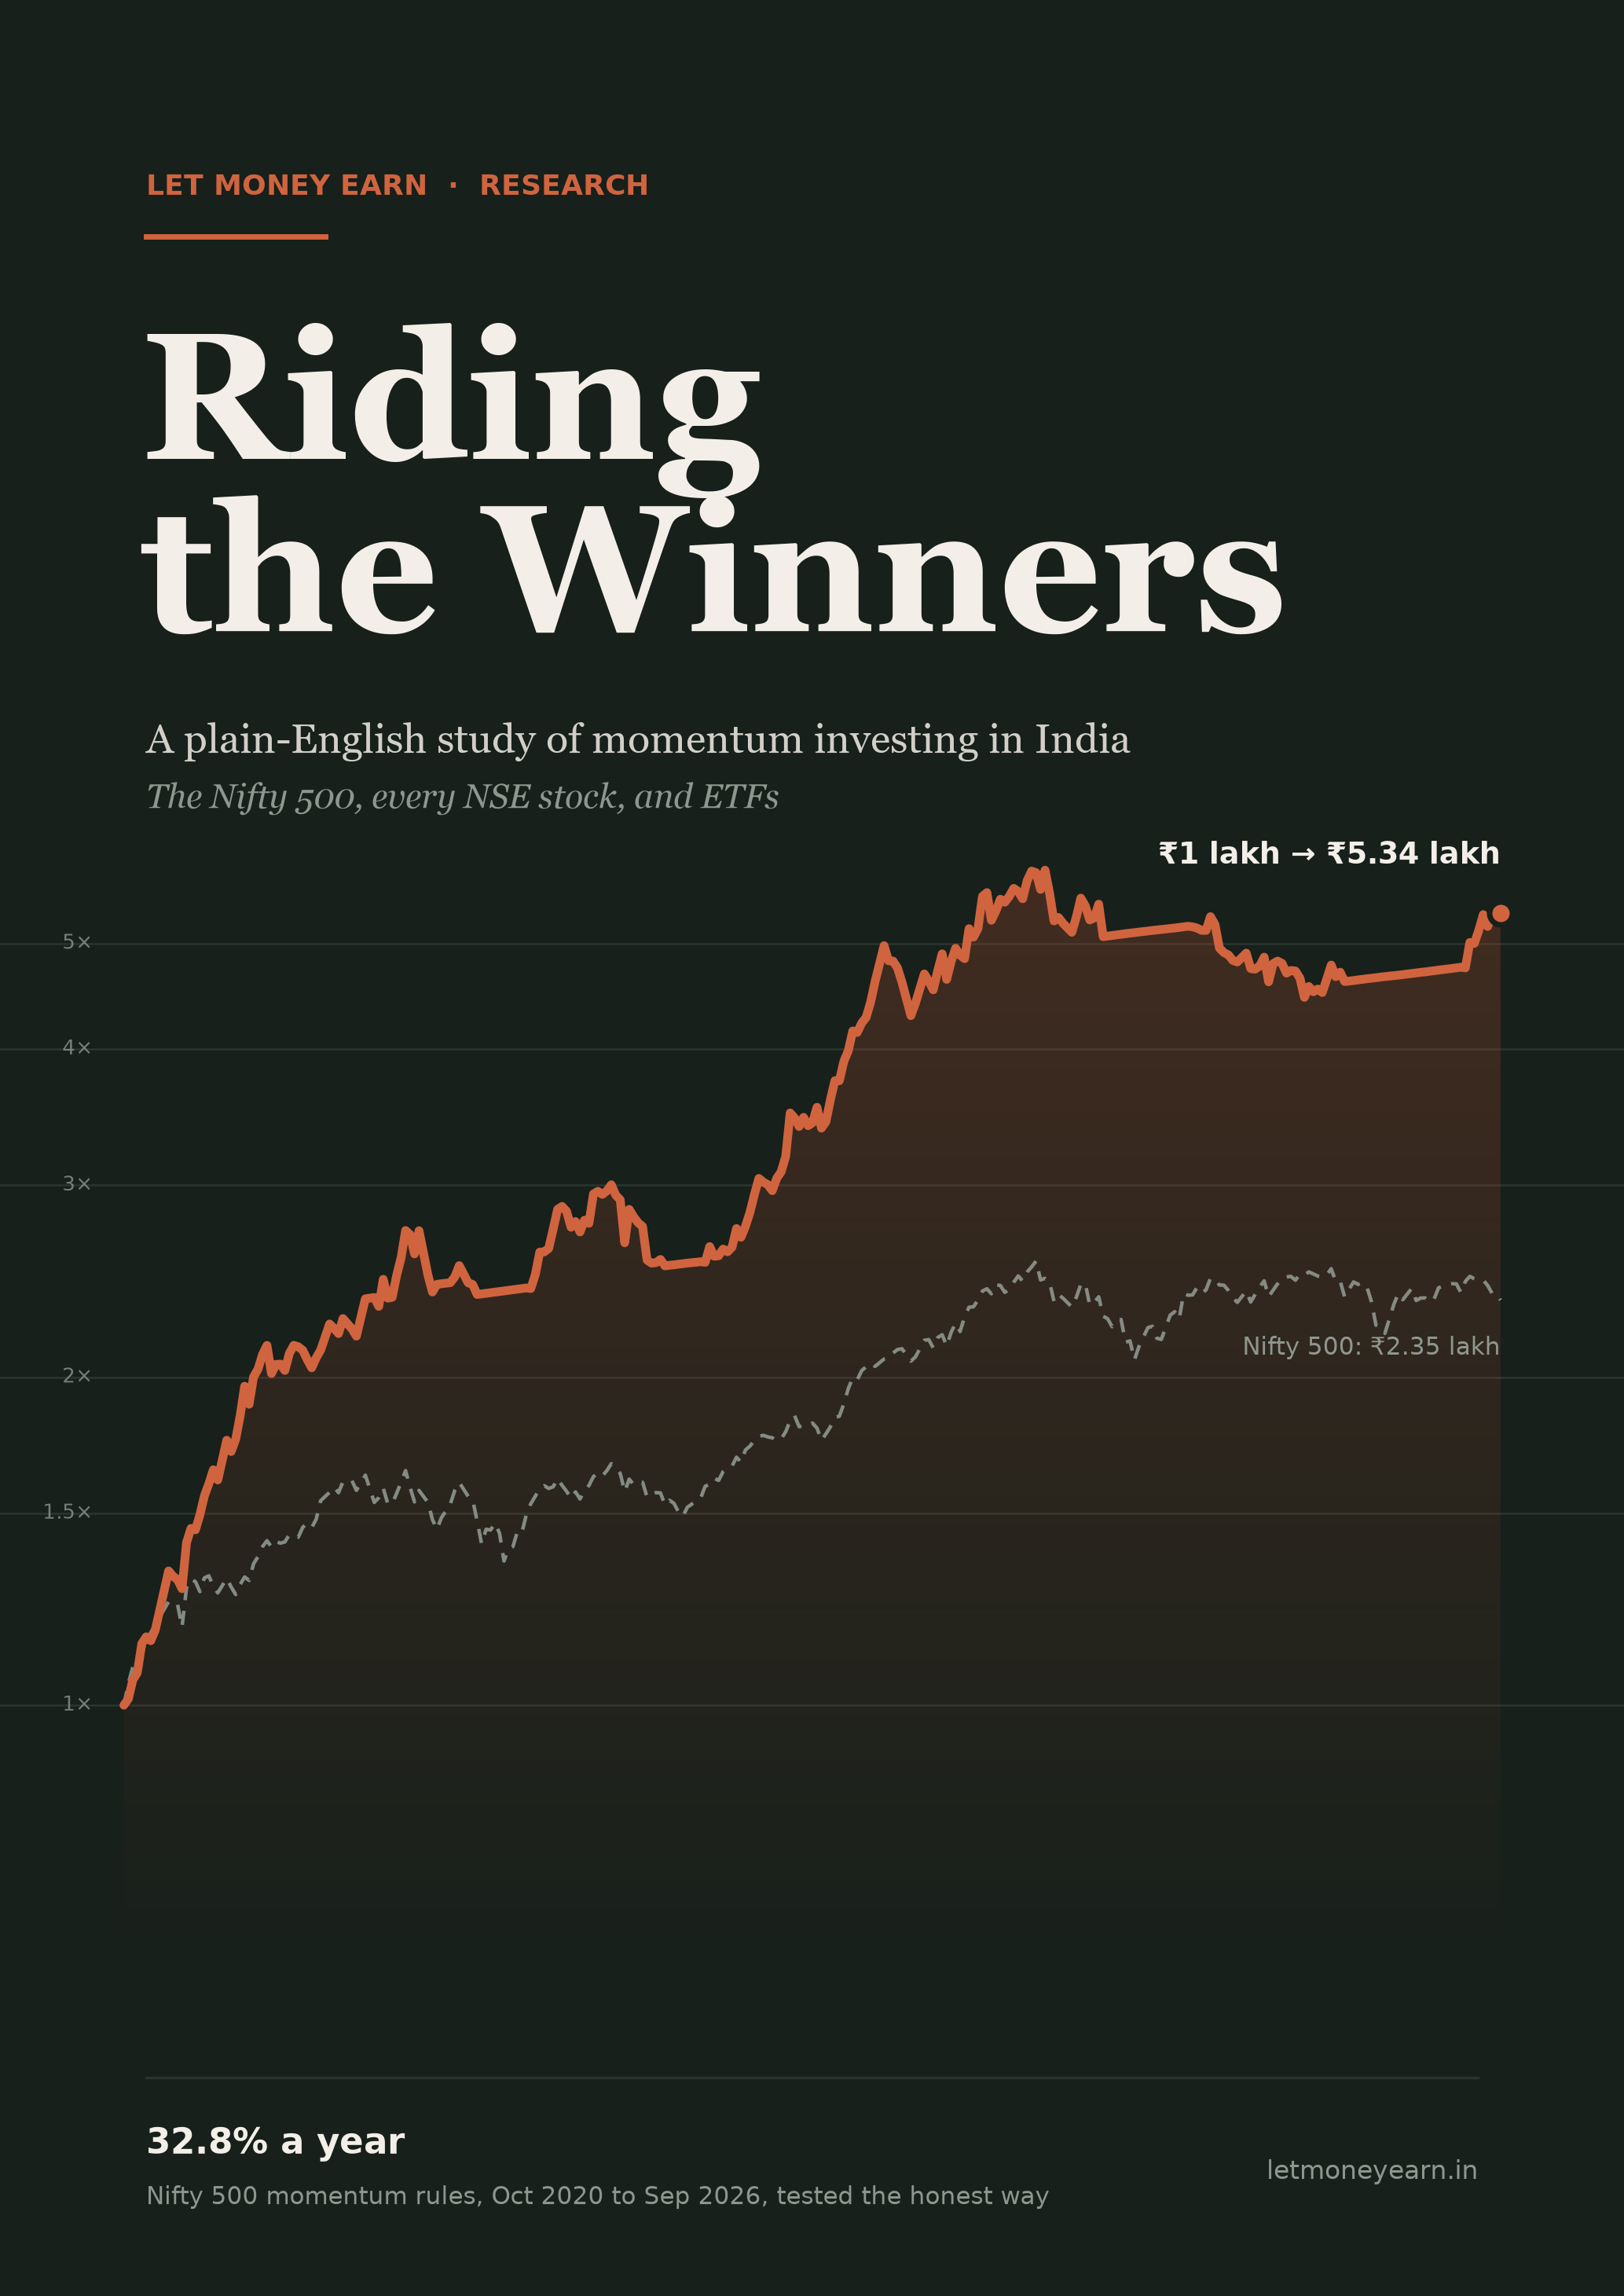

LET MONEY EARN · RESEARCH
Riding the Winners
A plain-English study of momentum investing in India: the Nifty 500, every NSE stock, and ETFs
What it is · where it came from · why it works · what the data shows · 32.8% a year on the Nifty 500, tested the honest way
Data to 24 Sep 2026

Before you read
This book is for information and education only. It is not investment advice and not a recommendation to buy or sell any security. Everything in it is based on a backtest: rules applied to past prices to see what would have happened. Backtests are hypothetical. Real trading has costs, delays and emotions that a backtest can't fully capture, and past results do not guarantee future returns. Stock names appear only because the rules picked them in the past; they are not suggestions. Please do your own research, and speak to a SEBI-registered adviser before investing.
Price data: Yahoo Finance. Index lists: NSE Indices (current and archived copies via the Wayback Machine). Chapter 11: NSE daily trading files and corporate-action lists. Chapter 11 benchmark: Nifty500 Momentum 50 index closes (to May 2026, then a Momentum 50 ETF). Study periods: Nifty 500 30 Oct 2020 to 24 Sep 2026; every NSE stock 29 Jan 2016 to 22 Sep 2026; ETFs 31 Oct 2017 to 25 Sep 2026.
© 2026 Let Money Earn. All rights reserved.

Contents
Introduction: the idea in one page 1
1. What is momentum investing? 2
A simple example 2
Two kinds of momentum 2
How momentum differs from other styles 3
What momentum is not 3
2. A short history of momentum 4
The traders (1900s to 1980s) 4
The academics catch up (1990s onwards) 4
Momentum in India 5
3. Why does momentum work, and why doesn't everyone do it? 6
Human behaviour 6
Risk 6
Why it hasn't been "arbitraged away" 6
What momentum asks of an investor 7
4. The strategy tested in this book 8
The monthly routine 8
The safety switch (checked every day) 8
How the score works 8
Why these particular rules? 9
5. How we tested it honestly 10
Trap 1: using today's list of stocks for the past 10
Trap 2: ignoring costs and taxes 11
Trap 3: trying many rules and keeping the best 11
What the test can't do 11
6. The results 12
The headline numbers 12
Year by year 12
The falls 13
Month by month 13
The trades 14
7. Stress tests: is it real? 15
Test 1: skill or luck? 15
Test 2: does it depend on one lucky setting? 15
Test 3: was the trading day lucky? 16
Test 4: survivorship bias 17
8. The safety switch: getting out of the way 18
Every time the switch moved to cash 18
Checking daily vs. once a month 19
Which moving average? 19
Should the waiting money go into gold? 20
Would a stop-loss help? 20
9. Costs, tax and how much money it can handle 21
Trading costs 21
Tax 21
How much money can it handle? 21
10. What it feels like to hold 23
You will spend most of your time below your last high 23
You will be wrong half the time 23
You will look foolish sometimes 23
Eggs in one basket 23
11. The same rules on every NSE stock 25
How it was tested 25
How many stocks, and how often? 25
Weekly beat monthly, from 25 stocks up 26
What the BE/BZ stocks and dividends added 27
The best combination in detail 27
Year by year 28
A different safety rule: the 50-day average of the Momentum 50 29
Is it the ranking, or just the filters? 30
How much money can it handle? 30
What the study shows 30
12. Momentum with ETFs 32
Why use ETFs? 32
The ETFs tested 32
The rules 33
The results 33
What it held 34
Does it depend on the settings? 35
The three studies side by side 36
13. Common mistakes, and questions people ask 37
Common mistakes 37
Questions people ask 37
Appendix A: Glossary 39
Appendix B: Data and method 40
Appendix C: Further reading 41

Introduction: the idea in one page
Most of us were taught one rule about the stock market: buy low, sell high. Momentum investing turns it on its head. It says: buy what is already going up, and sell it once it stops. Buy high, sell higher.
That sounds like chasing. It is, a little. But it is chasing with rules. You don't buy a stock because it's on the news or because a friend made money on it. You buy it because, measured calmly, it has risen more strongly and more steadily than almost everything else, and you sell it the moment it no longer does.
Does it work? For more than a hundred years, traders have said yes. For the last thirty, academic research has agreed: in markets all over the world, stocks that have done well over the past several months tend to keep doing well for a while longer. This book tests the idea on Indian stocks, carefully and honestly. From Oct 2020 to Sep 2026, a simple set of momentum rules on the Nifty 500 grew ₹1 lakh into about ₹5.34 lakh, or 32.8% a year. The Nifty 500 index grew ₹1 lakh into ₹2.35 lakh (15.6% a year) over the same period.
But the numbers are only half the story. The other half is what it feels like: the long months below your last high, the trades that lose, the times the rules sell right before the market bounces. A strategy only works if you can stick with it. So this book spends as much time on the pain as on the gain.
How to read this book. Chapters 1 to 3 explain what momentum is, where it came from and why it works. Chapters 4 to 9 describe our exact rules and put them through tough tests. Chapter 10 describes what holding it felt like. Chapter 11 runs the same rules on every stock on the NSE, Chapter 12 applies them to ETFs and compares all three studies, and Chapter 13 covers common mistakes and questions. If you only have ten minutes, read this introduction, Chapter 6 and Chapter 13.
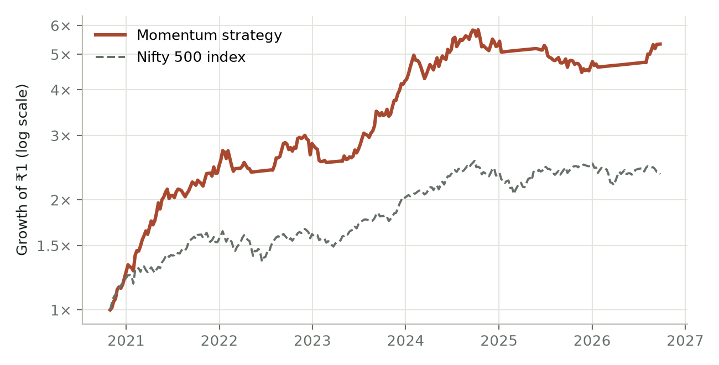
Figure 1. Growth of ₹1 with the momentum rules in this book, against the Nifty 500 index (Oct 2020 to Sep 2026). Log scale: equal percentage moves look the same size.

1. What is momentum investing?
Momentum is a word from physics: an object in motion tends to stay in motion. In investing it means the same thing. A stock that has been rising tends to keep rising for a while, and a stock that has been falling tends to keep falling. Not forever, and not every time, but often enough to build a strategy on.

A simple example
Imagine two stocks, A and B. A year ago both were at ₹100. Today both are at about ₹172. On paper, both returned the same. But look at how they got there.
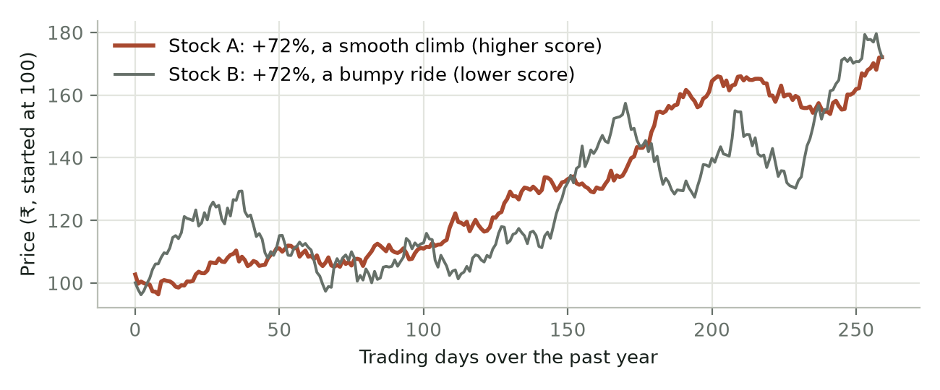
Figure 2. Two made-up stocks with the same one-year gain. A climbed steadily; B lurched up and down. A momentum investor prefers A.
Stock A climbed in a fairly smooth line. Stock B jumped up, crashed, jumped again. A momentum investor prefers A. Its rise looks like steady buying by many investors over many months, the kind of trend that tends to continue. B's rise looks like luck and noise. That is why the strategy in this book doesn't just rank stocks by how much they rose; it ranks them by how much they rose for each unit of bumpiness. You'll see exactly how in Chapter 4.

Two kinds of momentum
People use "momentum" for two related ideas. It helps to keep them apart:
- Relative momentum (also called cross-sectional momentum): compare stocks with each other and buy the strongest. "Of the 500 stocks in the Nifty 500, which 10 have been the best performers?" This is how our strategy picks stocks.
- Absolute momentum (also called time-series momentum or trend-following): compare an asset with its own past. "Is the market above or below where it has been on average over the last 200 days?" This is how our strategy decides whether to be in the market at all.
Our rules use both. Relative momentum chooses which stocks to own. Absolute momentum on the Nifty 500 decides whether to own stocks at all, or to wait safely in a liquid fund.

How momentum differs from other styles
Table 1. Momentum compared with other investing styles.
Style | What it buys | Why | Typical holding
Value | Cheap stocks (low price vs earnings, assets) | The market will eventually notice they are cheap | Years
Quality | Strong, profitable, low-debt businesses | Good businesses compound over time | Years
Growth | Companies growing sales and profits fast | Growth will continue and lift the price | Years
Momentum | Stocks whose prices are already rising strongly | Trends tend to persist for months | Months

Momentum is the only one of these that looks mainly at the price rather than the business. That makes it simple and fully rule-based: no forecasting, no reading annual reports, no opinions. It also makes it quite different from the others, which is why many investors use it alongside a value or quality portfolio rather than instead of one.

What momentum is not
- It is not day trading. Our strategy trades once a month, and a typical stock is held for about 91 days.
- It is not buying tips or hot stocks. Every buy and sell follows a written rule. Nothing is left to feel.
- It is not a way to get rich quickly or safely. It has had long losing stretches everywhere it has been studied. Chapter 10 covers them in detail.
- It is not predicting the future. The strategy never asks why a stock is rising, or whether it will rise. It only asks whether it is rising now, and reacts.

2. A short history of momentum
Momentum is not a new fad. Traders were using it a century ago, long before anyone could explain it. Academics ignored it for decades, then spent the last thirty years proving it and puzzling over why it works.

The traders (1900s to 1980s)
- Jesse Livermore (1900s to 1930s) was one of the most famous speculators in American history. His story, told in the 1923 book Reminiscences of a Stock Operator by Edwin Lefèvre, is full of momentum ideas: buy stocks that are making new highs, add to winners, cut losers quickly, and never argue with the market.
- George Chestnutt (1930s to 1960s) ran an American mutual fund using what he called relative strength: rank stocks and industries by how strongly they had risen, and own the leaders. He wrote that it is better to buy the leaders and leave the laggards alone.
- Nicolas Darvas (1950s), a professional dancer, turned a small sum into about two million dollars by buying stocks breaking out to new highs and protecting himself with stop-losses. His 1960 book How I Made $2,000,000 in the Stock Market is still widely read.
- Robert Levy (1967) published one of the first serious studies, Relative Strength as a Criterion for Investment Selection, in the Journal of Finance. He found that buying the strongest stocks beat the market. Many academics were unconvinced.
- Richard Driehaus and William O'Neil (1980s) made momentum mainstream among professional investors. Driehaus summed it up as "buy high, sell higher". O'Neil's CAN SLIM method, set out in his 1988 book How to Make Money in Stocks, includes "L" for Leader: buy the strongest stocks, not the laggards.
“It never was my thinking that made the big money for me. It always was my sitting.”
— Jesse Livermore, in Reminiscences of a Stock Operator (1923)

The academics catch up (1990s onwards)
For much of the 1970s and 1980s, finance professors believed markets were "efficient": prices already reflect all known information, so past prices can't predict future ones. Momentum should not exist. Then the evidence piled up.
- 1993: Jegadeesh and Titman. Narasimhan Jegadeesh and Sheridan Titman published Returns to Buying Winners and Selling Losers. Using US stocks from 1965 to 1989, they showed that buying the past 3 to 12 months' winners and selling the losers earned about 1% a month over the following months. This paper is the foundation of modern momentum research.
- 1997: Carhart. Mark Carhart showed that much of what looked like mutual-fund managers' skill was really momentum. Momentum became a standard "factor", alongside market, size and value, in how professionals measure returns.
- 2012 to 2013: momentum everywhere. Tobias Moskowitz, Yao Hua Ooi and Lasse Pedersen documented time-series momentum across futures markets (stock indices, bonds, currencies, commodities). Clifford Asness, Moskowitz and Pedersen then showed in Value and Momentum Everywhere that momentum works across countries and asset classes.
- 2016: two centuries of evidence. Christopher Geczy and Mikhail Samonov rebuilt US stock data back to 1801 and found momentum in the 1800s too, long before anyone wrote about it.
- 2016: the crashes. Kent Daniel and Tobias Moskowitz studied momentum crashes: rare, sudden periods when momentum loses very heavily, usually when a beaten-down market rebounds sharply (as in 1932 and 2009). This is momentum's biggest weakness, and a reason our rules include a market safety switch.

Momentum in India
Academic studies of Indian stocks have also found momentum effects, though Indian research has used shorter data histories than American studies. The idea became easy for ordinary investors to access when NSE Indices launched the Nifty200 Momentum 30 index in 2020, with history calculated back to 2005. Since then, NSE has added other momentum indices, and many mutual funds have launched momentum index funds and ETFs that track them.
Those funds are a simple way to get momentum exposure. The strategy in this book is different in a few ways: it looks at the wider Nifty 500, ranks stocks by return for each unit of risk, holds a concentrated 10 stocks, trades monthly, and steps out of the market entirely when the market is falling. Chapter 4 explains every rule.
Why a century of evidence matters. Any rule can look brilliant on a few years of data by luck. Momentum is different: it has been found in different centuries, countries and asset classes, by people who were trying to disprove it. That doesn't guarantee it will keep working, but it is far stronger evidence than a single good backtest.

3. Why does momentum work, and why doesn't everyone do it?
If buying winners works so well, why hasn't everyone done it until the effect disappeared? There are two kinds of answers: human behaviour and risk.

Human behaviour
- We react slowly to news. When a company's prospects improve, investors don't fully believe it at first. They wait for more proof. The price rises in steps as, one by one, investors catch up. Momentum rides that slow catching up.
- We sell winners too early and hold losers too long. Psychologists call this the disposition effect. Taking a profit feels good; selling at a loss feels like admitting a mistake. So winners are sold too soon (holding back their price rise) and losers are held too long (slowing their fall). The trends then play out over months instead of days.
- We anchor to old prices. "It was ₹200 last year, it can't be worth ₹400." Anchoring makes investors hesitant to buy a stock that has already risen, so the rise continues more slowly than it "should".
- We follow the crowd. Once a trend is visible, it attracts more buyers: news coverage, fund managers who need to own the winners, retail investors. That extends the trend, sometimes too far.

Risk
Some researchers argue momentum's returns are payment for a real risk: crashes. Momentum strategies occasionally lose very heavily in a short time, usually when a falling market suddenly reverses and last year's losers shoot up. Investors who earn momentum's extra returns are, in this view, being paid to accept that rare but painful risk.

Why it hasn't been "arbitraged away"
- It is uncomfortable. Momentum often means buying stocks that look expensive and selling ones that look cheap. It means long stretches of doing worse than the market. Most people give up at the worst moment.
- It costs money to run. The portfolio changes every month, so brokerage, taxes and price slippage eat into returns. Large funds can't trade small stocks without moving their prices.
- Professional fund managers risk their jobs. A manager who underperforms for two years may be fired, even if the strategy is sound. That career risk keeps many away.
The honest summary. Momentum seems to work because people are people: slow to react, reluctant to sell losers, eager to follow the crowd. It stays profitable partly because it is hard to stick with. The hardest part is not picking stocks. It is sticking to the rules when it hurts.

What momentum asks of an investor
Table 2. What the results mean in practice.
What the study found | What that asks of an investor
Every buy and sell follows a written rule | Following the rules without second-guessing them
A market check every day, trades once a month | A minute each day and some time at each month-end
A worst fall of 26% | Sitting through a large fall without selling in panic
Below its last high on 88% of days | Patience measured in years, not months
Only 51% of trades made money | Accepting that about half of all trades lose

4. The strategy tested in this book
Here is the complete rule book. There is nothing hidden: anyone with a spreadsheet and price data can follow it.

The monthly routine
- Start with the Nifty 500, as the index stood at that time. (Why "at that time" matters so much is the subject of Chapter 5.)
- Remove the weak and the illiquid. A stock stays on the list only if (a) its price is within 25% of its all-time high, (b) it closes above its 233-day average price, a sign of a long-term uptrend, and (c) on average at least ₹1 crore of its shares change hands each day, so it is easy to buy and sell.
- Score every remaining stock by how strongly and smoothly it has risen (explained below).
- Hold the top 10, with equal money in each when bought.
- Don't sell just for slipping a little. A stock you hold is sold only when it falls out of the top 30, or fails one of the filters in step 2. This buffer avoids needless trading.
- Trade once a month, on the last trading day. Money from sold stocks is split equally among the new buys.

The safety switch (checked every day)
Every day, compare the Nifty 500 index with its 200-day moving average (the average of its closing levels over the last 200 trading days, roughly the last ten months).
- If the Nifty 500 closes below its 200-day average three days in a row, sell everything that day and move the money into a liquid fund (a low-risk debt mutual fund, assumed here to earn 6.5% a year).
- Stay in the liquid fund until a month-end when the Nifty 500 is back above its 200-day average. Then buy the top 10 again.
Why three days? One day below the average often turns out to be a false alarm. Three in a row is a clearer sign that the market's trend has turned. Chapter 8 compares this choice with others.

How the score works
For each stock, we look at four periods: the last 252 trading days (about 12 months), 184 days (about 9 months), 126 days (6 months) and 63 days (3 months). For each period we calculate:
Score for the period = % return over the period ÷ annualised volatility
Volatility measures how much the price jumps around from day to day. Annualised volatility of 30% means the stock's daily moves are typical of a stock that swings around 30% in a year. The final score is the average of the four period scores.
Table 3. An example: the same return, different scores.
 | Stock A | Stock B
Return over the last 12 months | 60% | 60%
Annualised volatility | 25% | 50%
12-month score (return ÷ volatility) | 2.4 | 1.2

Both stocks returned 60%, but A did it with half the bumpiness, so it scores twice as high. Averaging four periods means a stock needs to have been strong over the long run and recently. A stock that shot up in the last month after a year of nothing won't rank near the top.

Why these particular rules?
- Near all-time high: momentum is strongest in stocks close to their peaks. Stocks far below their highs often have a problem.
- Above the 233-day average: a basic check that the long-term trend is up. (In practice, as Chapter 7 shows, stocks strong enough to rank in the top 10 are almost always in an uptrend already.)
- ₹1 crore daily turnover: avoids small, thinly traded stocks where buying and selling would move the price against you.
- Ten stocks: enough to spread risk, few enough to matter. Chapter 7 tests 5, 10, 15 and 20.
- The top-30 buffer: cuts trading roughly in half compared with selling anything that leaves the top 10, without hurting returns.
A note on these rules. They were written down before this study. They come from a working spreadsheet scanner, not from searching past data for the best-looking settings. Chapter 7 then tests what happens when each rule is changed.

5. How we tested it honestly
A backtest replays a strategy's rules on past prices to see what would have happened. It is the only way to test an idea without risking money, and also the easiest way to fool yourself. This chapter explains the traps and how the study avoided them.

Trap 1: using today's list of stocks for the past
The easy way to test a Nifty 500 strategy is to download today's list of 500 stocks and test on their past prices. That quietly cheats. Today's list contains the survivors: companies that did well enough to be in the index now. Companies that crashed, went bankrupt, merged or were dropped from the index are missing. Testing only on survivors is like judging a school by the students who graduated and ignoring those who dropped out. This error is called survivorship bias.
To avoid it, the study rebuilt the real Nifty 500 list for each past date. NSE only publishes today's list, but the Wayback Machine (web.archive.org) has saved copies of NSE's own list file over the years. The study found 9 such lists from Jul 2020 to Sep 2026. On each trading day, the backtest uses the latest list that existed on that day.
Table 4. The same rules on biased and honest stock lists.
Stock list | CAGR | Worst fall | Sharpe
Today's Nifty 500 list, used for every month (biased) | 36.0% | -21.5% | 1.31
Point-in-time Nifty 500 lists (honest) | 32.8% | -25.5% | 1.20

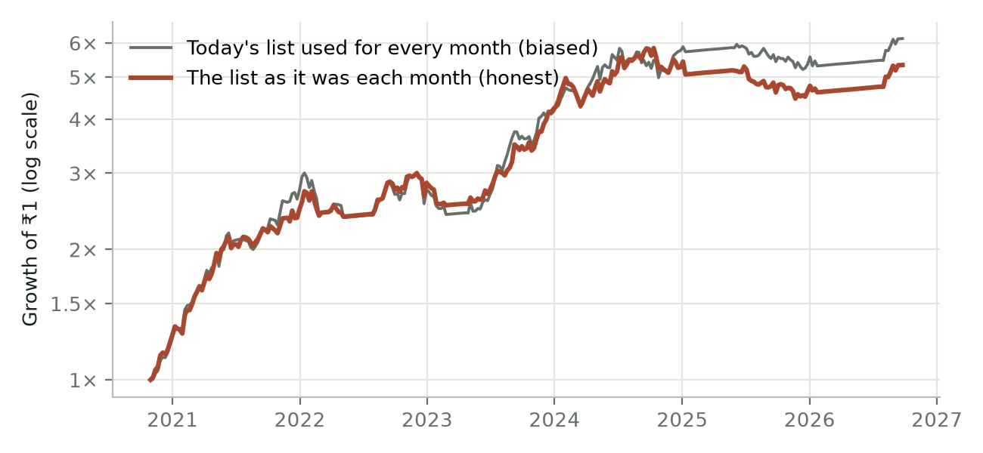
Figure 3. The same strategy, tested on today's list (biased) and on the list as it stood each month (honest).
The shortcut would have added about 3.2 pts a year to the result and made the worst fall look 4.0 pts smaller than it really was. Every number in this book uses the honest lists. If you ever see a momentum backtest on Indian stocks that doesn't say how it handled this, treat it with suspicion.

Trap 2: ignoring costs and taxes
Every trade costs money: brokerage, Securities Transaction Tax (STT), stamp duty, exchange charges, GST, and the gap between buying and selling prices. The study charges 0.25% on every buy and every sell. Chapter 9 shows results with higher costs, and after Indian capital-gains tax.

Trap 3: trying many rules and keeping the best
If you test enough versions of a strategy, one will look great by luck. The study guards against this in three ways: the rules were fixed before testing; Chapter 7 shows that small changes to them give similar results; and it compares the strategy with 200 random copies to check that the ranking really adds value.

What the test can't do
- Six years is short. The period (Oct 2020 to Sep 2026) was mostly a strong market for Indian stocks, with corrections in 2022 and 2024–25 but no crash like 2008 or March 2020. Chapter 11 tests the rules over a longer period that includes March 2020.
- Some past members are missing. A few companies that were in old Nifty 500 lists have no price history available (mostly merged or delisted ones). They are left out, so a small survivorship bias remains.
- Gaps between archived lists. No archived copy exists for some stretches (for example, July 2020 to May 2022). In those months the older list stays in use, so some index changes appear late.
- Prices are adjusted for splits but not dividends, for both the strategy and the index. Dividends would add a little to both.
- Trades are assumed at the closing price. Real trades may get slightly better or worse prices.

6. The results

The headline numbers
Table 5. Results from 30 Oct 2020 to 24 Sep 2026. Before tax, after 0.25% trading costs.
 | Momentum strategy | Nifty 500 index
Yearly growth (CAGR) | 32.8% | 15.6%
₹1 lakh became | ₹5.34 lakh | ₹2.35 lakh
Worst fall from a high (max drawdown) | -25.5% | -18.8%
Volatility (bumpiness) per year | 20.7% | 14.6%
Sharpe ratio (return for the risk taken) | 1.20 | 0.65
Trades | 151 | –
Share of trades that made money | 51% | –

Over about six years, the strategy grew money roughly 2.3 times as much as the Nifty 500. It also took more risk: its worst fall (-25.5%) was deeper than the index's (-18.8%), and its value jumped around more. The Sharpe ratio accounts for that: it measures return earned for each unit of bumpiness. The strategy's 1.20 against the index's 0.65 means it earned more even after allowing for its extra risk.

Year by year
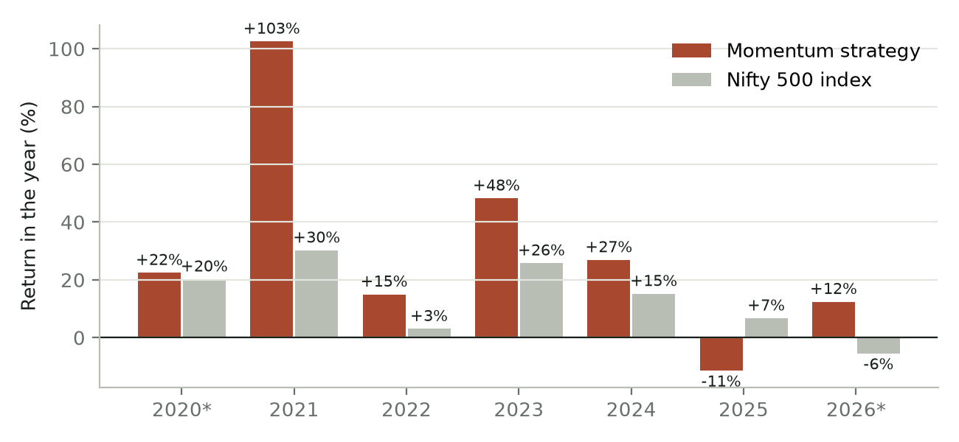
Figure 4. Return in each calendar year. * 2020 and 2026 are part-years.
Table 6. Returns by calendar year.
Year | Momentum strategy | Nifty 500 | Difference
2020 (part) | +22.5% | +20.2% | +2.2 pts
2021 | +102.5% | +30.2% | +72.3 pts
2022 | +15.0% | +3.0% | +11.9 pts
2023 | +48.2% | +25.8% | +22.5 pts
2024 | +26.9% | +15.2% | +11.7 pts
2025 | -11.5% | +6.7% | -18.2 pts
2026 (part) | +12.4% | -5.5% | +17.9 pts

The best year was 2021 (+103%), when strong stocks kept getting stronger. The worst was 2025 (-11.5%), a year when the strategy lagged the index. This pattern is typical: momentum makes most of its money in a few big years and can have frustrating years in between.

The falls
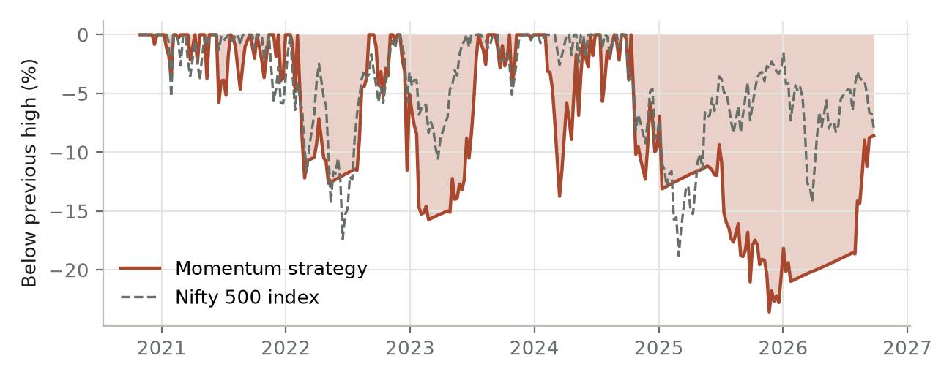
Figure 5. How far the strategy and the index were below their previous high at each point.
Table 7. The five biggest falls.
From a high on | To a low on | Fall | Back to the high on
23 Sep 2024 | 8 Dec 2025 | -25.5% | not yet
16 Nov 2022 | 22 Feb 2023 | -17.5% | 21 Jul 2023
8 Feb 2024 | 13 Mar 2024 | -16.0% | 27 May 2024
17 Jan 2022 | 24 Feb 2022 | -15.9% | 6 Sep 2022
3 Jun 2024 | 4 Jun 2024 | -12.9% | 14 Jun 2024

The worst fall started in Sep 2024 and bottomed in Dec 2025, 15 months later, and had not fully recovered by the end of the data. The safety switch moved to cash in January 2025, which stopped the fall from getting much deeper, but the portfolio still lost ground afterwards, both from the drop before the switch and from stocks that fell again after it re-entered.

Month by month
Out of 71 months, 72% were positive and the strategy beat the Nifty 500 in 61% of them. The best month gained +16.9% and the worst lost -9.9%. Some of the "positive" months were spent quietly in the liquid fund.

The trades
The strategy made 151 completed trades. Only 51% made money, not much better than a coin flip. But the average winning trade gained +38%, while the average losing trade lost only -10%. Winners were about 3.9 times bigger than losers. The five best trades alone made 27% of all profits.
Table 8. The five best trades.
Best trades | Bought | Sold | Return
ALKYLAMINE | Oct 2020 | Sep 2021 | +221%
APLAPOLLO | Oct 2020 | Sep 2021 | +161%
TRENT | Nov 2023 | Jan 2025 | +140%
TATAELXSI | Jan 2021 | Feb 2022 | +138%
FACT | Apr 2023 | Dec 2023 | +134%

Table 9. The five worst trades.
Worst trades | Bought | Sold | Return
FACT | Dec 2022 | Feb 2023 | -38%
OIL | Aug 2024 | Oct 2024 | -36%
ATGL | Jul 2022 | Jan 2023 | -33%
PCBL | Sep 2024 | Oct 2024 | -29%
BSE | May 2025 | Aug 2025 | -22%

This is the heart of momentum. You will be wrong about half the time. The strategy makes money because it cuts losers quickly (they drop out of the ranking) and lets winners run for as long as they stay strong. Anyone who sells winners early to "lock in profits", or holds losers hoping they come back, breaks the one thing that makes it work.

7. Stress tests: is it real?
A good-looking backtest proves little by itself. This chapter asks four hard questions.

Test 1: skill or luck?
The study ran 200 copies of the strategy with the same filters, costs and safety switch, but picking stocks at random from those that passed the filters instead of using the ranking. If the ranking were worthless, the real strategy would land in the middle of the random copies.
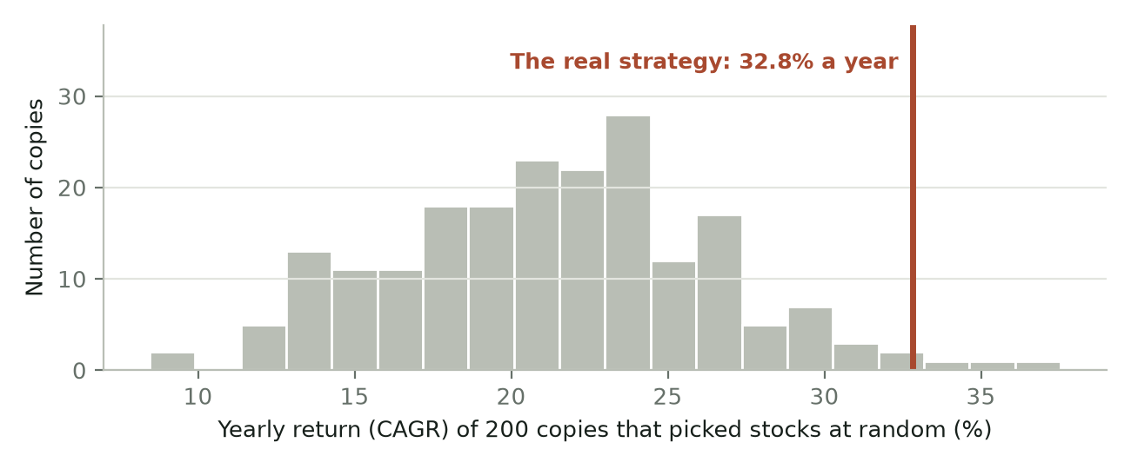
Figure 6. Yearly returns of 200 random copies (grey bars) and the real strategy (red line).
The random copies earned a median 21.4% a year (the middle 90% ranged from 13.6% to 29.3%). The real strategy earned 32.8% and beat 197 of the 200. The ranking adds real value. Notice too that the random copies beat the Nifty 500 (15.6%) on their own: the filters and the safety switch help even without the ranking.

Test 2: does it depend on one lucky setting?
If only the exact original settings worked, the result would probably be a fluke of fitting the past. Here each rule is changed while everything else stays the same.
Table 10. One rule changed at a time, everything else the same.
Change | CAGR | Worst fall | Sharpe
Our rules, unchanged | 32.8% | -25.5% | 1.20
Hold 5 stocks instead of 10 | 26.2% | -34.6% | 0.84
Hold 15 stocks | 33.2% | -18.8% | 1.25
Hold 20 stocks | 31.6% | -15.5% | 1.25
Sell when out of the top 10 (no buffer) | 30.8% | -28.2% | 1.08
Sell when out of the top 50 | 30.7% | -23.4% | 1.14
Score on 12 months only | 27.7% | -18.6% | 1.03
Score on 6 months only | 35.6% | -21.2% | 1.32
Must be within 15% of all-time high | 36.0% | -19.8% | 1.35
No all-time-high filter | 28.9% | -24.7% | 1.02
No 233-day trend filter | 32.8% | -25.5% | 1.20
Trade every 3 months, not monthly | 17.3% | -31.6% | 0.60

- Most changes move the result by a few points, not tens. That is a good sign: the strategy isn't balanced on a knife-edge.
- Holding more stocks cut the falls. With 15 or 20 stocks, the worst fall was -18.8% and -15.5%, against -25.5% with 10. Returns were similar, so holding 15 to 20 gave a noticeably smoother ride.
- Trading only every three months was clearly worse (17.3% a year). Momentum fades; the portfolio needs refreshing monthly.
- The trend filter never changed anything, because stocks strong enough to reach the top 10 are almost always in an uptrend anyway.

How many stocks to hold vs. when to sell
Table 11. Yearly return (and worst fall) for each combination.
 | Sell when out of top 10 | Sell when out of top 20 | Sell when out of top 30 | Sell when out of top 50
Hold top 5 | 30.5% (-32%) | 25.5% (-30%) | 26.2% (-35%) | 28.9% (-23%)
Hold top 10 | 30.8% (-28%) | 30.6% (-24%) | 32.8% (-26%) | 30.7% (-23%)
Hold top 15 | – | 31.1% (-19%) | 33.2% (-19%) | 35.2% (-21%)
Hold top 20 | – | 31.7% (-16%) | 31.6% (-15%) | 33.7% (-18%)

Every combination made money, and none depends on luck of one setting. Holding more stocks consistently reduced the worst fall. Selling sooner ("out of top 10") did not help and meant much more trading.

Test 3: was the trading day lucky?
Table 12. The same strategy traded on different days of the month.
Trade on | CAGR | Worst fall | Sharpe
Last trading day (our rule) | 32.8% | -25.5% | 1.20
1 day before month-end | 31.3% | -31.2% | 1.13
2 days before | 28.9% | -29.3% | 1.05
3 days before | 29.7% | -25.2% | 1.09
5 days before | 29.7% | -22.7% | 1.11
Mid-month (15th) | 29.0% | -21.7% | 1.06

Whichever day you trade, the strategy works, earning 28.9% to 32.8% a year. But the month-end day used in this book happened to be the best of these, so expect a couple of points less in real life. It's honest to plan for that.

Test 4: survivorship bias
Covered in Chapter 5: the honest lists cost about 3.2 pts a year compared with using today's list, and every number in this book already includes that.

8. The safety switch: getting out of the way
Momentum's biggest danger is a falling market. When the whole market drops, yesterday's winners often drop hardest. The safety switch is designed to step aside during those periods and wait in a liquid fund.
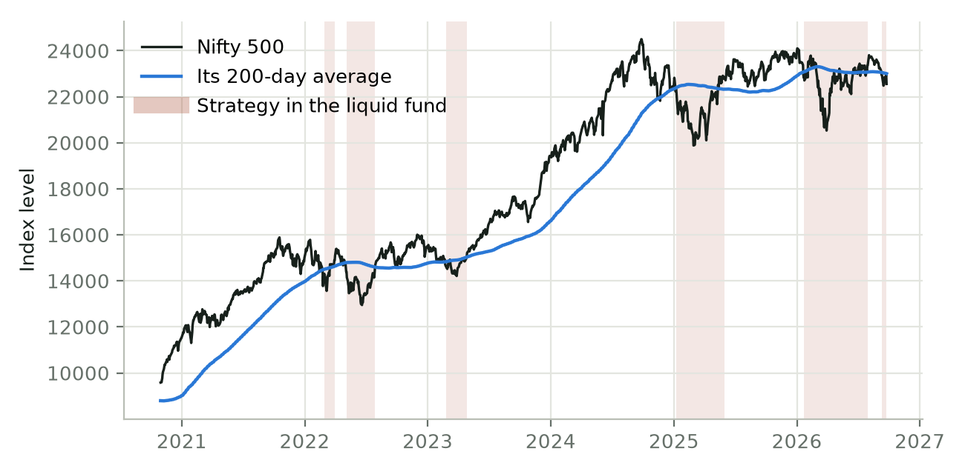
Figure 7. The Nifty 500, its 200-day average, and the periods the strategy spent in the liquid fund (shaded).

Every time the switch moved to cash
Table 13. The strategy's periods in the liquid fund.
Sold everything on | Bought back on | Nifty 500 meanwhile | Liquid fund
28 Feb 2022 | 31 Mar 2022 | +4.1% | +0.5%
5 May 2022 | 29 Jul 2022 | +1.9% | +1.5%
24 Feb 2023 | 28 Apr 2023 | +4.0% | +1.0%
8 Jan 2025 | 30 May 2025 | +2.6% | +2.4%
22 Jan 2026 | 31 Jul 2026 | +2.0% | +3.2%
11 Sep 2026 | still out | -1.4% | +0.2%

In this period the switch often stepped out just before the market steadied, so the index was slightly higher by the time the strategy bought back. That is the price of insurance: most of the time it costs a little. It pays off in a long, deep fall, which this six-year period didn't have. The longer whole-NSE test in Chapter 11 did include one: in the March 2020 crash the Nifty 500 fell 33% from its February level, while the rules there (top 30 stocks, weekly) fell 4%, having moved to the liquid fund early in the fall. The 2008 crash, when Indian stocks fell by more than half, is the kind of event the switch is designed for.

Checking daily vs. once a month
Table 14. How quickly the safety switch reacts.
Market check | CAGR | Worst fall | Sharpe
200-DMA, checked at month-end only | 26.7% | -37.8% | 0.92
200-DMA, exit after 1 close below | 31.4% | -30.0% | 1.17
200-DMA, exit after 2 closes in a row below | 32.8% | -22.9% | 1.20
200-DMA, exit after 3 closes in a row below (our rule) | 32.8% | -25.5% | 1.20
200-DMA, exit after 5 closes in a row below | 30.0% | -29.0% | 1.08
No safety switch (always invested) | 29.0% | -37.8% | 0.91

Checking the market only at month-end meant waiting up to a month while the market fell. Checking daily and acting after three closes in a row below the average cut the worst fall from -37.8% to -25.5%, and lifted the return from 26.7% to 32.8%. Acting after just one day meant more false alarms. Two or three days worked best, but with so few exits in six years, don't read too much into the exact number.

Which moving average?
A shorter average follows the market closely and reacts to small dips. A longer one moves slowly and only reacts to bigger falls. Here is the same strategy with four different averages behind the switch.
Table 15. The safety switch with different moving averages.
Safety switch | CAGR | Worst fall | Sharpe | Times sold out | Time invested | After tax
50-day average | 26.9% | -13.6% | 1.11 | 15 | 57% | 23.3%
100-day average | 31.7% | -14.2% | 1.24 | 9 | 67% | 27.9%
150-day average | 34.0% | -28.8% | 1.27 | 6 | 73% | 29.9%
200-day average (our rule) | 32.8% | -25.5% | 1.20 | 6 | 76% | 29.0%

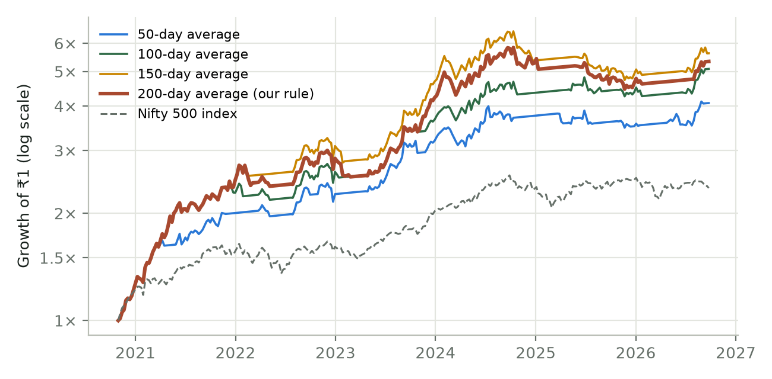
Figure 8. Growth of ₹1 with each moving average behind the safety switch.
- The 200-day average kept the most return, with a worst fall of -25.5%. It sold out only 6 times and stayed invested 76% of the time, so it caught the big rallies. (The 150-day did slightly better here, 34.0%, but with a deeper fall of -28.8%; a gap that small is within luck.)
- The 100-day average gave up a little return for much smaller falls: it kept the worst fall to -14.2% while earning 31.7% a year.
- The 50-day average cost the most: it sold out 15 times, spent 43% of the time in cash, missed much of the big rallies, and earned 23.3% after tax against 29.0% for the 200-day.
No single best answer. The choice is a trade-off between return and the depth of the falls along the way. A backtest can measure both; it can't say which an individual investor would actually sit through.

Should the waiting money go into gold?
Instead of a liquid fund, the study tried parking the money in GOLDBEES, a gold ETF, whenever the switch said stay out. Gold added 2.1 pts a year, but the ride got bumpier (volatility 24.2% vs 20.7%) and the Sharpe ratio fell from 1.20 to 1.12. Nearly all of the gain came from one spell in early 2025, when gold rallied sharply. In another spell (2026), gold fell while the liquid fund kept earning. The liquid fund's job is to keep money safe while you wait. Gold turns the wait into a second bet.

Would a stop-loss help?
A stop-loss sells a stock as soon as it falls, say, 10% during the month. It sounds sensible. It didn't help. On the honest lists, a 10% stop cut the return from 32.8% to 25.4% a year. When the stop sold a stock, it had bounced back by the next month-end 50% of the time: a 10% dip in a strong stock is usually just noise. The stop also made the worst fall deeper, not shallower (-28.6% against -25.5%). A trailing 10% stop did worse (22.1% a year), and wider stops of 15% and 20% still earned less than no stop (29.7% and 31.7%). To limit losses, the market safety switch works; individual stop-losses mostly add trades and costs.

9. Costs, tax and how much money it can handle

Trading costs
Table 16. The effect of trading costs.
Cost on each buy and sell | CAGR | Worst fall | Sharpe
0.1% | 33.7% | -24.7% | 1.23
0.25% (used in this book) | 32.8% | -25.5% | 1.20
0.5% | 31.3% | -26.8% | 1.14
1% | 28.3% | -29.3% | 1.02

Costs matter because the portfolio turns over about 2.4 times a year. With a discount broker, total costs (brokerage, STT, stamp duty, exchange fees, GST, and the buy-sell price gap) for liquid Nifty 500 stocks are usually around 0.2% to 0.3% per trade.

Tax
Profits on shares held for under a year are short-term capital gains, taxed at 20% (15% before 23 July 2024). Held for a year or more, they are long-term, taxed at 12.5% above an exemption limit (10% before 23 July 2024). Losses can be set off against gains. Because a typical stock is held for about 91 days, most profits here are short-term.
Table 17. Tax applied to every profit, year by year.
 | CAGR
Before tax | 32.8%
After capital-gains tax | 29.0%

Tax took about 3.9 pts a year. The study slightly overstates tax for small accounts, because it ignores the yearly long-term gains exemption. Tax rules change; check the current rules or ask a tax adviser.

How much money can it handle?
A large buy order in a small stock pushes its price up before you finish buying. The study compares each purchase with how much of that stock normally trades in a day.
Table 18. Each buy compared with the stock's normal daily trading.
Starting capital | Typical buy as % of a day's trading | Buys over 10% of a day's trading
₹10 lakh | 0.0% | 0%
₹1 crore | 0.2% | 1%
₹10 crore | 1.9% | 4%
₹100 crore | 19.1% | 69%

Buying more than about 10% of a day's trading is hard without moving the price. Up to about ₹10 crore, the buys are small next to these stocks' daily trading. At ₹100 crore, 69% of buys would be too big. For individual investors, size is not a problem.

10. What it feels like to hold
Backtest charts go up and to the right. Living through them doesn't feel that way. This chapter is about the experience, because that is what decides whether you earn the returns.

You will spend most of your time below your last high
The strategy was below its previous high on 88% of trading days. Most of the time, you will be looking at a portfolio worth less than it once was. New highs arrive in bursts, often after long waits. That is normal for any growth investment, and especially for momentum.

You will be wrong half the time
About 49% of trades lose money. Some lose 38% or more. You'll buy a stock at the top of the rankings and watch it fall the next month. Each individual trade will often feel like a mistake. Only the whole collection of trades works.

You will look foolish sometimes
- The safety switch will sell everything, and the market will rise the next week. It happened several times in this study.
- Your portfolio will lag the index for a whole year, as it did in 2025, while friends in index funds or "safe" stocks do better.
- You will own stocks that everyone says are overpriced, and sell stocks that look cheap.
The one thing to remember. Most people who give up on a strategy give up near the bottom, right before it recovers. Every number in this book assumes the rules were followed through every fall; an investor who stopped at the worst moment would have earned far less.

Eggs in one basket
No rule limits how much goes into one industry. On average the biggest industry made up 31% of the portfolio, and at one point 69%. When a sector is hot, momentum piles into it. That boosts returns in a boom and hurts in a bust.
Table 19. Average share of the portfolio by industry.
Industry | Average share of the portfolio
Capital Goods | 16%
Financial Services | 16%
Chemicals | 9%
Information Technology | 8%
Consumer Durables | 8%
Healthcare | 7%
Power | 6%
Consumer Services | 6%

11. The same rules on every NSE stock
Everything in Chapters 4 to 10 was tested on the Nifty 500. But more than 2200 companies traded on the NSE during the last ten years, and momentum is often strongest in the smaller ones outside the index. This chapter runs the same rules on every stock on the NSE, from Jan 2016 to Sep 2026 (10.6 years), and asks two practical questions: how many stocks should you hold, and should you rebalance every week or every month? It then tests a different safety rule.

How it was tested
- The stocks: NSE's own daily trading files, which list every stock that traded each day, including companies that later merged, were delisted or collapsed. So there is no survivorship bias of the kind Chapter 5 warns about: a stock enters the test when it starts trading and leaves when it stops, just as it did for real investors. 2,213 stocks passed the ₹1 crore turnover floor at some point.
- All series are included. Besides the normal EQ series, NSE moves some stocks into the BE and BZ series for extra surveillance or non-compliance. These trade for delivery only (no intraday trading) and often have tighter circuit limits. They can be bought, so the test includes them; the section below shows what they added and what that is worth in practice.
- The prices were adjusted for 808 splits and bonus issues, and 345 renamed stocks were joined to their new symbols. ETFs were excluded.
- Dividends are included. 14,547 dividends from NSE's corporate-action list are paid into cash on the ex-date and go into the next buys.
- The rules are the ones in Chapter 4: the same score, the same three filters (within 25% of the high, above the 233-day average, ₹1 crore traded a day), the same Nifty 500 safety switch and liquid fund, and 0.25% per trade.
- What changes: the number of stocks held (top 10 to top 50), the sell rule (a stock is sold once it falls below twice that rank: top 30 is sold below rank 60), and how often the portfolio is rebalanced (at each week's last close, or each month's).
Not the same test as Chapter 6. The period is longer (Jan 2016 onwards, not Oct 2020), the stock list is far wider, and the sell rule is different. The Nifty 500 itself earned 12.8% a year over this period. Compare the combinations in this chapter with each other and with the index, not with the numbers in Chapter 6.

How many stocks, and how often?
Table 20. Every combination on the whole NSE, 29 Jan 2016 to 22 Sep 2026. Before tax, after 0.25% costs, with dividends. Nifty 500: 12.8% a year, worst fall -38.3%.
Stocks held | Weekly: CAGR | Worst fall | Sharpe | Monthly: CAGR | Worst fall | Sharpe
Top 10 (sell below 20) | 33.9% | -51.3% | 1.13 | 32.8% | -46.1% | 1.12
Top 15 (sell below 30) | 34.2% | -44.5% | 1.25 | 35.3% | -39.8% | 1.30
Top 20 (sell below 40) | 34.4% | -34.5% | 1.31 | 35.4% | -37.5% | 1.37
Top 25 (sell below 50) | 36.7% | -33.4% | 1.43 | 34.2% | -33.1% | 1.37
Top 30 (sell below 60) | 37.2% | -25.9% | 1.50 | 35.0% | -32.1% | 1.45
Top 35 (sell below 70) | 36.3% | -26.4% | 1.48 | 33.1% | -30.6% | 1.39
Top 40 (sell below 80) | 35.0% | -25.9% | 1.44 | 32.2% | -30.0% | 1.37
Top 45 (sell below 90) | 34.0% | -25.1% | 1.42 | 31.8% | -30.5% | 1.36
Top 50 (sell below 100) | 33.7% | -24.3% | 1.42 | 31.2% | -31.4% | 1.34

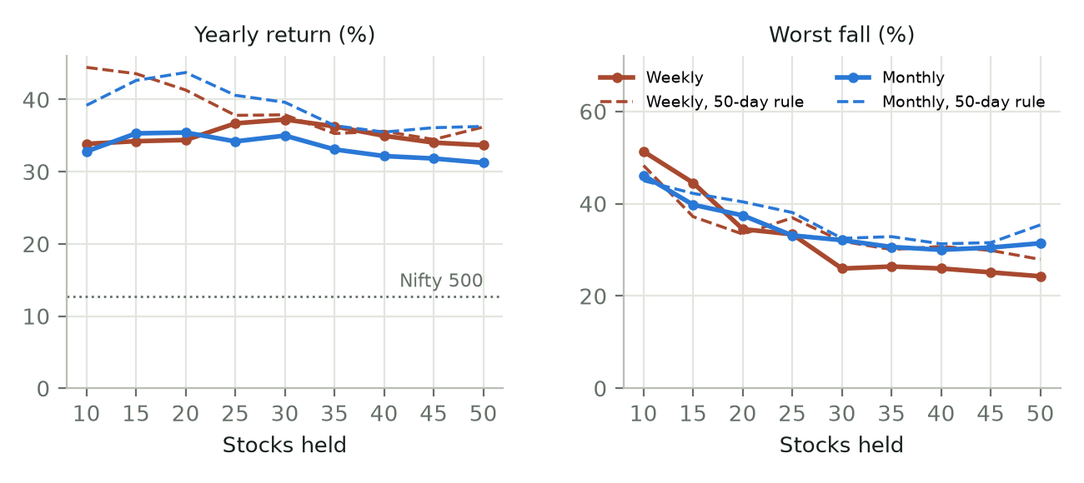
Figure 9. Yearly return and worst fall for each number of stocks held, rebalanced weekly and monthly. Dashed lines: the 50-day rule described later in this chapter.
- Every combination beat the Nifty 500 comfortably, earning 31% to 37% a year against the index's 12.8%.
- Ten stocks is too few on the whole NSE. Top 10 had the deepest falls (-51.3% weekly, -46.1% monthly) and, over its worst 3-year stretch, earned less than a liquid fund (0.3% and 1.3% a year). The stocks at the very top of an all-NSE ranking are often small and fast-moving; ten of them swing too much together.
- Around 25 to 35 stocks was the sweet spot. Weekly top 30 earned 37.2% a year with a worst fall of only -25.9%; top 25 (36.7%, -33.4%) and top 35 (36.3%, -26.4%) were close behind. That neighbouring settings agree matters more than which one came first.
- Beyond 30, little is gained. Holding 50 weekly trimmed the worst fall to -24.3% but gave up 3.6 pts a year against top 30, and meant many more orders.

Weekly beat monthly, from 25 stocks up
From 25 stocks upward, rebalancing every week earned more than every month, and from 30 upward it also fell less. At 30 stocks the gap was 2.2 pts a year (37.2% against 35.0%), with a worst fall of -25.9% against -32.1%. With 15 or 20 stocks, monthly made slightly more. There are two reasons weekly helps:
- Fading stocks are sold within a week, not up to a month later. In small stocks a month is a long time to hold something that has stopped working.
- The money goes back in sooner after the safety switch. Monthly waits for a month-end above the Nifty 500's 200-day average; weekly buys back at the first week-end above it. The weekly version was invested 76% of the time against 69%.
The price is more trading: about 4.0 portfolio turns a year weekly against 2.5 monthly. Even if every trade cost 0.5% instead of 0.25%, weekly top 30 still earned 34.5% against 33.1% for monthly.

What the BE/BZ stocks and dividends added
Letting in the BE and BZ series added a lot. Weekly top 30 earned 33.5% a year when it could buy only EQ-series stocks, and 37.2% with all series allowed. At 10 stocks the gap was far bigger (24.9% against 33.9%), carried by a handful of trade-to-trade winners.
Some of that gain could not have been captured. 17% of BE/BZ closing prices were locked at the upper circuit (the day's high, after a rise), against 1.7% of EQ closes. At a locked upper circuit there are buyers but no sellers, so a real buy order would usually not fill. Skipping those buys and taking the next stock instead brought weekly top 30 down to 35.5%, still ahead of EQ only. The reverse problem, a holding stuck at its lower circuit that can't be sold, is not modelled and flatters the result further.
Dividends added under a point a year: weekly top 30 made 36.5% without them. Momentum stocks tend to pay little.

The best combination in detail
Table 21. Three combinations side by side, with two indices. The Nifty500 Momentum 50 index is the ready-made fund version of the momentum idea. Both indices are price indices, without dividends.
 | Top 30, weekly | Top 30, monthly | Top 20, monthly, 50-day rule | Momentum 50 index | Nifty 500
Yearly growth (CAGR) | 37.2% | 35.0% | 43.7% | 17.7% | 12.8%
₹1 lakh became | ₹29.07 lakh | ₹24.41 lakh | ₹47.60 lakh | ₹5.66 lakh | ₹3.60 lakh
Worst fall | -25.9% | -32.1% | -40.4% | -39.4% | -38.3%
Sharpe ratio | 1.50 | 1.45 | 1.51 | 0.60 | 0.44
After capital-gains tax | 32.7% | 30.9% | 39.6% | – | –
Worst 3 years, per year | 14.5% | 6.2% | 21.0% | -3.8% | -6.8%
Worst 12 months | -18.3% | -21.4% | -33.1% | -30.6% | -33.2%
To 2020 / from 2021, per year | 30% / 44% | 23% / 46% | 39% / 48% | 15% / 20% | 13% / 13%

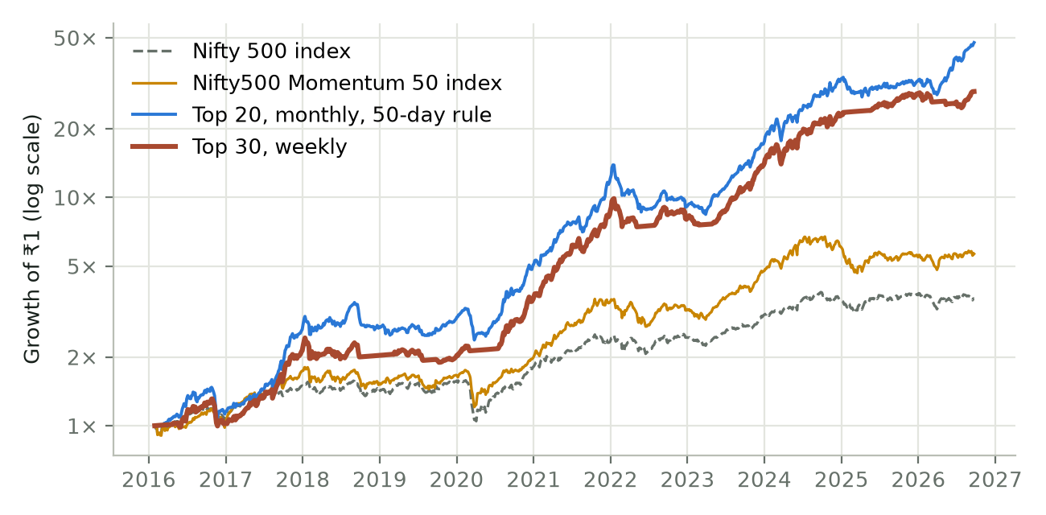
Figure 10. Growth of ₹1 on the whole NSE, log scale. Flat stretches in the weekly line are times the safety switch had the money in the liquid fund.
Weekly top 30 grew ₹1 lakh into about ₹29.07 lakh while the Nifty 500 grew it into ₹3.60 lakh. It did well in both halves of the period (29.9% a year to 2020, 43.7% from 2021), and it was ahead of the index over every 3-year stretch. Its trades look like Chapter 6's: only 45% made money, but the average winner gained +33% and the average loser lost -9%, and a typical stock was held for about 7 weeks.
Against the ready-made momentum index. The Nifty500 Momentum 50 index, which index funds and ETFs track, earned 17.7% a year with a worst fall of -39.4%. Weekly top 30 beat it by about 19.6 pts a year, and even buying EQ stocks only and after tax it stays well ahead. The index holds larger stocks, changes only twice a year and never steps out of the market, so it took the full falls of 2018–20 (-39%) and 2024–25 (-32%). A fund also needs no work and has none of the small-stock trading problems above, so the backtest gap overstates what a person running the rules by hand would keep.

Year by year
Table 22. Returns by calendar year.
Year | Top 30, weekly | Top 20, monthly, 50-day rule | Momentum 50 index | Nifty 500
2016 (part) | +2.2% | +15.1% | +3.9% | +10.1%
2017 | +108.7% | +129.0% | +67.2% | +35.9%
2018 | -4.7% | +2.9% | -11.5% | -3.4%
2019 | -1.3% | +8.4% | +7.8% | +7.7%
2020 | +80.9% | +71.4% | +19.9% | +16.7%
2021 | +142.9% | +141.4% | +77.8% | +30.2%
2022 | -7.0% | -24.9% | -8.3% | +3.0%
2023 | +70.1% | +90.3% | +46.7% | +25.8%
2024 | +63.8% | +88.4% | +26.3% | +15.2%
2025 | +25.7% | -0.0% | -7.9% | +6.7%
2026 (part) | +1.3% | +45.5% | +2.5% | -4.5%

Most of the gain came in a few big years (2017, 2020–21 and 2023–24), when small and mid-sized stocks rallied. 2018, 2019 and 2022 lost money for every combination tested (2018: -21% to -5%; 2022: -36% to -1%).
The worst fall for weekly top 30 came fast: it fell 25.9% in 20 trading days in Nov 2016, the demonetisation shock, too quick for the safety switch. The slower ones were harder to live with: from Jan 2022 it fell 25.3% and did not get back to that high until Aug 2023, and a 23% fall from Jan 2018 took until Aug 2020 to recover, about two and a half years. Chapter 10 describes what stretches like this feel like.

A different safety rule: the 50-day average of the Momentum 50
The Chapter 4 safety switch sells everything when the Nifty 500 closes below its 200-day average three days in a row. The study also ran every combination with a gentler rule in its place, one that never sells what you hold:
- No new buys while the Nifty500 Momentum 50 index closes below its 50-day average. Holdings are still sold when they fall below twice the target rank; the money from those sales waits in the liquid fund.
- On the first day it closes back above its 50-day average, the empty slots are filled, that same day, without waiting for the next rebalance.
- There is no switch to the liquid fund. The portfolio stays close to fully invested.
Table 23. Yearly return / worst fall with each safety rule.
Stocks held | Weekly: 200-day switch | Weekly: 50-day rule | Monthly: 200-day switch | Monthly: 50-day rule
Top 10 | 34% / -51% | 44% / -48% | 33% / -46% | 39% / -45%
Top 15 | 34% / -45% | 44% / -37% | 35% / -40% | 43% / -42%
Top 20 | 34% / -34% | 41% / -33% | 35% / -37% | 44% / -40%
Top 25 | 37% / -33% | 38% / -37% | 34% / -33% | 41% / -38%
Top 30 | 37% / -26% | 38% / -32% | 35% / -32% | 40% / -32%
Top 35 | 36% / -26% | 35% / -30% | 33% / -31% | 36% / -33%
Top 40 | 35% / -26% | 36% / -31% | 32% / -30% | 35% / -31%
Top 45 | 34% / -25% | 34% / -30% | 32% / -30% | 36% / -32%
Top 50 | 34% / -24% | 36% / -28% | 31% / -31% | 36% / -35%

- More return in 17 of 18 combinations, and a better Sharpe ratio in 11. The gain was largest with few stocks or monthly rebalancing: monthly top 20 earned 43.7% a year (Sharpe 1.51) and weekly top 15 43.6%, against 35.4% and 34.2% with the 200-day switch.
- Deeper falls with 25 stocks or more. Weekly top 30 fell -31.9% at worst with the 50-day rule, against -25.9% with the switch, and its worst 12 months went from -18.3% to -26.2%. Staying invested 99% of the time, against 76%, is where both the extra return and the deeper falls come from.
- It does not protect in a crash. In March 2020 monthly top 20 with the 50-day rule fell 26%, close to the Nifty 500's 33%, while weekly top 30 with the 200-day switch fell only 4%.
- Much of its edge came in 2023 and 2026, when the 200-day switch sat out rallies. Ten years hold only a few deep falls, so this could reverse in the next one.

Is it the ranking, or just the filters?
As in Chapter 7, the study replaced the ranking with random picks from the same filtered list, 10 times for each combination. Random picks at 30 stocks weekly already earned about 21.0% a year, well ahead of the Nifty 500: on the whole NSE, simply owning stocks near their highs and in an uptrend, with the safety switch on, did a lot of the work. Ranking by the momentum score added 16.3 pts a year on top. The best of the 10 random runs earned 24.8%, still well below the ranked version.

How much money can it handle?
Table 24. Weekly top 30: each buy compared with the stock's normal daily trading.
Starting capital | Typical buy as % of a day's trading | Buys over 10% of a day's trading
₹10 lakh | 0.1% | 0%
₹1 crore | 0.7% | 7%
₹10 crore | 6.8% | 41%
₹100 crore | 68.0% | 83%

This is where the whole NSE differs most from the Nifty 500. The stocks are smaller, so money runs out of room sooner. At ₹1 crore a typical buy is 0.7% of a day's trading, which is fine, though 7% of buys are already large for the stock. At ₹10 crore a typical buy is 7% of a day's trading, 41% of buys are too big, and these results would not hold. This version suits individual investors, not large funds.

What the study shows
- On the whole NSE, 10 stocks was too few. Holding 25 to 35, sold below twice that rank, gave the best balance of return and falls.
- Weekly rebalancing beat monthly from 25 stocks up, even at 0.5% per trade, for about 1.6 times the trading.
- The ranking added a lot on top of the filters, just as it did on the Nifty 500, and the rules beat the ready-made Momentum 50 index by a wide margin.
- The two safety rules suit different investors. The 200-day switch kept falls smallest with 25 stocks or more; the 50-day rule earned more with fewer stocks or monthly rebalancing, at the cost of deeper falls and no crash protection.
- Smaller stocks bring limits a backtest can't fully capture: trade-to-trade series, wider gaps between buying and selling prices, circuit limits, and far less room for large amounts of money.
Be careful with this result. Eighteen combinations were tested (thirty-six with the second safety rule) and the best are reported, so expect real results to be lower. The backtest trades at the closing price, even on days a small stock is stuck at its upper or lower circuit limit and couldn't really be bought or sold; skipping the upper-circuit buys alone cut weekly top 30 from 37.2% to 35.5% a year. The strategy includes dividends while the two indices do not, which flatters it by about 1–1.5 points a year. And 2016 to 2026 included several powerful small-cap rallies that may not repeat.

12. Momentum with ETFs
Everything so far has been about individual stocks. The same idea works with exchange-traded funds (ETFs): funds that trade on the exchange like a share and track an index, a sector, or a commodity such as gold. Instead of picking the 10 strongest stocks, you pick the strongest few ETFs, and let the rotation move between Indian shares, sectors, gold, silver and government bonds.

Why use ETFs?
- They can't go bust. An ETF holds a whole basket. A single company can collapse; a Nifty 50 ETF can't vanish overnight.
- They are already diversified, so you need only a handful of holdings instead of ten or more stocks.
- They cover more than shares. Gold, silver and government-bond ETFs let the rotation step away from equities when shares are weak, without a separate market switch.
- Trading is cheap and rare. ETFs have low costs, and the rotation in this chapter changed its holdings only a couple of times a year.
- The drawbacks: fewer choices, many sector ETFs are only a few years old, and some trade thinly.

The ETFs tested
Table 25. The 15 ETFs in the rotation, and the cash fund.
ETF | What it tracks | Trading since
AUTOBEES | Auto companies (Nifty Auto) | Jan 2022
CPSEETF | Central public-sector companies (Nifty CPSE) | Sep 2016
FMCGIETF | Consumer goods companies (Nifty FMCG) | Aug 2021
GOLDBEES | Gold | Sep 2016
HEALTHY | Healthcare companies | Oct 2021
INFRAIETF | Infrastructure companies (Nifty Infrastructure) | Jun 2024
LTGILTBEES | Long-term government bonds | May 2018
METALIETF | Metal companies (Nifty Metal) | Aug 2024
MODEFENCE | Defence companies (Nifty India Defence) | Aug 2024
MOREALTY | Real-estate companies (Nifty Realty) | Mar 2024
NIFTYBEES | India's 50 largest companies (Nifty 50) | Sep 2016
PHARMABEES | Pharma companies (Nifty Pharma) | Jul 2021
PSUBNKBEES | Public-sector banks (Nifty PSU Bank) | Sep 2016
PVTBANIETF | Private-sector banks (Nifty Private Bank) | Aug 2019
SILVERBEES | Silver | Feb 2022
LIQUIDCASE | Overnight money-market rates (used as cash) | Jan 2024

An ETF only enters the ranking once it has traded for about a year (the score needs a year of prices). So the list grew over time, exactly as it did for a real investor: in 2017 only NIFTYBEES, GOLDBEES, CPSEETF and PSUBNKBEES were eligible; the full list was only available from late 2025.

The rules
Table 26. Stock strategy and ETF rotation, side by side.
 | Stock strategy (Chapters 4 to 9) | ETF rotation
Universe | Nifty 500, as it stood each month | The 15 ETFs above, once each had a year of prices
Score and filters | Return ÷ volatility; near all-time high, above 233-day average, ₹1 crore turnover | The same
Holdings | Top 10 | Top 5, each a 1/5 slot
When to sell | Out of the top 30, or fails a filter | Out of the top 9, or fails a filter
Market safety switch | Yes: 3 closes below the Nifty 500's 200-day average | None: gold, bonds and cash take over on their own
Waiting money | Liquid fund | LIQUIDCASE (6.5% a year assumed before it existed)
Costs | 0.25% per trade | 0.25% per trade

The results
Table 27. ETF rotation from 31 Oct 2017 to 25 Sep 2026. Before tax, after costs.
 | CAGR | Worst fall | Volatility | Sharpe | ₹1 lakh became
ETF momentum | 18.6% | -21.5% | 12.1% | 0.96 | ₹4.56 lakh
NIFTYBEES (buy and hold) | 10.7% | -36.3% | 15.0% | 0.33 | ₹2.48 lakh
GOLDBEES (buy and hold) | 19.0% | -24.4% | 16.6% | 0.76 | ₹4.72 lakh

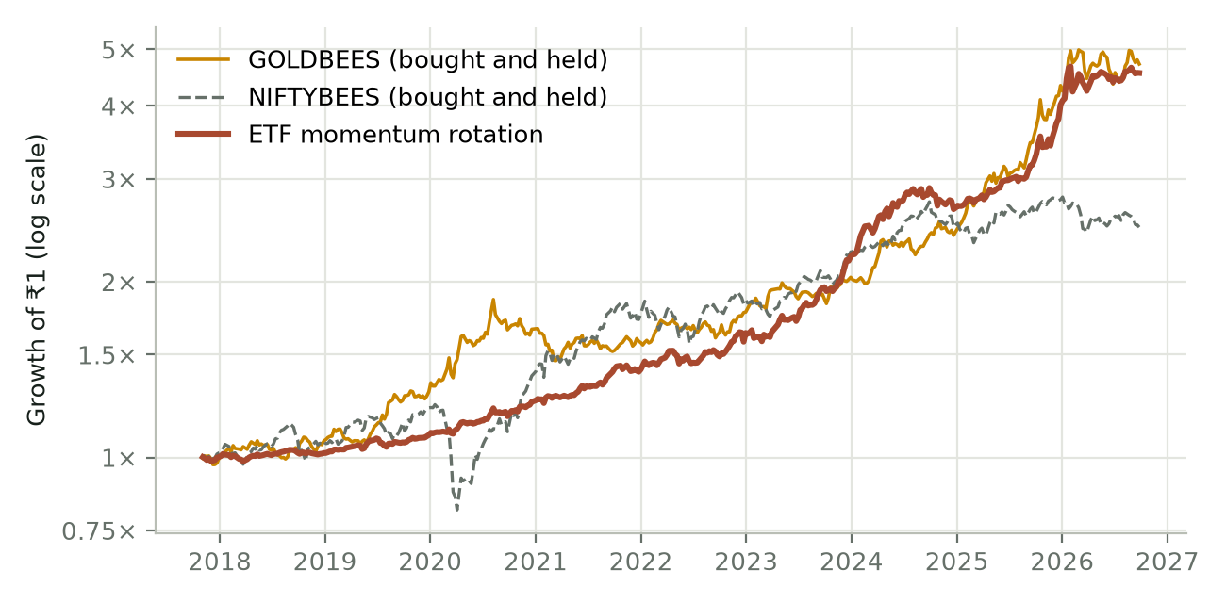
Figure 11. Growth of ₹1 with the ETF rotation, against simply holding NIFTYBEES or GOLDBEES.
The rotation earned 18.6% a year with a worst fall of only -21.5% and volatility of 12.1%, lower than even the Nifty's. NIFTYBEES earned 10.7% with a worst fall of -36.3% (the March 2020 crash). Simply holding GOLDBEES earned 19.0%, a little more than the rotation, because these were exceptional years for gold. The rotation's advantage is that it doesn't depend on gold continuing: it moves on when gold stops rising.
Its early years were quiet, because only a few ETFs existed and money often sat in cash (33% on average over the whole period). Since the last of them started trading (Aug 2024), it earned 24.7% a year while NIFTYBEES earned -2.6%.
Table 28. Returns by calendar year.
Year | ETF rotation | NIFTYBEES | GOLDBEES
2017 (part) | +0.3% | +1.8% | -0.4%
2018 | +1.5% | +4.8% | +6.7%
2019 | +7.5% | +13.6% | +22.9%
2020 | +14.3% | +15.4% | +27.0%
2021 | +13.1% | +26.0% | -5.2%
2022 | +15.5% | +5.5% | +12.8%
2023 | +35.2% | +21.0% | +14.7%
2024 | +21.0% | +10.4% | +19.4%
2025 | +49.6% | +11.7% | +71.8%
2026 (part) | +13.9% | -10.6% | +13.0%

What it held
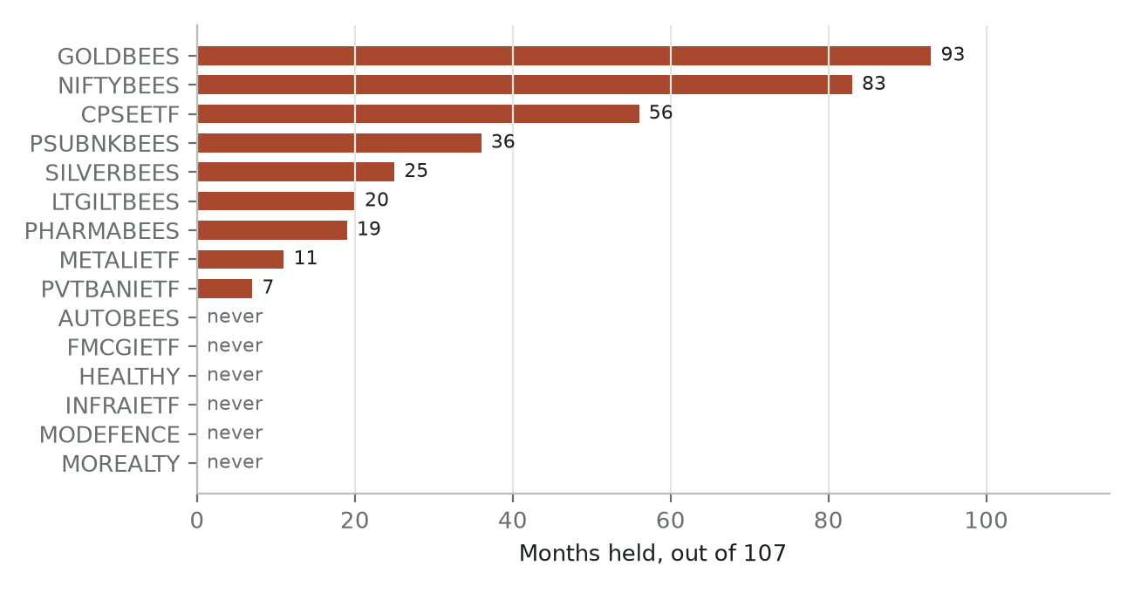
Figure 12. Months each ETF spent in the portfolio, out of 107.
Gold and the Nifty were the backbone, joined by PSU banks and CPSE companies during their long rally, and by silver, bonds, pharma and metals more recently. AUTOBEES, FMCGIETF, HEALTHY, INFRAIETF, MODEFENCE, MOREALTY were never picked. At the last month-end, for example: AUTOBEES: ranked below the top 5; FMCGIETF: 30% below its all-time high; HEALTHY: trades under ₹1 crore a day; INFRAIETF: below its 233-day average; MODEFENCE: ranked below the top 5; MOREALTY: ranked below the top 5.
There were only 21 completed trades, and 67% made money. The average winner gained +52%, the average loser lost just -5%, and a typical ETF was held for about 11 months.
Table 29. The five best ETF trades.
Best trades | Bought | Sold | Return
CPSEETF | May 2021 | Dec 2024 | +242%
SILVERBEES | Dec 2024 | Feb 2026 | +200%
PSUBNKBEES | Oct 2022 | Oct 2024 | +95%
NIFTYBEES | Jul 2020 | May 2022 | +52%
GOLDBEES | Dec 2018 | Jan 2021 | +51%

Does it depend on the settings?
Table 30. The ETF rotation with one setting changed.
Change | CAGR | Worst fall | Sharpe
Hold top 2 | 19.9% | -16.7% | 0.92
Hold top 3 | 20.8% | -27.5% | 0.87
Hold top 5 (our rule) | 18.6% | -21.5% | 0.96
Hold top 7 | 14.5% | -20.2% | 0.78
No filters at all | 11.9% | -24.3% | 0.43
No 233-day trend filter | 14.6% | -16.1% | 0.72
Add a NIFTYBEES market switch | 16.4% | -21.3% | 0.87

- Five is a sensible middle. Holding 2 or 3 earned a little more but gave a less steady ride; holding 7 earned clearly less.
- The filters matter. Without them the return dropped sharply. The trend filter did the most work, followed by the turnover filter.
- No market switch needed. Adding one lowered the return: with gold, bonds and cash on the list, the rotation already steps away from falling shares.
- When to sell and trading costs barely mattered, because the rotation trades so rarely.
Be careful with this result. The ETF list was chosen today, with some knowledge of which themes did well, and no ETF that closed down in the past can appear in it. Until 2021 only a handful of ETFs were eligible. And these were exceptional years for gold and, in 2025, silver. Treat the ETF numbers as more flattering, and less certain, than the stock study's.

The three studies side by side
Table 31. The three studies compared. The periods and universes differ, so compare each with its own benchmark and compare the character, not the exact numbers.
 | Nifty 500 stocks (Ch. 4–10) | Every NSE stock (Ch. 11) | ETF rotation (this chapter)
Period tested | Oct 2020 to Sep 2026 (5.9 years) | Jan 2016 to Sep 2026 (10.6 years) | Oct 2017 to Sep 2026 (8.9 years)
Holdings | 10 stocks, monthly | 30 stocks, weekly | 5 ETFs, monthly
Yearly growth (CAGR) | 32.8% | 37.2% | 18.6%
Benchmark over the same period | Nifty 500: 15.6% | Nifty 500: 12.8% | NIFTYBEES: 10.7%
Worst fall | -25.5% | -25.9% | -21.5%
Volatility | 20.7% | 18.4% | 12.1%
Sharpe | 1.20 | 1.50 | 0.96
Completed trades | 151 | 1403 | 21
Main risk | Deep falls in small and mid caps | Small, thinly traded stocks; limited capacity | Depends heavily on gold; few ETFs in early years

All three beat their benchmark by a wide margin. The stock versions earned more and fell harder; the whole-NSE version, with more stocks and weekly trading, held up over the longest period, including the March 2020 crash. The ETF rotation was the gentlest: fewer holdings, far fewer trades, the smallest falls, and it can hold gold and bonds when shares are weak. They differ in character more than one is simply better than the other.

13. Common mistakes, and questions people ask

Common mistakes
Table 32. Common momentum mistakes.
Mistake | Why it hurts
Selling winners early to "book profit" | The big winners pay for all the losers. Cutting them short removes the engine.
Holding losers "until they come back" | Falling stocks tend to keep falling. The ranking sells them for a reason.
Skipping the safety switch because "this time is different" | The switch exists for the rare, deep crash. You can't know in advance which fall will be the big one.
Quitting after a bad year | Every momentum strategy has bad years. Quitting locks in the loss and misses the recovery.
Testing on today's stock list | Survivorship bias makes a strategy look better and safer than it is (Chapter 5).
Tweaking the rules after every bad month | Constant changes mean you never follow any strategy long enough for it to work.
Ignoring costs and tax | At about 2.4 portfolio turns a year, small costs add up quickly.

Questions people ask

Isn't this just chasing stocks that have already gone up?
Yes, deliberately, but with rules. The evidence over a century is that stocks rising strongly and steadily tend to keep rising for months. The rules also make you sell when they stop, which casual chasing never does.

Why not just buy a momentum index fund?
That's a perfectly good, simpler option. Index funds handle the rebalancing for you. The strategy in this book differs in its stock universe, scoring, number of stocks, and especially its safety switch, which index funds don't have.

Will future returns be 33% a year?
Almost certainly not. That figure comes from one six-year period that was good for Indian stocks, before tax, and with the luckiest trading day. Expect lower returns, and deeper falls, in real life. What the study shows is that the approach worked across many settings and beat random stock picking, not that the future will match the past.

What if the market crashes like 2008?
The safety switch would sell after three closes below the 200-day average. It wouldn't avoid the first part of the fall, but it is designed to avoid most of a long, deep decline. The six-year Nifty 500 period had no such crash. The longer whole-NSE test in Chapter 11 includes the March 2020 crash: from 18 Feb 2020 to the low, the Nifty 500 fell 33%, while the momentum rules (top 30 stocks, weekly) fell 4%, because the switch had moved the money to the liquid fund early in the fall. One crash is not proof, but it is the kind of fall the switch was built for.

Does it work beyond the Nifty 500?
Chapter 11 runs the same rules on every stock on the NSE, including small companies and ones that later disappeared. It worked there too, with more stocks held, but it can absorb far less money because the stocks are smaller, and some of them trade only for delivery (the BE and BZ series).

Appendix A: Glossary
Term | Meaning
Backtest | Running a strategy's rules on past prices to see what would have happened. Hypothetical, not real trading.
CAGR | Compound annual growth rate: the average yearly growth. 20% means money grew by about a fifth each year.
Drawdown | A fall from a previous high. Max drawdown is the biggest such fall.
Volatility | How much a price jumps around, usually stated per year. Higher volatility means a bumpier ride.
Sharpe ratio | Return above a safe rate (here 6.5%), divided by volatility. Higher is better; above 1 is good.
Calmar ratio | Yearly return divided by the worst fall. More return per rupee of pain.
Moving average | The average closing price over a set number of recent days, such as 200.
Liquid fund | A mutual fund that invests in very short-term, low-risk debt. Used as a safe place to wait.
Survivorship bias | The error of testing only on things that survived to today, ignoring failures.
Point-in-time list | The list of index members as it actually stood on a past date.
Turnover | How much of the portfolio is replaced in a year. 2× means every stock is swapped about twice.
Rebalance | The regular (monthly or weekly) routine of selling and buying to bring the portfolio back in line with the rules.

Appendix B: Data and method
- Period: 30 Oct 2020 to 24 Sep 2026.
- Stocks: Nifty 500 members on the most recent archived NSE list dated on or before each trading day (9 lists). Past members without price data (mostly merged or delisted companies) are excluded.
- Prices: Yahoo Finance daily closes, adjusted for splits but not dividends. One-day moves over 60% are treated as bad data.
- Filters: within 25% of all-time high; close above the 233-day simple moving average; average daily turnover above ₹1 crore over the past year; at least 90% of price data available for each lookback.
- Score: for 252, 184, 126 and 63 trading days, % return divided by annualised volatility of daily returns; the average of the four.
- Portfolio: top 10, equal weight at purchase; sell when outside the top 30 or failing a filter; rebalance at the last trading day's close each month.
- Safety switch: sell everything on the day the Nifty 500 completes three closes in a row below its 200-day simple moving average; buy back at a month-end close above it. Waiting money earns 6.5% a year.
- Costs: 0.25% of trade value on every buy and sell. Tax only where stated.
- Benchmark: Nifty 500 price index (no dividends).
- Chapter 11 (whole NSE): 29 Jan 2016 to 22 Sep 2026; every stock in NSE's daily trading files in the EQ, BE and BZ series, adjusted for splits and bonus issues from NSE's corporate-action list (and, where no record exists, from whole-ratio price gaps), with dividends from the same list paid into cash on the ex-date; ETFs excluded; the high filter uses the highest price since 2015; rebalanced at each week's or month's last close, and after a safety-switch exit, bought back at the first such close above the 200-day average. The second safety rule compares the Nifty500 Momentum 50 index (closes to 22 May 2026, then carried on with a Momentum 50 ETF's daily moves) with its 50-day simple average of closes.

Appendix C: Further reading
- Edwin Lefèvre, Reminiscences of a Stock Operator (1923).
- Nicolas Darvas, How I Made $2,000,000 in the Stock Market (1960).
- Robert A. Levy, "Relative Strength as a Criterion for Investment Selection", Journal of Finance (1967).
- William J. O'Neil, How to Make Money in Stocks (1988).
- Narasimhan Jegadeesh and Sheridan Titman, "Returns to Buying Winners and Selling Losers", Journal of Finance (1993).
- Mark M. Carhart, "On Persistence in Mutual Fund Performance", Journal of Finance (1997).
- Tobias J. Moskowitz, Yao Hua Ooi and Lasse Heje Pedersen, "Time Series Momentum", Journal of Financial Economics (2012).
- Clifford S. Asness, Tobias J. Moskowitz and Lasse Heje Pedersen, "Value and Momentum Everywhere", Journal of Finance (2013).
- Kent Daniel and Tobias J. Moskowitz, "Momentum Crashes", Journal of Financial Economics (2016).
- Christopher C. Geczy and Mikhail Samonov, "Two Centuries of Price-Return Momentum", Financial Analysts Journal (2016).
- NSE Indices, methodology documents for the Nifty200 Momentum 30 and other momentum indices (niftyindices.com).

