**FIGURES**

Figure 1.



Figure 2.

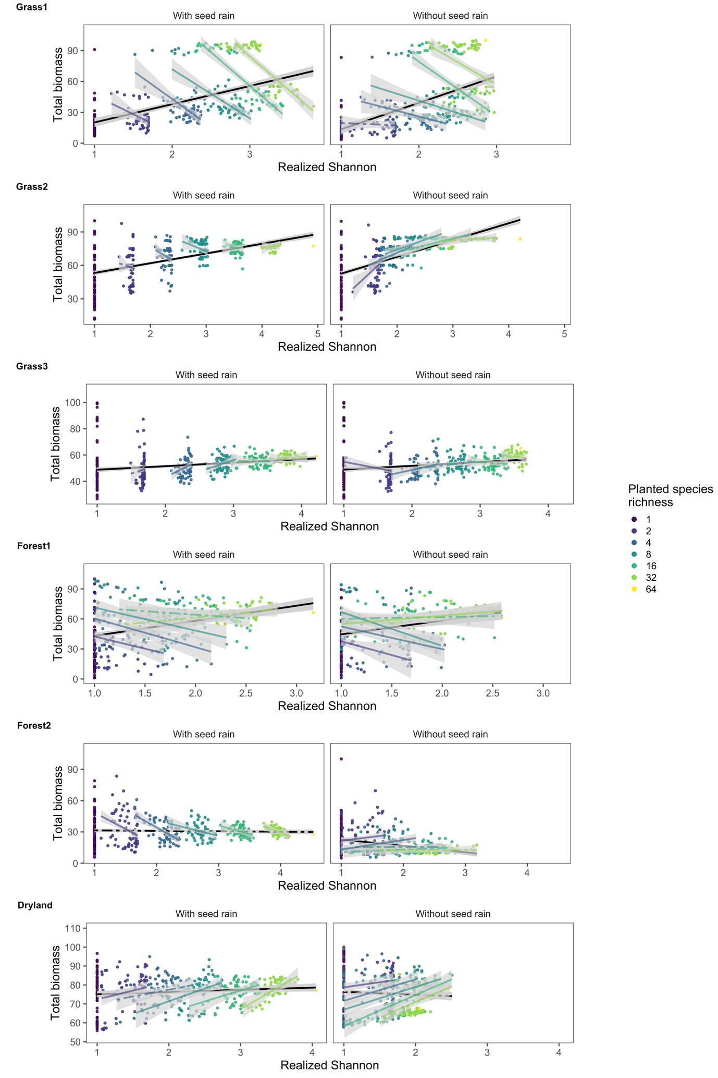

Figure 3.

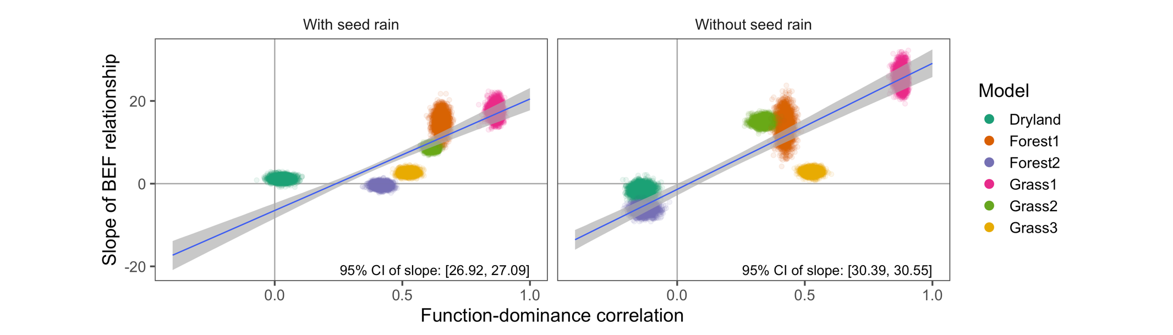

Figure 4.

