SimNet Results

This document describes the main results of our SimNet experiment. First, I briefly review the theory and experiment underlying this analysis, and then get straight into the results.

# Introduction

The central idea of our project was to, using our models, test how biodiversity and ecosystem functioning (BEF; in our case biomass) change with local and regional assembly processes. More specifically, we suggest that:

1. BEF patterns are context-dependent
2. This context-dependency is mediated by:
   * The degree to which the most competitive species also produce the most biomass
   * Tradeoffs between local and regional community assembly

In principle, we’re replicating Figure 1, taken from Leibold et al. (2017). It shows the relationship between biomass and diversity within the Jena Experiment. The bold line shows that the relationship between biodiversity and biomass tends to be generally positive. Throughout this document, this relationship will be referred to as the main effect of diversity. However, within richness treatments, there is actually a negative trend. This reflects local assembly processes removing species that are poor biomass producers within the community. We refer to this relationship as the within- planted species richness treatment effect of diversity.

# Simulation design

Using our six models, we replicated the Jena Experiment’s design by running communities of different planted species richness treatments (1, 2, 4, 8, 16, 32, and 64 species), where the species are randomly selected from a 64-species pool, with 64 communities per richness treatment. Initially, during the metacommunity stage, each community is run with seed addition from a metacommunity that mirrors the initial species mixture. Half-way through we eliminate the seed addition. This stage is called the isolation stage.

# Results

## The relationship between realized diversity and total biomass

The first results figure (Fig. 2) is a plot of how total mixture biomass changes with realized species diversity (here Shannon diversity) at the terminal year of the metacommunity and isolation phases. In effect, this is the “Leibold plot” for each simulation model, except showing how seed addition from the metacommunity changes the effect. All the simulations display unique biodiversity-biomass patterns, each based on the unique mechanisms underlying the assembly of their communities. For example, during the metacommunity phase, a pattern very similar to that reported by Leibold et al. is seen in Adam’s and Lindsay’s models as well as in PPA, wherein while a positive diversity-biomass relationship emerges across the initial species richness treatments, within the richness treatments there is a negative effect. However, in TROLL and Björn’s model this main effect is absent, likely because the plants’ mixture biomasses are not related to their monoculture biomasses. IBC-grass and Björn also both diverge from the Leibold-pattern in their within-treatment slopes. For IBC-grass, this occurs because diversity is maintained through negative density dependence. Because plants’ resource acquisition is decreased when there are neighboring conspecifics, in general plants will uptake more resources when surrounded by individuals of other species. Within Björn’s model, resource partitioning creates niches whose resources would be otherwise underutilized in low-diversity communities. Therefore, as diversity increases, more of these niches are filled and their resources are used to generate biomass. With seed addition (i.e., during the metacommunity phase) the highest-biomass species tend to be the most dominant within TROLL, thus creating within-treatment slopes similar to that of Adam’s and Lindsay’s model.

During the disassembly phase, we find that many of the models’ slopes become more positive, either flipping from negative to positive, as in Lindsay’s model and TROLL, or becoming less negative, as in Adam’s model and Björn’s. In Lindsay’s model, for example, the seed addition during the metacommunity phase forces many low biomass-producing species to remain abundant, inhibiting the high biomass-producing species. During the isolation phase, however, these poor producers decrease in abundance and are replaced by their higher biomass-producing competitors, removing this inhibition and thus leading to a more positive within-treatment effect. Both PPA and IBC-grass show little change after the removal of seed addition during the isolation phase.

We suggest that a key mechanism underlying the breadth of these simulations’ BEF patterns is the correlation between a species’ biomass in monoculture and to its biomass in mixture (i.e. its competitive ability). When these two quantities are positively correlated, the community may be more likely to have an overall positive relationship between realized diversity and biomass, but a negative relationship within the planted species richness treatments especially when the community is imbedded in a metacommunity. In other words, total mixture biomass may increase with total diversity, but only because larger species pools are more likely to contain these high-biomass producing species. However, within the treatment levels, diversity and total biomass will be strongly negatively correlated, because when a high-biomass producer is present in the community, it tends to dominate the community and extirpate its competitors. Therefore, we would expect that if one compares the degree of correlation between the species’ competitiveness and their biomass production to the relationship between diversity and total biomass within their communities, one would observe a general trend in which simulations with a positive correlation are more likely to exhibit strong positive overall diversity-biomass production relationships and strong negative within- planted species richness relationships.

If there is no correlation between a species’ biomass in monoculture and its biomass in mixture, this pattern is less likely. In some cases, such as in TROLL and Björn, the most competitive species are not necessarily those that produce the most biomass. This leads to a variety of patterns both within and between richness treatments, that are context-specific and explainable given the models’ assumptions and study area.

## Correlation between a species’ monoculture biomass and its biomass in mixture

In Figure 3, we find that each simulation demonstrates a different degree of correlation and that this correlation changes significantly based on whether external seed addition is present. While Adam’s model follows the pattern, we see that in Lindsay’s model, being in the middle of the monoculture-biomass range is actually the worst in terms of mixture biomass. This is because her trade-off is between high biomass production and the ability to grab the resources otherwise left behind. Being within the middle of the trade-off is not conducive to performance in mixture. Within TROLL, we see that propagule pressure from the metacommunity promotes a correlation between monoculture and mixture biomass, but once the community is isolated, the community becomes dominated by relatively small -- though very competitive -- species.

## A potential mechanism underlying the models’ relationships between diversity and biomass

In the final figure of the results, we connect this correlation between monoculture and mixture biomass more explicitly to the broader BEF patterns within each model. We nonparametrically bootstrap both the correlation coefficients for each model as well as the estimates (both the main and treatment effects) and run a reduced major axis regression with them. For the main effect (Fig. 4a), we confirm an overall pattern in which models that have a tight correlation between their species’ biomass in monoculture and biomass in mixture also tend to have a more positive relationship between their diversity and total mixture biomass. Interestingly, seed addition from a metacommunity tends to dampen this effect. That is, when a metacommunity is present, species that are not well suited to a given habitat - and likely less able to reduce local resources - are supported by source-sink dynamics. Without a metacommunity, these poorly-fit species are extirpated from the community, replaced by better competitors (who, coincidentally, also produce more biomass.)

In Figure 4b, we see the same relationship except for the within-treatment effects. As predicted, the slopes are reversed. This indicates that within simulations in which a species’ biomass in monoculture is positively correlated with its biomass in mixture, communities that have high diversity are likely composed of poor competitors. When a good competitor is present in the species mixture, it will proliferate, driving up total biomass while it reduces total biodiversity. Within simulations in which this correlation is not present, there is less of a relationship between community biomass and diversity. Isolation from a metacommunity dampens this general effect.

# Figures

## Figure 1.

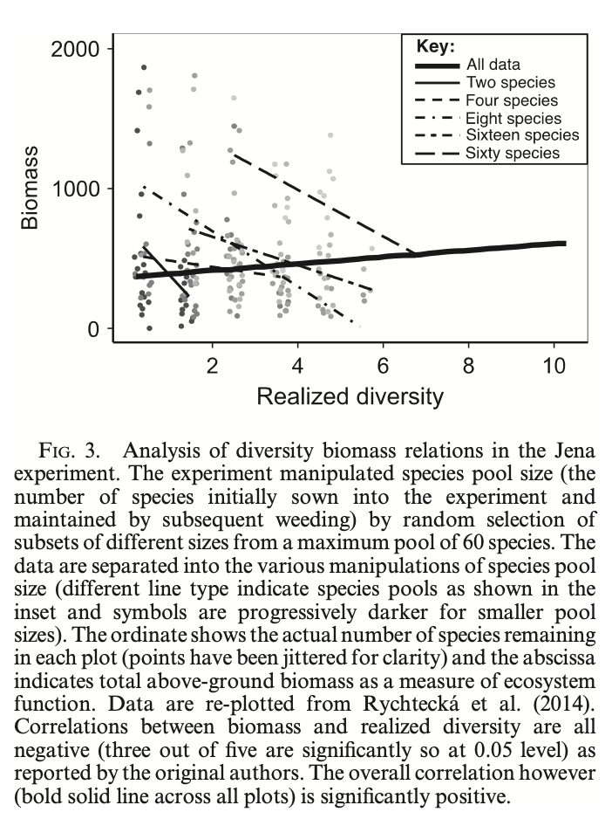

## Figure 2.

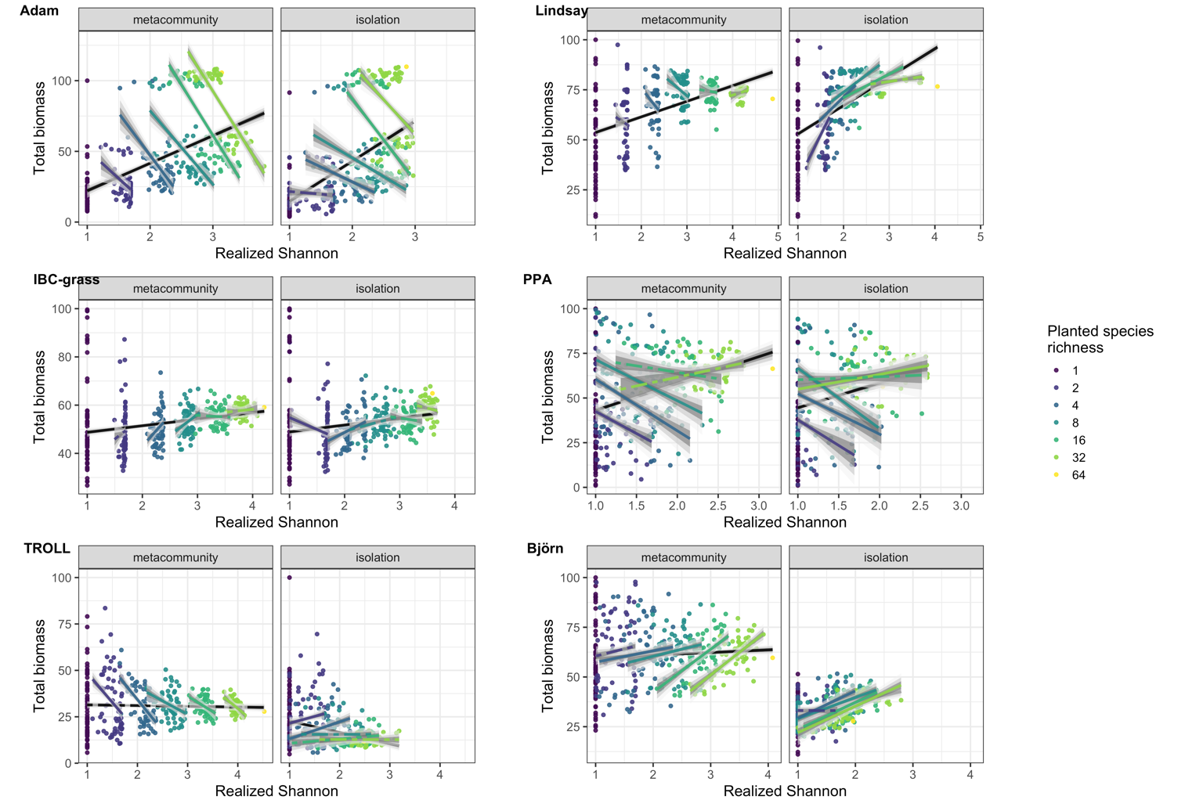The relationship between realized Shannon diversity and total community biomass for each of our models. Colored lines refer to the fits within-richness treatments, while the black lines refer to the larger trend, inclusive of all planted-species richness treatments. Total biomass is scaled from 0 – 100. The metacommunity stage is defined as the first 100 iterations of the simulation, in which external seed addition is present. The isolation stage is defined as the following 100 iterations, once external seed addition has been excluded. Ribbons represent the 95%, 80% and 50% credibility intervals of the fits, while estimates with dashed lines include a slope of 0 with their 89% highest density intervals, suggesting that they are not statistically significant.

## Figure 3.

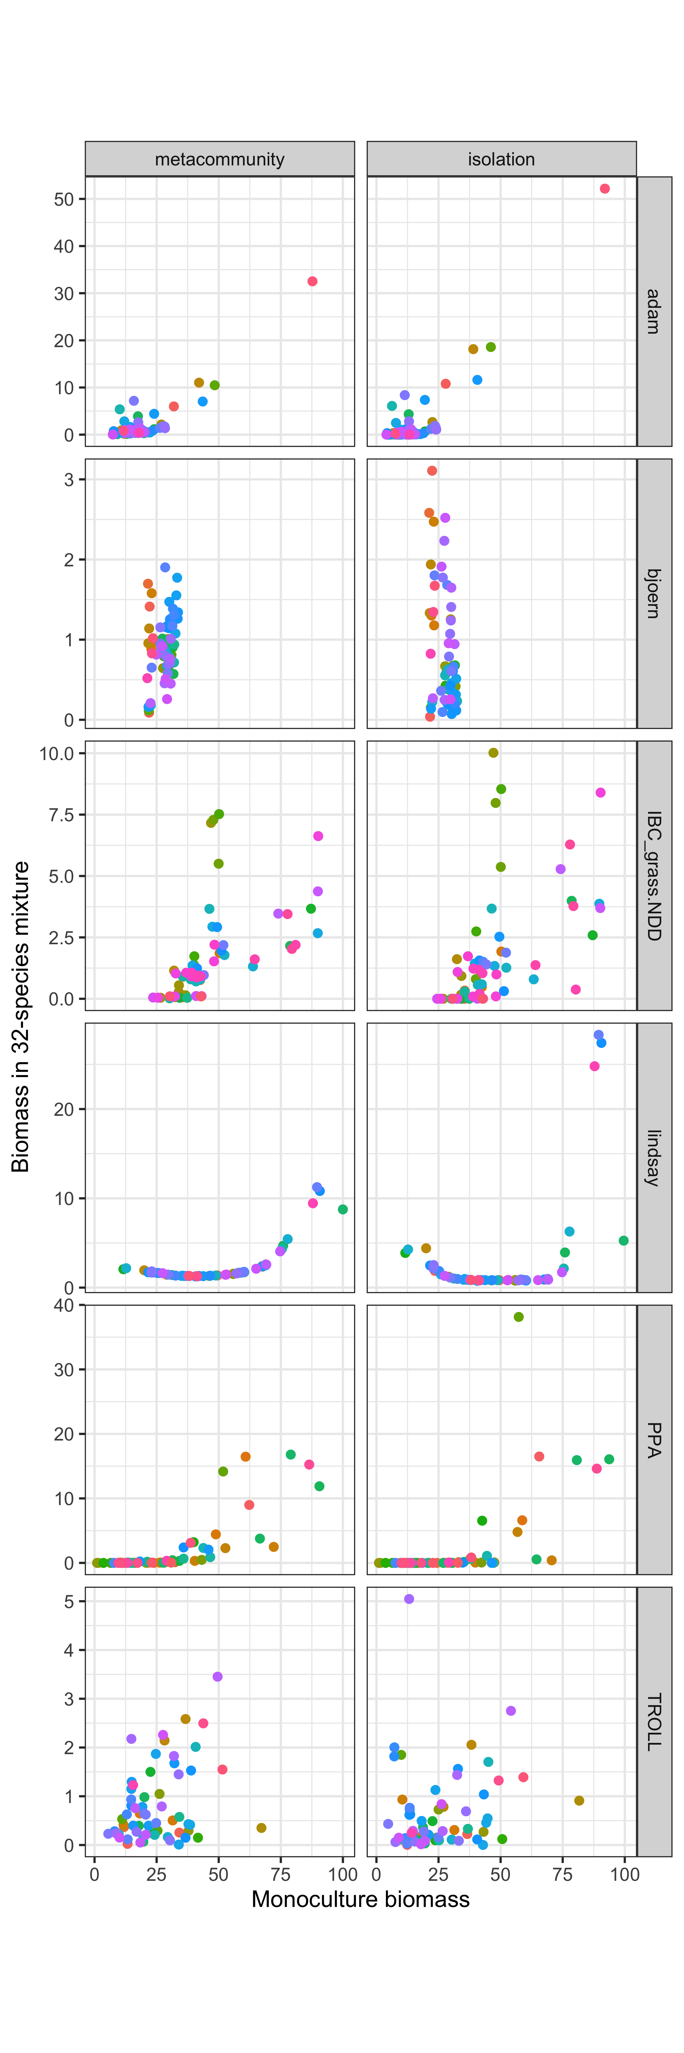

The relationship between a species’ biomass in monoculture versus its average biomass in 32-species mixture. Biomass values are scaled from 0-100 for each of the simulations. Biomass is measured at the terminal year of both the metacommunity phase and the isolation phase. Each point - and color - is a distinct species.

## Figure 4a.

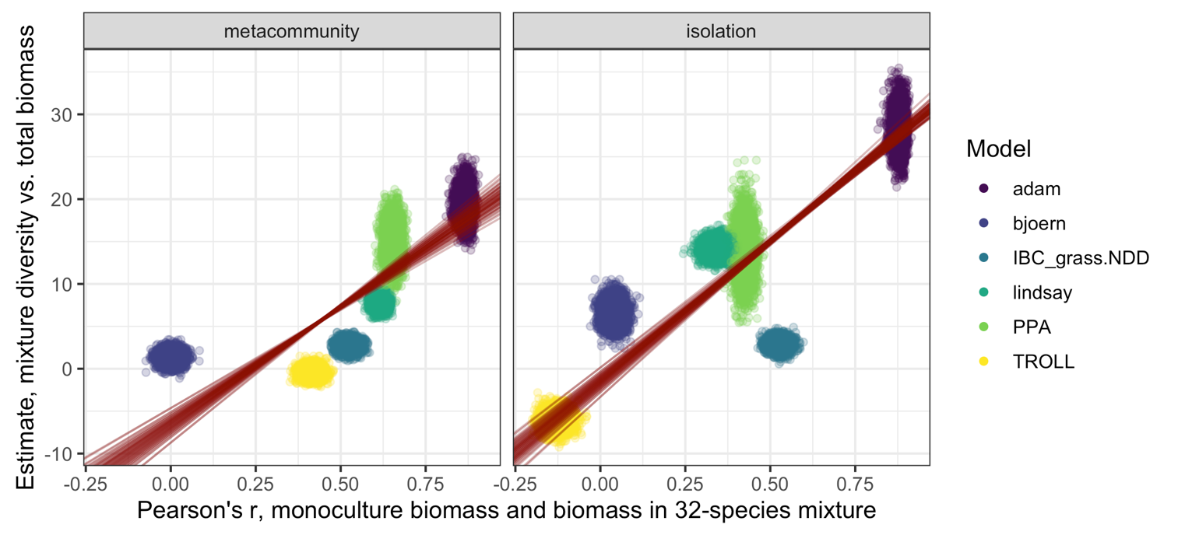

The correlation coefficient of the species’ monoculture biomasses and average 32-species mixture biomasses versus the estimates for the overall relationship between diversity and total biomass across treatments. Both values are derived through a nonparametric bootstrap of their underlying distributions (N bootstraps = 2500). Standard major axis regressions (lmodel2) are run on each bootstrapped dataset. Red lines indicate the 95% confidence intervals of the mean for the slope parameter, binned across the intercept estimates to account for their covariance.

## Figure 4b.

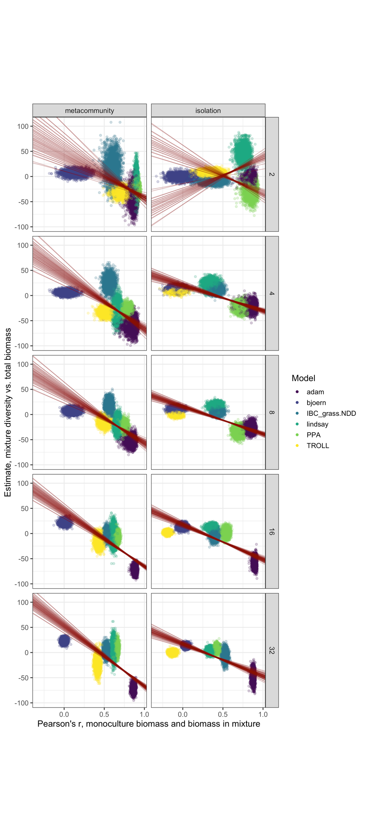

The correlation coefficient of the simulations’ species’ monoculture biomasses and average 32-species mixture biomasses versus the simulations’ estimates for the within-treatment (treatment) relationship between diversity and total biomass. Both values are derived through a nonparametric bootstrap of their underlying distributions (N bootstraps = 2500). Standard major axis regressions (lmodel2) are run on each bootstrapped dataset. Red lines indicate the 95% confidence intervals of the mean for the slope parameter, binned across the intercept estimates to account for their covariance.