**Pedigree Drawing Tool**

[**https://mscross92.github.io/didi_Draw/elements/pd/index.html**](https://mscross92.github.io/didi_Draw/elements/pd/index.html)

**General navigation**

A pedigree member can be manually moved, by dragging. A member can be moved anywhere along the X-axis; dragging in the Y-direction will change the generation of the pedigree member. The generation heights are fixed.

Holding the mouse down on the background and dragging will move the whole pedigree object about the screen.

The navigation panel in the top right corner of the drawing area can also be used to move the pedigree, and to zoom in, and out. Clicking the centre icon will auto-zoom and centre the pedigree to fit to the screen.

The side panel provides an overview of the current pedigree and can be used to edit the data for each family member.

Hovering the mouse over the rows in the *Pedigree member(s)* table will highlight the appropriate member in the pedigree drawing and will expand the row in the table, revealing a summary of the data entered for that member. Clicking on the pencil icon in the top right corner of the expanded table row allows you to add or edit these data. This can also be achieved by clicking on the pedigree member in the drawing.

**Adding family members**

Click on a pedigree member to select them. Add relations by clicking on the appropriate icon that appears around the selected pedigree member (parents, brother, sister, son, daughter, or spouse).

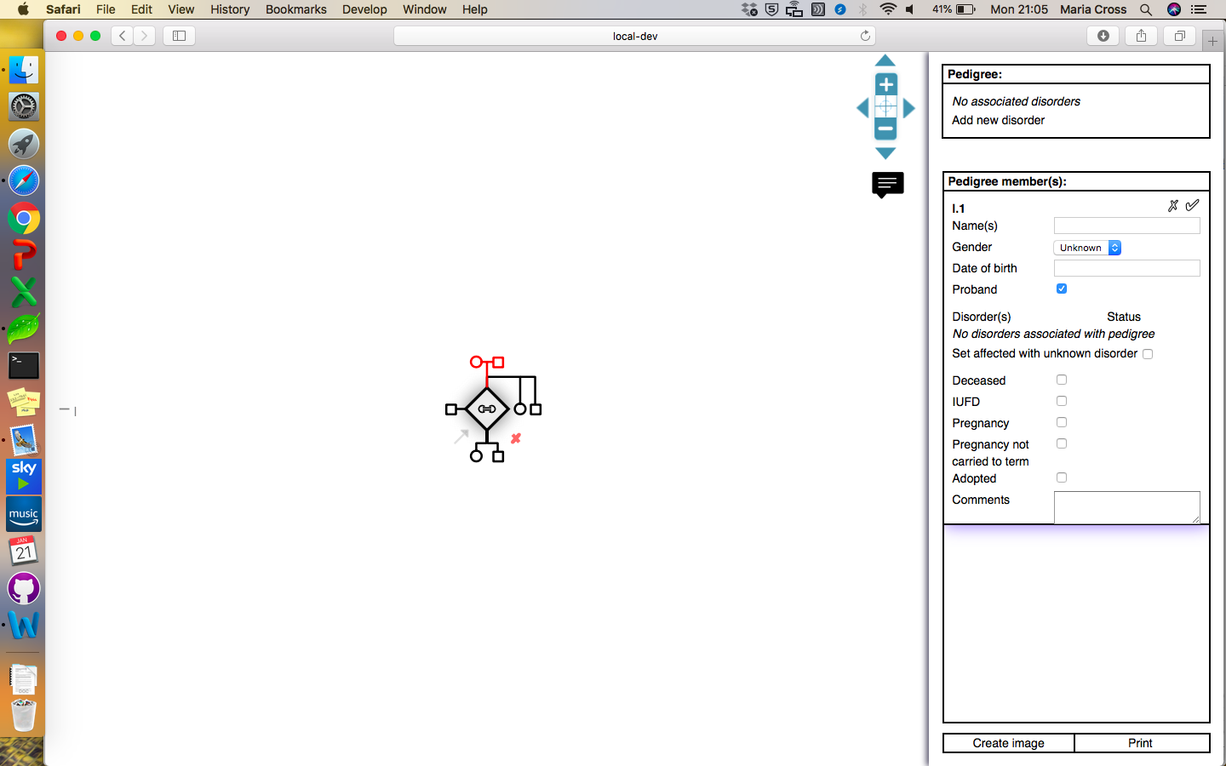 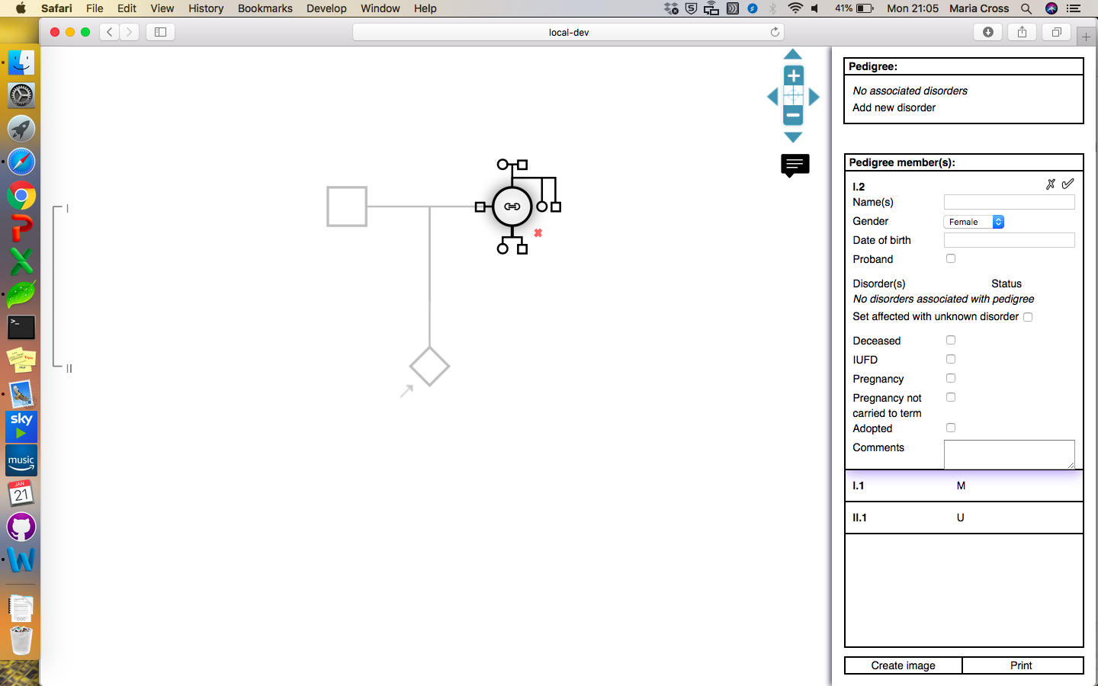

To remove / delete a pedigree member, first select the individual. Then click on the red cross that appears to the bottom right of the member in the drawing, or click on the cross in the top right corner of the row in the *Pedigree member(s)* table in the side panel.

You cannot delete pedigree members that have offspring – the offspring must first be removed.

Pedigree disorders

In the *Pedigree member(s)* table, you can indicate that a patient is affected with an unspecified disorder, resulting in a black fill in the drawing:

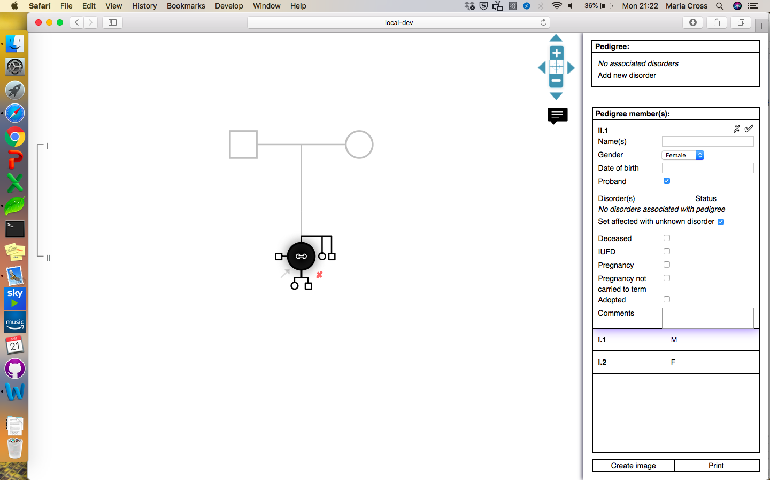

To specify that a pedigree member is affected with multiple or specific disorders, you must first define which disorders are present in the pedigree:

1. Click on the text *Add new disorder* in the *Pedigree* table in the side panel. This will reveal a text box.
2. Type the name of the disorder into the textbox
3. Press enter or click on the plus symbol next to the textbox to add this disorder to the pedigree
4. The disorder will be listed in the *Pedigree* table in the side panel and appear in the key in the drawing.

When a member is selected, the disorder now appears as a field in the *Pedigree member(s)* table. Use the drop down to specify the patient’s status for each disorder.

(A)-(C) (D)

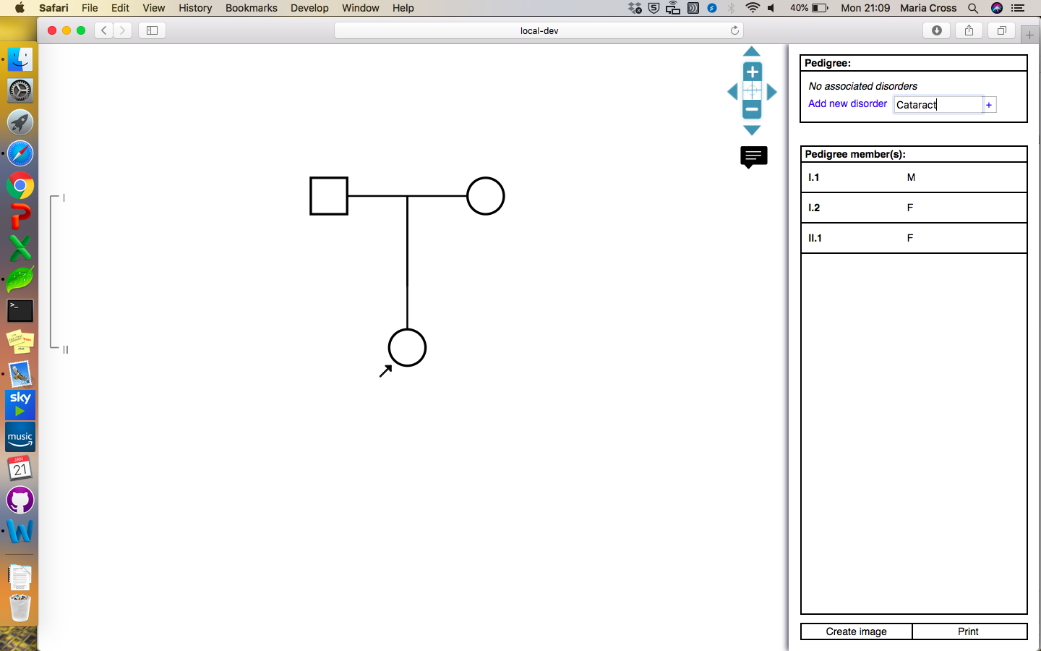 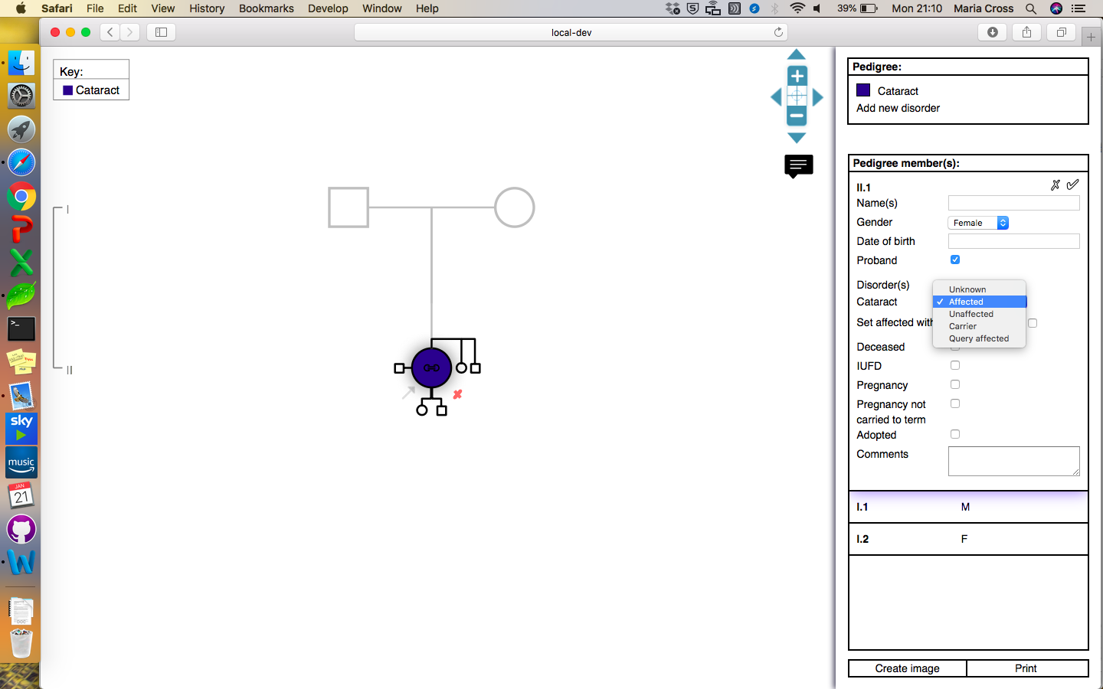

N.B. The *query affected* status was introduced for the clinical setting, to highlight suspected cases where it is not possible to confirm a diagnosis, e.g. in a deceased relative. Selecting this option will fill the individual in a slightly lighter colour.

Currently, only four disorders can be represented and visualised in a single pedigree.

Creating / editing relationships between existing pedigree members

This procedure can be followed to create new relationships between existing members of the pedigree or to edit existing relationships, for example to specify that siblings are mono- or dizygotic twins, or to indicate that parents are separated.

1. Click on the link icon in the centre of the selected family member.
2. The member will then highlight in red, and the menu to add relations disappears.
3. Click on the other pedigree member that you wish to create the relationship for; this will open a *Relationship type* dialogue. Select the relationship type that you wish to create.
4. Click OK; the pedigree will redraw, showing the new relationship.

(A) (B)

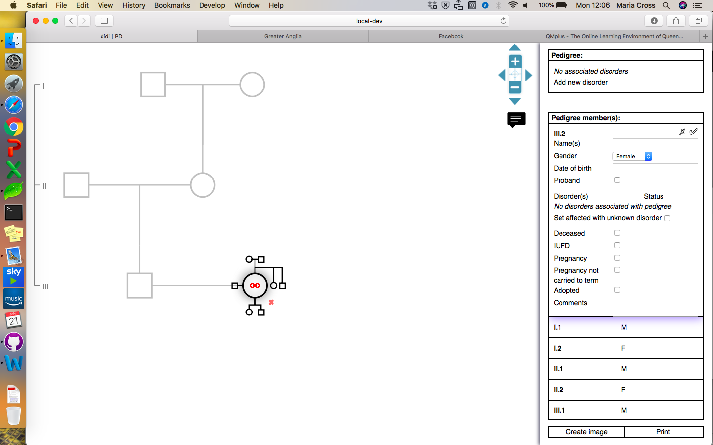 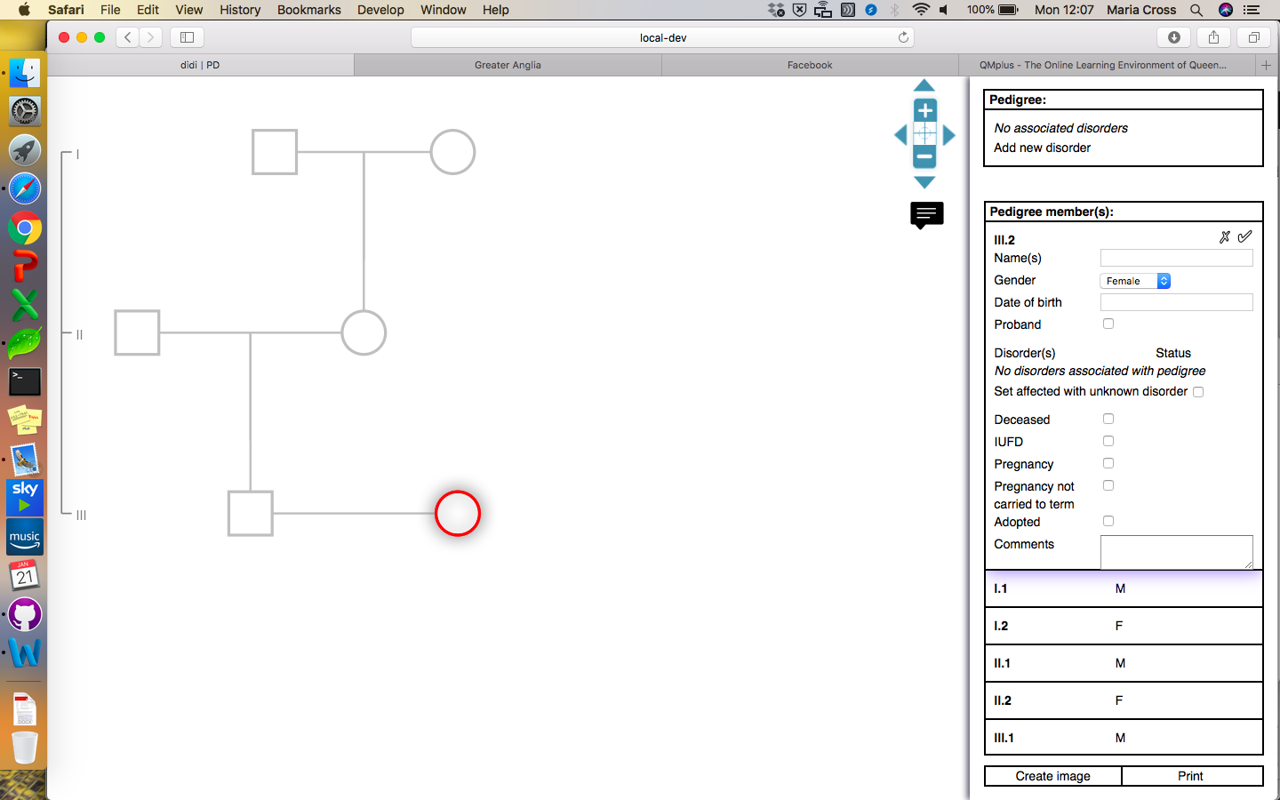

(C) (D)

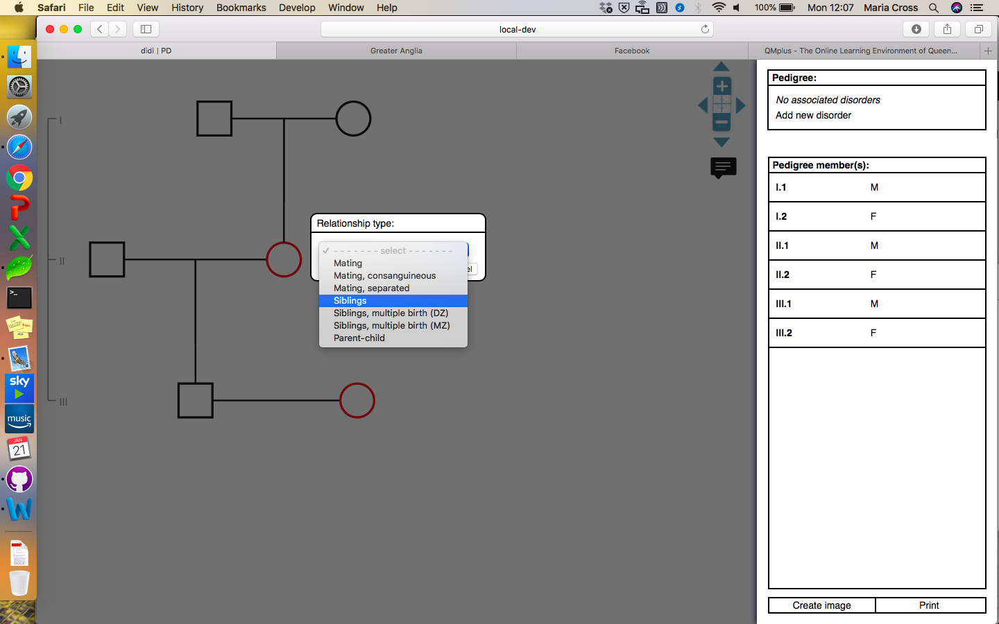 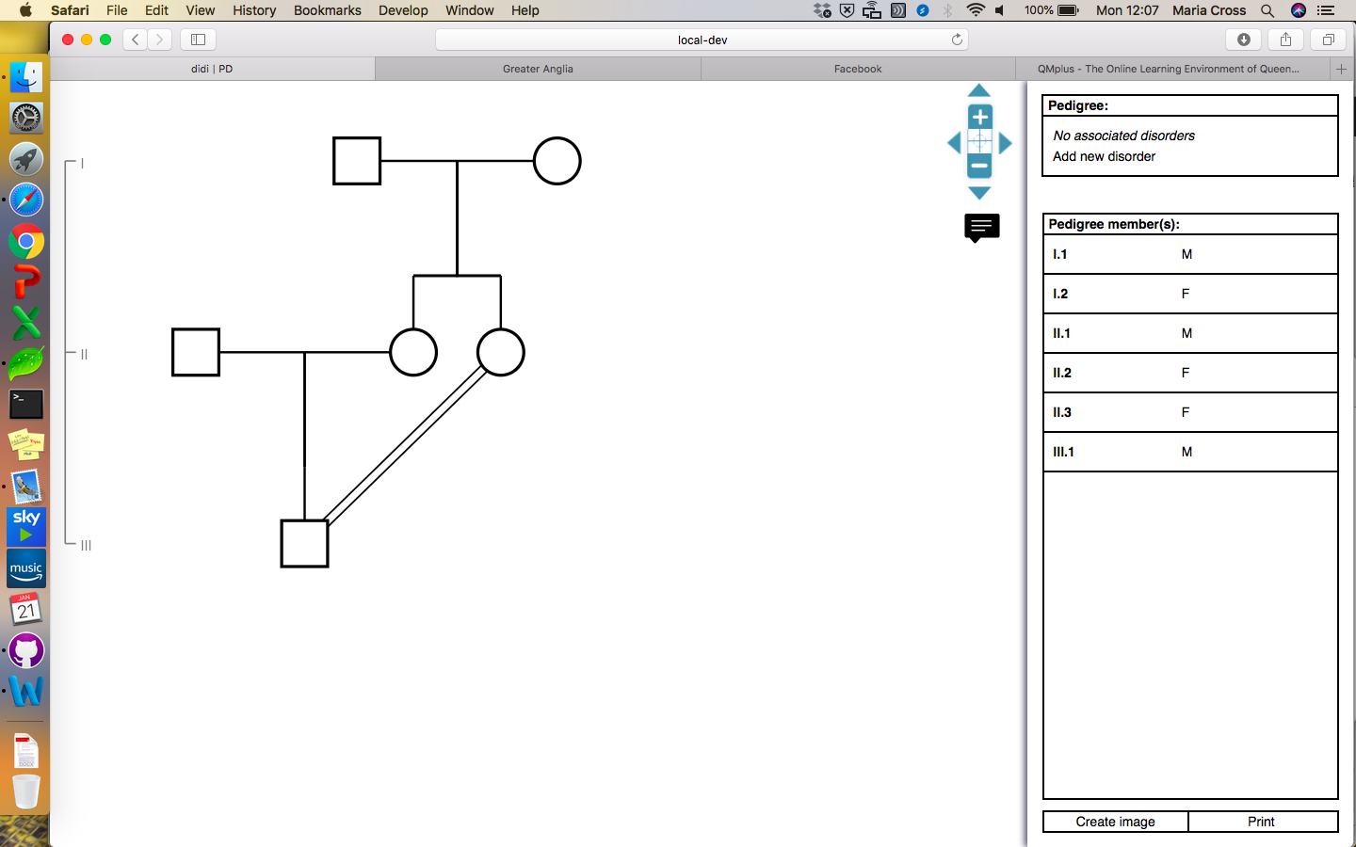

Consanguineous loops will be auto-calculated. And, as in the example, siblings are preferentially aligned on the same generation, sometimes causing a pedigree member to move once a new relationship has been added.

If you clicked on the link icon by mistake, deselect the pedigree member by clicking anywhere in the background, and click on them again to continue editing that individual.

Short cuts

Double click the selected family member to indicate that they are deceased.

Right click the selected family member to indicate that they are affected (unspecified disorder, i.e. black fill).

Labelling pedigree members

If required, text can be added to the drawing, below each pedigree member. Click on the speech box icon, below the navigation panel in the top right corner of the drawing area. This will open a multiple-select menu that can be used to specify which data appears in the text in the drawing.

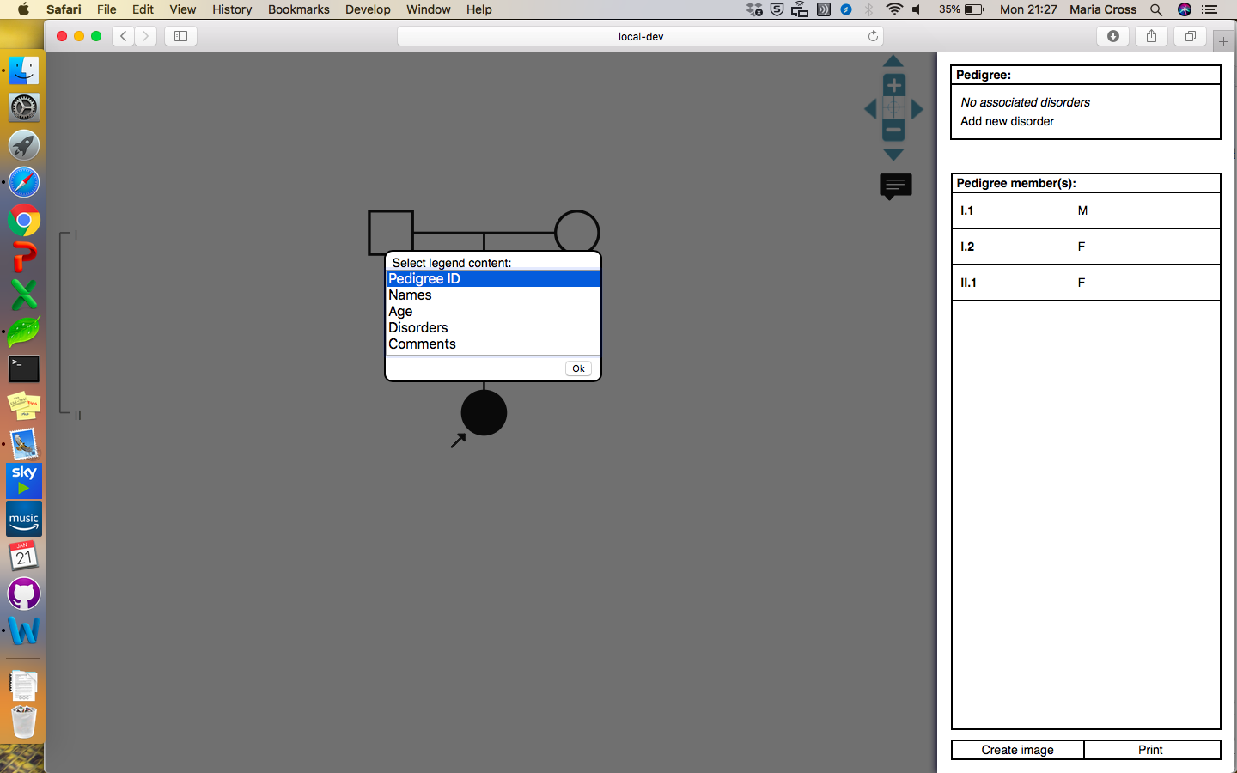 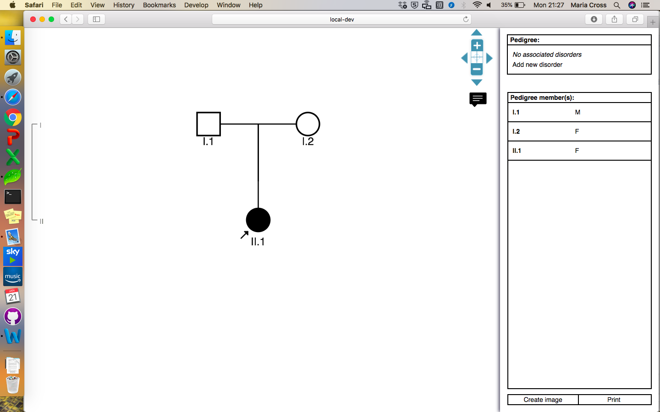

Each selected feature will display on a new line, below the pedigree members. The data for the labels can be entered in the sidebar. The pedigree ID field is auto-calculated.

**Saving pedigrees**

The hosted version of the tool does not store any data, and so the pedigrees cannot be saved. However, users can create and locally save an image of the pedigree.

To do so, click the *Create image* button at the bottom of the sidebar. This will open a new tab with an image of the pedigree. Right click this image and select *Save image as…* to save the image, or *Copy image* to paste it into a document etc.