Conveyor-Based AI Smart Bin for Four-Class Waste Segregation at Source: Design, Prototype, and Evaluation
Muhammad Ahsan Shah¹, Afifa², and Tayyaba Noor³
¹Department of Computer Science, Information Technology University, Lahore, Pakistan — mscs26017@itu.edu.pk
²Department of Artificial Intelligence, Government College Women University, Bahawalpur, Pakistan
³Department of Electrical Engineering, Namal University, Mianwali, Pakistan
Abstract— Most “smart bins” monitor fill level; they do not segregate waste. This paper presents a low-cost, self-funded prototype that classifies a single waste item and physically routes it, at source, into one of four streams—Paper, Plastic, Food, and Others—using a conveyor belt rather than the flap or trapdoor mechanism common in student prototypes. An HC-SR04 ultrasonic sensor detects an item within 20 cm and triggers the system; an ESP32-CAM captures its image and sends it over Wi-Fi to a desktop application, where a YOLOv8 classification model (YOLOv8n-cls) assigns the class; an Arduino Uno then restarts the conveyor and sweeps the servo arm for that class (neutral 90°, open 0°). Items whose confidence falls below 0.60, and unrecognised items, receive no servo action and travel to the end of the belt into Others, so a classification failure cannot deadlock the mechanism. The model was (re)trained on the public RealWaste dataset, remapped from nine classes to the four used here and supplemented with the authors’ own phone photographs (71 per class; 284 in total), giving 6,851 images verified by folder count. With a stratified 70/15/15 split, the retrained model reached 95.91% top-1 accuracy on validation and 95.06% on a held-out test set of 1,032 images (macro F1 ≈ 0.951); Plastic was the weakest class (recall 0.885), confused mainly with Others. A threshold sweep shows that the deployed 0.60 reject rule costs only 0.10 percentage points of accuracy while routing 2.2% of items to the fail-safe stream. In a separate physical conveyor trial reported by the authors, 34 of 40 items (85.0%) landed in the correct bin; the 6 misroutes were attributed by the authors to poorly resolved camera captures. The original goal—a fully wireless, standalone unit performing live real-time object detection—was scaled back under resource constraints to a PC-tethered classification design built from the authors’ own funds; the paper states this gap, and the remaining limitations, explicitly.
Keywords— smart bin, waste segregation, YOLOv8 classification, ESP32-CAM, conveyor sorting, IoT, source segregation

I. INTRODUCTION
Source segregation fails when it depends entirely on the person disposing of waste. Mixed disposal contaminates recyclables—wet food waste can render a batch of paper unrecyclable—and the sorting burden then falls on manual labour, with the health hazards and error rates that follow. Commercial and research “smart bins” have largely addressed a different problem: they sense fill level, report location, and optimise collection routes, but they accept whatever is thrown into them and leave the waste mixed [5], [6].
This paper describes a prototype that moves from smart monitoring to smart processing: an active unit that detects one item, classifies it with computer vision, and physically routes it into the correct compartment without human intervention. The prototype was built as a final-year project at the Islamia University of Bahawalpur and was funded entirely by the authors themselves. Its distinguishing design choice is mechanical. Most low-cost sorting prototypes tilt a flap or trapdoor into the appropriate bin; the present system instead carries the item on a linear conveyor belt driven by a 12 V DC gear motor, past a camera, to one of three servo-driven pusher arms, while the fourth stream, Others, is the end of the belt itself. A flap must be pushed open by, or must lift, the item—the worst case for thin, floppy paper and for heavy or sticky items—whereas a belt carries the item and a pusher acts on it sideways. No controlled flap-versus-conveyor trial exists in the literature, so this choice is presented as a design rationale, not a proven advantage.
The work began from a more ambitious idea: a totally wire-free, independent system that would perform live, real-time object detection on-device and sort waste with no attached computer. Resource constraints—above all the compute and memory budget of low-cost camera modules—forced a compromise that this paper states plainly rather than disguises: detection in the deployed system is image classification, inference runs on a tethered PC, and the ESP32-CAM serves as a capture and transport node. Section VI explains why this is the honest engineering trade-off at this price point, and Section VII lists what must change for the standalone version.
The contributions are deliberately narrow, because a conveyor, YOLOv8, and Arduino system for two classes already exists [11]: (1) a four-class conveyor design including a Food class and an explicit Others/reject route, on a low-cost ESP32-CAM → PC → Arduino Uno/L298N/SG90 stack; (2) a fail-safe sequencing rule in which low-confidence items default to Others by belt travel alone, so the mechanism cannot deadlock on an unrecognised item; and (3) a documented, reproducible retraining and evaluation of the classifier—per-class metrics, a confusion matrix, and a confidence-threshold sweep—kept distinct from a separately reported physical conveyor trial (34 of 40 items, 85.0%, in the correct bin) in Section V-E.
II. RELATED WORK
A. Waste classification benchmarks
The most-cited benchmark in this area is TrashNet, a 2,527-image, six-class set of single centred objects on white backgrounds [1]. On that set, transfer learning reaches the mid-90s: Aral et al. report 95% test accuracy with DenseNet121 and DenseNet169 [2], and Bircanoğlu et al. independently report 95% for a fine-tuned DenseNet121 against 81% for their smaller RecycleNet trained from scratch [3]—evidence that pretrained weights, not a novel small architecture, drive the TrashNet ceiling. Real-world sets are harder: TACO provides in-the-wild litter annotations [8], WaDaBa covers plastic resin subtypes [13], and MJU-Waste targets segmentation of real waste [14]. The dataset used here, RealWaste, was photographed in an actual landfill environment; its source paper reports 89.19% for InceptionV3 on RealWaste itself, against 49.69% for a model trained on staged diversion images and tested in the real environment [9]—the gap that motivates training on real, not staged, images.
B. Smart bins: monitoring versus segregation
Reviews of IoT waste systems consistently find fill-level sensing, location reporting, and collection-route optimisation to be the dominant functions [6], [7]. Sheng et al. combine LoRa telemetry with a TensorFlow classification model, but the classification informs the management system rather than driving a mechanism that separates the item at the point of disposal [5]. Systems that do segregate at source are rarer. Ziouzios and Dasygenis classify six TrashNet classes with a neural network at 92.1% in a low-cost bin [4], and a cloud-offloaded successor reports 93.4% with ResNet34—an architecture whose offload decision mirrors the one taken here [12]. Mano et al. couple YOLOv8 with an Arduino to separate biodegradable from non-biodegradable waste, but only into two streams and without a reject route [11].
C. Where this prototype sits
Against that background, the present system is, to the authors’ knowledge, the combination of (i) four classes including Food, (ii) a conveyor with lateral servo pushers rather than a flap, (iii) a trained Others class that doubles as the destination of a confidence-based reject rule, and (iv) evaluation reported at the per-class level with the reject rule itself swept over thresholds. Each element exists separately in the literature; the paper claims the combination, at student-prototype cost, and nothing more.
III. SYSTEM DESIGN
A. Architecture
Three hardware nodes share the work, split by compute budget (Fig. 1). The Arduino Uno is the real-time node: it polls the HC-SR04, drives the conveyor through an L298N, sweeps the three SG90 servos, and writes status to a 16×2 I2C LCD. The ESP32-CAM (AI-Thinker, OV2640) is the capture node: configured as a Wi-Fi web server, it serves SXGA (1280×1024) JPEG frames at quality 10 from a /capture endpoint, falling back to SVGA when PSRAM is unavailable. The PC is the inference node: a Python desktop application fetches the frame, classifies it, displays the result, and returns a single-character command over a 9600-baud serial link. Offloading inference is deliberate: even the smallest YOLOv8 classification model is far above the sub-megabyte TinyML budget of the ESP32-CAM, so the camera module is honestly a capture and transport node, not an inference device [10].
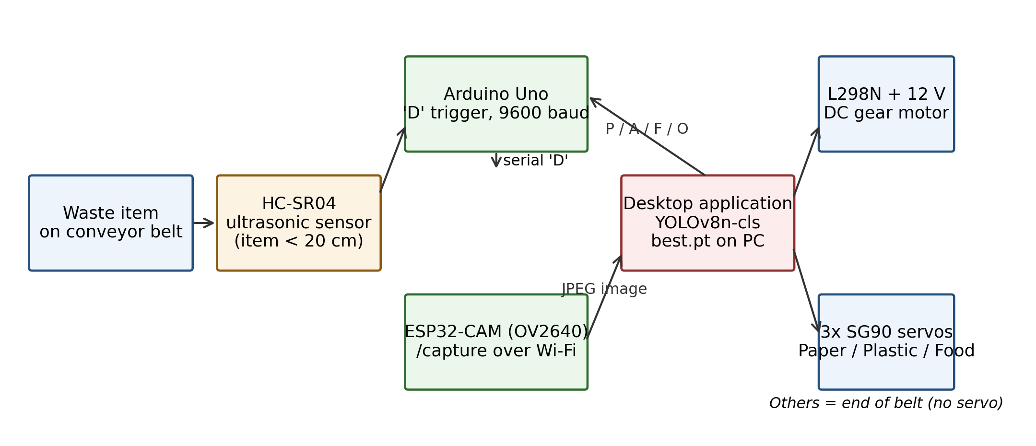
Fig. 1. System architecture. Sensing and actuation (Arduino Uno), image capture (ESP32-CAM), and inference (desktop PC) are separate nodes; the class command is a single character (P/A/F/O).
TABLE I. HARDWARE COMPONENTS AND CONNECTIONS
Component | Role in this system | Key connection
HC-SR04 ultrasonic sensor | Item trigger; item present below 20 cm | Trig pin 9, echo pin 10
ESP32-CAM (OV2640) | Image capture; /capture and /flash HTTP endpoints | Wi-Fi to desktop PC
Arduino Uno (ATmega328P) | Sequencing, motor and servo control, LCD status | UART 9600 baud to PC
L298N + 12 V DC gear motor | Conveyor belt drive | Conveyor control pin 8
SG90 servo × 3 | Pusher arms: Paper, Plastic, Food | Pins 4, 5, 6 (PWM)
16×2 LCD (I2C, 0x27) | On-device status and class display | I2C bus
Desktop PC application | YOLOv8n-cls inference, dashboard, statistics | Serial + HTTP

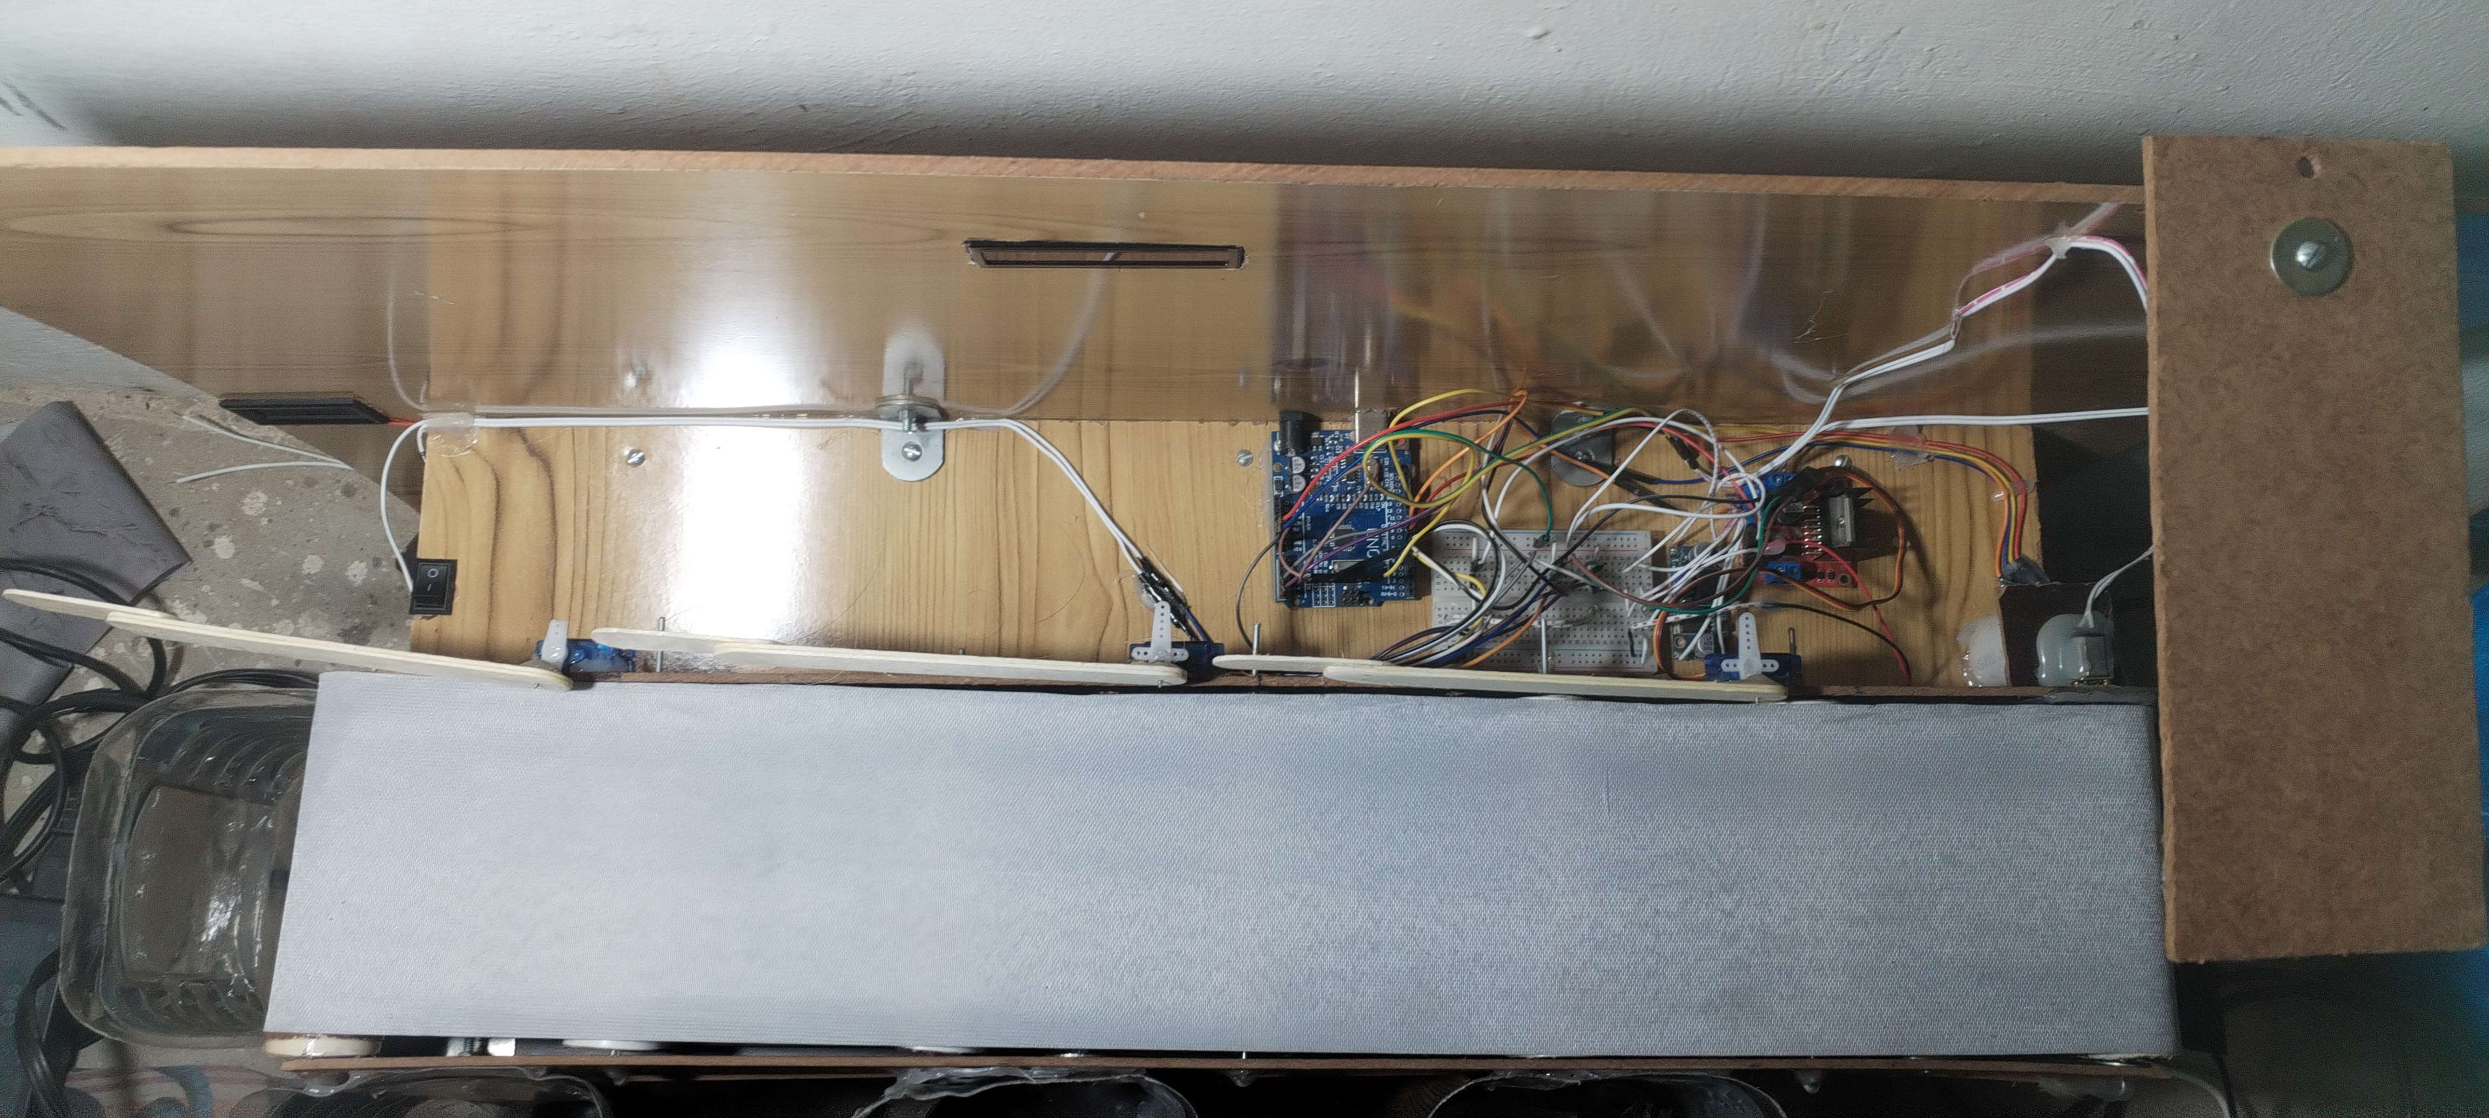
Fig. 2. The built prototype (top view): conveyor belt (foreground), Arduino Uno, breadboard wiring, L298N driver and the three servo pusher arms along the belt. The unit was assembled from low-cost, off-the-shelf parts funded by the authors.
B. Sensing: ultrasonic trigger
The HC-SR04 measures the echo duration t of an ultrasonic pulse; the item distance follows from the speed of sound in air (0.034 cm/µs) and the round trip:
d = (t × 0.034) / 2 (1)
An item is registered when d falls below 20 cm. The firmware then lights an indicator LED, shows “Waste Detected” on the LCD, waits 3 s for the item to settle, and sends the character “D” to the desktop application. The firmware has no debounce or state flag: an item left in the drop zone re-triggers the cycle roughly every 4 s, which Section VII records as a known limitation.
C. Classification and the reject rule
The desktop application requests a frame from /capture (a dummy request first, to clear the camera’s first-frame lag, then the real request), and classifies it with the trained model. The classifier returns a probability for each class through the softmax over the class logits z_i:
p_i = exp(z_i) / Σ_j exp(z_j) (2)
Training minimises the cross-entropy between the one-hot label y and the predicted distribution p:
L = − Σ_i y_i · log(p_i) (3)
The top-1 class and its confidence are read from the model output. The deployed decision rule is:
route = class, if confidence ≥ 0.60; Others, otherwise (4)
The corresponding command character—P (Plastic), A (Paper), F (Food), O (Others)—is sent to the Arduino. On receipt, the Arduino restarts the conveyor, sweeps the servo for that class from its neutral position of 90° to 0°, holds the cycle for 5 s, then returns the servo to 90° and stops the belt. (The project report describes the sweep as 0° to 90°; the firmware implements 90° → 0°, and this paper follows the firmware.) For Others, no servo is energised: the item simply rides the belt into the terminal bin.
D. End-to-end workflow and software
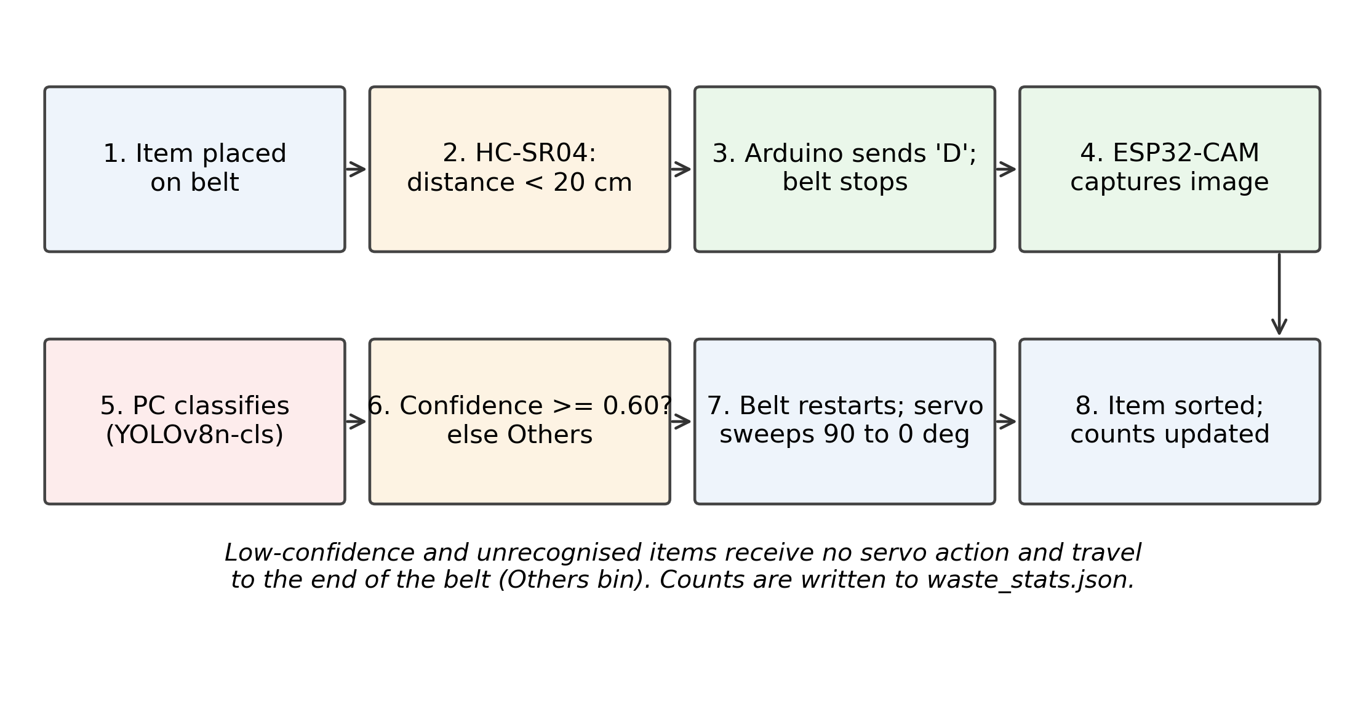
Fig. 3. End-to-end sorting workflow, from item detection to servo actuation, with the low-confidence route to Others requiring no servo action.
The desktop application (Fig. 4) shows the live feed, the classified result and its confidence, running per-class session counts, and a manual “force capture” override. Counts persist in a waste_stats.json file, so statistics survive restarts. A separate test build of the application runs with the serial link disabled for bench work on the classifier alone.
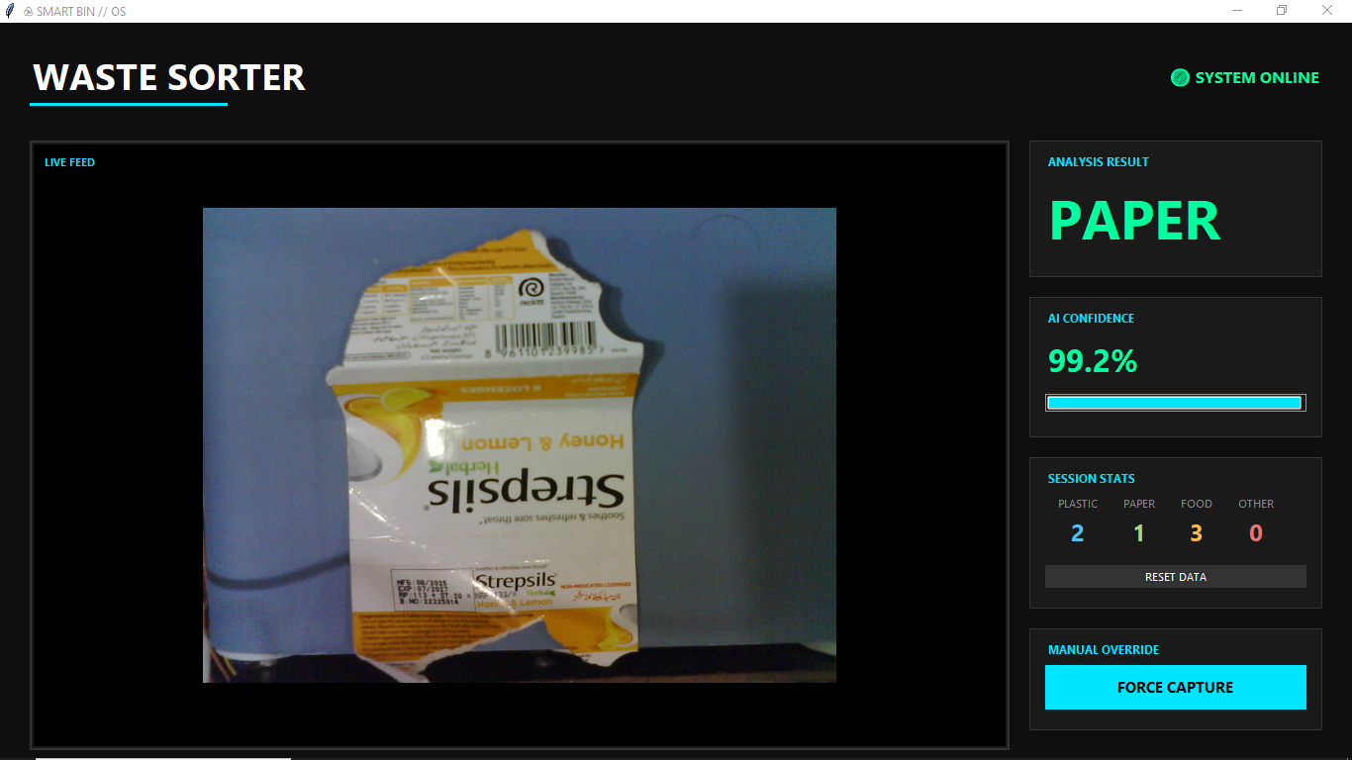
Fig. 4. Desktop application during a live sort: the captured item (a paper packet) is classified as Paper with 99.2% confidence; session counts for the four classes are shown at right.
IV. DATASET AND TRAINING
A. Source and remapping
The classifier is trained on RealWaste [9], a public dataset of 4,752 landfill waste images in nine classes (CC BY-NC-SA 4.0). The nine classes are remapped to the four streams the mechanism can physically separate: Paper (500) stays Paper; Plastic (921) stays Plastic; Food Organics (411) becomes Food; and the remaining six classes—Cardboard (461), Glass (420), Metal (790), Miscellaneous Trash (495), Textile (318) and Vegetation (436), 2,920 images in total—are merged into Others. Cardboard is assigned to Others, not Paper, in this remapping. The authors additionally photographed waste items with their phones and added them to every class: 71 images in Food (author-confirmed) and, by the authors’ recollection that the same number was added to each class, 71 in each of Paper, Plastic and Others—284 phone photographs in total, included inside the class totals below.
B. The authors’ working dataset
Table II gives the working dataset exactly as counted from the authors’ dataset folders in the retraining run of Section V: 6,851 images, reasonably balanced (no class below 21% of the data). One disclosure is required. A plain 9→4 remap of the 4,752-image RealWaste release plus 284 phone photographs accounts for 5,036 images; the working folders contain 1,815 more (Paper +1,260, Plastic +682, Food +979 and Others −1,106 relative to that baseline). The folder counts themselves are verified; the provenance of the difference—plausibly augmentation copies saved as images, duplicates, or partial exclusion of Others classes—was not recorded when the dataset was assembled and is not claimed here. The split below is by image, so a conclusion that depends on the extra images’ origin must wait until the dataset is rebuilt with a manifest.
TABLE II. WORKING DATASET (FOLDER-COUNTS VERIFIED; SHARES 26.7/24.4/21.3/27.5%) AND STRATIFIED 70/15/15 SPLIT, SEED 42
Class | Total | Train | Val | Test
Paper | 1,831 | 1,281 | 274 | 276
Plastic | 1,674 | 1,171 | 251 | 252
Food | 1,461 | 1,022 | 219 | 220
Others | 1,885 | 1,319 | 282 | 284
Total | 6,851 | 4,793 | 1,026 | 1,032

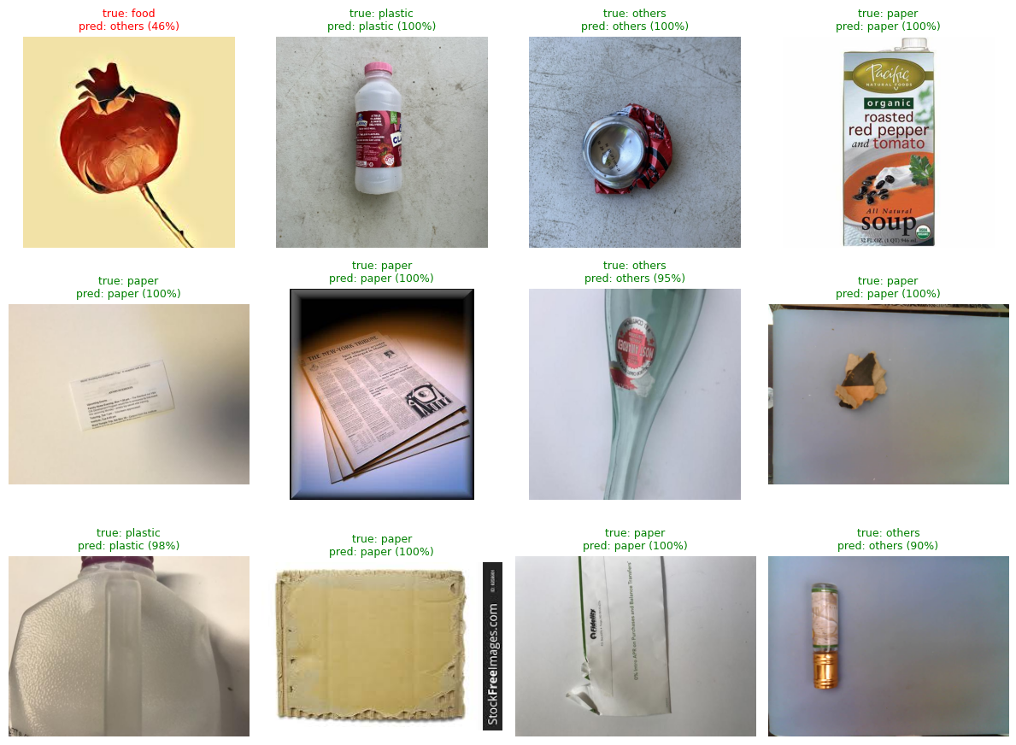
Fig. 5. Sample predictions on held-out test images (true vs. predicted class with confidence). Eleven of the twelve shown are correct; the single error (food → others, 46%) falls below the 0.60 threshold and would be routed to Others by the reject rule in any case.
C. Training configuration
Because the dataset is folder-per-class images with no bounding-box annotations, the correct task is classification, and the model is the classification variant YOLOv8n-cls—not YOLOv8 object detection [10]. Classification is also the correct task for the mechanism: the belt presents one item at a time and the servo needs only the item’s class, never its location. The retraining reported here starts from pretrained YOLOv8n-cls weights (1.44 M parameters) and trains for 30 epochs at 224×224 input, batch size 32, seed 42, on a Tesla T4 GPU (23 min). One corrupt JPEG in the Plastic folder was restored by the training pipeline. The deployed desktop application loads the resulting best.pt weights; the earlier project build used the same classification interface (top-1 class and confidence) throughout.
V. EXPERIMENTAL RESULTS
A. Overall and per-class performance
Performance is reported with the standard classification measures. For each class, with TP, FP and FN the true positives, false positives and false negatives:
Accuracy = correct predictions / total test images (5)
P = TP/(TP+FP), R = TP/(TP+FN), F1 = 2·P·R/(P+R) (6)
Training converged smoothly (Fig. 6): the classification loss fell from 0.81 to 0.04 over 30 epochs while validation top-1 accuracy rose from 87.4% to 95.9%. On the held-out test split the model scores 95.06% top-1 accuracy (981 of 1,032 images). Table III collects every headline metric of the run in one place. Top-5 accuracy is not reported: with only four classes it is trivially 100% and carries no information.
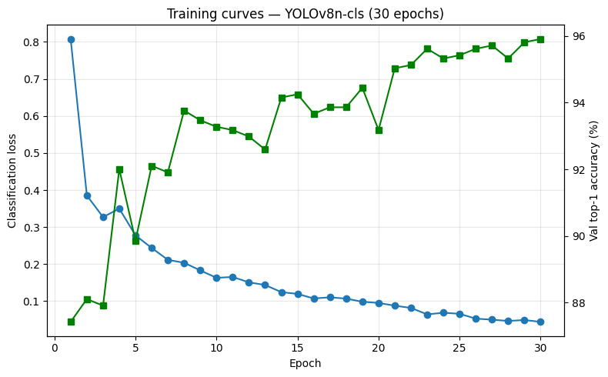
Fig. 6. Training curves for the YOLOv8n-cls retraining run: classification loss (left axis) and validation top-1 accuracy (right axis) over 30 epochs.
TABLE III. CLASSIFIER METRICS OF THE RETRAINING RUN (GOOGLE COLAB, TESLA T4), PLUS THE SEPARATE PHYSICAL TRIAL RESULT
Metric | Value | Notes
Validation top-1 accuracy | 95.91% | 1,026 images
Test top-1 accuracy | 95.06% | 981 / 1,032 images
Macro precision / recall / F1 | 0.952 / 0.951 / 0.951 | Mean over the four classes
Paper — P / R / F1 | 0.965 / 0.993 / 0.979 | Support 276
Plastic — P / R / F1 | 0.937 / 0.885 / 0.910 | Weakest class; see Fig. 7
Food — P / R / F1 | 0.982 / 0.991 / 0.986 | Strongest class
Others — P / R / F1 | 0.924 / 0.937 / 0.930 | Support 284
Accuracy at 0.60 reject rule | 94.96% | Reject rate 2.2% of test items
Model inference latency | 14 ms mean, 31 ms p95 | Tesla T4, per image; inference only
Model size | 1.44 M parameters | YOLOv8n-cls, best.pt ≈ 3.0 MB
Training time | 23 min, 30 epochs | Tesla T4, batch 32, 224×224
Physical sorting accuracy | 85.0% (34 / 40) | Separate author-reported conveyor trial; see Sec. V-E

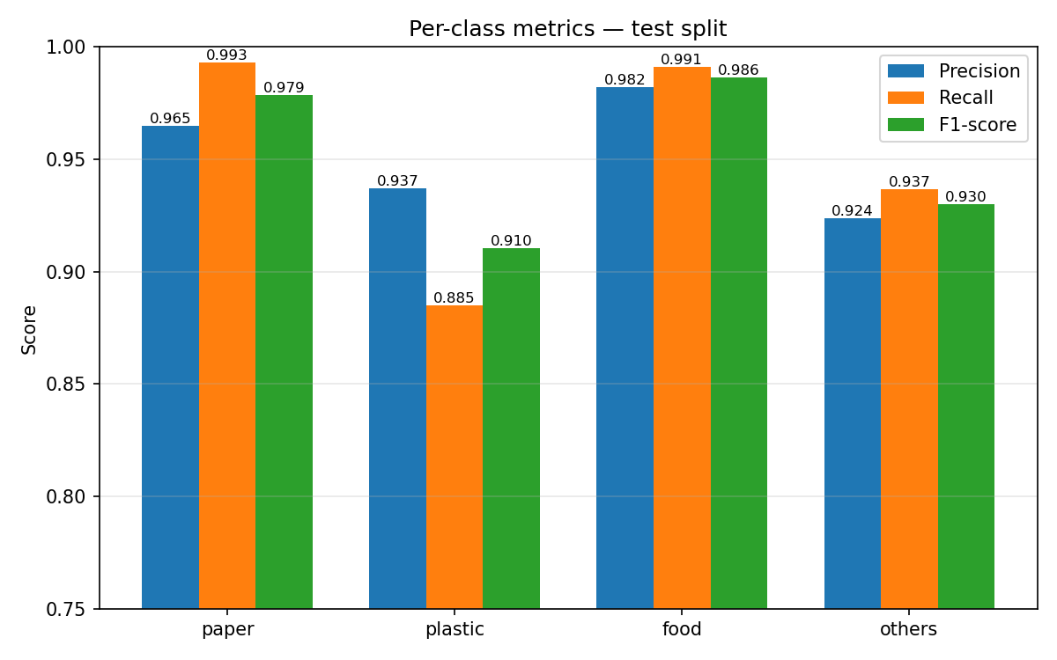
Fig. 7. Per-class precision, recall and F1 on the test split. Plastic recall (0.885) is the clear outlier; every other bar is at or above 0.92.
B. Error analysis
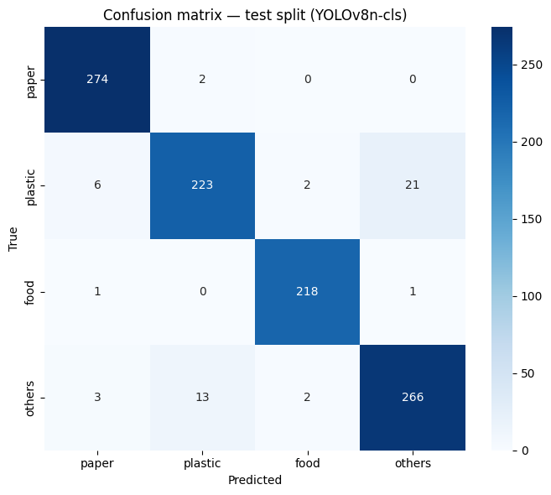
Fig. 8. Confusion matrix on the test split (rows: true class; columns: predicted class). The dominant error is Plastic → Others (21 items), followed by Others → Plastic (13).
The confusion matrix (Fig. 8) shows a single dominant failure mode: Plastic and Others confuse each other in both directions (34 of the 51 test errors). Transparent and crushed plastic items visually resemble the glass, metal and mixed items that populate Others, and Plastic recall (0.885) is the only per-class figure below 0.92. Paper and Food are close to ceiling (F1 0.979 and 0.986). The practical consequence is benign in one direction—Plastic sent to Others is lost recyclate, not contamination of a pure stream—while Others sent to Plastic (13 items) does contaminate the plastic stream, which is where future data collection should concentrate.
C. The 0.60 threshold, measured
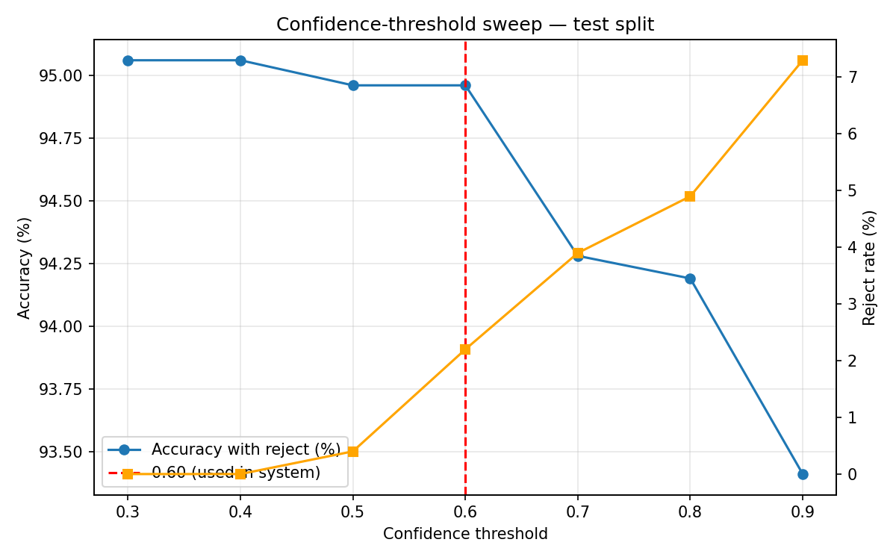
Fig. 9. Confidence-threshold sweep on the test split: accuracy with sub-threshold items routed to Others (left axis) and reject rate (right axis). The deployed threshold, 0.60, sits at the knee of both curves.
TABLE IV. CONFIDENCE-THRESHOLD SWEEP ON THE TEST SPLIT
Threshold | Accuracy with reject (%) | Reject rate (%)
0.30 | 95.06 | 0.0
0.40 | 95.06 | 0.0
0.50 | 94.96 | 0.4
0.60 | 94.96 | 2.2
0.70 | 94.28 | 3.9
0.80 | 94.19 | 4.9
0.90 | 93.41 | 7.3

The sweep (Fig. 9, Table IV) justifies the threshold the firmware already used. Raising the threshold from 0.30 to 0.60 costs only 0.10 percentage points of accuracy while sending 2.2% of items—the ones the model is least sure about—to the fail-safe stream; beyond 0.70 both accuracy and coverage degrade together. The 0.60 rule is therefore retained, now as a measured choice rather than an assumption.
D. System-level tests reported by the project
The project report’s earlier evaluation is kept separate from the retraining results above, because its protocol differs: on a 50-image held-out validation set of static images, the original build averaged 94% classification accuracy; a functional test passed all checkpoints on 20 physical items across the four categories; and a stress test ran 200 cycles in 60 minutes with 10 failed transmissions (5%), the L298N reaching at most 42 °C. The same report quotes a mean end-to-end latency of 1.8 s, which the firmware contradicts—the programmed delays alone (3 s settle + 1 s trigger + 5 s servo cycle) total about 9 s per item, before capture and inference—so this paper does not repeat the 1.8 s figure; end-to-end latency must be re-measured on the assembled unit. The 14 ms figure in Table III is model inference only, on a datacentre GPU, and is not a system latency.
E. Physical sorting trial (author-reported)
In a separate trial on the assembled conveyor, reported by the authors after the retraining run, 40 items were run through the system end-to-end. Of these, 34 landed in the correct bin and 6 did not, giving a physical sorting accuracy of 85.0% (34/40). This figure is kept strictly separate from the classifier metrics above: it is a bin-level outcome on physical items, not an image-level score on the held-out test set (95.06%), and the two must not be conflated or averaged.
The authors attribute the 6 incorrect placements to image quality: in their account, the affected items were captured at poor resolution, so the resulting images were classified incorrectly and the items were consequently routed to the wrong bin. No per-class breakdown, per-item log or preserved error images from this trial are available, so the resolution explanation is reported as the authors' account of the failures, not as an independently verified cause. A larger, instrumented trial is listed as future work.
TABLE V. PHYSICAL SORTING TRIAL — SEPARATE FROM THE IMAGE-LEVEL CLASSIFIER RESULTS IN TABLES III–IV; 6 MISROUTES ATTRIBUTED BY THE AUTHORS TO POORLY RESOLVED CAPTURES
Trial | Items | Correct | Wrong | Accuracy
Physical conveyor trial (author-reported) | 40 | 34 | 6 | 85.0%

VI. DISCUSSION
A. Why classification, not detection
A reviewer’s first question is why a YOLO model is used without bounding boxes or mAP. The answer is mechanical: the belt presents exactly one item, the camera frames it, and the actuator needs one label. Detection would additionally require box annotations that the dataset does not have, and would buy localisation the mechanism cannot use. Classification becomes the wrong choice only when the input changes—several items in frame, overlapping items, or counting—so those cases are stated as scope limits in Section VII, and detection is the stated upgrade path for the standalone version.
B. Why inference stays on the PC—for now
The original design goal was a wire-free, independent unit running live detection on-device. That goal collides with arithmetic: the ESP32-CAM offers a few hundred kilobytes of usable memory, while even YOLOv8n-class models need megabytes of weights and orders of magnitude more compute than the module provides; published edge deployments of YOLOv8 use Jetson-class or phone-class hardware, not camera microcontrollers [10]. With the project funded from the authors’ own pockets, a Jetson-class board was out of reach, so the design keeps the camera module for what it does well—capture and Wi-Fi transport—and puts inference on a PC the team already owned. The result is an IoT product in the literal sense: networked sensing and actuation around a remote model. The cost of that honesty is a tether (Wi-Fi plus serial) and a system that is not yet standalone; the benefit is a classifier that actually runs at the accuracy reported here instead of a quantised model whose accuracy was never measured.
C. What the numbers do and do not show
The retraining results show that a four-class remapping of a real-world dataset, plus a modest set of locally photographed images, trains a small classifier to about 95% top-1 on held-out images from the same distribution, and that a 0.60 reject rule is nearly free. The author-reported physical trial puts the assembled machine below that figure, at 85.0% (34/40): a gap of about 10 percentage points between image-level accuracy (95.06%) and bin-level accuracy. That gap is expected—camera angle, lighting, item orientation on the belt and servo timing all sit between an image-level score and a bin-level outcome—and the authors identify one concrete contributor: poorly resolved captures, which they report caused the 6 misroutes in the trial. Improving capture resolution and consistency, and then re-measuring with a larger instrumented trial, is therefore the first item of future work.
VII. LIMITATIONS
- Provenance gap: the working dataset (6,851 images, folder-verified) exceeds a plain RealWaste remap plus the authors’ phone photographs by 1,815 images, whose origin (augmentation copies, duplicates, or partial Others exclusion) was not recorded. Results are reported on the folders as they exist; a rebuilt dataset with a per-image manifest is needed for full reproducibility.
- Phone-photo counts: 71 per class is author-confirmed for Food and an author recollection for the other three classes; exact per-class phone counts were not recorded.
- Image-level split: the stratified 70/15/15 split is by image, not by physical item, so multiple photographs of one item could appear in both training and test data, which can inflate test accuracy.
- Single item per frame: the classifier assigns one label per image; multiple or overlapping items on the belt are out of scope and will be labelled as whichever class dominates.
- PC tether: inference requires a Wi-Fi link to the ESP32-CAM and a serial link to a PC running the desktop application; the unit is not standalone, contrary to the original design goal.
- Latency: end-to-end per-item time is dominated by programmed firmware delays (≈9 s per cycle) plus capture and inference; the report’s 1.8 s figure is inconsistent with the firmware and is not claimed. Model inference alone measured 14 ms mean on a Tesla T4, which does not transfer to the (non-inferencing) ESP32-CAM.
- Physical sorting trial is small and author-reported: the 85.0% bin-level figure rests on a single run of 40 items reported by the authors (34 correct, 6 incorrect), with no per-class breakdown, per-item log or preserved error images. The authors attribute the 6 errors to poorly resolved captures, but without an error log that cause cannot be verified from the trial data; a larger instrumented trial is still needed.
- Trigger behaviour: the firmware has no debounce/state flag, so an item left in the drop zone re-triggers the cycle about every 4 s; the HC-SR04 is also sensitive to soft, sound-absorbing surfaces such as fabric and foam.
- Fixed thresholds and timing: the 20 cm trigger distance, 0.60 confidence threshold (now sweep-justified) and the 3 s/5 s delays are constants, not adapted to item size, belt load or lighting.
- Model identity of the original build: the desktop code loads a generic best.pt; the architecture of the weights used in the original project build is not recorded. The retraining reported here (YOLOv8n-cls) is fully specified and reproducible from the supplied notebook.
- Dataset licence and scope: RealWaste is CC BY-NC-SA 4.0 (non-commercial, share-alike); the class set has no hazardous, e-waste or sanitary stream, and Others is a heterogeneous catch-all whose composition varies between deployments.
VIII. CONCLUSION AND FUTURE WORK
A conveyor-based smart bin that separates Paper, Plastic, Food and Others at source was designed, built from low-cost parts at the authors’ own expense, and evaluated at two distinct levels: at the classifier level, with a fully documented retraining run—95.06% top-1 accuracy on a 1,032-image held-out test set, per-class F1 from 0.910 (Plastic) to 0.986 (Food), and a measured justification for the 0.60 reject rule that routes uncertain items to a fail-safe Others stream—and, separately, in an author-reported physical conveyor trial in which 34 of 40 items (85.0%) landed in the correct bin, with the 6 misroutes attributed by the authors to poorly resolved captures. The system deliberately trades the original vision of a standalone, wire-free detection unit for a PC-tethered classification design that fits a student budget, and says so. Future work, in order: (1) a larger, instrumented physical sorting trial with a per-class breakdown, a preserved per-item error log, repeated runs and per-item cycle-time (end-to-end latency) measurement; (2) a rebuilt dataset with a per-image manifest and an item-level split; (3) targeted collection for the Plastic↔Others confusion; (4) firmware debounce and adaptive timing; and (5) migration of inference to an affordable edge board, restoring the standalone goal, with a detection model once multi-item frames are in scope.
Acknowledgment— The prototype was funded entirely by the authors. RealWaste is used under CC BY-NC-SA 4.0 [9].
REFERENCES
[1] M. Yang and G. Thung, “Classification of Trash for Recyclability Status,” Stanford Univ., CS229 Project Report, 2016. [TrashNet dataset].
[2] R. A. Aral, Ş. R. Keskin, M. Kaya, and M. Hacıömeroğlu, “Classification of TrashNet Dataset Based on Deep Learning Models,” in Proc. 2018 IEEE Int. Conf. on Big Data (Big Data), Seattle, WA, USA, 2018, pp. 2058–2062, doi: 10.1109/BigData.2018.8622212.
[3] C. Bircanoğlu, M. Atay, F. Beşer, Ö. Genç, and M. A. Kızrak, “RecycleNet: Intelligent Waste Sorting Using Deep Neural Networks,” in Proc. 2018 Innovations in Intelligent Systems and Applications (INISTA), 2018, pp. 1–7, doi: 10.1109/INISTA.2018.8466276.
[4] D. Ziouzios and M. Dasygenis, “A Smart Recycling Bin for Waste Classification,” in Proc. 2019 Panhellenic Conf. on Electronics & Telecommunications (PACET), Volos, Greece, 2019, pp. 1–4, doi: 10.1109/PACET48583.2019.8956270.
[5] T. J. Sheng, M. S. Islam, N. Misran, M. H. Baharuddin, H. Arshad, M. R. Islam, M. E. H. Chowdhury, H. Rmili, and M. T. Islam, “An Internet of Things Based Smart Waste Management System Using LoRa and TensorFlow Deep Learning Model,” IEEE Access, vol. 8, pp. 148793–148811, 2020, doi: 10.1109/ACCESS.2020.3016255.
[6] I. Sosunova and J. Porras, “IoT-Enabled Smart Waste Management Systems for Smart Cities: A Systematic Review,” IEEE Access, vol. 10, pp. 73326–73363, 2022, doi: 10.1109/ACCESS.2022.3188308.
[7] M. A. Hannan et al., “A Review on Technologies and Their Usage in Solid Waste Monitoring and Management Systems: Issues and Challenges,” Waste Management, vol. 43, pp. 509–523, 2015, doi: 10.1016/j.wasman.2015.05.033.
[8] P. F. Proença and P. Simões, “TACO: Trash Annotations in Context for Litter Detection,” arXiv:2003.06975, 2020.
[9] S. Single, S. Iranmanesh, and R. Raad, “RealWaste: A Novel Real-Life Data Set for Landfill Waste Classification Using Deep Learning,” Information, vol. 14, no. 12, art. 633, 2023, doi: 10.3390/info14120633.
[10] G. Jocher, A. Chaurasia, and J. Qiu, “Ultralytics YOLOv8,” software and documentation, 2023. [Online]. Available: https://docs.ultralytics.com
[11] B. Mano, K. S. Giri, A. Gokul, S. Hemanath, and S. Kumar, “An Automated Waste Separator for Biodegradable and Non-Biodegradable Materials Using YOLOv8 and Arduino,” J. Sci. Res. Rep., vol. 31, no. 8, pp. 1152–1161, 2025, doi: 10.9734/jsrr/2025/v31i83457.
[12] N. Baras, D. Ziouzios, M. Dasygenis, and C. Tsanaktsidis, “A Cloud Based Smart Recycling Bin for Waste Classification,” in Proc. 2020 9th Int. Conf. on Modern Circuits and Systems Technologies (MOCAST), 2020.
[13] J. Bobulski and J. Piatkowski, “PET Waste Classification Method and Plastic Waste DataBase—WaDaBa,” in Image Processing and Communications Challenges 9, Springer, 2018, pp. 57–64, doi: 10.1007/978-3-319-68720-9_8.
[14] T. Wang et al., “A Multi-Level Approach to Waste Object Segmentation,” Sensors, vol. 20, no. 14, art. 3816, 2020, doi: 10.3390/s20143816.

