What is it?
They hammered out thin sheets of gold and cut strands to be worked into the blue, purple and scarlet yarn and fine linen—the work of skilled hands. Exodus 39:3 NIV
CSS stands for Cascading Style Sheet. It specifies the layout, color, fonts, and spacing of the web elements in a web page.
It was developed by Håkon Wium Lie (http://people.opera.com/howcome/) while working for W3C in 1994. He is the current Chief Technology Officer of Opera Software.

Why should I care?
CSS is also used to style the web pages of a Chrome Application.
You link the CSS file with the HTML file using the link element like this:
<link rel="stylesheet" href="styles.css">
The link element must go inside the head element.
Since the link element can also be used for other things, we need to tell the browser that this is a link to a style sheet. That is done with the rel attribute.
The href attribute indicates the location of the CSS file. If it is in the same folder as the HTML file, you can just put the file name.
Each styling element in the CSS file starts with a comma-separated list of selectors, followed by a semicolon separated list of statements in curly brackets like this:
selector[, selector...] {
property: value;
[property: value;]
...
}
Example
* {
font-family: sans-serif;
}

Details

Fonts
In the example above we are setting the font-family for every element to sans-serif.


Selectors
The selector is the pointer to elements in the HTML page.
The * selector points to every element.
By specifying the name of an HTML element, you select every element with that name. For instance, if the selector is div, every div element in the web page is styled according to the statements you give inside the curly brackets following the selector.
A selector that is prefixed with # will point to elements with an id attribute value of the selector.
HTML:
<div id="div-1">Content</div>

CSS:
#div-1 {
height: 10px;
}
A selector that is prefixed with . will point to elements with a class attribute value of the selector.
HTML:
<div class="smallish">Content</div>
CSS:
.smallish {
height: 10px;
}
You can also combine the class selector with other selectors like this:
div.smallish {
height: 10px;
}
This is now only selecting the div elements that have a class attribute with a value of smallish.
If you specify two selectors separated by space, it means that the right selector has to be a descendant, or inside the other.
Example:
div a {
font-family: sans-serif;
}
This means that links (a elements) inside a div element will be sans-serif.

Colors
You specify the color of text with the color property, the color of the background is specified with the background-color property, and the border color with the border-colorproperty.
Example:
div {
color: white;
background-color: blue;
border-color: black;
}


The value of a color property can be specified as the name of the color. There are more than 150 color names that are supported.
The basic colors that must be supported by all browsers are specified here: http://www.w3.org/TR/css3-color/#html4
Most popular browsers also support these color names: http://www.w3.org/TR/css3-color/#svg-color
You can also specify the color as a numeric value. It is specified as a 6-digit hexadecimal value with a pound-sign (#) in front. The first two digits indicate the amount of red in the color, the next two digits the amount of green, and the last two indicate the amount of blue in the color. Since we add the colors together, and white contains all colors, you would specify white as #FFFFFF. The color red would be specified as #FF0000, the color green as #00FF00, and the color blue as #0000FF. This way of specifying a color as the red, green, and blue components is called RGB (Red Green Blue).
Example:
div {
color: #FFFFFF;
background-color: #0000FF;
border-color: #000000;
}

The Web site W3Schools.com has a color mixer page that can help you find the numeric values of colors:
http://www.w3schools.com/tags/ref_colormixer.asp
Be careful when you choose your colors. Some colors look great together, and some look terrible. Choosing a color scheme that has been created by a designer is a good idea. The Web site Paletton (http://paletton.com/) is great to put a color scheme together.
Consider also that some people are color blind, and choosing your colors wisely will help them use your application.
Finally if you are not familiar with hexadecimal values, you can also specify the numeric color values as a comma separated list like this: rgb(255, 255, 255).
Example:
div {
color: rgb(255, 255, 255);
background-color: rgb(0, 0, 255);
border-color: rgb(0, 0, 0);
}

What if we wanted to color every other row in a table differently. This is a very usual effect, and of course this is possible to do with CSS.
This is what it will look like in the browser:
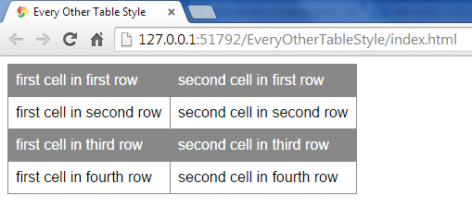
Here is the HTML:
<table>
<tr>
<td>first cell in first row</td>
<td>second cell in first row</td>
</tr>
<tr>
<td>first cell in second row</td>
<td>second cell in second row</td>
</tr>
<tr>
<td>first cell in third row</td>
<td>second cell in third row</td>
</tr>
<tr>
<td>first cell in fourth row</td>
<td>second cell in fourth row</td>
</tr>
</table>

You have to put it inside the body element of your index.html file.
Here is the CSS:
* {
font-family: sans-serif;
}

table {
border-collapse: collapse;
}

td {
padding: 0.5em;
border-width: thin;
border-style: solid;
border-color: #888888;
}

tr:nth-child(2n+1) {
background-color: #888888;
color: #ffffff;
}
First we use the * selector to select every element in the web page, and set the font-family to sans-serif.
* {
font-family: sans-serif;
}
Next we use the table selector to select every table element, and set the border-collapse property to collapse. This just means that if two elements are next to each other, and they both have a border, only one border will be shown.
table {
border-collapse: collapse;
}
Without it the table will look like this:
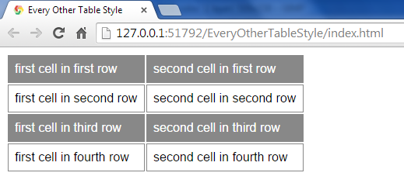
The td selector is used to set padding and border properties for every cell.
td {
padding: 0.5em;
border-width: thin;
border-style: solid;
border-color: #888888;
}
The padding property value has the effect of adding some space between the border and the content of the cell. The value 0.5em means half a character size, so if the font size changes, so does this value. The border properties gives us a border that is a solid thin line, with a gray color.
Now comes the interesting part; the :nth-child selector.
tr:nth-child(2n+1) {
background-color: #888888;
color: #ffffff;
}
The argument in parentheses; 2n+1 indicates index into the sibling elements in the parent element. The first child has index 1. So for any value of n; 0, 1, 2, ... we multiply by 2and add 1. The result becomes 1, 3, 5, ..., so all the odd numbers. The syntax is an+b. We could also have specified just 2n, and then it would have been all the even indexes. Since this is kind of complicated and hard to remember, you can also just give the argument odd or even.
Suppose we want to change just one particular element? That is also possible by not including the n in the argument. So if we wanted all the odd rows to be gray, but the very first row to be blue, we can do it like this:
tr:nth-child(1) {
background-color: blue;
color: #ffffff;
}

tr:nth-child(odd) {
background-color: #888888;
color: #ffffff;
}
Why did that not work? The first row is not blue.
Oh yeah, CSS means Cascading Style Sheets. So if something comes later it effectively adds to the effects already done in a cascading fashion. We first set the style for index 1, and then for all the odd indexes, and since 1 is an odd number, it overrides the first effect for the first row.
What we need to do is reverse the order like this:
tr:nth-child(odd) {
background-color: #888888;
color: #ffffff;
}

tr:nth-child(1) {
background-color: blue;
color: #ffffff;
}
Now we got the desired effect:
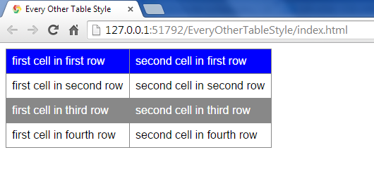
You can read more about this selector here:
https://developer.mozilla.org/en-US/docs/Web/CSS/:nth-child

Text Effects
In the previous section we saw that text can have different colors, but using CSS you can also make other effects on the text in you web page.
You can underline text using the text-decoration property with the underline value.
Example:
div {
text-decoration: underline;
}

You can make it italics using the font-style property with the italic value.
Example:
div {
font-style: italic;
}

You can make it bold using the font-weight property with the bold value.
Example:
div {
font-weight: bold;
}

You can make shadows using the text-shadow property. The value is specified as 4 arguments. The first is the horizontal distance of the shadow, the second is the vertical distance of the shadow, the third is the blur distance, and the fourth is the color of the shadow.
Example:
div {
text-shadow: 0.1em 0.1em 0.1em black;
}


Layout
Each HTML element has the following areas:
Content
Padding
Border
Margin

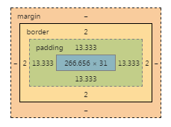
The content is the innermost box. Around the content is the padding, then the border, and finally the margin. The margin gives space to surrounding elements.
Use the following properties to describe the size of the different areas:
Property | Description
width | The width of the content area
height | The height of the content area
padding | The width of the padding area. Specify as 4 values separated by space. They indicate top, right, bottom, and left respectively. You can also specify the padding for individual directions by using the propertiespadding-top, padding-right, padding-bottom, and padding-left
border-width | The width of the border. As with the padding, you can specify it as 4 values separated by space indicating top, right, bottom, and leftrespectively. You can also specify the border width for individual directions by using the properties border-top-width, border-right-width, border-bottom-width, and border-left-width
margin | The width of the margin. As with the padding, you can specify it as 4 values separated by space indicating top, right, bottom, and leftrespectively. You can also specify the margin for individual directions by using the properties margin-top, margin-right, margin-bottom, andmargin-left
Example:
HTML:
<!DOCTYPE html>
<html>
<head>
<title>Examples</title>
<link rel="stylesheet" href="styles.css">
</head>
<body>
<div id="first">First</div>
<div id="second">Second</div>
</body>
</html>
Styles.css:
div {
color: white;
background-color: blue;
border-color: black;
border-style: solid;
}

div {
width: 100px;
height: 100px;
padding: 10px;
border-width: 5px;
margin: 20px;
}
Render:
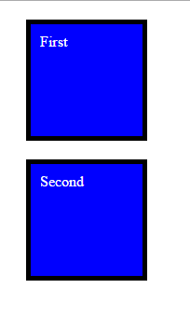
Did you notice how the two div elements were laid out vertically one after the other? We can change that using the float property. It can have the values left, right, or none, where none is the default. If we set float to left it means that the element should float over to the left inside the element it is in. If you float another element left, it will float as far to the left as it can. We already floated one element, so it will be placed to the right of that one.
Let's try it.
We will add the following to the Styles.css file:
div {
float: left;
}
It now renders like this:
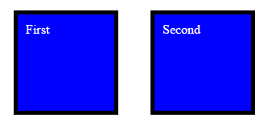
Normally the elements in a web page renders in one layer, but guess what? We can also change that.
The z-index property is used to indicate the elements elevation. The higher the number, the higher the elevation. You can imagine that elements with a higher elevation could cover other elements with lower elevation.
Let's try it.
div#first {
z-index: 1;
position: absolute;
left: 0;
}

div#second {
z-index: 2;
position: absolute;
left: 50px;
}
It renders like this:
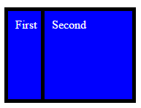

Units
Have you noticed that I have put px after each size? It means that I have given the size in pixels. A pixel is a tiny dot on your screen. Usually there will be 72 such pixels in one inch. We say that the pixel density of the screen is 72 PPI (Pixels Per Inch). Some people use DPI (Dots Per Inch) for the same thing. Some displays have higher PPI to be able to create a clearer picture in a smaller area. Therefore if you specify your layout using px, it will look smaller on some devices, and bigger on others.
Fortunately there are other ways to specify sizes than px. You can use in or %.
The in unit indicate size in inches. In this way you are guaranteed that the size will be the same no matter what display the web page is being shown on.
One risk here is that the page will be too big then to fit on some devices, and too small to look good on other devices.
The % unit to the rescue! This unit is used to indicate a size as a percentage of the parent element's size. So if you want one element that fills the whole screen, you can give it a width and a height property with the value 100%.
Let's try it!
HTML:
<!DOCTYPE html>
<html>
<head>
<title>Examples</title>
<link rel="stylesheet" href="styles.css">
</head>
<body>
<div id="whole">Fills whole page</div>
</body>
</html>

CSS:
div#whole {
width: 100%;
height: 100%;
}
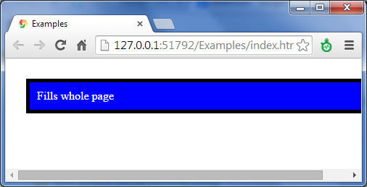
Oops! What happened?
Well the height: 100% means 100% of the height of the parent. Since the parent is the body element that doesn't have any height defined it will have auto by default, which means to fit to content.
The solution is to set height: 100% on every parent element like this:
html, body {
height: 100%;
}
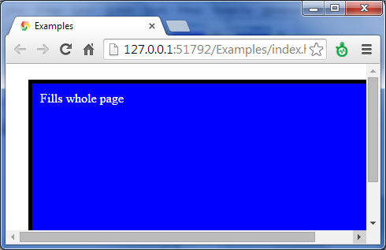
It is better, but still not what we want. If our content is 100% of the parent, and adding the margin, border, and padding the total area of our element is going to be bigger than the parent, and the scroll-bars appear.
Final solution:
* {
padding: 0;
border-width: 0;
margin: 0;
}

div {
color: white;
background-color: blue;
border-color: black;
border-style: solid;
}

html, body {
height: 100%;
width: 100%;
}

body {
padding: 1%;
box-sizing: border-box;
background-color: black;
}

div#whole {
width: 100%;
height: 100%;
padding: 5%;
box-sizing: border-box;
}
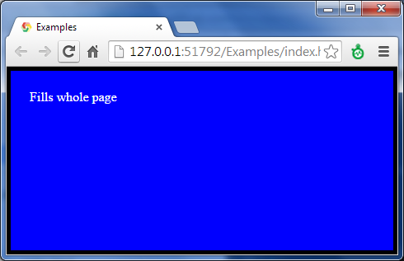
There are a couple of tricks here. First we are using the * selector to select every element in the page and set padding, border-width, and margin to 0.
* {
padding: 0;
border-width: 0;
margin: 0;
}
The next thing to note is that the div#whole element has a new property box-sizing that we haven't talked about before. The property describes how the size of a box is to be calculated. The default value is content-box. It means that width and height only indicate the content. The border-box value that we specified means that the width and height now are taken to include padding and border.

div#whole {
width: 100%;
height: 100%;
padding: 5%;
box-sizing: border-box;
}
The final trick is that the border now scales with the size of the window. Since we cannot specify a border-width in percent - I didn't tell you this before, but now you know - we specify the padding of the parent element instead, and set the background-color of the parent to the desired border color; black.
body {
padding: 1%;
box-sizing: border-box;
background-color: black;
}

Where can I find more information?
CSS Tutorial (http://www.w3schools.com/css/)
CSS | MDN (https://developer.mozilla.org/en-US/docs/Web/CSS)
Cascading Style Sheets (http://www.w3.org/Style/CSS/Overview.en.html)

