What is it?
They lean on the web, but it gives way; they cling to it, but it does not hold.
Job 8:15 NIV
HTML5 is an abbreviation that stands for Hyper Text Markup Language version 5.
It is an extension to XML; eXtensible Markup Language.
HTML was invented by Tim Berners-Lee (@timbl - https://github.com/timbl) in 1989 while he worked for CERN - http://home.web.cern.ch/. The early versions of HTML was based on SGML (Standard Generalized Mark-up Language), and so they were not XML.

Why should I care?
HTML5 is what makes up web pages, and since a Web Application consists of web pages, we need to know how to create HTML5 content.
Let's look at XML syntax first.
An XML document is a file, that contains structured information. The structure is defined by using the following characters that have special meaning in XML:
< > / " = & # ;

Details

Elements
The < and > characters are used to define elements.
An element can either have content, or be empty.
An empty element must start with < and end with />. In between is the name of the element and maybe some attributes, we'll get back to those.
<html />
The word html is the name of the element. An element in XML can have any name.
An element with content must first have a start-tag that starts with < and ends with >, then comes the content, which can be text, or other elements, and then at the end comes the end-tag, which starts with </ and ends with >.
<html>
Some content
</html>
An element can have any number of child-elements, which can again have child-elements to any level of nesting you want.
<html>
<head>
<title>My first web page</title>
</head>
<body>
<p>Here is a paragraph</p>
</body>
</html>
It is customary to indent child-elements, but it is not necessary. It just makes it more pretty, and easier to read.
Something like this is perfectly legal XML syntax:
<html><body><p>Here is a paragraph</p></body></html>

Structure of a Web Page
An HTML5 file must always start with:
<!DOCTYPE html>
This tells the browser that what follows is HTML5.
Next comes the html element. It does not need to have any child-elements, so this is a perfectly legal HTML5 document:
<!DOCTYPE html>
<html/>
The first child-element of the html element is the head element.
The head element contains things like title, meta, script, style, link etc.
Example:
<head>
<title>My First Web Page</title>
<meta charset="utf-8" />
</head>
The body element is the next child-element of the html element. It contains the content of the document.
Example:
<body>
<h1>This is the biggest header</h1>
<h2>This is smaller</h2>
<p>This is a paragraph</p>
</body>

Web addresses
A web address or a so called URL (Uniform Resource Locator) is used to indicate the location of a web page, an image, or some other resource.
A URL can be relative, or absolute. Absolute URLs always contain a scheme. A relative URL is relative to a base URL.
Examples:
Absolute: https://github.com/mscsbend/Chromium-Course/wiki/HTML5
Relative: /mscsbend/Chromium-Course/wiki/HTML5
Relative: CSS
Relative: ../wiki
Please note that even though one of the URLs above starts with a slash (/), it is still a relative URL, but it has an absolute path.
The parts of a URL:
scheme:scheme-specific-part
The parts of an HTTP URL:
http://hostname:port/path?query#fragment
The scheme can be either http, or https. The https scheme indicates that the connection is secured and encrypted.
The hostname is the name of the computer that the web resource is located on such as github.com.
The port is the TCP port number. It basically means the channel the communication goes on. The default value for the http scheme is 80, and if that is used, it does not need to be specified. Default for the https scheme is 443.
The path is the location in the file system of the host computer. Usually it maps to be relative to a so called document root of the web site, but not necessarily.
The query is extra parameters that the web resource may need. It may specify how to render the content.
The fragment points to an anchor inside the resource.

Headings
The elements h1, h2, h3, h4, h5, and h6 are headings. The higher the number, the smaller the heading.
You will use these elements to mark sections and chapters in your document. Usually you will expect to be able to link directly to one of these elements by appending some hash-tag (#) to the end of the web address to get to the fragment. And yes, hash-tags were not invented by Twitter. In HTML lingo a hash-tag is called a pound-sign.
Actually the hash-tag does not point to an h* element, but rather to an a element, that will usually be placed right inside the h* element.
Example:
<h1><a name="top" />The top heading</h1>
The address to go straight to "The top heading" would be:
http://www.some-domain.com/some-path/some-page.html#top

Links
The a element is used to either indicate a link to somewhere, or as the destination of a link. In HTML5 lingo that is called an anchor.
Use it as an anchor by specifying the name attribute. To navigate to an anchor in a page, append the hash-tag (#) followed by the value of the name attribute to the address of the page. An anchor is usually invisible and so the element will be left empty; without content.
Example:
<a name="top" />
To use the a element as a link, specify the href attribute. The href attribute value is the web address of another page, or it could be inside the same page by just specifying the hash-tag followed by the name of an anchor in the page. The content of the a element will be the text that the user can click on. A link is usually (but not always) displayed in blue underlined font.
Example:
<a href="#top">Go to the top</a>
<a href="http://github.com">Visit GitHub</a>

Images
The img element is used to show images in the web page.
The src attribute indicates the location of the image as a URL.
Example:
<img src="https://assets-cdn.github.com/images/modules/logos_page/Octocat.png" />
This result in the following image being inserted in the web page:

An image can be used as a link instead of text. To make this effect, just add the img element in the content of the a element like this:
<a href="https://github.com">
<img src="https://assets-cdn.github.com/images/modules/logos_page/Octocat.png" />
</a>

Lists
Lists can be ordered or numbered like this:
- First item
- Second item
Or they can be unordered or bulleted like this:
- Some item
- Another item

The ordered list is specified using the ol element and the unordered list by specifying the ul element. Each list item is specified with the li element.
Here is the HTML for the two examples above:
<ol>
<li>First item</li>
<li>Second item</li>
</ol>

<ul>
<li>Some item</li>
<li>Another item</li>
</ul>
Lists can also be nested like this:
<ol>
<li>First item in the top level</li>
<ol>
<li>Second level item</li>
<li>Another second level item</li>
</ol>
<li>Second item in the top level</li>
</ol>
It shows like this in the web page:
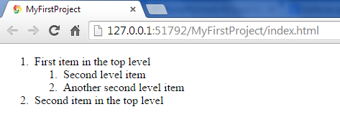

Tables
Tables lets you put web page content into rows and columns. Each table is defined by a table element.
Each row in the table is defined using the tr element inside the table element.
Inside the tr element, each cell is defined using the td element. The content of the td element can be text or other HTML elements such as a, img, etc.
Example:
<table>
<tr>
<td>first row, first cell</td>
<td>first row, second cell</td>
</tr>
<tr>
<td>second row, first cell</td>
<td>second row, second cell</td>
</tr>
</table>
Renders like this:
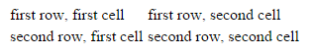
If we add a bit of styling it is easier to see where the cells are - more about that in the next chapter.
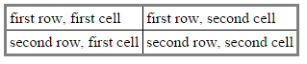
You can define headings using the th element.
Example:
<table>
<tr>
<th>heading row, first cell</th>
<th>heading row, second cell</th>
</tr>
<tr>
<td>second row, first cell</td>
<td>second row, second cell</td>
</tr>
</table>
Renders like this:
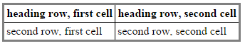
Cells can be joined either horizontally using the colspan attribute or vertically using the rowspan attribute.
Example:
<table>
<tr>
<th colspan="2">heading row, first cell</th>
<th colspan="2">heading row, second cell</th>
</tr>
<tr>
<td rowspan="2" colspan="2">second row, first cell</td>
<td rowspan="2">second row, second cell</td>
<td>second row, third cell</td>
</tr>
<tr>
<td>second row, first cell</td>
</tr>
<tr>
<td>third row, first cell</td>
<td>third row, second cell</td>
<td>third row, third cell</td>
<td>third row, fourth cell</td>
</tr>
</table>
Renders like this:
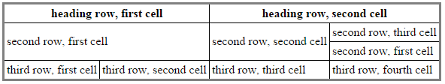

Forms
Forms are used to let the user enter information to be sent to a server, or to be used by the page.
The input element is used to input most of the data in a form. The type attribute indicates how the data is to be entered. If the type attribute has the value text, the input element is used to enter a simple text in one line.
Example:
<form>
<label for="name">Name</label>
<input id="name" name="name" type="text" /><br/><br/>
<label for="age">Age</label>
<input id="age" name="age" type="text" />
</form>
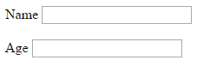
The label element shows what information is expected to be entered. The for attribute points to the id attribute of an input element, so we can see what it is a label for.
The name attribute is used by the server when the form is received. It is what identifies the input.
With the value attribute, you can fill in the input element like this:
<form>
<label for="name">Name</label>
<input id="name" name="name" type="text" value="Palle Cogburn" /><br/><br/>
<label for="age">Age</label>
<input id="age" name="age" type="text" value="47" />
</form>
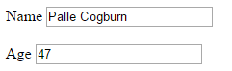
The placeholder attribute is used to give the user information about what to enter. This information is cleared as soon as the user starts entering data.
<form>
<label for="name">Name</label>
<input id="name" name="name" type="text"
placeholder="Enter your name" /><br/><br/>
<label for="age">Age</label>
<input id="age" name="age" type="text"
placeholder="How old are you?" />
</form>
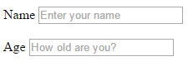
You can show a drop-down list of options with the select element.
<label for="month">Birth month</label>
<select id="month" name="month">
<option value="1">January</option>
<option value="2">February</option>
<option value="3">March</option>
<option value="4">April</option>
<option value="5">May</option>
<option value="6">June</option>
<option value="7">July</option>
<option value="8">August</option>
<option value="9">September</option>
<option value="10">October</option>
<option value="11">November</option>
<option value="12">December</option>
</select>
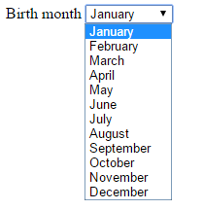
Inside the select element, each option element specifies the potential value of theselect element in the value attribute.
If there are only two options, using a checkbox is the best solution. The type attribute value of checkbox in the input element is used for this.
<label for="married">Married</label>
<input id="married" name="married" type="checkbox" checked />
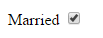
Notice how there is a checked attribute in the input element. If it is there, the checkbox is checked, otherwise it is unchecked.
Usually there will be a button on the form to submit the information when you are done filling it out. This is an input element with the type attribute value of submit.
<input type="submit" value="Submit" />
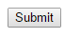
The action attribute on the form element is used to tell the browser the web addresswhere the form data should be sent to when the submit button is clicked.
Here is a web page where you can search on Google:
<!DOCTYPE html>
<html>
<head>
<title>Search</title>
</head>
<body>
<form action="http://google.com/search">
<input name="q" type="text" placeholder="Enter search text here" />
<input type="submit" value="?" />
</form>
</body>
</html>
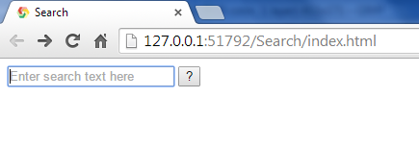
When you type in some text to search for; "mscsbend" in the example, and then press the<Enter> key or click the button, you will see the result from Google in the browser. Try it! 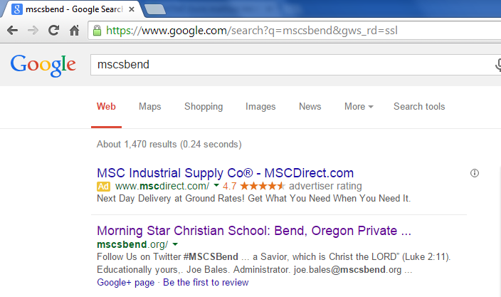
Notice that the input element with the name attribute equal to q now appears in the URL query part with the value you entered.
(https://www.google.com/search?q=mscsbend&gws_rd=ssl)
There are other elements you can put on forms, and you can explore these on your own here:
http://www.w3schools.com/html/html_forms.asp

Where can I find more information?
HTML Tutorial (http://www.w3schools.com/html/)
HTML (Hyper Text Markup Language | MDN (https://developer.mozilla.org/en-US/docs/Web/HTML)
HTML5 (http://www.w3.org/TR/html5/)

Challenges
- Create a web page with a table of some of your friends. The table could contain first name, last name, birthday, phone number, etc.
- Create a web page with pictures, as a photo album.
- Create a web page with a form that has different types of input. An example could be a form where you fill in your personal information.

