1. Create a .java file (AACCPanelImportExportBean.java file) in : “aacc-perspective/src/main/java com.fis.buyside.controlcenter.ui.web.launchPad”.

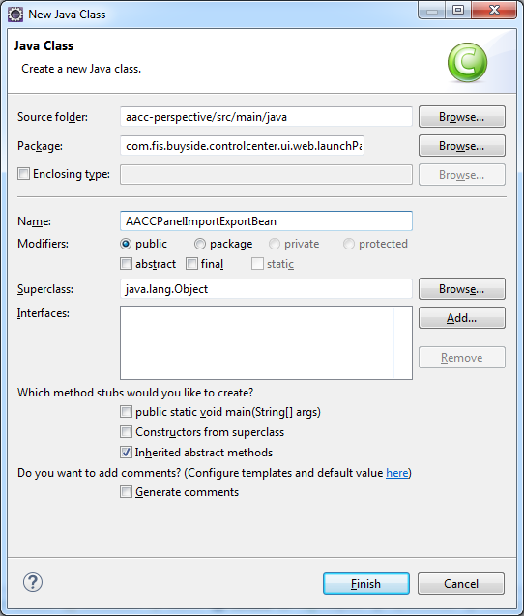

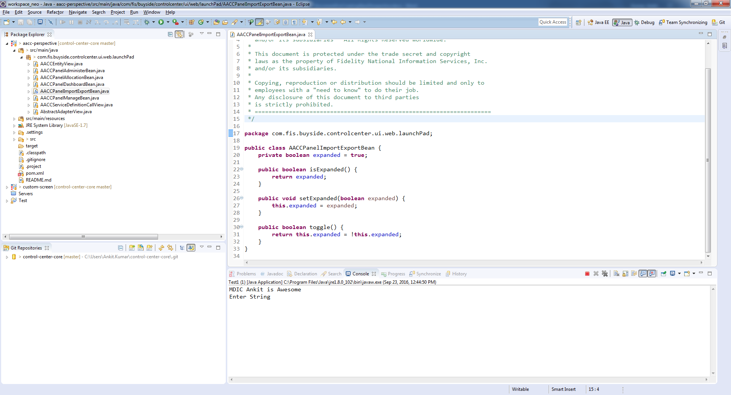

1. Go to /aacc-perspective/src/main/resources/META-INF/spring/html5-AACC-context.xml and create bean for .java file (**aacc_importexport_bean)**

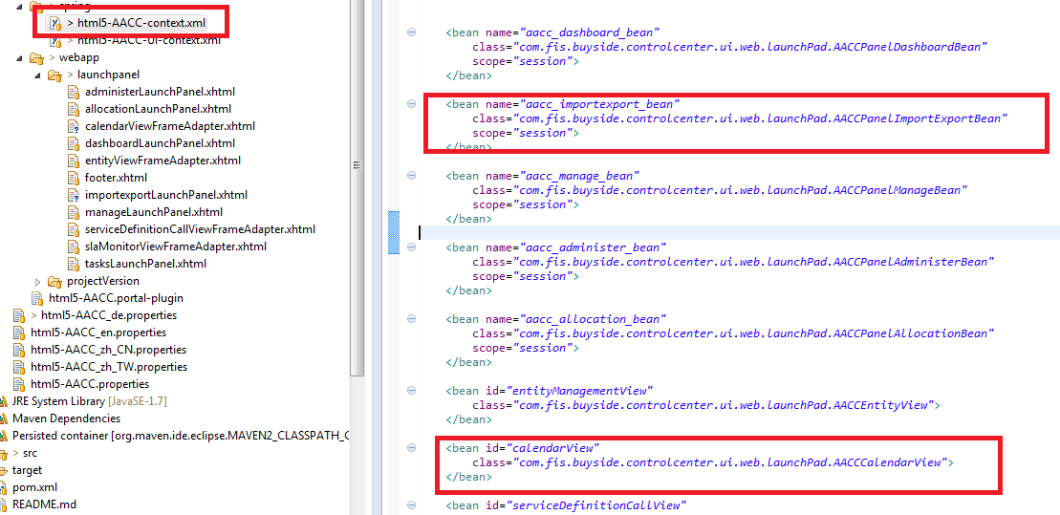

1. Create new **.xhtml** file(importexportLaunchPanel.xhtml) inside /aacc-perspective/src/main/resources/META- INF/webapp/launchpanel.

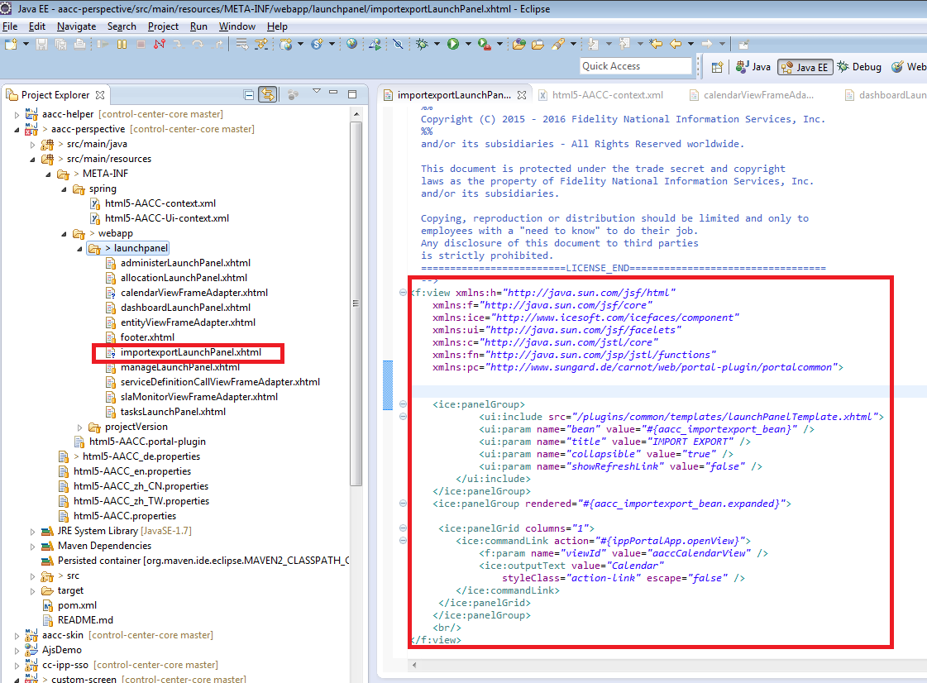

1. Go to /aacc-perspective/src/main/resources/META-INF/spring/html5-AACC-Ui-context.xml.

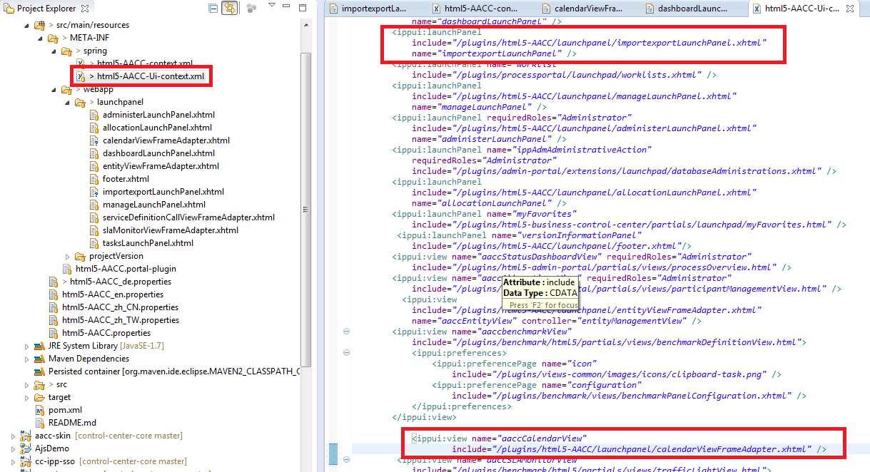

1. Run mvn clean install -o in aacc-persperctive.

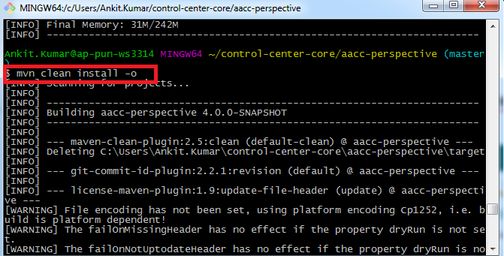

1. See the required changes.

