 | 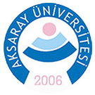

CALVIN (Python Version)
Spring 2026 Shortcourse
with Hands-on Tutorials

Prepared by
Mustafa Sahin Dogan
msdogan@ucdavis.edu, msahindogan@aksaray.edu.tr

Dates: April 27-30, 2026
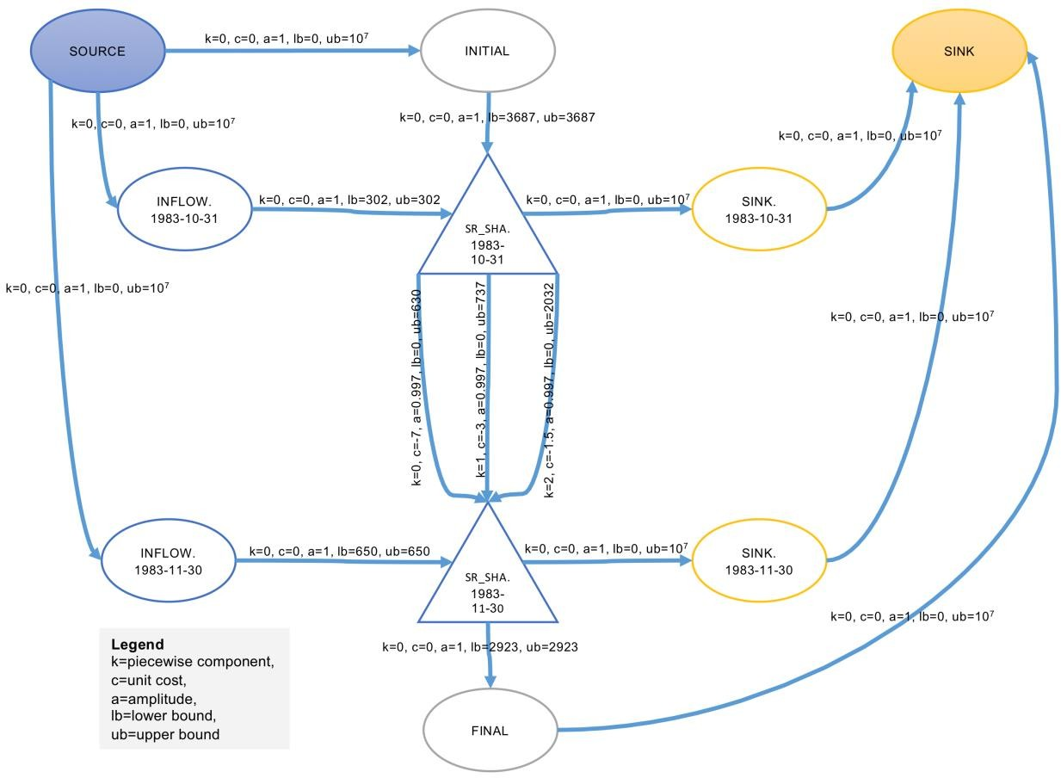

Date: April 27-30, 2026 from 9am-4pm
Location: Zoom (online)
Registration: https://forms.gle/HyHkCJJzJ4QtZyNPA
Shortcourse GitHub Repo: https://github.com/msdogan/CALVIN-shortcourse

Tentative Agenda and Topics

Day | Time |  | Topics
1 | 9am-12pm | - | Brief introductions, CALVIN background, and software installation
 | 1pm-4pm | - | Network-flow optimization and CA water network
2 | 9am-12pm | - | CALVIN hydrology and economics, components of the model
 | 1pm-4pm | - | HOBBES database and network matrix export
3 | 9am-12pm | - | Creating CALVIN runs (Python version) and running the model
 | 1pm-4pm | - | Postprocessing outputs and analyzing results
4 | 9am-12pm | - | Modifying the model for policy scenarios (“No Overdraft” example)
 | 1pm-4pm | - | Comparing output scenarios and analyzing effects of a “no overdraft” policy on CA’s water supply system, Q&A and discussion

Summary

This shortcourse is intended for those who are interested in California’s water supply system and large-scale water optimization modeling. Mechanics of the CALVIN model will be covered. This crash course introduces open-source CALVIN version modeled in Python-based Pyomo environment, employing faster solvers and giving an opportunity for better representation of the system. It walks through steps for required software installation process for the CALVIN model, as well as creating a model run and postprocessing results.

Recommended readings
- Original publication of CALVIN (Draper et al., 2003):

Draper, A. J., Jenkins, M. W., Kirby, K. W., Lund, J. R., & Howitt, R. E. (2003).
Economic-Engineering Optimization for California Water Management. Journal of Water Resources Planning and Management, 129(3), 155–164. https://doi.org/10.1061/(ASCE)0733-9496(2003)129:3(155)

- Open-source Python version of CALVIN (Dogan et al., 2018):

Dogan, M. S., Fefer, M. A., Herman, J. D., Hart, Q. J., Merz, J. R., Medellín-Azuara, J., & Lund, J. R. (2018). An open-source Python implementation of California’s hydroeconomic optimization model. Environmental Modelling & Software, 108, 8– 13. https://doi.org/10.1016/j.envsoft.2018.07.002

Documentation and related theses/publications: https://calvin.ucdavis.edu

