# 生成catalog

CATfctEditorAssistant -create-new-catalog -catalog-name SJDFeatExtCatalog.CATfct -with-client-id SJD123 -into-directory JEEHangerDefineFrame1

2.在生成的.osm文件中定义特征属性  
 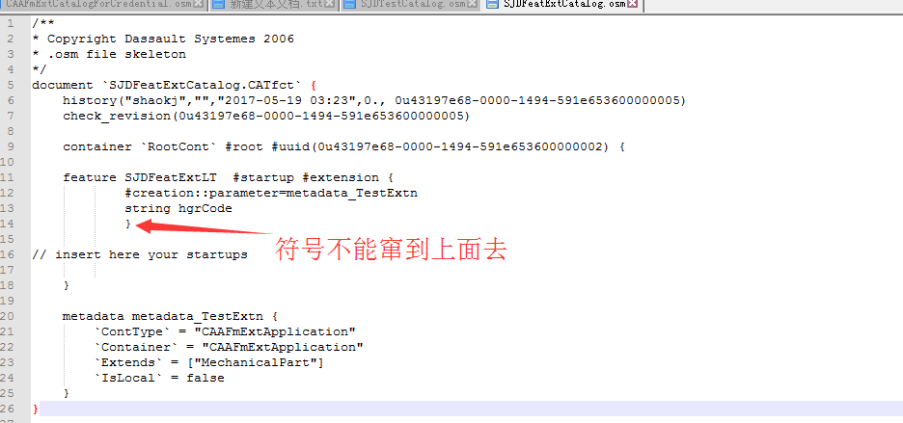

3.将.osm文件和.catfct文件拷贝到graphic文件下，更新catalog  
 CATfctEditorAssistant -update-catalog -catalog-name SJDFeatExtCatalog.CATfct -with-client-id SJD123 -with-osm JEEHangerDefineFrame1\CNext\resources\graphic\SJDFeatExtCatalog.osm -into-directory JEEHangerDefineFrame1

4.将cat.fct文件转为.osm文件，查看更新后的catalog内容

CATfctEditorAssistant -describe-as-osm -catalog-name SJDFeatExtCatalog.CATfct -with-client-id SJD123 -as SJDFeatExtCatalog.osm -into-directory JEEHangerDefineFrame1

CATfctEditorAssistant -update-catalog -catalog-name NIOWeldingPoint.CATfct -with-client-id NIOWeldingPoint -with-osm E:\NIO\Document\WeldingPoint\Feature\7\NIOWeldingPoint.osm -into-directory E:\NIO\Document\WeldingPoint\Feature\7

CATfctEditorAssistant -describe-as-osm -catalog-name NIOWeldingPoint.CATfct -with-client-id NIOWeldingPoint -as NIOWeldingPoint.osm -into-directory E:\NIO\Document\WeldingPoint\Feature\7

CATfctEditorAssistant -describe-as-osm -catalog-name NIOWeldingPoint.CATfct -with-client-id NIOWeldingPoint -as NIOWeldingPoint-describe.osm -into-directory E:\NIO\Document\WeldingPoint\Feature\7

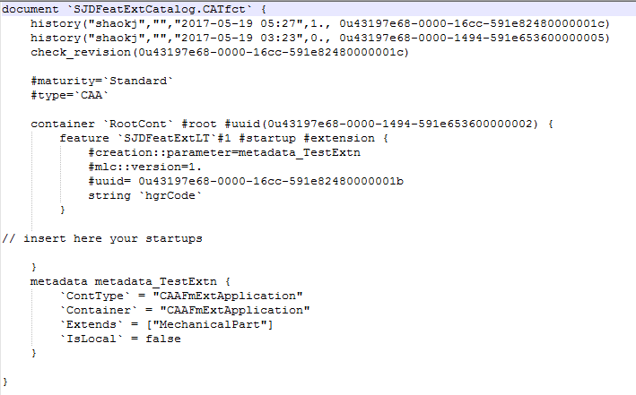

5.创建一个接口frame

6.在frame下的cpp mode下创建一个接口，接口必须是public

7.在借口中定义获取属性值与设置属性值的方法名

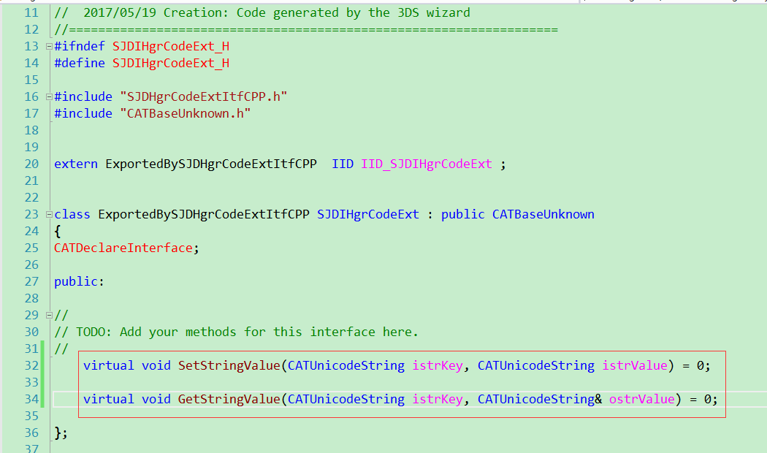

8.在命令所在的frame下创建一实现model

9.在molder下创建一扩展实现.cpp，实现定义的接口

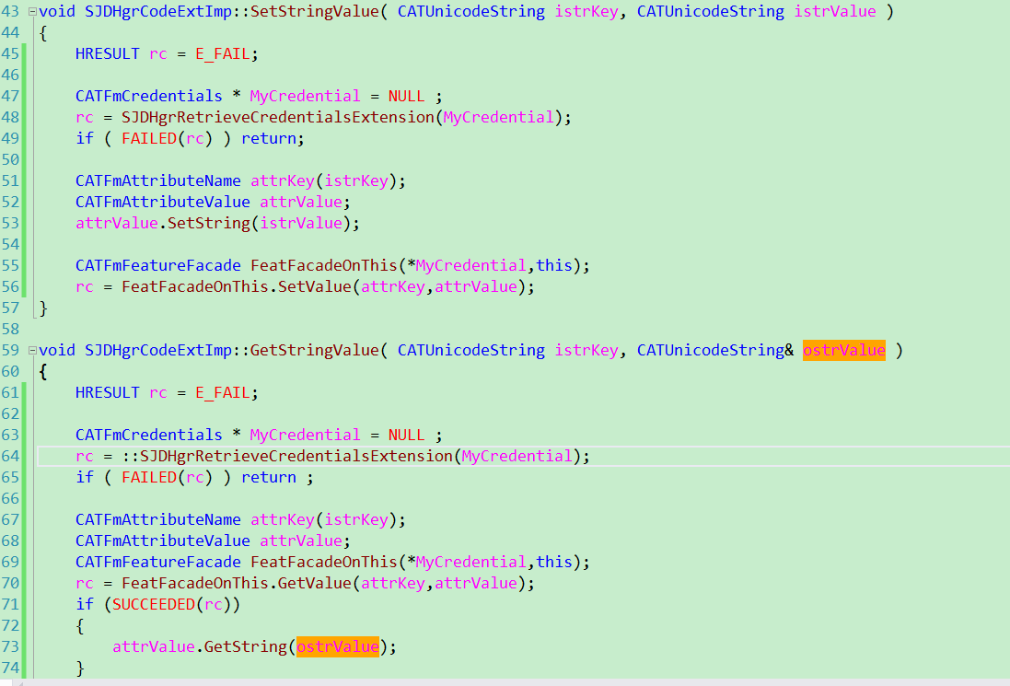

10.创建一.cpp去编写添加扩展，获取扩展，以及取得catalog证书的方法

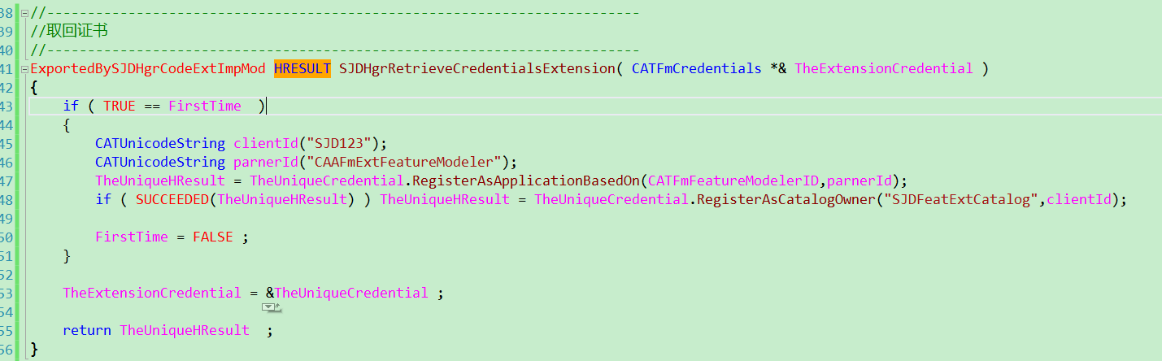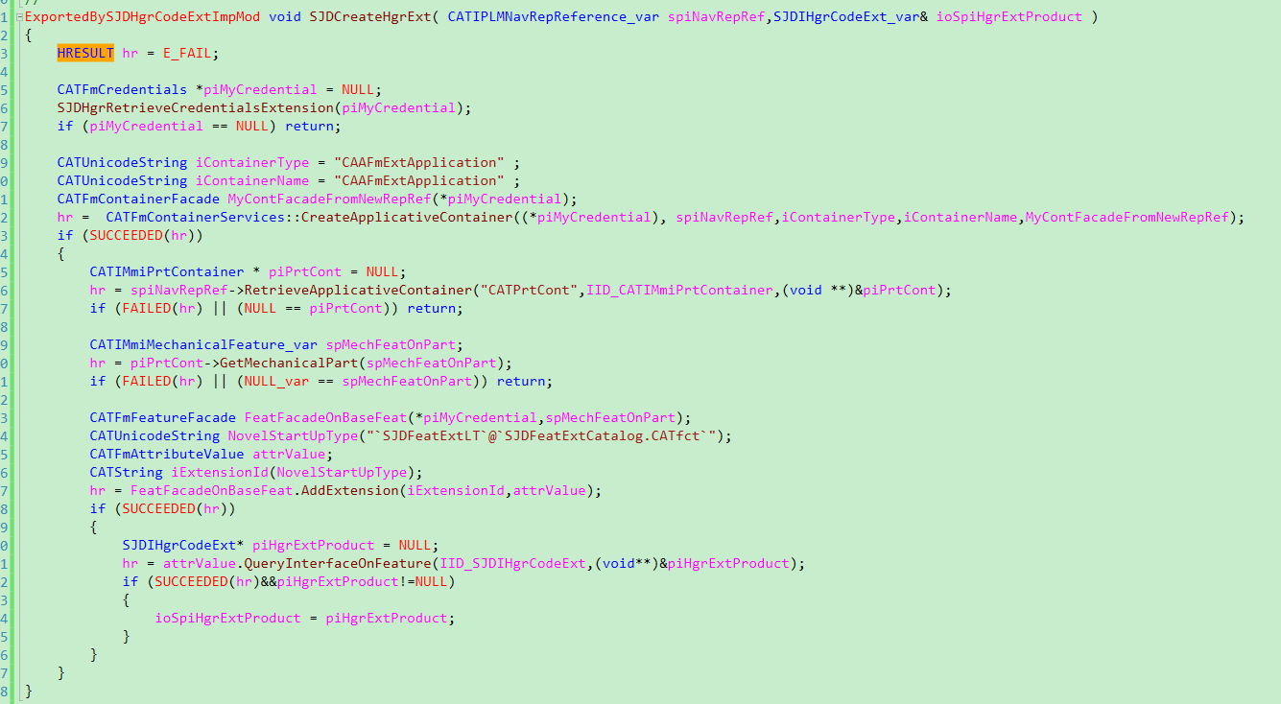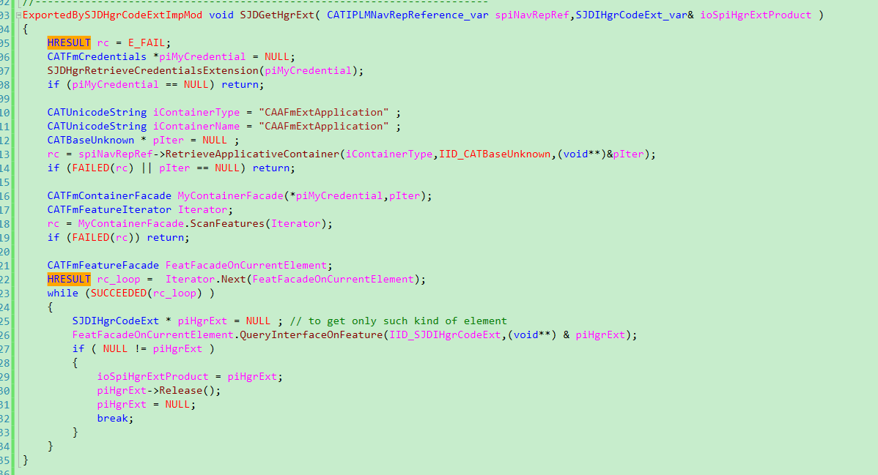

# 更新CATfct文件的步骤：

1. 将已有的catfct文件先生成osm 文件（对应workspace 的\win_b64\resources\graphic的fct文件转换成osm文件）

CATfctEditorAssistant -describe-as-osm -catalog-name NIOWeldingPoint.CATfct -with-client-id NIOWeldingPoint -as NIOWeldingPoint.osm -into-directory E:\NIO\Document\WeldingPoint\Feature\7

CATfctEditorAssistant -describe-as-osm -catalog-name YFJCJoinCATFct.CATfct -with-client-id YFJCJoinCATFct -as YFJCJoinCATFct.osm -into-directory E:\CAAProgram\CATfctWsp\SMCSpotWeldFrm\CNext\resources\graphic

1. 修改osm文件

3.将修改的osm文件重新生成catfct文件(并将osm文件名修改，方便与以前的osm文件对比)

CATfctEditorAssistant -update-catalog -catalog-name NIOWeldingPoint.CATfct -with-client-id NIOWeldingPoint -with-osm E:\NIO\Document\WeldingPoint\Feature\7\NIOWeldingPoint.osm -into-directory E:\NIO\Document\WeldingPoint\Feature\7

CATfctEditorAssistant -update-catalog -catalog-name YFJCJoinCATFct.CATfct -with-client-id YFJCJoinCATFct -with-osm E:\CAAProgram\CATfctWsp\SMCSpotWeldFrm\CNext\resources\graphic\YFJCJoinCATFct.osm -into-directory E:\CAAProgram\CATfctWsp\SMCSpotWeldFrm\CNext\resources\graphic

4.将新生成的catfct文件生成osm,已检查cattfct中属性是否更新

CATfctEditorAssistant -describe-as-osm -catalog-name NIOWeldingPoint.CATfct -with-client-id NIOWeldingPoint -as NIOWeldingPoint-describe.osm -into-directory E:\NIO\Document\WeldingPoint\Feature\7

CATfctEditorAssistant -describe-as-osm -catalog-name YFJCJoinCATFct.CATfct -with-client-id YFJCJoinCATFct -as YFJCJoinCATFct-describe.osm -into-directory E:\CAAProgram\CATfctWsp\SMCSpotWeldFrm\CNext\resources\graphic