**Wi-Fi CERTIFICATION TEST HOUSE**

**TVision Test Results**

**Date : June 25, 2021**

.



Name: **TVision**

Location: Wi-Fi Certification Test House

Responsible Person: Berk Celebi

Contents

**1.** **UDP Test** 3

**1.1 TVision Dashboard** 3

**1.2 TVision Interface Connection** 3

**1.3 DuT (TVision) Health** 4

**1.4 Temperature Monitoring** 7

**1.5 Network Traffic** 8

**1.6 Gateway Frequency** 11

**1.7 Interface Frequency** 11

**1.8 Speed** 12

**1.9 SSID Connection** 12

**2.** **WAN Test** 13

**2.1 Average Throughput** 13

**2.2 DuT (TVision) Health** 14

**2.3 Temperature Monitoring** 15

**2.4 Network Traffic** 16

## **UDP Test**

### **1.1 TVision Dashboard**

### **1.2 TVision Interface Connection**

### **1.3 DuT (TVision) Health**

One of the most important parameters of a test is the DuT Health monitor. During the testing process, devices are forced with high traffic transaction loads. All the heartbeats of the DuT is monitored and logged during testing process. This information helps to identify root causes of a problem by looking from the hardware & software harmony perspective.

Any memory leaks or CPU consuming operations are marked as inspection points, they are combined with other readings at exact time intervals in order to cross reference the problem definitions.

All metrics (for e.g. CPU, Memory, Network, Disk space) related with the DuT can be observed from “DuT Health Monitoring” pages.

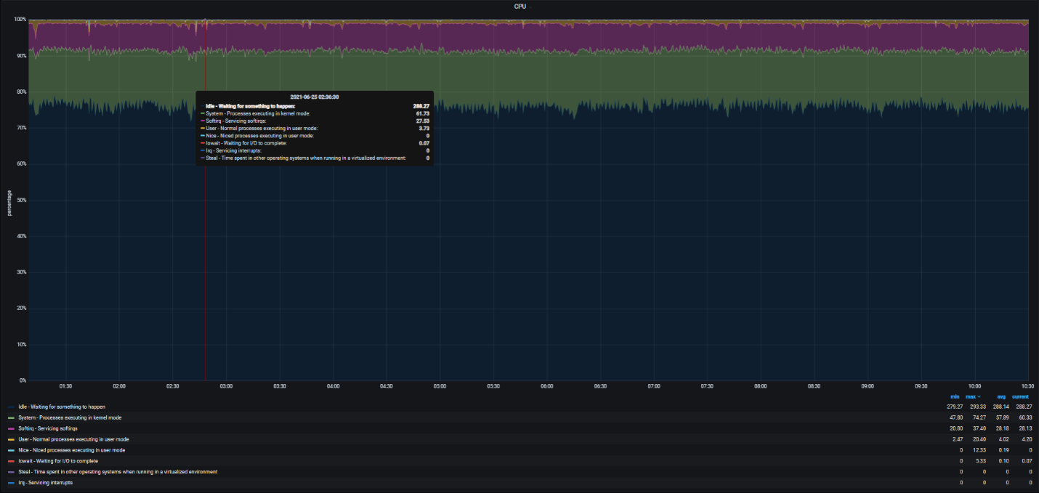

* CPU and memory usage was within standard values.
* Root directory space usage showed usage of 100%.

### **1.4 Temperature Monitoring**

DuT Temperatures (Hardware thermal zone temperature) are monitored and logged during the whole test execution process. Any high temperature reading cross referenced with the running test scenario in order to identify the root cause of a problem.

* There was no temperature peak during the UDP test.

### **1.5 Network Traffic**

Transmit/Receive comparison shows that the difference between transmit & receive packages. The loss between these two indicators gives us the idea of device’s channel utilization and protocol overhead values.

* Iperf bandwidth parameter was 100M.
* Lost amount was less than 2%.
* Average throughput was 110 Mbps.
* Iperf run for almost 10 hours without any disconnections.

### **1.6 Gateway Frequency**

* Gateway firmware: 143
* Channel configuration: Auto (for all radio)
* Device: Standalone

### **1.7 Interface Frequency**

Band steering is a technique used in dual band Wi-Fi equipment that encourages newer client devices to use the less congested 5 GHz network, freeing up resources on the 2.4 GHz band for single-band clients.

* During the UDP test, channel was 149.
* There was no channel movement during congestion on channel 149.

### **1.8 Speed**

### **1.9 SSID Connection**

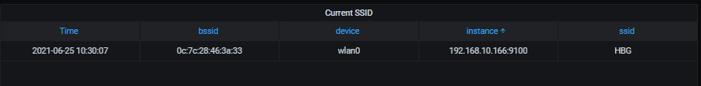

## **WAN Test**

### **2.1 Average Throughput**

Average throughput graphs give the idea of average reception rate of a client at a constant location.

By the help of this test, we can identify the throughput rate of a client under different signal quality values. Also, we can monitor the device performance of intelligent band steering conditions. We expect to see that DuT should steer the client from 5Ghz to 2.4 GHz in case the client has poor signal reception.

* During the WAN test, YouTube 4K video was streamed.
* Location of the test house limited the throughput to 16.6 Mbps.
* During the WAN test, 89 clients were connected to the gateway running throughput in 5 minutes loop (89 clients ran Iperf in LAN).

### **2.2 DuT (TVision) Health**

* CPU and memory usage was higher than LAN test but still within acceptable limit.

### **2.3 Temperature Monitoring**

* The temperature was higher than the LAN testing but within the acceptable limit.

### **2.4 Network Traffic**

