**HAFIZ MUHAMMAD UZAIR RIAZ  
MSDS18016**

**TASK-1 : Load pre-trained CNN model and fine-tune FC Layers**

First of all as per mentioned in the Assignment document, the number of samples are less than on the shared link while training I have gone through the number of samples and found 12000 number of training samples in my data set

So first of all as per requirement we have to use 2 models VGG16 and res18 model and need to change the FC layers of model so as per my roll number I have total 260 neurons in first FC layer and only 2 neuron in the last layer as we have only 2 classes.

Here are the images for VGG16 and Resnet 18

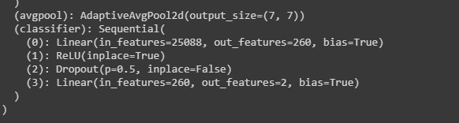

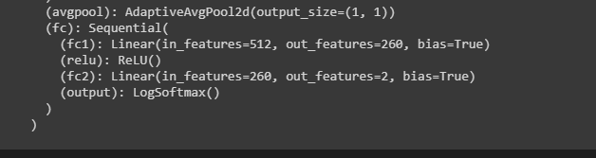

After Freezing all the other layers and only FC layers remains unfreeze and we have perform training on both the models with only FC layers unfreez

The Loss and accuracy we have obtained in case of **VGG16** is

**Loss:** 0.1543

**Accuracy obtained on validation set is:** 92%

And in case of **RESNET 18** we have loss and accuracy is as follows

**Loss:** 0.1432

**Accuracy obtained on validation set is:** 90%

While the Testing accuracy on VGG16 is **97%** and RESNET18 is **96%**

The Confusion matrix of both VGG16 and RESNET 18 is as

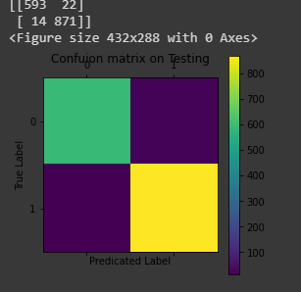 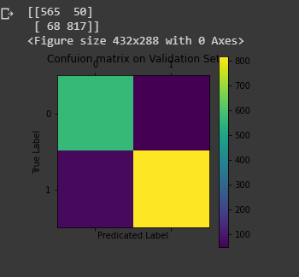

Confusion matrix of RESNET18

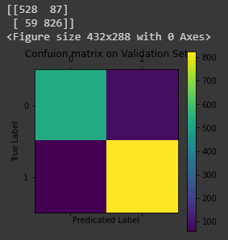 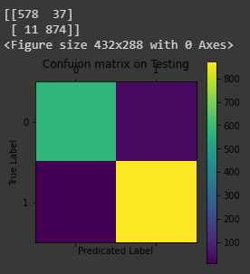

The F1 Measure for both the models is more than 1 which clearly indicates that our both the models are performing much better on the test images.

Also the from the loss curves it has been clearly indicated that the loss decreases gradually.

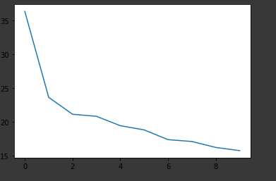 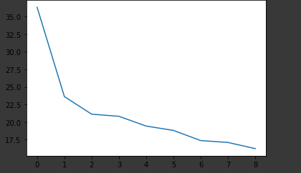

The above mentioned curves are the Loss curves for both VGG 16 and RESNET 18 model and on the x axis we have number of Epochs and y-axis has the Loss value ,in both the Scenarios, it has been clear that as the number of Epochs increases the Error value increases results in the increase of accuracy as well.

**TASK-2: Load pre-trained CNN model and fine-tune FC Layers**

For Task 2 we have performed many experiments regarding the freezing and unfreezing all the layers to one layer.

* Test our accuracy on already pre-trained model
* Test our Accuracy on models that have only one convolutional layer unfreeze
* Test our accuracy on the model with FC layer unfreeze only while the rest of the model is freeze.

## Test our accuracy on already pre-trained model

The Accuracy we obtained on already pre- trained model is nearly negligible we were only able to get 50% and even less than 50 % of accuracy in case of VGG16 model.

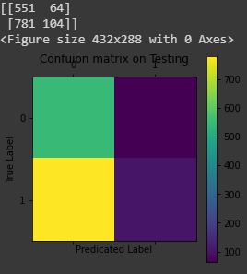 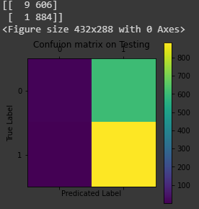

The Left matrix is of VGG16 while the Right one is RESNET 18 and it has been seen clearly from the Confusion matrix that False positive in case VGG 16 ad False negative Count in case of RESNET 18 is very much high that results in decrease of accuracy

## Test our Accuracy on models that have only one convolutional layer unfreeze

The Accuracy we obtained on models with one layer Convolutional layer is 96% in case of VGG16 and 96 % in case of RESNET 18

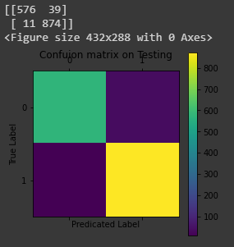 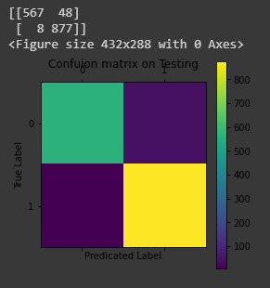

Both the F-measure value also is upti 0.8 resuting that our models with just one layer of convolution has performed amazingly much better.

## Test our accuracy on the model with FC layer unfreeze only while the rest of the model is freeze.

While freezing all layers except the FC layer VGG16 has accuracy on the test data is as 96% and RESNET 18 achieve 95 %

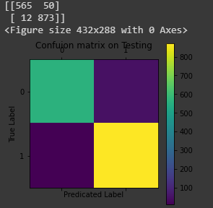 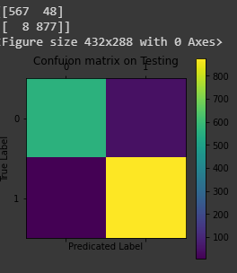

A brief summary of all the experments on VGG 16 is as

|  |  |  |  |  |  |
| --- | --- | --- | --- | --- | --- |
| Experiment | Epochs | Accuracy | Loss | Recall | precision |
| Pre Trained model | 05 | 46% | 1.03 | 0.0045 | 0.056 |
| Unfreeze one Conv layer | 05 | 96% | 0.13 | 0.95 | 0.40 |
| FC Layers unfreeze | 05 | 96% | 0.13 | 0.98 | 0.39 |
|  |  |  |  |  |  |
|  |  |  |  |  |  |

A brief summary of all the experments on RESNET 18 is as

|  |  |  |  |  |  |
| --- | --- | --- | --- | --- | --- |
| Experiment | Epochs | Accuracy | Loss | Recall | precision |
| Pre Trained model | 05 | 50% | 2.58 | 0.05 | 0.03 |
| Unfreeze one Conv layer | 05 | 96% | 0.14 | 0.97 | 0.39 |
| FC Layers unfreeze | 05 | 95% | 0.10 | 0.95 | 0.35 |
|  |  |  |  |  |  |
|  |  |  |  |  |  |