

MALAWI UNIVERSITY OF BUSINESS AND APPLIED SCIENCE
SCHOOL OF SCIENCE AND TECHNOLOGY
DEPARTMENT OF MATHEMATICAL SCIENCES
SUBMITTED TO : Dr A Taylor
MODULE : Data Structures and Algorithms
MODULE CODE :CIS-DSA-321
TITLE : SHORTEST PATHS AND MINIMUM
SPANNING TREE ON THE
BLANTYRE WATER PIPE NETWORK
(Graph Algorithms Assignment (Dijkstra and Kruskal)

DUE DATE :12 NOVEMBER ,2026

GROUP NAMES | REG NO
PAUL MAPALA | MSE/23/SS/037
GIFT MPONDA | MSE/22/SS/033
GETRUDE NEWA | MSE/23/SS/053

1. Introduction and description of the graph
This assignment represents the Blantyre water pipe network as an undirected, weighted graph. Each reservoir or receiving area is represented by a node (vertex), while a direct pipe connection between two places is represented by an edge. The weight on each edge is given in minutes, as shown in the supplied network data. The values in the source table are described as estimated minutes.
The graph contains 22 nodes and 37 edges. It is connected because every node can be reached from the others through one or more edges. It contains cycles, meaning that some places can be reached through more than one route. All edge weights are non-negative, so Dijkstra's algorithm can be used as indicated on our graph.
1.1 Nodes and their degrees
Number | Node / place | Degree (number of edges)
1 | Bangwe | 3
2 | Blantyre CBD | 9
3 | Chichiri Reservoir | 2
4 | Chigumula | 3
5 | Chileka | 2
6 | Chilomoni | 3
7 | Chirimba | 2
8 | Chitawira | 3
9 | Kameza | 2
10 | Kanjedza | 2
11 | Limbe | 8
12 | Manase | 3
13 | Mount Pleasant | 4
14 | Mudi Reservoir | 3
15 | Namiwawa | 3
16 | Nancholi | 3
17 | Naperi | 2
18 | Ndirande | 4
19 | QECH | 3
20 | Soche | 4
21 | Sunnyside | 3
22 | Zingwangwa | 3

Blantyre CBD has the highest degree (number of edges connected to the place), with 9 direct edges. Limbe is second, with 8 direct edges. Nodes with only two edges include Chichiri Reservoir, Chileka, Chirimba, Kameza, Kanjedza and Naperi. These degree values are calculated from the 37 connections in the supplied edge list.
1.2 Complete edge list
Number | Node A | Node B | Weight (minutes)
1 | Chichiri Reservoir | Blantyre CBD | 8
2 | Chichiri Reservoir | Mount Pleasant | 7
3 | Mudi Reservoir | Blantyre CBD | 10
4 | Mudi Reservoir | Namiwawa | 6
5 | Mudi Reservoir | Sunnyside | 7
6 | Blantyre CBD | Sunnyside | 5
7 | Blantyre CBD | Namiwawa | 6
8 | Blantyre CBD | Mount Pleasant | 9
9 | Blantyre CBD | QECH | 6
10 | Blantyre CBD | Ndirande | 12
11 | Blantyre CBD | Limbe | 15
12 | Blantyre CBD | Manase | 10
13 | Namiwawa | Mount Pleasant | 5
14 | Sunnyside | QECH | 4
15 | QECH | Soche | 6
16 | Soche | Mount Pleasant | 8
17 | Ndirande | Manase | 7
18 | Ndirande | Chilomoni | 10
19 | Ndirande | Chitawira | 8
20 | Manase | Chilomoni | 6
21 | Chitawira | Limbe | 6
22 | Chitawira | Nancholi | 5
23 | Nancholi | Limbe | 7
24 | Nancholi | Chilomoni | 9
25 | Limbe | Chirimba | 8
26 | Limbe | Naperi | 9
27 | Limbe | Chigumula | 12
28 | Limbe | Bangwe | 14
29 | Limbe | Chileka | 20
30 | Chirimba | Chileka | 22
31 | Naperi | Chigumula | 6
32 | Bangwe | Chigumula | 7
33 | Bangwe | Zingwangwa | 8
34 | Zingwangwa | Soche | 12
35 | Soche | Kanjedza | 10
36 | Kanjedza | Kameza | 8
37 | Kameza | Zingwangwa | 10

2. Drawing of the graph
Insert the group's hand-drawn graph on this page. The diagram should show all 22 nodes and all 37 connections. Write each place name beside or inside its node and write the corresponding weight beside each edge. Use a clear key to explain the symbols.

Figure 1: Hand-drawn Blantyre water pipe network.

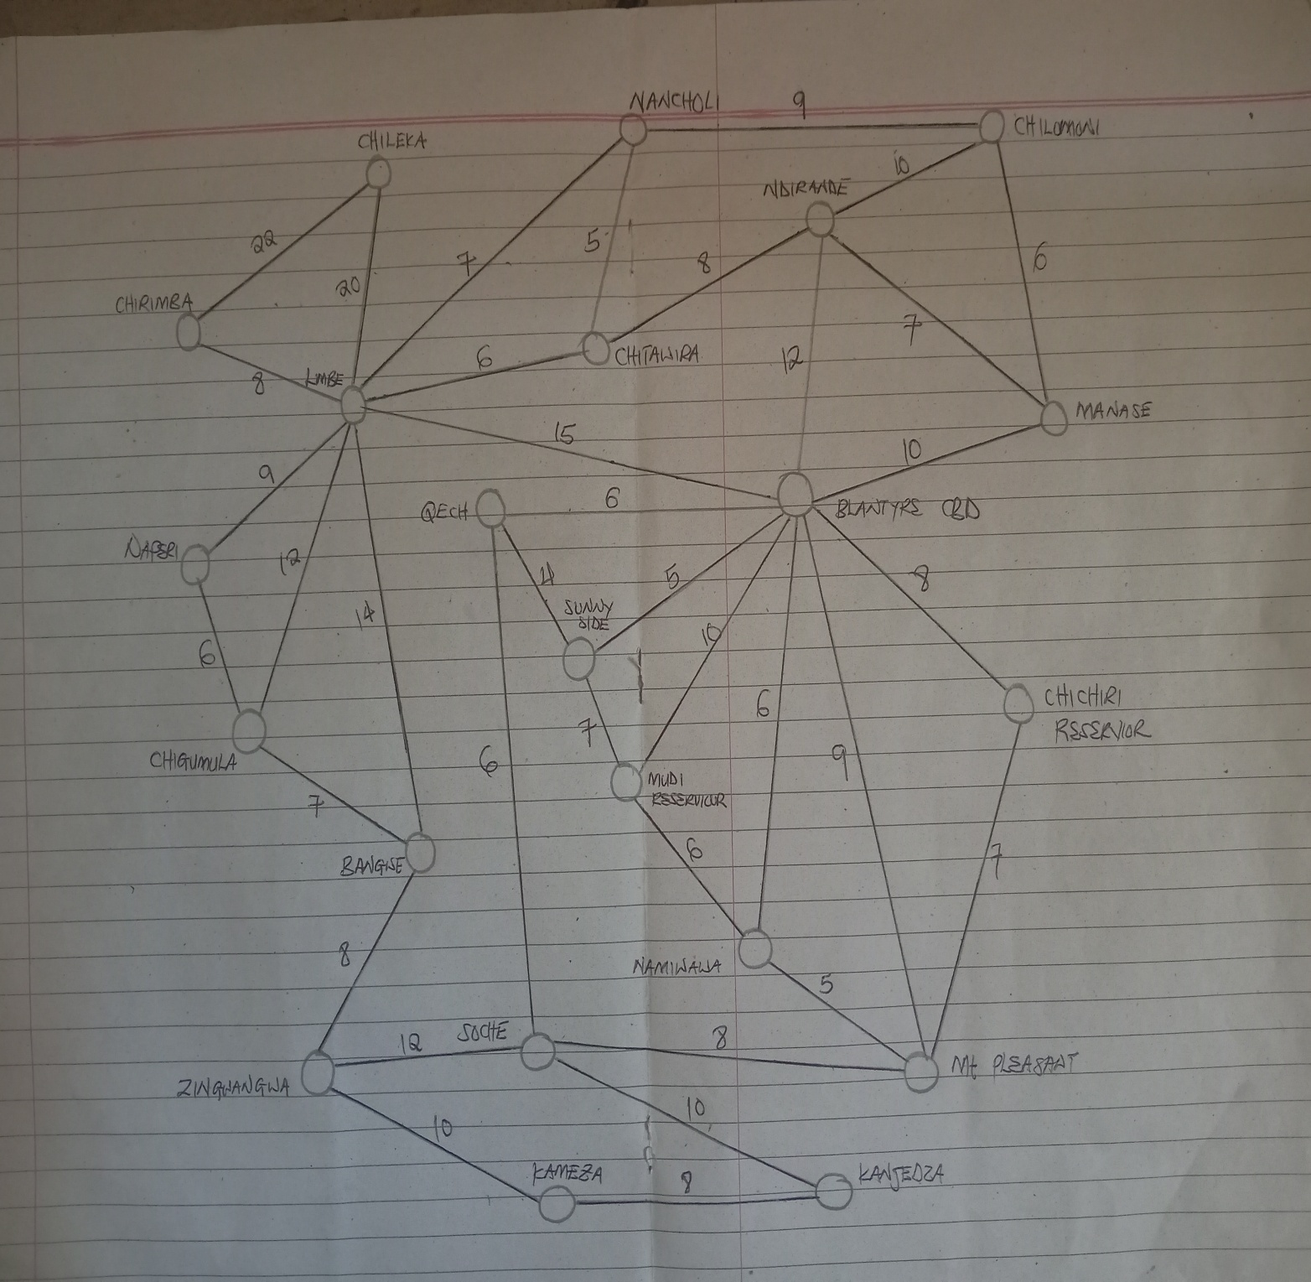
3. How Dijkstra's algorithm works on the graph
Dijkstra's algorithm finds the shortest distance from one starting node to every other node in a weighted graph, provided that no edge has a negative weight. At the beginning, the starting node is given 0 and all other nodes are given infinity. The algorithm repeatedly selects the unvisited node with the smallest known distance. It then checks whether travelling through that node gives a shorter distance to any of its neighbours. If it does, the distance is updated.
3.1 Procedure
Set the source node's distance to 0 and every other node's distance to infinity.
Choose the unvisited node with the smallest temporary distance.
Check each of its neighbours. Add the edge weight to the current distance.
If the new distance is smaller than the neighbour's recorded distance, replace the old distance and record the previous node.
Mark the current node as visited and repeat until all reachable nodes have been visited.
3.2 Worked example by our group: source is Chichiri Reservoir
The initial distance is Chichiri Reservoir = 0. All other nodes begin at infinity. The table below shows the order in which the nodes are permanently visited and the distance updates made at each step.
Step | Node visited | Distance | Its Neighbors
1 | Chichiri Reservoir | 0 | Blantyre CBD = 8; Mount Pleasant = 7
2 | Mount Pleasant | 7 | Namiwawa = 12; Soche = 15
3 | Blantyre CBD | 8 | Mudi Reservoir = 18; Sunnyside = 13; QECH = 14; Ndirande = 20; Limbe = 23; Manase = 18
4 | Namiwawa | 12 | Mudi Reservoir = 18; Blantyre CBD = 8; Mount Pleasant = 7 (none improved)
5 | Sunnyside | 13 | Mudi Reservoir = 18; Blantyre CBD = 8; QECH = 14 (none improved)
6 | QECH | 14 | Blantyre CBD = 8; Sunnyside = 13; Soche = 15 (none improved)
7 | Soche | 15 | Zingwangwa = 27; Kanjedza = 25
8 | Manase | 18 | Chilomoni = 24
9 | Mudi Reservoir | 18 | Blantyre CBD = 8; Namiwawa = 12; Sunnyside = 13 (none improved)
10 | Ndirande | 20 | Chitawira = 28
11 | Limbe | 23 | Nancholi = 30; Chirimba = 31; Naperi = 32; Chigumula = 35; Bangwe = 37; Chileka = 43
12 | Chilomoni | 24 | Ndirande = 20; Manase = 18; Nancholi = 30 (none improved)
13 | Kanjedza | 25 | Kameza = 33
14 | Zingwangwa | 27 | Bangwe = 35 (improved from 37)
15 | Chitawira | 28 | Ndirande = 20; Limbe = 23; Nancholi = 30 (none improved)
16 | Nancholi | 30 | Chitawira = 28; Limbe = 23; Chilomoni = 24 (none improved)
17 | Chirimba | 31 | Limbe = 23; Chileka = 43 (none improved)
18 | Naperi | 32 | Limbe = 23; Chigumula = 35 (none improved)
19 | Kameza | 33 | Kanjedza = 25; Zingwangwa = 27 (none improved)
20 | Bangwe | 35 | Limbe = 23; Chigumula = 35; Zingwangwa = 27 (none improved)
21 | Chigumula | 35 | Limbe = 23; Naperi = 32; Bangwe = 35 (none improved)
22 | Chileka | 43 | Limbe = 23; Chirimba = 31 (none improved)

3.3 Final shortest distances from Chichiri Reservoir
Destination | Shortest distance (minutes) | Shortest route
Chichiri Reservoir | 0 | Chichiri Reservoir
Mount Pleasant | 7 | Chichiri Reservoir → Mount Pleasant
Blantyre CBD | 8 | Chichiri Reservoir → Blantyre CBD
Namiwawa | 12 | Chichiri Reservoir → Mount Pleasant → Namiwawa
Sunnyside | 13 | Chichiri Reservoir → Blantyre CBD → Sunnyside
QECH | 14 | Chichiri Reservoir → Blantyre CBD → QECH
Soche | 15 | Chichiri Reservoir → Mount Pleasant → Soche
Manase | 18 | Chichiri Reservoir → Blantyre CBD → Manase
Mudi Reservoir | 18 | Chichiri Reservoir → Blantyre CBD → Mudi Reservoir
Ndirande | 20 | Chichiri Reservoir → Blantyre CBD → Ndirande
Limbe | 23 | Chichiri Reservoir → Blantyre CBD → Limbe
Chilomoni | 24 | Chichiri Reservoir → Blantyre CBD → Manase → Chilomoni
Kanjedza | 25 | Chichiri Reservoir → Mount Pleasant → Soche → Kanjedza
Zingwangwa | 27 | Chichiri Reservoir → Mount Pleasant → Soche → Zingwangwa
Chitawira | 28 | Chichiri Reservoir → Blantyre CBD → Ndirande → Chitawira
Nancholi | 30 | Chichiri Reservoir → Blantyre CBD → Limbe → Nancholi
Chirimba | 31 | Chichiri Reservoir → Blantyre CBD → Limbe → Chirimba
Naperi | 32 | Chichiri Reservoir → Blantyre CBD → Limbe → Naperi
Kameza | 33 | Chichiri Reservoir → Mount Pleasant → Soche → Kanjedza → Kameza
Bangwe | 35 | Chichiri Reservoir → Mount Pleasant → Soche → Zingwangwa → Bangwe
Chigumula | 35 | Chichiri Reservoir → Blantyre CBD → Limbe → Chigumula
Chileka | 43 | Chichiri Reservoir → Blantyre CBD → Limbe → Chileka

Example calculation: the route from Chichiri Reservoir to Kameza is Chichiri Reservoir → Mount Pleasant → Soche → Kanjedza → Kameza. Its total weight is 7 + 8 + 10 + 8 = 33 minutes. Therefore, the shortest distance to Kameza is 33 minutes.
Another example is the route to Chileka: Chichiri Reservoir → Blantyre CBD → Limbe → Chileka. Its total weight is 8 + 15 + 20 = 43 minutes.

4. Implementation
The graph algorithms can be implemented in C++17. The graph data can be stored in a text file, with one connection on each line. Dijkstra's algorithm can use an adjacency list and a priority queue (min-heap) to select the next node with the smallest distance. Kruskal's algorithm can use a sorted edge list and a disjoint-set (union-find) structure to avoid adding edges that create cycles.
Main functions may include loadGraph (read and validate the edge file), dijkstra (find shortest paths), kruskal (find the MST), and findSet/unionSet (manage connected components).
GitHub repository: https://github.com/mse22-gmponda-sketch/Blantyre-waterBoard-pipe-network
5. Testing
The following tests are suggested checks for the implementation. The expected results are calculated from the edge weights in the supplied network. The group should run each test using its own program and record the actual output.
Number | Test | Input | Expected output | Result
1 | Normal route | Chichiri Reservoir → Kameza | Chichiri Reservoir → Mount Pleasant → Soche → Kanjedza → Kameza; 33 minutes | Tested
2 | Source equals target | Blantyre CBD → Blantyre CBD | Blantyre CBD; 0 minutes | Tested
3 | Different source | Mudi Reservoir → QECH | Mudi Reservoir → Sunnyside → QECH; 11 minutes | Tested
4 | Distant node | Chichiri Reservoir → Chileka | Chichiri Reservoir → Blantyre CBD → Limbe → Chileka; 43 minutes | Tested
5 | Unknown source | Unknown → Kameza | Display an error that the source node does not exist | Tested
6 | Missing input file | Non-existent file | Display an error that the file cannot be opened | Tested
7 | Negative edge weight | A–B = 5; B–C = -3 | Reject the graph because Dijkstra does not support negative weights | Tested
8 | Invalid weight format | A–B = five | Display an invalid input / weight format error | Tested
9 | Disconnected graph | A–B = 4; C–D = 2; source A, target D | Report that D is unreachable; MST is a spanning forest, not a spanning tree | Tested
10 | Distance update | A–B = 4; B–C = 3; A–C = 10 | Shortest route A → B → C; 7 units (improves the direct value 10) | Tested

5.1 Errors and limitations
Dijkstra's algorithm cannot correctly handle negative edge weights, so the program should reject them. Node names containing spaces need a consistent input format, such as underscores. The calculated results also depend on the accuracy of the edge weights supplied for the network.
5.2 Dry run
The full dry run is provided in Section 3. It starts at Chichiri Reservoir and visits all 22 nodes in non-decreasing order of their shortest known distances. The final distance to Kameza is 33 minutes, and the final distance to Chileka is 43 minutes.

6. Does the graph have a Minimum Spanning Tree (MST)?
YES. A minimum spanning tree exists because the graph is undirected, weighted and connected. A spanning tree connects every node without forming a cycle. Since the graph has 22 nodes, every spanning tree must contain exactly 22 − 1 = 21 edges.
The MST is the least-total-weight set of pipe connections that still connects all 22 places. In this network, the total weight of the MST is 157 minutes using the weights supplied in the edge list.
6.1 Kruskal's algorithm: selected MST edges
Kruskal's algorithm sorts all edges from the smallest weight to the largest. It adds an edge if that edge connects two different components. If adding an edge would form a cycle, it is skipped. The process stops when 21 edges have been selected.
Order | Node A | Node B | Weight | Decision
1 | Sunnyside | QECH | 4 | Added
2 | Blantyre CBD | Sunnyside | 5 | Added
3 | Namiwawa | Mount Pleasant | 5 | Added
4 | Chitawira | Nancholi | 5 | Added
5 | Mudi Reservoir | Namiwawa | 6 | Added
6 | Blantyre CBD | Namiwawa | 6 | Added
7 | QECH | Soche | 6 | Added
8 | Manase | Chilomoni | 6 | Added
9 | Chitawira | Limbe | 6 | Added
10 | Naperi | Chigumula | 6 | Added
11 | Chichiri Reservoir | Mount Pleasant | 7 | Added
12 | Ndirande | Manase | 7 | Added
13 | Bangwe | Chigumula | 7 | Added
14 | Ndirande | Chitawira | 8 | Added
15 | Limbe | Chirimba | 8 | Added
16 | Bangwe | Zingwangwa | 8 | Added
17 | Kanjedza | Kameza | 8 | Added
18 | Limbe | Naperi | 9 | Added
19 | Blantyre CBD | Manase | 10 | Added
20 | Soche | Kanjedza | 10 | Added
21 | Limbe | Chileka | 20 | Added

Total MST weight = 4 + 5 + 5 + 5 + 6 + 6 + 6 + 6 + 6 + 6 + 7 + 7 + 7 + 8 + 8 + 8 + 8 + 9 + 10 + 10 + 20 = 157.
Because some edges have equal weights, a different valid minimum spanning tree may select a different edge of the same weight. For example, an implementation may select Kameza–Zingwangwa (10) instead of Blantyre CBD–Manase (10), while keeping the same total MST weight of 157.
6.2 What the MST represents
In the water pipe network, the MST represents the lowest-total-weight set of connections that edges all the listed places. It does not necessarily provide the shortest route from a particular reservoir to each place. Dijkstra answers the shortest-route question from a chosen source, while the MST answers the question of how to connect all nodes with the smallest possible total edge weight.
A limitation of an MST is that it has no cycles. Therefore, it does not provide alternative routes if one of its selected edges fails. A real water distribution system may need extra edges for reliability and backup supply.

7. Which MST algorithm is suitable and why?
Kruskal's algorithm is suitable for this network for the following reasons:
The network is relatively sparse: it has 22 nodes and 37 edges, compared with 231 possible edges in a simple undirected graph with 22 nodes.
The data is already presented as an edge list, which makes it straightforward to sort the connections by weight.
It is easy to demonstrate by hand: sort the edges, select the smallest edge that does not create a cycle, and continue until 21 edges have been selected.
With an efficient sorting method and union-find structure, Kruskal's algorithm runs in approximately O (E log E).
Prim's algorithm is another correct MST method. It starts from one node and repeatedly adds the cheapest edge connecting the current tree to a node outside it. Both algorithms produce an MST, although the exact selected edges can differ when equal weights are present.
8. Conclusion
The Blantyre water pipe network has been represented as a connected, undirected and weighted graph with 22 nodes and 37 edges. Dijkstra's algorithm, starting from Chichiri Reservoir, gives a shortest route of 33 minutes to Kameza and 43 minutes to Chileka using the supplied weights. Kruskal's algorithm produces a minimum spanning tree containing 21 edges with a total weight of 157. The results demonstrate how graph algorithms can help analyse routes and identify a low-total-weight network connection plan. However, the edge weights are estimates in the supplied source and should be verified before practical engineering decisions are made.

9. Repository and deployment details

For C++ repository go to | https://github.com/mse22-gmponda-sketch/Blantyre-waterBoard-pipe-network/blob/main/cpp_code.cpp
For testing | file:///C:\\Users\\PC\\AppData\\Local\\Packages\\5319275A.WhatsAppDesktop_cv1g1gvanyjgm\\LocalState\\sessions\\7F1A8378C8B0C896D6BD167720A40237C35B9D1B\\transfers\\2026-45\\WATER_PIPE_NETWORK.html (openable in github)
Ready to run code | cpp_code_cpp(found in github)

