MALAWI UNIVERSITY OF BUSINESS AND APPLIED SCIENCES

SCHOOL OF SCIENCE AND TECHNOLOGY
DEPARTMENT OF MATHEMATICAL SCIENCES EDUCATION
PROGRAM : BACHELOR OF SCIENCE IN MATHEMATICAL SCIENCES
EDUCATION (MATHEMATICS & COMPUTING)
MODULE TITLE : DATA STRUCTURES AND ALGORITHMS
MODULE CODE : CIS-DSA-321
YEAR : THREE
SUBMITTED TO : DR. A TAYLOR
GROUPMEMBERS : JOYCE MEMORY KAKHOBWE(MSE/23/SS/021)
:RAPHAEL GLYN(MSE/23/SS/015)
: CHARITY KACHIGAMBA(MSE/23/SS/019)
ASSIGNMENT : ONE
DUE DATE : 12 NOV, 2026.

- WEIGHTED GRAPH CREATION
Node | Agent location | Node | Agent location
A | Blantyre CBD | K | Namiwawa
B | Ndirande | L | Chilomoni
C | Chirimba | M | Manyowe
D | Kameza | N | Chigumula
E | Machinjiri | O | BCA
F | Chichiri | P | Chilobwe
G | Limbe | Q | Zingwangwa
H | Bangwe | R | Manja
I | Mpingwe | S | Soche
J | Mapanga | T | Nancholi

Graph definition: G = (V, E), where V = {A, B, C, D, E, F, G, H, I, J, K, L, M, N, O, P, Q, R, S, T}. The 31 undirected edges are listed on the next page.
Meaning of a weight: A-B with weight 4 means a model travel time of 4 minutes from A to B or from B to A. The weight is neither an amount of money nor a transfer fee.

Complete edge list
Link | Minutes | Link | Minutes
A-B | 4 | A-F | 7
B-C | 6 | B-G | 4
C-D | 5 | C-H | 8
D-E | 7 | D-I | 6
F-G | 3 | E-J | 5
G-H | 5 | F-K | 5
H-I | 4 | G-L | 7
I-J | 6 | H-M | 3
K-L | 6 | I-N | 8
L-M | 3 | J-O | 4
M-N | 5 | K-P | 6
N-O | 4 | L-Q | 5
P-Q | 5 | M-R | 7
Q-R | 4 | N-S | 4
R-S | 6 | O-T | 6
S-T | 3 | - | -

- GRAPH

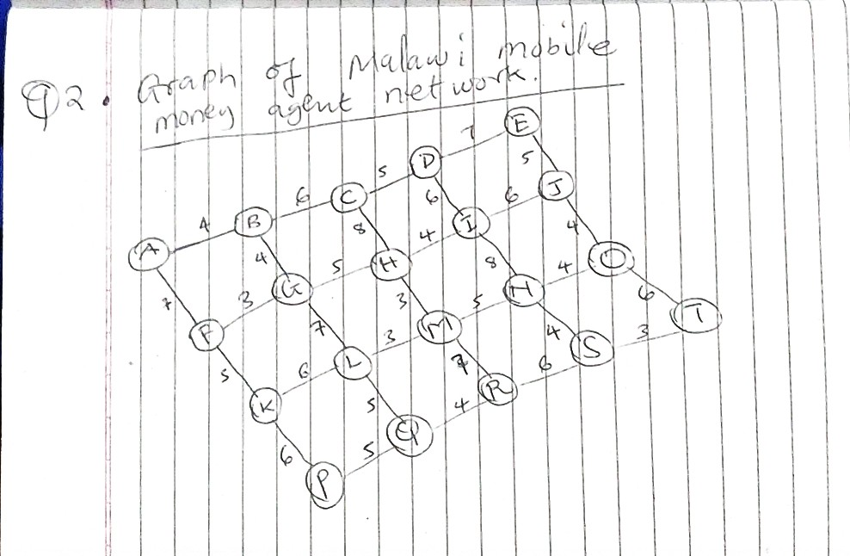

The graph above is Weighted, undirected mobile money agent network. Circles are agents; lines are two-way travel links; numbers show assumed minutes. No arrows are used because both directions have the same weight.

3. how Dijkstra works
1. Give A a distance of 0 and every other node a distance of infinity, meaning no route is known yet.
2. Choose the unvisited node with the smallest tentative distance. If distances tie, choose any.
3. Add its distance to each outgoing link weight. This gives a candidate distance to a neighbour.
4. If the candidate is smaller than the neighbour's current distance, replace the distance and record the chosen node as its predecessor.
5. Mark the chosen node as settled. Its shortest distance is now final. Repeat until T is settled, or continue to settle all reachable nodes.
6. Trace predecessors backwards from T to A, then reverse that list to obtain the route.
First iteration:
At A: B = 0 + 4 = 4; F = 0 + 7 = 7.
Choose B next because 4 < 7. From B: C = 4 + 6 = 10; G = 4 + 4 = 8.
Choose F next because 7 is the smallest remaining label. From F: G would be 7 + 3 = 10, so keep G = 8. Set K = 7 + 5 = 12.
Choose G next: H = 8 + 5 = 13 and L = 8 + 7 = 15.

Update rule: candidate = distance to chosen node + link weight. Update a neighbour only if candidate < its current distance. Equal distances keep the existing predecessor.
Complete dry run from A

Step | Chosen / time | New or improved labels | Priority order after processing
1 | A / 0 | B=4 via A; F=7 via A | B(4), F(7)
2 | B / 4 | C=10 via B; G=8 via B | F(7), G(8), C(10)
3 | F / 7 | K=12 via F | G(8), C(10), K(12)
4 | G / 8 | H=13 via G; L=15 via G | C(10), K(12), H(13), L(15)
5 | C / 10 | D=15 via C | K(12), H(13), D(15), L(15)
6 | K / 12 | P=18 via K | H(13), D(15), L(15), P(18)
7 | H / 13 | I=17 via H; M=16 via H | D(15), L(15), M(16), I(17), P(18)
8 | D / 15 | E=22 via D | L(15), M(16), I(17), P(18), E(22)
9 | L / 15 | Q=20 via L | M(16), I(17), P(18), Q(20), E(22)
10 | M / 16 | N=21 via M; R=23 via M | I(17), P(18), Q(20), N(21), E(22), R(23)
11 | I / 17 | J=23 via I | P(18), Q(20), N(21), E(22), J(23), R(23)
12 | P / 18 | None | Q(20), N(21), E(22), J(23), R(23)
13 | Q / 20 | None | N(21), E(22), J(23), R(23)
14 | N / 21 | O=25 via N; S=25 via N | E(22), J(23), R(23), O(25), S(25)
15 | E / 22 | None | J(23), R(23), O(25), S(25)
16 | J / 23 | None | R(23), O(25), S(25)
17 | R / 23 | None | O(25), S(25)
18 | O / 25 | T=31 via O | S(25), T(31)
19 | S / 25 | T=28 via S | T(28)
20 | T / 28 | None | Empty

At step 18, T is first reached through O: 25 + 6 = 31. At step 19, S improves it: 25 + 3 = 28. At step 20, T is settled. Discovering T at 31 was not enough to stop; its label could still improve.
Final shortest distances and route
Agent | Shortest time from A | Predecessor
A - Blantyre CBD | 0 | -
B - Ndirande | 4 | A
C - Chirimba | 10 | B
D - Kameza | 15 | C
E - Machinjiri | 22 | D
F - Chichiri | 7 | A
G - Limbe | 8 | B
H - Bangwe | 13 | G
I - Mpingwe | 17 | H
J - Mapanga | 23 | I
K - Namiwawa | 12 | F
L - Chilomoni | 15 | G
M - Manyowe | 16 | H
N - Chigumula | 21 | M
O - BCA | 25 | N
P - Chilobwe | 18 | K
Q - Zingwangwa | 20 | L
R - Manja | 23 | M
S - Soche | 25 | N
T - Nancholi | 28 | S

Backtracking: T <- S <- N <- M <- H <- G <- B <- A.
Shortest route: A - B - G - H - M - N - S - T.
Total time: 4 + 4 + 5 + 3 + 5 + 4 + 3 = 28 minutes.
In place names: Blantyre CBD - Ndirande - Limbe - Bangwe - Manyowe - Chigumula - Soche – Nancholi.

- ALGORITHM IMPLEMENTATION.
Code in c++.
Refer to the code.cpp in the repository.

5. TEST THE ALGORITHM
1. Main route
Input | Expected output | Actual output / error
Default graph; A to T | 28; path A - B - G - H - M - N - S - T | 28; path A - B - G - H - M - N - S - T [PASS]

2. Reverse route
Input | Expected output | Actual output / error
Default graph; T to A | 28; path T - S - N - M - H - G - B - A | 28; path T - S - N - M - H - G - B - A [PASS]

3. Same agent
Input | Expected output | Actual output / error
Default graph; A to A | 0; path A | 0; path A [PASS]

4. Direct neighbour
Input | Expected output | Actual output / error
Default graph; A to B | 4; path A - B | 4; path A - B [PASS]

5. Disconnected destination
Input | Expected output | Actual output / error
Nodes A,B,C; edge A-B:4; A to C | unreachable; path [] | unreachable; path [] [PASS]

6. Zero weight
Input | Expected output | Actual output / error
Nodes A,B,C; A-B:0, B-C:2, A-C:5; A to C | 2; path A - B - C | 2; path A - B - C [PASS]

7. Negative weight
Input | Expected output | Actual output / error
Nodes A,B; edge A-B:-2; A to B | Weights must be finite and non-negative | Weights must be finite and non-negative [PASS]
.
8. Invalid source
Input | Expected output | Actual output / error
Default graph; Z to T | Unknown start or destination | Unknown start or destination [PASS]

9. Equal alternatives
Input | Expected output | Actual output / error
A-B:1, A-C:1, B-D:1, C-D:1; A to D | 2; path A - B - D | 2; path A - B - D [PASS]

10. Invalid edge endpoint
Input | Expected output | Actual output / error
Nodes A,B; edge A-Z:1 | Unknown edge endpoint | Unknown edge endpoint [PASS]

11. Non-finite weight
Input | Expected output | Actual output / error
Nodes A,B; edge A-B:Infinity | Weights must be finite and non-negative | Weights must be finite and non-negative [PASS]

12. MST
Input | Expected output | Actual output / error
Default graph | {"edges": 19, "total": 81, "connected": true} | {"edges": 19, "total": 81, "connected": true} [PASS]

13. All pairs cross-check
Input | Expected output | Actual output / error
20 x 20 ordered pairs on default graph | 400/400 distances and reconstructed path costs match | 400/400 distances and reconstructed path costs match [PASS]

14. Independent MST check
Input | Expected output | Actual output / error
Default graph; start A | 81 | 81 [PASS]

6. The graph has MST. The graph is undirected, weighted and connected. Therefore, it has a minimum spanning tree (MST). A spanning tree connects every node without forming a cycle. Since there are 20 nodes, every spanning tree must contain 20 - 1 = 19 edges.The MST is a set of 19 direct cash redistribution links that keeps all 20 agents connected while minimising the sum of selected link travel times. Other agents can still be reached indirectly through the selected links.
The MST total is 81 minutes, meaning the sum of its 19 edge weights.
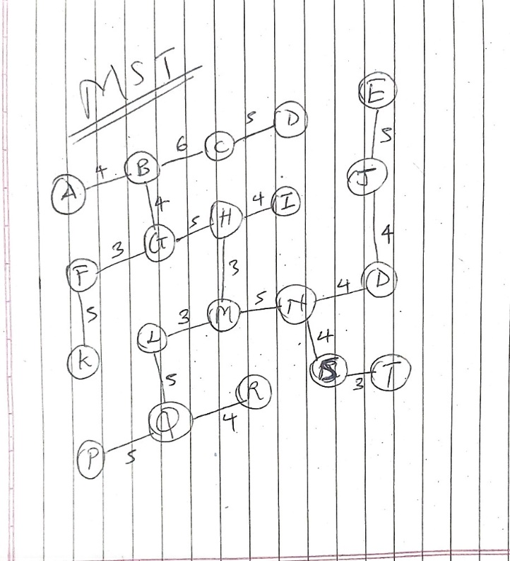

7. Kruskal's algorithm will be used. Sorting the small list and checking for cycles is simple to explain and implement. Prim's algorithm would also be valid; Kruskal is chosen for its clear edge-by-edge procedure.
Procedure: Sort links from smallest to largest weight. Begin with each node separate. Accept a link only when its endpoints belong to different components. Otherwise skip it, because it would create a cycle. Stop when 19 links have been accepted. Ties are processed in any order.
Step | Accepted link | Weight | Running total
1 | F-G | 3 | 3
2 | H-M | 3 | 6
3 | L-M | 3 | 9
4 | S-T | 3 | 12
5 | A-B | 4 | 16
6 | B-G | 4 | 20
7 | H-I | 4 | 24
8 | J-O | 4 | 28
9 | N-O | 4 | 32
10 | N-S | 4 | 36
11 | Q-R | 4 | 40
12 | C-D | 5 | 45
13 | E-J | 5 | 50
14 | F-K | 5 | 55
15 | G-H | 5 | 60
16 | L-Q | 5 | 65
17 | M-N | 5 | 70
18 | P-Q | 5 | 75
19 | B-C | 6 | 81

Example of a rejected link: I-N has weight 8. By then I and N are connected through I-H-M-N, so adding I-N would create a cycle. It is skipped. The selected 19 edges connect all 20 nodes and have total weight 81.

8. Refer to the code.cpp in the repository and test it using rules in question 5.

