Nottingham Trent University

School of Science and Technology

Personal Trainer Organiser

by

“Michael Seth Ezan Abraham”

in

2019/2020 Academic Year

Project report in part fulfilment

of the requirements for the degree of

Bachelor of Science with Honours

in

Software Engineering

I hereby declare that I am the sole author of this report. I authorize the Nottingham Trent University to lend this report to other institutions or individuals for the purpose of scholarly research.

I also authorize the Nottingham Trent University to reproduce this report by photocopying or by other means, in total or in part, at the request of other institutions or individuals for the purpose of scholarly research.

Signature

Michael Seth Ezan Abraham

Abstract

This project set out to acknowledge the current position in which the Personal Training industry is in, and highlight ways to develop this industry and its work atmosphere through the integration of technology. Within a market targeted predominantly towards large gym branches, this project explores how self-employed personal trainers record data for their training sessions and how this can be simplified for practical use during one to one training sessions in a gym environment. Following agile methodology, which seemed tailored for the production of a mobile application, different development techniques and procedures like mock-up designing and use case modelling were deployed through recurrent phases of the project’s evolution. Ultimately, after concept testing and redesigns of prototypes, a minimal viable product was created that allowed functional and user testing commence. In a summary of findings, although the project had fallen short of producing an Android mobile application that was fully implemented with all the desired features aligned throughout the development of the project, the features integrated hailed superior to the novel approach the trainers took to recording data. The intent of the application was well received by the testing participants, and with future work and further adjustments, this application could be a real success on the app market and a helpful tool in the advancement of the Personal Training industry.

Acknowledgements

Through the completion of this project I have received a great amount of assistance and support. First and most importantly I would like to thank my supervisor, Mr. P. Fitzgerald, who’s guidance and knowledge helped immeasurably in the structuring of the project topic and report documentation.

I would like to acknowledge the personal trainers and their clients who devoted their time to helping construct a foundation for the project’s idea. Their collaboration and input were integral to the applications development, specifically A. Leak, whom without an understanding of a trainer’s requirements could not be established.

I would also like to thank my family and friends for the support offered during difficult periods of the project. Their honest and wise counselling helped me to stay grounded, focused and motivated throughout the project.

Table of Contents

Abstract ii

Acknowledgements iii

Table of Contents iv

List of Figures viii

List of Tables ix

CHAPTER 1 1

Introduction 1

1.1 Introduction 1

CHAPTER 2 3

CONTEXT 3

2.1 Introduction 3

2.2 Industry Research 3

2.2.1 Personal Training Industry 3

2.2.2 Technology/Social Medias Impact on Health & Fitness 4

2.3 Application Research 5

2.3.1 AFPA 5

2.3.2 FitBod 6

2.4 Evaluation 9

CHAPTER 3 11

New Ideas 11

3.1 Introduction 11

3.2 Project Planning 2.0 11

3.2.1 Methodology 11

3.2.2 Gantt Chart 12

3.2.3 Participants 13

3.3 Application Requirements 14

3.3.1 Application Aims 14

3.3.2 Functional Requirements 14

3.3.3 Non-Functional Requirements 16

3.4 Development Options 16

3.4.1 Development Environment 17

3.4.2 Back End Development 18

3.4.3 UI Development & Design 18

3.5 Usability & Guidelines 19

3.5.1 Usability 19

3.5.2 Layout 19

3.5.3 Navigation 20

3.5.4 Colour Scheme 20

CHAPTER 4 22

IMPLEMENTATION or INVESTIGATION 22

4.1 Introduction 22

4.2 Designs & Diagrams 23

4.2.1 Use Cases 23

4.2.2 Mock-ups 26

4.3 Implementation Diary 30

4.3.1 Application Setup 30

4.3.2 Utilisation of Fragments & Activities 31

4.3.3 Authentication Implementation 32

4.3.4 Further Research Explored for Development of The Client Flow 33

4.3.5 Database Implementation & The Impacts on The Application Flows 35

CHAPTER 5 38

RESULTS / DISCUSSION 38

5.1 Introduction 38

5.2 User Testing 39

5.2.1 User Testing Goals 39

5.2.2 Concept Testing (Pre-Development Phase) 39

5.2.3 User Testing (Pre-Launch Phase) 43

5.3 Requirement Testing 47

5.3.1 Functional & Non-Functional Requirement Testing 48

5.3.2 Use Case Requirement Testing 50

CHAPTER 6 54

CONCLUSIONS / FUTURE WORK 54

6.1 Conclusions 54

6.2 Future Work 55

6.3 Legal, Social, Ethical and Professional Issues //TODO 56

6.4 Synoptic Reflections 56

ReferenceS 58

Bibliography 59

Appendix 61

List of Figures

Figure 1: FitBod Interface Analysis 7

Figure 2: Application Colour Scheme 21

Figure 3: Authorisation Flow Design 26

Figure 4: Clients Flow Design 27

Figure 5: Workout Flow Design 28

Figure 6: Session Scheduling Flow Design 29

Figure 7: Client-Side Application Design 29

Figure 8: A Screenshot of How Sign Up Authentication Was Implemented. 33

Figure 9: A Screenshot of How Firebase Admin SDK Is Implemented. 34

Figure 10: A Screenshot of The Firestore & Realtime Database Setups. (RTD on left, Firestore Database to the right). 36

Figure 11: Top 10 Adjectives Retrieved from The Overall Satisfaction in Concept Testing. 42

Figure 12: Bar Chart of User Testing Results. 45

Figure 13: An Illustration on Progress of The Implemented Requirements 50

List of Tables

Table 1: Microsoft Office. 5

**Note:** To insert List of Tables here follow the instruction below. You may also right click on the above text and use “Update Field” to update the list of tables.

Insert > Reference > Index and Tables … > Table of Figures > Caption Label => Table



Introduction

## Introduction

To understand where the foundations to this project laid, one must first understand the projects background. One day when the author was completing a workout session with a personal trainer, it was evident by the hordes of lose paper and notes that the approach that trainers took to recording session data with clients were not as forward-thinking as the rapidly developing industry. This therefore sparked a conversation and the basis for this project, how can personal trainers easily and quickly record training session data? Pen and paper were too outdated and tedious, while note pages on phones became too cluttered and unorganised. So, what if there was a centralised application for storing all their information?

This project set out to produce an application that would overcome the shortcomings of data recording and innovate an industry. Throughout this report you will understand the pathway taken to achieve this goal and create a product that could become integral to a trainer’s arsenal when facing an action-packed day in their work environment. Alongside a qualified trainer, requirements can be developed to conquer the practical needs of a self-employed personal trainers.

The contents of Chapter 2 will guide you through the available systems that provide similar features. Although targeted towards different audiences, the strong features and weaknesses of each systems and app will be evaluated by the section to provide a greater insight into what is expected from the newly developed application, illustrated throughout the contents of Chapter 3. While Chapter 4 offers a detailed account of the implementation and the issues that would arise, the section will aim to provide an understanding behind the mechanics of the application so when the results and testing methods are evaluated throughout Chapter 5 and we reach Chapter 6, you will have gained enough insight to impose your own conclusion that is hopefully affirmed by that of the reports.



CONTEXT

## Introduction

In this chapter time was taken to investigate and discuss the current position in which the Health & Fitness sector and Personal Training industry is in, and highlight requirements alongside a specification devised by the author and a Level 3 Personal Trainer that can help to develop the way in which technology is integrated into their industry and work environments.

Within this chapter, mechanics of different applications (available to the public on various platforms) which produce similar goals to this project’s proposed idea will be reviewed. The intended outcomes of numerous applications will be highlighted, alongside the benefits and downfalls of each, and where applicable the applications layout shall be assessed to bring clarity to what is required of the newly developed application to be successful and fit for its purpose. Reviewed across different sections of software standards, this chapter will help to bring an understanding of what is currently available on the market and where this project’s idea will fit in that ecosystem.

## Industry Research

### Personal Training Industry

“Operators in this industry offer fitness training to individuals or small groups. They may also provide personalised fitness, health, and dietary advice. Personal trainers are typically self-employed, but some are working on contract with gyms and fitness studios.” [1]

Within the UK, the personal training industry is valued at £671m according to IBIS World in July 2020. Within a 5-year time span (between 2015 & 2020) the industry saw a growth of 1.4%, and with a current push of health and fitness through social media and its correlating benefits to the improvement of mental health evidenced through scientific studies, the growth of this industry is expected to continue to increase steadily upwards.

ACSM’s 2019 trend prediction also saw wearable technology at the top of the industries expected trend for the years to come. This documents how PTs are integrating wearable technology to help with tracking and recording of client data, and with new devices such as Apple Watches and a variety of different Android watches available for purchase, this should help to boost the development and usage of applications and software targeted within the Personal Training industry.

### Technology/Social Medias Impact on Health & Fitness

Over the years in the modern era of society, technology has helped to mould the public perception of Health & Fitness. Beforehand health magazines, documentation and televised/recorded workout routines were some of the main ways to present and encourage healthy living (besides actually attending a gym and their lessons). Now through the access of social media, Personal Trainers are able to communicate with clients through platforms like Instagram, Facebook, and Twitter. The convenient accessibility of these platforms for all means that many are exposed to videos and information about health and fitness on a regular basis. This has truly help to increase the profile of the Personal Training industry and allow PTs to grow their cliental easier and quicker than ever.

## Application Research

### AFPA

This part of the documentation illustrates AFPA’s top rated applications that can help personal trainers convey their results and recordings to their clients. The publication gives a list of their top 10 fitness organisation applications, accompanied by a brief summary of the apps features and how they can be used. The publication starts at their number 1 application and works its way down to number 10.

The publication lists the names and platforms of all the applications that it discusses, along with links to their websites for further information. After further research using these provided sources, the superior applications were selected and the findings where are as followed:

* **The Training Notebook** (IOS, Android & Web) – This application allows PTs to organise their clients and their contact information, create and save workouts (also supplying some pre-created templates) and schedule training sessions. Layouts to use the application are available for website, iPhone, iPad and Android. Although PTs can email workouts to their clients, there is no feature for the client to view recordings or engage in the sessions.
* **Coach Pro** (IOS) – This application manages clients (allowing PTs to add goals, view session dates and contact information), organises billing records by clients, provides a calendar for scheduling sessions and allows PTs to add session notes through voice recordings or through keyboard typing. The application uses a navigation bar along the bottom and list the contents of the application in consecutive fragment. This application has greater variety of features compared to the other applications however, the design of these features is very standard and the layout of the application very minimal.
* **FitSW** (IOS, Android & Web) – In my opinion this application offers the best all-round solution for PTs to organise their work and client based on this information provided in the publication. Along with common client management, workout building and scheduling features, the application provides capabilities for nutrition planning and notifications through automated emails. The application also allows PTs to conversate and engage with their clients through in-app messaging and emailing features allows them to receive graphs of their progress.

This article gives a good overview of the different systems and their abilities however lack an in-depth analysis of each. Further research into the applications are required to gain a full grasp of its capabilities, however due to the large number of applications available this article provides a good shortlist that works as a foundation to understanding the different features available for organising personal trainer’s workload.

### FitBod

Fitbod is a personal fitness application available for iOS that creates and records workouts with the capability to track progression for each training session and individual exercises. Fitbod portrays a good comparison to what the projects application workout creator should seek to expand for the aid of personal trainers.

For insight into this application primary research undergone, testing the application during real training sessions in a gym for two weeks. During this testing period exercises were completed on all muscle groups provided by the application twice through, allowing to experience the analytical features that are also available. The feedback and results were on the app was as followed…

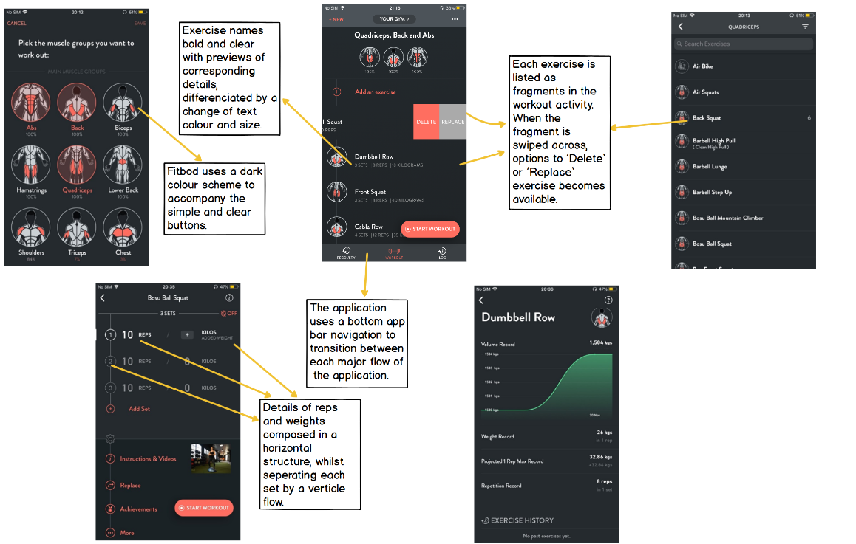

Figure : FitBod Interface Analysis

Good features:

* Application uses a revers chronological navigation flow to move between activities in each major task, saving the state of the page when transitioning through the applications hierarchy.
* Comes programmed with a database of different exercise for a variety of main and accessory muscle groups, including gif videos to help explain the exercises.
* Automatically creates a workout for the user depending on the selected muscle group.
* The application provides the ability to save created workouts for use in later sessions.
* Provides a log section where the details of previous sessions can be found. This displays each exercise, the amount of reps completed, and the weight completed.

Limitations (In retrospective to outcome of the project):

* The application is targeted towards personal exercising so does not include features for personal trainers to organises cliental.
* A feature is provided for viewing sessions for specific dates, however these only show previous sessions completed and there corresponding recorded data (for the new application, a calendar should also facilitate the ability to plan for future sessions).
* The application offers vast categorisations of different muscle groups that aren’t required for personal trainers and introduce intricacy when finding and planning exercises for workouts.

ISO 9126 Evaluation of FitBod:

**Functionality:** The application is suitable for its deliberate purpose of planning workouts and tracking exercises. The application automates workout creation for users dependent on the targeted muscle groups (which is not required for the development of this project through the trainer specification but is a useful tool to note). The app ensures accuracy and integrity of data by restricting the user to input data through numbers only.

**Reliability:** From experience with the application whilst testing for this research, minor bugs were encountered which led to the application crashing on several occasions. However, there was consideration that the application was trailed in a beta version, therefore it was more likely to be prone to errors. Although these crashes occurred, the application was able to successfully re-execute, recovering a few actions behind where it crashed.

**Usability:** The application provided an easy to understand UI with relevant tags for descriptions and a complimentary colour schemes for aesthetic pleasure. ‘?’ buttons were located in the top corner of the screen to aid learnability of different features provided by the application.

## Evaluation

Upon research of similar systems that relate to this project and its proposed ideas, documentation obtainable were scarce. Applications available as tools for personal training are predominantly comprehensive systems that seem to target gym related businesses. This has highlighted that the application this project should set out to develop should be targeted more towards self-employed personal trainers who are responsible for their own independent clients, rather than a roster of trainers with records of their cliental.

The applications discussed in the AFPA section of this chapter were a few examples of a minimal selection of apps targeted specifically towards personal trainers that are actually beneficial. When evaluating these applications as a collective when compared against the criteria supplied through the client specification [*Appendix A],* these applications offered excessive features in which some provide remarkable analysis tools, however all promote complexity if they are used for recording data during sessions. Although ‘FitSW’ allowed for communication with clients through texts in an in-app messenger and by email, none of the applications seemed to offer a client-side integrated into their apps.

The Fitbod application has many elements integrated that makes the app a useful tool for workout planning and data tracking. The features provided, such as the log or workout flow, represent a constructive foundation for the functionality that is required to develop parts of the new application. The log flow includes simple, well presented data of previous exercises completed, that help to present progression when using the application over extensive time periods. The workout flow also illustrates a well-structured approach for developing training sessions; while the automated workout creation is not required for qualified personal trainers, the steps to constructing a workout session is efficiently represented by the features of this application. With improvements to this applications limitation, a clearer understanding was made of how this projects application could be developed.



New Ideas

## Introduction

When this project began, the question of ‘how can a personal trainer simplify data recording during a training session’ was explored. Chapter 2 set out to research the systems currently present and if they fit the criteria provided by a personal trainer. This chapter presents a newly proposed idea that this project has formed of how to tackle the question.

Within this chapter, an improved and detailed project plan has been written. A breakdown of how the application should be composed has been provided, giving details of its intended capabilities and features. Informed research has also provided a clearer outlining of the applications infrastructure, specifying the software and hardware necessary to develop this mobile application.

## Project Planning 2.0

### Methodology

A combination of factors played a role in the decision of the methodology chosen for this project. Each stage of the development process had initially been planned out through the Gantt Chart; however, this represented a procedure that coincides with a Waterfall Methodology and after a deeper understanding of how the project would be attempted, alternative methodologies were explored.

After consideration of the different methodology available for Mobile Application Development, the one most suited for this project was Agile Methodology. Agile Methodology is “characterized by the division of tasks into short phases of work and frequent reassessment and adaptation of plans” [2], which conveniently suites the circumstances of this project. The involvement of the personal trainer, through their specification and reviews, meant that suggestions for components of the application could change throughout the development of the project. Agile Methodology allows for flexibility between stages of the development process (design, implementation, testing, etc.) and serves as a good advocate for improvement alongside development.

### Gantt Chart

As this project developed over time, different external factors would affect the timing presented originally in the project planning document. Upon realisation of this, the Gantt chart was revisited and modified to give a clearer prediction of the time scale required to complete each task *[*Appendix B*].

One main area that had not been included in the initial project planning Gantt chart was inclusion of deadlines in other modules. These deadlines provide a huge factor in the delegation of time available to make progress with the project and its tasks. Although different pieces of coursework would be completed alongside the project, the Gantt chart did not compensate for additional time they may have required. Appended to the Gantt chart were green rows that signify the periods when deadlines for other modules were approaching; these ranged from one to two weeks, during which more time was allocated to focus on submitting the work to acceptable standards.

A change in methodology also affected the contents and structure of the original Gantt chart. To correspond to the Agile Methodology chosen, some of the tasks within the implementation and testing phases needed to show overlaps to illustrate the reassessment and adaptation of the application. This meant that some task (i.e. ‘coding of mobile application’) were required to be extended and some dates were adjusted to give a more accurate representation of projects progression.

Due to unforeseen medical issues, the dates scheduled to start and end some of the task broken down in the Gantt chart were missed. This meant that dates that were allocated had to be reorganised in order to reach manageable and realistic deadlines.

*\*An updated view of the Gantt Chart can be viewed in the Appendix.*

### Participants

As briefly mentioned in the context chapter, during research (along with insight provided by the trainer’s specification) the intended audience this project seeks to target was highlighted. Overall, the projects main benefactor would be a personal trainer, whom may or may not be self-employed but are responsible for the organisation of their own cliental and one-to-one training sessions. The application also targets these cliental, aiming to bring an environment to communicate with their trainers, and provides access to their training records to promote healthy living. In this project both entities play a role in the development of the application…

**Personal Trainer:** As the trainer gains the most benefits from the application, it is only right that they also have the most impact to the vision of the application. A Level 3 personal trainer has been selected to provide an insight into how training sessions are undergone and what would be useful features to include in the application. Aforementioned, the trainer’s main involvement includes the specification that would help as a foundation for the applications requirements. The trainer also serves as a reviewer of the MVP (minimal viable product), testing the application within a few of their sessions to help provide feedback for positives features of the application, future work and to highlight any bugs that they may have encountered.

**Client:** Helpfully, the personal trainer has allowed access to 4 of their clients; varied from different ages, ages ranging 18+, with a variety of genders, and slight difference in experience levels (experience based on the time they have been training with the trainer). This allows for the client-side of the application to be tested and receive feedback of its features and capabilities.

All individual participating in the project will be required to complete a consent and participation form [*Appendix C & D]* prior to the client reviews. The client reviews include anonymous questionnaires later discussed in chapter 5 that help to gain an understanding over user satisfaction and draw a conclusion to whether the application simplifies data recording and promotes a healthy lifestyle.

## Application Requirements

### Application Aims

The initial problem this project intends to challenge is how do personal trainers record data for their training sessions and what tools are available to aid them. After researching into different systems that are obtainable supporting the criteria in the trainer specification, a focused application idea was found.

The aim of the application is to simplify data recording for personal trainers during one to one training sessions and provide practicality when using it within a gym environment. The application should also provide engaging features for clients to become more involved with their training progression, ultimately promoting a healthier lifestyle.

### Functional Requirements

o **Register user.**

*The mobile application should facilitate the ability to create an account either as a ‘trainer’ or a ‘client’. All users can set a username and password accompanied with their personal information (i.e. name, date of birth, profile icon, etc.), however trainers should be able to add more detailed information (level of training, employer, facilities or locations available for sessions, etc.).*

o **Sign out.**

*Once user has completed their desired activities on the application, they should be able to exit the application and sign out of their account.*

o**Add and organise clients under a trainer’s roster.**

*Trainer should be able to view; add and remove the clients they have registered to their accounts.*

o **Schedule sessions with clients.**

*The client should be able to request to book a session with their trainer; the trainer can then choose to accept or reject the request. If a session has been organised in person, the trainer should then be able to book the session in to their calendar.*

o **Create and save workouts.**

*The mobile application should allow for trainers to easily create workouts (a combination of different exercise) prior to their sessions so they can easily log clients exercise recordings during training sessions. They can also save these workouts to reuse and edit for other clients later.*

o **Assign workouts to a client’s sessions.**

*The mobile application should allow for trainers to set saved workouts to scheduled sessions with clients. If the session that they intend to carry out has not been made, then the option to create a new one should also be available.*

o **View client’s previous recordings of sessions.**

*Both client and trainer should be able to view details of previous exercise recordings. Option to view recordings of exercises should also be available (i.e. exercise name, weight, sets, reps). The client profile should work as a hub for tracking progression of a client.*

o **View scheduled sessions in calendar.**

*Trainer should be able to view and amend a calendar of sessions they have booked with all their clients. They may also add ‘events’ to organise and view their shifts and other activities alongside their sessions. Clients should be able to view their next scheduled sessions with their trainer.*

o **Provide pre-logged exercises.**

*For the Minimal Viable Product (MVP) the application should come programmed with a selection of exercises that can easily be accessed to create workouts.*

### Non-Functional Requirements

o **Clear layout with understandable navigation flow.**

*The mobile application should follow Google Design guidelines for usability and layout designs in order to create a smooth flowing application.*

o **Quick recording feature.**

*The mobile application should allow a way for the personal trainer to quickly input data of reps, weights, and sets; this will allow for simplistic use of the application when training the clients.*

## Development Options

This section of the report ventures into the software and hardware that have been considered when implementing the application. After researching tools that were available for mobile development the choices were as followed…

### Development Environment

Firstly, the important decision of which environment that the application would be programmed in was made. After research into different Mobile OS (Operating Systems) for development and the quality of documentation available online, the decision to use Android was taken. Many different Integrated Development Environments (IDE) were available for programming Android applications, however it was clear from the start that Android Studio was the best software for this project. As my mobile development was at a beginner’s level of knowledge and was a skill that I wished to improve of the course of the academic year, Android Studio’s well documented user guides serves as a great tool alongside the software to improve one’s mobile development abilities. Unlike Visual Studios IDE that requires mobile apps to be programmed using Xamarin (Forms) and C#, Android Studio allows for programming in (Android) Java and XML, which accompanies a drag and drop design environment that provides a design view whilst coding; this is beneficial to the methodology of this project as a visual concept of the completed android application is present throughout development to be compared against the designed paper prototypes. The ability to use XML also becomes very useful when using .sketch files (later mentioned in the UI section of the development options chapter).

As mentioned above, Android Studio supports development in Java and Kotlin. The design option to use Java as the language when implementing the application was chosen for several reasons. One major factor was that due to the knowledge and resources acquired of Java over the 3 years at university, Java seemed the more sensible option to showcase one’s coding abilities. Within the mobile application module, lab and lecture notes are available on NOW that touch on coding in Android Studio with Java; this prevents time wasting and searching through pages of the internet trying to find helpful resources and means that assistance is available through module leaders who are experienced with this language and environment.

### Back End Development

As Android Studio had been selected as an IDE, Google also provides Firebase as a development platform that can be integrated into applications. Firebase offers tools that help to manage the infrastructure of a mobile application. Many of the tools made available by Firebase simplifies the implementation of back end features within this project’s application (i.e. authentication, database, etc.). Connectivity between the database and the hardware (Android mobile) are established using the hardware’s wireless network interface installed into the mobiles motherboard. Rather than storing information locally, Firebase allows the application to be run on different devices and lets information be stored and accessed anytime, anywhere (providing a connection can be established).

### UI Development & Design

Mentioned previously, Android Studio has an integrated UI design view to see the outcome of the XML code before compiling the application. However, before implementation phase of the application can begin, paper prototypes are to be prepared to give an understanding of how the application will look and flow. The software chosen to produce the mock-ups was Balsamiq. This interface design tool allows paper prototypes to be efficiently prepared prior to the implementation therefore mapping out each page, the navigation flow and providing a foundation for the use cases to be written.

Once the paper prototypes have been prepared and implementation has begun, Android Studio’s drag and drop environment doesn’t provide a professional finish the application. Lunacy is another interface design tool that saves elements in .sketch files to later transpose into XML compatible formats. Lunacy is a free native software that can be used to improve the applications aesthetics (but is not compulsory to use). The software will help transfer the paper prototype design to Android Studio bringing consistency throughout the projects designing phase.

## Usability & Guidelines

When evaluating the usability and different guidelines of features to be implemented into the application, I have chosen to abide by the guidelines provided by the Google Design Documentation; this is mainly due to the development options of Android Studio, which is developed and managed by Google, and offers a detailed account of how to approach the development of mobile applications effectively and efficiently.

* *Further specific examples of where these guidelines were considered are highlighted through the annotations in the Mock-ups [Chapter 4: Figures 3-7].*

### Usability

The application is targeted towards qualified personal trainers and their clients aged 18 and above. The application should use a clear font in standard size, which according to Google Design Guidelines should roughly be 11sp with Calibri font. The font colour should also be of contrast to the background colour scheme. Following these guidelines will help to present information visibly to all user while maximising the usage of space available on android devices.

### Layout

When planning the way in which features of the application shall be presented and arranged, Google Design Guidelines and Lunacy documentation (where applicable) shall be referred to in order to provide a consistent structure throughout the application pages and different device screen sizes. The understanding and utilization of uniform elements and spacing, presented through Google Design Guidelines, will aid in encouraging consistency of widget positioning and structure across platforms accessible to the application and provides a responsive environment for a variety of users.

### Navigation

Google Design Guidelines offers a selection of options for navigation systems. The navigation chosen for this application took the layout and usability guidelines into consideration, as well as the flow of the applications pages. The initial idea of the application corresponds with a lateral navigational direction, as the flow of the application through either the client or trainer side can be sub sectioned into three main flows. Therefore, as the divided flows do not exceed the guidelines recommended 2-4 category split, the preferred navigation component selected was a bottom navigation bar. This provides clarification of the flows intended outcome for trainers when using the application during sessions, as the current flow path is displayed at all times this should help to prevent jumping between pages whilst distractions may be occurring during the sessions. It also allows for an easy and quick transition between the top levels of the applications hierarchy.

### Colour Scheme

The colour palette selected *[Figure 2]* was a product of user testing. Four colour schemes were created which abided by the Google Design Guidelines for colour usage and supplied an assortment of colours that provides a complementary and professional ambiance to the applications design.

Five users (2 users were peers within a module, 2 where randomly selected users and 1 was the Personal Trainer) were given the option to select their favourite colour scheme from the four provided; the colour scheme with the largest consensus would then be pick as the applications colour palette. After a clear agreement (3/5 picking Figure 2, including the Personal Trainer) the palette shown below was hailed most appropriate for the application based on target audience, the applications intentions and overall appeal.

The colour palette provides enough variation of complementary colours to assign primary, secondary and additional colour schemes to the UI widgets, toolbars, fonts and other accessories.



Figure : Application Colour Scheme



IMPLEMENTATION or INVESTIGATION

## Introduction

Chapter 4 provides a documented description of the implementation process of the project. This section will illustrate the steps that were taken to produce the application and the reasoning behind why features and elements were laid out.

Following the agile methodology selected at the beginning of the project, a set of requirements were established in Section 3.3, allowing for the transition of the project into the next stage of the methodology’s lifecycle; the design. Therefore, for the development of a mobile application this meant that firstly a set of Use Cases were devised that formed a foundation for Mock-ups to be designed from, which would help to give a clear understanding of how the application should be laid out and transitioned through.

After illustrating the methods utilised for the design process, the remaining sections of chapter 4 details the key procedures in the applications development. The contents of these sections document the implementation like a diary, in chronological order, to portray the progression of the development process and underline the shortcomings and challenges as they occurred.

## Designs & Diagrams

### Use Cases

|  |  |  |  |  |
| --- | --- | --- | --- | --- |
| **Use Case Name:** Authorisation Flow | | | **ID Number: 1** | |
| **Short Description:** This system allows trainers to log in using their credentials else if no credentials have been registered, they are able to create a new account. | | | | |
| **Trigger:** System activated once the program starts up or the previous trainer on the application signs out. | | | | |
| **Type:** Internal | | | | |
| **Major inputs:** | | **Major outputs:** | | |
| **Description**  Username  Password  User Details | **Source**  User  User  User | **Description**  New User Account | | **Source**  Database |
| **Major Steps Performed:**   1. User is prompted to enter their username and password to gain access to the system. 2. Once the user enters the correct details into the system, they are then transferred to the default activity for the corresponding user role (trainer or client). 3. If no prior details have been registered with the system, then the trainer is able to navigate to a sign-up screen in which they enter their details and create a password to gain authorisation. | | | **Actors & Roles:**   * Trainer (*more access)* * Client   Both these users can create a new account however, different users will have different levels of capabilities/features.  Clients might only be able to be invited through a Trainers referral code.  Both actors defined as user in source | |

|  |  |  |  |  |
| --- | --- | --- | --- | --- |
| **Use Case Name:** Client Flow | | | **ID Number: 2** | |
| **Short Description:** This flow depicts the way in which the trainer can add, view, and manage clients they have on the application. | | | | |
| **Trigger:**  Once trainer authorisation has been approved and logged in/ When the ‘Client’ tab has been pressed on the bottom navigation bar. | | | | |
| **Type:** Internal | | | | |
| **Major inputs:** | | **Major outputs:** | | |
| **Description**  Client Name *\*to search*  Client Details | **Source**  Trainer  Trainer | **Description**  Client Name  Client Information  Client Sessions  Client Session Log | | **Source**  Database  Database  Database  Database |
| **Major Steps Performed:**   1. Once loaded a list of the clients (if any are created) are shown on the screen to the trainer. 2. If a new client needs to be added, then the trainer can press the ‘Add New Client’ button. They can then enter the client’s details and once the confirm button is pressed then a new client record is added to the database and they are returned back to the client list. 3. Any newly added clients are appended and can now be seen in the Client list. Trainers can then press on the tab with the required clients name to move to their Client Profile. 4. Some client information should become visible and some options should be available to perform actions for these clients. 5. If ‘Start Session’ is pressed, then a shortcut takes the trainer to the next scheduled session in the Workout flow for the client. 6. If ‘Book Session’ is pressed, then a shortcut takes the trainer to the booking activity of the Schedule flow. 7. If ‘Session Log’ is pressed, then a page of completed sessions dates will be displayed. If a tab of the sessions is pressed, then the exercise information for the corresponding session will be displayed. | | | **Actors & Roles:**   * Trainer   Only the trainers are able to have access to the Client flow. This UI option should only be visible to them.  Clients are able to see their own Client Profile but are only allowed to view their session logs (categorised under home in their UI design). | |

|  |  |  |  |  |
| --- | --- | --- | --- | --- |
| **Use Case Name:** Workout Flow | | | **ID Number: 3** | |
| **Short Description:** This flow describes the process of creating, viewing, and managing workouts for sessions, as well as the recording and storing of the sessions data. | | | | |
| **Trigger:**  Pressing the ‘Workout’ tab of the bottom navigation bar/ Access through the ‘Start Session’ shortcut button in the Client flow. | | | | |
| **Type:** Internal | | | | |
| **Major inputs:** | | **Major outputs:** | | |
| **Description**  Weight recordings  Set recordings  Workout Name | **Source**  Trainer  Trainer  Trainer | **Description**  Workout Saves  Exercises | | **Source**  Database  Database |
| **Major Steps Performed:**   1. Once loaded the activity should list the names of saved workouts the trainer has previously prepared (if any) along with an option to create new ones. 2. If the ‘Add New Workout’ button is pressed, then the trainer will be taken to a new blank activity with only a ‘Add New Exercise’ button. 3. Once the ‘Add New Exercise’ button is pressed, an option with ‘Upper Body’ or ‘Lower Body’ will become available to the trainer. Once the trainer selects which body split their desired exercise would be categorised under, an activity listing all the exercise for that body split will be displayed. 4. Trainers may scroll through and select the exercise they wish to add to the workout, which will send them to an activity where they can add sets, reps and weights to the workouts exercise. 5. Steps 3 & 4 may be repeated where necessary until the workout is completed to the trainer’s desires. The ‘Save Workout’ button can then be pressed, and the trainer will be prompted to name and confirm the workout save. 6. Any newly added workouts are appended and can now be seen in the Workout list. Trainers can then press on the tab of the required workout to view and amend the saved plan. | | | **Actors & Roles:**   * Trainer   Only the trainers are able to have access to the Workout flow. This UI option should only be visible to them and not to the Client. | |

|  |  |  |  |  |
| --- | --- | --- | --- | --- |
| **Use Case Name:** Schedule Flow | | | **ID Number: 4** | |
| **Short Description:** This shows the process of how trainers can book sessions with their clients and view them by dates. | | | | |
| **Trigger:**  The ‘Schedule’ tab is pressed on the bottom navigation bar/ Access through the ‘Book Session’ shortcut button in the Client flow. | | | | |
| **Type:** Internal | | | | |
| **Major inputs:** | | **Major outputs:** | | |
| **Description**  Date/Time  Workout Name | **Source**  Trainer  Trainer | **Description**  Workout Name  Scheduled Sessions | | **Source**  Database  Database |
| **Major Steps Performed:**   1. When the activity is loaded then a calendar will be displayed allowing the trainer to press on the desired date. The time slots for the corresponding date will then be displayed. 2. Each time slot can either be booked or free. If the time slot is free, then the trainer may press on the tab to create a new session. A new activity will provide a calendar to pick a date, a time picker that will show the designated time and a two drop-down widgets; one pick the participating client and one that allows the trainer to assign a saved workout to the session. 3. Once all fields in step 2 have been selected then the option to ‘Book’ the session can become available. 4. Any newly added workouts are appended and can now be seen in the previously selected time slot. Trainers can then press on the tab of the desired time slot to edit or cancel the session. | | | **Actors & Roles:**   * Trainer   Only the trainers are able to have access to this version of the Schedule flow. This UI option should only be visible to trainers and is labelled as ‘Sessions’ for clients, with restricted access (they can only view their own time slots and previous sessions). | |

### Mock-ups

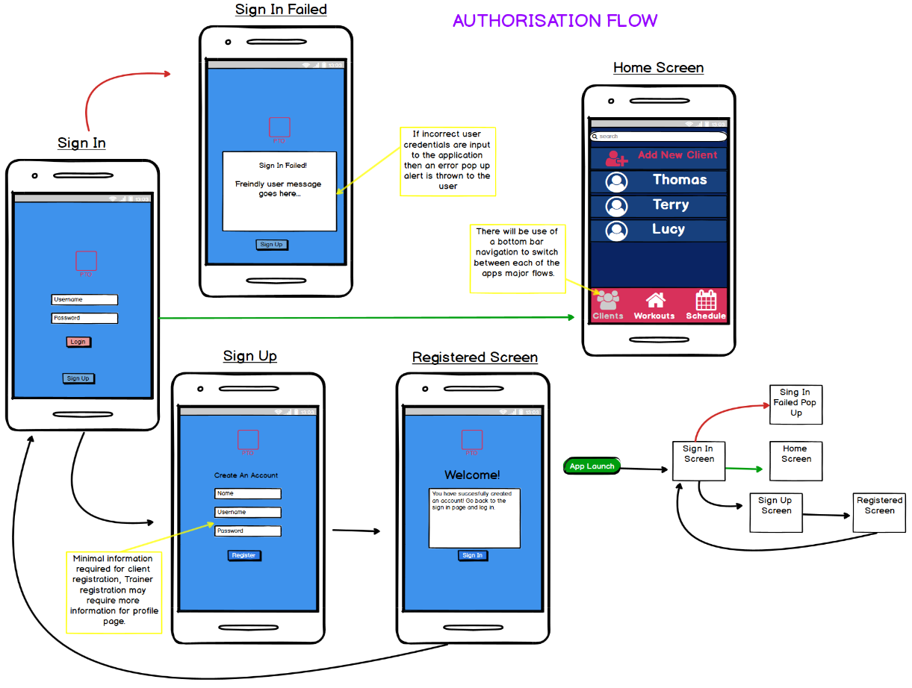

Figure : Authorisation Flow Design

Figure 3 depicts the process and the different screens displayed to the user when they go through the procedure of creating and signing into an account. This mock-up corresponds with the steps noted throughout use case ID #1. Each arrow from one screen to another represents the flow of screen transitions; the green arrows signifies a successful sign in, whereas the red arrow shows a sign in failure.

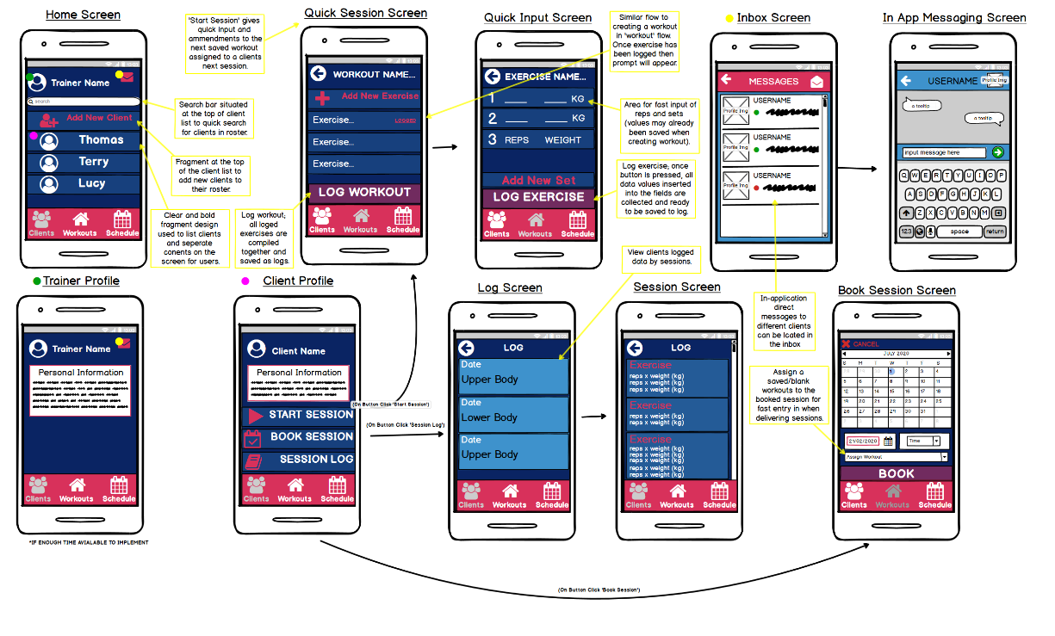

Figure : Clients Flow Design

Figure 4 illustrates the Client flow that is described through use case ID #2. Upon successful authorisation, this is the first screen visible to users with a Trainer role. The colour-coded dots on the widgets in the ‘Home Screen’ mock-up represents an onClick action that changes the users view to one of the three subsequent fragments annotated above.

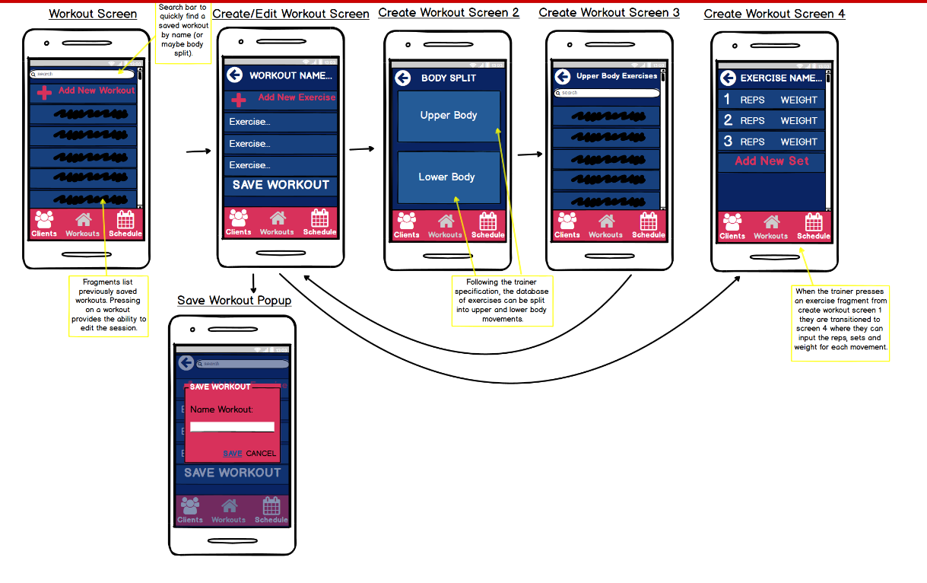

Figure : Workout Flow Design

Figure 5 displays the flow described in use case ID #3. This view is only visible to users with a Trainer role applied to the account.

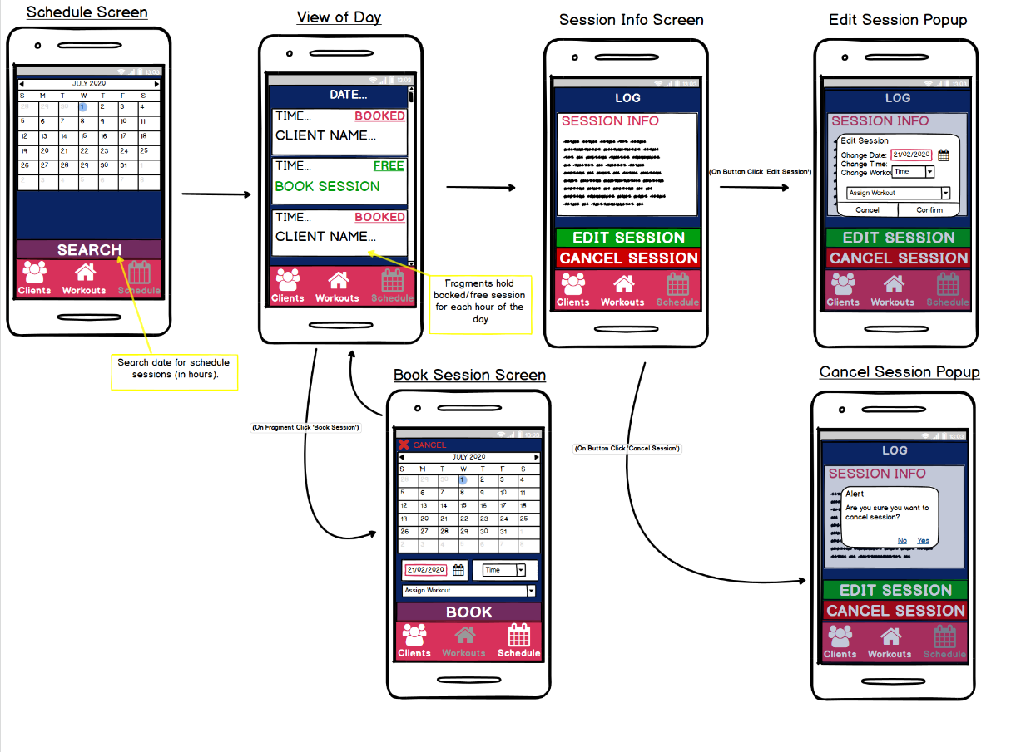

Figure : Session Scheduling Flow Design

Figure 6 illustrates the process that is undergone to book a session with a client and is described through use case #4.

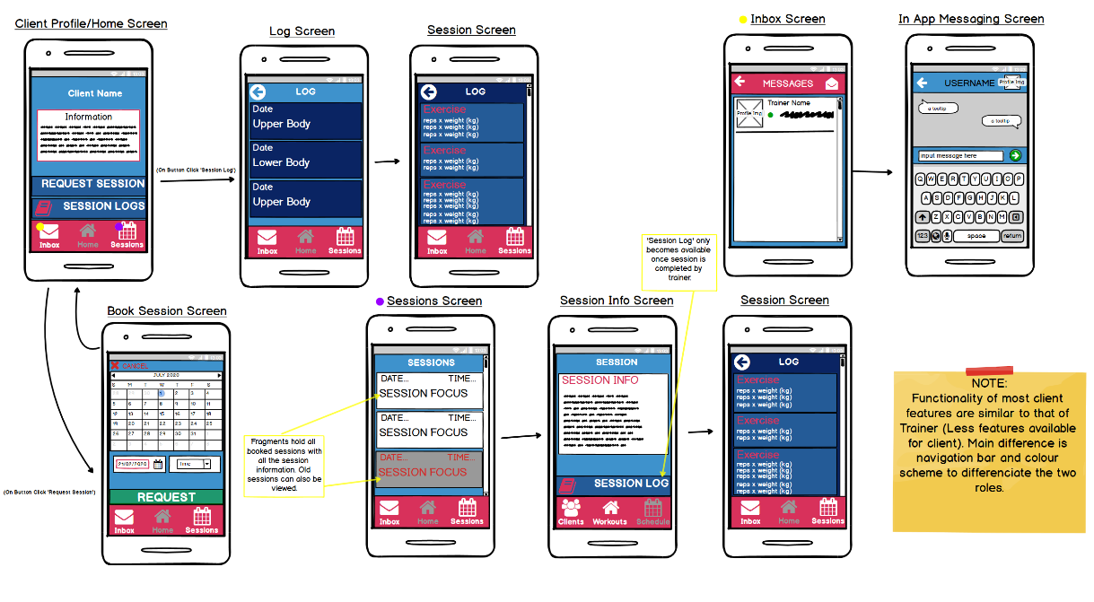

Figure : Client-Side Application Design

Figure 7 shows the view that is displayed once logged in as a user with a Client role assigned to their account. Similar to Figure 4, the ‘Home Screen’ in this mock-up design has been colour-coded with onClick responses to show the events and the flows that occur once the navigation buttons have been triggered.

## Implementation Diary

### Application Setup

Once the design and planning of the project had been completed, a blueprint to how the implementation of the application was presented, and development could begin. The first steps of this process involved the setup of the application in Android Studio and other environments like Firebase and Lunacy that would help to build the system from the front end and back.

When starting the new application project, dependencies were required to be referenced inside the apps ‘build.gradle’ file. This allowed me to include references to Firebase and the different SDKs the platform provides for ease of use (later documented in detail). Once these dependencies were included the next step was to create and link a new Firebase project from the online console.

Firebase provides a serverless, No-SQL platform that allows developers to concentrate more on server-side coding than back-end development. An account can simply be made by logging into a Google account, and after filling out some project details, a few clicks later you are provided with a server app that allows for storing information to a cloud database and many other features. Android Studio (also a product of Google) allows users to quickly link Firebase projects to applications through the ‘Tools’ menu in the software.

### Utilisation of Fragments & Activities

To truly understand the development process undergone using Android Studio, one must first grasp a context of how pages are built in order to be displayed. A variety of page layouts are provided by Android Studio, however for the production of this application and the purpose of this explanation, only fragments and activities are used. When created, both activities and fragments are separated into two files; an XML file (used to develop the UI of a page) and a Java file (used to provide UI elements with functionality). From research, you may come to understand that an Activity provides a screen that users can interact with and can exist independently, whereas a Fragment represents a “sub-activity” which has its own lifecycle and receives its own input events but may only live inside an activity.

Based on the understanding of these components and their characteristics, a couple of elements in the development process were impacted…

Firstly, to provide functionality to each page in the application, UI elements must be present. Therefore, the rule of thumb for the development of each page in the application was to first construct the XML file in its entirety and provide each page with the correct widgets to mirror the established mock-up designs. After which the UI elements could then be given functionality through the Java files to allow the user to have an interactive experience.

Secondly, the relationship between Activities and Fragments provided a foundation for the implementation of the navigation system. Illustrated throughout the mock-up designs and in the ‘Navigation’ section of Chapter 3.5, a bottom navigation bar was deemed acceptable for use in the application and to accomplish this it was required to take advantage of both Activities and Fragments. The use of an Activity provided and interactive environment to present a bottom bar menu along the base of its display, while allowing a Frame Layout to occupy the remaining space above. Within the Frame Layout, the contents of a Fragment could populate its view and with the buttons of the bottom navigation bar assigned to different switch statements, the Frame Layout could display and transition between different flows of the application.

### Authentication Implementation

One advantage of using Firebase as a development tool is the range of easy-to-use SDKs and UI libraries provided by Google, one of which provides simple user authentication. Figure 8 illustrates how the function to create a new user with a Trainer role was implemented into the application. As depicted below the function firstly finds the UI element in the accompanying XML file and assigns them to variables; with these variables it is then possible to get the texts stored inside UI elements and/or verify user input through different methods (verification of inputs is shown within the ‘if’ statements of the functions screenshot). Once inputs have been verified successfully, highlighted in blue, the values are passed through a simple method provided by the Firebase library to create the account. If the email details provided are new to the system, then a reference to this user’s details can be saved to the database and access can be granted to the application. The utilisation of the Firebase Authentication SDK meant that the implementation of the trainer registration was completed swiftly.

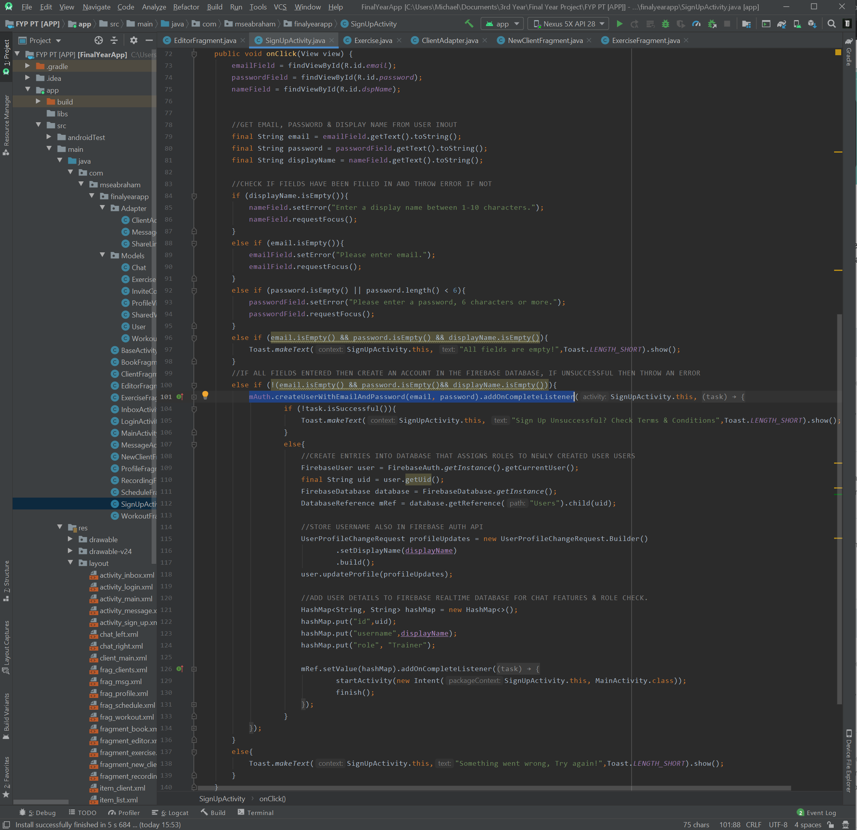

Figure : A Screenshot of How Sign Up Authentication Was Implemented.

### Further Research Explored for Development of The Client Flow

An area of the projects development that reached a plateau was made evident during the implementation of the Client flow. Underlined through the requirements in Chapter 3, one purpose of the Client flow would be to “add and organise clients under a trainer’s roster”. This meant that the trainer should be able to complete some administrative functions inside the application like creating and removing Client accounts. After researching into how this could be made possible, the understanding was that it was not possible to do so through the application itself, instead it can only be done through Firebase Admin SDK which must be run on the server side of the application for security purposes.

Utilizing Firebase Admin SDK caused a few setbacks to development; first of all this was beyond the resources taught in the Mobile Application Development module of the university course, and furthermore after researching how to use Admin SDK there was a realisation that Node.js must be incorporated into the system and this was a language and environment that had not yet been endeavoured. Luckily, Firebase documentation guides offered excellent resources and description on how to integrate Node.js into the application and although it was difficult at first, once the concept of deploying functions to Firebase Cloud Functions (a serverless framework provided by the Firebase console) and calling them through HTTP request was grasped, the development of the application began to steadily progress again.

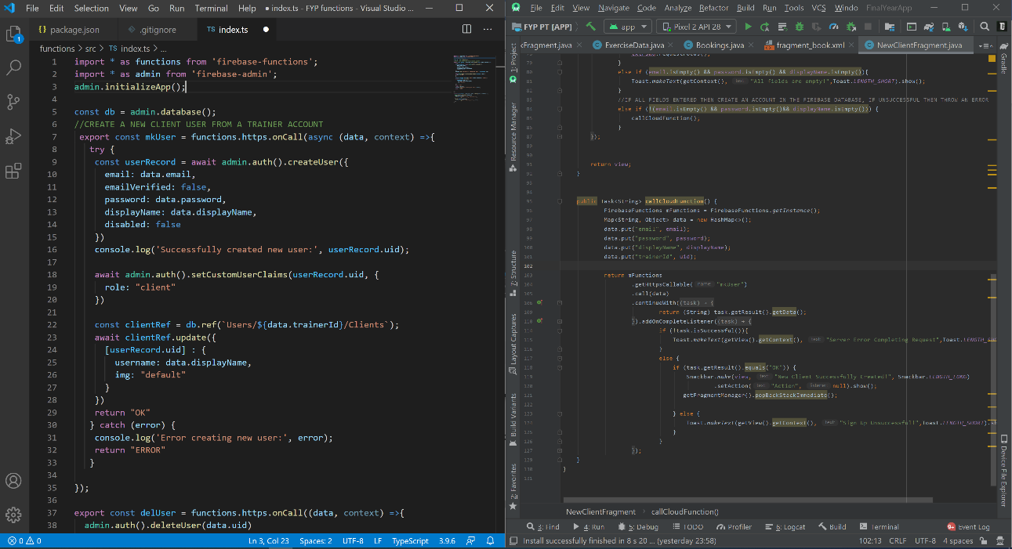

Figure : A Screenshot of How Firebase Admin SDK Is Implemented.

Figure 9 is a screenshot of the components that are required to use the Admin SDK. The window on the left of the screenshot is the Node.js code that creates a new client user which is deployed to Firebase Cloud Functions. The window on the right side of the screenshot shows how that cloud function is called from within the mobile application in Android Studio. Details of how the two codes combined creates a new client user is explained through the project demo.

### Database Implementation & The Impacts on The Application Flows

Firebase provides a service that allows developers to focus on the client side of an applications development and (among various features) manages their servers for the storage of application data, delivering a ‘serverless’ database. Firebase is accompanied with two cloud-based database solutions: Firestore and Firebase Realtime Database (RTD). The No-SQL formatting of both database solutions caused difficulties when designing class diagrams, resulting in the dismissal of that approach to conceptual modelling. Although both databases solutions support real-time database syncing, the main differences between them are the simplicity of Firestore querying and data fetching in comparison to the RTD, and the changes in pricing models and scalability.

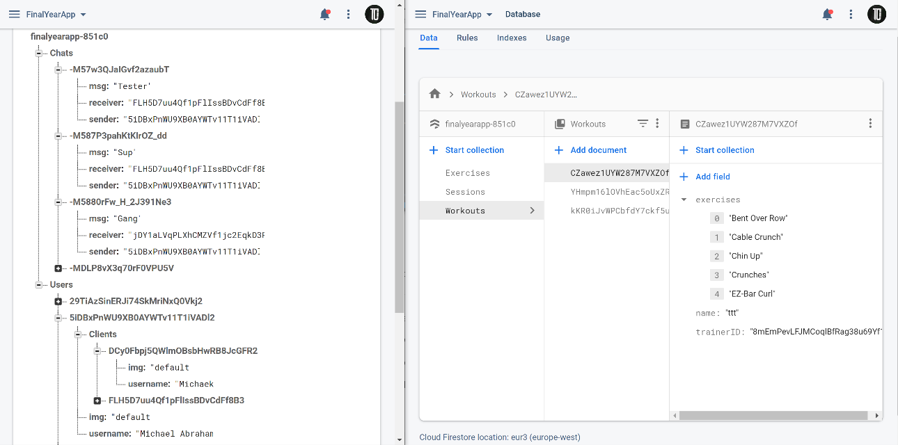

Figure : A Screenshot of The Firestore & Realtime Database Setups. (RTD on left, Firestore Database to the right).

For the development of the application, both database solutions were integrated. According to the Firebase documentation this comes at no drawback to the performance of the application, but for this project served to deliver clarity between the stored data in different flows of the app. The saved data from the Client Flow and the apps messaging features both reside within the RTD. The giant JSON tree format that the RTD provides made posting and retrieval of message data straightforward and easily accessible. User details, used for the Client Flow, were also manipulated for the purpose of the in-app messaging features concluding that that data should also be stored in the RTD for simplicity. As shown above in figure 9 (illustrated through the ‘clientRef’ method), when creating new client accounts using HTTP functions in node.js, referencing the user details in the RTD can effortlessly update trainer’s information with new client details.

The remaining data for exercises, workout saves, bookings and session recordings are located in the Firestore database. This database solution offered a more structured approach to storing data, using documents (a key-value store with the capability of pointing to sub-collections) and collections (an assortment of documents) to construct a hierarchical archive of data. As intended by the Google Firebase developers, this allowed simple and compound queries to be easily called within the app and for the purpose of this project multiple queries were performed in the application to retrieve the previously stated custom objects of data. However aforementioned, this No-SQL structure was the cause of the renounced class diagram. The absence of a conceptual model made planning and visualising an approach to storing Firestore data difficult. Firebase prepared little guidance on how to structure and model data storing during the design phase of an application, so rather than having a blueprint prepared for swift implementation, data was manually inserted into the database console and reverse engineered to be displayed and posted from within the app. As an attempt to implementing data storage for an isolated set of data this was a reasonable approach, which took time and much consideration to establish but was achievable. The obstacles occurred when integrating different sets of data which had relational information; this led to multiple reimplementation’s of objects and their associated functions, which became extremely unproductive and resulted in an unnecessary consumption of time. Consequently, some features were not able to be implemented due to the complications met at this stage of the development.

### Implementation Setbacks

Towards the latter stage of the development process, as mentioned in the section above, time was wasted restructuring the application. This meant that some features, maybe not as key as others, were unable to be implemented. To fully understand the downfalls to measure the success of the project, these areas must be documented and explored. As mentioned in the section prior, the main downfall was with the implementation of the bookings in the database. Consequently, this cause disturbance to the production of the Logs which was a main feature of both the Client and the Trainer accounts. The several restructures of the booking’s documents affected the contents of the session logs. Originally logs were saved stored in a mapped array but reading these became a problem, so a restructuring began to resolve this issue. Subsequently this then caused a problem with retrieving the bookings from the schedules, causing another restructuring of the database. This further lead once more with the logs, now being unable to write to them. Ultimately this meant creating a field within bookings to take a string of logs as an ID which could be used to reference logs as document. Ultimately, in the end the application was successfully constructed to read and write to logs and bookings however, this is being referenced to note how much time this wasted. In the end there was not enough time to finish the Client side of the application or to setup and adapter to view the logs. In hindsight, a more detailed approach to designing the backend of the application should have been completed. This may not have happened if an SQL database was integrating; maybe the implantation of the server side could have been easier.

Another setback that could quickly be touched on was the medical situations that occurred over the year and the horrific pandemic that swept the entire globe. All these situations definitely caused a lot of added stress to the problems of the project. These are the unforeseen circumstances that could not be accounted for in the planning of the Gantt chart.



RESULTS / DISCUSSION

## Introduction

This section of the report will convey the steps taken to complete the final phase in the agile methodologies’ lifecycle for this project’s development: the testing phase. The chapter splits testing into three sections; user testing, requirement testing and functional testing. Tackling testing through these approaches meant that there was a greater understanding of how well the application performed, as well as providing a truer understanding of how users interacted with the application whilst presenting an opportunity for users to also contribute feedback on their experience.

In the accompanying subsections of ‘User Testing’ an insight into the user testing goals determined at the beginning of the project are detailed, how they evolved throughout the lifecycle of development is explored and the approaches underwent for testing these goals are documented. The ‘Requirement Testing’ section assesses the application against both the functional and non-functional requirements defined in Chapter 3 and the use cases documented in Chapter 4. Finally, the ‘Functional Testing’ section explores the employment of the testing libraries offered through the Android Studio environment. All processed results for each of the testing methods are then illustrated and analysed throughout each sections section.

## User Testing

This section explores the approach taken for user testing in this project. The user testing practiced during pre-development varied from the practice undergone in the pre-launch phase (due to the global pandemic, COVID-19), however an atmosphere that best replicated a gym environment was produced, abiding by government guidelines and regulations.

Both concept testing and the user testing commenced in person. This allowed reactions expressed through body language to be gauged while in the working environment; it also made the distribution and collection of testing equipment and data much simpler.

### User Testing Goals

* The application should allow users to easily document workout session data in a workout environment.
* The application should be easily navigable and clear to all users.
* The application should perform efficiently and as bug free as possible.
* The application should be user-friendly to entice users to consistently use the application for their workout sessions.

### Concept Testing (Pre-Development Phase)

This phase of user testing took place before the development of the application. This testing method allotted preparations of mock-up designs to present to participants in order to gauge reactions and provide feedback. The provided feedback was then later used to adjust the designs and produce a more appropriate minimum viable product (MVP). The Concept Testing was split into three stages; impression testing (to get the participants expected task outcomes, to show them initial mock-up designs and then evaluate whether their expected outcomes align with these designs), navigation expectations (investigate how the user may interact with the application) and overall satisfaction. Before the concept testing commenced the 10 participants were briefed with the background of the project (mainly derived from the project proposal) to gain an understanding of what type of application they would be helping to construct.

#### Impression Testing

During this phase of the concept testing, participants were given two minutes to ‘quickly write down any task that they would expect to achieve when using the application for both a client and trainer’. The expected tasks returned by the participants were as followed:

1. To register and sign in as either a client or trainer account.
2. To manage and view clients that employ a trainer.
3. To book a session with a trainer.
4. To view sessions that have been booked and any session details.
5. To create a session plan.

Participants were then showed the original version of the mock-up designs. Every flow of the application had an initial designed prototype that was exhibited to participants for 20 seconds each after which, they were then asked to recall memorable features. One notable reaction that was observed during this part of the of the concept testing was when a participant pulled a screwed face when presented with a design prototype; the noted response was that “that colour scheme is hideous”. After several similar responses, the colour palette of the application was altered, ultimately leading to the selection process for the colour scheme explained in section 3.5.4. Other responses that were noted was the “modern approach to the navigation system” and the range of capabilities that the prototype advertised. When asked if the application satisfied the expected task devised by participants at the beginning of the session, 100% said yes.

#### Navigation Expectations

For this phase of the concept testing the users were once again shown the original design prototypes but this time were asked to describe what actions they believe would unfold if they were to press different UI elements. In hindsight, this became a trivial task because the mock-up designs were well annotated, so it was easy to follow. However, participants assured that the simplistic formatting of UI elements and fragment transitions were appropriate. Any unnecessary transitions were noted and later removed from the designs.

#### Overall Satisfaction

Finally, this phase of the concept testing concluded the testing approach and provided an overview of how the clients reacted to the application during the development phase. A list of 30 positive and negative adjectives were tabled for each participant to highlight a small collection of words which best reflected their feelings towards the application and design prototypes; after processing these results, it was made evident that the most picked words were simple, clear, free-flowing, uncluttered and blinding. Majority of these words categorised as positive adjectives, however ‘blinding’ was a highly picked negative word which most participants related to the with the colour scheme. In conclusion, the applications setup was a successful prototype, but it was highlighted that the colour palette must be addressed to satisfy more potential users.

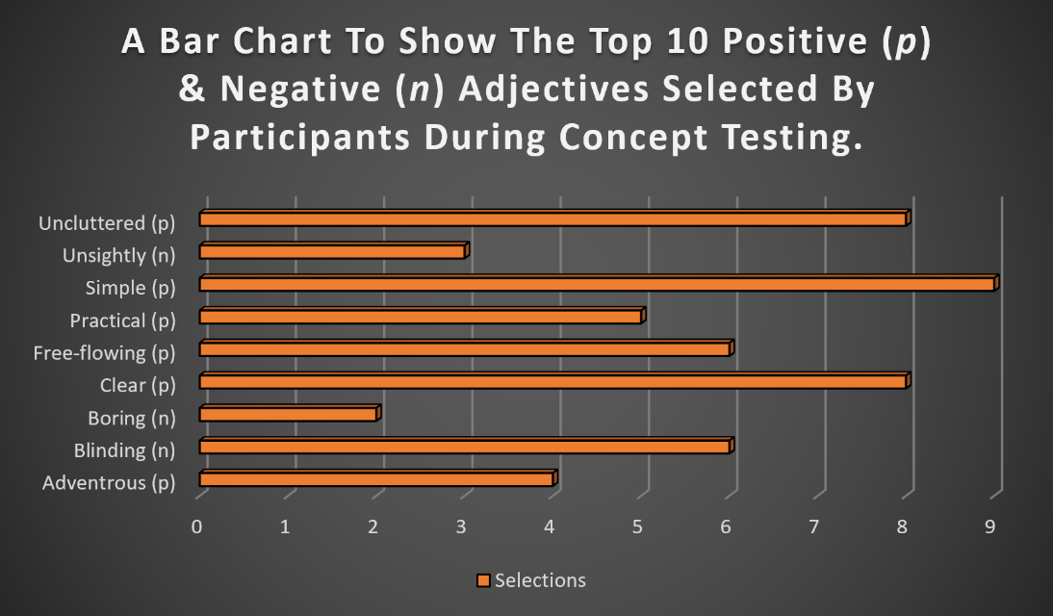

Figure : Top 10 Adjectives Retrieved from The Overall Satisfaction in Concept Testing.

The high ratio of positive adjectives selected to reflect the participants feelings towards the application indicated that the design prototypes were following the right path to fulfilling the user requirements. The results illustrated, along with additional notes taken from verbal feedback, the many positives and the flaws of the designed mock-ups. After analysing the results collected during this phase of early testing, further action plans (for example UI redesign or use case remodelling) were laid out to help establish the progression made through the project and the methodology lifecycle. Concept testing completed under agile methodology was a successful combination utilised for the design of an app as the agile practice provided a flexible style to development, while the results taken from the concept test aided in restructuring tactics to progress through the project.

### User Testing (Pre-Launch Phase)

#### User Testing Structure

The participants recruited for users testing were 2 trainers and 6 clients (3 for each trainer). This was a limited set of candidates to help follow the government protocols for interaction during the pandemic, however the correlation between the behaviour of the selected candidates were the consistency of their training sessions (3 or more workout sessions a week) meaning the filtered participants would best represent our target audience for clients.

The environment prepared for the conducting of the tests was a small gym-like container. The container provided enough space for cardio workouts, a variety of exercise machines and some free weights (dumbbells, kettle bells, Olympic sized barbells, etc.) to complete a simple workout session. Every client session was scheduled for an hour slot so each participant could spend 30 minutes completing the workout and testing the app, then the remainder of the session could be used for collecting results and sanitizing equipment to prepare for the next session.

The desired outcome of the user testing was to understand if the application met the goals defined throughout the project’s development. Firstly, the session structure and the expectations of the participants were explained to each client at the beginning. Afterwards the trainer took each client through a workout, designed via the app, whilst being observed from a safe distance. Once all the exercises were completed, the trainers began preparing for the next session while clients were allocated 10 minutes to test their features of the app following a script of tasks that had been devised. A further 15 minutes was then given to debrief the participants and request any further feedback. Once the trainer took all of their clients, feedback from them was then documented.

#### Client Results

After the session with the Clients were completed, the opportunity occurred for clients to independently trial the app and provide their feedback through a quantitative satisfaction report. The participating clients were asked 8 questions, ranking each answer from 1 through 5 (with 1 being strongly disagree and 5 strongly agree). The questions asked and response received were as followed:

Table 1: Participants Questionnaire Summary

|  |  |  |  |  |  |
| --- | --- | --- | --- | --- | --- |
| Questions | Answers | | | | |
|  | Strongly Agree (1) | Agree (2) | Neither Agree nor Disagree (3) | Disagree (4) | Strongly Disagree (5) |
| Q1. The session you just partook in was a good session? | 4 | 2 | 2 | 0 | 0 |
| Q2. The session you just partook in was enjoyable? | 5 | 1 | 0 | 0 | 0 |
| Q3. The session was made more enjoyable directly because of the app? | 3 | 3 | 1 | 1 | 0 |
| Q4. The use of the app during your session made it run more smoothly? | 1 | 4 | 3 | 0 | 0 |
| Q5. The app was simple enough for use whilst working out? | 5 | 2 | 1 | 0 | 0 |
| Q6. The app would be convenient for regular use during your sessions? | 5 | 2 | 1 | 0 | 0 |
| Q7. The features available to clients were beneficial? | 0 | 1 | 4 | 1 | 2 |
| Q8. The features available to trainers were beneficial? | 6 | 0 | 2 | 0 | 0 |
| Q9. The application was distinctive compared to others available on the market? | 2 | 3 | 4 | 0 | 0 |
| Q10. You would recommend this app to other clients working with trainers? | 2 | 4 | 2 | 0 | 0 |

When analysing the data collected from the clients and trainers you can see a clear positive trend, the graph in Figure 12 helps to illustrates this. This is good response shows that the app was accepted well by the clients, whom after speaking to during the I person result collections, claimed there were many positive things to take from the app although not complete.

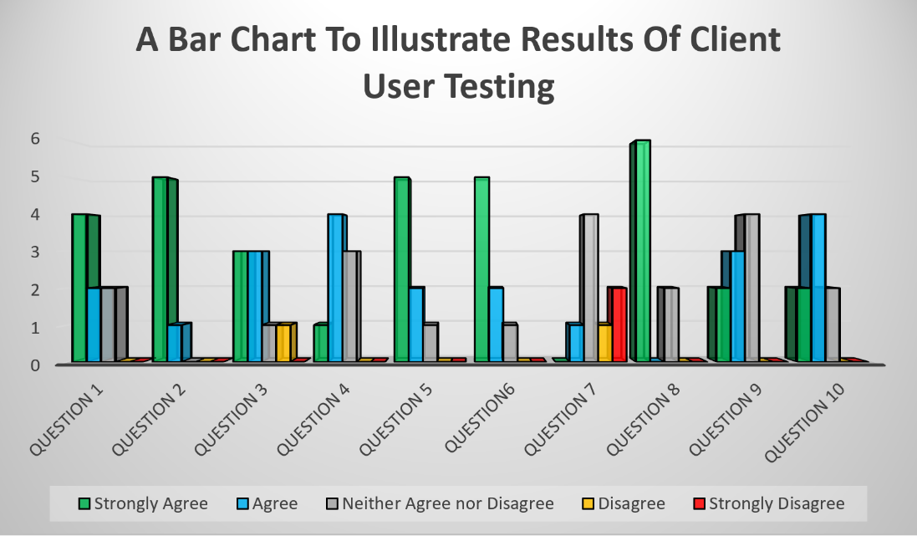

Figure : Bar Chart of User Testing Results.

#### Trainer Results

The results accumulated from this section are arguably the most important results from the testing as the application is more targeted towards the trainers than any other stakeholder. The results taken from the trainers would give the most accurate insight on how successful the application has been developed, as they have been more directly exposed to the alternative methods of data recording for sessions. Although the trainers answered the same questions and were included in the results shown above in the Client results (table 1 and figure 12), they were asked 6 additional questions targeted at the product as a whole. The answers received were qualitative results to gauge a deeper understanding of the trainer’s feelings towards the final product they encountered, the results were as followed:

Table 2: Trainer’s Additional Questionnaire Results.

|  |  |
| --- | --- |
| Questions | Answers |
| Q1. Do you believe the application achieved everything it set out to complete? | I do not believe that the application completed every task that it set out to complete but the areas it indevoured into seemed very promising. |
| No but a lot of the tasks that we thought of at the beginning of the project were done, even some that we did not think was possible, so I highly commend the effort. |
| Q2. Was the product produced exactly what you expected based on the trainer specification? | Everything I recommended as an addition was on the app, so I have been very impressed with what was produced, yes. |
| To the developer’s standards, probably not. But the features that were made in the trainer app exceeded my expectations. |
| Q3. How efficiently could you compete your data recording? (Please give details) | Way quicker than I ever have with my notepads that is for sure. Did not waste any time faffing around with scrap pieces of paper, so I’m chuffed with that. |
| This for me was the most impressive part. I’m used to taking the whole set to write recordings whilst clients continue exercising, so to do it in a couple click was very impressive. |
| Q4. What improvements would you request to make on the application? | I know that the data was being added to the database because it was out on display from the laptop, but I’d definitely make displaying the session logs through the app a top priority. |
| For me I would recommend displaying data, think that’s the only real part of the app that wasn’t done but would be helpful. |
| Q5. What was your favourite feature of the application and why? | Definitely the adding clients. It was proper easy to do and I could even send messages to them through the app. I thought that was a great feature to include that most of the other apps I have used don’t have. |
| Adding the bookings was my favourite part. It was really simple for me to use and the way you explained each time slot getting changed seemed very genius. |
| Q6. With 1 being extremely unpleased and 5 extremely pleased, how satisfied are you with the application? | 4, we set a lot of criteria in the planning section so for the application to turn out how it has with only a single person creating it, I give you big plaudits. |
| 5, I’m a proper out of date person when it comes to technology, but this was simple to use and very easy. I think I a lot more can still be done to improve the app but its definitely on the right tracks to being a success. |

Upon reflection of the results attained from the trainers, one could conclude that the attempt to create the product that they had envisaged through the trainer specification was somewhat successful. The feedback retrieved seemed rather positive, although some constructive criticism was acknowledged.

## Requirement Testing

Ultimately, the aims of this testing were to review if the application completes their intended tasks. As mentioned in the introduction to this chapter each functional requirement, non-functional requirement and use case developed during the design lifecycle of the project were tested. The requirement tests set out to assess each task or goal to clarify its expected outcomes and compares them against the actions that actually unfold after the development of the features into the application.

### Functional & Non-Functional Requirement Testing

To begin the requirement testing, firstly the functional/non-functional requirements were analysed. Each requirement was attempted through the MVP and the results were documented into a table…

Table 3: Functional & Non-Functional Requirement Review

|  |  |  |  |  |
| --- | --- | --- | --- | --- |
| Functional/Non-Functional Requirement | Does It Complete Requirement? | | | If Partially or No What Is Needed for The Feature to Fulfil the Requirements? |
|  | Yes | Partially | No |  |
| Register user. | 🗹 | - | - | N/A |
| Sign out. | 🗹 | - | - | N/A |
| Add and organise clients under a trainer’s roster. | - | 🗹 | - | Located in the Client Flow, users are able to view the clients they have registered and add new clients using the code deployed to Cloud Functions console. However, the delete clients feature is deployed to the console but not linked into the application/ |
| Schedule sessions with clients. | 🗹 | - | - | N/A |
| Create and save workouts. | 🗹 | - | - | N/A |
| Assign to a client’s session. | 🗹 | - | - | N/A |
| View client’s previous recordings of session. | - | - | 🗹 | Details of a sessions exercise logs are stored to the database, however the setup to view this saved information is not yet implemented. |
| Edit client’s profile. | - | - | 🗹 | After liaison with the trainers, this became a superfluous requirement. It was initially intended to change update the personal info of a user but those were no longer collected when the accounts were register. However, this feature still holds relevant for the editing of user registration info, for example passwords. |
| View scheduled sessions in a trainer’s calendar. | 🗹 | - | - | N/A |
| Provide pre-logged exercises. | 🗹 | - | - | N/A |
| Quick Recording Feature. | - | 🗹 | - | The application has a layout to complete a session and enter the exercise log details. However, the page does not fully work as intended. The exercise data can be added numerous times rather than limited to once per exercise in the workout. |

Evidently shown through the requirement test results collected, the development of the application can be categorised as moderately successful due to the 64% completion ratio of implemented requirements. Both partial and non-completed requirements only accounted for 36% of the applications criteria. Although this percentage could be improved for future work on the application, this represents a positive image for progress made towards the applications aims documented in section 3.3.1.

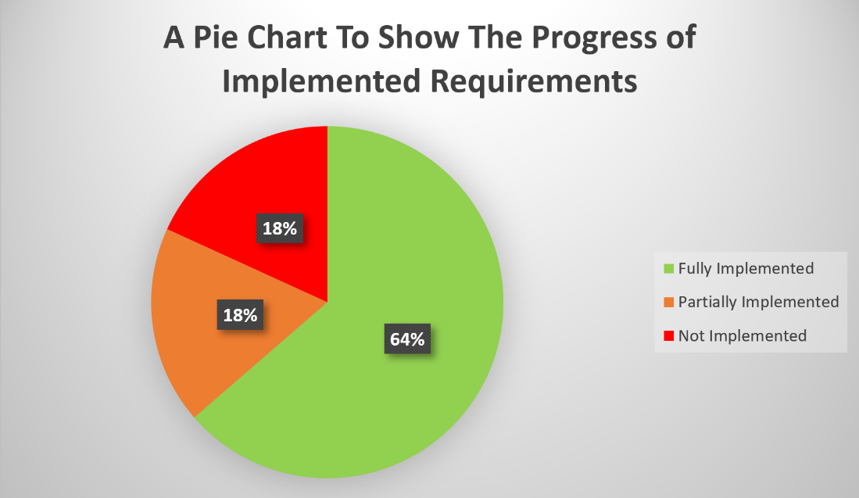

Figure : An Illustration on Progress of The Implemented Requirements

### Use Case Requirement Testing

The next method used to test the quality of the application was the use case test. For this task, each use case and their intended outcomes were noted, after which every case was then tested through the application. Any contrasting results to the intended incomes were documented in the notes field to highlight any inconsistencies.

Use Case Name [ID]: Authorisation Flow [#1]

**Intended Outcome:** This system should allow trainers to log in using their credentials else if no credentials have been registered, they are able to create a new account.

Actual Outcome: Upon the applications load up, a check for any active account sessions previously logged into the device is attempted; if a user is available then the session may begin and the user is sent to the home page, else if not the a view for authorisation is created. Within this activity the user is prompted to enter a registered email and password to login or sign up to create a new trainer account. If the user requests to register an account after inputting a valid formatted and unregistered email address, 6-character minimum password and a display name, then a new account is created.

Notes: This use case specified in the Actors & Roles field that ‘clients might only be able to be invited through a Trainers referral code’ however, after development of the application the most efficient way to create a user account was through a logged in trainer using the Firebase Admin SDK.

Use Case Name [ID]: Client Flow [#2]

Intended Outcome: Provide a functional layout that allows trainers to view, add and delete clients from the application.

Actual Outcome: Trainers are able to add new Client accounts and view these Clients in the layouts contact roster. Buttons are displayed to start new sessions on the current date, book sessions for the viewed Client and view completed session logs, although the quick book session and session logs are not yet implemented in the application.

Notes: Unfortunately, a function was created and deployed to the Firebase Cloud Function on the applications server-side that deletes Client users, however this was unable to be triggered from the applications client-side so the feature was not added to the app.

**Use Case Name [ID]:** Workout Flow [#3]

**Intended Outcome**: The flow should allow trainers to create, view, and manage workouts for sessions, as well as facilitate recording and storing of the sessions data.

**Actual Outcome:** The application allows trainers to create and view the workouts they have saved to their accounts. However, after remodelling of application logic and data storing during development, using this flow to store session data became unnecessary and instead was moved to the start session area of the Client Flow.

**Notes:** Although this use case no longer supports logging session data to the database, the creation of workouts through this flow allows for the feature to be possible elsewhere.

**Use Case Name [ID]:** Schedule Flow [#4]

**Intended Outcome:** This flow should allow trainers book sessions with their clients and view them by dates and time.

**Actual Outcome:** The application allows users trainers book sessions with their clients and view them by dates and time.

In conclusion based on the results of the use case tests, the application completed the fundamental aspects of what was planned from the outset, although not all outcomes were identical. Presumably, this may have been impacted through the methodology and the evolving requirements formulated throughout the development of the application. As the criteria of expectations changed, the approaches to the project’s tasks were remodelled and ultimately this was destined to affect the way in which the applications features would be used.



CONCLUSIONS / FUTURE WORK

## Conclusions

Although the data in the user testing from client participants were largely positive, the results from the functional testing was mainly successful and the feedback from the trainers were very encouraging, this should not cloud the fact that the project did achieve all the targets that it set out to complete. The results show that a great foundation has been built to develop an application that could become very useful tool for Personal Trainers completing one to one workout sessions with their clients. With some understandable improvements and some further expansions, this product produced from the project could be a highly beneficial and profitable application.

The background behind the project that is documented through the report and the high satisfaction represented through the feedback of the trainers, from a partially completed application illustrates an obvious area within the app market that has not yet fully been explored. In regard to the application solely, even though testing of the implemented features were successful, improvements can be made to make it a more productive product. However, in regard to the project as a whole, the results support that it was a successful attempt to resolve an issue that was present. The project set out to explore ‘how a personal trainer can simplify data recording during a training session’ and based on the response of the trainers and clients, you can conclude that the project was triumphant.

## Future Work

The project had many features that could have been added, expanded on, or improved to create a more complete application. One area of additional development that could have helped the application further meet the requirements, laid within the client side of the application. Due to the scarce time that remained after the trainer side of the application was implemented and the limited information that was taught during the Mobile Application Development module, the features implemented into the client side were insignificant compared to that of the trainer side. A feature that allows clients to ‘Request A Session’ was modelled in the design documentation but was not included in the MVP. Although the projects early designs note state that “functionality of most client features are similar to that of a trainer”, including additional features like requesting sessions would likely entice more user engagement from the clients.

An additional feature that could be integrated into the application is notifications. There are various elements of the application that could be elevated with the incorporation of notifications; for example, notifications delivered via the app when approaching or at the beginning of scheduled sessions would help to remind users of bookings and direct them back to the application. Once again this would very likely help to increase user engagement and is also a common feature of most applications developed at present.

Another feature that would improve the application would be the development of user profiles. Allowing clients and trainers to edit information on a user profile page (i.e. personal information, qualifications, areas of sports expertise, contact details, etc.) opens avenues for the integration of countless features, which may stray slightly from the applications original proposed purpose but would create a more accomplished application. Allowing personal details to be stored and edited would alter the data protection regulations the app currently abides by, however this could create a platform for trainers to promote their businesses to potential clients and a provide a space to carry out digital marketing through, while simultaneously organising their workload; creating a centralized hub for their business.

## Legal, Social, Ethical and Professional Issues

One common legal issue that required consideration during the development of the application was copyright infringements. In order to ensure that the contents within the mobile application was all original, all work completed was of the author. Use of images online was refrained from to certify that the application could not be subject to infringements.

Originally the application planned to hold information on the trainer and each of their clients, so it was important that it coincides with the laws in the ‘Data Protection Act 2018’. However, this element became redundant and the only personal information taken from the user was the email and their names for a display name (although any name could be entered). Necessary security access rules were written to the firebase data to ensure that these data protection standards were abided by.

One ethical issue that had to be considered and was defined in the project planning report was for the capabilities for clients and trainers to delete personal information from the database as of when they decide. Options for removal of user credentials were integrated into the account and purging of any associating data was also carried out to ensure ethical standards are upheld.

Finally, in order to ensure that the application overcomes any professional issues and its intentions are properly communicated to any consumer, instructions on its capabilities will be located on a ‘About’ page which served as a user guide.

## Synoptic Reflections

This completion of this project has definitely taught some valuable skills to that can be transferred over to many aspects of life. First and foremost, this project has taught the importance of dedication. When things seem as if they are unattainable in life, take a step back, reimagine an approach to your goal and go again; and most importantly, no matter how many times you fail, never give up! There is always a way to solve a situation, whether this be a recurring syntax error or even a problem at work or in your social life. Take a step back, evaluate the situation and try a different tactic.

Secondly this project has instilled the importance of training your mind but also letting it relax. Nothing is more important in life than a persons physical and mental health, so when you do anything in life one must learn to give everything and work to the best of your abilities but take time to unwind and recalibrate appropriately. Pushing yourself too hard can be more unproductive than helpful.

Also, this project has taught a level of understanding in android development that was not known prior. The subject had been attempted but only on the most basic, surface level understanding of the topic. This is a skill that employers could look for, and now with a MVP that could be expanded on an improved, a asset has been developed that could showcase some skills and capabilities. The completion of this project, the lack of education received on the mobile application module of the Software Engineering course and the pandemic, forced one’s hand to focus largely on independent work which consequently sparked an interest into further research of many subject areas also.

ReferenceS

[1] IBIS World. (N/A) *What is Personal Trainers industry in the UK?* [Online] [Accessed on July 7th, 2020] <https://www.ibisworld.com/united-kingdom/market-research-reports/personal-trainers-industry/>

[2] eDesk HUB. (Oct 18th, 2017) *Why Agile Methodology for Mobile App Development.* [Online] [Accessed on March 1st, 2020] <https://medium.com/@edeskhub/why-agile-methodology-for-mobile-app-development-e685b41ea462>

Bibliography

IBIS World, *Personal Trainers in the UK - Market Research Report*, IBIS World, <https://www.ibisworld.com/united-kingdom/market-research-reports/personal-trainers-industry/>, 07/07/2020

Trainer Essential, *39 Personal Training Industry Statistics [Market Size, Growth & Trends]*, Trainer Essential, <https://www.traineressentials.com/personal-training-industry-statistics/>, 07/07/2020

(Thompson, Walter R. Ph.D., FACSM), *WORLDWIDE SURVEY OF FITNESS TRENDS FOR 2019*, ACSMs Health & Fitness Journal, <https://journals.lww.com/acsm-healthfitness/Fulltext/2018/11000/WORLDWIDE_SURVEY_OF_FITNESS_TRENDS_FOR_2019.6.aspx>, 07/07/2020

Jenn Sinrich, *6 Ways That Social Media Has Changed Health and Fitness*, Aaptiv, <https://aaptiv.com/magazine/social-media-fitness>, 07/07/2020

Google, *Material Foundation*, Google, [https://material.io/design/layout/understanding-layout.html#](https://material.io/design/layout/understanding-layout.html), 09/07/2020

Google, *Material Guidelines*, Google, <https://material.io/design/usability/accessibility.html#hierarchy>, 09/07/2020

John D. Binford, *10 Apps Personal Trainers Can Use to Improve Communication with Their Clients*, AFPA, <https://www.afpafitness.com/blog/10-apps-and-software-that-personal-trainers-can-use-with-clients>, 16/12/2019

Fitness Software, *FitSW Features*, FitSW Fitness Software, <https://www.fitsw.com/features/>, 19/12/2019

Android Developers, *Design & Quality Documentation*, Google Developers, <https://developer.android.com/design>, 26/02/2019

eDesk HUB, *Why Agile Methodology For Mobile App Development,* Medium, <https://medium.com/@edeskhub/why-agile-methodology-for-mobile-app-development-e685b41ea462>, 01/03/2020

Firebase, *Firebase Guides*, Google Developers, <https://firebase.google.com/docs/guides>, 01/01/2020

Firebase, *Activities*, Google Developers, <http://developer.android.com/guide/components/activities.html>, 20/07/2020

Firebase, *Fragments*, Google Developers, <http://developer.android.com/guide/components/fragments.html>, 20/07/2020

Appendix

APPENDIX A: Trainer Specification

Interviewed Personal Trainer: Adam Leak (PureGym, Milton Keynes)

13/12/2019

* **How do you plan your client’s workout sessions?**

Before the session begins you have a rough overview of what the session might entail however the machines may not always be available so they may change depending. When people start, they aren’t too experienced so most of the sessions are planned upper and lower body split.

* **What do your consultations include?**
* Sign a waiver that covers trainer legally.
* PARQ: Training history, Goals, Eating habits, Injuries, Preferred Exercises, Age, Name, Height, Weight, Medical Information (asthma, diabetes, pregnancy).

*Not required to be included in the application as these legal and personal documents are stored securely in office. (Could be a future feature).*

* **How do you currently record your client’s data?**
* Carries a little book with client’s name and the day of the session. Attempted exercises, the weight limit and the reps achieved are noted down for each exercise. The units of measure always in KG (Stones not necessary).
* Cardio:

12,9,7- client must burn these calorie amounts. Record the timing it takes to reach that calorie and then try and beat the time next session.

Wasting time and money doing any other cardio. Most PTs make clients do cardio in their own time.

* **What do you do with the data once it has been recorded?**

No graphs made with data. Only use data as a reference of what to beat in the next session, which brings consistency.

*Some clients ask for pictures of the weights and reps recorded.*

* **How do you communicate with your clients?**

Email or through texts. They can message whenever they feel but a PT would only message them to remind them on sessions or to have a catch up during the week to make sure they are staying on track.

Clients age between the ages around 18 to 65 (although there is no maximum age range, this is just typical of his and most public gyms). Minimum age for the gym is 16+ however personal trainers do not take on clients until the ages of 18.

* **What features do you feel would be necessary to include?**
* Section for exercises weights, reps and sets. Notes section for each exercise to jot information on movements.
* Cardio section that you explain what you have done in the session (Optional).
* A way to communicate to the clients in the application.
* Graphs would be good to show visual representation of progress, however that is not necessary (Optional).
* Personal information must be kept secure so information on PARQ not necessary in application as they are kept locked in written documents.
* Simple flow for creating workout; create workout –> upper/lower split –> add exercise with weights sets and reps -> save.
* Needs to be usable during one to one training sessions
* **Do you have to make your data available to anyone else except your clients?**

No, the gym (in which he works in) doesn’t get involved between clients. Workout data can be disclosed to other PTs but all data taken from the consultation is private.

Adam is a self-employed trainer, so all work is deemed independent but as the gym provides him with facilities to train clients he has timetable sessions for classes.

APPENDIX B: Gantt Chart 2.0

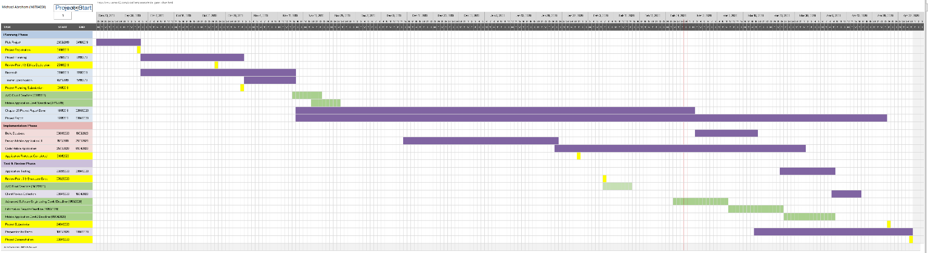

APPENDIX C: Participation Form

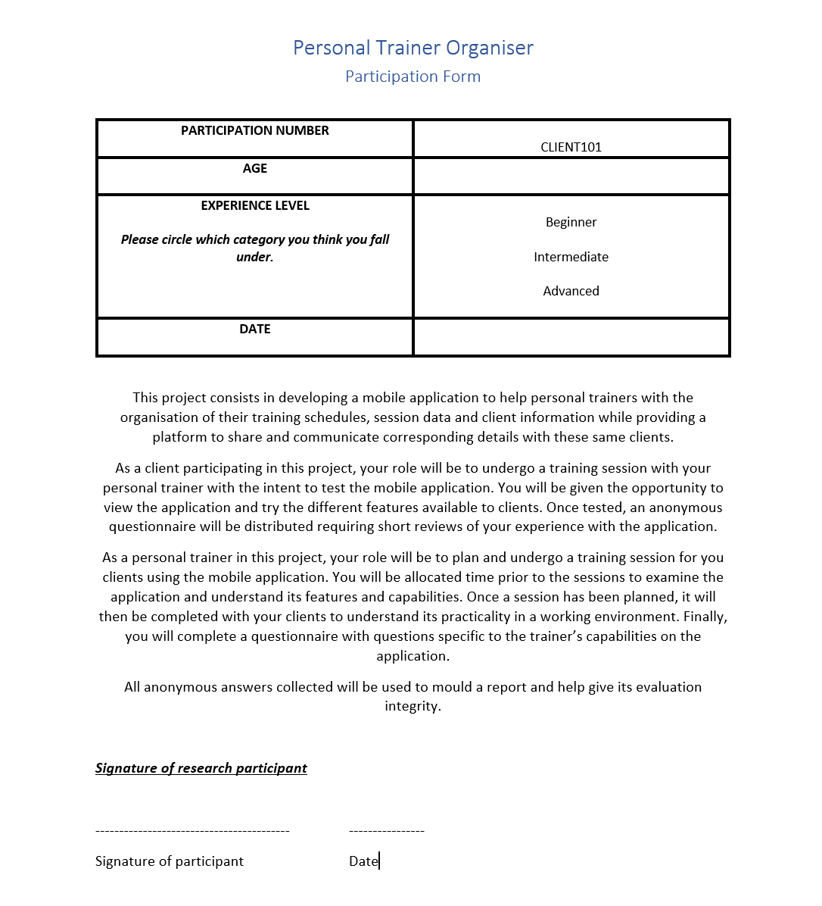

APPENDIX D: Consent Form