**[Check if Grid can be Cut into Sections](https://leetcode.com/problems/check-if-grid-can-be-cut-into-sections/)**

You are given an integer n representing the dimensions of an n x n grid, with the origin at the bottom-left corner of the grid. You are also given a 2D array of coordinates rectangles, where rectangles[i] is in the form [startx, starty, endx, endy], representing a rectangle on the grid. Each rectangle is defined as follows:

* (startx, starty): The bottom-left corner of the rectangle.
* (endx, endy): The top-right corner of the rectangle.

**Note**that the rectangles do not overlap. Your task is to determine if it is possible to make **either two horizontal or two vertical cuts** on the grid such that:

* Each of the three resulting sections formed by the cuts contains **at least** one rectangle.
* Every rectangle belongs to **exactly** one section.

Return true if such cuts can be made; otherwise, return false.

**Example 1:**

**Input:** n = 5, rectangles = [[1,0,5,2],[0,2,2,4],[3,2,5,3],[0,4,4,5]]

**Output:** true

**Explanation:**

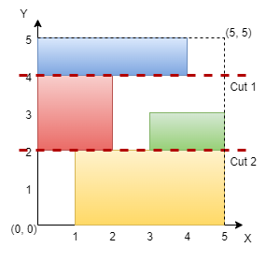

The grid is shown in the diagram. We can make horizontal cuts at y = 2 and y = 4. Hence, output is true.

**Example 2:**

**Input:** n = 4, rectangles = [[0,0,1,1],[2,0,3,4],[0,2,2,3],[3,0,4,3]]

**Output:** true

**Explanation:**

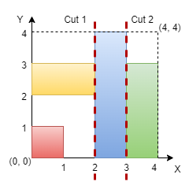

We can make vertical cuts at x = 2 and x = 3. Hence, output is true.

**Example 3:**

**Input:** n = 4, rectangles = [[0,2,2,4],[1,0,3,2],[2,2,3,4],[3,0,4,2],[3,2,4,4]]

**Output:** false

**Explanation:**

We cannot make two horizontal or two vertical cuts that satisfy the conditions. Hence, output is false.

**Constraints:**

* 3 <= n <= 109
* 3 <= rectangles.length <= 105
* 0 <= rectangles[i][0] < rectangles[i][2] <= n
* 0 <= rectangles[i][1] < rectangles[i][3] <= n
* No two rectangles overlap.