* **[Homework 10](https://bbhosted.cuny.edu/webapps/assignment/uploadAssignment?content_id=_22036746_1&course_id=_1180432_1&assign_group_id=&mode=view)**

 Plot everything!

In this homework we will explore the matplotlib library and its features by plotting the results of previous assignments.

**Please do all of the following:**

* 1. Express the cars.data.csv data as a series of bar graphs.  The x-axis represents a feature and the y-axis is the frequency in the sample.  Do this with the 'buying', 'maint', 'safety', and 'doors' fields with one plot for each for a total of four.  Make each graph a subplot of a single output.  Something like this:

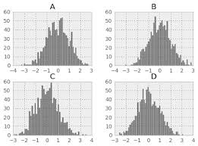

* 1. Plot your results from the linear regression in homework 5 and 7 (for any of the provided data sets).  The plot should include.  1) a scatter of the points in the .csv file 2) a line showing the regression line (either from the calculation in homework 5 or line-fitting from homework 7).  3) something on the plot that specifies the equation for the regression line.  Something like this:

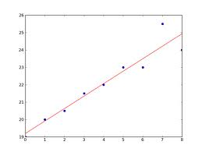

* 1. Create an overlay of the center points found in objects.png from homework 8.  The image should be in the background and the object centers can be small circles or points at or around the center points.  Something like this:

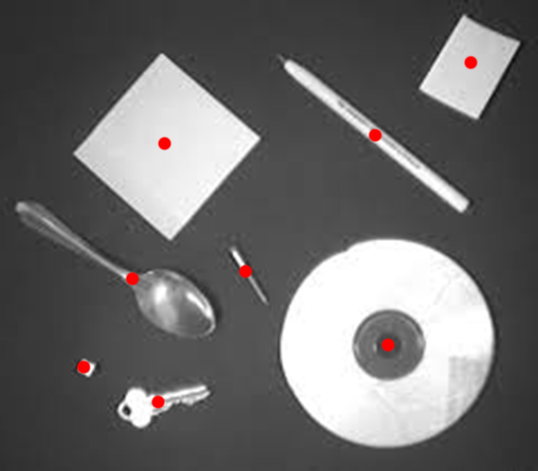

* 1. Plot a line graph that shows the hour by hour change in number of server requests from the HTTP in homework 9.  The x-axis is the discrete hour intervals (e.g. 13:00 – 14:00) and the y-axis is the number of requests.  Something like this:

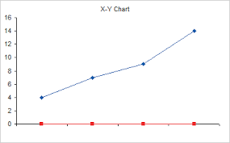

As with previous assignments, many of the details of the implementation are up to you.  However, keep this in mind.  Much of the purpose of plotting is to communicate data and the information therein effectively and efficiently.  Your plots should be able to be interpreted easily and be robust enough to express the data used to create it.  This means include things like labels, legends, proper scaling, etc.  Also, you don't need to perform the operations themselves from the previous homework.  You can just have a static list of data, e.g. for the center points in part 3 you can have a list hard coded or read in somewhere.